
UNIVERSITY OF LUCKNOW
FACULTY OF ENGINEERING & TECHNOLOGY
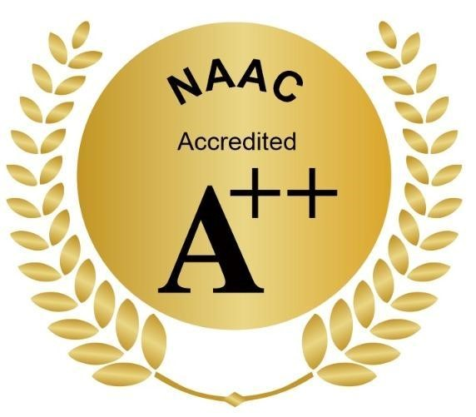
Second Campus, Jankipuram Extension, Lucknow-226031 (U.P.), India

Date: 05/September/2026

Sub: Smart India Hackathon 2026 – Nomination

I am pleased to nominate the below team from our college to participate in Smart India Hackathon 2026. AICTE Application No/ UGC Registration No for our college is __U-0524_.

Team : The LOLgorithms

 | Name | Gender (M/F) | Email id | Mobile no. | Stream | Academic  Year
Team Leader | Ashutosh Singh | M | ashutoshsingh290108@gmail.com | 7985481629 | CSE -AI | 2024-28
Team  Member | Ayush Arya | M | ayusharya9695@gmail.com | 9695565768 | CSE -AI | 2024-28
Team  Member | Amartya Singh | M | amartyasingh658@gmail.com | 9140187108 | CSE -AI | 2024-28
Team  Member | Md. Saklain Khan | M | saklainkhan728@gmail.com | 7398629836 | CSE | 2024-28
Team  Member | Akarsh Gupta | M | akarshxai@gmail.com | 7800251795 | CSE -AI | 2024-28
Team  Member | Alisha Rahman | F | alisharahman675@gmail.com | 7408174475 | CSE -AI | 2024-28

Sincerely,

