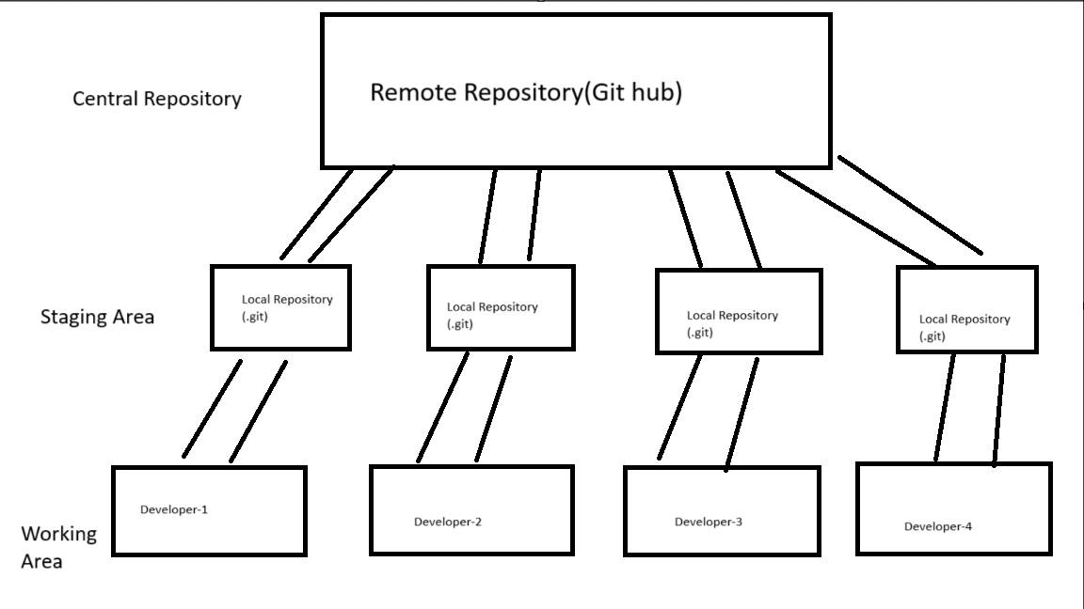

1. git init – To initialize a git repository or local repository in a local machine.
2. git status-To check track status of files i.e. in staging area or in working area.
3. git add <file name> - to add a file into staging area or local repository.
4. git rm --cached <file name> - to remove a file from staging area.
5. git commit -m message – to commit after some feature is added.
6. git log – to view the commits history.
7. git restore <file> -When you make any changes in the file after staging. then to discard changes in working directory use git restore <file> command.
8. git commit -a -m "my third commit" – commit without add the modified file into staging area.
9. git diff - to see the changes you made to a file in working directory.
10. git diff --staged - to see the changes you made to a file in staging area.
11. git branch -M main – to cerate a new branch
12. HTTPS- to connect to remote repository and every time needs login
13. SSH- to connect to remote repository by using creating a password once
14. ssh-keygen -o – to create the key to connect to remote repository.
15. git remote add origin [git@github.com:ashutoshswain4032/Test.git-](mailto:git@github.com:ashutoshswain4032/Test.git-) To connect to remote repository.
16. git push -u origin main - push the data to remote repository.
17. git remote rm origin - to remove the connection with remote repository.
18. git remote -v – to see the connected repository
19. git tag -a v1.0 -m "1st release" – to create a new tag.
20. git tag – to see all the tags.
21. git show v1.0 – to see detailed information about a particular tag
22. git push origin v1.0 – to push a tag to remote repository.
23. git clone repo-link – to clone a repository to local machine.
24. git checkout -b feature1 /git switch -c feature1 – create a new branch and switch to that branch.
25. git branch – to check the no. of branch.
26. git switch/checkout branch name – switch to the branch.
27. git branch branchname – to create a new branch.
28. git branch - - all – to see the remote branches and local branches.
29. git branch -d branch name – to delete a branch.
30. git merge feature1 – to merge a branch with current branch.
31. After merging we need to pull the data from remote repository.
32. git pull origin main – to pull the data from remote repository.
33. And then git push origin main to push the data.
34. git rebase feature2 – to merge two branches but the extra line in the graph is removed
35. git checkout commit-id – go to the commit with the commit id given.
36. git checkout -b light-version – create new branch to hold the older commit.
37. git stash- used to save the data without commit,
38. git stash apply- to view the saved data.
39. git stash list – to see no stash you done.
40. git fork – to copy a entire repository into the remote repository.
41. Pull request – by using this you can request another repository to change in their code which you have done in their repository by forking their project.