**How to put repository on git from command line** By-YASHPREET!

Link for reference

<https://help.github.com/en/articles/adding-an-existing-project-to-github-using-the-command-line>

when you get an error for pull and all

git pull -rebase (basically merge) (Async ho gya tha jaise readme bn gya)

1. Create a new repository on GitHub. To avoid errors, do not initialize the new repository with README, *license*, or *gitignore* files. You can add these files after your project has been pushed to GitHub.

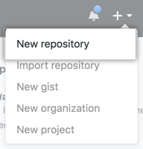

1. Open folder and put cmd in search bar

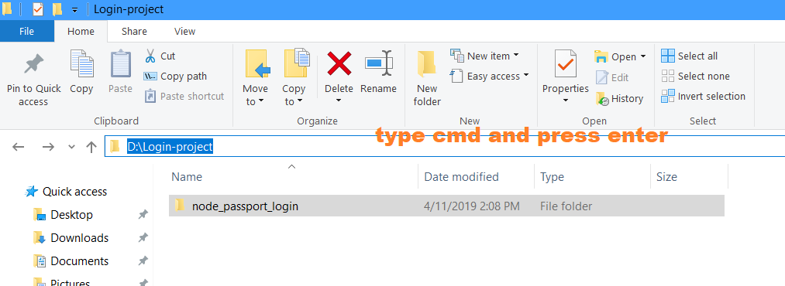

1. Initialize the local directory as a Git repository.

$ git init

1. Add the files in your new local repository. This stages them for the first commit.

$ git add .

1. Commit the files that you've staged in your local repository.

$ git commit -m "First commit"

1. At the top of your GitHub repository's Quick Setup page, click  to copy the remote repository URL.

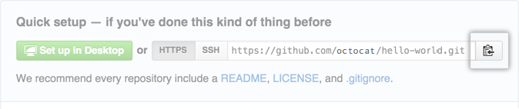

7. To add a new remote, use the git remote add command on the terminal, in the directory your repository is stored at.

$ git remote add origin https://github.com/user/repo.git

# Set a new remote

$ git remote -v

# Verify new remote

> origin https://github.com/user/repo.git (fetch)

> origin https://github.com/user/repo.git (push)

* TAKE Reference from <https://help.github.com/en/articles/adding-a-remote>

1. [Push the changes](https://help.github.com/en/articles/pushing-to-a-remote) in your local repository to GitHub.

$ git push -u origin master

* If push have some error try doing putting -f(or -–force) in end of statement

For e.g.: - $ git push origin master -f

Note: - If any other error is there just try to stack over flow 😊

For Updating Already Uploaded file

1. For checking status what are extra or deleted files

$ git status

1. Add the files in your new local repository. This stages them for the first commit.

$ git add .

3. Commit the files that you've staged in your local repository.

$ git commit -m "First commit"

4.[**Push the changes**](https://help.github.com/en/articles/pushing-to-a-remote) in your local repository to GitHub.

$ git push origin master