Q1. wap to demonstrate ternary operator .define a variable marks  .ask its value from user and using ternary operator check if marks > 40 store "Pass" in result varible else store "Fail"

**package** assignment;

**import** java.util.Scanner;

**public** **class** PASS_FAIL {

**public** **static** **void** main(String[] args)

{

Scanner s = **new** Scanner(System.***in***);

**int** marks;

marks = s.nextInt();

System.***out***.println((marks>=27) ? "pass" : "fail");

}

}

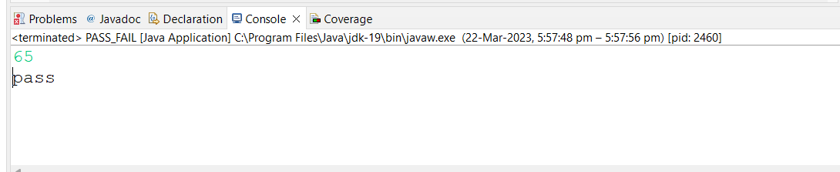

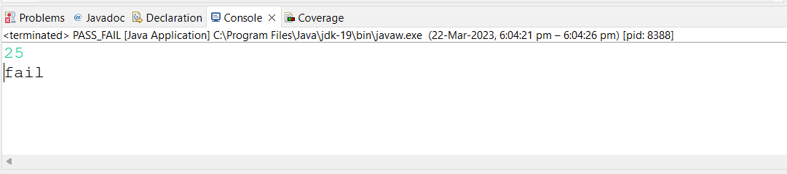

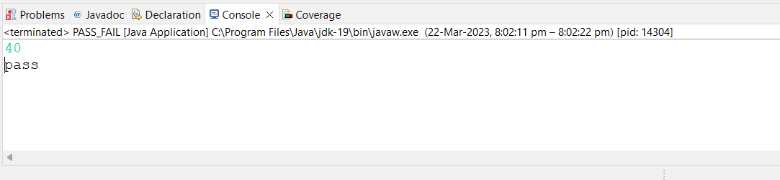

Q 2 using ternary check if number entered by user is positive or negative .  
In case number is positive store "Positive number" else store negative number to Result variable

**package** assignment;

**import** java.util.*;

**public** **class** POSITIVE_NEGATIVE {

**public** **static** **void** main(String[] args) {

Scanner s = **new** Scanner(System.***in***);

System.***out***.println("Enter the number:");

**int** number = s.nextInt();

String result = (number >= 0) ? "Positive number" : "Negative number";

System.***out***.println(result);

}

}

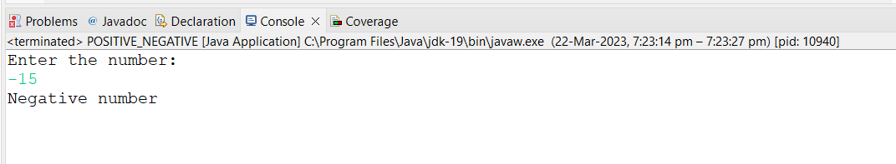

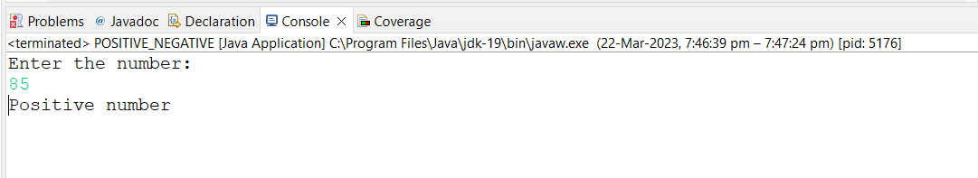

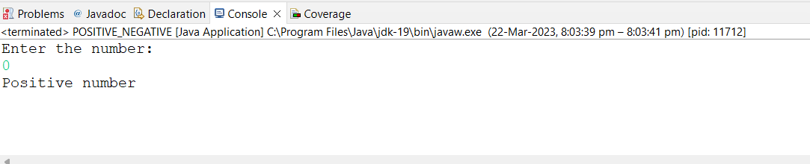

Q 3 WAP to ask name ,age and salary of an employee and print on console.

**package** assignment;

**import** java.util.Scanner;

**public** **class** EmployeeDetails {

**public** **static** **void** main(String[] args) {

Scanner s = **new** Scanner(System.***in***);

System.***out***.print("Enter employee name: ");

String name = s.nextLine();

System.***out***.print("Enter employee age: ");

**int** age = s.nextInt();

System.***out***.print("Enter employee salary: ");

**double** salary = s.nextDouble();

System.***out***.println("Employee name: " + name);

System.***out***.println("Employee age: " + age);

System.***out***.println("Employee salary: " + salary);

}

}

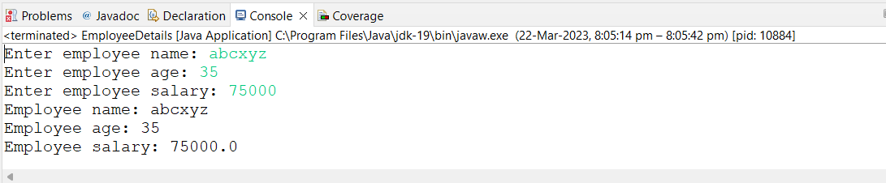

Q 4 wap  that ask two numbers from user and print greater number among two

**package** assignment;

**import** java.util.Scanner;

**public** **class** GreaterNumber {

**public** **static** **void** main(String[] args) {

Scanner input = **new** Scanner(System.***in***);

System.***out***.print("Enter first number: ");

**int** num1 = input.nextInt();

System.***out***.print("Enter second number: ");

**int** num2 = input.nextInt();

System.***out***.println("Greater number is:" + (num1 > num2 ? num1 : num2));

}

}



Q 5 wap to ask product name and price of product from user and calculate discount i.e   
if price > 2000 then discount is 10 percent of price   
else   
discount is 7 % of price

**package** assignment;

**import** java.util.Scanner;

**public** **class** Discount {

**public** **static** **void** main(String[] args) {

Scanner s = **new** Scanner(System.***in***);

System.***out***.println("Product name:");

String name = s.next();

System.***out***.println("Price of product");

**double** price = s.nextInt();

**double** discount, total;

**if** (price > 2000) {

discount = 10;

total = price - price * discount / 100;

System.***out***.println("Discounted Price =" + total);

} **else** {

discount = 7;

total = price - price * discount / 100;

System.***out***.println("Discounted Price =" + total);

}

}

}

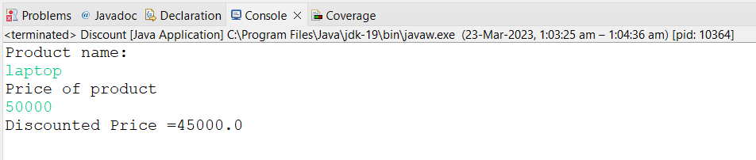

Q 6   Wap to swap two numbers

**package** assignment;

**import** java.util.Scanner;

**public** **class** SwapNumber {

**public** **static** **void** main(String[] args) {

Scanner input = **new** Scanner(System.***in***);

System.***out***.println("Enter two numbers");

**int** c;

**int** a = input.nextInt();

**int** b = input.nextInt();

System.***out***.println("Before swapping" + " a=" + a + " b=" + b);

c = a;

a = b;

b = c;

System.***out***.println("After swapping" + " a=" + a + " b=" + b);

}

}

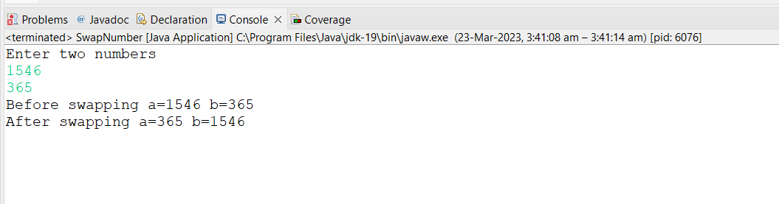

Q 7  How to swap two numbers without using a third variable?

import java.util.Scanner;

public class SwapWithoutThirdVariable {

public static void main(String[] args) {

Scanner input = new Scanner(System.in);

System.out.print("Enter the first number: ");

int a = input.nextInt();

System.out.print("Enter the second number: ");

int b = input.nextInt();

System.out.println("Before swapping: a = " + a + " and b = " + b);

a = a + b;

b = a - b;

a = a - b;

System.out.println("After swapping: a = " + a + " and b = " + b);

}

}

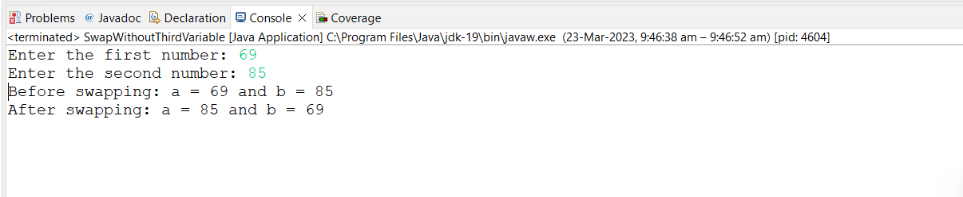

Q 8 wap to check is number is evenor odd.

**package** assignment;

**import** java.util.Scanner;

**public** **class** EvenOdd {

**public** **static** **void** main(String[] args) {

Scanner s = **new** Scanner(System.***in***);

System.***out***.println("enter the number");

**int** n = s.nextInt();

**if** (n % 2 == 0)

System.***out***.println("number is even");

**else**

System.***out***.println("number is odd");

}

}

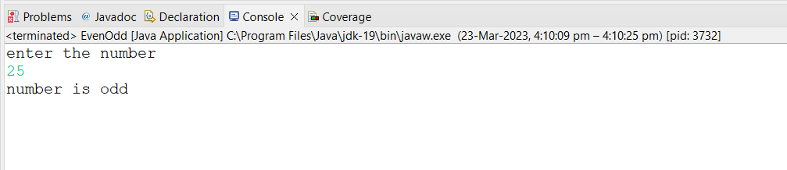

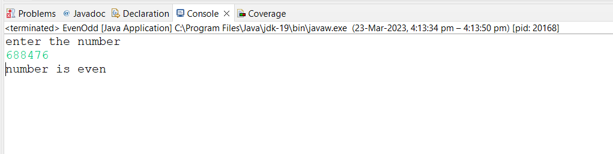

Q 9   A school has following rules for grading system:  
 a. Below 25 - F  
 b. 25 to 45 - E  
 c. 45 to 50 - D  
 d. 50 to 60 - C  
 e. 60 to 80 - B  
 f. Above 80 - A  
 Ask user to enter marks and print the corresponding grade

**package** assignment;

**import** java.util.Scanner;

**public** **class** GradingSystem {

**public** **static** **void** main(String[] args) {

Scanner input = **new** Scanner(System.***in***);

System.***out***.print("Enter your marks: ");

**float** marks = input.nextFloat();

**char** grade;

**if** (marks < 25) {

grade = 'F';

} **else** **if** (marks >= 25 && marks < 45) {

grade = 'E';

} **else** **if** (marks >= 45 && marks < 50) {

grade = 'D';

} **else** **if** (marks >= 50 && marks < 60) {

grade = 'C';

} **else** **if** (marks >= 60 && marks < 80) {

grade = 'B';

} **else** {

grade = 'A';

}

System.***out***.println("Your grade is: " + grade);

}

}

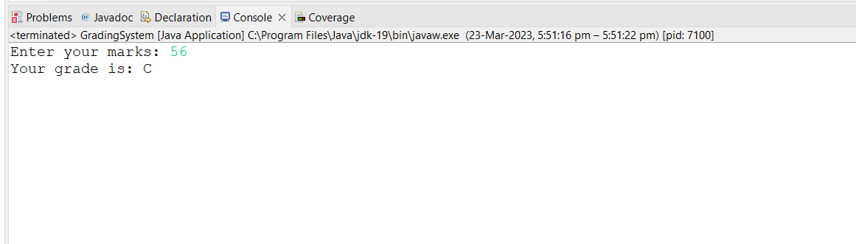

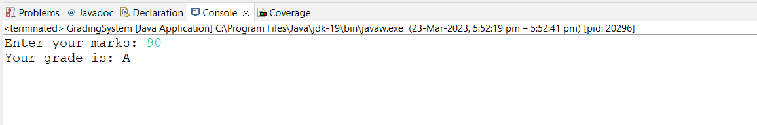

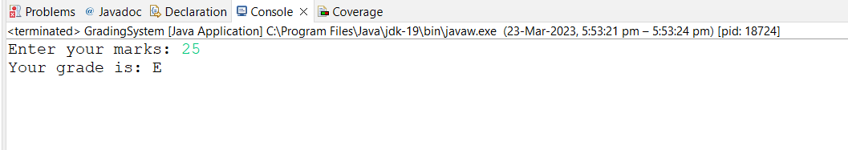

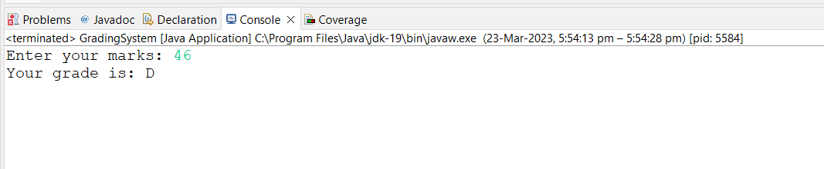 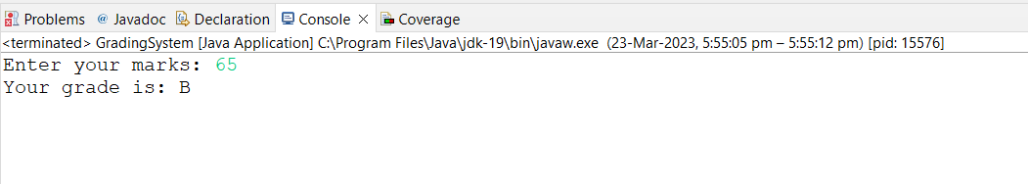

Q  10 wap to check greater number among three numbers

**package** assignment;

**import** java.util.Scanner;

**public** **class** GreaterNumberthree {

**public** **static** **void** main(String[] args) {

Scanner input = **new** Scanner(System.***in***);

System.***out***.print("Enter the first number: ");

**int** num1 = input.nextInt();

System.***out***.print("Enter the second number: ");

**int** num2 = input.nextInt();

System.***out***.print("Enter the third number: ");

**int** num3 = input.nextInt();

**if** (num1 > num2 && num1 > num3) {

System.***out***.println(num1 + " is the greatest number.");

} **else** **if** (num2 > num1 && num2 > num3) {

System.***out***.println(num2 + " is the greatest number.");

} **else** {

System.***out***.println(num3 + " is the greatest number.");

}

}

}

