Notification System
This document explains what all software’s required for this project and from where\how to download.

Software Pre-requisites:
Below are the software pre-requisite that should be installed on your local machine for notification project.
- JDK Version is Used: 17.0.12
- Gradle version is used: 9.7.0
- Git Bash used for develoment: Git-2.55.0.4-64-bit
- Eclipse IDE for Enterprise Java and Web Developers
Version: 2026-06 (4.40.0)
Build id: 20260604-0653

Step1 – JDK Download Steps:
Go to site https://www.oracle.com/java/technologies/javase/jdk17-archive-downloads.html
From this site (as shown below in screenshot), you can download jdk17.0.12.
Download jdk-17.0.12_windows-x64_bin.exe (sha256 ) (as shown in below screenshot).
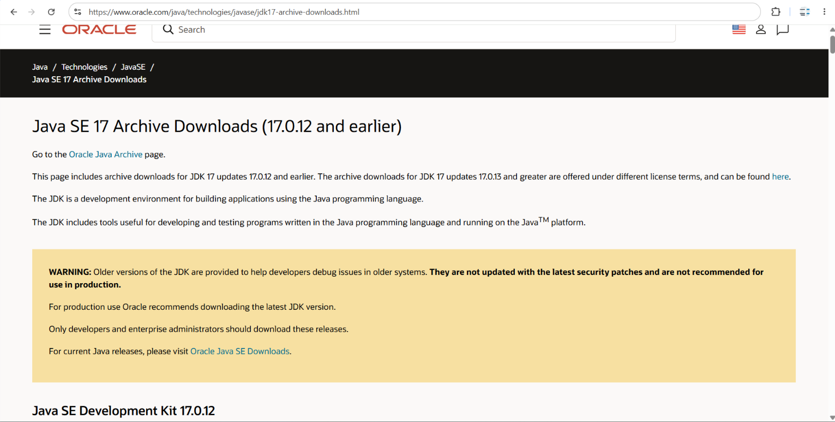

Step2 – Gradle Download Steps:
Go to site https://gradle.org/releases/
From this site (as shown below in screenshot), you can download gradle-9.7.0-bin.
Download by clicking binary-only link (as shown in below screenshot).
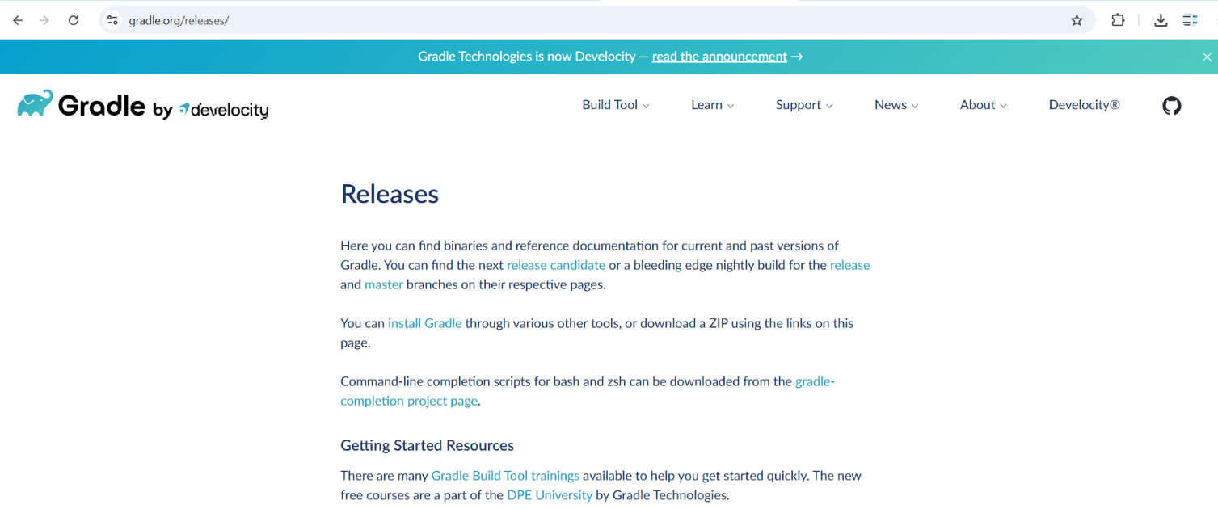


Step3 – GIT Bash Download Steps:
Go to site https://git-scm.com/install/windows
From this site (as shown below in screenshot), you can download Git-2.55.0.4-64-bit.
Download by clicking Click here to download link (as shown in below screenshot).

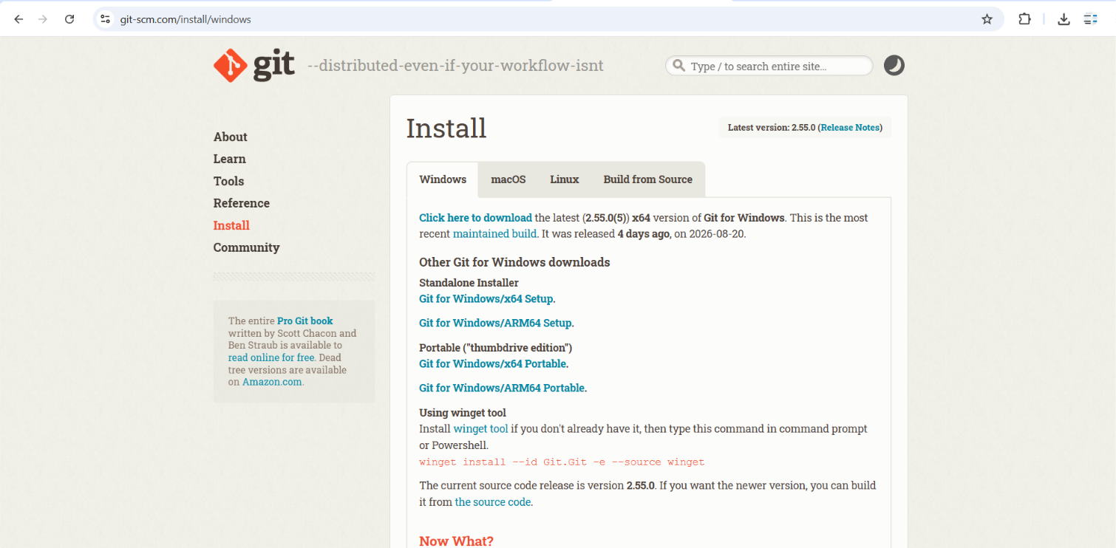

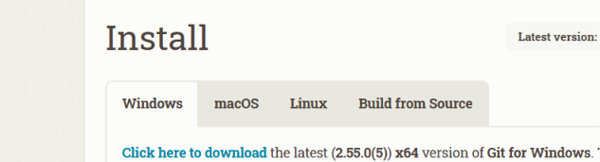

Step4 – Eclipse Download Steps:
Go to site https://www.eclipse.org/downloads/
From this site (as shown below in screenshot), you can download eclipse-inst-jre-win64.
Download by clicking Download link (as shown in below screenshot). You need to select download option Download x86_64.

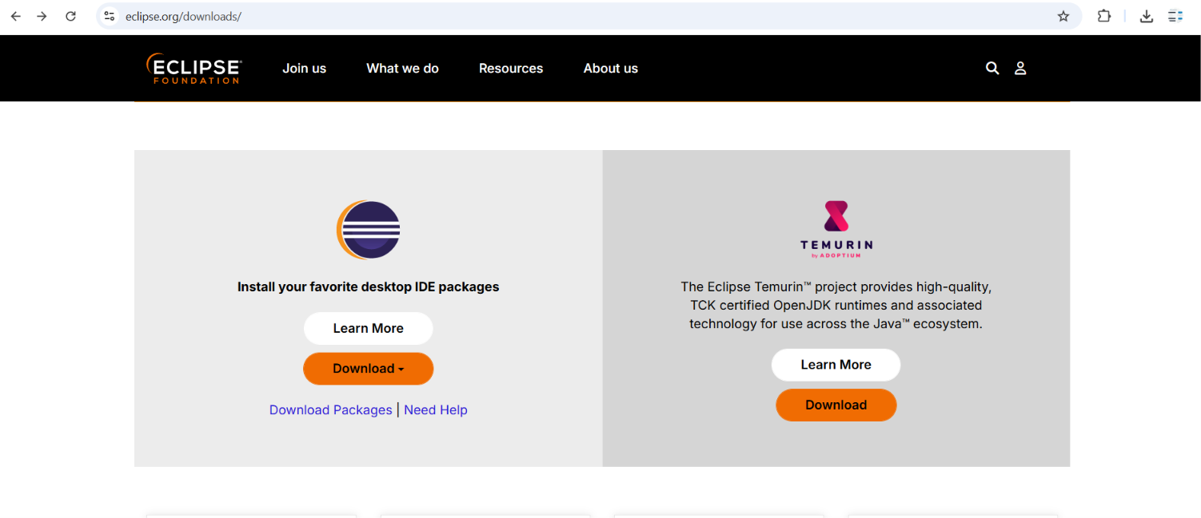

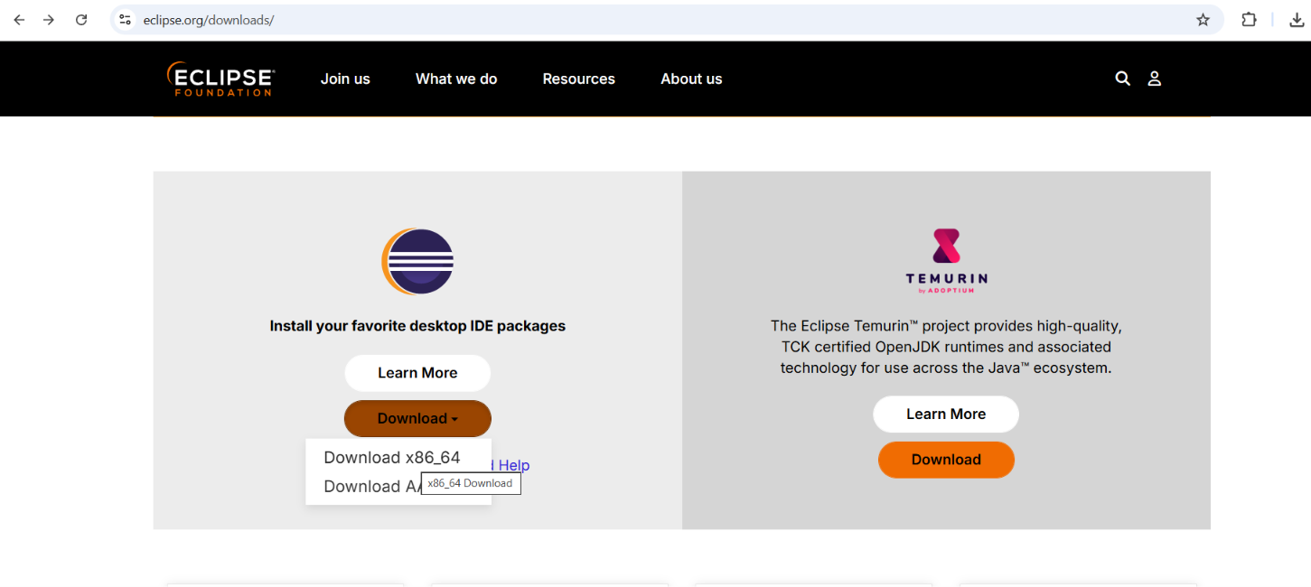
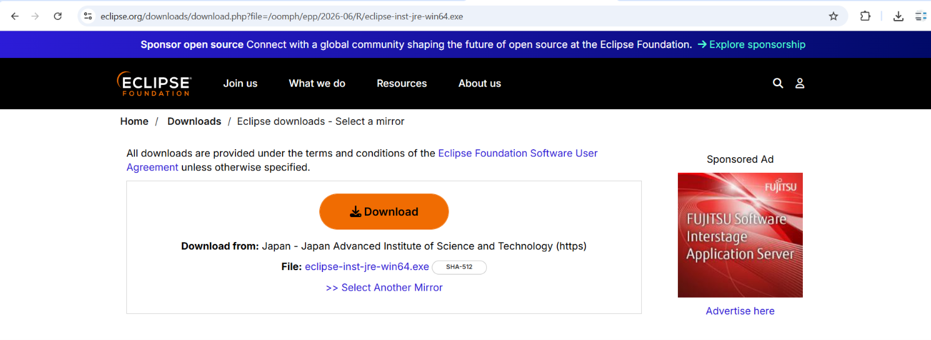

Once you install JDK, Gradle, GIT on your machine, check version of each software using below commands in command prompt. If versions are shown correctly, that means all these software’s are installed successfully.
java -version
gradle -version
git --version

