Notification System
This document explains steps to create this project. This project is based on spring boot framework.
Software Pre-requisites:
Below are the software pre-requisite that should be installed on your local machine.
- JDK Version is Used: 17.0.12
- Gradle version is used: 9.7.0
- Eclipse IDE for Enterprise Java and Web Developers:
Version: 2026-06 (4.40.0)
Build id: 20260604-0653
- Git Bash used for develoment: Git-2.55.0.4-64-bit
Once you install JDK, Gradle, GIT on your machine, check version of each software using below commands in command prompt:
- java -version
- gradle -version
- git --version

Below are steps that explain how to create initial project code and then how to import project is Eclipse.
Step1: This project is developed using spring boot. Go to Spring Initializr web site. We will generate initial project code from this site.
Give default options and provide couple of dependencies as shown below:
Click GENERATE to generate the code.

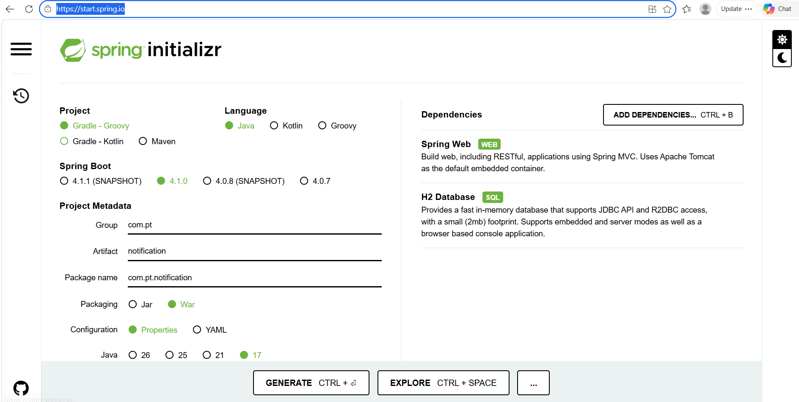

Step2: Once you click GENERATE button, it will create notification.zip file containing initial project files.
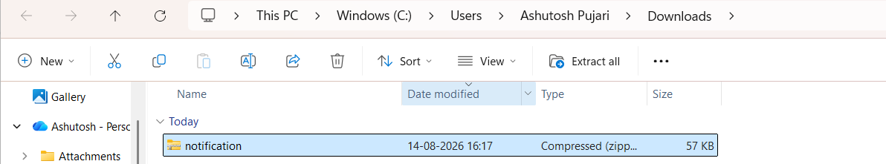

Copy this file in appropriate folder and unzip this zip file. After unzip, it should look like below folder structure (i.e. project files under notification folder):

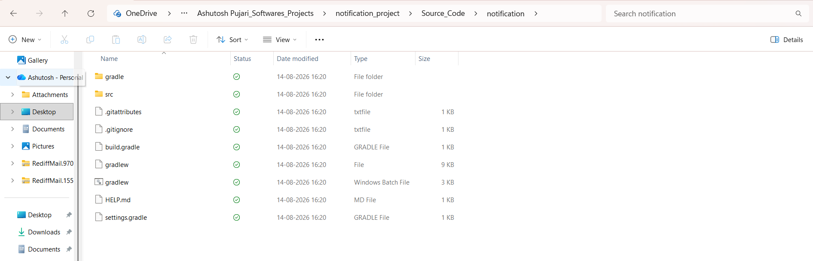

Step3: Next step is to import this gradle based project into your Eclipse. In this project we are using Eclipse as IDE tool.
Under File menu of Eclipse, there is Import option as shown below. Click Import option.
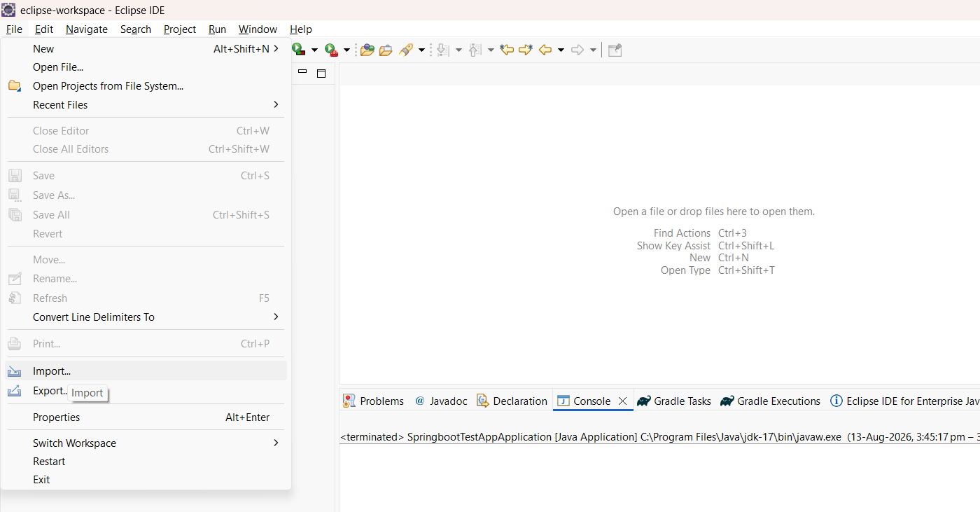

Then you get a window from where you can select project type. We will select Gradle Existing Gradle Project as shown below. Click Next button.
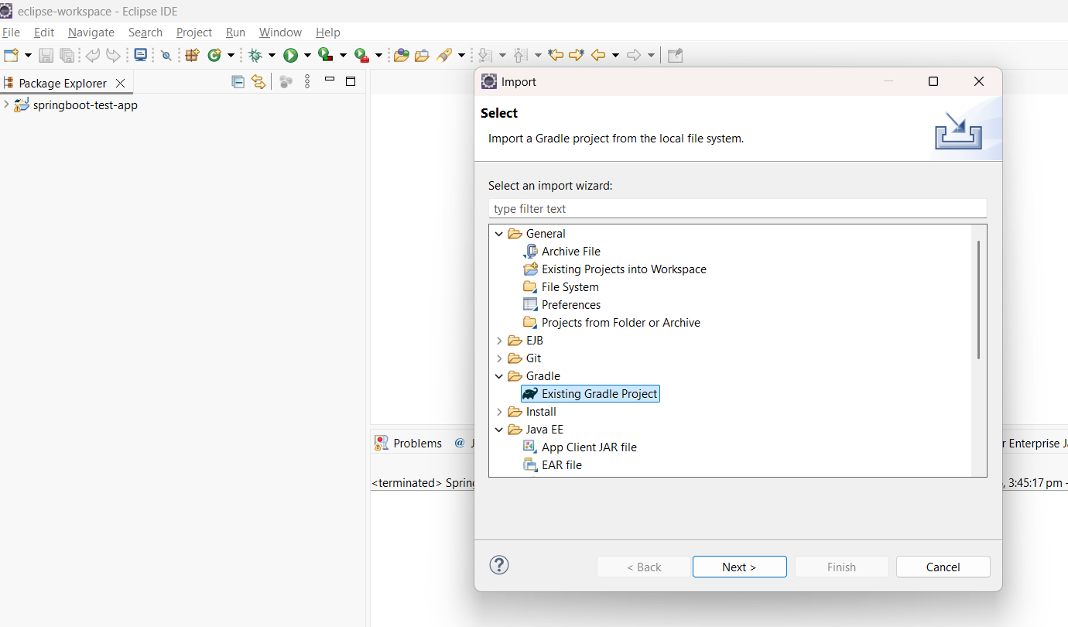
Next you get a window to select your project root directory as shown below:
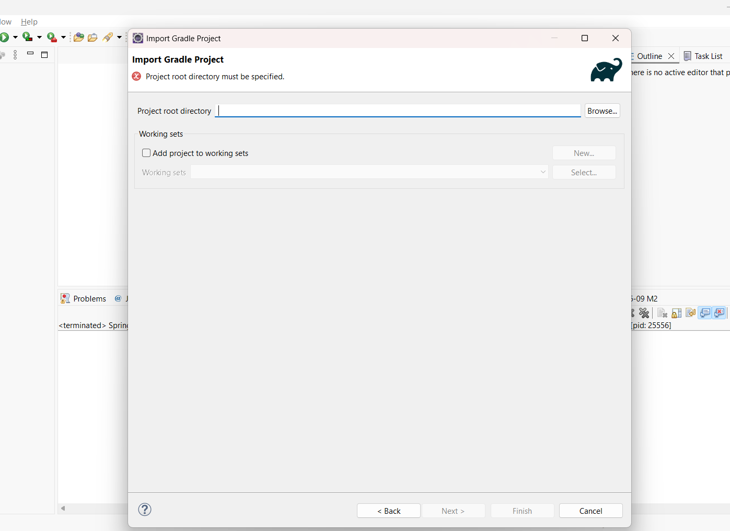

Next step is to select your project root folder which you have extracted (as shown below). This should be the folder under which you can see all project files. Click Select Folder button.
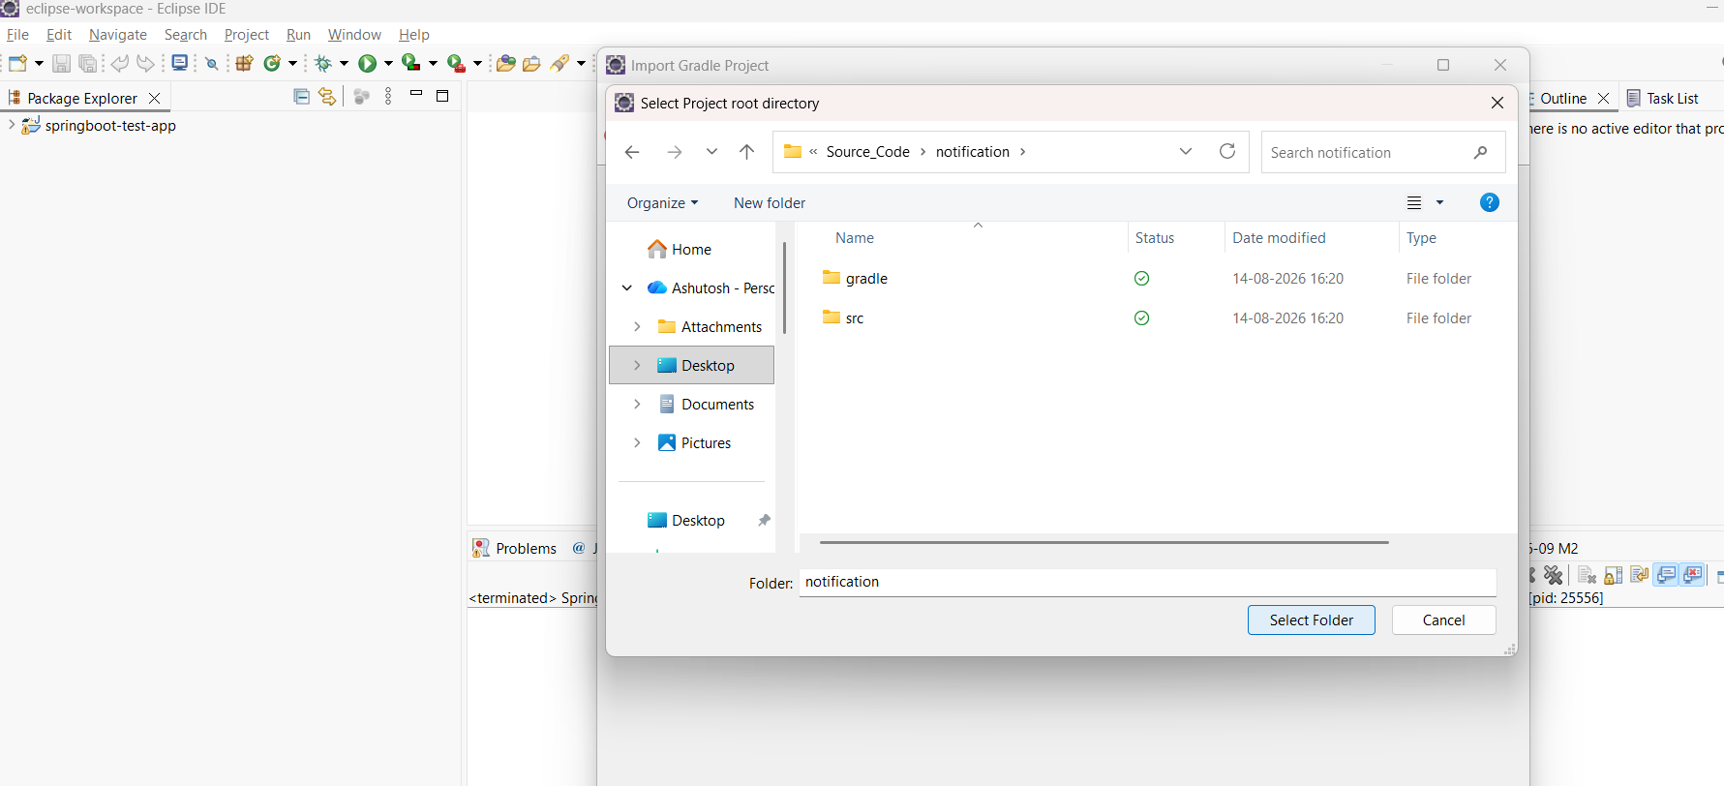

You will get below screen after selecting the project root folder:
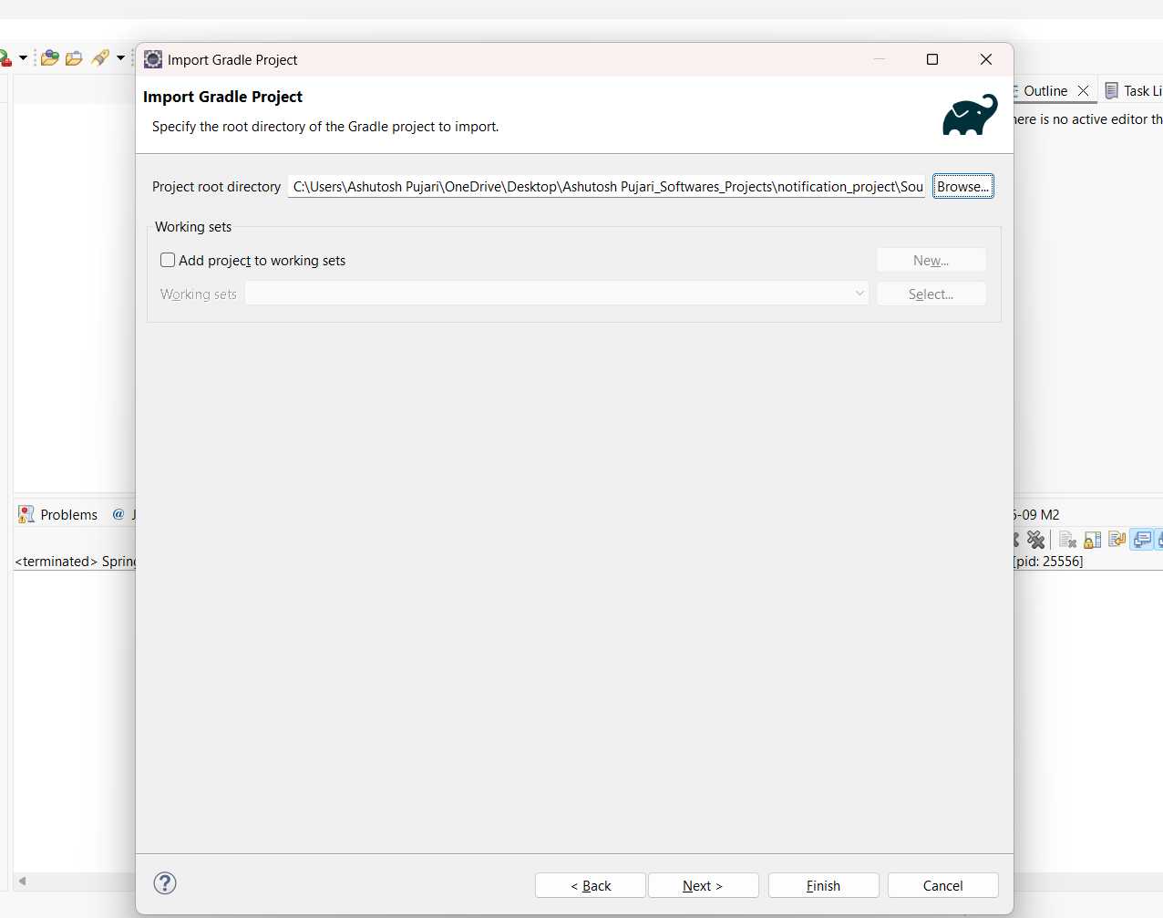

Click Next button. You can see below window. Keep default options as is. Click Next button
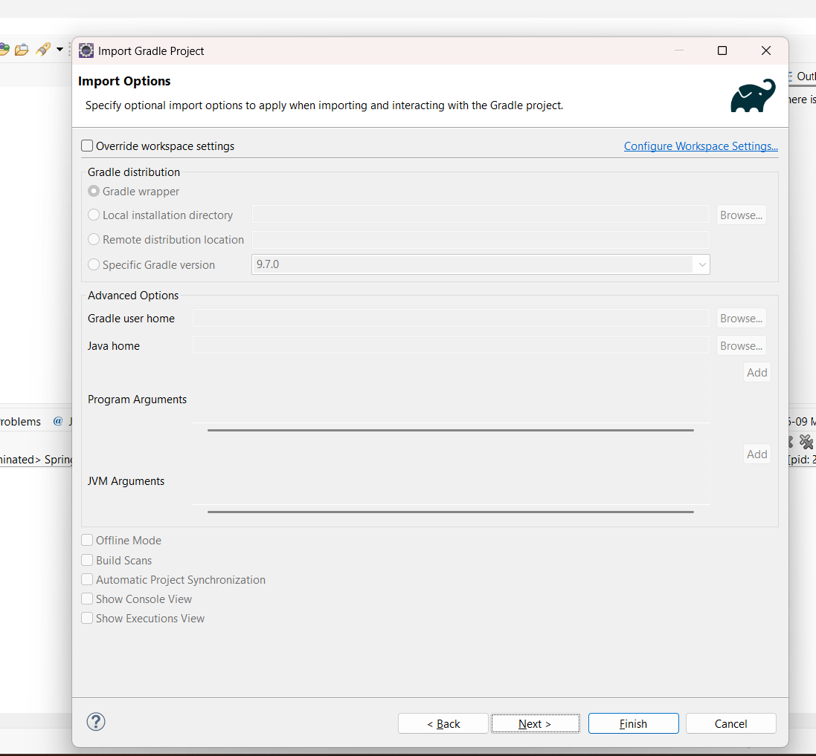

You will now get Import Preview window as shown below. Click Finish button.
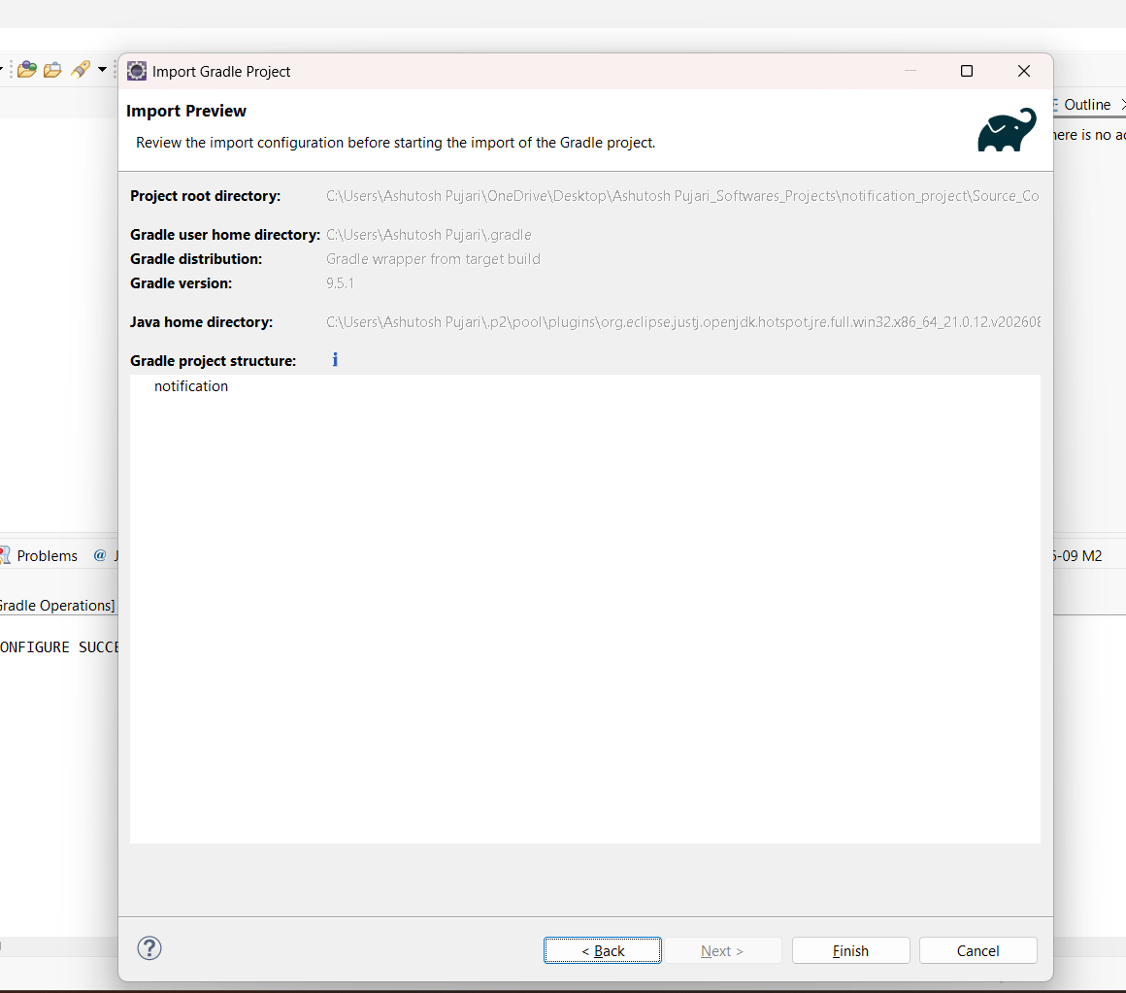

Once you click Finish button, notification project will be successfully imported in Eclipse as shown below. You should not see any errors in the project.
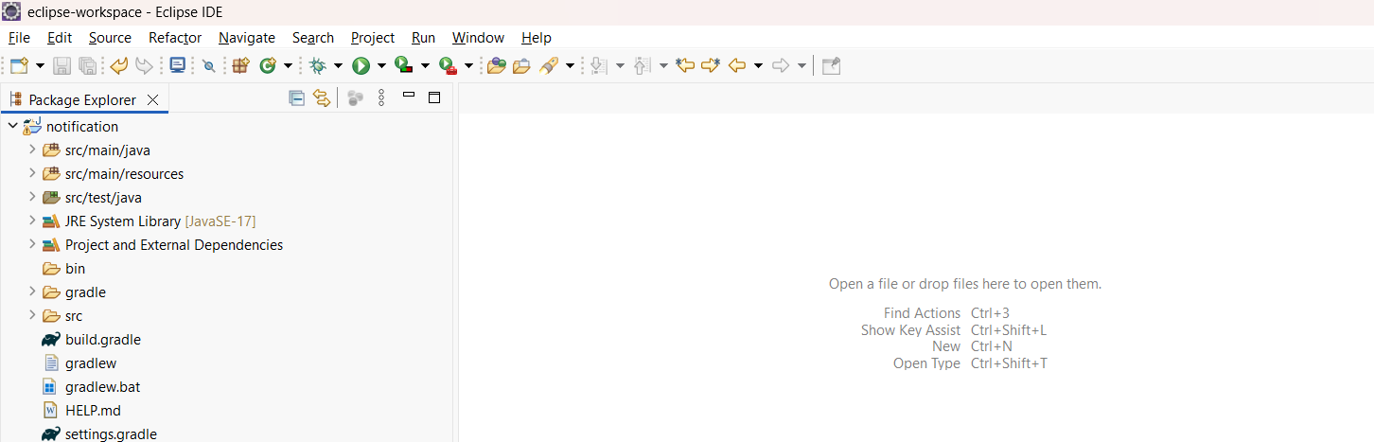

Now, the project is successfully imported. You can now start coding within the project.

