How to fetch code from GitHub
Below screenshot shows, how to fetch code from GitHub repository. First Open GitBash.
Then go to your project folder where you want to copy your code from GitHub. In this case the project folder is:
C:\Users\Ashutosh Pujari\OneDrive\Desktop\Ashutosh Pujari_Softwares_Projects\CodeFromGitHub\notification
Give git init command in this folder.
Then provide git clone command to pull code from GitHub repository. In this case the git clone command will look like:
https://github.com/ashutoshvpujari1-pixel/notification.git
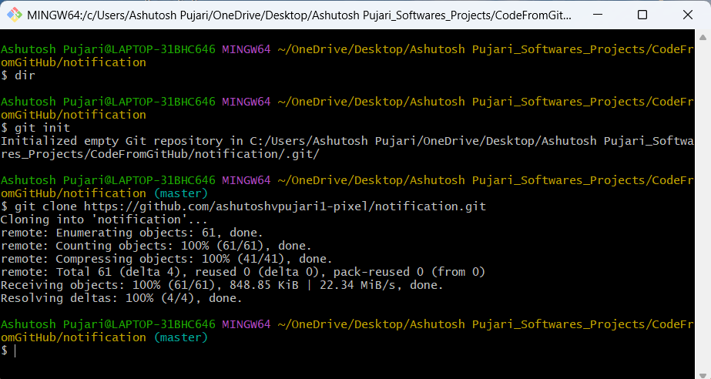

Once code is pulled from GitHub, project structure will look as shown in below screenshot:

