Date –03/02/2022

**1. Show the list of city, state, country**

Query- SELECT city.city_name, statet.state_name, country.country_name

FROM country

JOIN statet ON country.country_id = statet.country_id

JOIN city ON city.state_id = statet.state_id;

**2. Show the Count of city state wise**

Query :- SELECT s.state_name, COUNT(c.city_id) AS CountOfCities

FROM city as c LEFT JOIN statet as s ON c.state_id = s.state_id

GROUP BY s.state_name;

**3. Show the count of state country wise**

SELECT c.country_name, COUNT(s.state_id) AS CountOfstates

FROM statet as s LEFT JOIN country as c ON s.country_id = c.country_id

GROUP BY c.country_name;

**4. Find all states whose country is India**

Query - SELECT country.country_name, statet.state_name

FROM country

INNER JOIN statet ON country.country_id = statet.country_id

WHERE country_name = 'India';

**5. Find all the cities whose state Maharashtra**

Query - SELECT statet.state_name, city.city_name

FROM statet

INNER JOIN city ON statet.state_id = city.state_id

WHERE state_name = 'maharashtra';

**6. Find all the countries that start with a**

Query - SELECT * FROM country WHERE country_name LIKE 'A%';

**7. Find all the countries that start with z**

Query - SELECT * FROM country WHERE country_name LIKE 'Z%';

**8. Find all the states that start with "ha" character in the names**

Query - SELECT * FROM statet WHERE state_name LIKE 'Ha%';

**9. Find two countries having highest number of cities.**

QUERY - SELECT COUNT(city.city_name) AS count_of_cities, country.country_name

FROM country

JOIN statet ON country.country_id = statet.country_id

JOIN city ON city.state_id = statet.state_id

GROUP BY country_name

ORDER BY count_of_cities DESC

LIMIT 2;

**10. Find two countries having lowest number of cities.**

QUERY -SELECT COUNT(city.city_name) AS count_of_cities, country.country_name

FROM country

JOIN statet ON country.country_id = statet.country_id

JOIN city ON city.state_id = statet.state_id

GROUP BY country_name

ORDER BY count_of_cities ASC

LIMIT 2;

Country Table

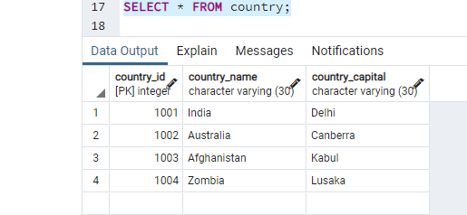

State Table

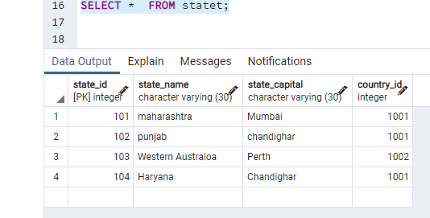

City table

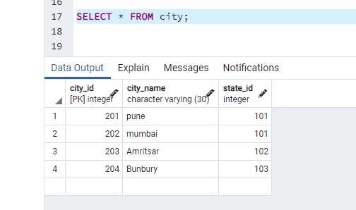

**1. Show the list of city, state, country**

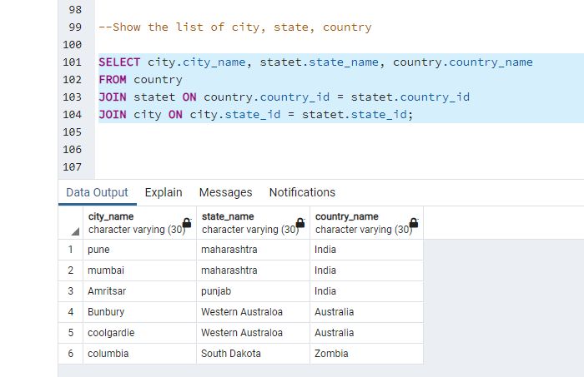

**2. Show the Count of city state wise**

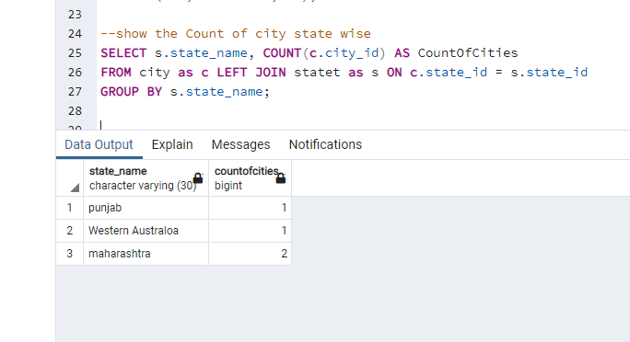

**3.Show the count of state country wise**

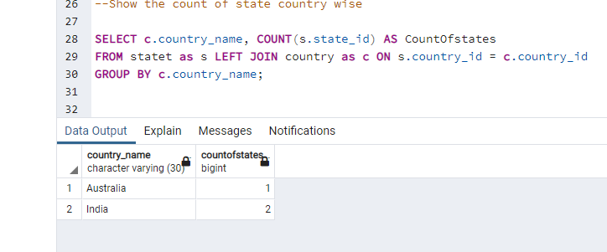

**4. Find all states whose country is India**

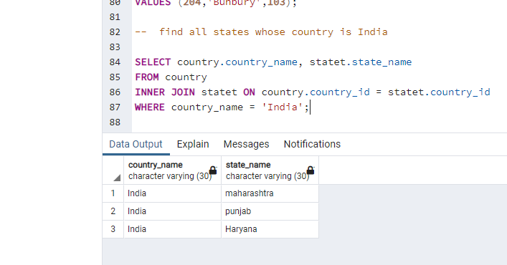

**5. Find all the cities whose state Maharashtra**

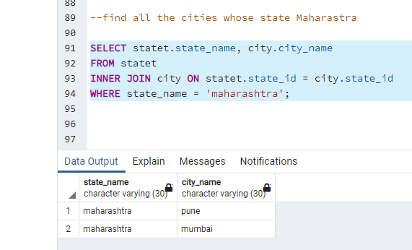

**6. Find all the countries that start with a**

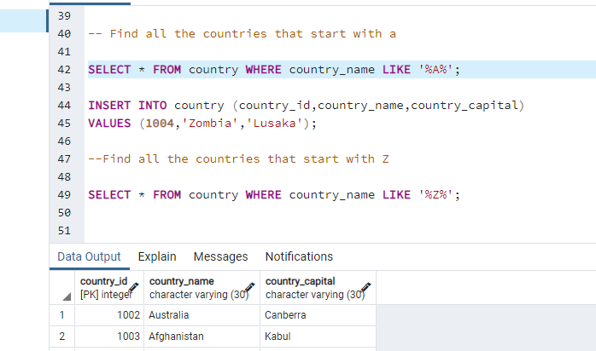

**7. Find all the countries that start with z**

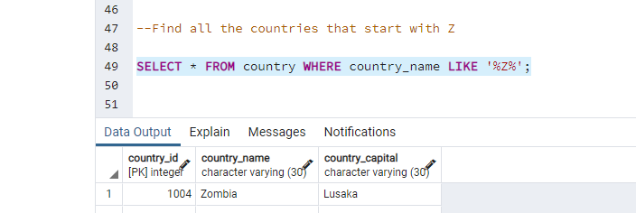

**8. Find all the states that start with "ha" character in the names**

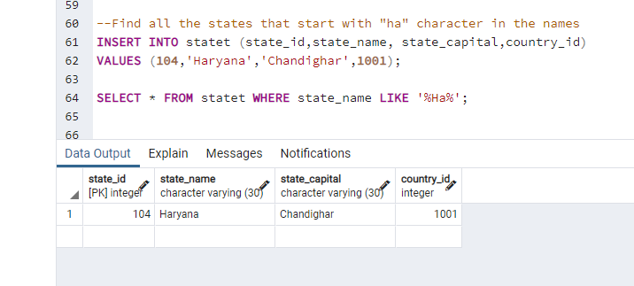

**9. Find two countries having highest number of cities.**

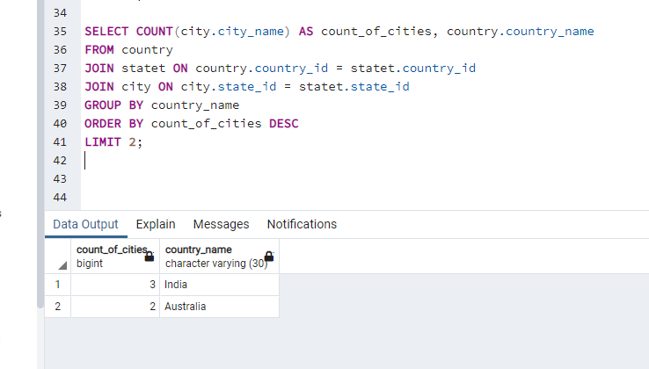

**10. Find two countries having lowest number of cities.**

