MUTUAL FUND ANALYTICS

Capstone Project I

Submitted By:
Ashutosh Giri
BTech Artificial Intelligence & Data Science
University School of Automation and Robotics
Guru Gobind Singh Indraprastha University
Submitted To:
Bluestock Fintech
Project Duration: 20 June 2026 – 10 July 2026
Technologies Used:
• Python
• Pandas
• NumPy
• SQLite
• SQL
• Matplotlib
• Power BI
• GitHub
Submission Date: 10 July 2026

Executive Summary
The Mutual Fund Analytics project is an end-to-end data analytics solution developed to analyse the performance of Indian mutual funds, investor behaviour, portfolio allocation, and market trends using Python, SQL, SQLite, and Power BI. The project aims to transform raw financial datasets into meaningful insights that can support informed investment decisions.
The project begins with the collection and preprocessing of multiple mutual fund datasets, including fund master data, NAV history, Assets Under Management (AUM), SIP inflows, scheme performance, investor transactions, portfolio holdings, and benchmark indices. An automated ETL pipeline was developed to clean, validate, and transform the raw datasets before storing them in a structured SQLite database.
Exploratory Data Analysis (EDA) was performed to identify trends in mutual fund performance, investor demographics, transaction patterns, category-wise fund growth, and portfolio allocation. SQL queries were used to extract meaningful business insights and support analytical reporting.
The project also includes comprehensive performance analytics by calculating financial metrics such as Annual Returns, Alpha, Beta, Sharpe Ratio, Sortino Ratio, Standard Deviation, Maximum Drawdown, Value at Risk (VaR), and Conditional Value at Risk (CVaR). Advanced analytical techniques including Investor Cohort Analysis, SIP Continuity Analysis, Portfolio Diversification Analysis, and a Mutual Fund Recommendation System were implemented to evaluate investor behaviour and fund performance.
An interactive four-page Power BI dashboard was developed to visualize key performance indicators, fund performance, investor analytics, SIP trends, and market insights. The dashboard enables users to explore the data through interactive filters and visualizations, making complex financial information easier to understand.
Overall, this project demonstrates the practical application of Data Engineering, Data Analysis, Financial Analytics, SQL, Business Intelligence, and Data Visualization to solve real-world problems in the mutual fund industry. The solution provides investors and analysts with a comprehensive framework for evaluating mutual fund performance and making data-driven investment decisions.

Project Objectives
The primary objective of this project is to develop an end-to-end Mutual Fund Analytics solution capable of transforming raw mutual fund data into meaningful insights using data engineering, financial analytics, and business intelligence techniques. The project focuses on analysing fund performance, investor behaviour, portfolio allocation, and market trends to support better investment decision-making.

Objectives
- Develop an automated ETL pipeline to collect, clean, and preprocess mutual fund datasets.
- Store cleaned data in a structured SQLite relational database for efficient querying.
- Perform SQL-based analytical queries to extract business insights.
- Conduct Exploratory Data Analysis (EDA) to identify trends and patterns in mutual fund performance.
- Calculate important financial performance metrics such as Annual Return, Sharpe Ratio, Alpha, Beta, Sortino Ratio, Maximum Drawdown, Value at Risk (VaR), and Conditional Value at Risk (CVaR).
- Analyse investor behaviour using Investor Cohort Analysis and SIP Continuity Analysis.
- Evaluate portfolio diversification and sector allocation.
- Develop a basic recommendation system to suggest mutual funds based on quantitative performance metrics.
- Design an interactive four-page Power BI dashboard for visualizing fund performance, investor analytics, SIP trends, and market insights.
- Generate business recommendations that assist investors in making informed investment decisions.

Project Overview
The Mutual Fund Analytics project is an end-to-end financial data analytics solution developed to analyse Indian mutual fund performance, investor behaviour, portfolio allocation, and market trends. The project integrates data engineering, database management, financial analytics, and business intelligence techniques to transform raw mutual fund data into meaningful insights that support investment decision-making.
The project starts with collecting multiple mutual fund datasets including Fund Master, NAV History, AUM, SIP inflows, investor transactions, portfolio holdings, scheme performance, and benchmark indices. An automated ETL pipeline cleans, validates, and transforms the data before storing it in a structured SQLite database. SQL queries and Exploratory Data Analysis (EDA) are then used to identify market trends, fund performance, and investor behaviour. Advanced analytics such as Sharpe Ratio, Alpha, Beta, Sortino Ratio, Maximum Drawdown, Value at Risk (VaR), Conditional Value at Risk (CVaR), Investor Cohort Analysis, SIP Continuity Analysis, Portfolio Diversification Analysis, and a Mutual Fund Recommendation System are implemented to evaluate investment performance and risk. Finally, an interactive four-page Power BI dashboard presents the results through dynamic visualizations and business insights.

Project Workflow
Raw Mutual Fund Datasets
│
▼
Data Collection
│
▼
ETL Pipeline
│
▼
Data Cleaning
│
▼
SQLite Database
│
▼
SQL Analytics
│
▼
Exploratory Data Analysis
│
▼
Performance Analytics
│
▼
Advanced Analytics
│
▼
Mutual Fund Recommendation
│
▼
Power BI Dashboard
│
▼
Business Insights & Recommendations

Technologies Used
Technology | Purpose
Python | Data preprocessing, analytics and automation
Pandas | Data cleaning and manipulation
NumPy | Numerical computations
SQLite | Relational database management
SQL | Analytical querying
Matplotlib | Data visualization
Power BI | Interactive dashboard development
Git & GitHub | Version control
Jupyter Notebook | Analysis and documentation

Figure 1: Project Directory Structure
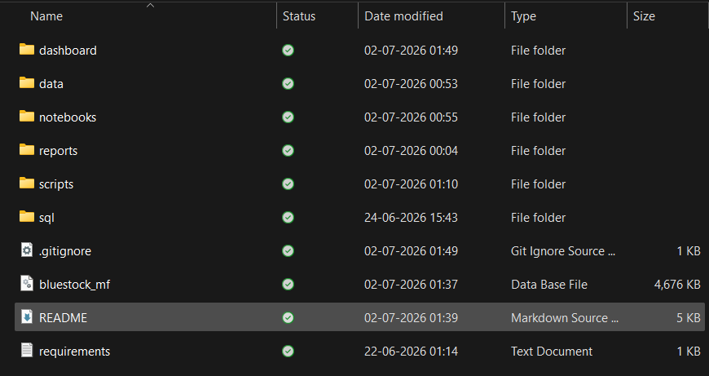

Dataset Description

Data Sources
The Mutual Fund Analytics project utilizes multiple datasets covering different aspects of the Indian mutual fund industry. These datasets include fund master information, historical NAV prices, Assets Under Management (AUM), SIP inflows, category-wise investments, investor transactions, portfolio holdings, benchmark indices, and live NAV data collected through MFAPI. These datasets provide a comprehensive view of fund performance, investor behaviour, and market trends.

Dataset Summary
Dataset | Description
01_fund_master.csv | Mutual fund master details
02_nav_history.csv | Historical NAV records
03_aum_by_fund_house.csv | Assets Under Management by AMC
04_monthly_sip_inflows.csv | Monthly SIP inflow statistics
05_category_inflows.csv | Category-wise investment inflows
06_industry_folio_count.csv | Industry folio statistics
07_scheme_performance.csv | Scheme returns and risk metrics
08_investor_transactions.csv | Investor transaction records
09_portfolio_holdings.csv | Portfolio holdings and sector allocation
10_benchmark_indices.csv | Benchmark index performance
Live NAV Files | Real-time NAV fetched using MFAPI

Data Cleaning and Preprocessing
Before analysis, all datasets underwent preprocessing to ensure consistency and accuracy. The cleaning process included handling missing values, removing duplicate records, correcting data types, converting date columns into datetime format, validating numerical fields, standardizing categorical values, and preparing processed datasets for analysis. The cleaned files were stored in the 'data/processed' directory.

Database Loading
After preprocessing, the cleaned datasets were loaded into a structured SQLite database. The database schema was designed to support efficient SQL queries for fund performance, investor analytics, transaction analysis, and dashboard reporting. This centralized database served as the primary source for EDA, performance analytics, advanced analytics, and the Power BI dashboard.
Figure 2: Raw Dataset Files in data/raw Directory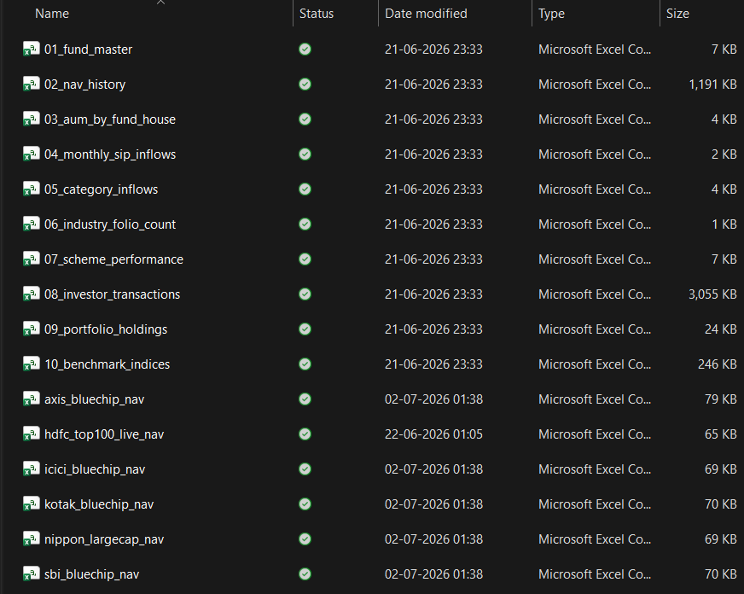

ETL Pipeline & Data Cleaning Process

ETL Pipeline
The Mutual Fund Analytics project implements an Extract, Transform and Load (ETL) pipeline to automate data preparation. Raw datasets and live NAV data are extracted, validated, cleaned and transformed before being loaded into an SQLite database for further analysis.

ETL Workflow
Extract Raw CSV Files
│
▼
Fetch Live NAV (MFAPI)
│
▼
Merge & Validate Data
│
▼
Handle Missing Values
│
▼
Remove Duplicate Records
│
▼
Standardize Data Types
│
▼
Generate Cleaned CSV Files
│
▼
Load into SQLite Database
│
▼
EDA • Performance Analytics • Dashboard

Data Cleaning Process
- Handled missing values and validated records.
- Removed duplicate observations.
- Converted date columns into datetime format.
- Validated NAV, AUM, return and transaction values.
- Standardized categorical values.
- Saved processed datasets into the data/processed folder.

ETL Output
The ETL pipeline generated cleaned datasets, populated the SQLite database, and produced processed files used in SQL analytics, EDA, Performance Analytics, Advanced Analytics and the Power BI dashboard.
Figure 3: ETL Pipeline Scripts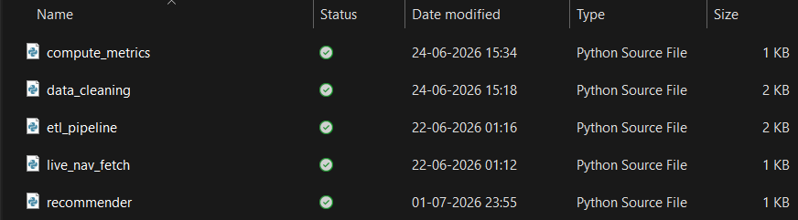

SQLite Database Design & SQL Analytics

Database Design
The cleaned datasets were stored in an SQLite relational database to enable efficient storage, retrieval, and analytical querying. Separate tables were created for NAV history, scheme performance, investor transactions, benchmark indices, portfolio holdings, and other supporting datasets. Primary keys and common identifiers such as AMFI Code were used to maintain relationships between datasets.

Database Schema
The database schema was designed to reduce redundancy while supporting fast analytical queries. SQLite was selected because it is lightweight, portable, and well suited for data analytics projects.

SQL Analytics
SQL queries were executed to answer important business questions related to mutual fund performance, investor behaviour, and market trends.
- Top performing mutual funds based on annual return.
- Fund houses with the highest Assets Under Management (AUM).
- Category-wise investment inflows.
- Monthly SIP collection trend.
- Investor transaction distribution by transaction type.
- Top portfolio sectors by allocation.
- Benchmark performance comparison.
- Average return by mutual fund category.
- Highest rated schemes based on Morningstar ratings.
- Risk analysis using Alpha, Beta and Sharpe Ratio.

Key Outcome
The SQL layer provided the foundation for Exploratory Data Analysis, dashboard development, performance analytics, and business reporting by transforming raw data into actionable insights.
Figure 4: SQL Schema and Query Files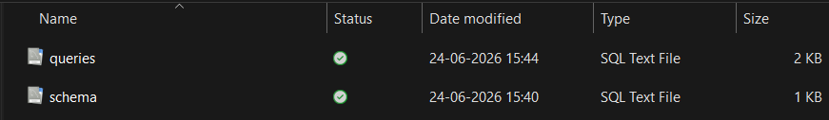

Performance Analytics

Introduction
Performance Analytics was conducted to evaluate the financial performance of mutual funds using historical return and risk measures. Various quantitative metrics were analysed to identify high-performing funds, compare fund categories, and understand the relationship between returns and investment risk.
The analysis helps investors assess fund quality based on risk-adjusted performance rather than returns alone.

Performance Metrics
Metric | Description
Annual Return | Measures yearly percentage return generated by a fund.
Alpha | Measures excess return compared to benchmark performance.
Beta | Indicates volatility relative to the overall market.
Sharpe Ratio | Measures risk-adjusted return considering total volatility.
Sortino Ratio | Measures downside risk-adjusted return.
Standard Deviation | Represents overall investment risk and volatility.
Maximum Drawdown | Measures the largest decline from peak portfolio value.
Expense Ratio | Annual management fee charged by the fund.

Performance Analysis Process
The historical mutual fund performance dataset was processed to calculate and compare multiple performance indicators. Risk-adjusted metrics were analysed to determine which funds delivered better returns for the level of risk undertaken.
Comparisons were performed across different fund houses, investment categories, and benchmark indices. Statistical summaries and visualizations were generated to highlight performance differences and identify consistently performing mutual funds.

Key Findings
- Large Cap and Flexi Cap funds generated relatively stable long-term returns.
- Higher Sharpe Ratio values indicated superior risk-adjusted performance.
- Funds with lower Maximum Drawdown demonstrated better downside protection.
- Alpha values identified funds outperforming their benchmark indices.
- Lower Expense Ratio funds generally provided improved long-term investment efficiency.
- Risk levels varied significantly across different mutual fund categories.
Figure 5: Normalized Performance Comparison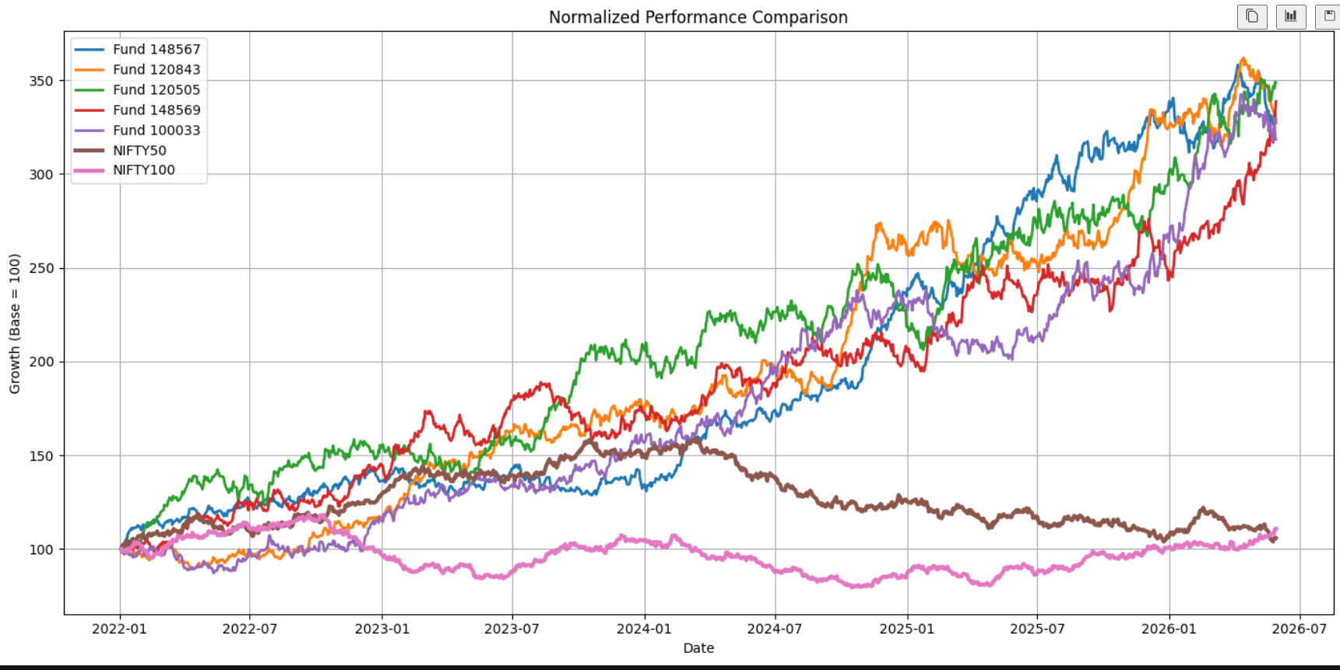

Conclusion:
The normalized performance comparison shows that different mutual funds exhibited varying growth trajectories over the analysis period. While some funds consistently outperformed the benchmark indices, others demonstrated relatively stable returns with lower volatility. The comparison highlights the importance of long-term performance evaluation and diversification in mutual fund investment decisions.

Advanced Analytics & Risk Analysis

Introduction
Advanced analytics techniques were implemented to evaluate mutual fund risk, portfolio stability, and investor behaviour. Risk-adjusted metrics and portfolio analysis were used to support data-driven investment decisions.

Advanced Analytics Performed
- Value at Risk (VaR) estimation
- Conditional Value at Risk (CVaR)
- Sharpe Ratio analysis
- Beta and Alpha evaluation
- Maximum Drawdown analysis
- Investor Cohort Analysis
- SIP Continuity Analysis
- Mutual Fund Recommendation Engine

Key Findings
The analysis identified funds with superior risk-adjusted returns and lower downside risk. VaR and CVaR quantified potential losses, while Sharpe Ratio and Maximum Drawdown helped compare fund quality. The recommendation engine suggested suitable funds based on return, risk and consistency metrics.
Figure 6: Rolling 90-Day Sharpe Ratio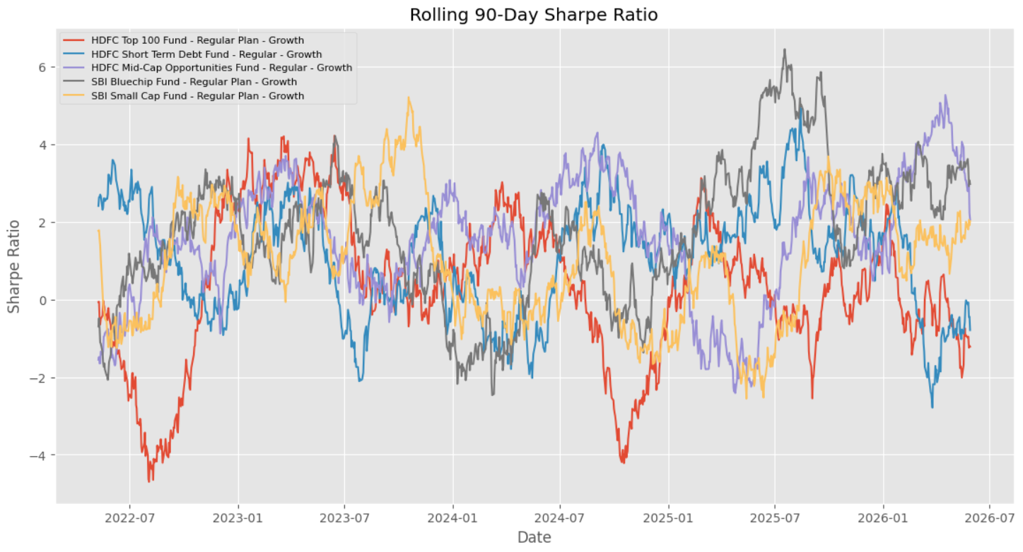

Conclusion:
The rolling 90-day Sharpe Ratio indicates changes in risk-adjusted performance over time. Higher Sharpe Ratio values represent better returns for the level of risk undertaken, whereas lower or negative values indicate weaker risk-adjusted performance. This analysis helps identify funds that consistently delivered superior returns while maintaining controlled risk.

Interactive Power BI Dashboard

Dashboard Overview
An interactive four-page Power BI dashboard was developed to present key insights derived from the Mutual Fund Analytics project. The dashboard enables users to explore fund performance, investor behaviour, market trends, and portfolio statistics through dynamic visualisations and slicers.

Dashboard Pages
Dashboard Page | Description
Industry Overview | KPIs including Total AUM, SIP Inflows, Folios, Schemes, AUM trends and AMC comparison.
Fund Performance | Normalized fund performance, benchmark comparison, risk vs return analysis and fund scorecard.
Investor Analytics | Transaction distribution, age-group analysis, state-wise investment and monthly transaction trends.
SIP & Market Trends | SIP inflows versus market indices, category inflows and market trend analysis.

Key Dashboard Features
- Interactive slicers for Fund House, Category and Time Period
- Drill-down visualizations
- KPI cards for major financial indicators
- Benchmark comparison charts
- Professional business dashboard layout

Figure 7 – Mutual Fund Industry Overview Dashboard
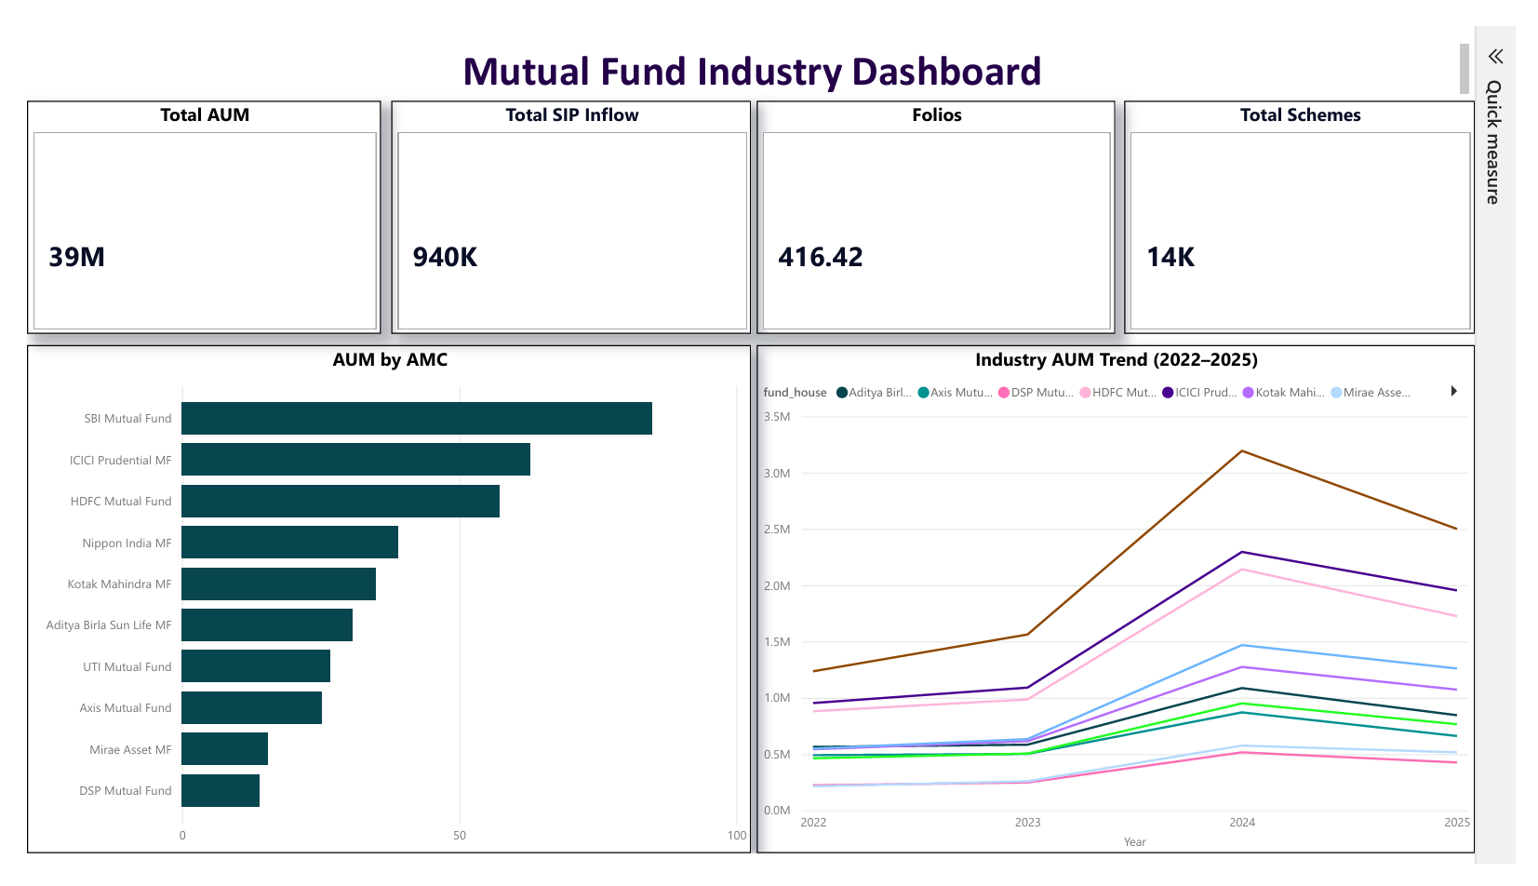

Conclusion
The dashboard transforms complex mutual fund data into an intuitive decision-support system. Interactive filters and visualisations enable investors and analysts to quickly identify trends, compare schemes, and evaluate investment performance.

Business Insights & Recommendations

Key Business Insights
- Equity-oriented mutual funds delivered comparatively stronger long-term returns than most debt-oriented categories.
- SIP inflows increased consistently, reflecting growing investor participation and long-term investment confidence.
- Large Cap and Flexi Cap funds demonstrated relatively stable performance with controlled volatility.
- Risk-adjusted metrics such as Sharpe Ratio and Alpha helped identify consistently performing schemes.
- Benchmark comparison highlighted several funds that outperformed market indices over the analysis period.

Business Recommendations
- Diversify investments across multiple fund categories to reduce portfolio risk.
- Prefer funds with higher Sharpe Ratio and consistent Alpha for long-term investing.
- Adopt SIP investments to benefit from rupee-cost averaging and disciplined investing.
- Review portfolio allocation periodically based on changing market conditions.
- Compare fund performance with benchmark indices before making investment decisions.

Figure 8: Fund Performance Dashboard
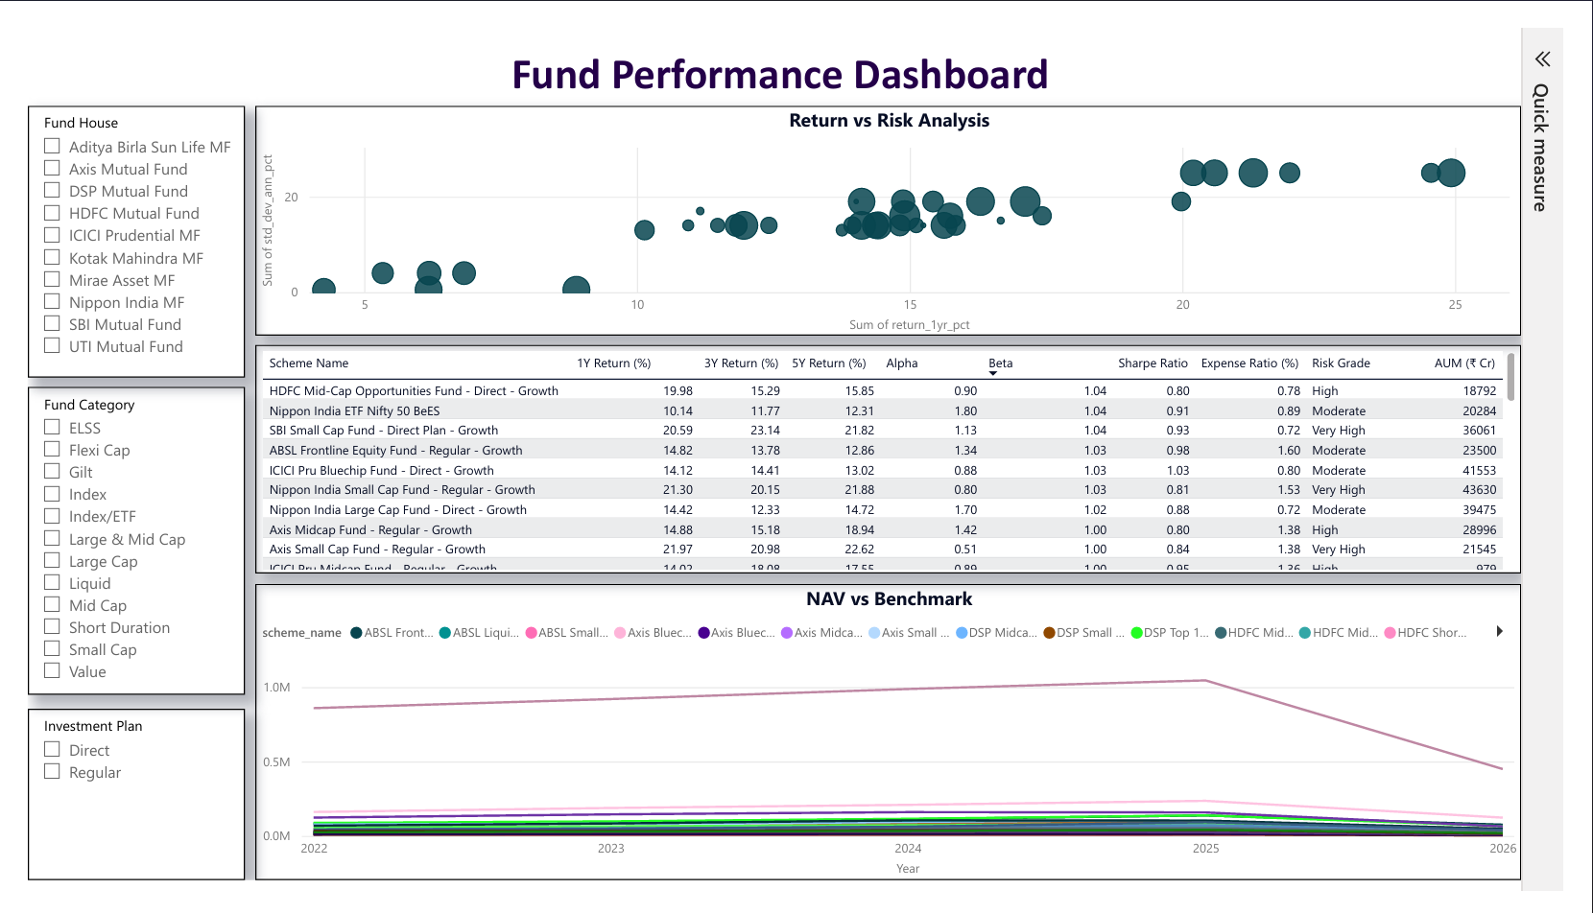

Conclusion
The business insights generated from this project help investors understand fund performance, risk characteristics, and investment behaviour. These recommendations support better portfolio management and informed financial decision-making.

Investor Analytics Dashboard
The Investor Analytics dashboard focuses on analysing investor behaviour across different states, age groups, transaction types, and monthly investment trends. It enables detailed demographic analysis and investment pattern identification.

Figure 9 – Investor Analytics Dashboard
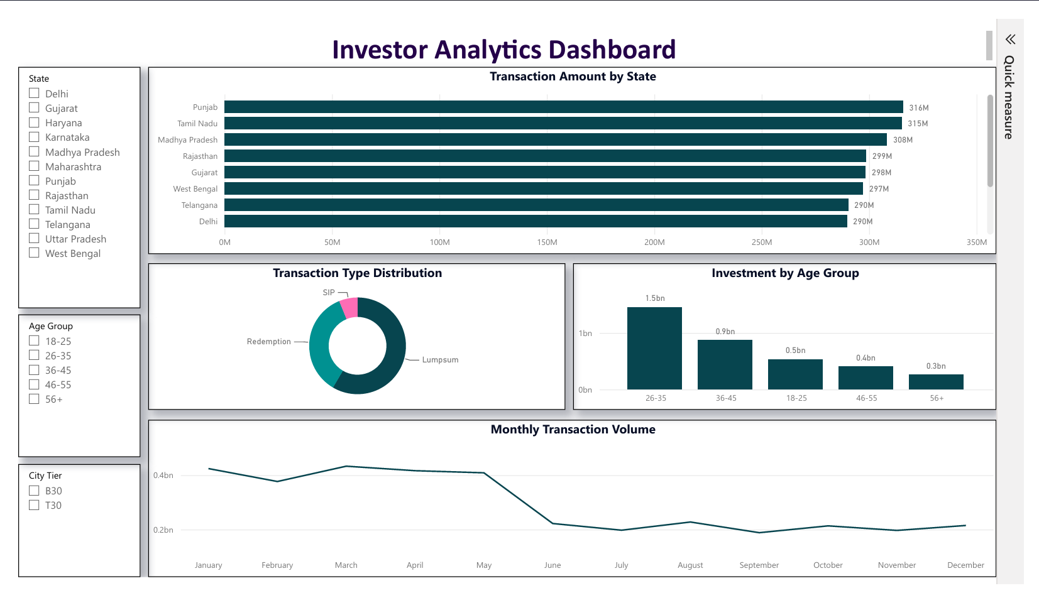

Conclusion
The Investor Analytics dashboard highlights investor demographics and transaction behaviour. It helps identify investment preferences across age groups, states, and transaction types, enabling better customer segmentation.

SIP & Market Trends Dashboard
The SIP & Market Trends dashboard compares SIP inflows with benchmark market indices and category-wise investment trends. It enables analysis of long-term investment behaviour and market performance.

Figure 10 – SIP & Market Trends Dashboard
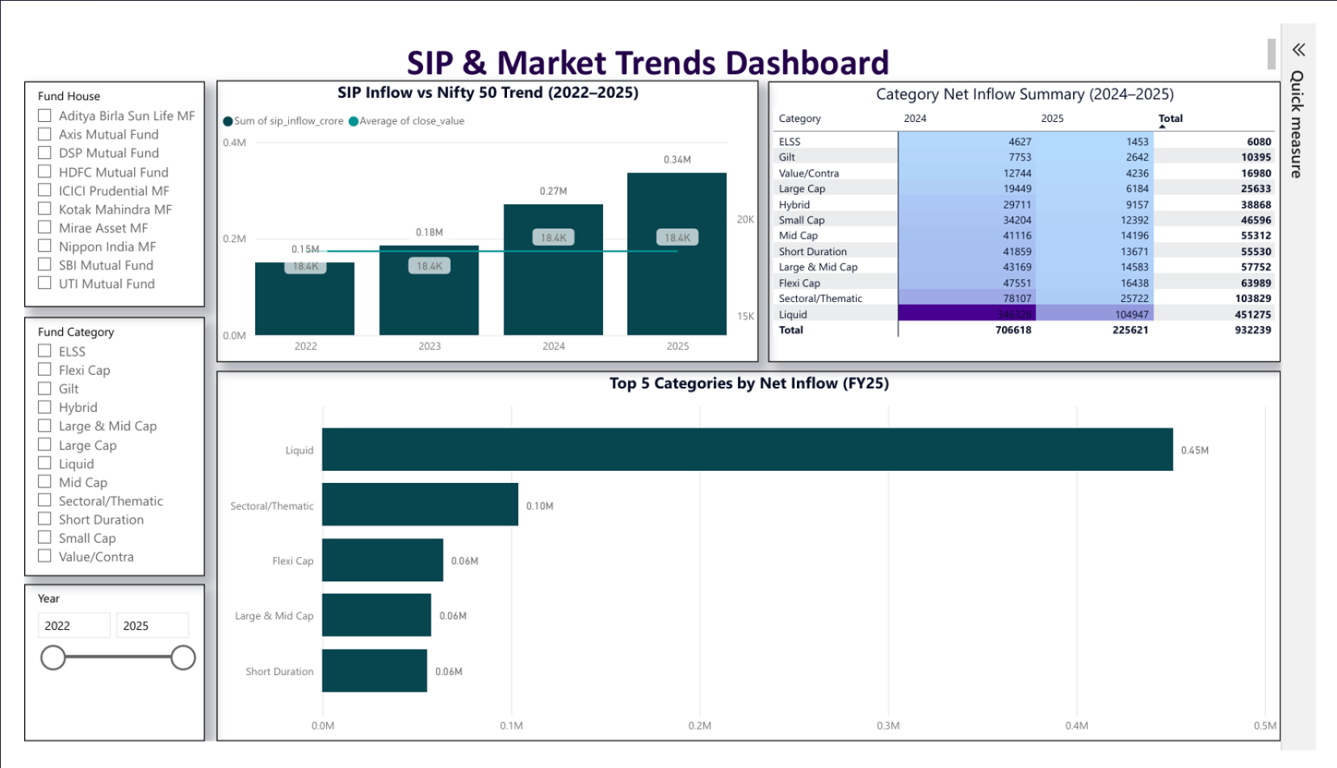

Conclusion
The dashboard illustrates the relationship between SIP inflows and market movements while highlighting category-wise investment trends. These insights support long-term investment planning and market analysis.

References
This project was developed using publicly available datasets, official documentation, and widely adopted data science tools.
- MFAPI (https://www.mfapi.in/) – Live Mutual Fund NAV Data
- AMFI India – Mutual Fund Industry Information
- Microsoft Power BI Documentation
- SQLite Documentation
- Pandas Documentation
- NumPy Documentation
- Matplotlib Documentation
- Python Documentation
- Scikit-learn Documentation
- Git & GitHub Documentation

Project Deliverables Submitted
- ETL Pipeline Scripts
- SQLite Database and SQL Queries
- EDA Notebook
- Performance Analytics Notebook
- Advanced Analytics Notebook
- Power BI Dashboard (.pbix)
- Final Project Report
- Presentation Slides
- GitHub Repository

Acknowledgement
I sincerely thank Bluestock Fintech for providing me the opportunity to work on the Mutual Fund Analytics Capstone Project. This project significantly enhanced my practical knowledge of Python, SQL, SQLite, ETL pipelines, data analytics, financial analytics, Power BI dashboard development, and business intelligence. I am grateful for the guidance, resources, and learning experience that helped me successfully complete this project.

End of Report
This report presents the complete end-to-end implementation of the Mutual Fund Analytics Capstone Project. All objectives, analyses, dashboards, and business insights have been successfully completed.

