XGBoost
XGBoost is an optimized distributed gradient boosting library designed for efficient and scalable training of machine learning models. It is an ensemble learning method that combines the predictions of multiple weak models to produce a stronger prediction. XGBoost stands for “Extreme Gradient Boosting” and it has become one of the most popular and widely used machine learning algorithms due to its ability to handle large datasets and its ability to achieve state-of-the-art performance in many machine learning tasks such as classification and regression.
One of the key features of XGBoost is its efficient handling of missing values, which allows it to handle real-world data with missing values without requiring significant pre-processing. Additionally, XGBoost has built-in support for parallel processing, making it possible to train models on large datasets in a reasonable amount of time.
XGBoost can be used in a variety of applications, including Kaggle competitions, recommendation systems, and click-through rate prediction, among others. It is also highly customizable and allows for fine-tuning of various model parameters to optimize performance.
XgBoost stands for Extreme Gradient Boosting, which was proposed by the researchers at the University of Washington. It is a library written in C++ which optimizes the training for Gradient Boosting.
XGBoost is an implementation of Gradient Boosted decision trees. XGBoost models majorly dominate in many Kaggle Competitions.
In this algorithm, decision trees are created in sequential form. Weights play an important role in XGBoost. Weights are assigned to all the independent variables which are then fed into the decision tree which predicts results. The weight of variables predicted wrong by the tree is increased and these variables are then fed to the second decision tree. These individual classifiers/predictors then ensemble to give a strong and more precise model. It can work on regression, classification, ranking, and user-defined prediction problems.

Advantages of XGBoost:
- Performance: XGBoost has a strong track record of producing high-quality results in various machine learning tasks, especially in Kaggle competitions, where it has been a popular choice for winning solutions.
- Scalability: XGBoost is designed for efficient and scalable training of machine learning models, making it suitable for large datasets.
- Customizability: XGBoost has a wide range of hyperparameters that can be adjusted to optimize performance, making it highly customizable.
- Handling of Missing Values: XGBoost has built-in support for handling missing values, making it easy to work with real-world data that often has missing values.
- Interpretability: Unlike some machine learning algorithms that can be difficult to interpret, XGBoost provides feature importances, allowing for a better understanding of which variables are most important in making predictions.

Disadvantages of XGBoost:
- Computational Complexity: XGBoost can be computationally intensive, especially when training large models, making it less suitable for resource-constrained systems.
- Overfitting: XGBoost can be prone to overfitting, especially when trained on small datasets or when too many trees are used in the model.
- Hyperparameter Tuning: XGBoost has many hyperparameters that can be adjusted, making it important to properly tune the parameters to optimize performance. However, finding the optimal set of parameters can be time-consuming and requires expertise.
- Memory Requirements: XGBoost can be memory-intensive, especially when working with large datasets, making it less suitable for systems with limited memory resources.

How XGBoost Runs Better with GPUs
CPU-powered machine learning tasks with XGBoost can literally take hours to run. That’s because creating highly accurate, state-of-the-art prediction results involves the creation of thousands of decision trees and the testing of large numbers of parameter combinations. Graphics processing units, or GPUs, with their massively parallel architecture consisting of thousands of small efficient cores, can launch thousands of parallel threads simultaneously to supercharge compute-intensive tasks.
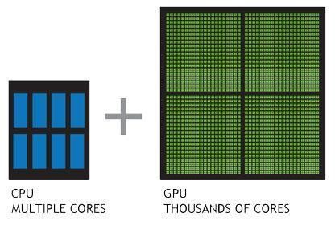
NVIDIA developed NVIDIA RAPIDS™—an open-source data analytics and machine learning acceleration platform—or executing end-to-end data science training pipelines completely in GPUs. It relies on NVIDIA CUDA® primitives for low-level compute optimization, but exposes that GPU parallelism and high memory bandwidth through user-friendly Python interfaces.
Focusing on common data preparation tasks for analytics and data science, RAPIDS offers a familiar DataFrame API that integrates with scikit-learn and a variety of machine learning algorithms without paying typical serialization costs. This allows acceleration for end-to-end pipelines—from data prep to machine learning to deep learning. RAPIDS also includes support for multi-node, multi-GPU deployments, enabling vastly accelerated processing and training on much larger dataset sizes.
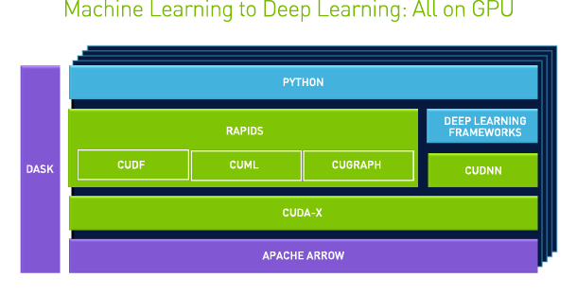

Parameters in XGBoost
- Learning Rate (eta): An important variable that modifies how much each tree contributes to the final prediction. While more trees are needed, smaller values frequently result in more accurate models.
- Max Depth: This parameter controls the depth of every tree, avoiding overfitting and being essential to controlling the model’s complexity.
- Gamma: Based on the decrease in loss, it determines when a node in the tree will split. The algorithm becomes more conservative with a higher gamma value, avoiding splits that don’t appreciably lower the loss. It aids in managing tree complexity.
- Subsample: Manages the percentage of data that is sampled at random to grow each tree, hence lowering variance and enhancing generalization. Setting it too low, though, could result in underfitting.
- Colsample Bytree: Establishes the percentage of features that will be sampled at random for growing each tree.
- n_estimators: Specifies the number of boosting rounds.
- lambda (L2 regularization term) and alpha (L1 regularization term): Control the strength of L2 and L1 regularization, respectively. A higher value results in stronger regularization.
- min_child_weight: Influences the tree structure by controlling the minimum amount of data required to create a new node.
- scale_pos_weight: Useful in imbalanced class scenarios to control the balance of positive and negative weights.

Why XGboost?
XGBoost is highly scalable and efficient as It is designed to handle large datasets with millions or even billions of instances and features.
XGBoost implements parallel processing techniques and utilizes hardware optimization, such as GPU acceleration, to speed up the training process. This scalability and efficiency make XGBoost suitable for big data applications and real-time predictions.
It provides a wide range of customizable parameters and regularization techniques, allowing users to fine-tune the model according to their specific needs.
XGBoost offers built-in feature importance analysis, which helps identify the most influential features in the dataset. This information can be valuable for feature selection, dimensionality reduction, and gaining insights into the underlying data patterns.
XGBoost has not only demonstrated exceptional performance but has also become a go-to tool for data scientists and machine learning practitioners across various languages. It has consistently outperformed other algorithms in Kaggle competitions, showcasing its effectiveness in producing high-quality predictive models.

When to use XGboost?
- XGBoost is well-suited for scenarios with a substantial number of training samples.
- XGBoost is versatile in handling a mix of categorical and numeric features.
- XGBoost remains a strong choice, where only numeric features are present. Its effectiveness in handling numeric data, coupled with regularization techniques, contributes to robust model performance.

When Not to use XGboost?
- Limited training samples.
- Image recognition and Natural Language Processing tasks.
- Unstructured Data.

Why does XGBoost perform so well?
XGBoost and Gradient Boosting Machines (GBMs) are both ensemble tree methods that apply the principle of boosting weak learners (CARTs generally) using the gradient descent architecture. However, XGBoost improves upon the base GBM framework through systems optimization and algorithmic enhancements

