Problem Statement
Peer-to-peer lending
Context:
Peer-to-peer lending is a form of direct lending of money to individuals or businesses without an official financial institution participating as an intermediary in the deal. P2P lending is generally done through online platforms that match lenders with the potential borrowers.

P2P lending offers both secured and unsecured loans. However, most of the loans in P2P lending are unsecured personal loans. Secured loans are rare for the industry and are usually backed by luxury goods. Due to some unique characteristics, peer-to-peer lending is considered as an alternative source of financing.

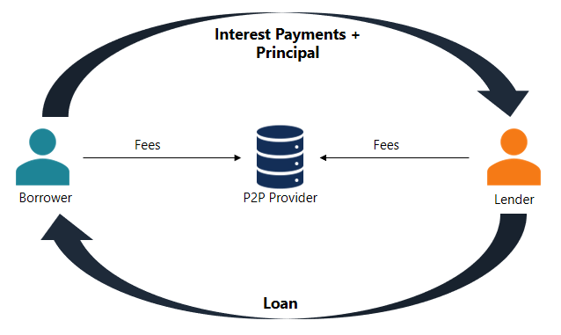

How it works?

Peer-to-peer lending is a fairly straightforward process. All the transactions are carried out through a specialized online platform. The steps below describe the general P2P lending process:

- A potential borrower interested in obtaining a loan completes an online application on the peer-to-peer lending platform.
- The platform assesses the application and determines the risk and credit rating of the applicant. Then, the applicant is assigned the appropriate interest rate.
- When the application is approved, the applicant receives the available options from the investors based on his credit rating and assigned interest rates.
- The applicant can evaluate the suggested options and choose one of them.
- The applicant is responsible for paying periodic (usually monthly) interest payments and repaying the principal amount at maturity.

The company that maintains the online platform charges a fee for both borrowers and investors for the provided services.

Problem Statement:

Design and create an architecture for the peer-to-peer lending platform with the below functional requirements and non-functional requirements.

Users:

Lender: A lender is any user who is willing to lend money to the potential borrower.
Borrower: A borrower is any user who is looking to borrow money from a potential lender.
Approver: An approver is part of the lending platform who reviews and approves the borrowings submitted by borrowers.
Management: The management can be a single or a group of people who reviews the performance of the platform and manage it.

High level functional requirements
- Self-registration process for the lenders and borrowers.
- KYC document submission and approval.
- Online submission of an application by borrower to borrow the money.
- Approval of applications submitted by borrowers by assigning credit risk, interest rate, etc.
- Lender (Investors) reviews the applications and express the willingness to lend money.
- Borrower accepts the money and starts the EMI along with interest.
- Options for the borrower and lender to track the status of the application and the repayments.
- Option for the borrower to stop the payment for a month after the approval from the lender (platform’s credit score should affect).
- An appropriate AI based algorithm to be used to calculate the credit risk for the borrowers.
- A similar AI based algorithm should be devised to give an appropriate metric for the lender as well.
(More requirements should be created on these lines)
Additional Information
The Peer-to-Peer Lending Platform should guarantee a smooth, secure, and scalable experience to all the parties involved. The platform should guarantee uninterrupted access round the clock and enable users to carry out transactions without any halt. The system should be easily accessible on different devices such as mobiles, tablets, laptops, and desktops, facilitating ease of access for lenders as well as borrowers. With increasing users and transactions, the system should be capable of supporting the growing load effectively with minimal adaptations.
For ensuring flexibility, the platform must support easy transitions across various cloud service providers. Security is still of utmost importance, with all online payments following Central Bank / Bank Regulator (like RBI) guidelines and providing full safety and privacy for users. The platform must also provide APIs for financial institutions, which will enable smooth integration for business partnerships. The overall experience must be optimized for quick response times, which will ensure seamless interaction for users accessing the system.

