1. **Exponential series**

In this assignment we use Taylor series expansion for calculating the value of exponent in KEIL

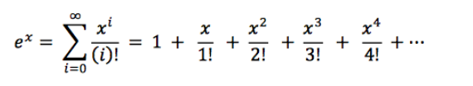

Different values of **ex** are being calculated using KEIL , C program and Absolute value for different value of x.

**Table:** Value of exponential function for different value of **x**

|  |  |  |  |  |  |
| --- | --- | --- | --- | --- | --- |
| **S.No.** | **x** | **ex (ARM)** | **ex (C Program)** | **ex (Absolute value)** | **No. of iterations** |
| 1. | 1 | 2.71828 | 2.718 | 2.71828 | 20 |
| 2. | 2 | 7.38906 | 7.388713 | 7.3891 | 20 |
| 3. | 3 | 20.0855 | 20.066393 | 20.0855 | 20 |
| 4. | 4 | 54.5979 | 54.598148 | 54.5982 | 20 |
| 5. | 5 | 148.403 | 148.4131 | 148.4132 | 20 |
| 6. | 6 | 403.428 | 403.428 | 403.4288 | 20 |
| 7. | 7 | 1096.62 | 1096.6331 | 1096.6332 | 20 |
| 8. | 8 | 2980.68 | 2980.958 | 2980.958 | 20 |
| 9. | 9 | 8099.52 | 8103.0839 | 8103.0839 | 20 |
| 10. | 10 | 2.20E+04 | 22026.464844 | 22026.4658 | 20 |
| 11. | 12 | 1.63E+05 | 162754.796875 | 162754.7914 | 30 |
| 12. | 14 | 1.20E+06 | 1202604.25 | 1202604.284 | 30 |
| 13. | 16 | 8.88E+06 | 8886111 | 8886110.521 | 30 |
| 14. | 18 | 6.53E+07 | 65659968 | 65659969.14 | 30 |
| 15. | 20 | 4.75E+08 | 485165184 | 485165195.4 | 30 |
| 16. | 25 | #INF | 72004902912 | 72004899337 | 30 |

We can see in the above table that as value of x increases number of iterations should have to increase in order to get less error in the output.

Also for large value of **X** KEIL simulator output shows #INF

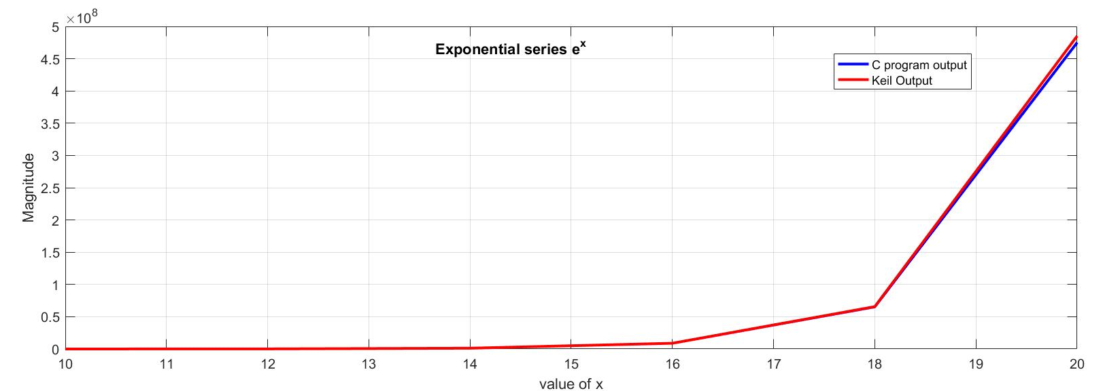

Fig : Output of exponential function

1. **Tan x series**

For calculating **tan x** series we first calculate **sin x** term and **cos x** term using taylor series expansion.

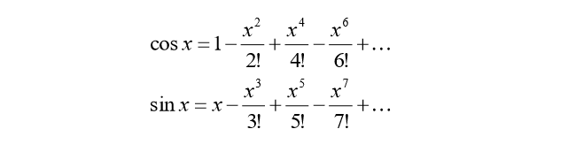

Then we find value of tan x = (sin x / cos x)

|  |  |  |  |  |
| --- | --- | --- | --- | --- |
| **S.No.** | **Angle(rads)** | **Angle(degree)** | **Tan x (KEIL)** | **Tan x (C program)** |
|  | 0.174532​ | 10 | 0.174533 | 0.176326 |
|  | 0.349064​ | 20 | 0.363968 | 0.363968 |
|  | 0.523596​ | 30 | 0.577347 | 0.577347 |
|  | 0.698128​ | 40 | 0.839093 | 0.839093 |
|  | 0.872660​ | 50 | 1.19174 | 1.191742 |
|  | 1.047192​ | 60 | 1.73202 | 1.732029 |
|  | 1.221724​ | 70 | 2.74742 | 2.747422 |
|  | 1.396256​ | 80 | 5.67084 | 5.671036 |
|  | 1.570788​ | 90 | 120341 | 120094.2 |
|  | 1.745320​ | 100 | -5.67159 | -5.67159 |
|  | 1.919852​ | 110 | -2.74756 | -2.74756 |
|  | 2.094384​ | 120 | -1.7321 | -1.7321 |
|  | 2.268916​ | 130 | -1.19178 | -1.19178 |
|  | 2.443448​ | 140 | -0.83912 | -0.83912 |
|  | 2.617980​ | 150 | -0.57737 | -0.57737 |
|  | 2.792512​ | 160 | -0.36399 | -0.36399 |
|  | 2.967044​ | 170 | -0.17634 | -0.17634 |
|  | 3.141576​ | 180 | -1.67E-05 | -1.70E-05 |
|  | 3.316108​ | 190 | 0.176308 | 0.176309 |
|  | 3.490640​ | 200 | 0.363949 | 0.363949 |
|  | 3.665172​ | 210 | 0.577324 | 0.577324 |
|  | 3.839704​ | 220 | 0.839064 | 0.839065 |
|  | 4.014236​ | 230 | 1.1917 | 1.191702 |
|  | 4.188768​ | 240 | 1.73196 | 1.731962 |
|  | 4.363300​ | 250 | 2.74727 | 2.74728 |
|  | 4.537832​ | 260 | 5.67048 | 5.670484 |
|  | 4.712364​ | 270 | 39977.3 | 40031.41 |
|  | 4.886896​ | 280 | -5.67213 | -5.67214 |
|  | 5.061428​ | 290 | -2.74772 | -2.74771 |
|  | 5.235960​ | 300 | -1.73219 | -1.73216 |
|  | 5.410492​ | 310 | -1.19187 | -1.19182 |
|  | 5.585024​ | 320 | -0.83924 | -0.83915 |
|  | 5.759556​ | 330 | -0.57756 | -0.57739 |
|  | 5.934088​ | 340 | -0.36431 | -0.36401 |
|  | 6.108620​ | 350 | -0.17693 | -0.17636 |
|  | 6.283152 | 360 | -0.00108 | -3.30E-05 |

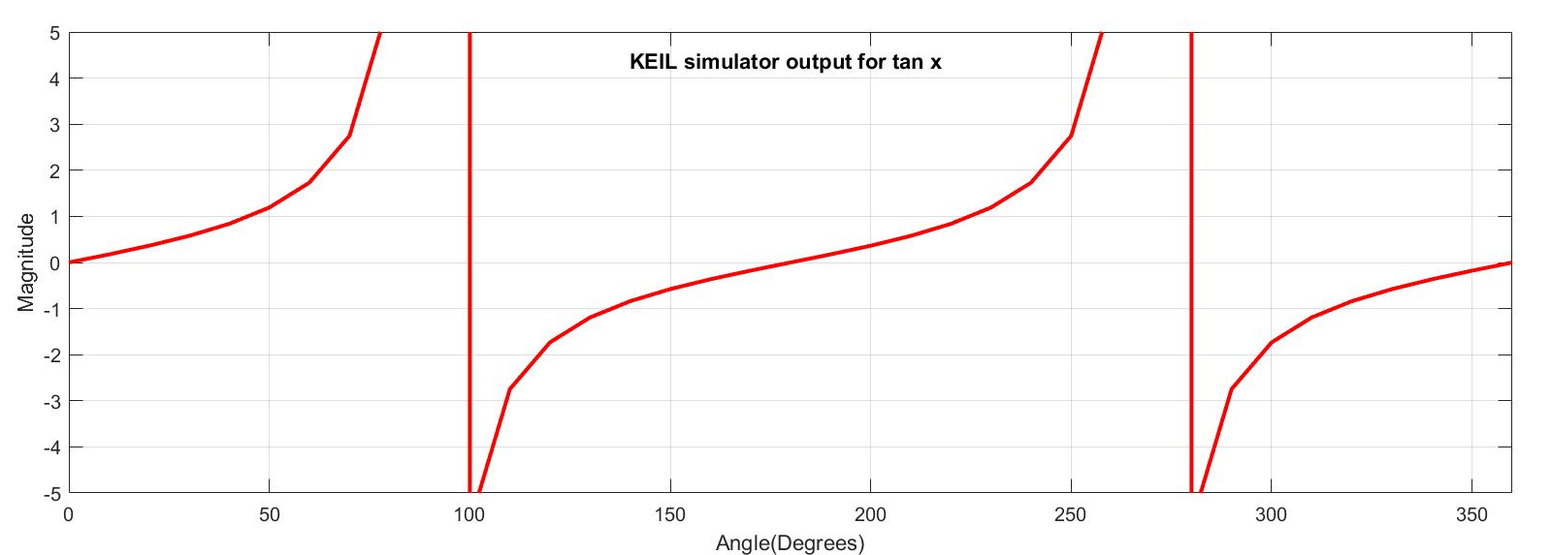

Fig :Graph obtained from KEIL simulator

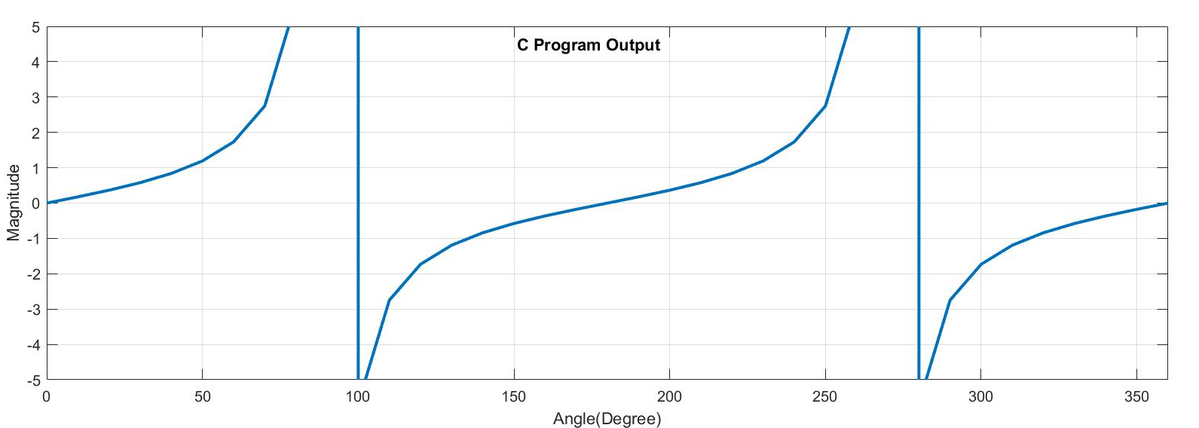

Fig : Graph obtained from C program

As we can see from the graph the output values obtained from KEIL simulator and C program is nearly same.