DigiSlate
An Interactive Smart Board

Table of Contents
1) Introduction To The Creator 3
2) Fundamentals 4
2.1) UI Part Look and Fill 4

Introduction To The Creator
Hello
I am Ashwin Parmar. I have recently created a project named DigiSlate.
Here, I am representing my latest designed project DigiSlate which means “A Digital Interactive Smart Board”.
This project is built on the basis of technology C++ language and integrated with QT framework.

Fundamentals

UI Part Look and Fill
Lets come to the UI Part. This is a type of ui look a like for my product. There are different components available as button to press and draw different shapes on the board.
Mainly this board is created for educational purpose, used for teaching to student by free hand draw and easy created different shapes. Easy to used configration of board and neat clean arragement.
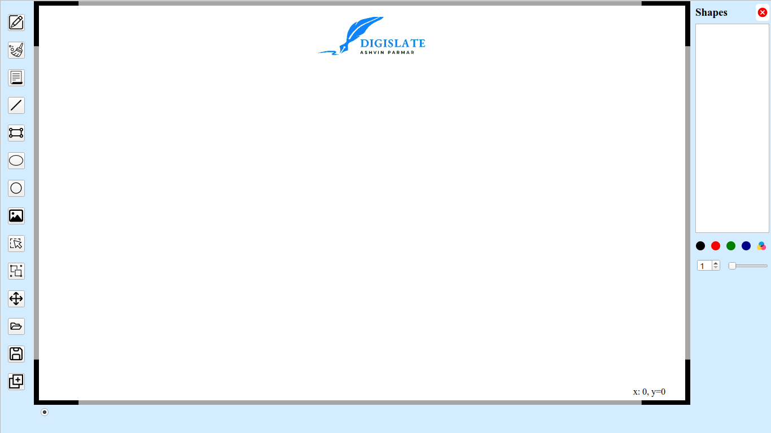Figure 1: DigiSlate Board

Programming File Arragement for Project Understanding
Let’s talk about file structure of out project. Here you see in figure 2, There are four sections.
- Header Files: Its includes all the Header Files build for our project.
Shapes_header: Its includes all the different shapes header files. Its used to declare nessasary functionality of specific shapes.
Other Header Files: There are free header files available which having the generalised code for working of project. About the specific files, may be we discussed below some pages.
- Source Files: Its includes all the Source Files build for our project
Shapes_src: Over here, All the shapes source files are stored. There are all the definations of methods declared in their respective header files.
Other Source Files: There more free source files available, which includes the specific functionality for making the project runnable.
- Form File: Its includes all the Form files for Presentation UI Parts.
- Resources File: Its includes all the resources files used in our project. you can puts them up right here.
DigiSlate.pro: It is the File which is nessasary file for build our project using QT Creator. Directly click on it and easily build complete project in seconds.
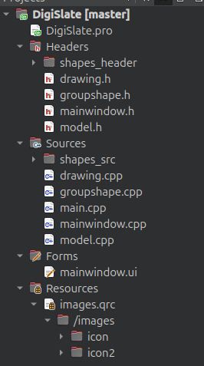Figure 2: FIle Representation

Features of DigiSlate Shapes Tools
Let me show you all of this Button’s working one by one. You can only draw inside the board area.
Listen/Note: Here, my drawable component may not be clear because I don't have a graphics tablet. For teaching on smart board you must have a graphics tablet or digitizer, this is a necessary component for smart board. You can also use a Smart TV if applicable. It works on both because overall it is a desktop application.

Free Hand Draw Shapes
This is Free Hand Tool Working, Over there in the figure 3, You can see the working of free hand tool. Its start working when clicked on the First button from the tool bar list.
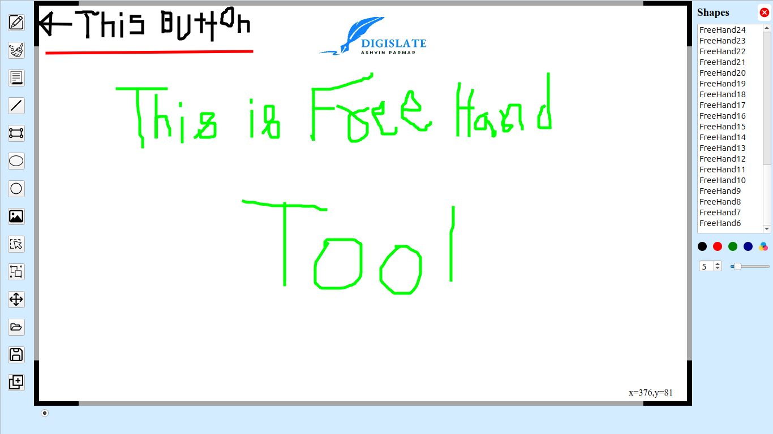Figure 3: Free Hand Tool

Line Shape
This is Line Shape working, Over there in the figure 4, You can see the tool is used to draw straight lines. Wherever you clicked on the board screen it will draw a line until you release the mouse button or digitizer pen from the pad.
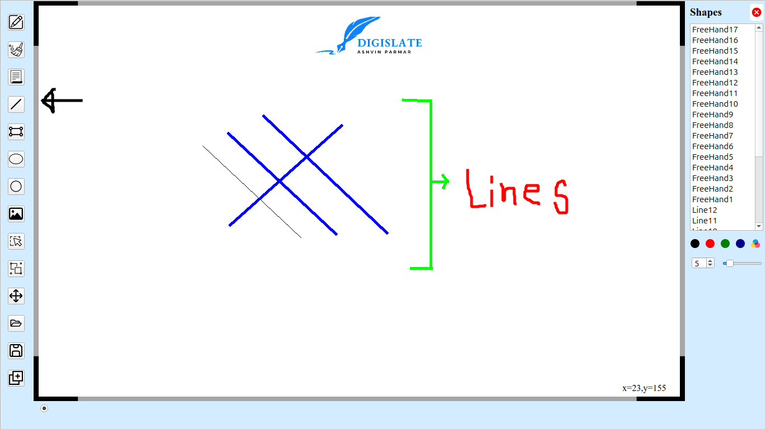Figure 4: Line Shape

Rectangle Shape
Over here Rectangle Shape in figure 5, You can see the tool is used to draw rectangle shape. Wherever you clicked on the board screen it will draw a rectangle from that point to until you release the mouse button or digitizer pen from the pad.
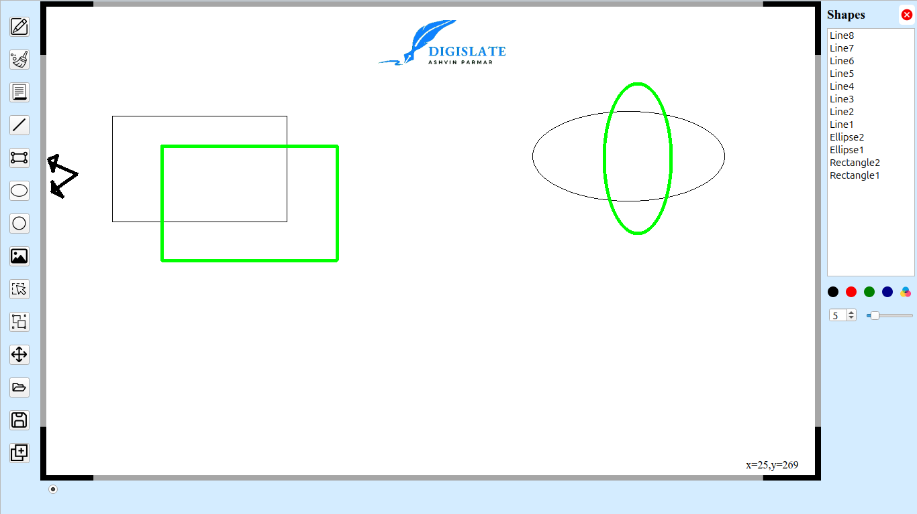Figure 5: Rectangle and Ellipse Shape

Ellipse Shape
Similarly like Rectangle, You can draw Ellipse Shape as shown in Above Figure 5.

Circle Shape
For Circle shape, when you press the mouse button, its start making a circle from that point to be as center and draged distance as there radius. When realease your mouse button, you get circle with that radius.
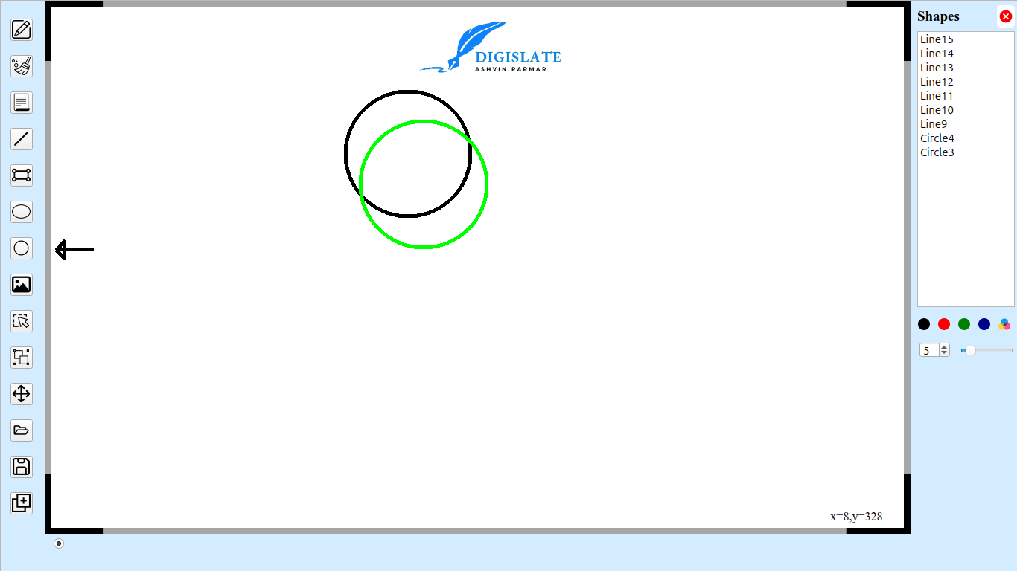Figure 6: Circle Shape

Image import
You can import any amout of images from the file to here. Let me show you the process.
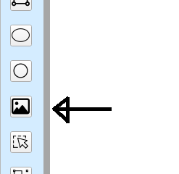Step 1: Click Button
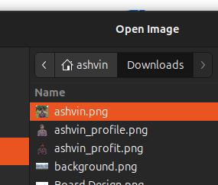Step 2: Select File
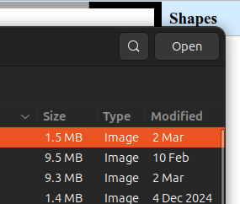Step 3: Click Open Button

Now Click on board from mouse and drag until the size of image you needed. Output will be like as shown in figure 7.
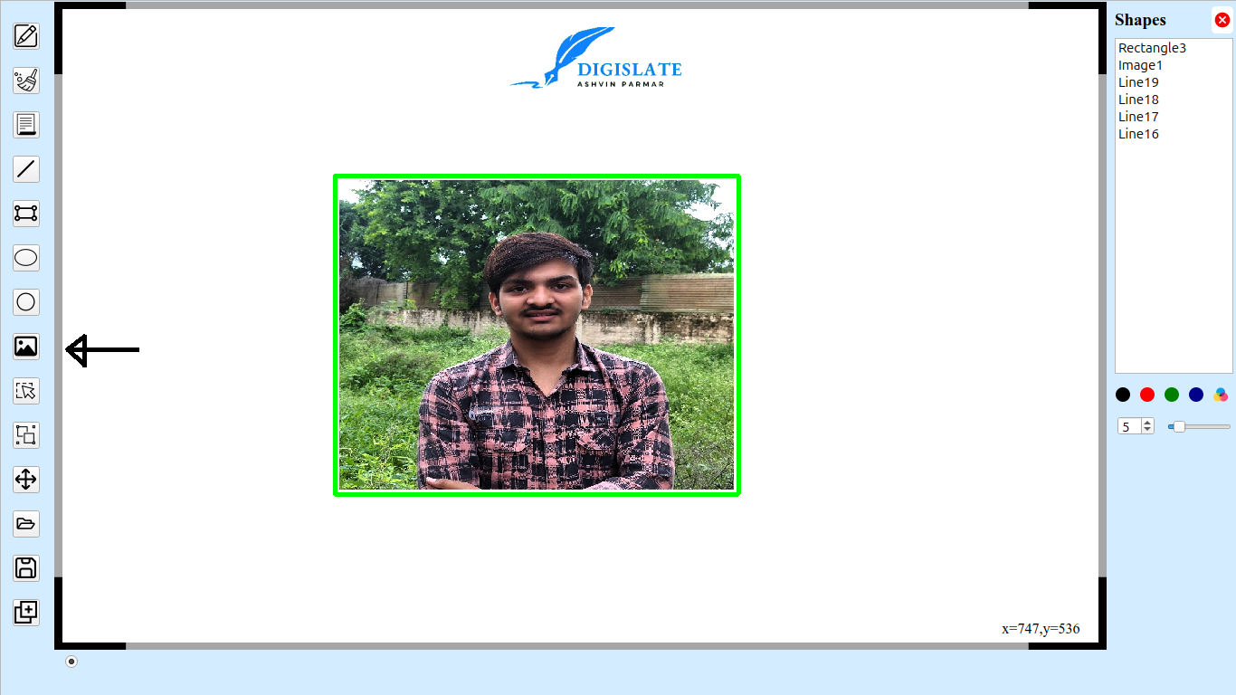Figure 7: Image Import

Special Feature of DigiSlate

History of Shapes
There are a Model/View based stack of all the shapes that have been drawed on the board are maintained as history up right there in shaped list. You can see each shapes are given a unique id/name with there specific category.
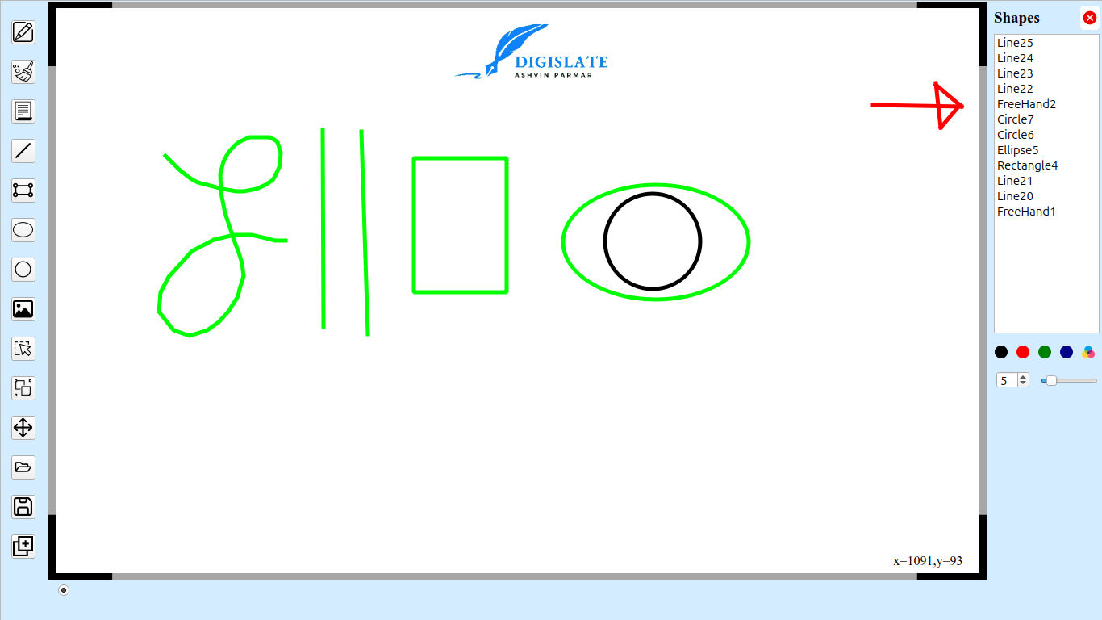

- Provides a clean digital slate for writing, sketching, and annotating.
- Supports smooth touch-based or stylus input for an intuitive experience.
- Displays real-time coordinate tracking for precision.

