Heuristic Analysis – Planning

By Ashvin Someshwar

This report presents the results of different search strategies in the Air Cargo Planning problems. This report is presented by problem listing out the best search strategy for each.

# Problem 1

## Result Table

|  |  |  |  |  |  |  |
| --- | --- | --- | --- | --- | --- | --- |
| Strategy | Informed | Plan length (Optimal) | Expansions | Goal Tests | New Nodes | Execution Time (s) |
| Breadth First Search | No | 6 (Yes) | 43 | 56 | 180 | 0.03 |
| Breadth First Tree Search | No | 6 (Yes) | 1458 | 1459 | 5960 | 1.032 |
| Depth First Search | No | 20 (No) | 21 | 22 | 84 | 0.016 |
| Depth Limited Search | No | 50 (No) | 101 | 271 | 414 | 0.098 |
| Uniform Cost Search | No | 6 (Yes) | 55 | 57 | 224 | 0.0403 |
| Recursive Best First Search (h - 1) | Yes | 6 (Yes) | 4229 | 4230 | 17023 | 2.96 |
| Greedy Best First Graph Search (h - 1) | Yes | 6 (Yes) | 7 | 9 | 28 | 0.005 |
| A* search (h - 1) | Yes | 6 (Yes) | 55 | 57 | 224 | 0.0392 |
| A* search (h – ignore preconditions) | Yes | 6 (Yes) | 41 | 43 | 170 | 0.0391 |
| A* search (h – pg levelsum) | Yes | 6 (Yes) | 11 | 13 | 50 | 1.058 |

## Optimal Sequence

**Plan Length = 6**

Load(C1, P1, SFO)

Load(C2, P2, JFK)

Fly(P2, JFK, SFO)

Unload(C2, P2, SFO)

Fly(P1, SFO, JFK)

Unload(C1, P1, JFK)

## Uninformed Searches

Among the uninformed searches the execution time for depth first search algorithm is the best coming up with a plan in 0.016s. However the plan is not optimal.

The best uninformed search strategy seems to be the Breadth First Search algorithm which executes in 0.03s and comes up with an optimal plan.

## Informed Searches

Surprisingly for this problem the Greedy Best First Search algorithm comes up with an optimal plan in 0.005s with minimum number of node expansions and goal tests. However, this cannot be considered optimal since the algorithm itself is not optimal and the heuristic used is a mock heuristic.

The A* search with ignore preconditions seems to be the best algorithm which executes in 0.0391s. Although, it explores more paths than the levelsum heuristic the search completes much faster because of the simple heuristic function.

# Problem 2

## Result Table

|  |  |  |  |  |  |  |
| --- | --- | --- | --- | --- | --- | --- |
| Strategy | Informed | Plan length (Optimal) | Expansions | Goal Tests | New Nodes | Execution Time (s) |
| Breadth First Search | No | 9 (Yes) | 3343 | 4609 | 30509 | 15.636 |
| Depth First Search | No | 619 (No) | 624 | 625 | 5602 | 4.073 |
| Uniform Cost Search | No | 9 (Yes) | 4853 | 4855 | 44041 | 14.155 |
| Greedy Best First Graph Search (h - 1) | Yes | 21 (No) | 998 | 1000 | 8982 | 3.119 |
| A* search (h - 1) | Yes | 9 (Yes) | 4853 | 4855 | 44041 | 13.312 |
| A* search (h – ignore preconditions) | Yes | 9 (Yes) | 1450 | 1452 | 13303 | 5.039 |
| A* search (h – pg levelsum) | Yes | 9 (Yes) | 86 | 88 | 841 | 251.44 |

## Optimal Sequence

**Plan Length = 9**

Load(C1, P1, SFO)

Load(C2, P2, JFK)

Load(C3, P3, ATL)

Fly(P2, JFK, SFO)

Unload(C2, P2, SFO)

Fly(P1, SFO, JFK)

Unload(C1, P1, JFK)

Fly(P3, ATL, SFO)

Unload(C3, P3, SFO)

## Uninformed Searches

Uniform Cost Search performs the best amongst the uninformed searches with an execution time of 14.155s however expands more nodes than the Breadth First Search.

## Informed Searches

A* with ignore preconditions performs best with an execution time of 5.039s.

# Problem 3

## Result Table

|  |  |  |  |  |  |  |
| --- | --- | --- | --- | --- | --- | --- |
| Strategy | Informed | Plan length (Optimal) | Expansions | Goal Tests | New Nodes | Execution Time (s) |
| Breadth First Search | No | 12 (Yes) | 14663 | 18098 | 129631 | 156.153 |
| Depth First Search | No | 392 (No) | 408 | 409 | 3364 | 2.662 |
| Uniform Cost Search | No | 12 (Yes) | 18223 | 18225 | 159618 | 79.88 |
| Greedy Best First Graph Search (h - 1) | Yes | 22 (No) | 5578 | 5580 | 49150 | 26.138 |
| A* search (h - 1) | Yes | 12 (Yes) | 18223 | 18225 | 159618 | 87.874 |
| A* search (h – ignore preconditions) | Yes | 12 (Yes) | 5040 | 5042 | 44944 | 26.616 |
| A* search (h – pg levelsum) | Yes | 12 (Yes) | 325 | 327 | 3002 | 1635.80 |

## Optimal Sequence

**Plan Length = 12**

Load(C1, P1, SFO)

Load(C2, P2, JFK)

Fly(P2, JFK, ORD)

Load(C4, P2, ORD)

Fly(P1, SFO, ATL)

Load(C3, P1, ATL)

Fly(P1, ATL, JFK)

Unload(C1, P1, JFK)

Unload(C3, P1, JFK)

Fly(P2, ORD, SFO)

Unload(C2, P2, SFO)

Unload(C4, P2, SFO)

## Uninformed Searches

The fastest optimal search is the Uniform Cost Search although it expands more nodes than Breadth First Search.

## Informed Searches

The most optimal search is the A* with ignore preconditions heuristic.

# Analysis

Among the uninformed search strategies the fastest is the depth first search algorithm. It does not have to expand many nodes and take up much working memory either. However, as seen from the AIMA book on the comparison of algorithms Depth First Search is not guaranteed to complete and the search is not optimal either (Norvig and Rusell 2009). From our analysis **Uniform Cost Search** seems to be the best among the uninformed search strategies in case we need the optimal solution in the fastest execution time.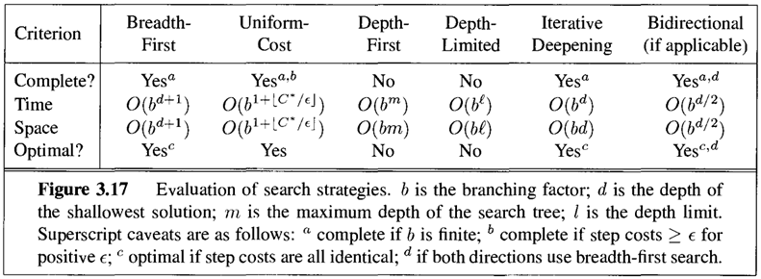

Amongst the informed search strategies the heuristic used made the difference on execution time. The level sum heuristic expands lesser nodes than ignore preconditions. This heuristic assumes the goals are independent and calculates the sum of level costs of individual goals. Whereas the ignore preconditions heuristic calculates the minimum number of actions to be performed to reach the goal state. Ignore preconditions performs much better than level sum because this is simpler than level sum and the cost of calculating the heuristic is much lesser. Hence **A* search with the ignore preconditions** seemed to be the best informed search strategy.

# Bibliography

Norvig, Peter, and Stuart Rusell. *Artificial Intelligence : A mordern approach.* Prentice Hall, 2009.