Project Report
BuildMyTour
Smart Travel Planning and Booking System
Kamani Science And Prataprai Arts College, Amreli
BCA SEM - 5 | 2026
By Ashvin Makvana

A Project Report On

“Smart Travel Planning and Booking System”
✪BuildMyTour✪
Kamani Science & Prataprai Arts College, Amreli

Developed By
Ashvin Makvana (Roll No - ______)
Guided By
Mr. Rakesh Sir Savaliya Mr. Ravi Sir Joshi Year Of Submission
Submitted in partial fulfillment of the requirement for
the award of the degree of Bachelor of Computer Application
(BCA)

2026-2027


Saurashtra University-Rajkot
Develop By Ashvin Makvana 2



No | Title | Page No
1 | Preface | 5
2 | Acknowledgement | 6
3 | Abstract | 7
4 | Introduction | 8
5 | Time Line Chart | 9
6 | Project Profile | 10
7 | Hardware Requirement | 11
8 | Software Requirement | 11
9 | Requirement Specification | 12
10 | Problem Definition | 13
11 | Project Planning& Scheduling | 14-15
12 | System Analysis | 16
13 | Feasibility Study | 17-18
14 | Project Page Structure | 19
15 | Data Dictionary | 20-22
16 | Data Flow Diagram | 23-25
17 | Context & First Level Diagram | 24-25
18 | ER Diagram | 26
19 | Use case Diagram | 27
20 | Activity Diagram | 28-30
21 | Screenshot (Page UI) | 31
22 | Future Scope & References | 65
3 Develop By Ashvin Makvana

Preface
The main objective of a computer science student is to gain practical knowledge along with theoretical knowledge. Developing a project provides valuable experience in understanding how software concepts are applied in a real-world application.
Through the development of BuildMyTour – Smart Travel Planning and Booking System, we gained practical experience in web development, database management, user authentication, trip planning, booking management and software testing.
BuildMyTour is designed to provide a simple and organized platform for planning tours according to trip requirements such as trip type, travel date, duration, number of travelers and budget. The system generates a suitable tour plan and provides a structured booking workflow.
During the development of this project, we learned about different strategies and software engineering concepts that can be applied while designing and developing a web-based system. This project has provided useful practical knowledge and experience for our future career.
We are pleased to present this project report. Proper care has been taken while organizing the report so that the information is easy to understand. The report describes the analysis, design, development, database, testing and major features of the BuildMyTour system.
Developed By Ashvin Makvana

Acknowledgment
I am a student of BCA Sem-5 studying in the Kamani Science & Prataprai Arts College, Amreli. I would like to thank all the people who have given their support in shaping the BuildMyTour – Smart Travel Planning and Booking System.
I thank Mr. Rakesh Sir Savaliya and Mr. Ravi Sir Joshi for giving me guidance and co-operation in understanding the system. I also thank them for their unconditional help in making this project.
I have great deal of gratitude towards our Head of Department who encourages in taking up this activity. I thank all faculties and administrative staffs of the institute.
I am also thankful to all those friends who have helped me in this endeavor either directly or indirectly and especially my family.
Thanks to all!!
Ashvin Makvana
Develop By Ashvin Makvana 6

Abstract
BuildMyTour – Smart Travel Planning and Booking System is a web portal developed to help users plan and book tours in a simple and organized way. The system provides a Smart Trip Planner through which users can select their trip type, start date, duration, number of travelers and budget. Based on these details, the system matches suitable tour packages and generates a travel plan.
The project provides facilities for user registration and login, trip planning, package selection, checkout, booking confirmation, viewing bookings and submitting reviews. The system also provides an Admin section where the administrator can manage users, trip types, tour packages, bookings and reviews.
BuildMyTour is developed as a web-based academic project using HTML5, CSS3, JavaScript and Bootstrap for the front end, PHP for the back end and MySQL/MariaDB for database management. XAMPP is used as the local development environment. The system stores generated trip plans and booking information in the database and provides a structured platform for managing travel planning and booking activities.
Develop By Ashvin Makvana 7

Introduction
Travel planning often requires users to collect information about destinations, tour packages, travel duration, budget and booking details from different sources. Managing these activities manually can make the planning process time-consuming and less organized. To address this requirement, BuildMyTour – Smart Travel Planning and Booking System is developed as a web-based travel planning and booking system.
BuildMyTour provides a simple platform where users can register and login, enter their travel requirements and use the Smart Trip Planner to find suitable tour packages. The planner considers details such as trip type, start date, duration, number of travelers and budget. Based on the selected requirements, the system matches available tour packages and generates a travel plan for the user.
The system has two main sections, namely User and Admin. In the User section, users can plan a trip, view the generated plan, select a suitable package, complete the checkout process, view their bookings and submit reviews. In the Admin section, the administrator can manage users, trip types, tour packages, bookings and reviews.
The project is developed using HTML5, CSS3, JavaScript and Bootstrap for the front end, PHP for the back end and MySQL/MariaDB for database management. XAMPP is used as the local development environment. The system provides an organized approach to travel planning and booking while keeping the implementation simple and suitable for an academic project.
Develop By Ashvin Makvana 8

Time Line Chart
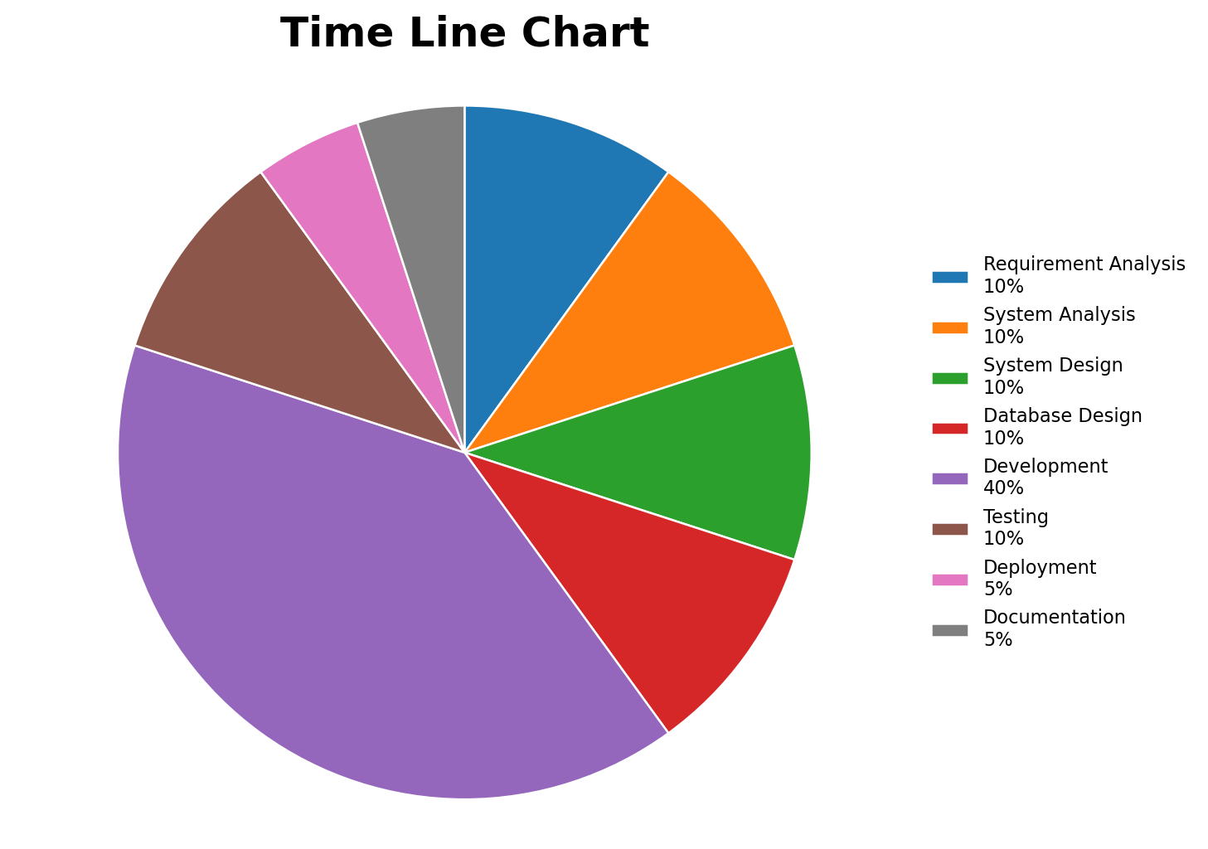
Requirement Analysis | → | 10 Days
System Analysis | → | 10 Days
System Design | → | 10 Days
Database Design | → | 10 Days
Development | → | 40 Days
Testing | → | 10 Days
Deployment | → | 5 Days
Documentation | → | 5 Days
Develop By Ashvin Makvana 9

Project Profile
➢ Project Name : Smart Travel Planning and Booking System
➢ Website Name : BuildMyTour
➢ Developed by : Ashvin Makvana
➢ Front End Tool : HTML5, CSS3, JavaScript, Bootstrap 5.3
➢ Back End Tool : PHP 8+ (Core PHP), MySQL / MariaDB
➢ Local Server : XAMPP (Apache + MySQL / MariaDB)
➢ Computer System : Computer / Laptop suitable for local web development
➢ Project Details : Provides a platform for users to plan trips, find suitable tour packages, generate a travel plan according to trip requirements, make bookings and submit reviews. The Admin section is used to manage users, trip types, tour packages, bookings and reviews.
➢ Completion Time : 100 Days
➢ Guided by : Mr. Rakesh Sir Savaliya & Mr. Ravi Sir Joshi
➢ Submitted by : Saurashtra University, Rajkot
Develop By Ashvin Makvana 10

Hardware Requirement
❖ Computer / Laptop
❖ Minimum 4 GB RAM
❖ Intel Core i3 processor or equivalent
❖ Keyboard and Mouse
❖ Monitor / Display
❖ Internet / Network connection
Software Requirement
❖ Operating System : Microsoft Windows
❖ Front End Tools : HTML5, CSS3, JavaScript, Bootstrap 5.3
❖ Back End Tool : PHP 8+ (Core PHP)
❖ Database : MySQL / MariaDB
❖ Local Server : XAMPP (Apache + MySQL / MariaDB)
❖ Code Editor : Visual Studio Code or similar editor
❖ Browser Specification : Google Chrome, Mozilla Firefox or Microsoft Edge
❖ Documentation Tool : Microsoft Word
Develop By Ashvin Makvana 11

Requirement Specification
In this section provides requirements overview of the system.
● Registration : User must be registered in the system to use the important functionality of BuildMyTour. Unregistered users cannot create a trip or make a booking.
● Login : User can login to the system by entering valid email and password for using the protected functionality of the system.
● Smart Trip Planner : User can enter trip type, start date, duration, number of travelers and budget. The system uses these details to find suitable tour packages and generate a travel plan.
● Tour Package : User can view available tour packages and their details and select a suitable package according to the trip requirements.
● Booking : User can proceed with a selected tour package, complete the checkout process and receive booking confirmation after successful booking.
● My Bookings : User can view the details of previously created bookings from the My Bookings section.
● Review : User can submit a review for the booked tour package.
● Admin : Administrator can login and manage users, trip types, tour packages, bookings and reviews.
Develop By Ashvin Makvana 12

Project Problem Definition
● Maintain User Profile
● Maintain Trip Planning
● Maintain Trip Package Selection
● Maintain Booking
● Maintain Payment / Checkout
● Maintain Review and Rating
Develop By Ashvin Makvana 13

Project Planning & Scheduling
Project planning is an aspect of Project Management, which comprises of various processes. The aim of these processes is to ensure that various Project tasks are well coordinated and they meet the various project objectives including timely completion of the project. The project plan reflects the current status of all project activities and is used to monitor and control the project.
The Project Planning tasks ensure that various elements of the Project are coordinated and therefore guide the project execution. Project Scheduling is one of the important tasks of Project Planning and helps in arranging the activities of the BuildMyTour project in a systematic sequence.
Project Planning & Scheduling as under :
● Preliminary Investigation
● Requirement Analysis
● System Analysis
● System Design
● Database Design
● Coding / Development
● Testing
● Implementation
● Documentation
Develop By Ashvin Makvana 14

Project Planning & Scheduling as under :
System Analysis
System Design
Preliminary Investigation
Coding
Testing
Maintenance
Implementation
Develop By Ashvin Makvana 15

System Analysis
System analysis is the process of identification of objectives and requirements, evaluation of alternative solutions and recommendation for a more feasible solution. In other words, system analysis is the step by step process of gathering, recording and interpreting facts. The main aim of analysis is to determine problem areas and to take solutions to reduce or eliminate them.
System analysis itself breaks into two stages:
1. Preliminary analysis :
2. Detailed analysis :
During analysis, data are collected from the available files, decision points and transactions of the system using various tools like Data Flow Diagram (DFD).
For BuildMyTour, the analysis focuses on understanding user registration and login, trip planning, tour package selection, booking, reviews and the administrative functions required to manage the system.
Develop By Ashvin Makvana 16

Feasibility Study
A purpose of feasibility study is to check out the possibility of a computerized solution to the observed problem before much time and money are spent on it. A feasibility study is carried out to select a suitable system that meets the required performance and functional requirements.
For BuildMyTour, the feasibility study helps to determine whether the proposed Smart Travel Planning and Booking System can be developed and operated using the available technology, resources and budget.
They are three types of feasibility Study :
1. Technical
2. Operational
3. Economical
Technical :
Technical feasibility considers whether the desired project can be completed within the framework of available technology. BuildMyTour is a web-based system developed using HTML5, CSS3, JavaScript, Bootstrap 5.3, PHP 8+ and MySQL/MariaDB with XAMPP. These technologies are available for local development, so the technical requirements can be fulfilled.
Operational :
Operational feasibility considers whether the developed system can be used effectively by its intended users. BuildMyTour provides registration, login, smart trip planning, tour package selection, booking, reviews and administrative management. These functions support the normal activities required for planning and managing trips.
Economical :
Economical feasibility considers the cost of developing and operating the system. BuildMyTour uses commonly available development tools such as XAMPP, PHP, MySQL/MariaDB, Bootstrap and a web browser. The project is developed as an academic system, so the required development resources are limited and manageable.
Develop By Ashvin Makvana 17

Technical :
BuildMyTour can be developed and run using the available computer system, XAMPP local server, PHP 8+, MySQL/MariaDB and standard web browsers. Therefore, the technical requirements of the proposed system can be satisfied.
Operational :
The system is designed for simple operation by users and administrators. Users can register, log in, plan a trip, select a tour package, make a demo booking and submit reviews. Administrators can manage users, trip categories, tour packages, bookings and reviews.
Economical :
The project is economically feasible because it uses readily available and commonly used development technologies. As an academic web project, it does not require expensive hardware or licensed development software for its basic development and testing.
Thus, the feasibility study indicates that BuildMyTour can be developed with the available technical resources, can be operated by its intended users and can be completed within the manageable resources of an academic project.
Develop By Ashvin Makvana 18

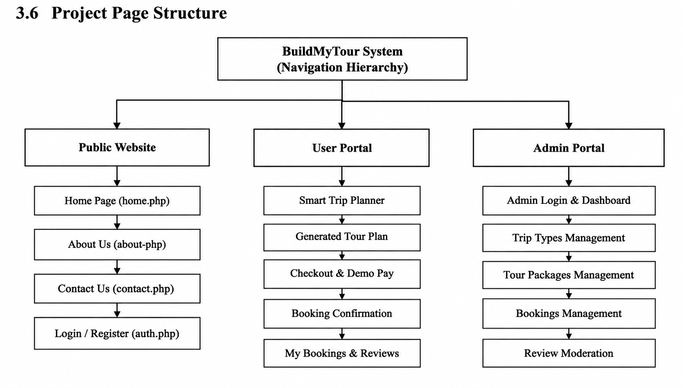
Develop By Ashvin Makvana 19

Data Dictionary
The data Dictionary is a set of table. MySQL uses it to maintain information about its own database.
➢ Data dictionary contains the following information :
✓ Name of the table of database.
✓ User information such as privileges.
✓ Name and data-type of all columns in database table.
❖ Database Name : buildmytour
1. admins :
This table is used to store admin information.
Field | Data Type | Size | Attribute
id | Int | 11 | Primary Key
name | Varchar | 100 | -
email | Varchar | 150 | Unique
password | Varchar | 255 | -
status | Enum | active/inactive | -
created_at | Timestamp | - | -

2. users :
This table is used to store user registration information.
Field | Data Type | Size | Attribute
id | Int | 11 | Primary Key
name | Varchar | 100 | -
email | Varchar | 150 | Unique
phone | Varchar | 20 | -
password | Varchar | 255 | -
created_at | Timestamp | - | -

3. trip_categories :
This table is used to store trip category information.
Field | Data Type | Size | Attribute
id | Int | 11 | Primary Key
name | Varchar | 100 | Unique
description | Varchar | 255 | -
status | Enum | active/inactive | -

Develop By Ashvin Makvana 20

4. tour_packages :
This table is used to store tour package information.
Field | Data Type | Size | Attribute
id | Int | 11 | Primary Key
category_id | Int | 11 | Foreign Key
title | Varchar | 150 | -
description | Text | - | -
destination | Varchar | 100 | -
duration_days | Int | 11 | -
price | Decimal | 10,2 | -
image_destination | Varchar | 255 | -
image_transport | Varchar | 255 | -
image_hotel | Varchar | 255 | -
image_meal | Varchar | 255 | -
status | Enum | active/inactive | -

5. trips :
This table is used to store generated trip plan information.
Field | Data Type | Size | Attribute
id | Int | 11 | Primary Key
user_id | Int | 11 | Foreign Key
trip_type_id | Int | 11 | Foreign Key
start_date | Date | - | -
duration_days | Int | 11 | -
travelers | Int | 11 | -
budget | Decimal | 10,2 | -
generated_plan_json | LongText | - | -
created_at | Timestamp | - | -

6. bookings :
This table is used to store booking information.
Field | Data Type | Size | Attribute
id | Int | 11 | Primary Key
user_id | Int | 11 | Foreign Key
trip_id | Int | 11 | Foreign Key
package_id | Int | 11 | Foreign Key
travelers | Int | 11 | -
total_amount | Decimal | 10,2 | -
payment_method | Varchar | 50 | -
payment_status | Varchar | 30 | -
booking_status | Varchar | 30 | -
booking_reference | Varchar | 50 | Unique
created_at | Timestamp | - | -

Develop By Ashvin Makvana 21

7. reviews :
This table is used to store user review and rating information.
Field | Data Type | Size | Attribute
id | Int | 11 | Primary Key
user_id | Int | 11 | Foreign Key
package_id | Int | 11 | Foreign Key
rating | Int | 11 | -
review | Text | - | -
status | Enum | active/inactive | -
created_at | Timestamp | - | -

The above tables together maintain the main data required for users, administrators, trip categories, tour packages, generated trips, bookings and reviews in the BuildMyTour system.
Develop By Ashvin Makvana 22

Data Flow Diagram
The DFD gives brief idea on how the designed system is working. It also suggests to us the type of users who using this system and the process involved in the system.
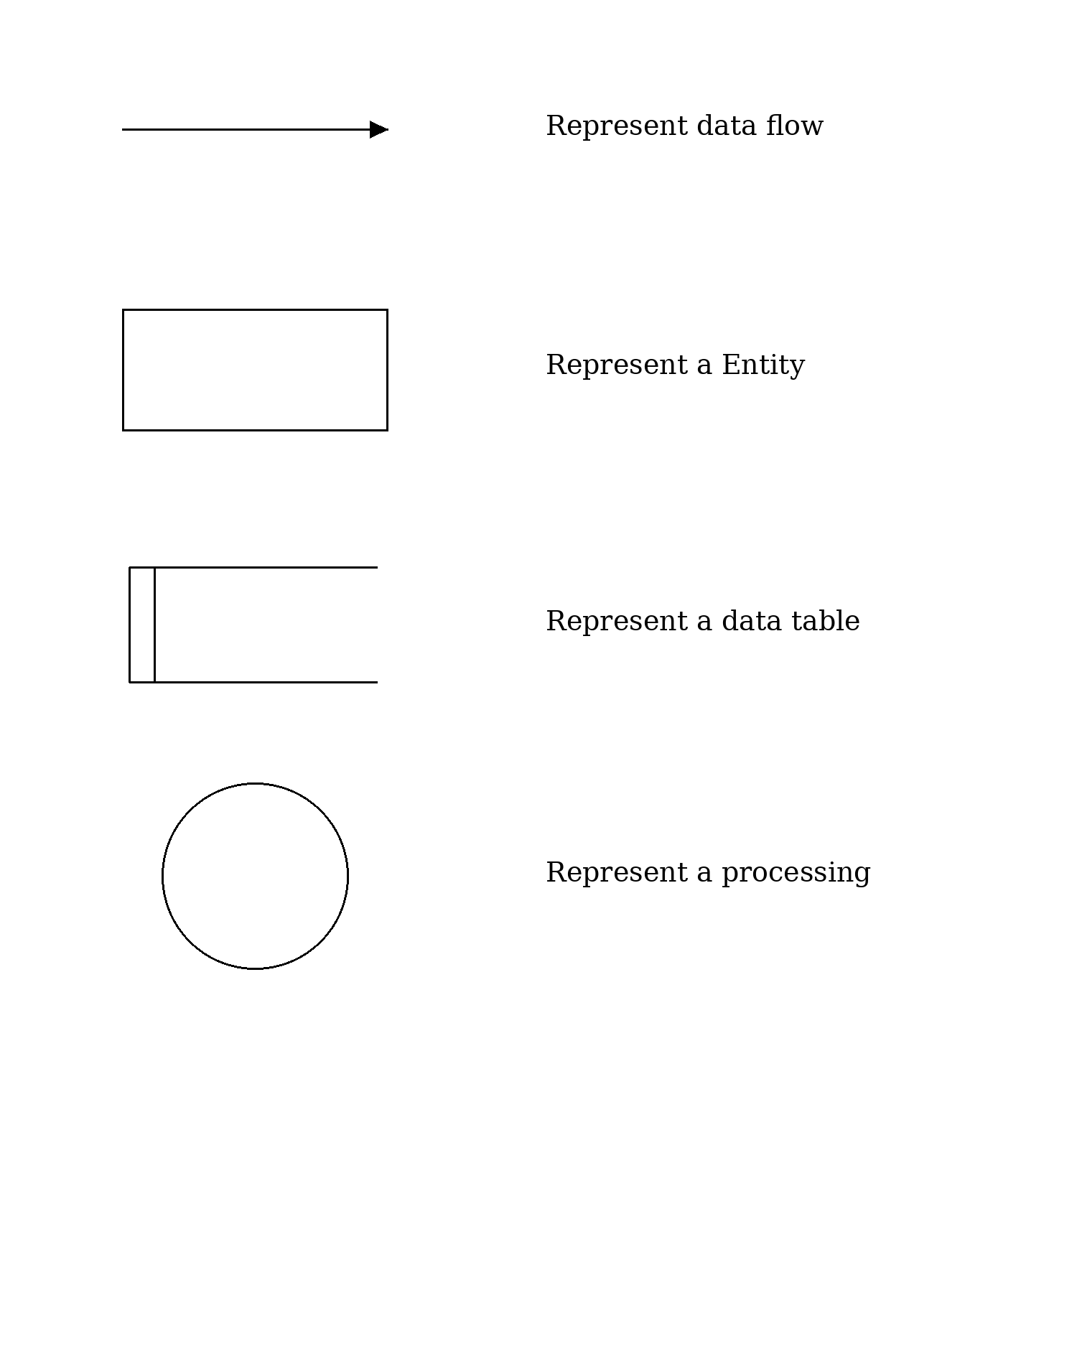
Develop By Ashvin Makvana 23

Context Level Diagram
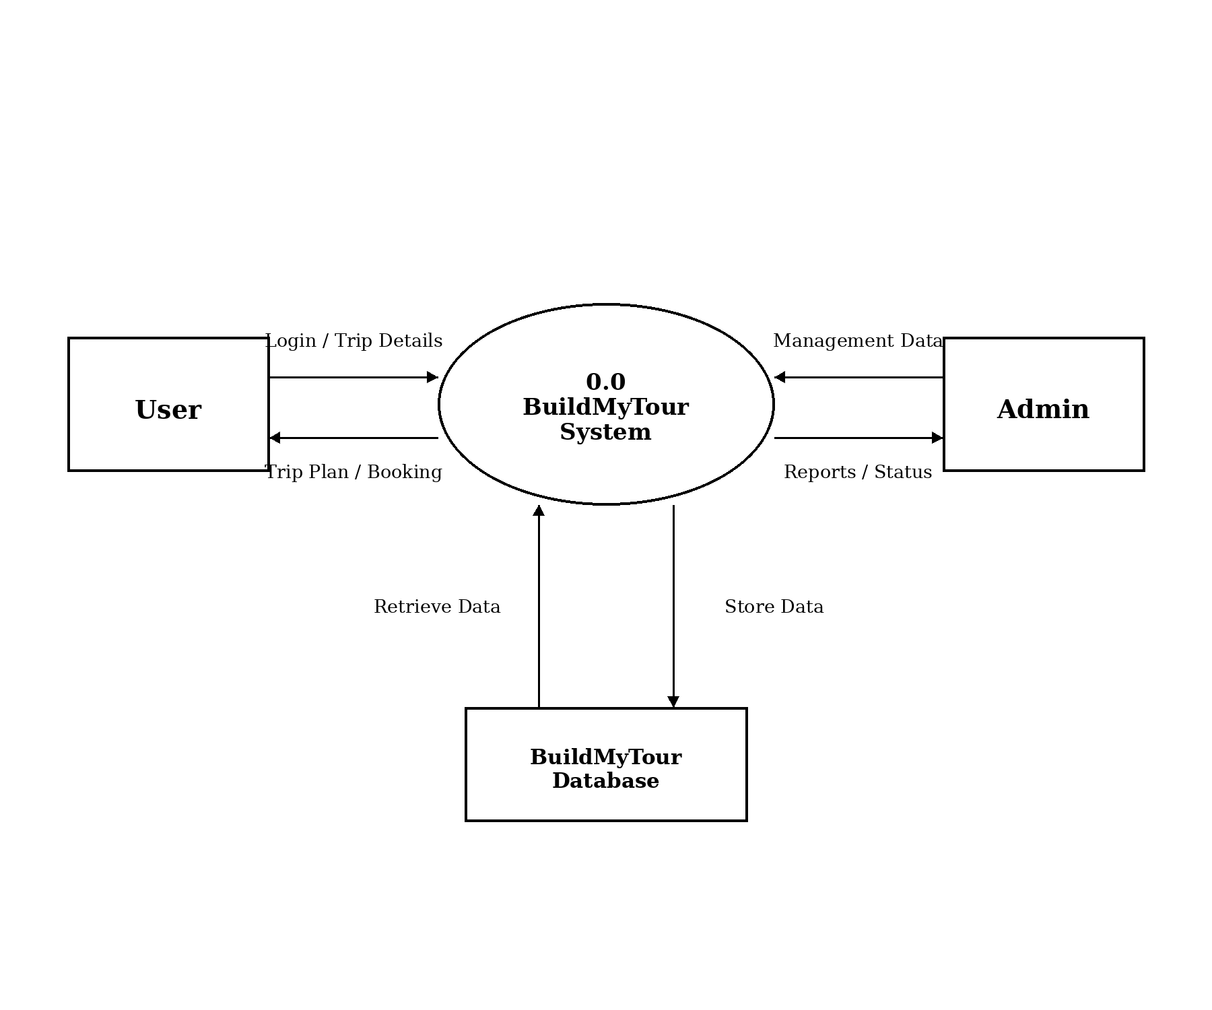
24 Develop By Ashvin Makvana

1st Level Diagram
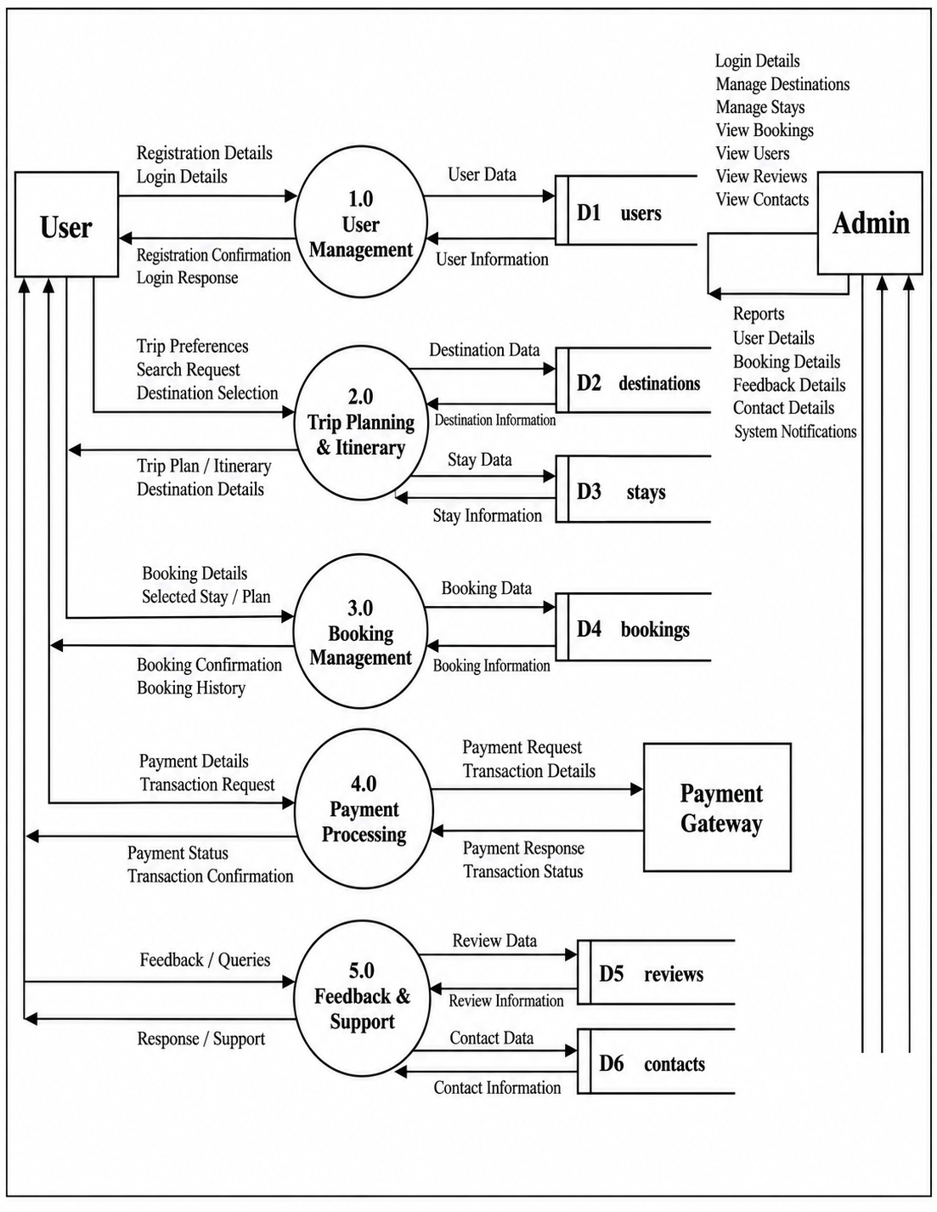
25 Develop By Ashvin Makvana

ER Diagram
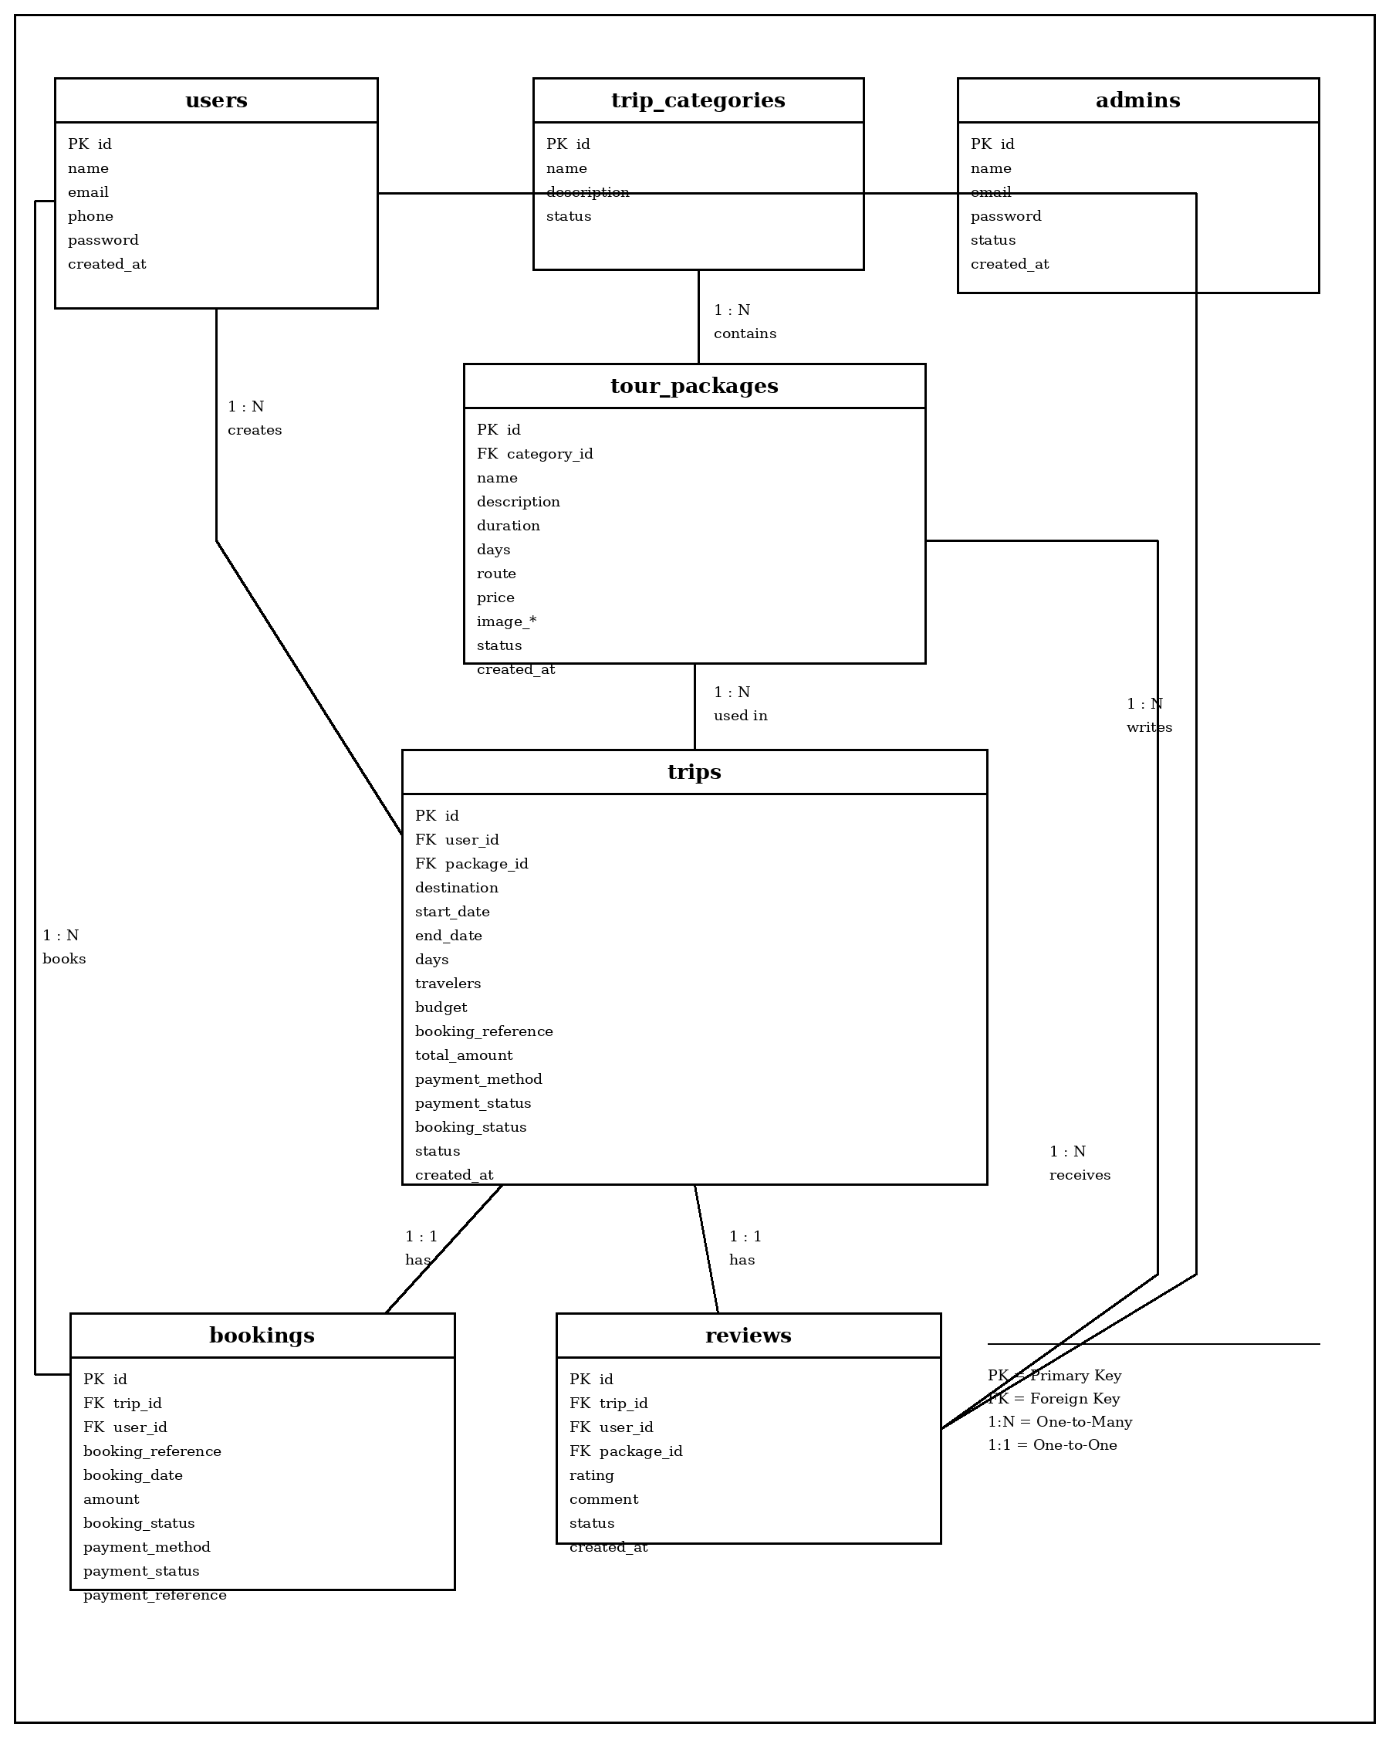
26 Develop By Ashvin Makvana

Use Case Diagram
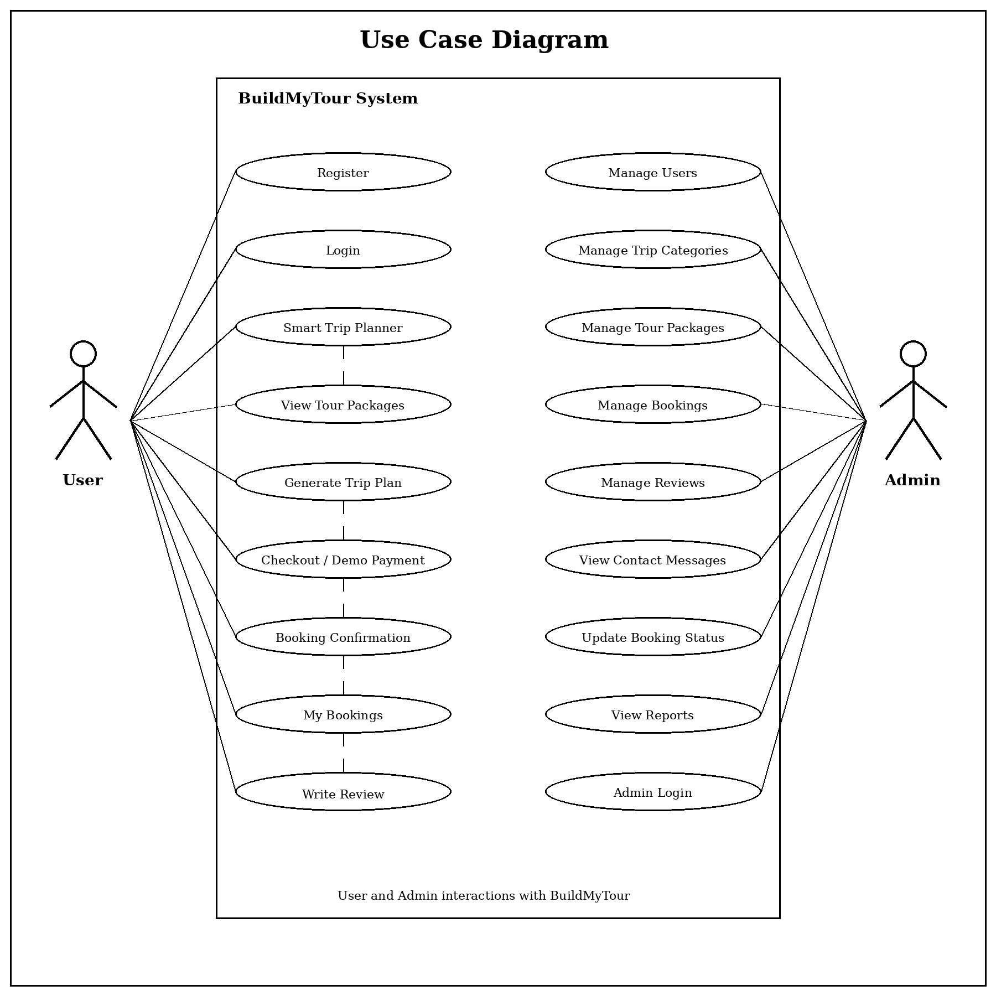
27 Develop By Ashvin Makvana

Activity Diagram
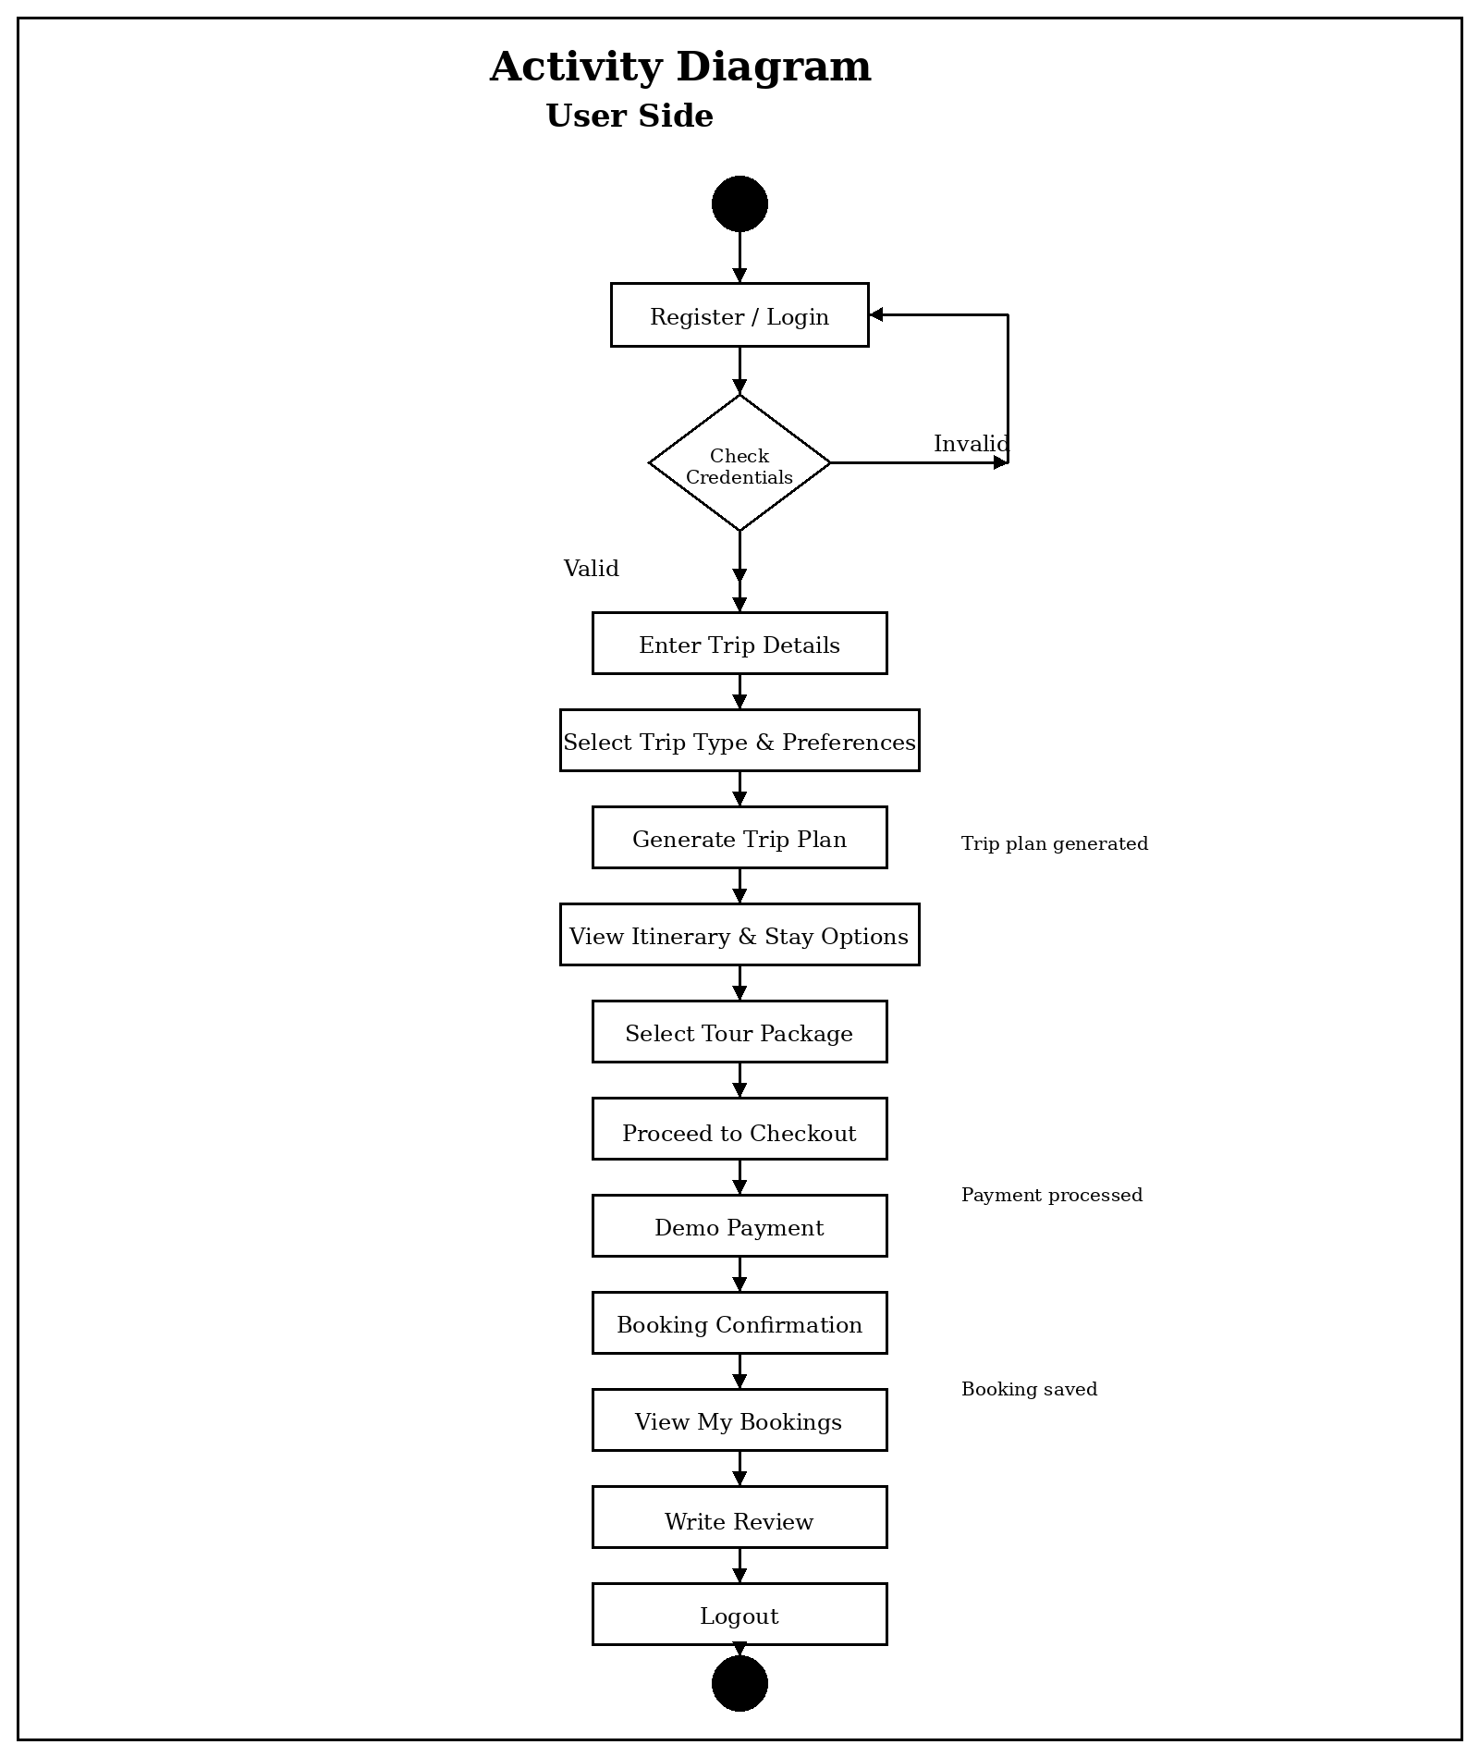
28 Develop By Ashvin Makvana

Activity Diagram
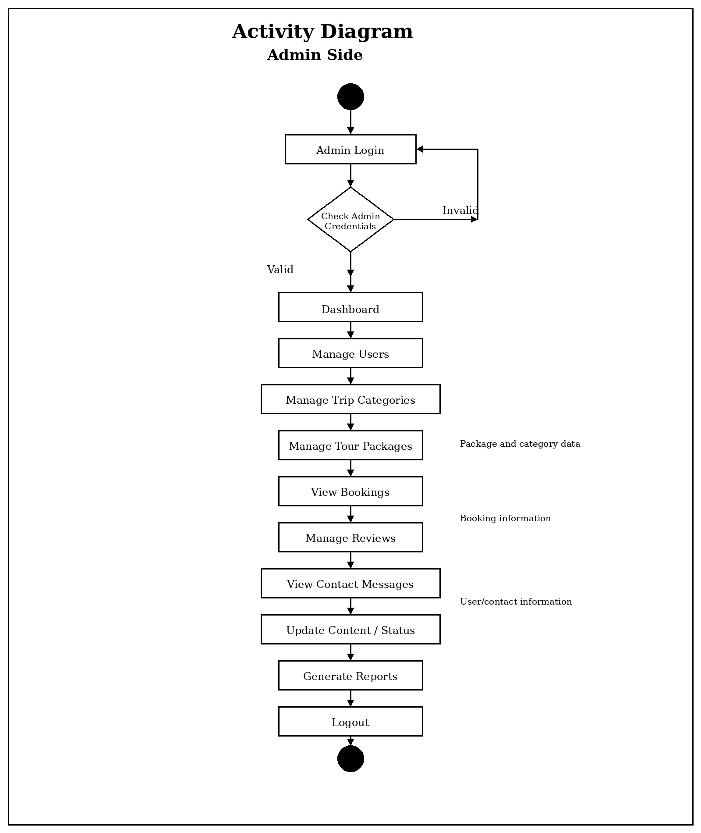
29 Develop By Ashvin Makvana

Activity Diagram
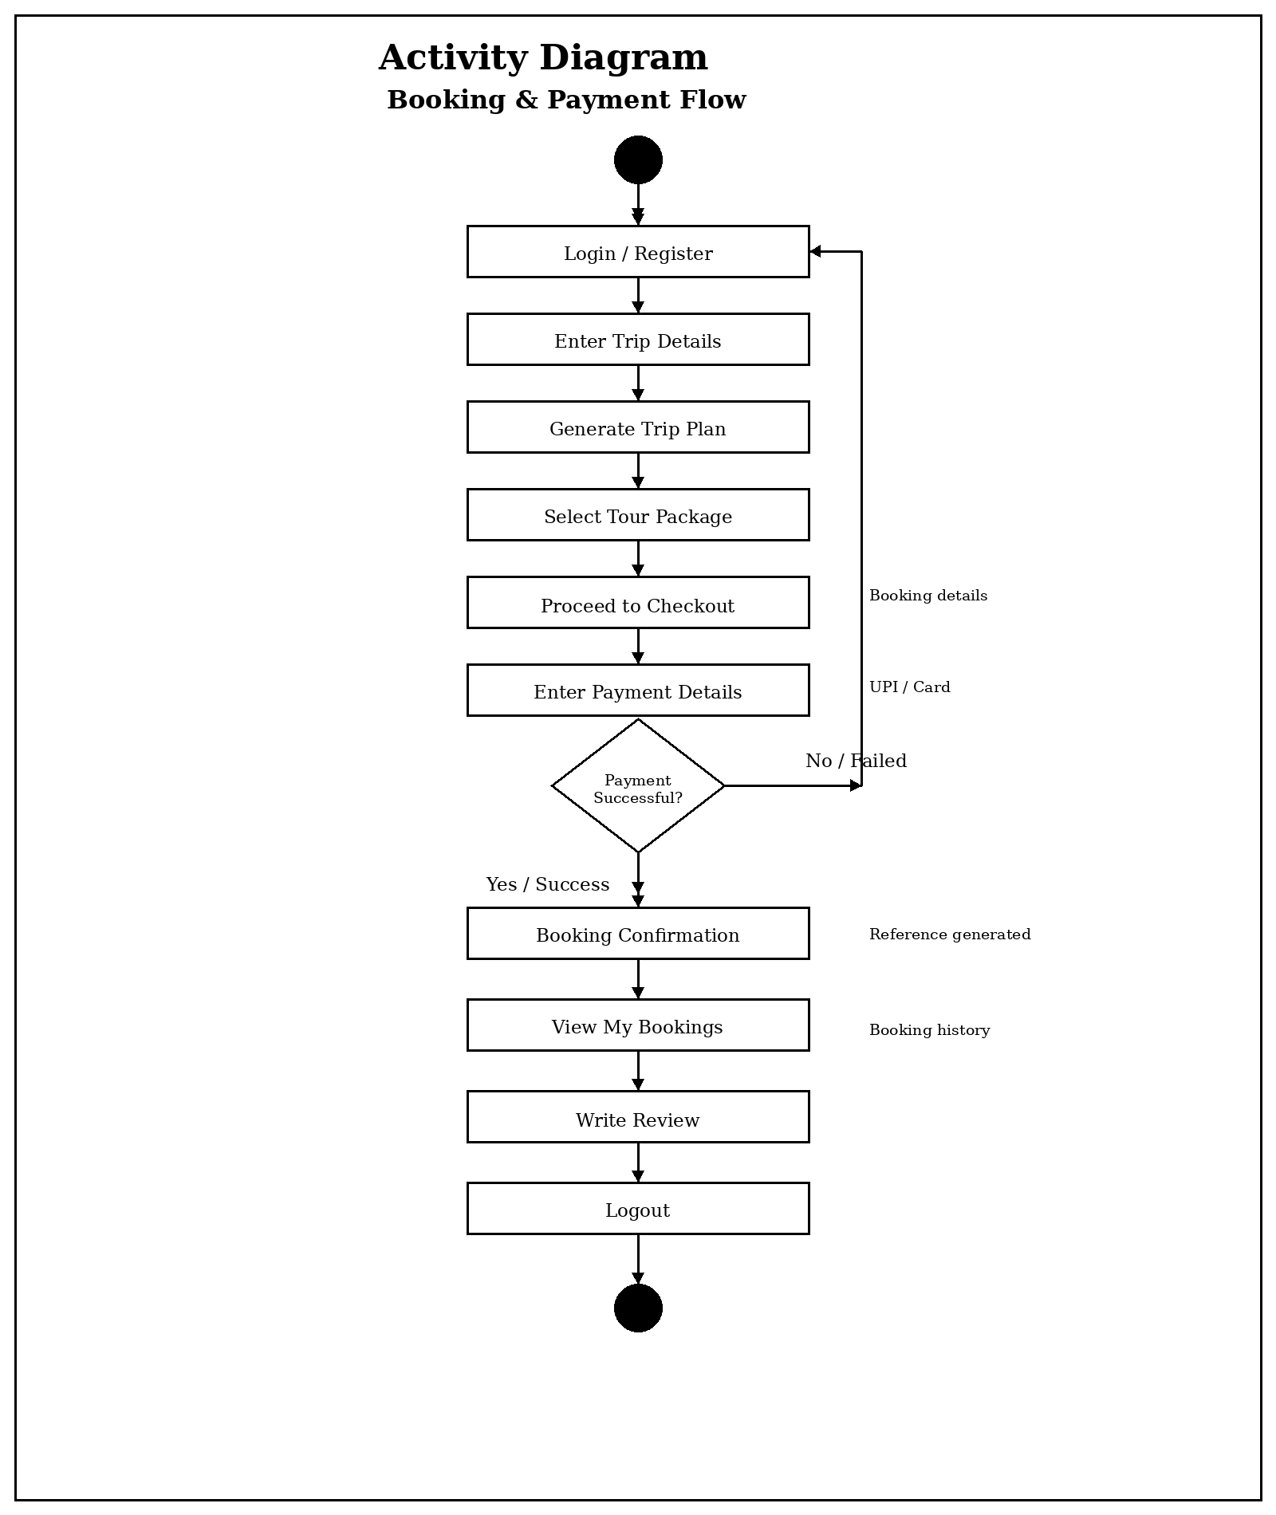
30 Develop By Ashvin Makvana

Screen Shots
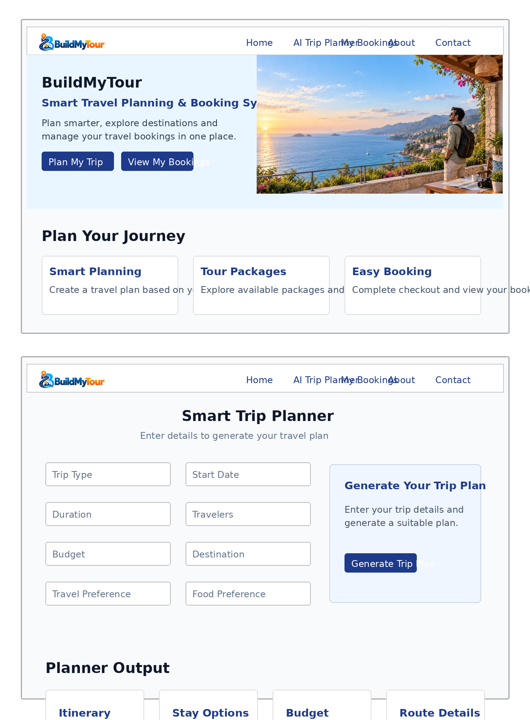
31 Develop By Ashvin Makvana

