

AProjectReportOn

“SMART TRAVEL PLANNING AND BOOKING SYSTEM”
✪BuildMyTour✪
KamaniScience&PrtapraiArtsCollege,Amreli

DevelopedBy
GohilJay(EnrollmentNo-24CS002UG02938)
GuidedBy
Mr.Nilesh Parghi YearOf Submission
Submittedinpartial fulfillmentof therequirement for
theawardofthedegreeofBachelorofComputerApplication
(BCA)

2026-2027


SaurashtraUniversity-Rajkot

2
DevelopByJayGohil


3 DevelopByJayGohil
Index

No | Title | PageNo
1 | Preface | 5
2 | Acknowledgement | 6
3 | Abstract | 7
4 | Introduction | 8
5 | TimeLineChart | 9
6 | ProjectProfile | 10
7 | HardwareRequirement | 11
8 | SoftwareRequirement | 11
9 | RequirementSpecification | 12
10 | ProblemDefinition | 13
11 | ProjectPlanning&Scheduling | 14
12 | SystemAnalysis | 16
13 | FeasibilityStudy | 17
14 | ProjectPageStructure | 19
15 | DataDictionary | 22
16 | DataFlowDiagram | 27
17 | Context&FirstLevelDiagram | 28-29
18 | ERDiagram | 30
19 | UsecaseDiagram | 31
20 | ActivityDiagram | 32-34
21 | Screenshot(PageUI) | 35
22 | FutureScope&References | 65

Preface

Themainobjectiveofanycomputersciencestudentistogetpracticalknowledgeaspossible.Beingabletohaveapracticalknowledge by developing a project is a lifetime experience. As practicalknowledge is important as theoretical knowledge we are thankful ofhavingaproject.

Through the development of the project we had a great experienceof various strategies that can be applied in development of the project.Thisprojectis thesteppingstoneforourcareer.

We are pleased to present this project report. Proper case has beentaken while organizing the report so that it is easy to comprehend. Also,varioussoftwareengineeringconceptshavebeenimplemented.

Acknowledgment

We are student of BCA sem-5 Studying in the Kamani Science CollegeAmreli. We Thankstotheentirepersonwhohasgiven their Supportinshapingofthesystem.

WethankMr.RakeshSirSavaliyaandRaviSirJoshiforgivingusguidance and co-operation in understanding the system. We also thanks them fortheirunconditionalhelpinmakingofthisproject.

Wehavegreatdealofgratitudetowardsourheadofdepartmentwhoencourages in taking up this activity. We thank all faculties and administrativestaffsoftheinstitute.

I am also thankful to all those friends who have helped me in this endeavoreitherofindirectly&especiallymyfamily.

Thankstoall!!

Ashvin Makvana

Abstract

The online Freelance Marketplace is a Web Portal on which freelancers andEmployers interact with each other in this platform, an employer usually post aproject and many freelancers bid on that project, the most efficient bid. In thiswaytheemployergets hisjobdoneandthefreelancers earnmoney.

This project aims to develop a freelance marketplace where not only anemployer could post a project for bidding but freelancers could also offers his/herservicesforbuyers.

Freelancers and client both can be benefited from this bidding. Client whowish to hire internationally can take advantage of favorable overseas exchangerates,resultinginworkbeingdonefor50-90%lessthaniftheprojectwheredone in country and also given access to a huge pool of potential work and havetheabilitytoworkindependentlyfromtheirhomesratherthanforacompany.

Introduction

Clientsoftenneedcustomsoftwaredevelopedtoenhancetheirbusinessorforpersonaluse.Theseclientsposttheirprojectsonthissite,alongwitha
maximumamountthattheyare willingtopay. Theprojectisseenbyfreelancer’savailable world-wide and they place their bids on doing the work. The freelancercan browse through each other bidders resume certifications and previous workhistoryonthesite
Freelancer is a term commonly used for a person who is self-employed andis not necessarily committed as a particular employer. Freelancers can takeseveral projects. It becomes difficult for a freelancer to manage every task andremember it. For this issue we came up with a solution, this freelancermanagement system helps the freelancers to manage their projects, there are twomodules in this system namely Admin and Freelancer section. Admin can loginand add freelancer, manage freelancers, create and assign projects to freelancers,they can also check the progress of the allotted projects along with the report. InFreelancer section, user can login and get new projects assigned, they can viewproject progress, previous completed projects and they can also give theirfeedback on it. This is how the system helps to manage the tasks and to get thetasktoafreelancer.
Whenthefreelancersfindbyclientstheylike,theycanhirethemonthespotto make the transaction a safe, the client does not pay the freelancer directly, butescrows the funds into a special account. This guarantees to the freelancer thatthe client is credit-worthy, and also resources the client because the freelancerreceivesnomoneyuntiltheworkiscomplete. Whentheworkiscompletedthe
freelancers release the funds to the freelancers. When the work is completed,bothpartiesratetheotherpartytohelpfutureclientsandfreelancersonthesite.

TimeLineChart

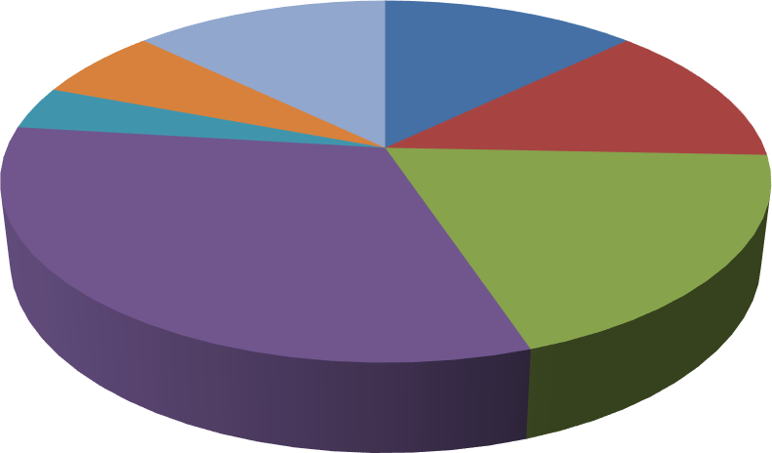
Preliminary Investigation 10Days
System Analysis 10 Days
SystemDesign 15 Days
Coding 25 Days
Testing 3Days
Implementation 5Days
Maintenance 15 Days

ProjectProfile

- ProjectName : FreelancingSystem

- Developedby : GohilJay

- FrontEnd tool : PHP,JavaScript ,Ajax
- BackEndtool : PHPMySQL

- OperatingSystem:Microsoft Windows7&MicrosoftWindows10

- ComputerSystem:Pentium-IVorHigher, RAM:256MB

- ProjectDetails :Providebestplatformforfreelancersand
Employers, employers post the project andfreelancers get this project and both of benefitthisportal

- CompletionTime:3Months

- Guidedby :Mr.RakeshSavaliya &Mr. RaviJoshi

- Submittedby :SaurashtraUniversity,Rajkot

HardwareRequirement

- 512+MBOfRAM
- MultimediaKeyboardAndMouse
- GHzProcessor
- Monitor
- Printer

SoftwareRequirement

  - OperatingSystem: Microsoft windows7&Microsoft windows10
  - FrontEndTools:PHP,JavaScript,CSS,Ajax, SublimeText3
  - BackEndTools : PHPMySQL
  - DocumentationTool:Microsoft word2007
  - BrowserSpecification:GoogleChrome,MozillaFirefox

RequirementSpecification

In thissectionprovidesrequirementsoverviewofthesystem.

Registration:

  - Employer :

If employerwantstopostprojectthen mustberegistered,unregisteredemployercan’tpostaproject.

Freelancer :

Iffreelancerwant togettheproject thenmustberegistered,unregisteredfreelancercan’tgetaproject.

Login:

Customerlogintothesystembyenteringvaliduseridandpasswordfortheuseimportantfunctionalityofsystem.

PostProject:

Employercaneasilypostprojectinthissystem.

Get Project:

Freelancercan easilygetprojectusingthissystem.

SendProjectToEmployer:

Aftercompletedtheprojectfreelancergetfullpayment.

GenerationReport:

Aftercompletingallactivitiesemployerandfreelancergetfullreportofproject.

ProjectProblemDefinition

- MaintainUserProfile

- MaintainProjectFilter

- MaintainPayment

- MaintainRatingOfFreelancer

- MaintainAllocatedWork

ProjectPlanning&Scheduling

Project planning is an aspect of Project Management, which comprises ofvarious processes. The aim of these processes is to ensure that various Projecttasks are well coordinated and they meet the various project objectives includingtimelycompletionoftheproject.ProjectPlanningisanaspectofProjectManagement thatfocuses a lotonProjectIntegration. The project plan reflectsthe current status of all project activities and is used to monitor and control theproject.

The Project Planning tasks ensure that various elements of the Project arecoordinated and therefore guide the project execution. Project Scheduling is oneof the mostimportant taskof ProjectPlanning andalso the most difficult tasks.In very large projects it is possible that several teams work on developing theproject.Theymayworkonitinparallel.Howevertheirworkmaybeinterdependent.

- ProjectPlanning&Schedulingasunder:

SystemAnalysis

System analysis is the process of identification of objectivesandrequirements,evaluationofalternativesolutionsandrecommendation for a more feasible solution. In other words, systemanalysisisthestepbystepprocessofgathering,recordingandinterpreting facts. The main aim of analysis is to determine problemareasandtotakesolutions toreduceoreliminatethem.

  - Systemanalysisitselfbreaksintotwostages:

Preliminary analysis:

- Detailedanalysis:

Duringanalysis,dataarecollectedfromtheavailablefiles,decision points and transactions of the systems using various tools likeDataFlowDiagram (DFD).

FeasibilityStudy

A purpose of feasibility study is to check out the possibility of acomputerized solution to the organization’s observed problem before verymuchmoneythathasbeenspenton.

A feasibility study is carried out to select the best system that meetsperformancerequirements.Only by spending the time to evaluate thefeasibility doI reduce the chances for extreme embarrassment at laterstageofthesystem project.

ForthecompletefeasibilitystudyIneedtoconcentrateonfollowing
area:

- TheyarethreetypesoffeasibilityStudy:

- Technical
- Operational
- Economical

Technical:

Technical feasibility considers whether the desired project canbe completed within the framework of available technology. As ourproject was website designing, this was not much of a problem, asmanyadvancedweb-editingtools areavailable.

Operational:

Operational feasibility was done to assure that the product thatwould be developed would be used. Since a cards and gifts have tohave a website of its own sooner or later, that wasn’t much of aproblem.

Economical:

Our Commercial Website is Economically Feasible Because.Wehavedevelopedthiswebsiteonly foronetime.Only futureenhancement is required on the other hand every client can view oursite any time or many time as per their requirement. So the futureeconomical expenses are null. So we can say that this website istotallyeconomicallyfeasible.

ProjectPageStructure

    - EmployerSide:

    - FreelancerSide:

    - AdminSide:

DataDictionary

ThedataDictionaryisasetoftable.MySQLusesittomaintaininformationaboutthis owndatabase.

Datadictionarycontainsthefollowinginformation:

      - Nameofthetableofdatabase.
      - Userinformationsuchasprivileges.
      - Nameanddata-typeofallcolumnsindatabasetable.

- DatabaseName :codex

admin_login:

Thistableisusedtostoreadmininformation.

Field | DateType | Size | Attribute
admin_id | Int | 10 | PrimaryKey
admin_name | Varchar | 50 | -
admin_username | Varchar | 50 | -
admin_email | Varchar | 100 | -
admin_pass | Varchar | 100 | -

users:
Thistableisusedtostoreuserregistrationinformation.

Field | DataType | Size | Attribute
user_id | Int | 11 | PrimaryKey
username | Varchar | 50 | -
email | Varchar | 100 | -
role | Varchar | 30 | -
pass | Varchar | 100 | -
status | Int | 11 | -

postwork:

Thistableisusedtostorepost workallinformation.

Field | DataType | Size | Attribute
pw_id | Int | 10 | PrimaryKey
employer_id | Int | 11 | ForeignKey
pw_title | Varchar | 50 | -
pw_details | Varchar | 500 | -
pw_doc | Varchar | 100 | -

Application :
This table is used to store all information about workapplication.

Field | DataType | Size | Attribute
ap_id | Int | 10 | PrimaryKey
pw_id | Int | 10 | ForeignKey
freelancer_id | Int | 11 | ForeignKey
work_title | Varchar | 100 | -
ap_name | Varchar | 50 | -
ap_gender | Varchar | 20 | -
ap_dob | Date | - | -
ap_expectsal | Double | - | -
skill | Varchar | 500 | -
status | Int | 10 | -
time | Timestamp | - | -

sendwork:
Thistableisusedtostoresendworkdetailstoclient.

Field | DataType | Size | Attribute
sw_id | Int | 11 | PrimaryKey
pw_id | Int | 10 | ForeignKey
employer_id | Int | 11 | ForeignKey
user_id | Int | 11 | ForeignKey
work_title | Varchar | 100 | -
work_details | Varchar | 500 | -
lastdate | Date | - | -
upload_work | Varchar | 200 | -
status | Varchar | 50 | -
time | Timestamp | - | -
PAYID | Varchar | 20 | -
TXNAMOUNT | Double | - | -
TXNDATE | Varchar | 11 | -
TXNSTATUS | Varchar | 30 | -

getwork:
Thistableisusedtostoregetworkinformationfromtheclient.

Field | DataType | Size | Attribute
gw_id | Int | 10 | PrimaryKey
sw_id | Int | 11 | ForeignKey
user_id | Int | 11 | ForeignKey
work_title | Varchar | 100 | -
status | Varchar | 30 | -
upload_work | Varchar | 200 | -
feedback | Varchar | 500 | -
pay_value | Double | - | -
time | Timestamp | - | -
PAYID | Varchar | 50 | -
TXNAMOUNT | Double | - | -
TXNDATE | Varchar | 20 | -
TXNSTATUS | Varchar | 20 | -

contactus :
Thistableisusedtostorecontactusinformation.

Field | DateType | Size | Attribute
c_id | Int | 10 | PrimaryKey
name | Varchar | 50 | -
email | Varchar | 100 | -
subject | Varchar | 200 | -
message | Varchar | 500 | -

bank_details:

Thistableisusedtostore freelancerbankdetails.

Field | DateType | Size | Attribute
b_id | Int | 10 | PrimaryKey
user_id | Int | 11 | -
bank_name | Varchar | 50 | -
acc_no | Varchar | 50 | -
ifsc_code | Varchar | 30 | -
address | Varchar | 60 | -
status | Varchar | 10 | -

rating:

Thistableisusedtostoreratingoffreelancer.

Field | DateType | Size | Attribute
id | Int | 10 | PrimaryKey
user_id | Int | 11 | -
rating | Float | - | -
count | Int | 10 | -

DataFlowDiagram
The DFD gives brief idea on how the designed system is working. It alsosuggests to us the type of users who using this system and the process involved inthesystem.

Representdataflow

RepresentaEntity

Represent adata table

Representaprocessing

ContextLevelDiagram

AccountCreated NewAccountCreated

CreateNewAccount
Freelancers/
employers
MakeLogin

TransferToLoginPage Username&PasswordDoesNotMatch

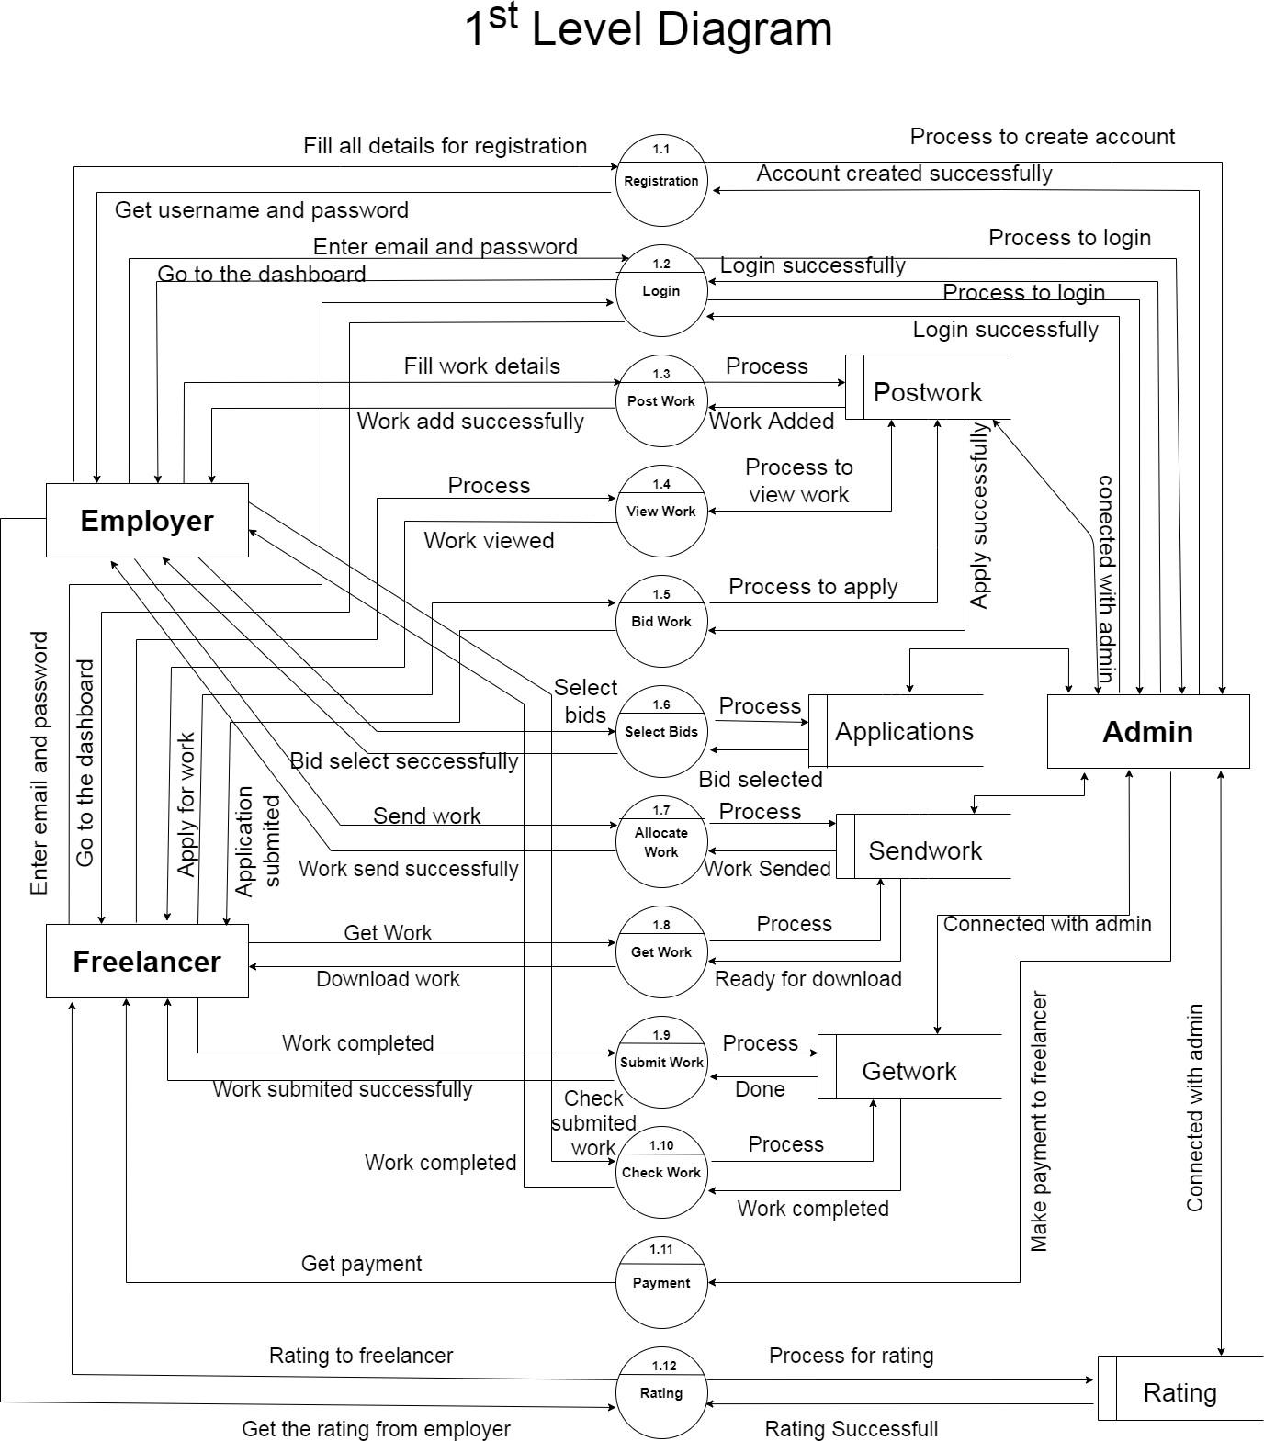

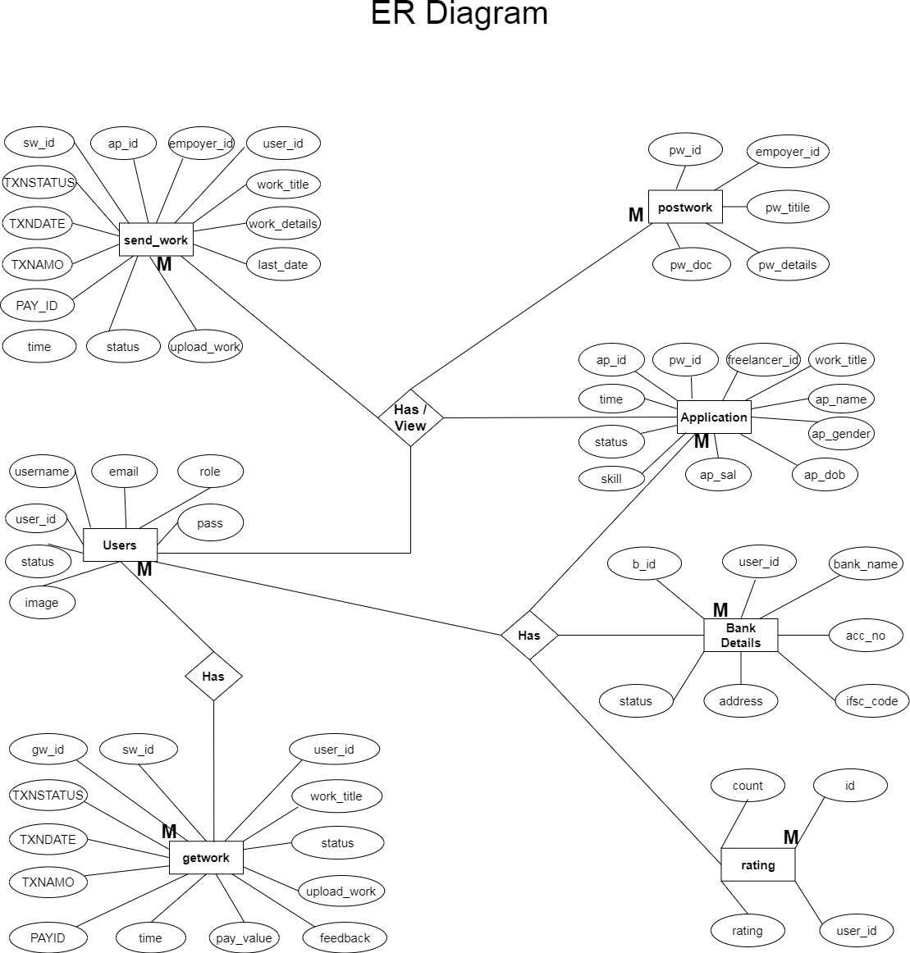

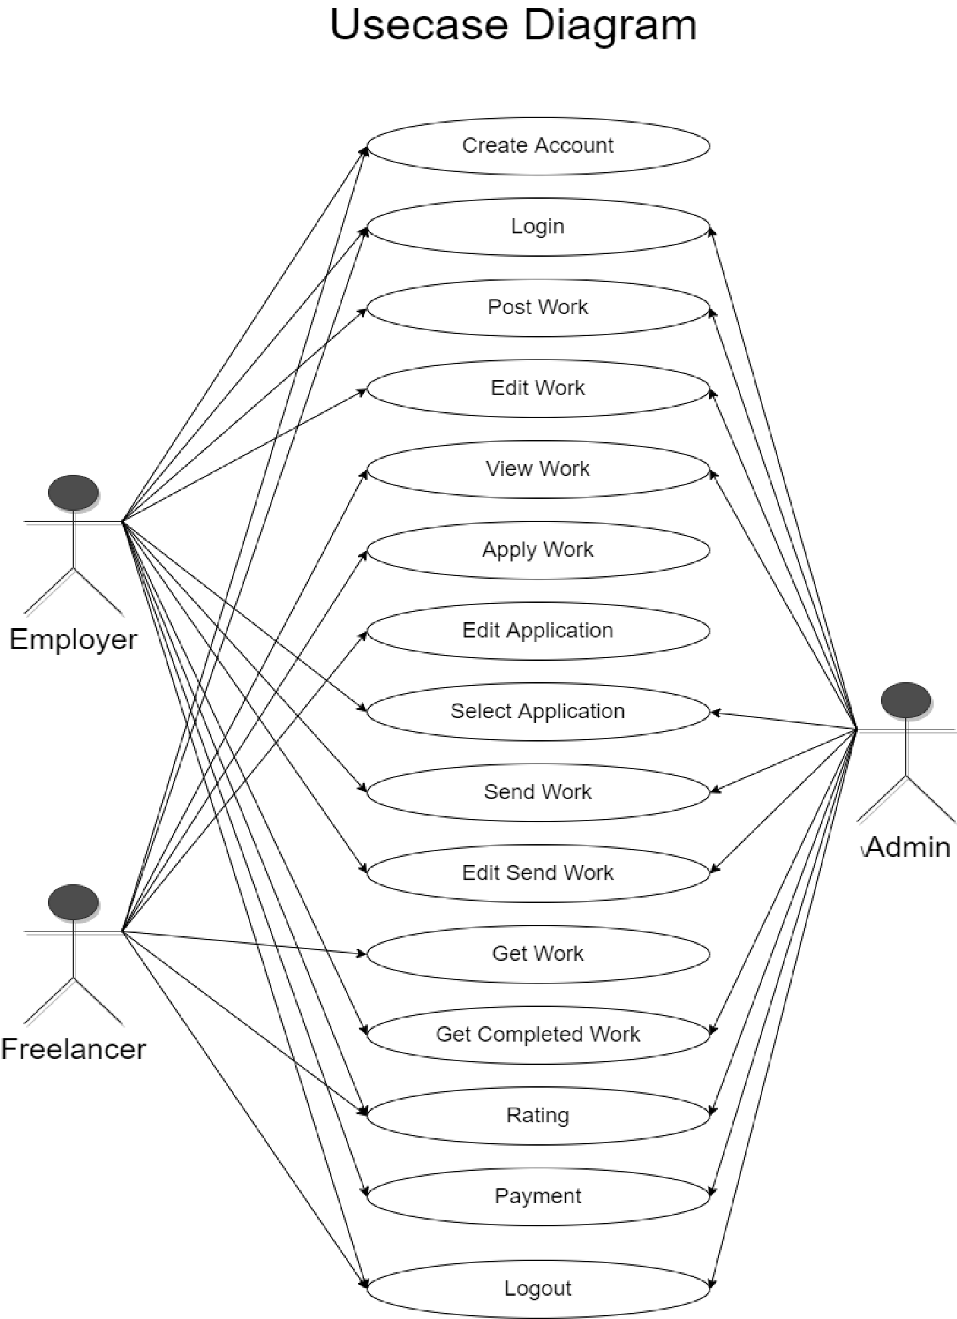
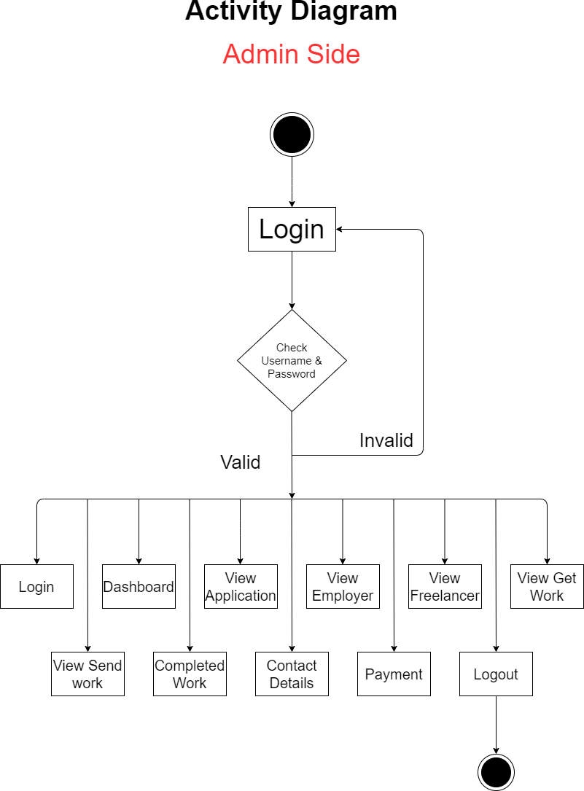

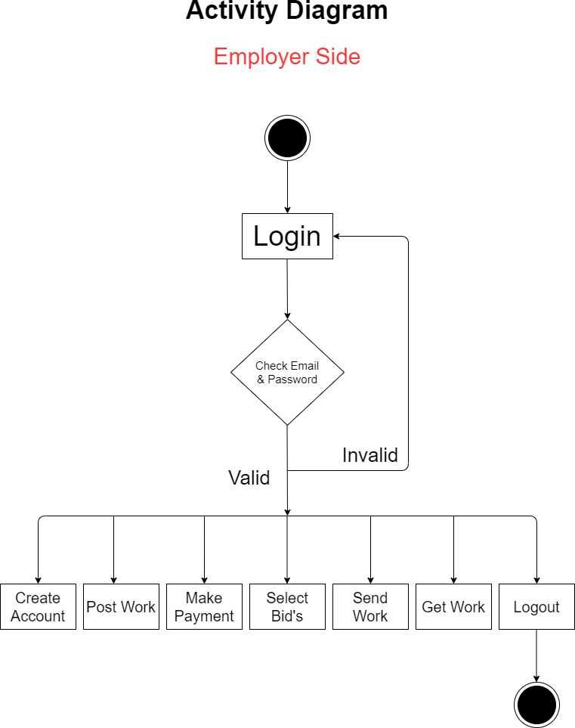

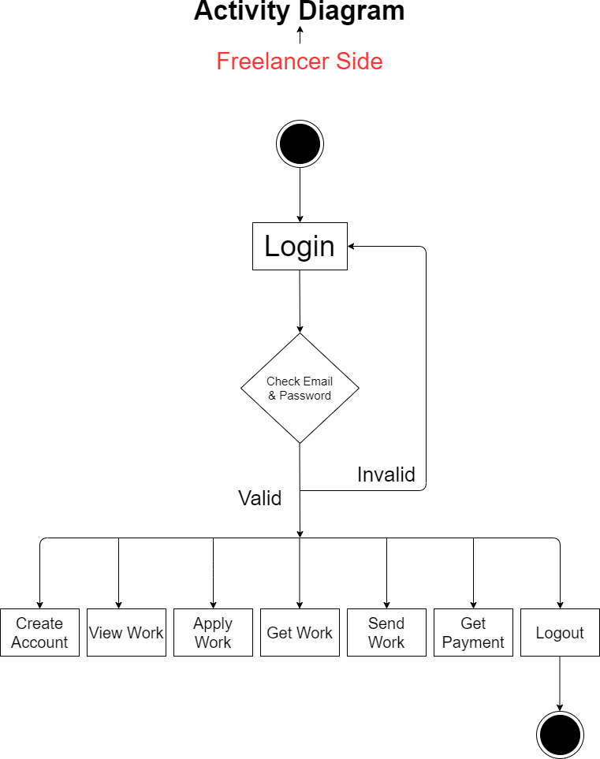

34 DevelopByJayGohil

- MainIndexFile:

ScreenShots

FrontWebsite



- WhatGreat AboutIt? :
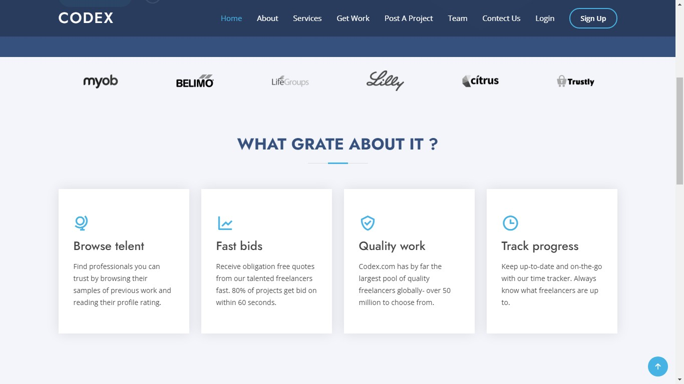

- WhyCodex?:

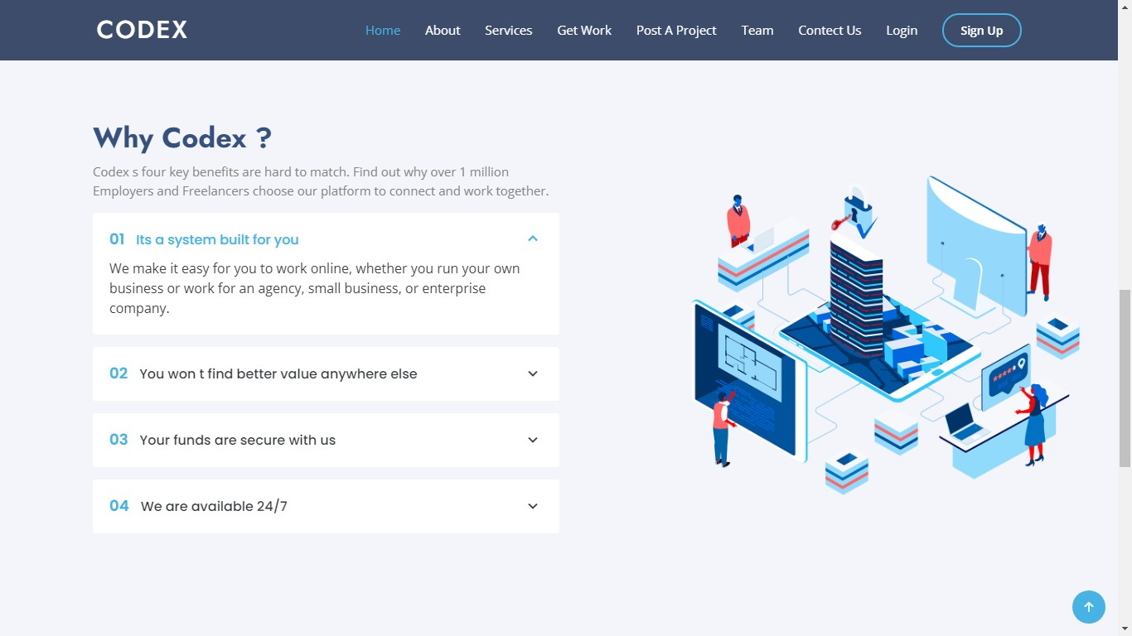

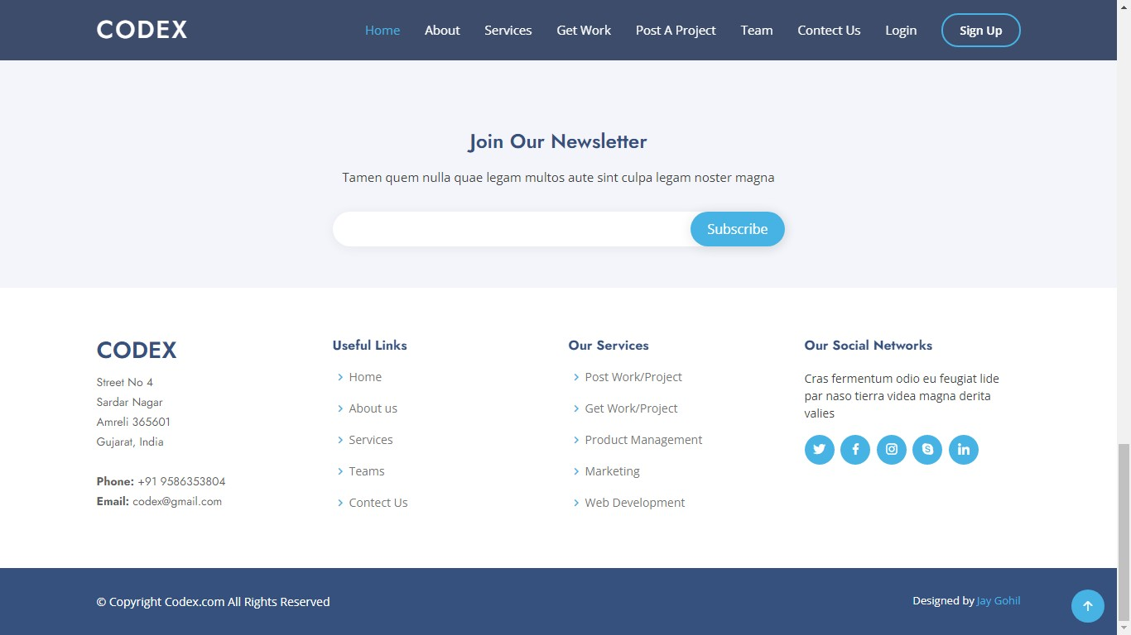
- FooterArea:

36 | DevelopByJayGohil

- AboutUs:


- AboutUsFooter:

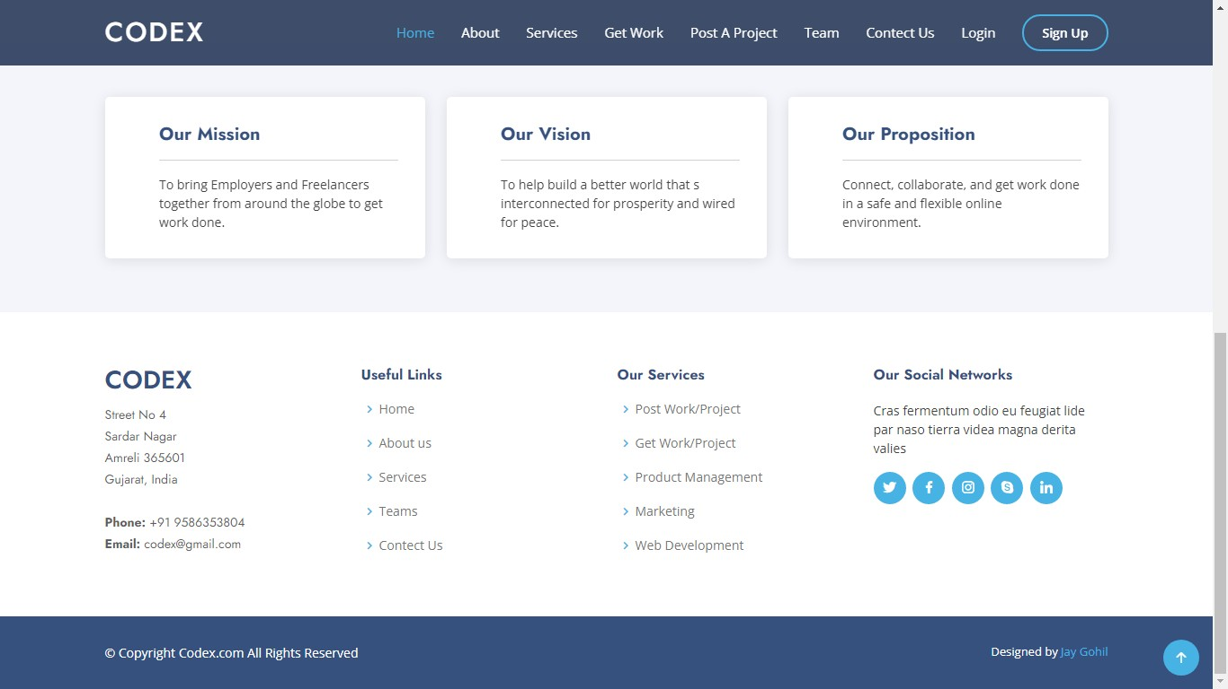

- Services:


- Team:

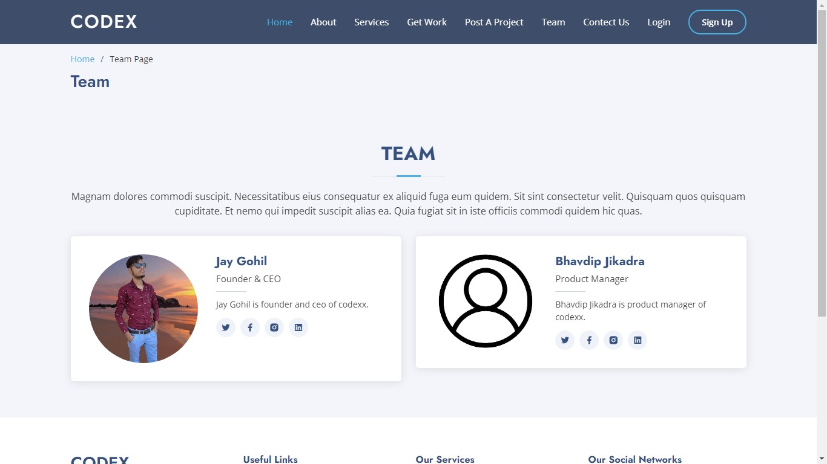
38 | DevelopByJayGohil

- RegistrationAccountType :

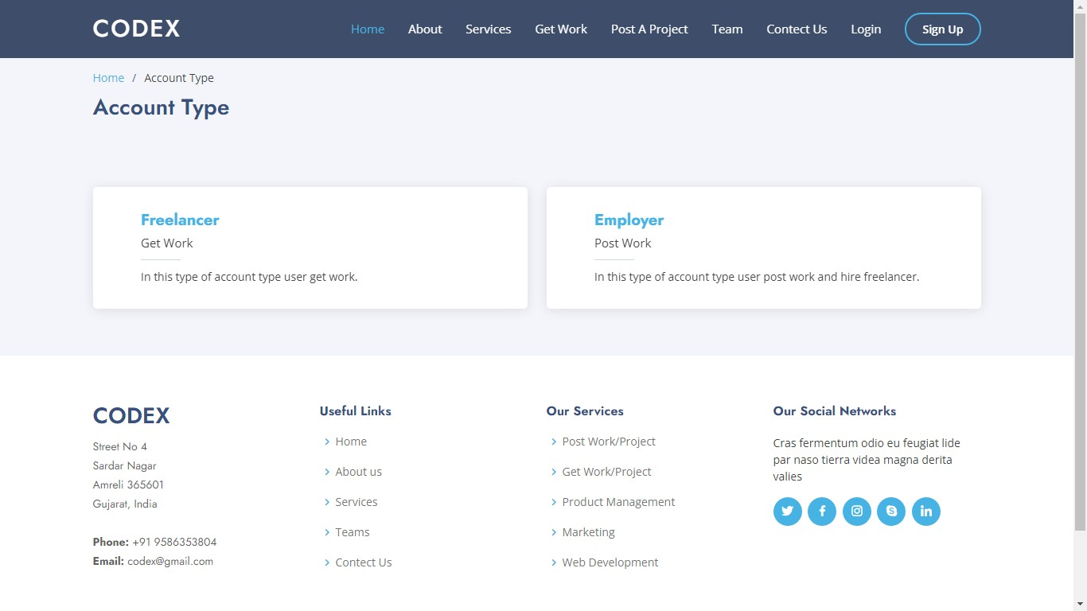

EmployerSide
- EmployerRegistrationForm :
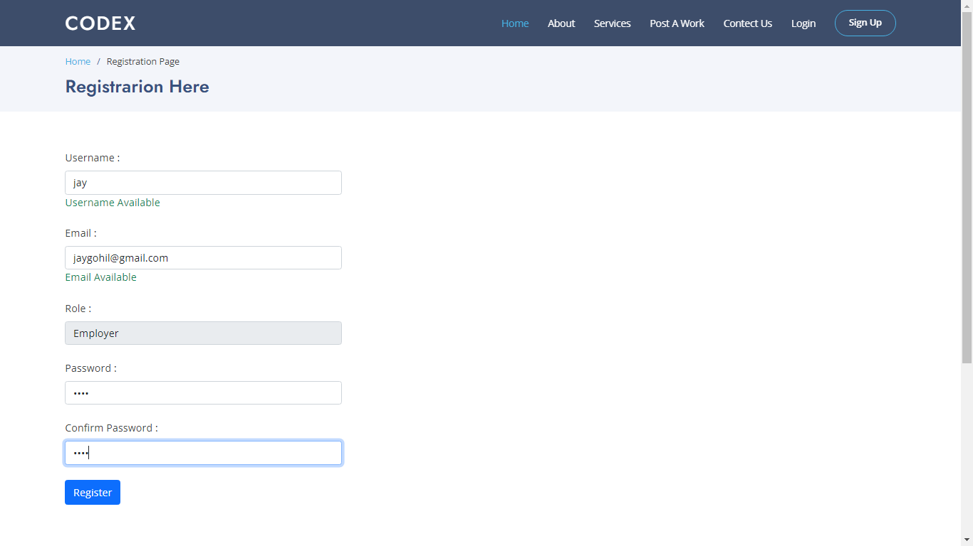

- LoginForm:
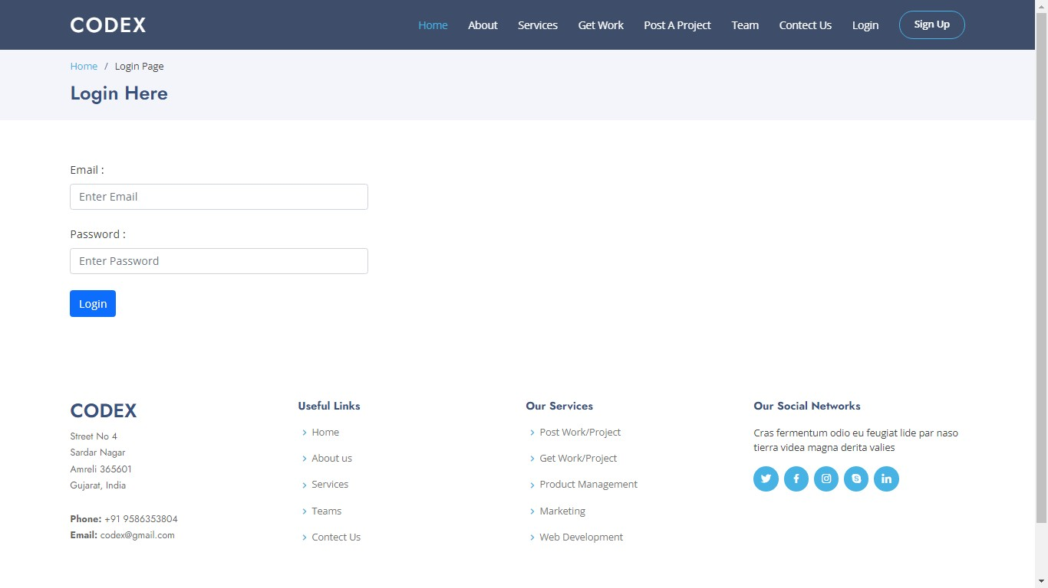

- EmployerIndexPage :


- NeedSomethingDone:

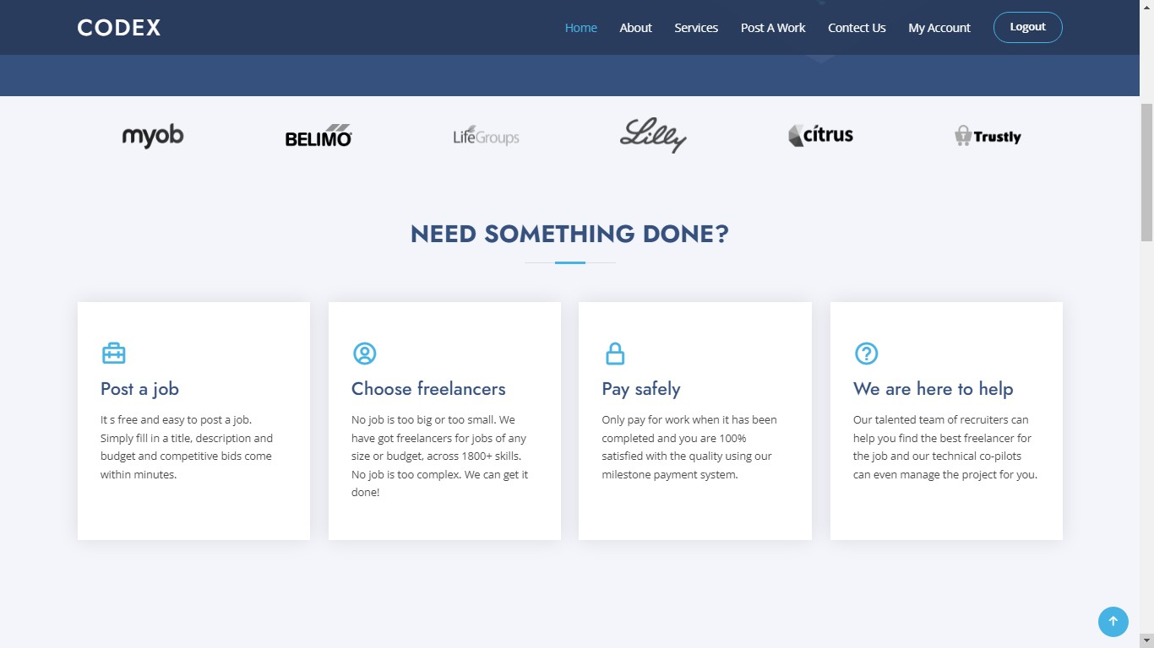

- Hire:
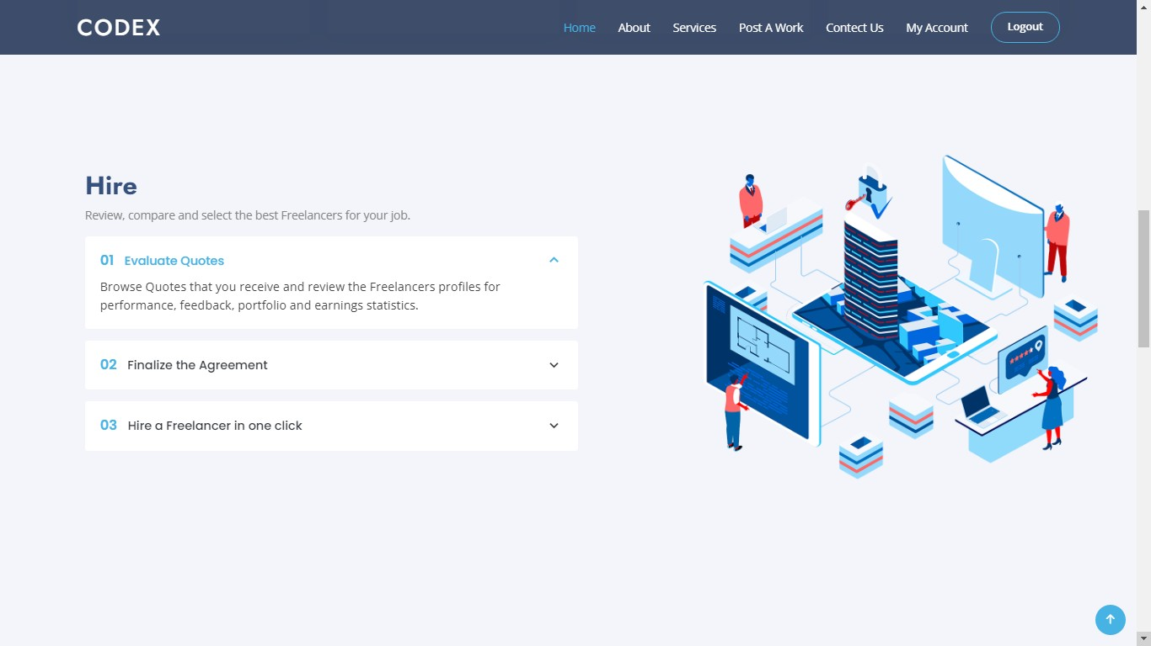

- Manage:

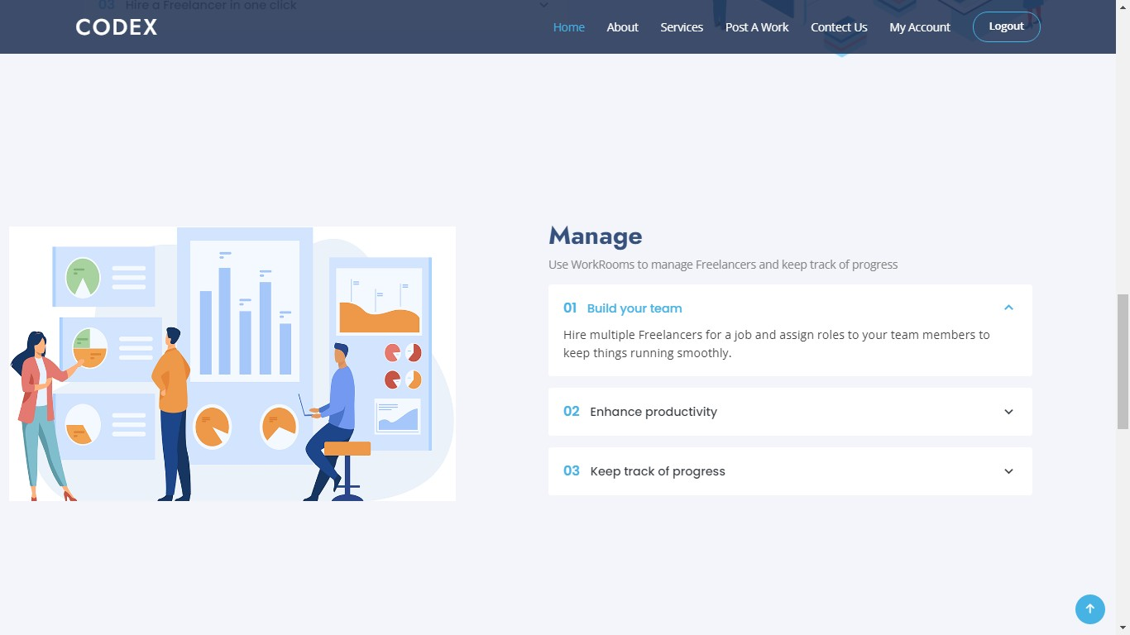

- Pay:

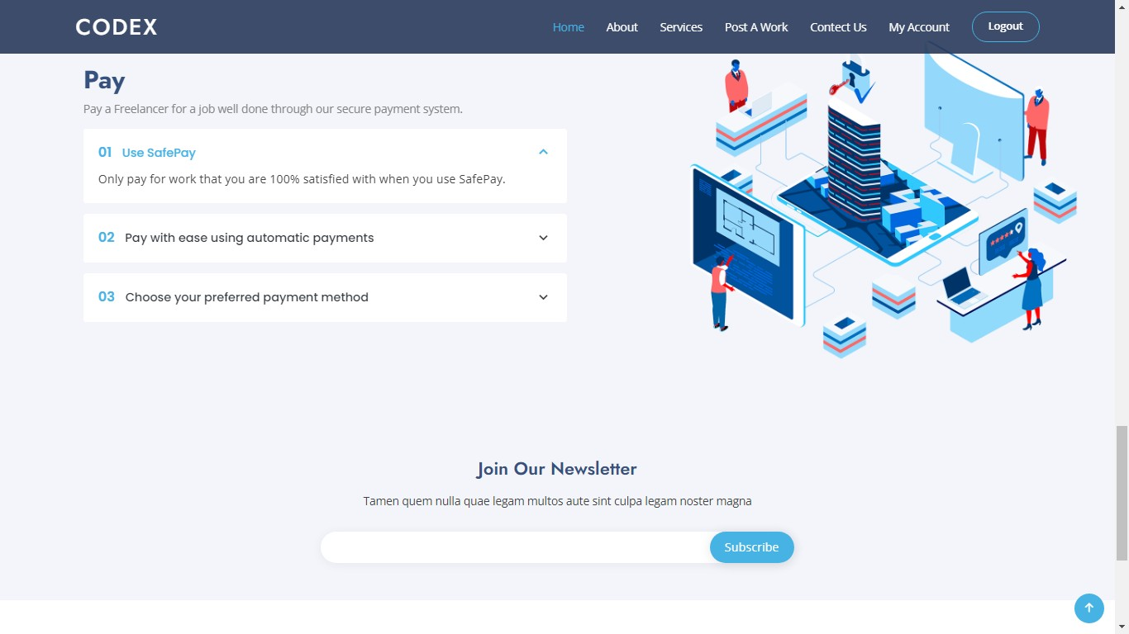

- EmployerAllWork:

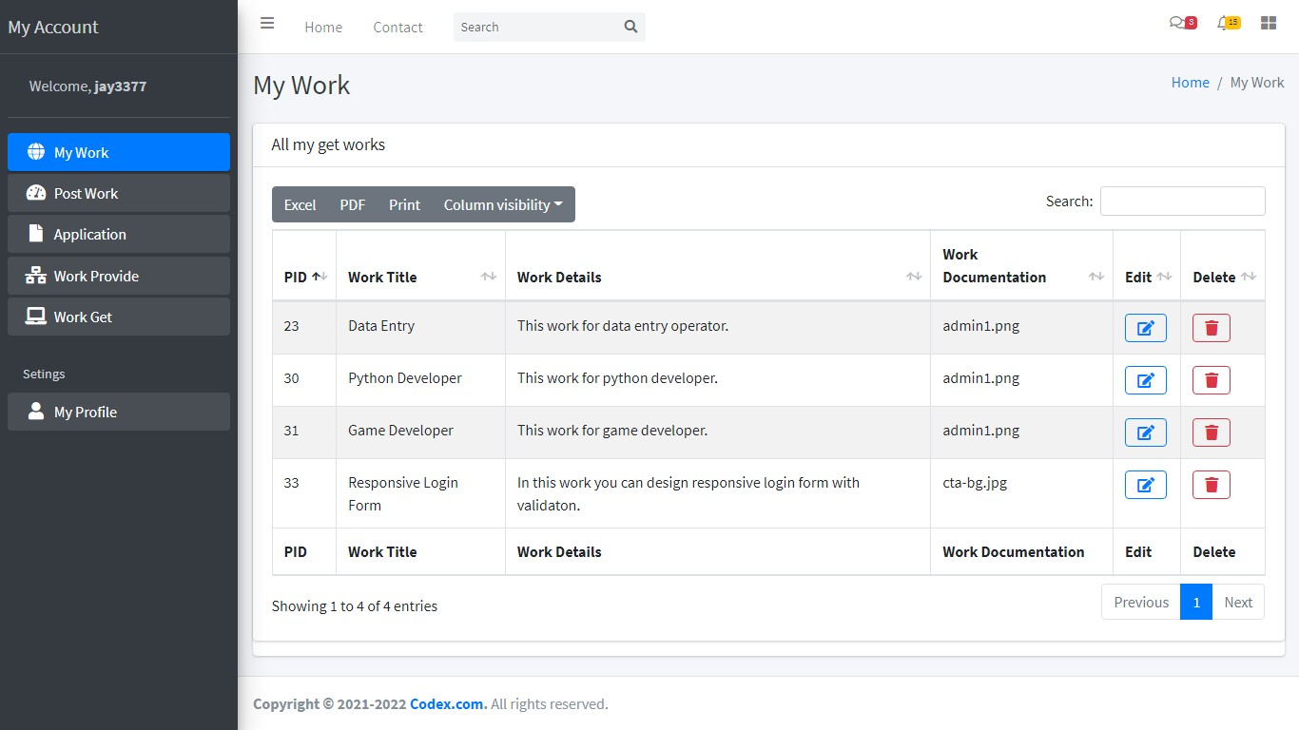
43 | DevelopByJayGohil

- Edit Work :
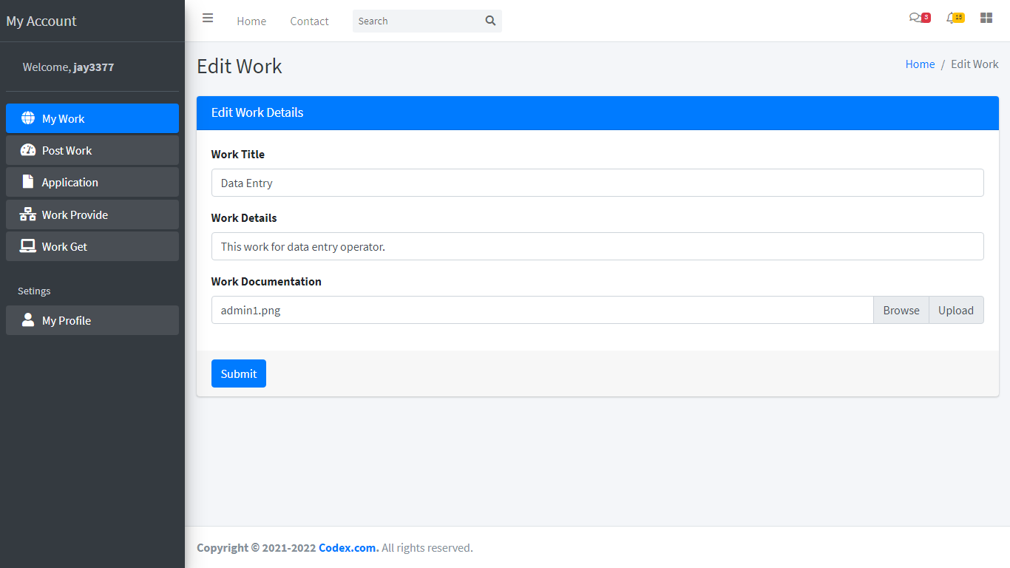

- DeleteWork:

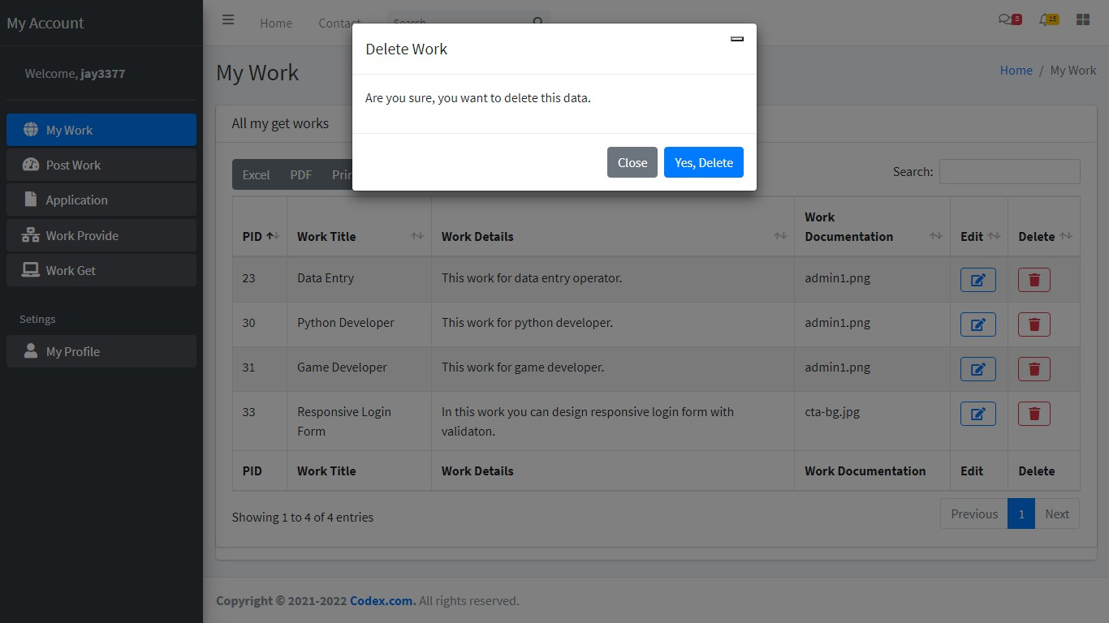

- PostWork :

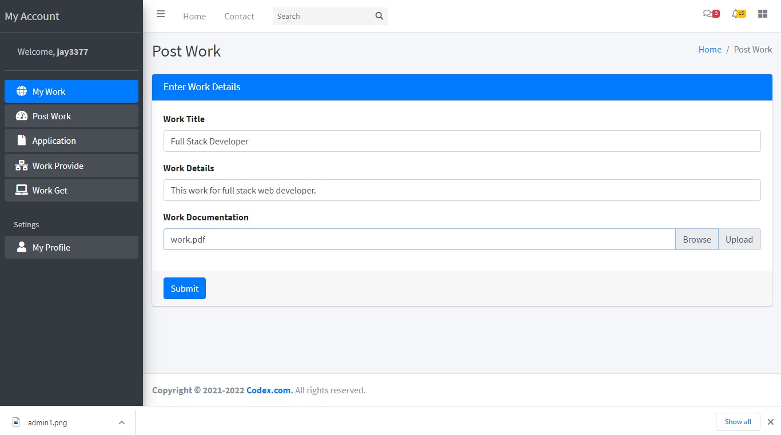
- Applications:

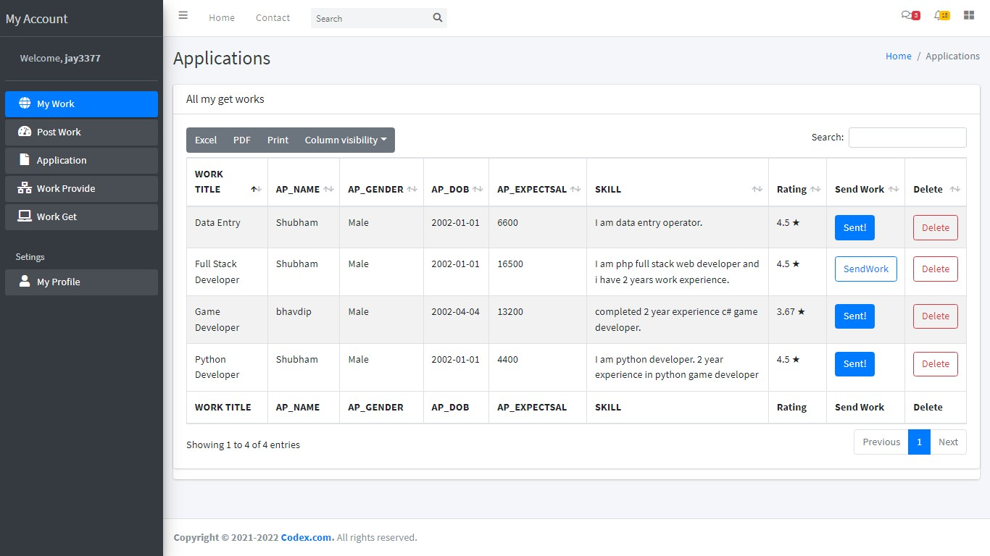

- SendWork:
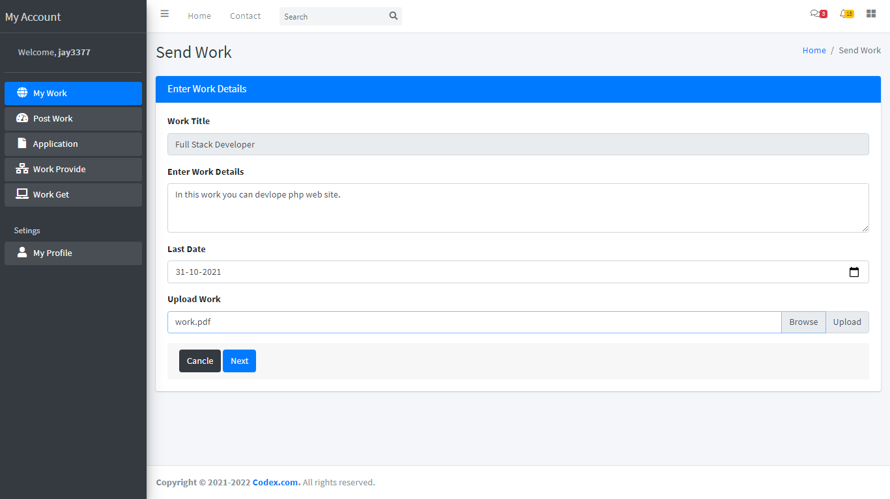

- Payment:

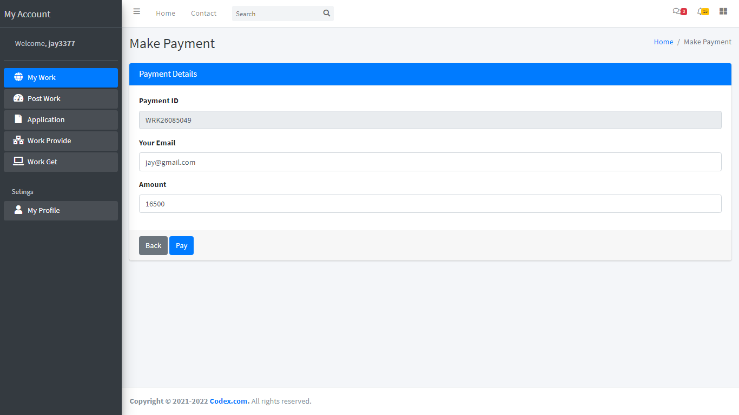

- PaymentProcess:

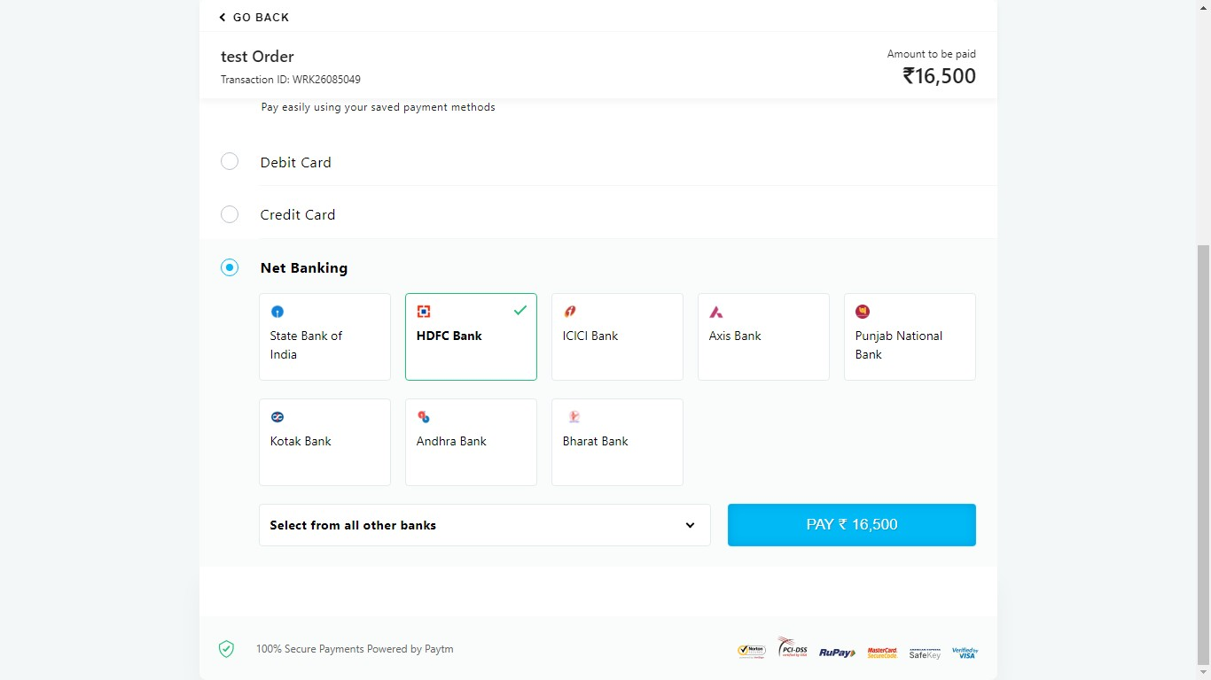

- PaymentSuccess:

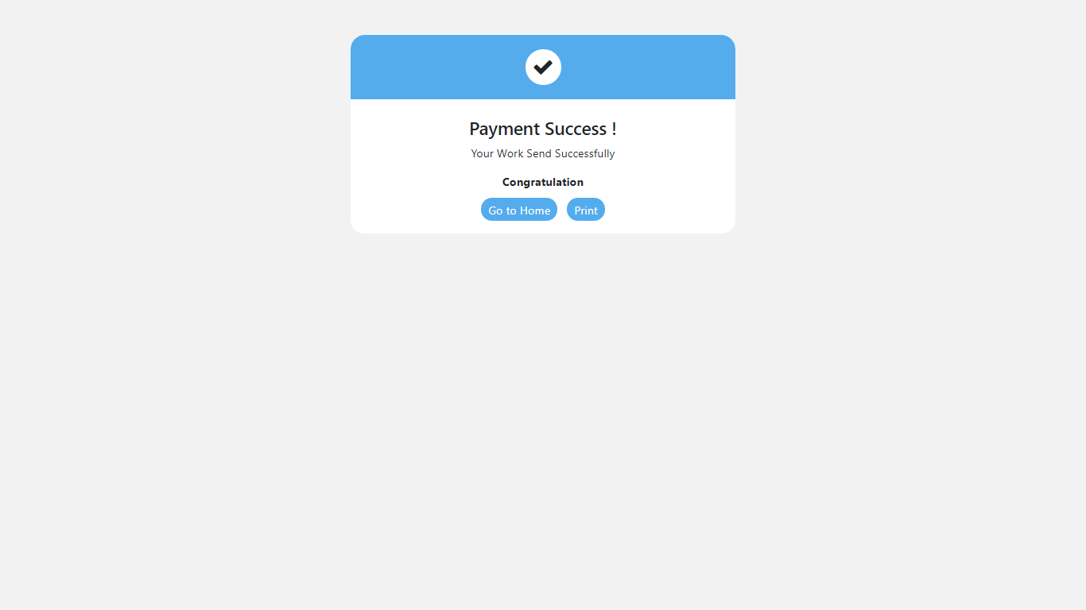

- ProvidedWork :
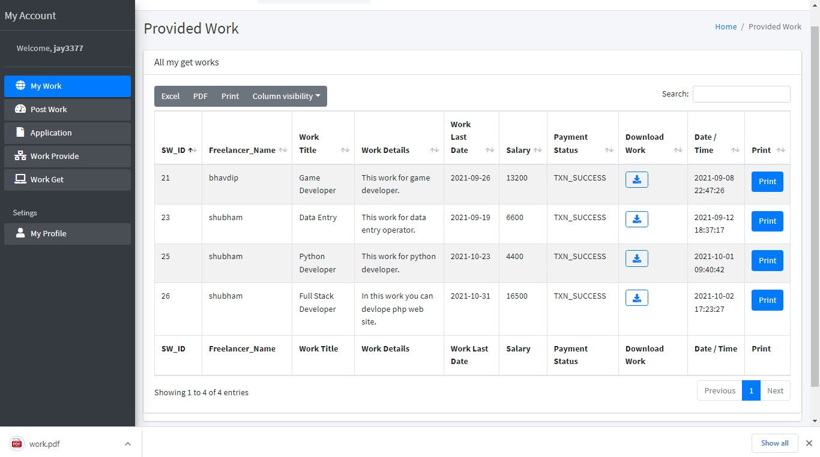

- Invoice:
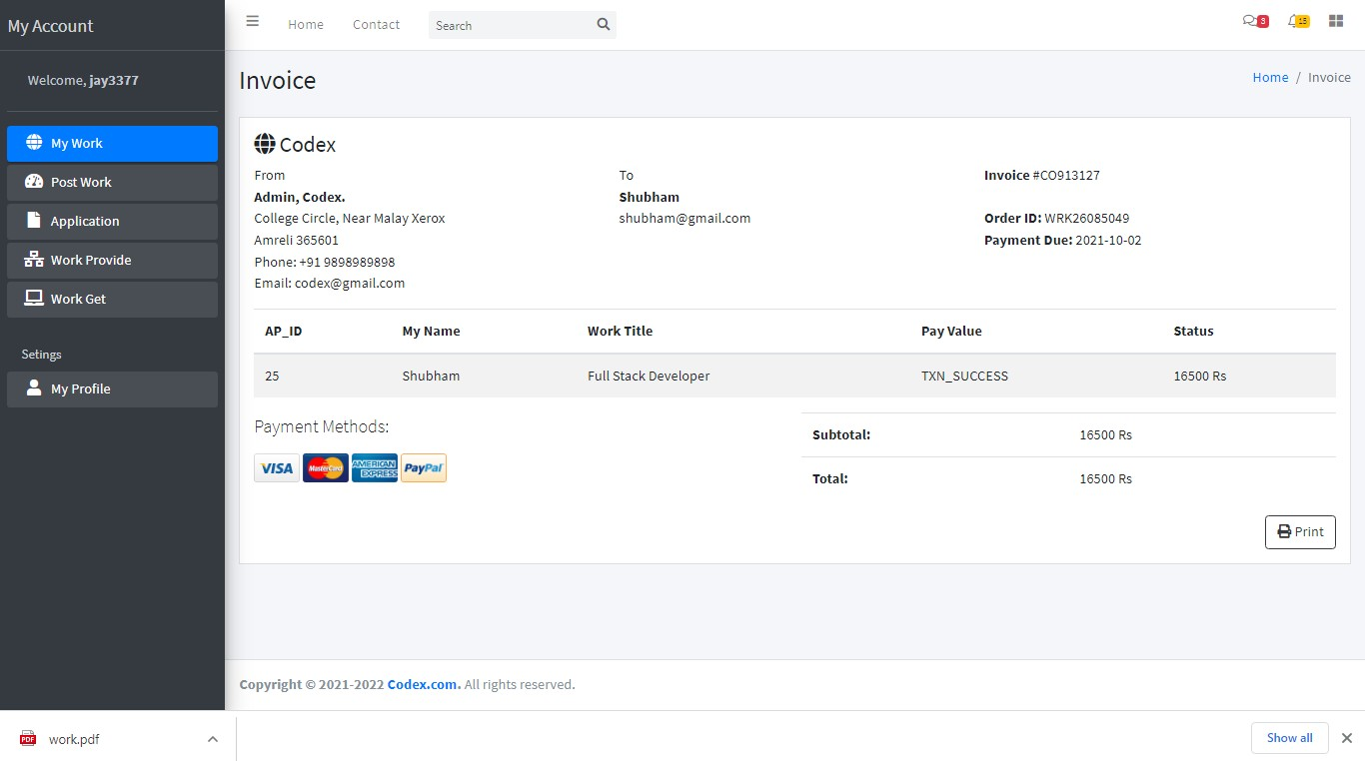

- ReturnedWork:
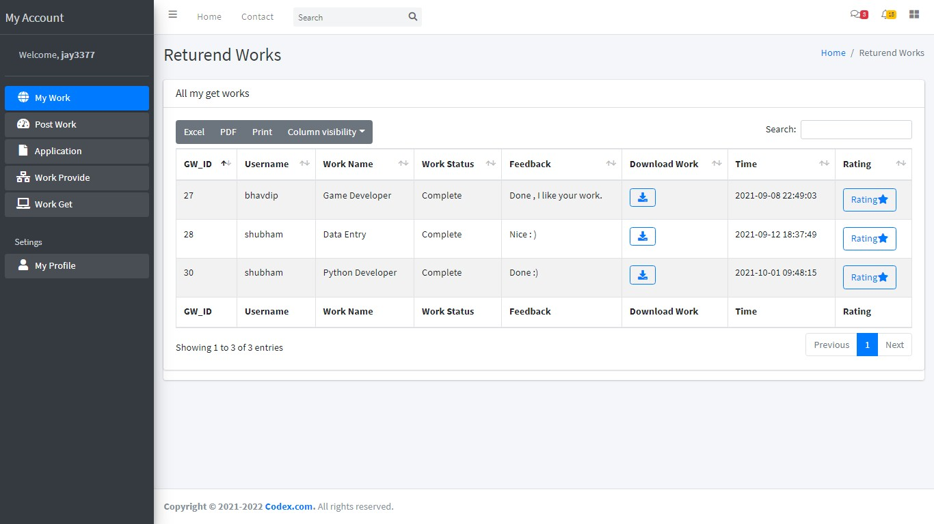

- RatingToFreelancer:

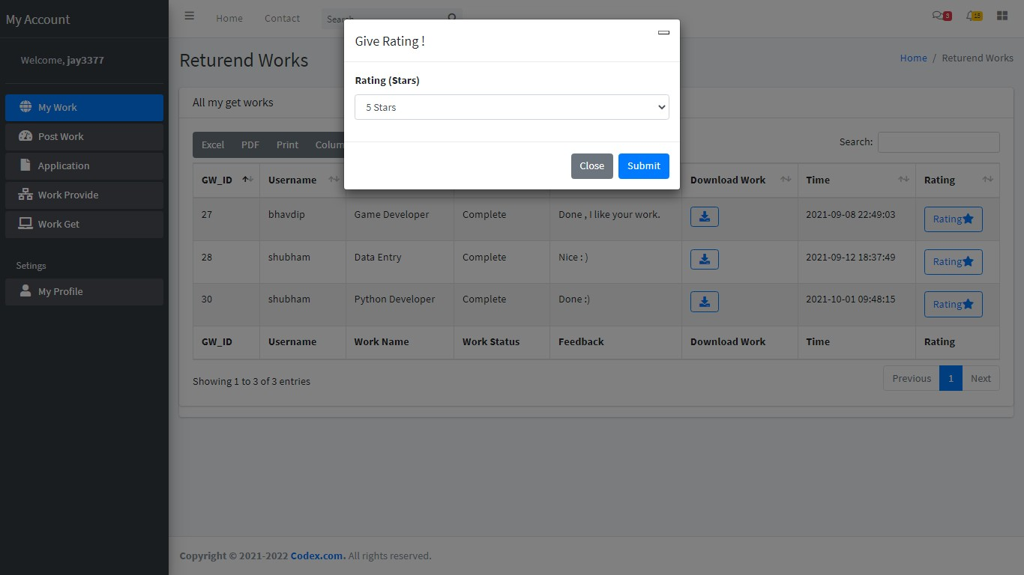

- EmployerProfile:
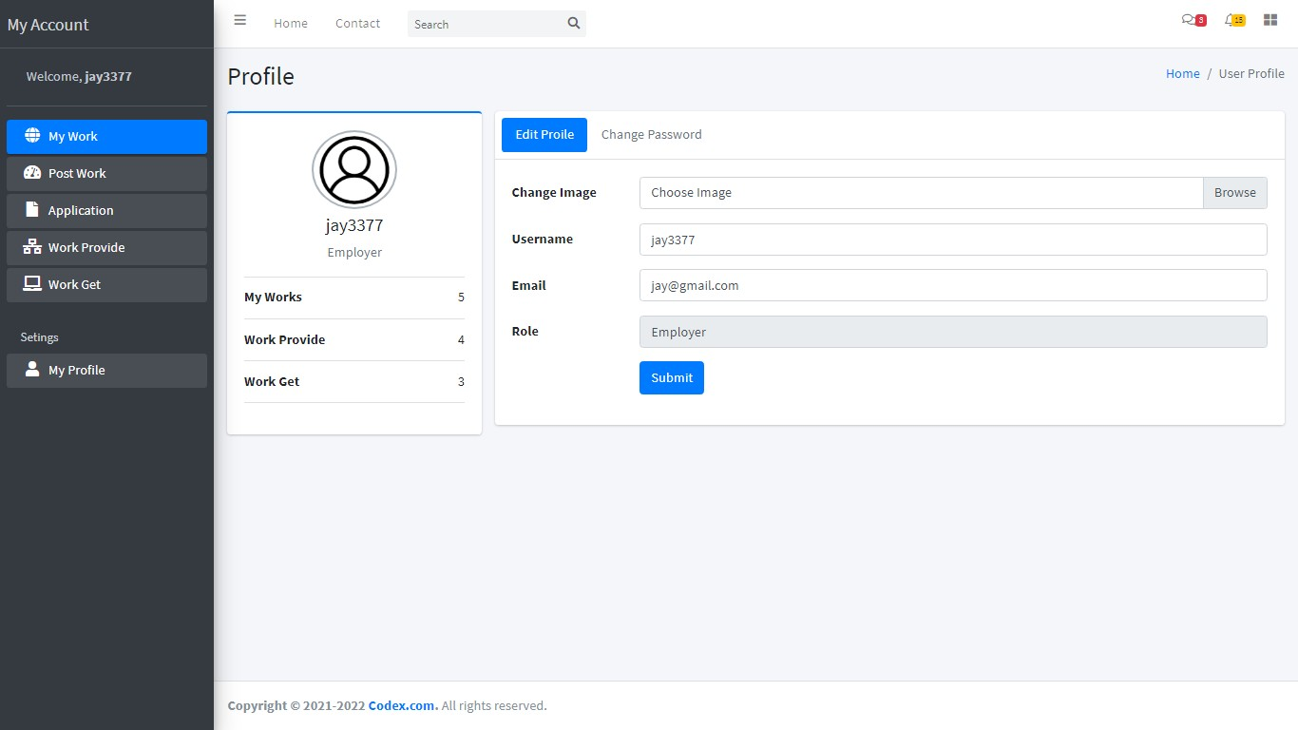

- ChangePassword:
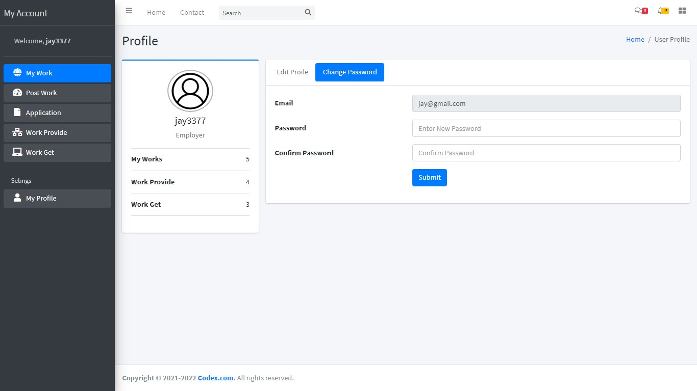

FreelancerSide
- FreelancerIndexPage:


- NeedSomethingDone:

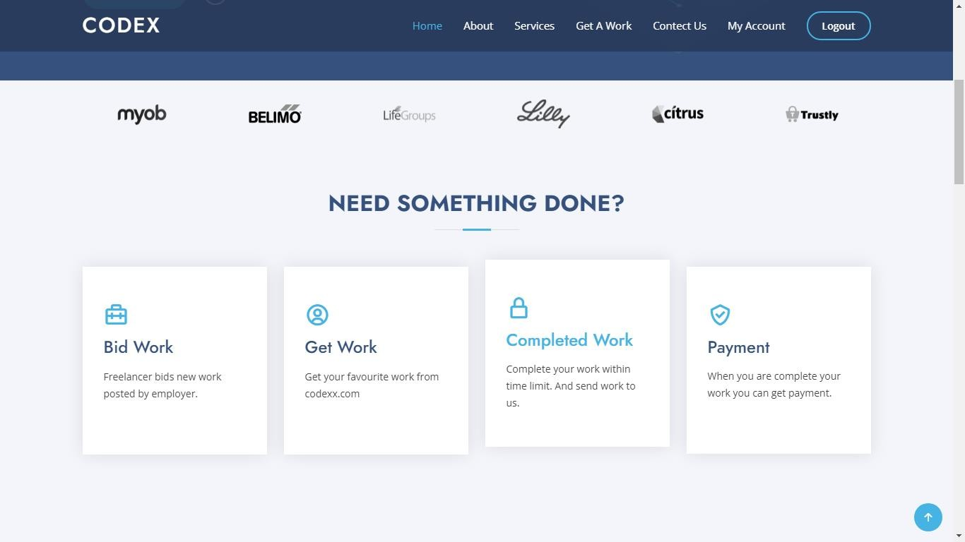
51 | DevelopByJayGohil

- FindTheRightForYou:



- ManageTheWork:
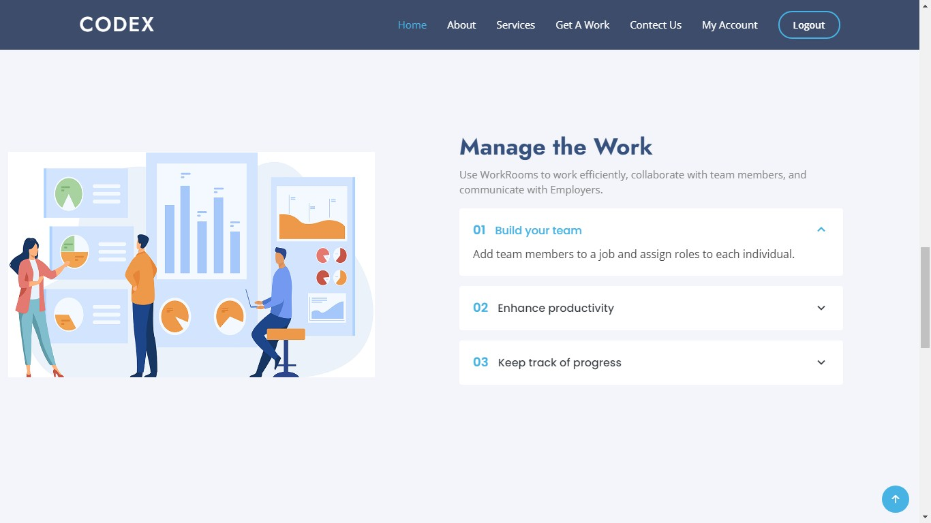

- 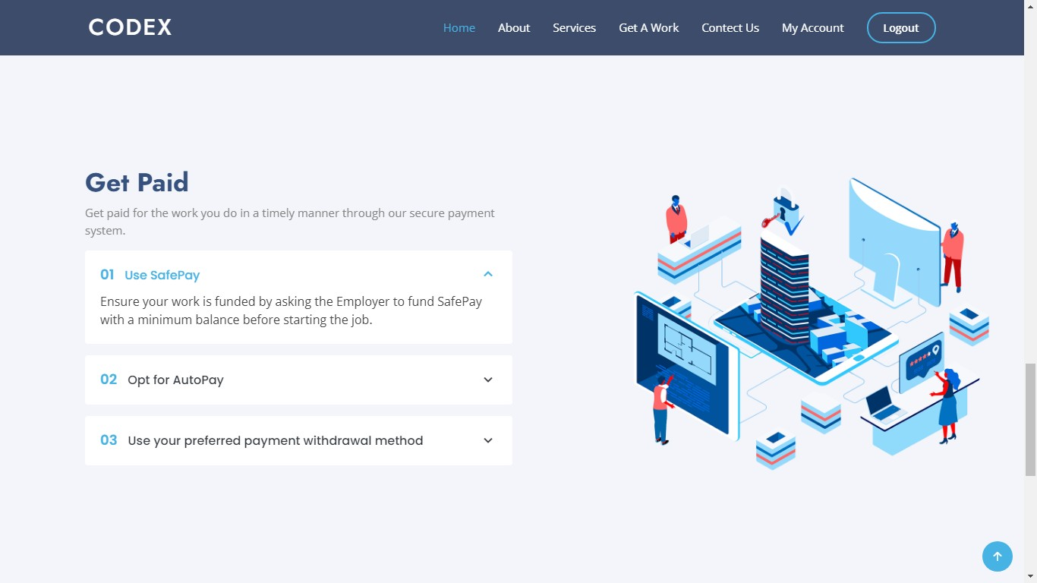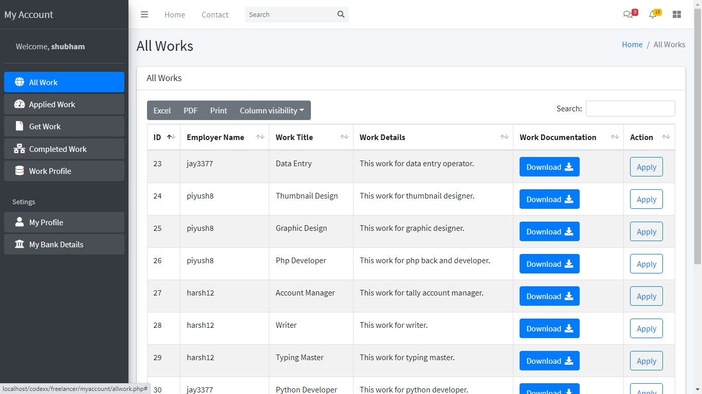GetPaid:

- Allwork:

- AppliedWork :
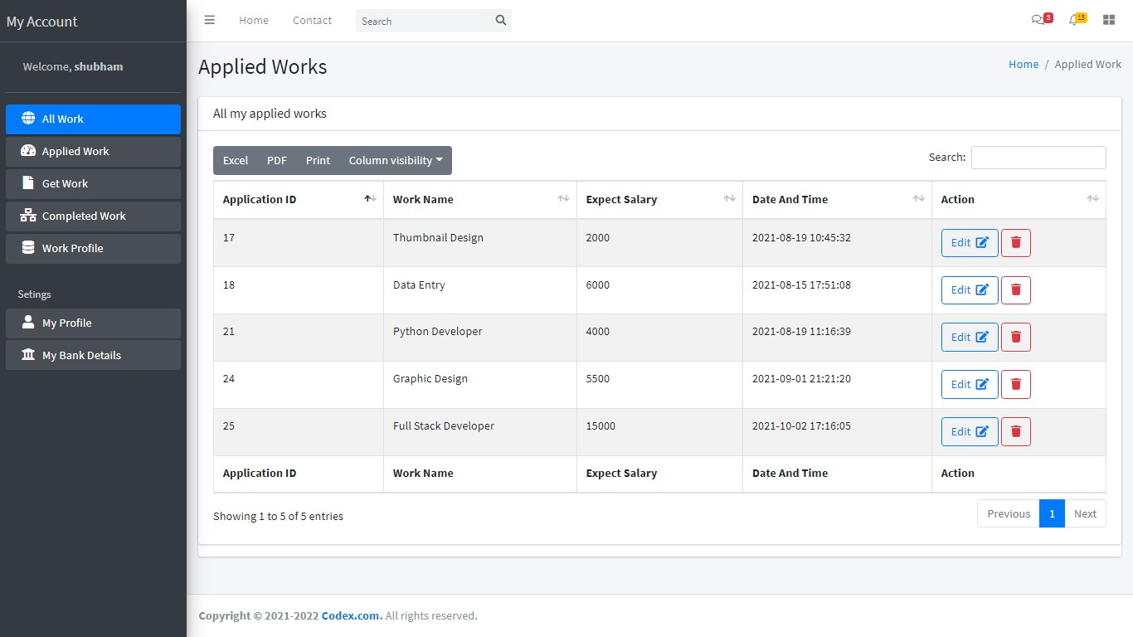

- EditApplication:

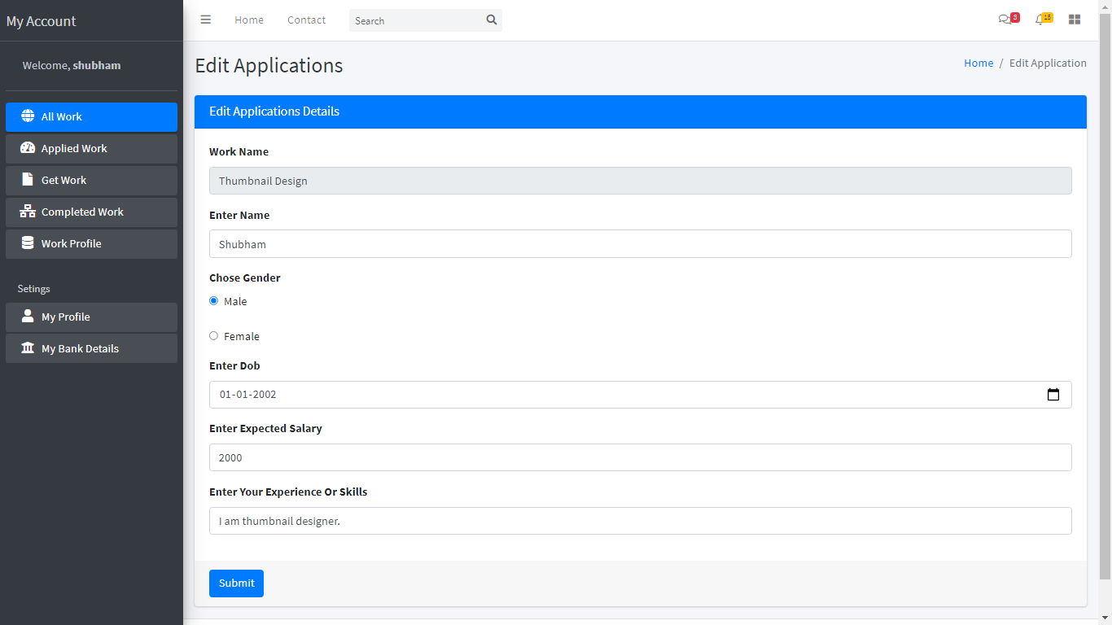

- CompletedWork:

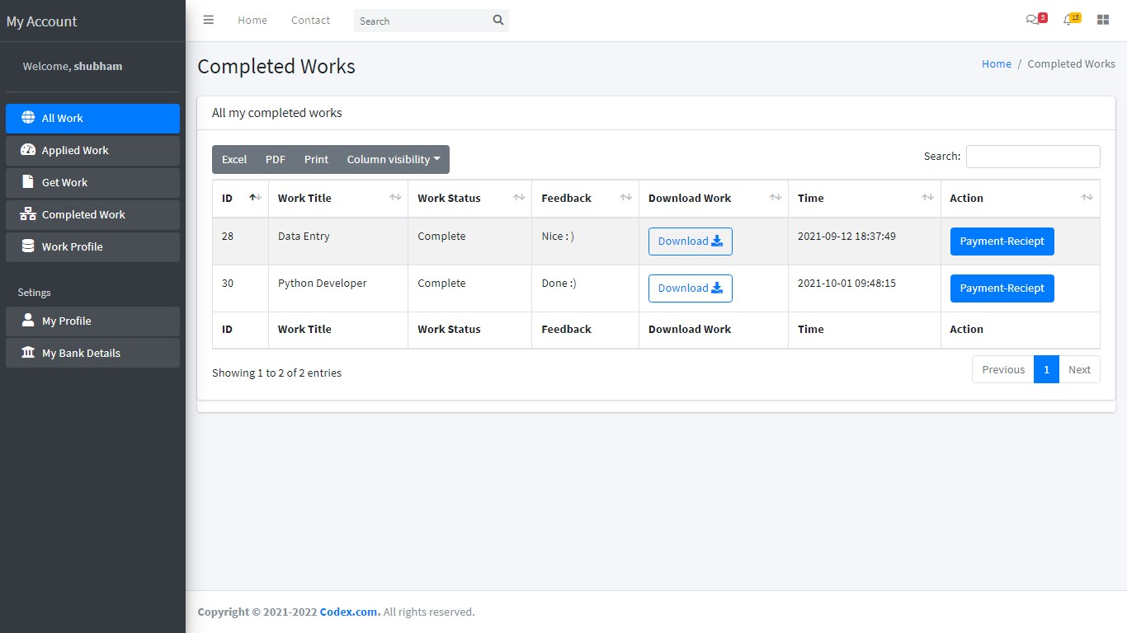

- FreelancerWorkProfile :

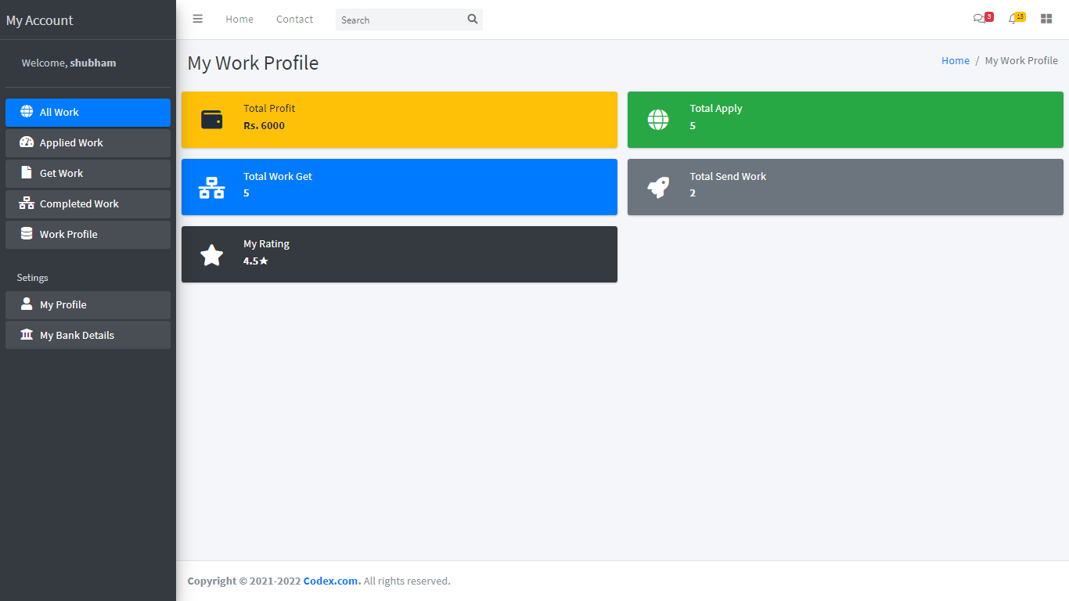

- FreelancerProfile:

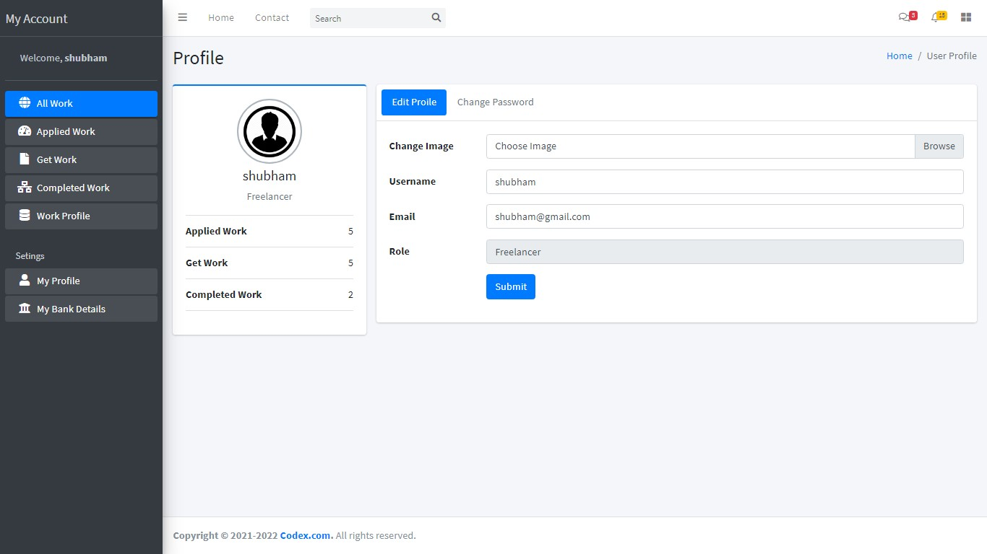

- ChangePassword:
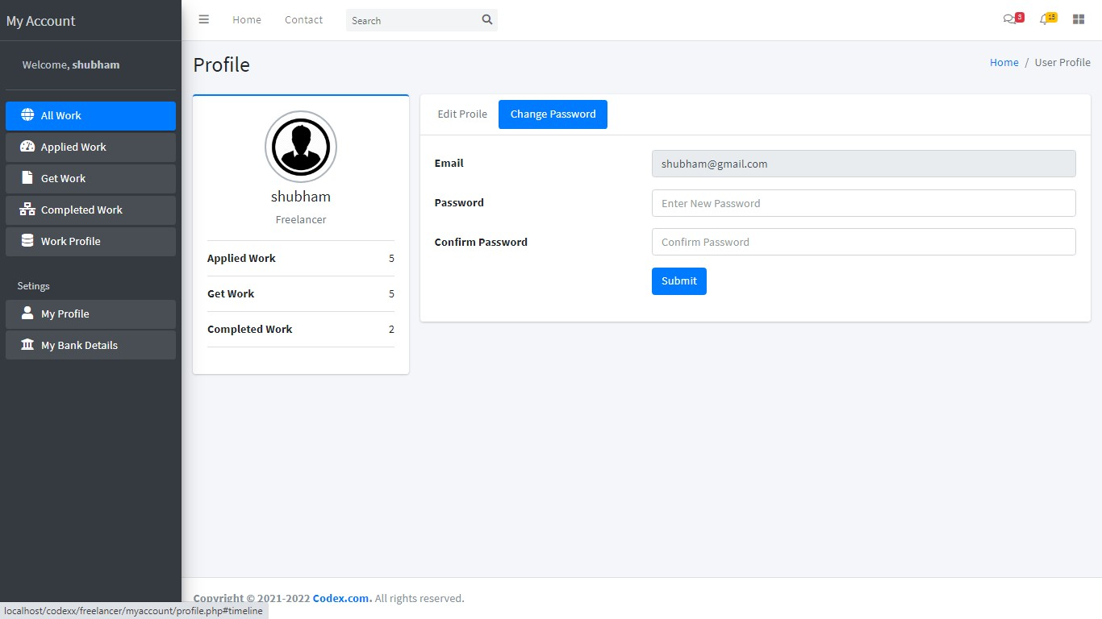

- FreelancerBankDetails:

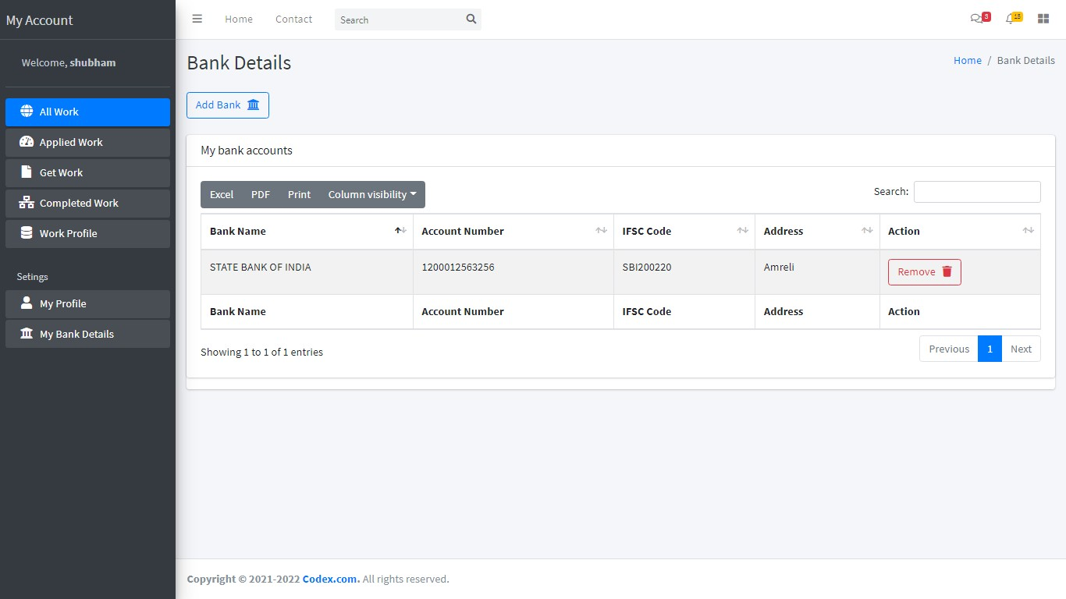

- AddBankDetails:
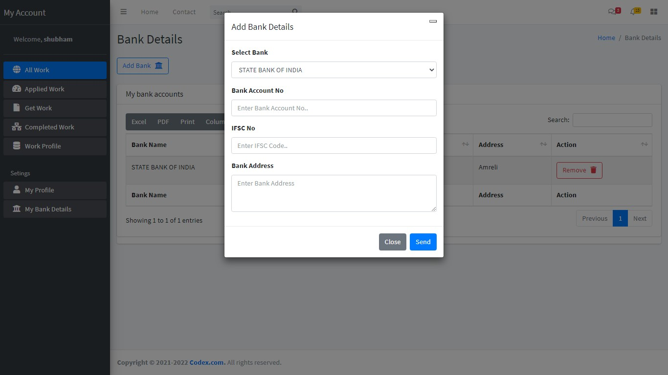

AdminSide
- LoginForm:

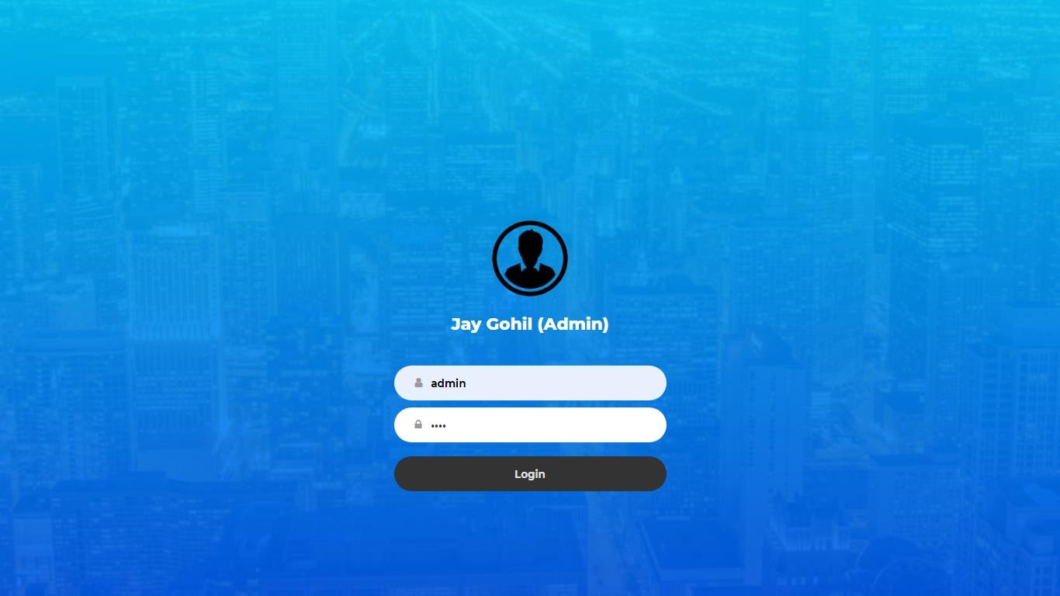

- AdminDashboard:
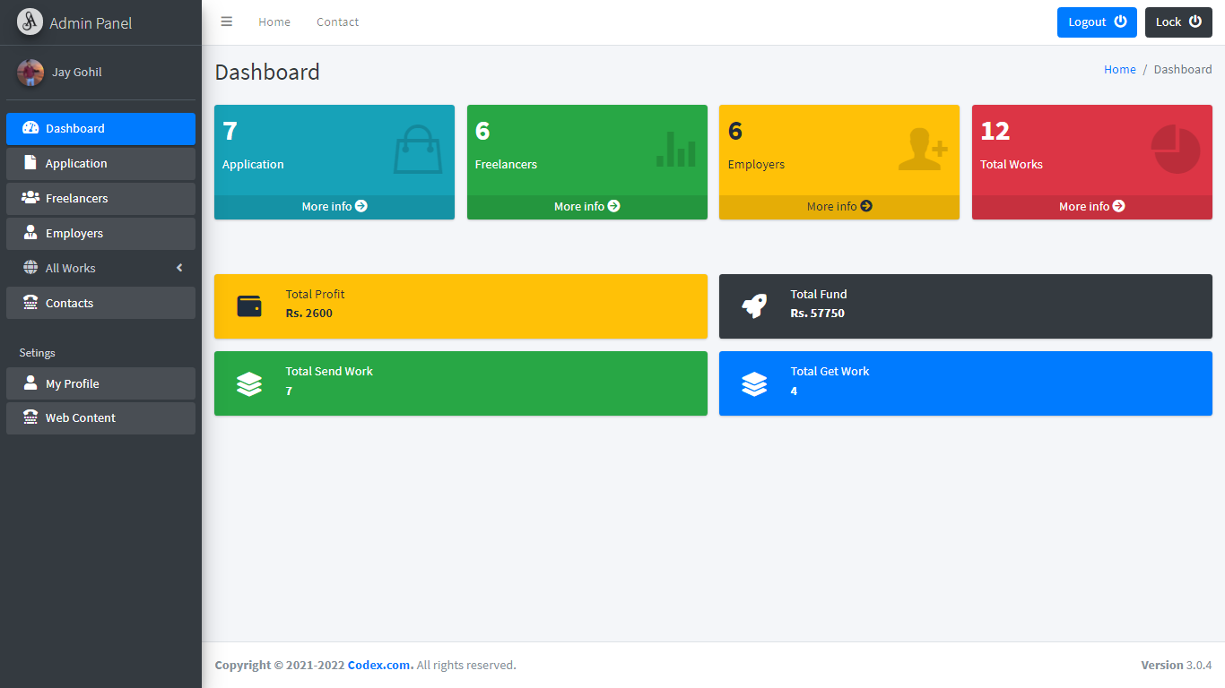

- AllApplication:
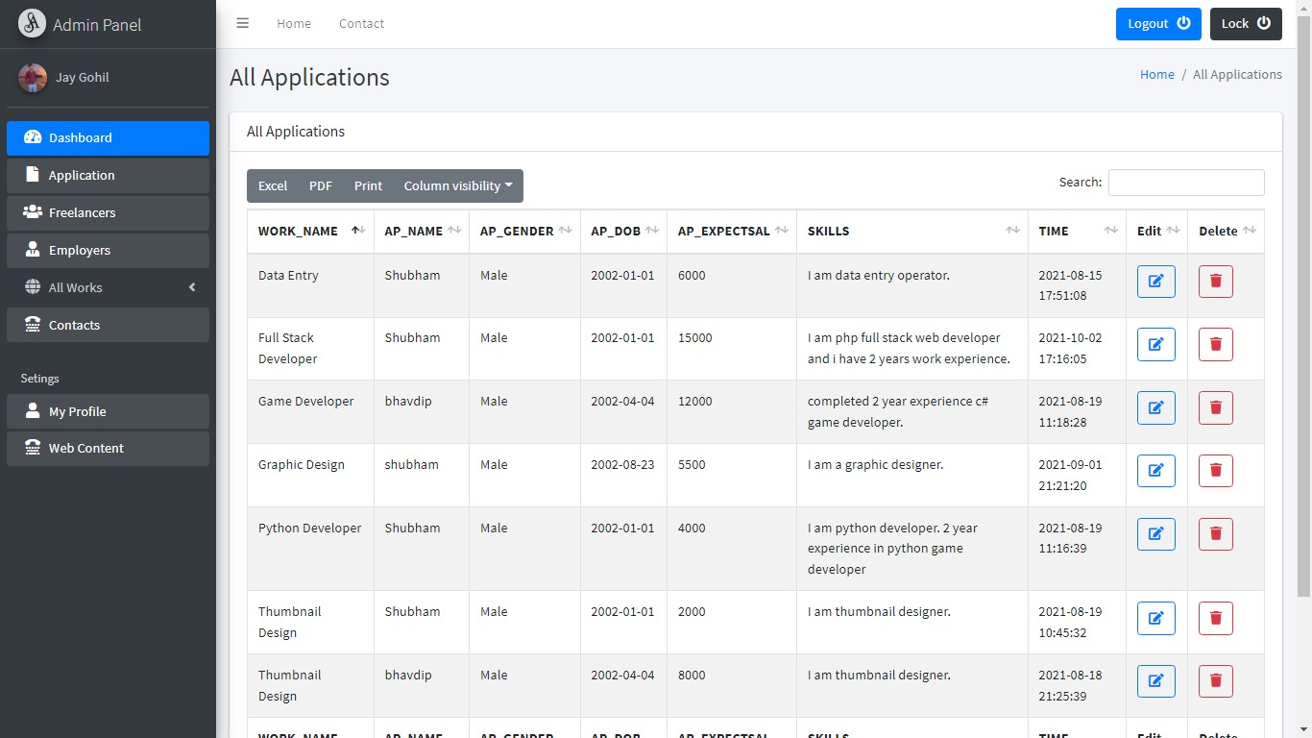

- AllFreelancers:

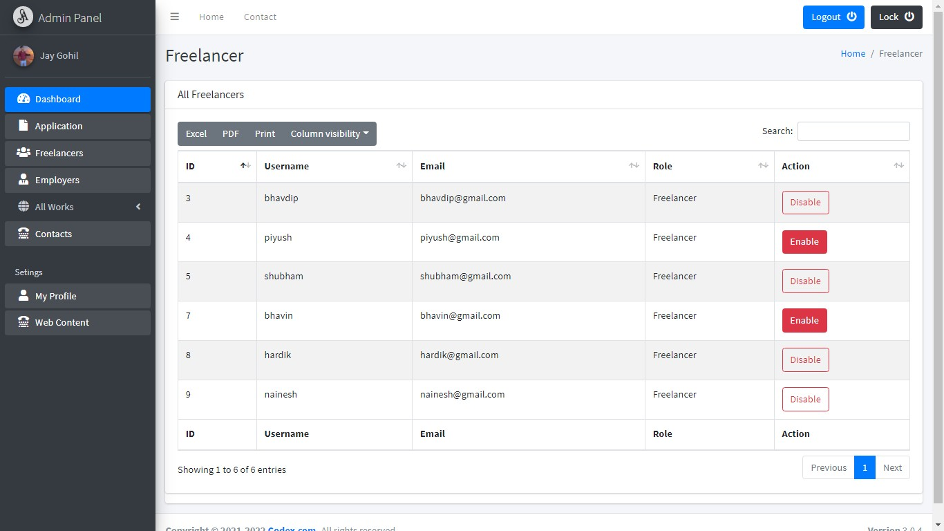

- AllEmployers:

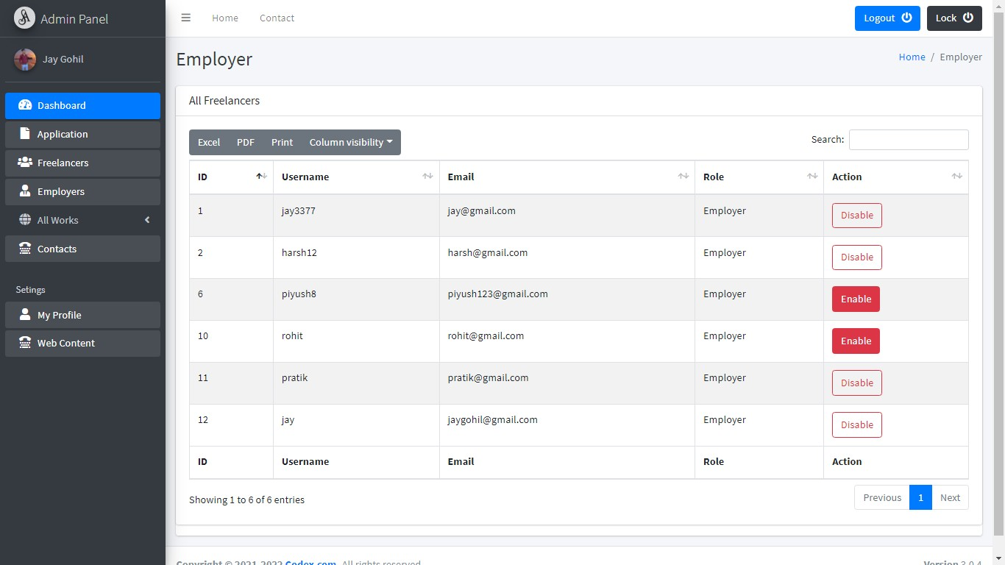

- AllWork:

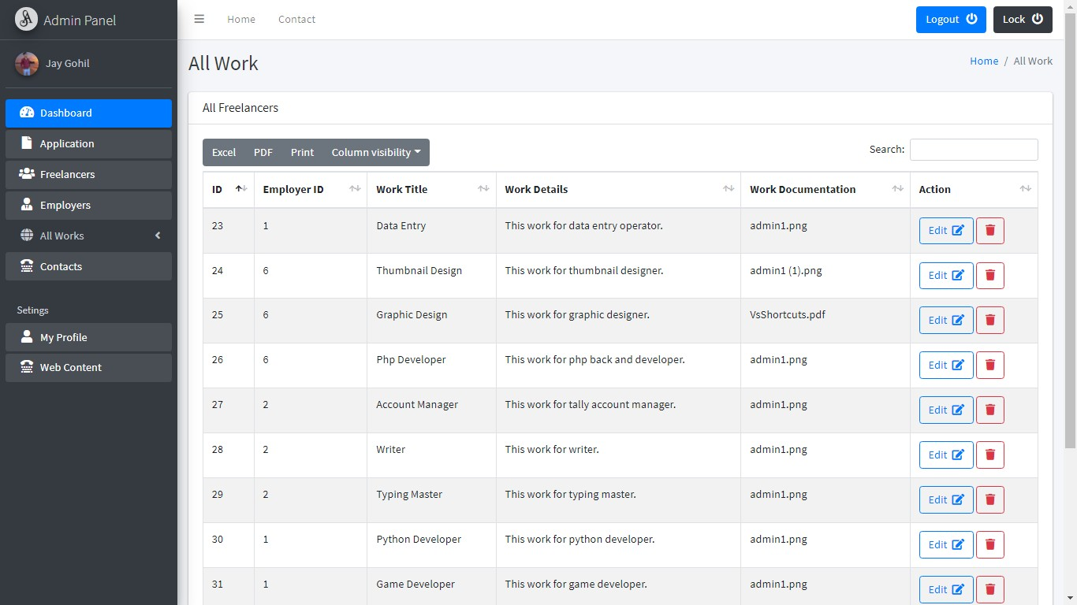

- SendWork:
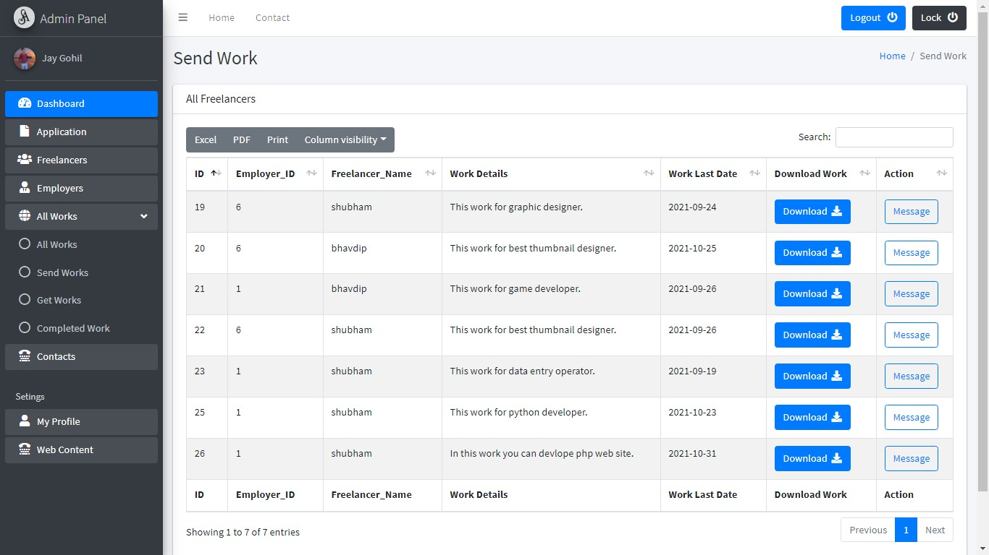

- GetWork:
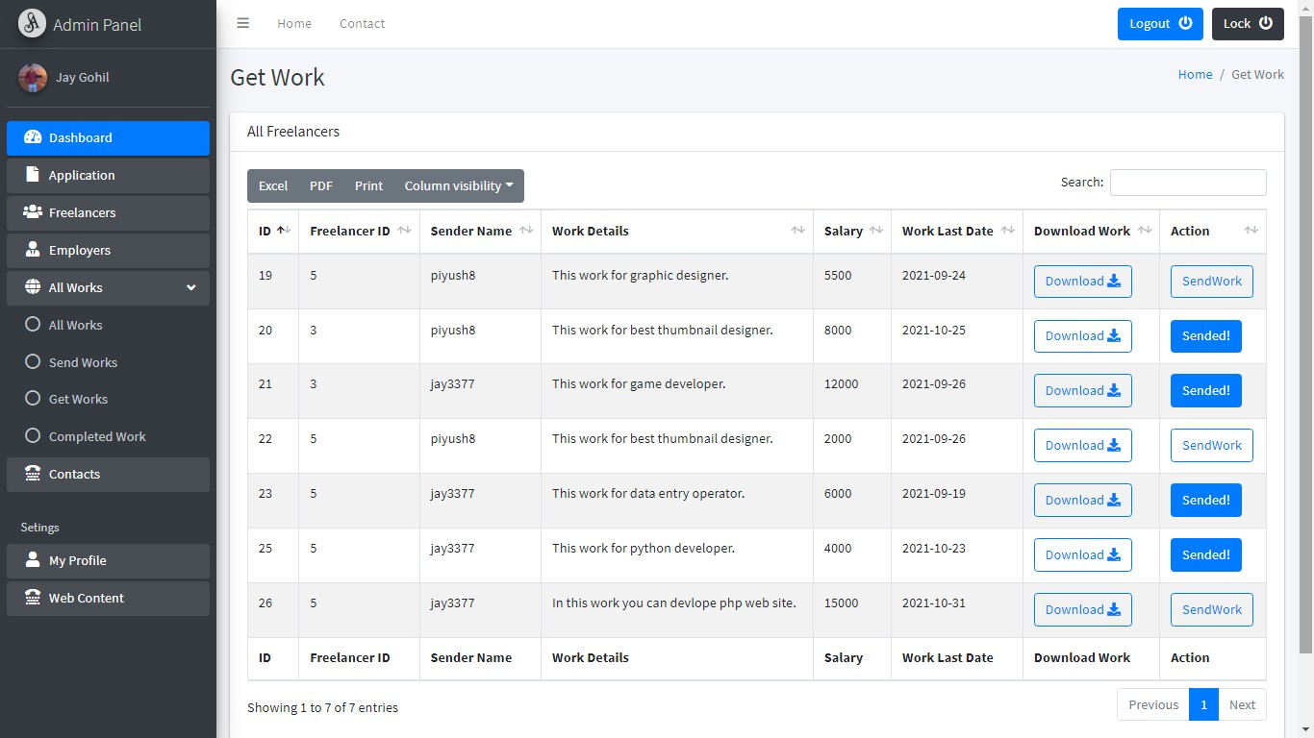

- ReturnedWork:
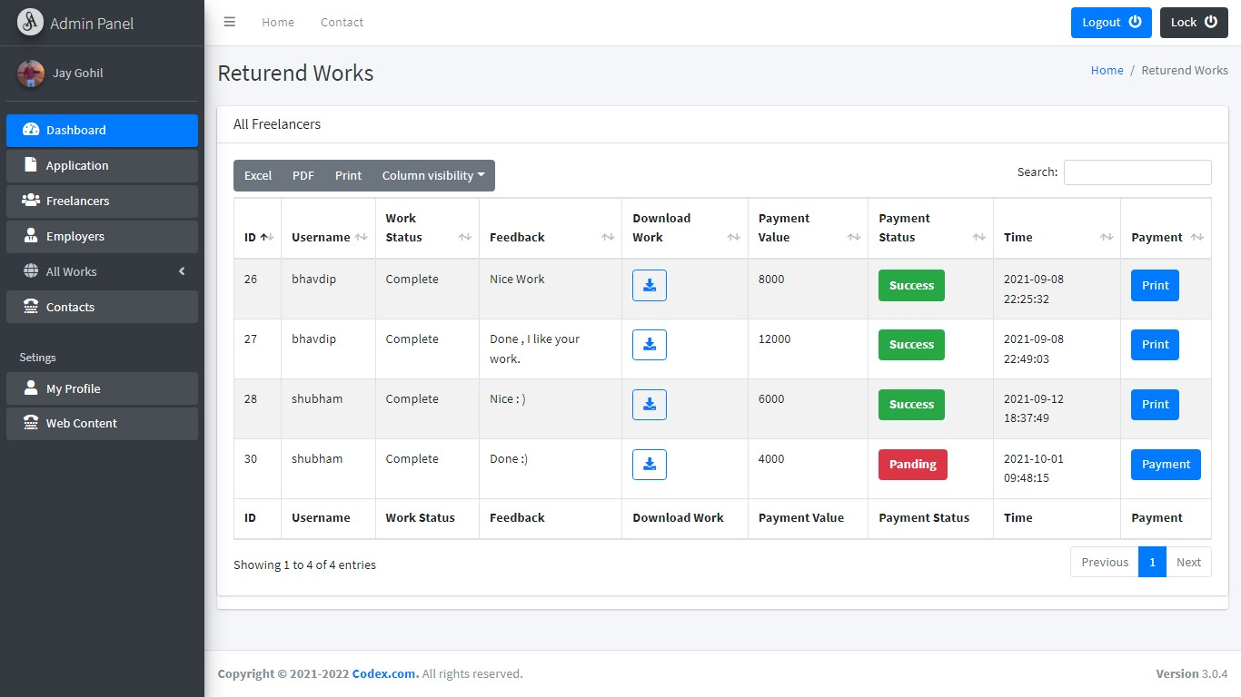

- Contacts:

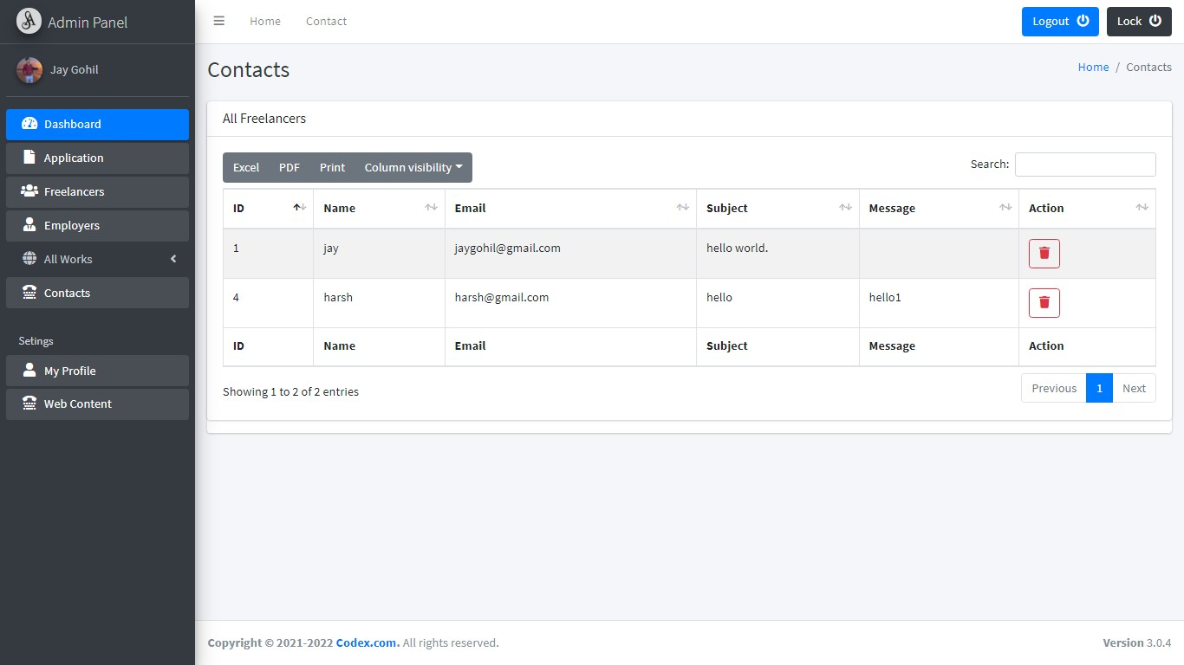

- Profile:

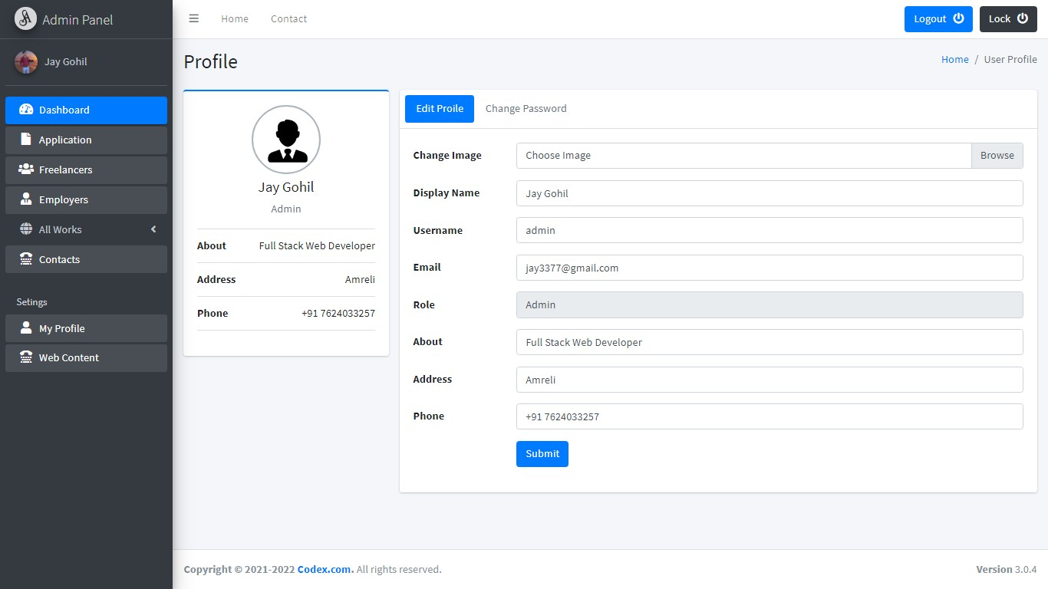

- ChangePassword:

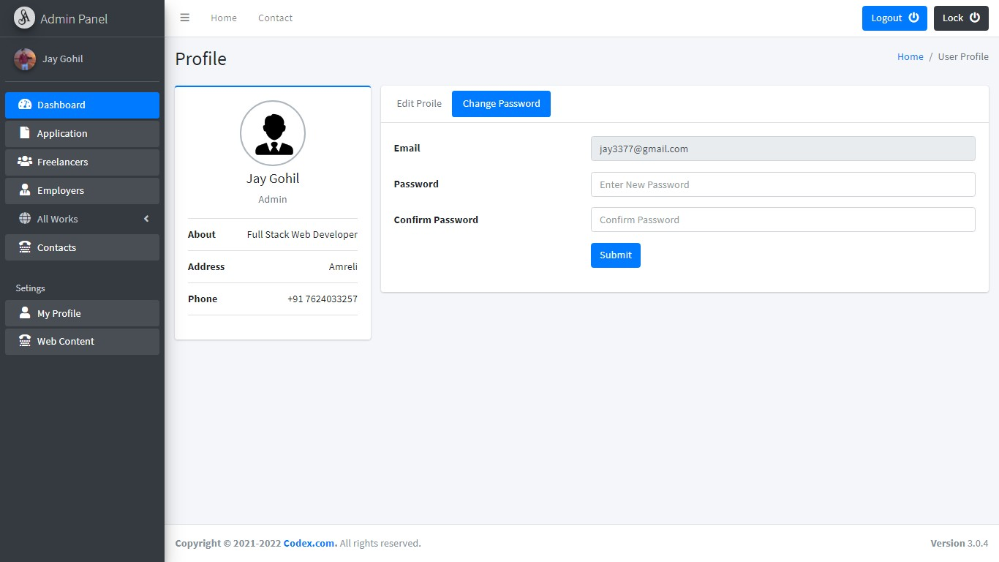

- ChangeWebContent:

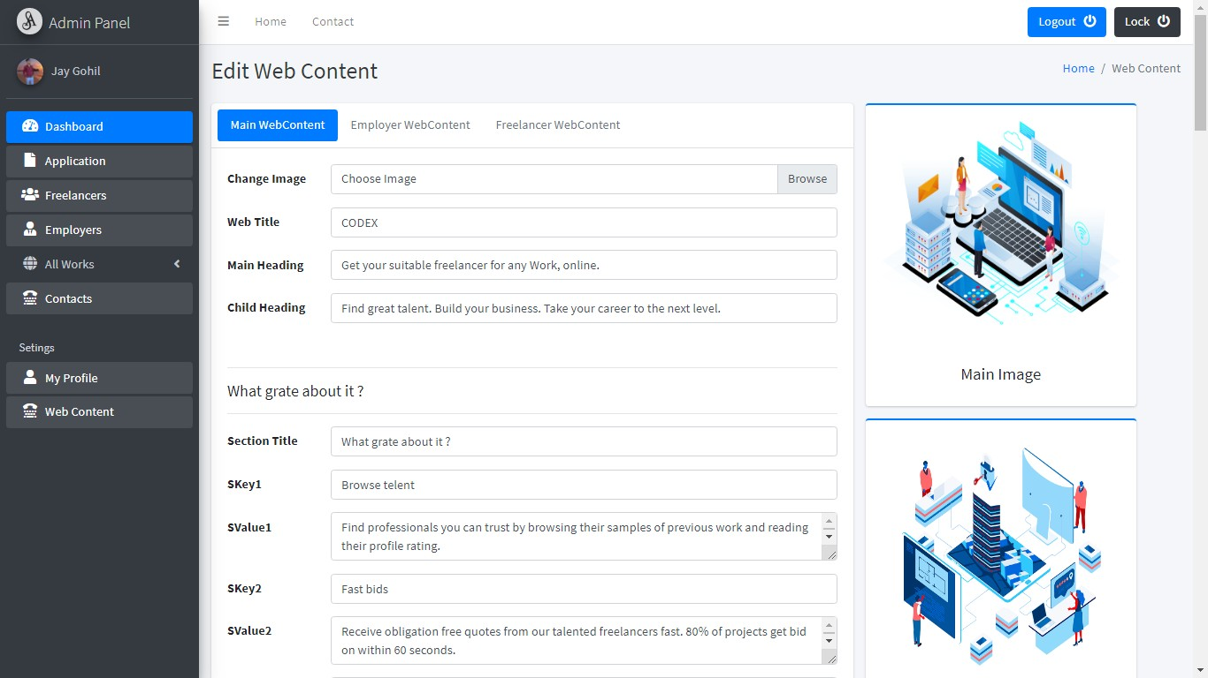

- LockSystem:

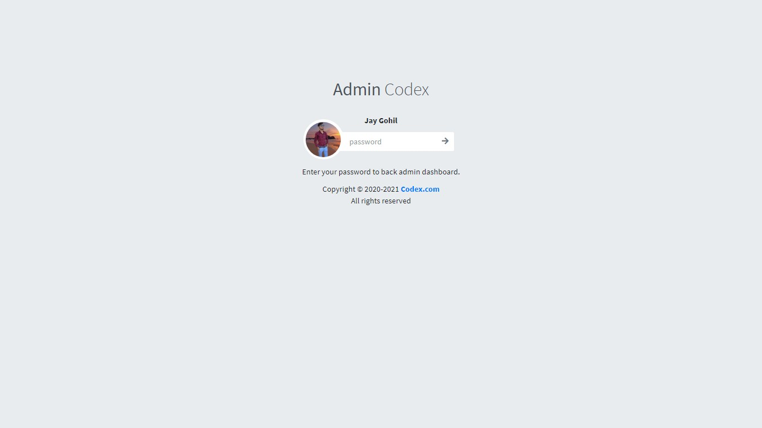

FutureScope

The future scope of this project to help most unemployed persons andhelpthem toearnmoneyfrom home.
Freelancing in India has already become popular enough to catch hold ofa large segment of job-seeking, independent professionals looking forward tolearning new ideas and explore more work genres. Freelancing in India sees aremarkable growth, giving a new voice to the modern, hard-working youth fromdifferentaspectsofIndiansociety.
The future of freelancing in India looks promising. Many individuals arechoosingtowork accordingtotheirpreferencelikewheretheywant,whentheywantandtheworkoftheirchoice.

Bibliography

- www.google.com
- www.upwork.com
- https://getbootstrap.com/
- PhpManual

ThisdocumentationiscreatedbyGohilJay
***

CD/DVD
Belowitemsareincludedincd/dvd.
- Project
- Database
- Documentation
- Screenshots

