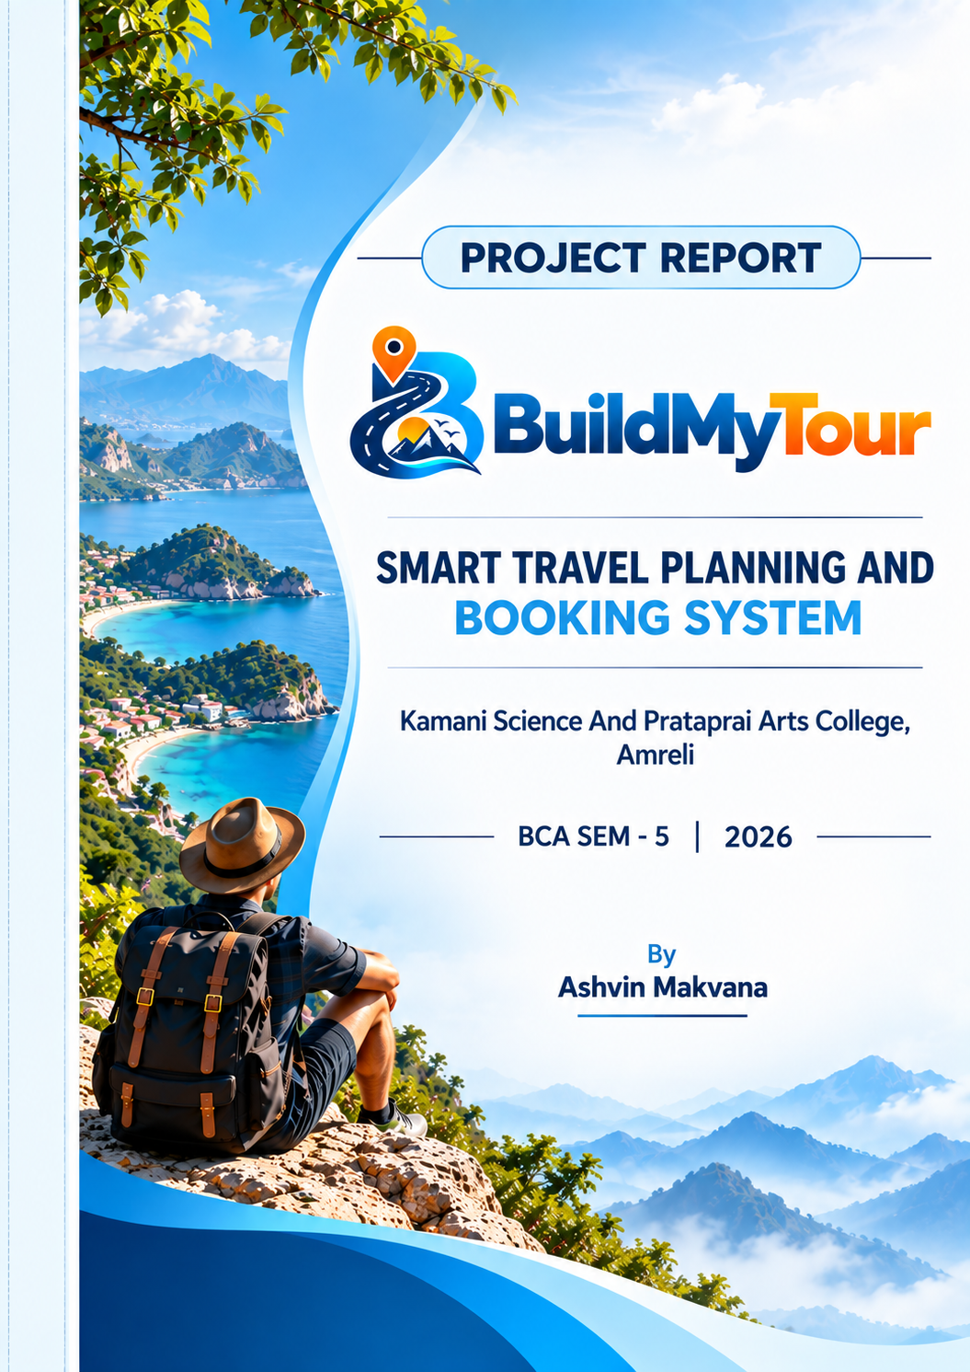

INDEX
No | Title | Page No
1 | Preface | 5
2 | Acknowledgement | 6
3 | Abstract | 7
4 | Introduction | 8
5 | Time Line Chart | 9
6 | Project Profile | 10
7 | Hardware Requirement | 11
8 | Software Requirement | 11
9 | Requirement Specification | 12
10 | Problem Definition | 13
11 | Project Planning & Scheduling | 14-15
12 | System Analysis | 16
13 | Feasibility Study | 17-18
14 | Project Page Structure | 19-21
15 | Data Dictionary | 22-26
16 | Data Flow Diagram | 27
17 | Context & First Level Diagram | 28-29
18 | ER Diagram | 30
19 | Use Case Diagram | 31
20 | Activity Diagram | 32-34
21 | Screenshot (Page UI) | 35-64
22 | Future Scope & References | 65
23 | CD/DVD | 66

INDEX (CONTINUED)
Section | Included Content | Page Range
Preliminary | Cover + College Certificate Blank + Index | 1-4
Documentation | Preface, Acknowledgement, Abstract, Introduction | 5-8
Analysis | Timeline, Profile, Requirements, Problem Definition | 9-13
Design | Planning, Analysis, Feasibility, Page Structure | 14-21
Database & Diagrams | Data Dictionary, DFD, Context, ER, Use Case, Activity | 22-34
Interface Documentation | Project UI / Visual Documentation | 35-64
Closing | Future Scope, References, CD/DVD | 65-66

Preface
The main objective of a computer application project is to gain practical knowledge by applying concepts learned during the academic course. A semester project provides an opportunity to understand the complete software development process, from identifying a problem to designing, developing, testing and documenting a working system.
BuildMyTour is developed as a web-based Smart Travel Planning and Booking System. The project combines travel package information, preference-based trip planning, generated itinerary details, checkout, payment recording, booking management and reviews in one application.
This documentation presents the project in a structured format similar to the college project documentation pattern. It covers the project profile, requirements, problem definition, planning, system analysis, feasibility study, page structure, database dictionary, system diagrams, interface documentation, future scope and references.

Acknowledgement
I would like to express my sincere gratitude to the management and faculty members of Kamani Science And Prataprai Arts College, Amreli, for providing the opportunity and academic environment required to complete this semester project.
I am thankful to my project guide and the faculty members of the BCA Department for their guidance, suggestions and support throughout the analysis, development, testing and documentation of the BuildMyTour system.
I also thank my classmates, friends and family members for their encouragement and support during the completion of this project.
Thanks to all!!
Ashvin Makvana

Abstract
BuildMyTour is a web-based Smart Travel Planning and Booking System developed as a BCA Semester V academic project. The application provides a centralized platform through which users can plan a trip, view suitable tour packages and complete a booking workflow.
The Smart Trip Planner accepts trip type, start date, duration, number of travelers and total budget. It matches an active tour package using trip category and duration and generates a travel plan containing destination, transportation, accommodation, meal plan, activities and calculated cost.
The generated trip can continue to checkout and payment. Users can view their booking information through My Bookings and submit reviews. The administrator can manage trip categories, tour packages, users, bookings and reviews.
The system uses PHP for server-side processing, HTML/CSS and JavaScript for the web interface, Bootstrap 5.3 for responsive components, and MySQL/MariaDB for database storage. The project is designed for local development using XAMPP.

Introduction
Travel planning can involve several decisions such as destination, duration, transportation, accommodation, activities and budget. When users collect this information manually from different sources, comparing alternatives can become difficult and time-consuming.
BuildMyTour provides a single web platform for organizing these activities. Users can register and log in, enter their travel requirements in the Smart Trip Planner, receive a generated plan, continue to checkout, record payment information and manage their bookings.
The system contains two primary areas: the User section and the Admin section. The User section focuses on travel planning and booking, while the Admin section provides management of categories, packages, users, bookings and reviews.
The project demonstrates practical implementation of web programming, relational database management, authentication, business logic, responsive design and software documentation.

Time Line Chart
Project planning divides development into coordinated activities. The following schedule represents the planned stages used for the BuildMyTour academic project.
Development Activity | Estimated Duration
Preliminary Investigation | 10 Days
System Analysis | 10 Days
System Design | 15 Days
Database Design | 7 Days
Coding | 25 Days
Testing | 5 Days
Implementation | 5 Days
Documentation | 7 Days

Development Flow: Preliminary Investigation → System Analysis → System Design → Database Design → Coding → Testing → Implementation → Documentation

Project Profile
Project Information | Details
Project Name | Smart Travel Planning and Booking System
Website Name | BuildMyTour
Developed By | Ashvin Makvana
Course | Bachelor of Computer Application (BCA)
Semester | BCA Semester – 5
College | Kamani Science And Prataprai Arts College, Amreli
Front End Tool | HTML5, CSS3, JavaScript, Bootstrap 5.3
Back End Tool | PHP 8+
Database | MySQL / MariaDB
Operating Environment | Microsoft Windows + XAMPP
Development Server | Apache
Database Name | buildmytour
Database Tables | 7
Project Type | Web-based application
Academic Year | 2026

Hardware Requirement
• Processor: Intel/AMD dual-core processor or higher.
• RAM: Minimum 4 GB recommended.
• Storage: Minimum 10 GB free space for local development.
• Monitor: 1366×768 resolution or higher.
• Multimedia keyboard and mouse.

Software Requirement
• Operating System: Microsoft Windows 10/11 or compatible.
• Web Server: Apache through XAMPP.
• Programming Language: PHP 8+.
• Database: MySQL / MariaDB.
• Frontend: HTML5, CSS3, JavaScript, Bootstrap 5.3.
• Browser: Google Chrome, Mozilla Firefox or Microsoft Edge.
• Database Tool: phpMyAdmin.
• Documentation Tool: Microsoft Word.

Requirement Specification
This section provides an overview of the functional requirements of the BuildMyTour system.
Function | Requirement
Registration | User must register before using protected booking functionality.
Login | User/admin enters valid credentials to access important functionality.
Smart Trip Planner | User enters trip type, date, duration, travelers and budget.
Package Matching | System selects an active package based on category and duration.
Generated Plan | System prepares transport, hotel, meals, activities and total cost.
Checkout | User reviews generated trip information before booking.
Payment | User selects UPI or Card and payment information is recorded.
Booking | System stores booking reference, amount and status.
My Bookings | User can view existing booking information.
Reviews | User can submit rating and comment.
Admin Management | Admin manages categories, packages, users, bookings and reviews.

Project Problem Definition
The traditional travel planning process may require users to compare multiple package details, calculate total cost, select accommodation and transportation, and then manage booking information separately. This creates unnecessary manual effort and may make it difficult to identify a suitable package within a fixed budget.

Objectives
• Provide a centralized travel planning and booking platform.
• Generate a trip plan according to user preferences.
• Maintain tour package information in a relational database.
• Calculate trip cost based on package price and traveler count.
• Validate the user's budget before allowing booking.
• Provide a structured checkout and payment workflow.
• Provide booking history and review functionality.
• Provide administrative control over categories, packages, users, bookings and reviews.

Project Planning & Scheduling
Project planning is an important part of project management. It coordinates the activities required to complete the project within the available academic time. The plan helps organize investigation, analysis, design, coding, testing and documentation.
The BuildMyTour project was divided into phases so that each stage could produce the information required by the next stage. Requirements were identified first, followed by system analysis and design. Database and interface structures were then implemented before testing and documentation.
Phase | Major Activities | Deliverable
Preliminary Investigation | Identify travel planning problem | Problem statement
System Analysis | Identify actors, processes and requirements | Requirement specification
System Design | Architecture, page flow, database and diagrams | System design
Database Design | Tables, keys and relationships | Database schema
Coding | PHP, frontend and SQL implementation | Working application
Testing | Functional and validation tests | Test results
Documentation | Diagrams, visuals and report | Final documentation

Project Planning & Scheduling (Continued)

Development Activities
• Preliminary Investigation
• System Analysis
• System Design
• Database Design
• Coding
• Testing
• Implementation
• Maintenance / Documentation

Project Execution Flow
Requirement Collection → Requirement Analysis → System Design → Database Design → Implementation → Testing → Debugging → Documentation

Expected Outcome
The expected outcome is a working web application that allows users to plan and book tours while providing administrators with facilities to maintain the application's core travel data.

System Analysis
System analysis is the process of identifying objectives and requirements, evaluating alternative solutions and recommending a feasible system. It involves collecting, recording and interpreting information about users, transactions and processes.

Stages of System Analysis
Stage | Description
Preliminary Analysis | Understand the existing travel planning problem and identify major requirements.
Detailed Analysis | Define users, processes, data, business rules, database entities and system interactions.

Main Actors
Actor | Role
User | Plans trips, views packages, books tours and submits reviews.
Administrator | Manages categories, packages, users, bookings and reviews.

Data Flow Diagrams, Entity Relationship Diagrams, Use Case Diagrams and Activity Diagrams are used to represent the system logically.

Feasibility Study
A feasibility study determines whether the proposed computerized solution can be developed and operated successfully within available resources. The BuildMyTour project was evaluated in the following areas.

Technical Feasibility
The project is technically feasible because it uses common web technologies such as PHP, HTML, CSS, JavaScript, Bootstrap and MySQL/MariaDB. XAMPP provides Apache and database services for local development.

Operational Feasibility
The application follows a simple workflow familiar to travel users: registration, trip planning, package selection, checkout, payment, booking and review. Administrators receive a dedicated management area.

Economic Feasibility
For an academic project, the system can be developed using freely available development technologies and local server software. Therefore, the initial development cost is low.

Feasibility Study (Continued)

Schedule Feasibility
The project is divided into manageable stages so that analysis, design, implementation, testing and documentation can be completed within the semester project schedule.

Organizational / User Feasibility
The proposed system reduces the number of separate steps required for travel planning and provides centralized information. The role-based separation of User and Administrator functions also supports clear operation.

Conclusion of Feasibility Study
Based on technical, operational, economic and schedule considerations, BuildMyTour is feasible as an academic web application and provides a practical foundation for future expansion.

Project Page Structure

User Side
User Side – Page Structure
• Home / Main Index
• Registration / Login
• Smart Trip Planner
• Generated Tour Plan
• Tour Package Details
• Checkout
• Payment
• Booking Confirmation
• My Bookings
• Booking Details
• Review
• About
• Contact
• Logout

Project Page Structure (Continued)

Admin Side
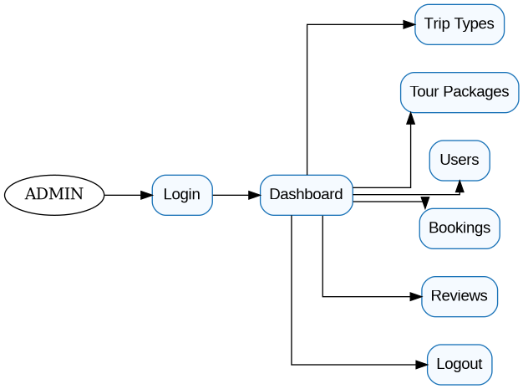
Admin Side – Page Structure
• Admin Login
• Dashboard
• Trip Categories
• Tour Packages
• Add / Edit / Delete Package
• Users
• Bookings
• Reviews
• Logout

Project Page Structure – Main Data Flow
User Action | System Response
Register / Login | Authenticate and open user functionality.
Enter Trip Requirements | Validate and process planner inputs.
Generate Plan | Find matching package and calculate plan cost.
Checkout | Display trip and payment information.
Complete Payment | Store payment and booking information.
My Bookings | Retrieve user's booking records.
Submit Review | Store review for package/trip.
Admin Login | Authenticate administrator.
Manage Data | Create, update or delete categories/packages and manage users/bookings/reviews.

Data Dictionary
The data dictionary describes the database tables, their fields, data types and purpose. BuildMyTour uses the database named buildmytour and contains seven main tables.

1. admins
Field | Data Type | Size | Attribute
id | INT | 11 | Primary Key
name | VARCHAR | 100 | Required
email | VARCHAR | 150 | Unique / Required
password | VARCHAR | 255 | Required
status | ENUM | active/inactive | Default active
created_at | TIMESTAMP | - | Default current timestamp

2. users
Field | Data Type | Size | Attribute
id | INT | 11 | Primary Key
name | VARCHAR | 100 | Required
email | VARCHAR | 150 | Unique / Required
phone | VARCHAR | 20 | Optional
password | VARCHAR | 255 | Required
created_at | TIMESTAMP | - | Default current timestamp

3. trip_categories
Field | Data Type | Size | Attribute
id | INT | 11 | Primary Key
name | VARCHAR | 100 | Unique / Required
description | VARCHAR | 255 | Optional
status | ENUM | active/inactive | Default active

Data Dictionary (Continued)

4. tour_packages
Field | Data Type | Size | Attribute
id | INT | 11 | Primary Key
category_id | INT | 11 | Foreign Key
name | VARCHAR | 180 | Unique / Required
description | TEXT | - | Package description
duration | VARCHAR | 60 | Optional
days | INT | 11 | Required
route | VARCHAR | 500 | Optional
price | DECIMAL | 10,2 | Per-person price
image | VARCHAR | 255 | Main package image
image_destination | VARCHAR | 255 | Destination image
image_transport | VARCHAR | 255 | Transport image
image_hotel | VARCHAR | 255 | Hotel image
image_meal_plan | VARCHAR | 255 | Meal plan image
offer_percentage | DECIMAL | 5,2 | Offer percentage
offer_start_date | DATE | - | Optional
offer_end_date | DATE | - | Optional
status | ENUM | active/inactive | Package status
created_at | TIMESTAMP | - | Default current timestamp

Data Dictionary (Continued)

5. trips
Field | Data Type | Size | Attribute
id | INT | 11 | Primary Key
user_id | INT | 11 | Foreign Key
package_id | INT | 11 | Foreign Key
destination | VARCHAR | 180 | Required
start_date | DATE | - | Required
end_date | DATE | - | Required
days | INT | 11 | Trip duration
travelers | INT | 11 | Traveler count
budget | DECIMAL | 10,2 | Total budget
generated_plan_json | LONGTEXT | - | Generated plan
booking_reference | VARCHAR | 50 | Unique
total_amount | DECIMAL | 10,2 | Total amount
payment_method | ENUM | UPI/Card | Payment method
transaction_id | VARCHAR | 100 | Transaction identifier
payment_status | ENUM | pending/success/failed | Payment status
booking_status | ENUM | not_booked/pending/confirmed/completed/cancelled | Booking status
status | ENUM | planned/booked/completed/cancelled | Trip status
created_at | TIMESTAMP | - | Default current timestamp

Data Dictionary (Continued)

6. bookings
Field | Data Type | Size | Attribute
id | INT | 11 | Primary Key
trip_id | INT | 11 | Foreign Key / Unique
user_id | INT | 11 | Foreign Key
booking_reference | VARCHAR | 50 | Unique / Required
booking_date | TIMESTAMP | - | Default current timestamp
amount | DECIMAL | 10,2 | Required
booking_status | ENUM | pending/confirmed/completed/cancelled | Status
payment_method | ENUM | UPI/Card | Payment method
payment_status | ENUM | pending/success/failed | Payment status
payment_reference | VARCHAR | 100 | Optional

7. reviews
Field | Data Type | Size | Attribute
id | INT | 11 | Primary Key
trip_id | INT | 11 | Foreign Key / Unique
user_id | INT | 11 | Foreign Key
package_id | INT | 11 | Foreign Key
rating | TINYINT | 4 | Rating
comment | TEXT | - | Review text
status | ENUM | pending/approved/rejected | Review status
created_at | TIMESTAMP | - | Default current timestamp

Data Dictionary – Table Relationships
Parent Table | Child Table | Relationship
trip_categories | tour_packages | One category can contain many packages.
users | trips | One user can create many trips.
tour_packages | trips | One package can be referenced by many trips.
trips | bookings | A trip can have its booking record.
users | bookings | One user can have many bookings.
trips | reviews | A trip can be associated with a review.
users | reviews | One user can submit reviews.
tour_packages | reviews | A package can receive reviews.

The relationships support consistent storage and retrieval of travel planning, booking and review information.

Data Flow Diagram
The Data Flow Diagram gives a brief idea of how information moves through the BuildMyTour system. It identifies external entities, processes and data storage used by the application.
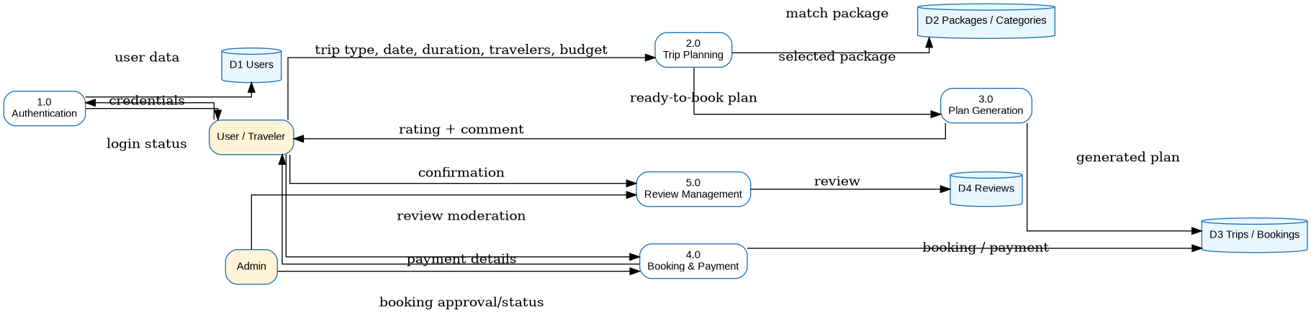
Level-1 Data Flow Diagram

Context Level Diagram
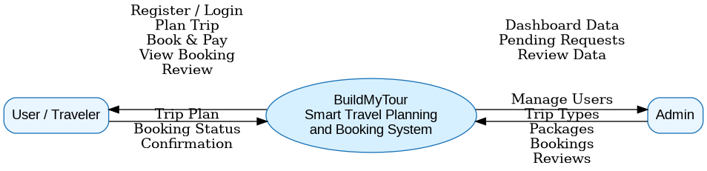
Context Level Diagram
The context view represents the BuildMyTour system as a single process interacting with the User and Administrator. Users provide travel and booking information, while administrators manage system data.

First Level Diagram
First Level / Level-1 Diagram
The first-level process view expands the system into major functional processes such as authentication, trip planning, package handling, booking/payment and administration.

ER Diagram
The Entity Relationship Diagram represents the database entities and their relationships. The design connects users, categories, packages, trips, bookings and reviews while maintaining primary and foreign key relationships.
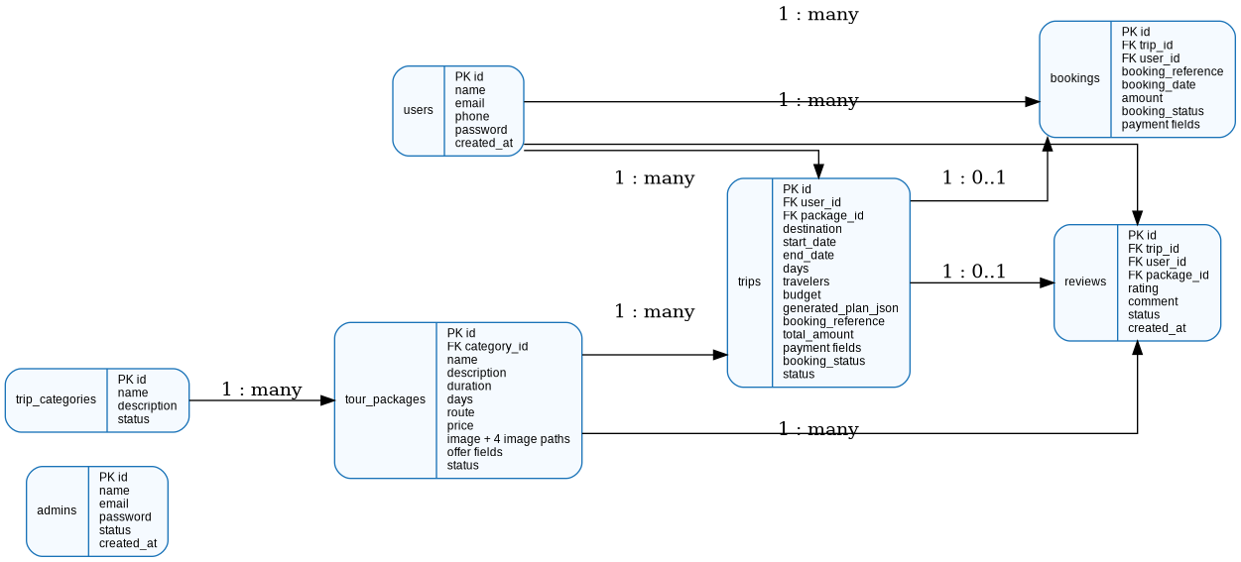
Entity Relationship Diagram

Use Case Diagram
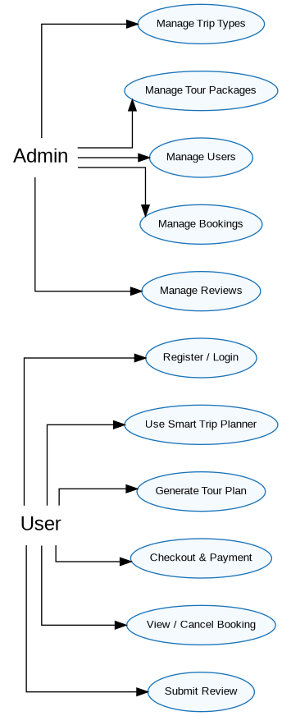
Use Case Diagram

Main User Use Cases
• Register / Login
• Use Smart Trip Planner
• View Generated Plan
• View Tour Package
• Checkout and Payment
• Booking Confirmation
• My Bookings
• Submit Review
• Logout

Activity Diagram – User
User Activity Diagram
The user activity flow starts with authentication and continues through trip planning, package matching, generated plan review, checkout, payment and booking confirmation. After booking, the user can access booking information and review functionality.

Activity Diagram – Admin
Admin Activity Diagram
The administrator activity flow begins with admin authentication and continues to the dashboard. From the dashboard, the administrator can manage categories, packages, users, bookings and reviews.

System Architecture
BuildMyTour System Architecture
The architecture separates the presentation, application and data responsibilities. The browser provides the interface, PHP processes requests and MySQL/MariaDB stores persistent records.

Screenshot (Page UI)
Leh–Ladakh Adventure Expedition – Package Visual
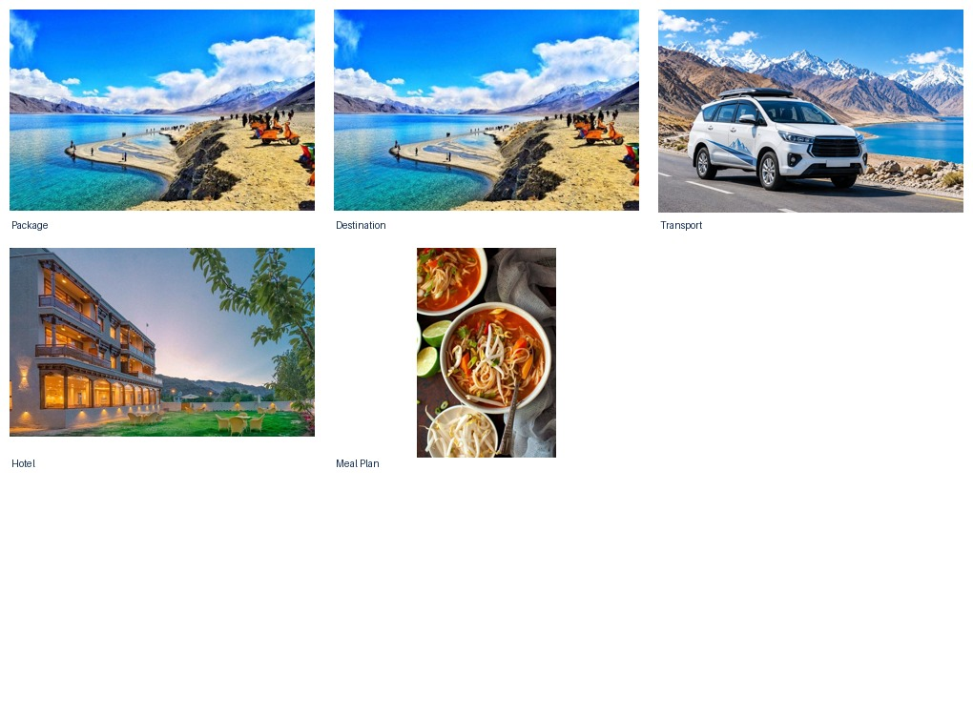
Figure 35 – Leh–Ladakh Adventure Expedition package
This visual represents the package content used by BuildMyTour. Package information is stored in the tour_packages table and can be managed through the Admin section.

Screenshot (Page UI)
Gir Wildlife Safari Adventure – Package Visual
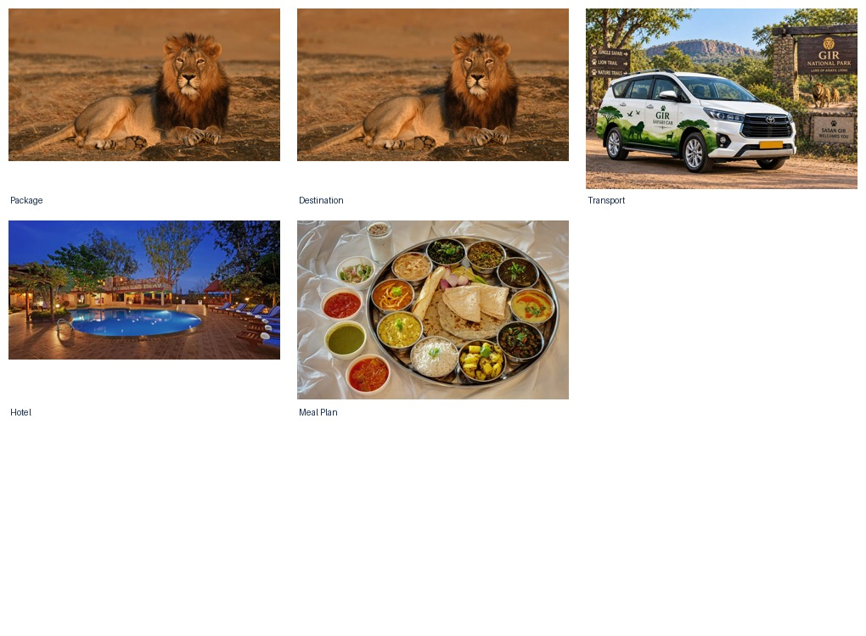
Figure 36 – Gir Wildlife Safari Adventure package
This visual represents the package content used by BuildMyTour. Package information is stored in the tour_packages table and can be managed through the Admin section.

Screenshot (Page UI)
Rishikesh Adventure & Spiritual Escape – Package Visual
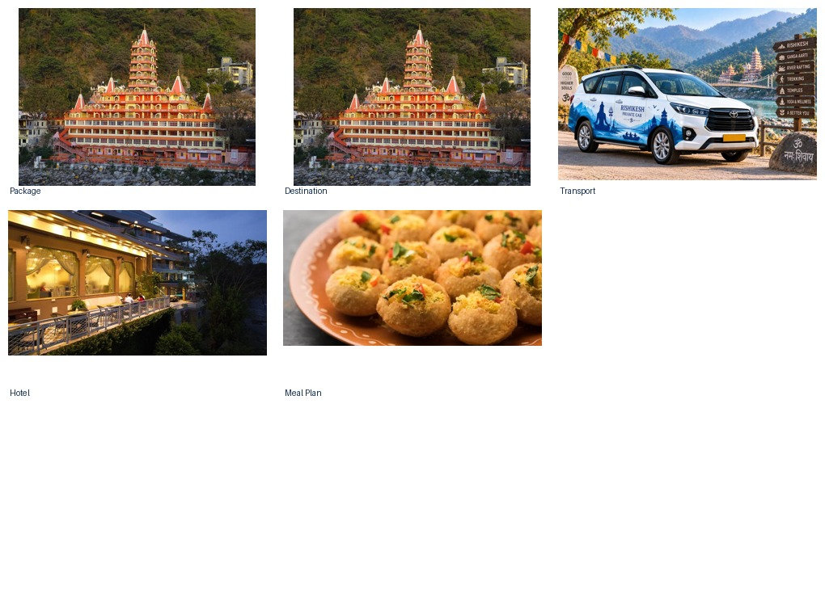
Figure 37 – Rishikesh Adventure & Spiritual Escape package
This visual represents the package content used by BuildMyTour. Package information is stored in the tour_packages table and can be managed through the Admin section.

Screenshot (Page UI)
Rajasthan Royal Heritage Journey – Package Visual
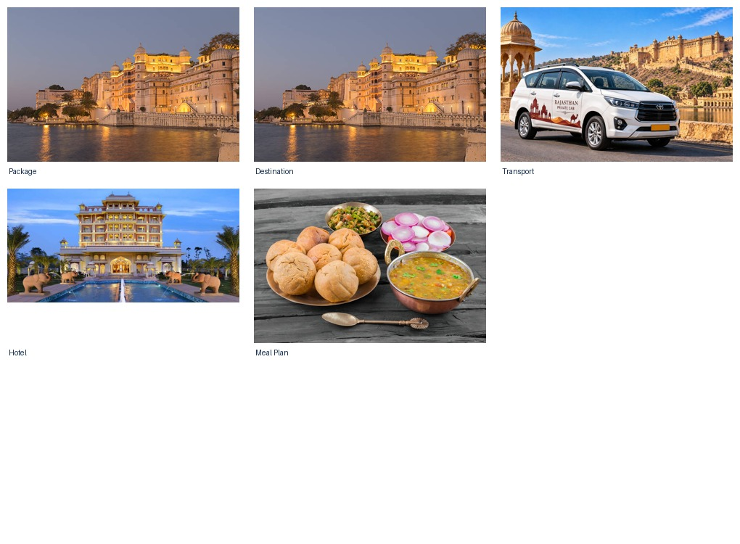
Figure 38 – Rajasthan Royal Heritage Journey package
This visual represents the package content used by BuildMyTour. Package information is stored in the tour_packages table and can be managed through the Admin section.

Screenshot (Page UI)
Kutch White Desert & Cultural Escape – Package Visual
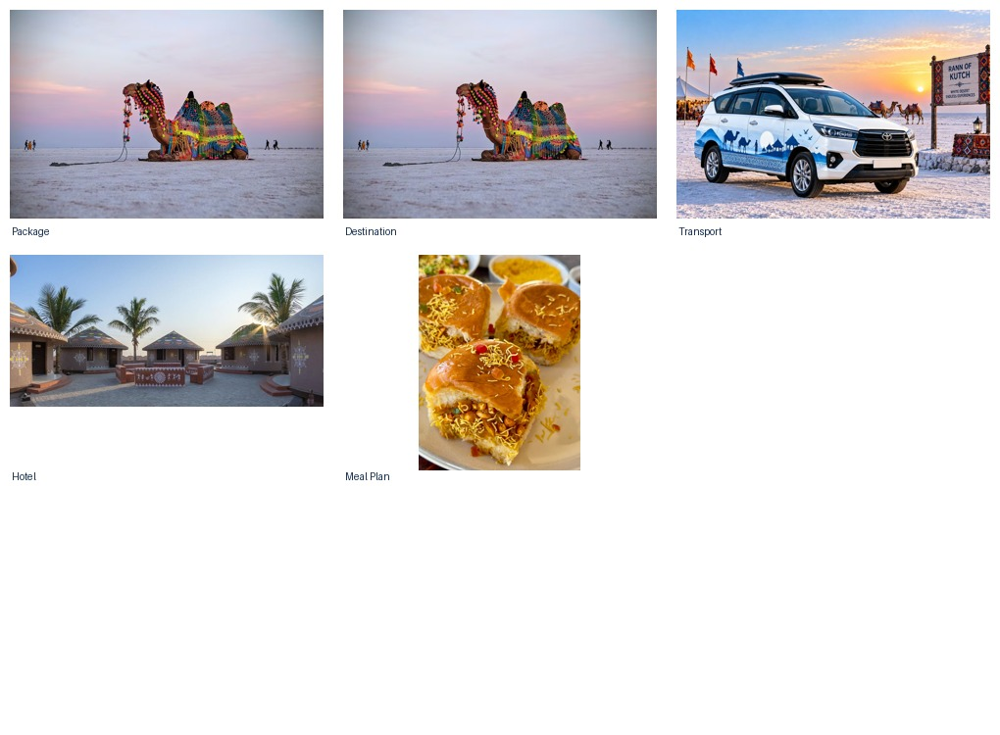
Figure 39 – Kutch White Desert & Cultural Escape package
This visual represents the package content used by BuildMyTour. Package information is stored in the tour_packages table and can be managed through the Admin section.

Screenshot (Page UI)
Ujjain–Omkareshwar Temple Tour – Package Visual
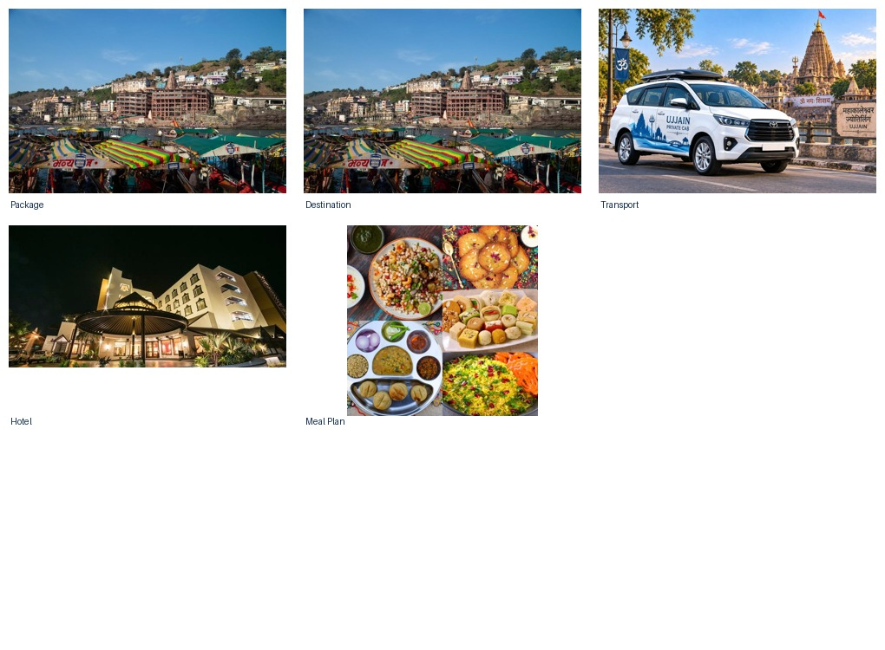
Figure 40 – Ujjain–Omkareshwar Temple Tour package
This visual represents the package content used by BuildMyTour. Package information is stored in the tour_packages table and can be managed through the Admin section.

Screenshot (Page UI)
Leh–Ladakh Adventure Expedition – Destination
Figure 41 – Leh–Ladakh Adventure Expedition
Destination visual asset used in the tour package presentation.

Screenshot (Page UI)
Gir Wildlife Safari Adventure – Destination
Figure 42 – Gir Wildlife Safari Adventure
Destination visual asset used in the tour package presentation.

Screenshot (Page UI)
Rishikesh Adventure & Spiritual Escape – Destination
Figure 43 – Rishikesh Adventure & Spiritual Escape
Destination visual asset used in the tour package presentation.

Screenshot (Page UI)
Rajasthan Royal Heritage Journey – Destination
Figure 44 – Rajasthan Royal Heritage Journey
Destination visual asset used in the tour package presentation.

Screenshot (Page UI)
Kutch White Desert & Cultural Escape – Destination
Figure 45 – Kutch White Desert & Cultural Escape
Destination visual asset used in the tour package presentation.

Screenshot (Page UI)
Ujjain–Omkareshwar Temple Tour – Destination
Figure 46 – Ujjain–Omkareshwar Temple Tour
Destination visual asset used in the tour package presentation.

Screenshot (Page UI)
Leh–Ladakh Adventure Expedition – Transport
Figure 47 – Leh–Ladakh Adventure Expedition
Transport visual asset associated with the selected tour package.

Screenshot (Page UI)
Gir Wildlife Safari Adventure – Transport
Figure 48 – Gir Wildlife Safari Adventure
Transport visual asset associated with the selected tour package.

Screenshot (Page UI)
Rishikesh Adventure & Spiritual Escape – Transport
Figure 49 – Rishikesh Adventure & Spiritual Escape
Transport visual asset associated with the selected tour package.

Screenshot (Page UI)
Rajasthan Royal Heritage Journey – Transport
Figure 50 – Rajasthan Royal Heritage Journey
Transport visual asset associated with the selected tour package.

Screenshot (Page UI)
Kutch White Desert & Cultural Escape – Transport
Figure 51 – Kutch White Desert & Cultural Escape
Transport visual asset associated with the selected tour package.

Screenshot (Page UI)
Ujjain–Omkareshwar Temple Tour – Transport
Figure 52 – Ujjain–Omkareshwar Temple Tour
Transport visual asset associated with the selected tour package.

Screenshot (Page UI)
Leh–Ladakh Adventure Expedition – Hotel / Accommodation
Figure 53 – Leh–Ladakh Adventure Expedition
Hotel visual asset associated with the selected tour package.

Screenshot (Page UI)
Gir Wildlife Safari Adventure – Hotel / Accommodation
Figure 54 – Gir Wildlife Safari Adventure
Hotel visual asset associated with the selected tour package.

Screenshot (Page UI)
Rishikesh Adventure & Spiritual Escape – Hotel / Accommodation
Figure 55 – Rishikesh Adventure & Spiritual Escape
Hotel visual asset associated with the selected tour package.

Screenshot (Page UI)
Rajasthan Royal Heritage Journey – Hotel / Accommodation
Figure 56 – Rajasthan Royal Heritage Journey
Hotel visual asset associated with the selected tour package.

Screenshot (Page UI)
Kutch White Desert & Cultural Escape – Hotel / Accommodation
Figure 57 – Kutch White Desert & Cultural Escape
Hotel visual asset associated with the selected tour package.

Screenshot (Page UI)
Ujjain–Omkareshwar Temple Tour – Hotel / Accommodation
Figure 58 – Ujjain–Omkareshwar Temple Tour
Hotel visual asset associated with the selected tour package.

Screenshot (Page UI)
Leh–Ladakh Adventure Expedition – Meal Plan
Figure 59 – Leh–Ladakh Adventure Expedition
Meal-plan visual asset associated with the selected tour package.

Screenshot (Page UI)
Gir Wildlife Safari Adventure – Meal Plan
Figure 60 – Gir Wildlife Safari Adventure
Meal-plan visual asset associated with the selected tour package.

Screenshot (Page UI)
Rishikesh Adventure & Spiritual Escape – Meal Plan
Figure 61 – Rishikesh Adventure & Spiritual Escape
Meal-plan visual asset associated with the selected tour package.

Screenshot (Page UI)
Rajasthan Royal Heritage Journey – Meal Plan
Figure 62 – Rajasthan Royal Heritage Journey
Meal-plan visual asset associated with the selected tour package.

Screenshot (Page UI)
Kutch White Desert & Cultural Escape – Meal Plan
Figure 63 – Kutch White Desert & Cultural Escape
Meal-plan visual asset associated with the selected tour package.

Screenshot (Page UI)
Ujjain–Omkareshwar Temple Tour – Meal Plan
Figure 64 – Ujjain–Omkareshwar Temple Tour
Meal-plan visual asset associated with the selected tour package.

Future Scope
The current BuildMyTour project provides a practical academic implementation of travel planning and booking. The system can be enhanced with additional real-world services and intelligent features.
• Integration with live flight and hotel availability APIs.
• Real payment gateway integration.
• Interactive maps and route visualization.
• Email and SMS booking notifications.
• PDF itinerary and invoice generation.
• Multilingual user interface.
• Advanced personalized travel recommendations.
• Admin analytics and reporting.
• Real-time booking availability and cancellation workflows.

References / Bibliography
• PHP Manual – php.net
• MySQL Documentation – dev.mysql.com
• Bootstrap Documentation – getbootstrap.com
• MDN Web Docs – developer.mozilla.org
• XAMPP – apachefriends.org
• BuildMyTour project source code and database schema

CD / DVD
The following items are intended to be included with the final project submission media, as applicable to the college requirement.
• Project Source Code – BuildMyTour
• Database – buildmytour.sql
• Project Documentation – Word/PDF report
• Project Screenshots / Supporting Visuals
Student Name: Ashvin Makvana
Project: Smart Travel Planning and Booking System
Website: BuildMyTour
Academic Year: 2026

