

A Project Report On

“Freelancing System”
✪CODEX✪
Kamani Science & Prtaprai Arts College, Amreli

Developed By
Gohil Jay (Roll No - 5038)
Guided By
Mr. Rakesh Sir Savaliya Mr. Ravi Sir Joshi Year Of Submission
Submitted in partial fulfillment of the requirement for
the award of the degree of Bachelor of Computer Application
(BCA)

2021-2022


Saurashtra University-Rajkot

2
Develop By Jay Gohil
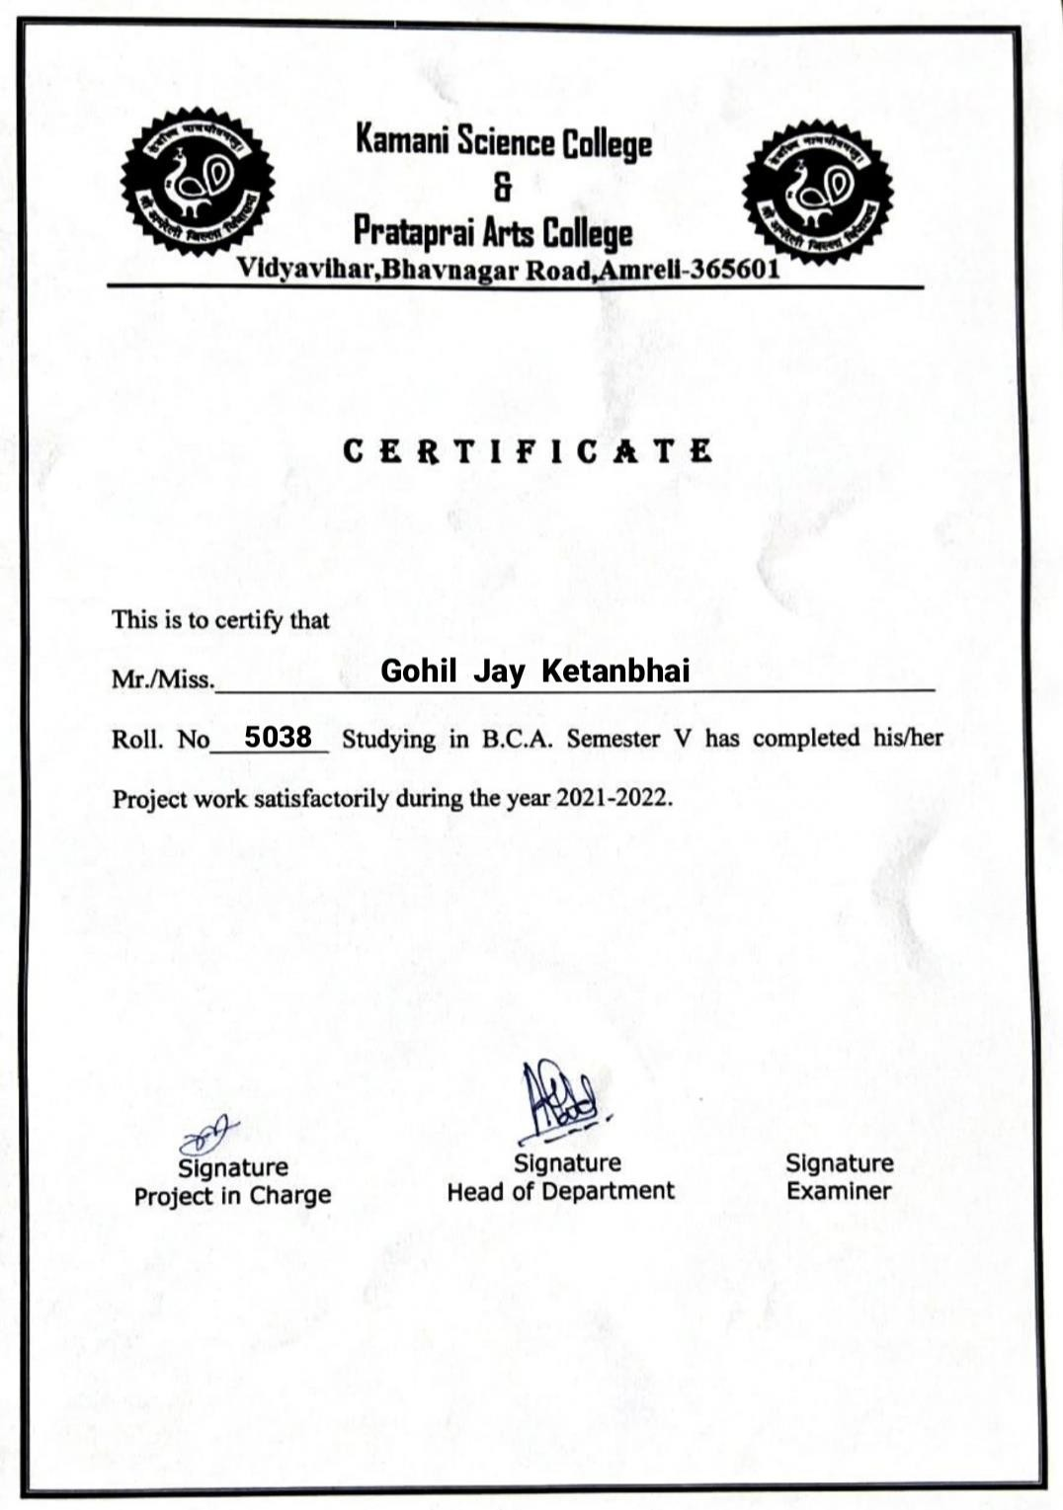

3 Develop By Jay Gohil
Index

No | Title | Page No
1 | Preface | 5
2 | Acknowledgement | 6
3 | Abstract | 7
4 | Introduction | 8
5 | Time Line Chart | 9
6 | Project Profile | 10
7 | Hardware Requirement | 11
8 | Software Requirement | 11
9 | Requirement Specification | 12
10 | Problem Definition | 13
11 | Project Planning& Scheduling | 14
12 | System Analysis | 16
13 | Feasibility Study | 17
14 | Project Page Structure | 19
15 | Data Dictionary | 22
16 | Data Flow Diagram | 27
17 | Context & First Level Diagram | 28-29
18 | ER Diagram | 30
19 | Use case Diagram | 31
20 | Activity Diagram | 32-34
21 | Screenshot (Page UI) | 35
22 | Future Scope & References | 65
4
Develop By Jay Gohil

Preface

The main objective of any computer science student is to getpractical knowledge as possible. Being able to have a practical knowledge by developing a project is a lifetime experience. As practical knowledge is important as theoretical knowledge we are thankful of having a project.

Through the development of the project we had a great experience of various strategies that can be applied in development of the project. This project is the stepping stone for our career.

We are pleased to present this project report. Proper case has been taken while organizing the report so that it is easy to comprehend. Also, various software engineering concepts have been implemented.

5
Develop By Jay Gohil

Acknowledgment

We are student of BCA sem-5 Studying in the Kamani Science College Amreli. We Thanks to the entire person who has given their Support in shaping of the system.

We thank Mr. Rakesh Sir Savaliya and Ravi Sir Joshi for giving us guidance and co-operation in understanding the system. We also thanks them for their unconditional help in making of this project.

We have great deal of gratitude towards our head of department who encourages in taking up this activity. We thank all faculties and administrative staffs of the institute.

I am also thankful to all those friends who have helped me in this endeavor either of indirectly & especially my family.

Thanks to all!!

Gohil Jay

6
Develop By Jay Gohil

Abstract

The online Freelance Marketplace is a Web Portal on which freelancers and Employers interact with each other in this platform, an employer usually post a project and many freelancers bid on that project, the most efficient bid. In this way the employer gets his job done and the freelancers earn money.

This project aims to develop a freelance marketplace where not only an employer could post a project for bidding but freelancers could also offers his/her services for buyers.

Freelancers and client both can be benefited from this bidding. Client who wish to hire internationally can take advantage of favorable overseas exchange rates , resulting in work being done for 50-90% less than if the project where done in country and also given access to a huge pool of potential work and have the ability to work independently from their homes rather than for a company.

7
Develop By Jay Gohil

Introduction

Clients often need custom software developed to enhance their business or for personal use. These clients post their projects on this site, along with a
maximum amount that they are willing to pay. The project is seen by freelancer’s available world-wide and they place their bids on doing the work. The freelancer can browse through each other bidders resume certifications and previous work history on the site
Freelancer is a term commonly used for a person who is self-employed and is not necessarily committed as a particular employer. Freelancers can take several projects. It becomes difficult for a freelancer to manage every task and remember it. For this issue we came up with a solution, this freelancer management system helps the freelancers to manage their projects, there are two modules in this system namely Admin and Freelancer section. Admin can login and add freelancer, manage freelancers, create and assign projects to freelancers, they can also check the progress of the allotted projects along with the report. In Freelancer section, user can login and get new projects assigned, they can view project progress, previous completed projects and they can also give their feedback on it. This is how the system helps to manage the tasks and to get the task to a freelancer.
When the freelancers find by clients they like, they can hire them on the spot to make the transaction a safe, the client does not pay the freelancer directly, but escrows the funds into a special account. This guarantees to the freelancer that the client is credit-worthy, and also resources the client because the freelancer receives no money until the work is complete. When the work is completed the
freelancers release the funds to the freelancers. When the work is completed, both parties rate the other party to help future clients and freelancers on the site.

8
Develop By Jay Gohil

Time Line Chart

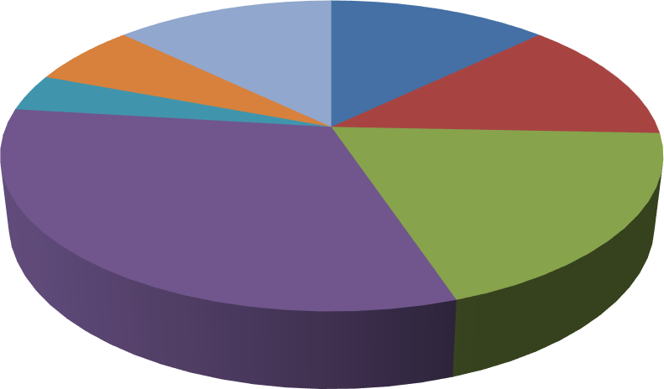
Sales
Priliminary
Investigation
13%
Implementation
6%
Testing 4%
Maintanance
13%
System Analysis
13%
Coding
32%
System Design
19%
Preliminary Investigation 10 Days
System Analysis 10 Days
System Design 15 Days
Coding 25 Days
Testing 3 Days
Implementation 5 Days
Maintenance 15 Days

9
Develop By Jay Gohil

Project Profile

- Project Name : Freelancing System

- Developed by : Gohil Jay

- Front End tool : PHP , JavaScript , Ajax
- Back End tool : PHP MySQL

- Operating System : Microsoft Windows 7 &Microsoft Windows 10

- Computer System : Pentium-IV or Higher, RAM: 256 MB

- Project Details : Provide best platform for freelancers and
Employers, employers post the project and freelancers get this project and both of benefit this portal

- Completion Time : 3 Months

- Guided by : Mr. Rakesh Savaliya & Mr. Ravi Joshi

- Submitted by : Saurashtra University, Rajkot

10
Develop By Jay Gohil

Hardware Requirement

- 512+ MB Of RAM
- Multimedia Keyboard And Mouse
- GHz Processor
- Monitor
- Printer

Software Requirement

  - Operating System : Microsoft windows 7 & Microsoft windows 10
  - Front End Tools : PHP , JavaScript , CSS , Ajax , Sublime Text 3
  - Back End Tools : PHP MySQL
  - Documentation Tool : Microsoft word 2007
  - Browser Specification : Google Chrome , Mozilla Firefox

11
Develop By Jay Gohil

Requirement Specification

In this section provides requirements overview of the system.

Registration :

  - Employer :

If employer wants to post project then must be registered, unregistered employer can’t post a project.

Freelancer :

If freelancer want to get the project then must be registered, unregistered freelancer can’t get a project.

Login :

Customer login to the system by entering valid user id and password for the use important functionality of system.

Post Project :

Employer can easily post project in this system.

Get Project :

Freelancer can easily get project using this system.
12
Develop By Jay Gohil

Send Project To Employer :

After completed the project freelancer get full payment.

Generation Report :

After completing all activities employer and freelancer get full report of project.

Project Problem Definition

- Maintain User Profile

- Maintain Project Filter

- Maintain Payment

- Maintain Rating Of Freelancer

- Maintain Allocated Work

13
Develop By Jay Gohil

Project Planning & Scheduling

Project planning is an aspect of Project Management, which comprises of various processes. The aim of these processes is to ensure that various Project tasks are well coordinated and they meet the various project objectives including timely completion of the project. Project Planning is an aspect of Project Management that focuses a lot on Project Integration. The project plan reflects the current status of all project activities and is used to monitor and control the project.

The Project Planning tasks ensure that various elements of the Project are coordinated and therefore guide the project execution. Project Scheduling is one of the most important task of Project Planning and also the most difficult tasks. In very large projects it is possible that several teams work on developing the project. They may work on it in parallel. However their work may be interdependent.

14
Develop By Jay Gohil
- Project Planning & Scheduling as under :

Preliminary Investigation
System Analysis

System Design
Coding
Testing
Maintenance
Implementation

15
Develop By Jay Gohil

System Analysis

System analysis is the process of identification of objectives and requirements, evaluation of alternative solutions and recommendation for a more feasible solution. In other words, system analysis is the step by step process of gathering, recording and interpreting facts. The main aim of analysis is to determine problem areas and to take solutions to reduce or eliminate them.

  - System analysis itself breaks into two stages:

Preliminary analysis :

- Detailed analysis :

During analysis, data are collected from the available files, decision points and transactions of the systems using various tools like Data Flow Diagram (DFD).

16
Develop By Jay Gohil

Feasibility Study

A purpose of feasibility study is to check out the possibility of a computerized solution to the organization’s observed problem before very much money that has been spent on.

A feasibility study is carried out to select the best system that meets performance requirements. Only by spending the time to evaluate the feasibility do I reduce the chances for extreme embarrassment at later stage of the system project.

For the complete feasibility study I need to concentrate on following
area:

- They are three types of feasibility Study :

- Technical
- Operational
- Economical

17
Develop By Jay Gohil

Technical :

Technical feasibility considers whether the desired project can be completed within the framework of available technology. As our project was website designing, this was not much of a problem, as many advanced web-editing tools are available.

Operational :

Operational feasibility was done to assure that the product that would be developed would be used. Since a cards and gifts have to have a website of its own sooner or later, that wasn’t much of a problem.

Economical :

Our Commercial Website is Economically Feasible Because. We have developed this website only for one time. Only future enhancement is required on the other hand every client can view our site any time or many time as per their requirement. So the future economical expenses are null. So we can say that this website is totally economically feasible.

18
Develop By Jay Gohil

Project Page Structure

    - Employer Side :

Employer Side

Logout
Get Work
Get Application
Registration
/Login

Post Work
Send Work
Payment

19
Develop By Jay Gohil

    - Freelancer Side :

Freelancer Side

Logout
Send Work
Apply Work
Registration
/Login

View All Work
Get Work
Get Payment

20
Develop By Jay Gohil

    - Admin Side :

Admin Side

Manage Payment
Manage Employers
View All Work
Login

View All Application
Manage Freelancers
Logout

21
Develop By Jay Gohil

Data Dictionary

The data Dictionary is a set of table. MySQL uses it to maintain information about this own database.

Data dictionary contains the following information :

      - Name of the table of database.
      - User information such as privileges.
      - Name and data-type of all columns in database table.

- Database Name : codex

admin_login :

This table is used to store admin information.

Field | Date Type | Size | Attribute
admin_id | Int | 10 | Primary Key
admin_name | Varchar | 50 | -
admin_username | Varchar | 50 | -
admin_email | Varchar | 100 | -
admin_pass | Varchar | 100 | -

22
Develop By Jay Gohil

users :
This table is used to store user registration information.

Field | Data Type | Size | Attribute
user_id | Int | 11 | Primary Key
username | Varchar | 50 | -
email | Varchar | 100 | -
role | Varchar | 30 | -
pass | Varchar | 100 | -
status | Int | 11 | -

postwork :

This table is used to store post work all information.

Field | Data Type | Size | Attribute
pw_id | Int | 10 | Primary Key
employer_id | Int | 11 | Foreign Key
pw_title | Varchar | 50 | -
pw_details | Varchar | 500 | -
pw_doc | Varchar | 100 | -

Application :
This table is used to store all information about work application.

23
Develop By Jay Gohil
Field | Data Type | Size | Attribute
ap_id | Int | 10 | Primary Key
pw_id | Int | 10 | Foreign Key
freelancer_id | Int | 11 | Foreign Key
work_title | Varchar | 100 | -
ap_name | Varchar | 50 | -
ap_gender | Varchar | 20 | -
ap_dob | Date | - | -
ap_expectsal | Double | - | -
skill | Varchar | 500 | -
status | Int | 10 | -
time | Timestamp | - | -

sendwork :
This table is used to store send work details to client.

Field | Data Type | Size | Attribute
sw_id | Int | 11 | Primary Key
pw_id | Int | 10 | Foreign Key
employer_id | Int | 11 | Foreign Key
user_id | Int | 11 | Foreign Key
work_title | Varchar | 100 | -
work_details | Varchar | 500 | -
last date | Date | - | -
upload_work | Varchar | 200 | -
status | Varchar | 50 | -
time | Timestamp | - | -
PAYID | Varchar | 20 | -
TXNAMOUNT | Double | - | -
TXNDATE | Varchar | 11 | -
TXNSTATUS | Varchar | 30 | -

getwork :
This table is used to store getwork information from the client.

24
Develop By Jay Gohil

Field | Data Type | Size | Attribute
gw_id | Int | 10 | Primary Key
sw_id | Int | 11 | Foreign Key
user_id | Int | 11 | Foreign Key
work_title | Varchar | 100 | -
status | Varchar | 30 | -
upload_work | Varchar | 200 | -
feedback | Varchar | 500 | -
pay_value | Double | - | -
time | Timestamp | - | -
PAYID | Varchar | 50 | -
TXNAMOUNT | Double | - | -
TXNDATE | Varchar | 20 | -
TXNSTATUS | Varchar | 20 | -

contactus :
This table is used to store contact us information.

Field | Date Type | Size | Attribute
c_id | Int | 10 | Primary Key
name | Varchar | 50 | -
email | Varchar | 100 | -
subject | Varchar | 200 | -
message | Varchar | 500 | -

bank_details :

This table is used to store freelancer bank details.

25
Develop By Jay Gohil

Field | Date Type | Size | Attribute
b_id | Int | 10 | Primary Key
user_id | Int | 11 | -
bank_name | Varchar | 50 | -
acc_no | Varchar | 50 | -
ifsc_code | Varchar | 30 | -
address | Varchar | 60 | -
status | Varchar | 10 | -

rating :

This table is used to store rating of freelancer.

Field | Date Type | Size | Attribute
id | Int | 10 | Primary Key
user_id | Int | 11 | -
rating | Float | - | -
count | Int | 10 | -

26
Develop By Jay Gohil

Data Flow Diagram
The DFD gives brief idea on how the designed system is working. It also suggests to us the type of users who using this system and the process involved in the system.

Represent data flow

Represent a Entity

Represent a data table

Represent a processing

27
Develop By Jay Gohil

Context Level Diagram

Account Created New Account Created
Process
To Create
New Account
0.0
Freelancing
Project
Admin
Codex
Process To
Login

Create New Account
Freelancers/
employers
Make Login

Transfer To Login Page Username & Password Does Not Match

28
Develop By Jay Gohil

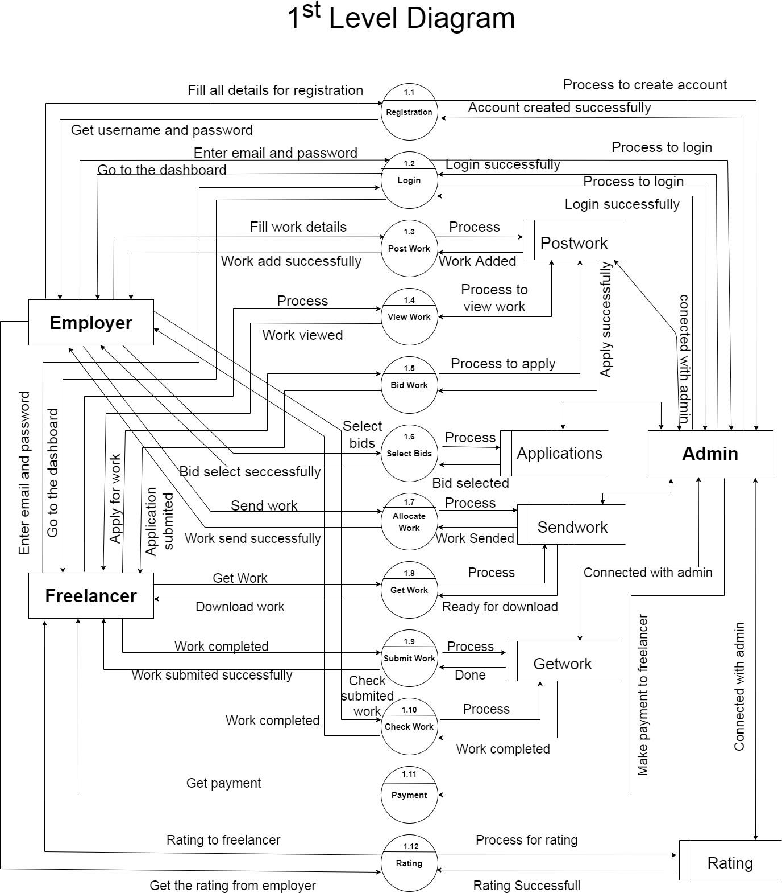

29
Develop By Jay Gohil
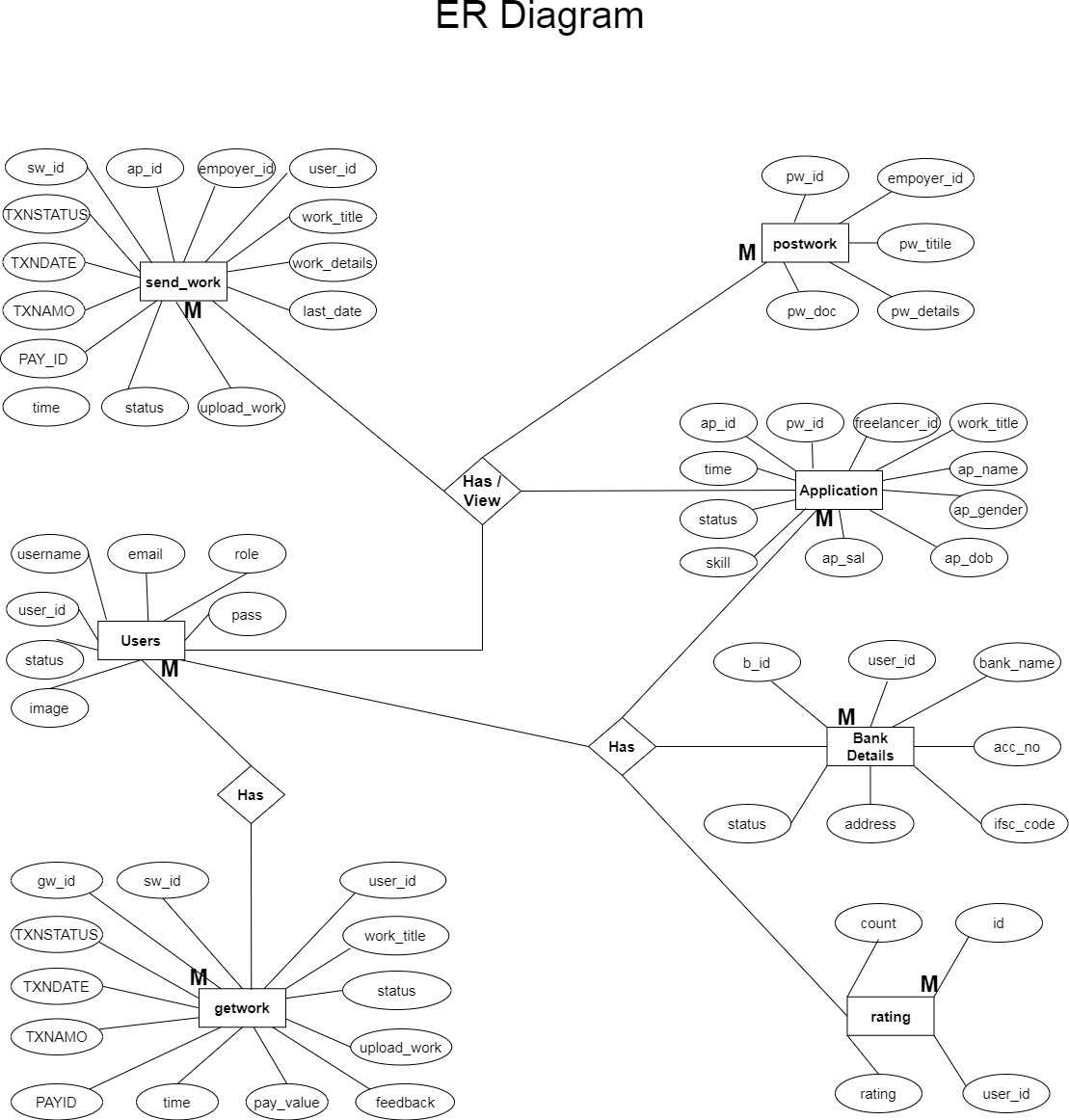

30
Develop By Jay Gohil
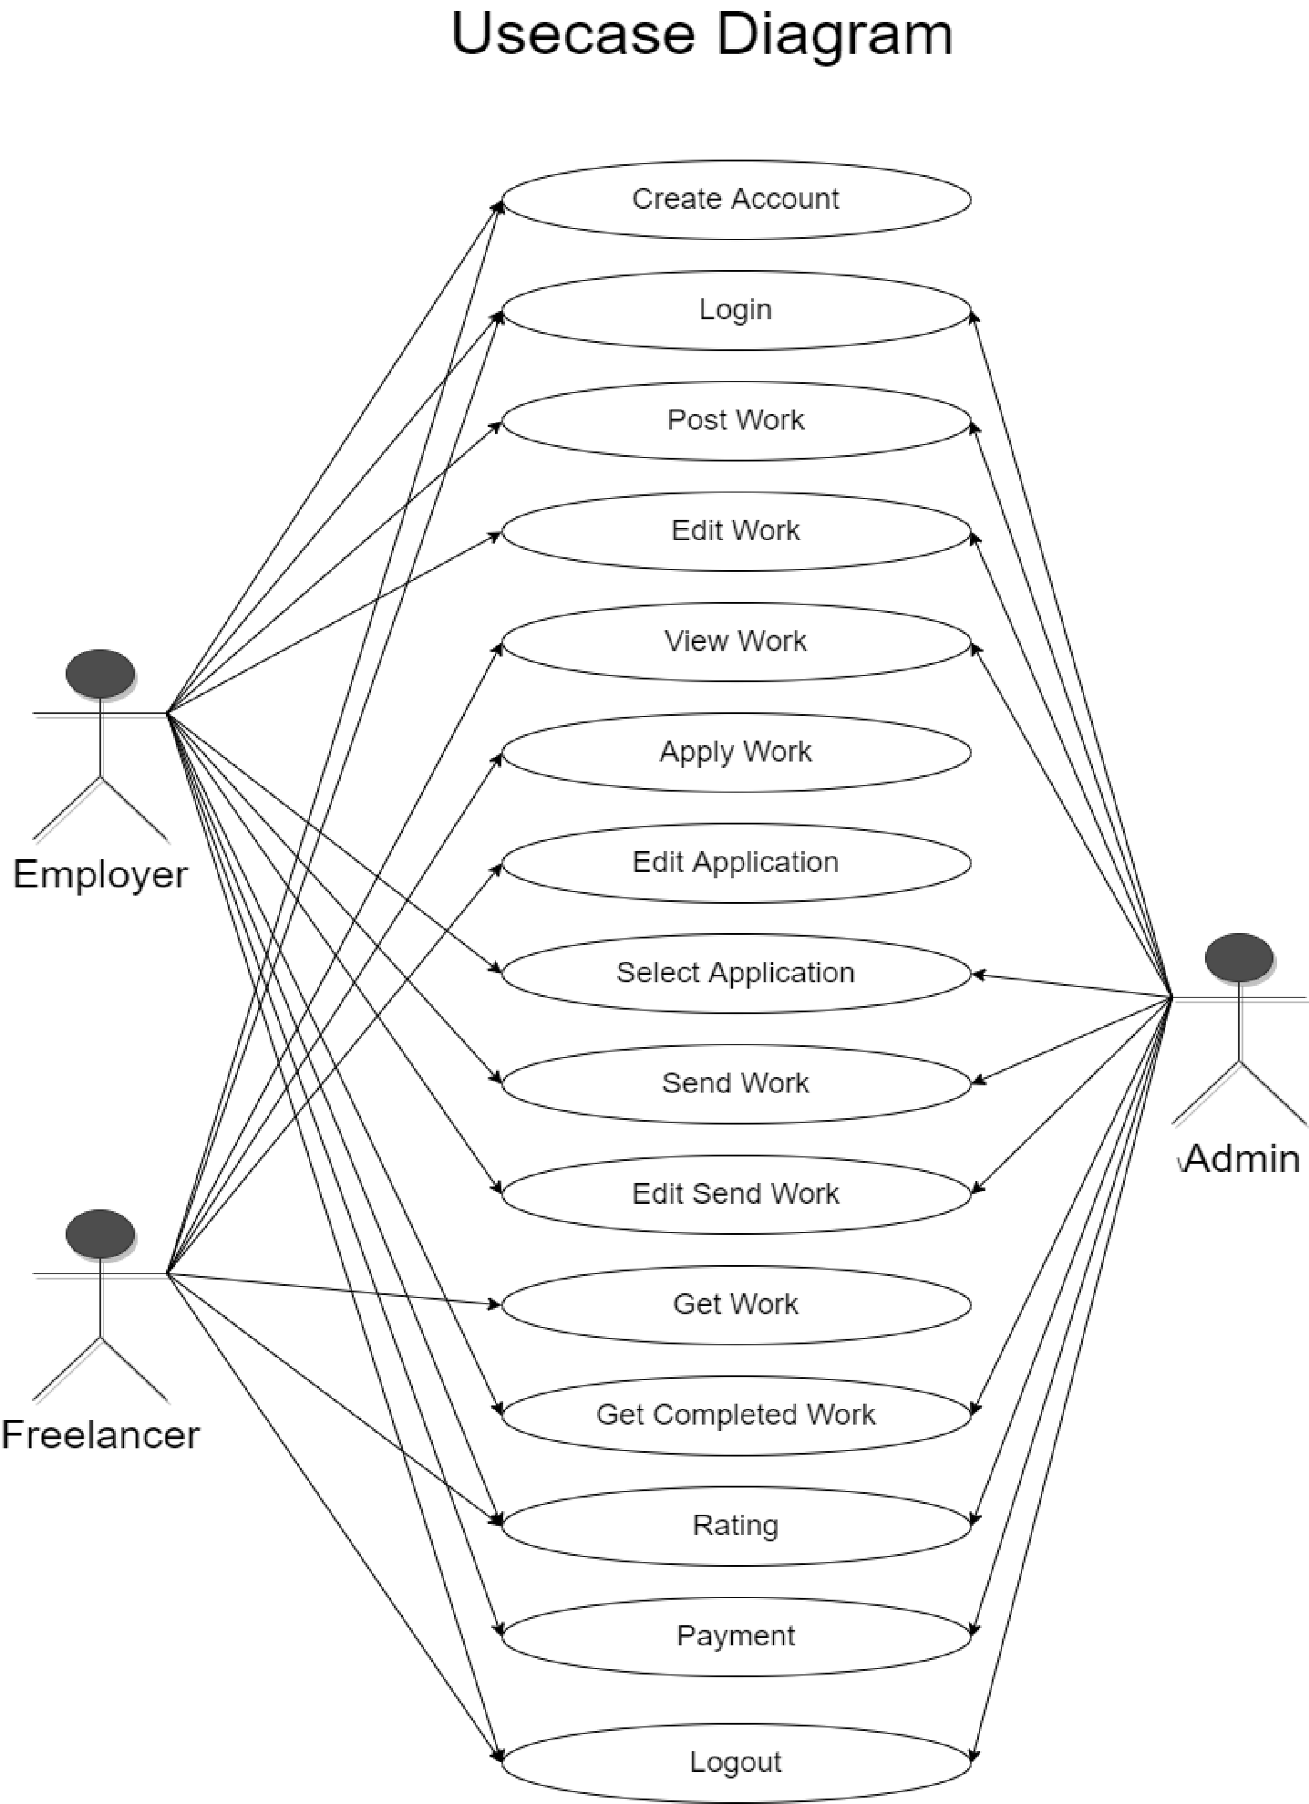
31 Develop By Jay Gohil
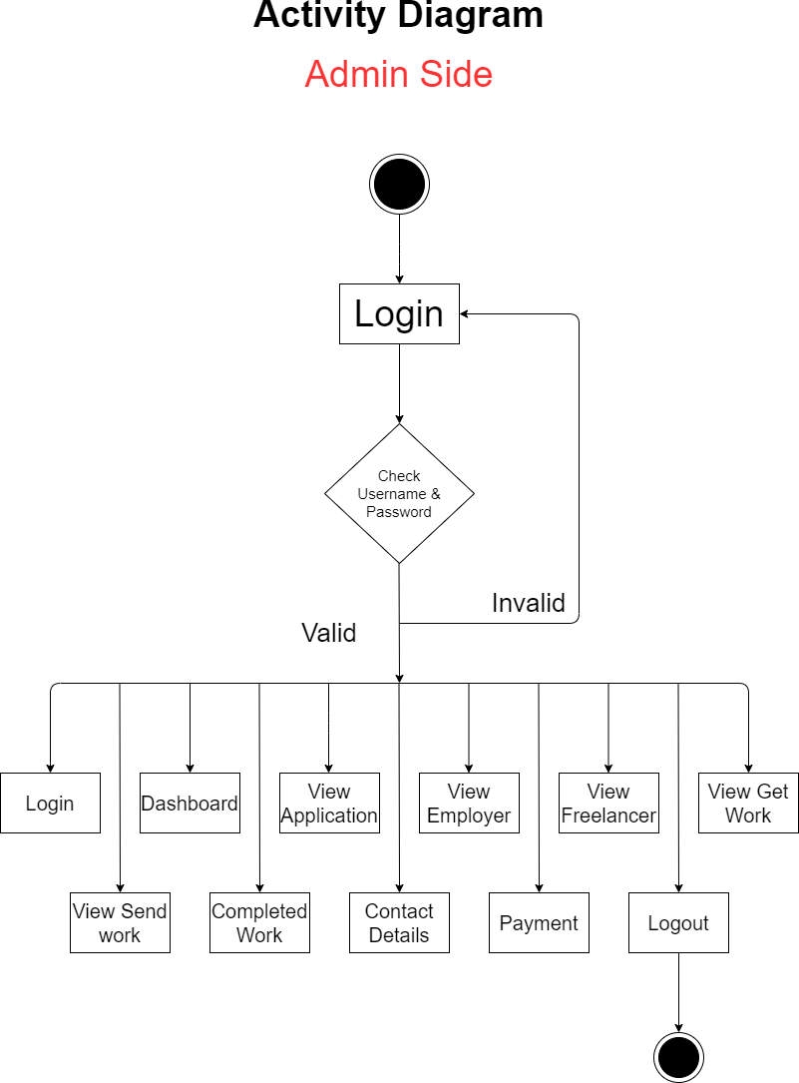

32
Develop By Jay Gohil
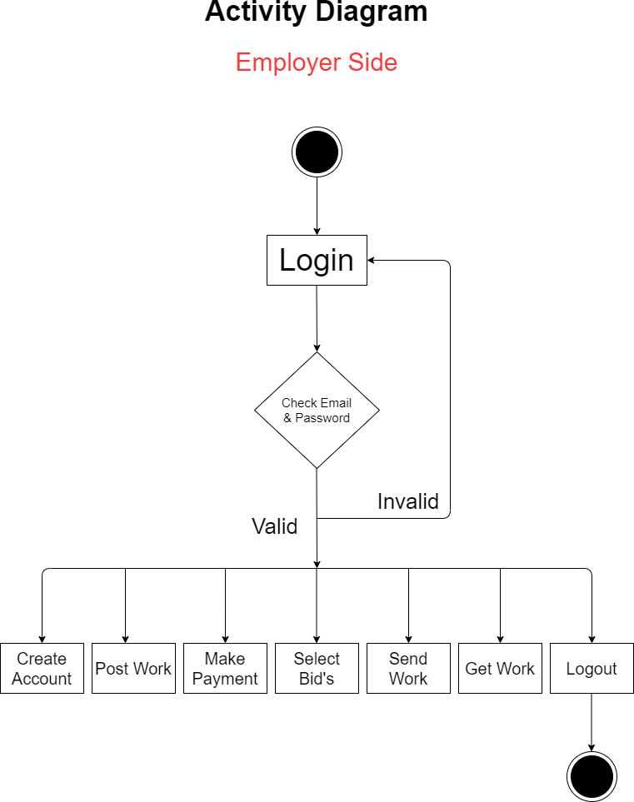

33
Develop By Jay Gohil
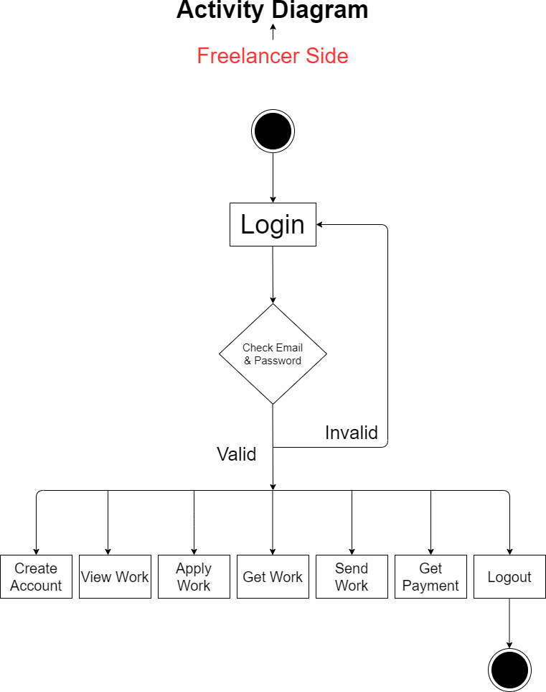

34 Develop By Jay Gohil

- Main Index File :

Screen Shots

Front Website

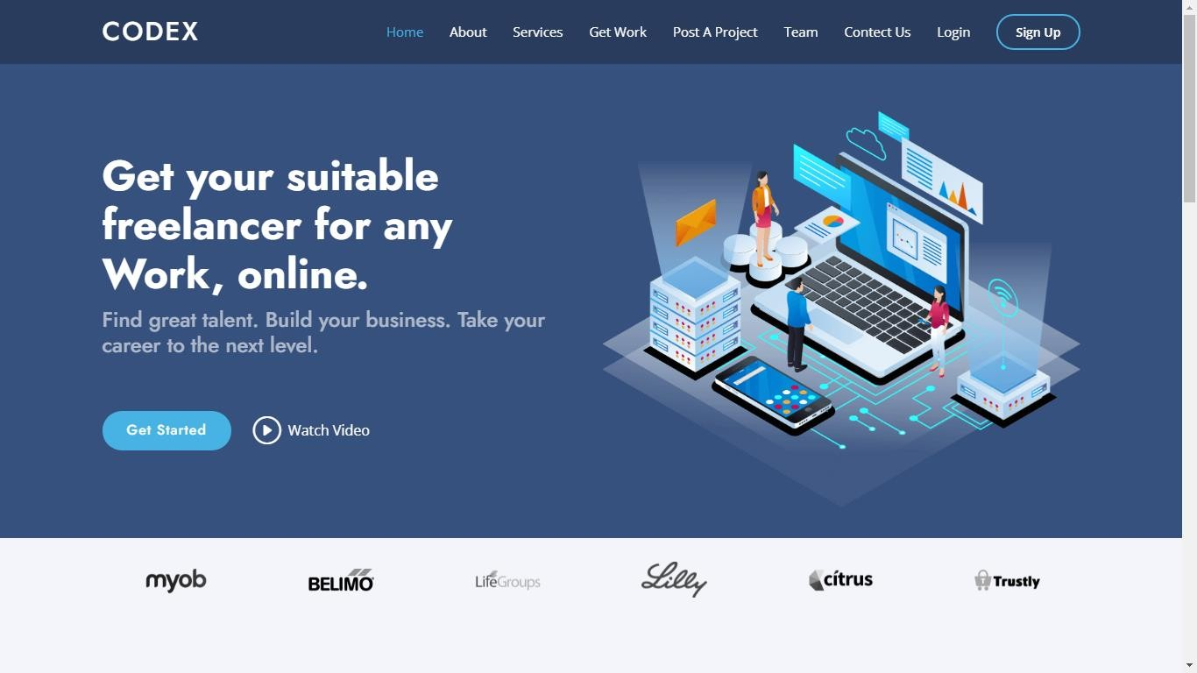

- What Great About It ? :
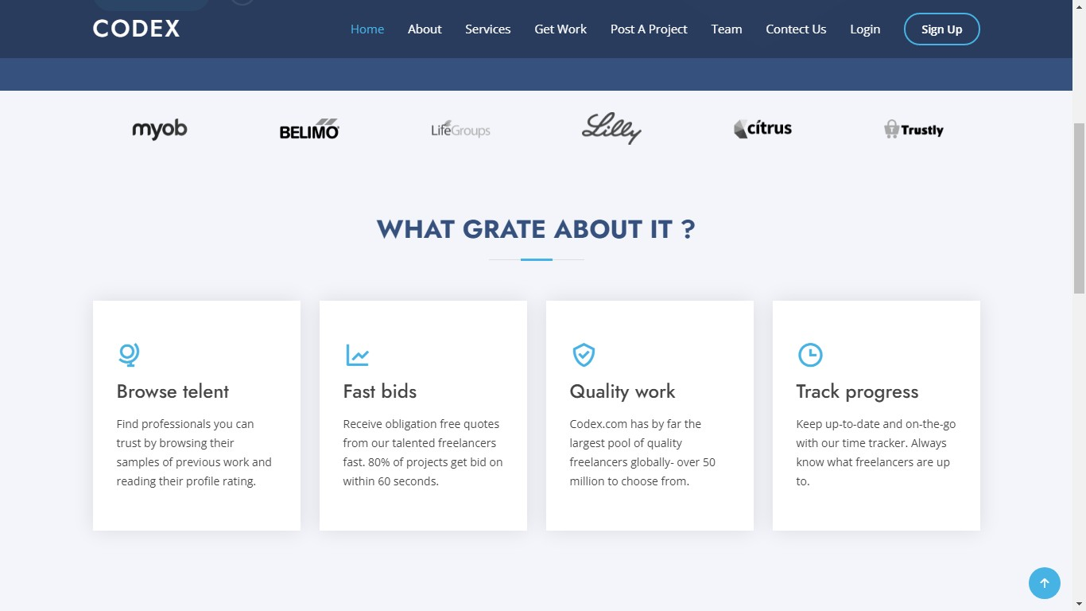
35
Develop By Jay Gohil

- Why Codex ? :

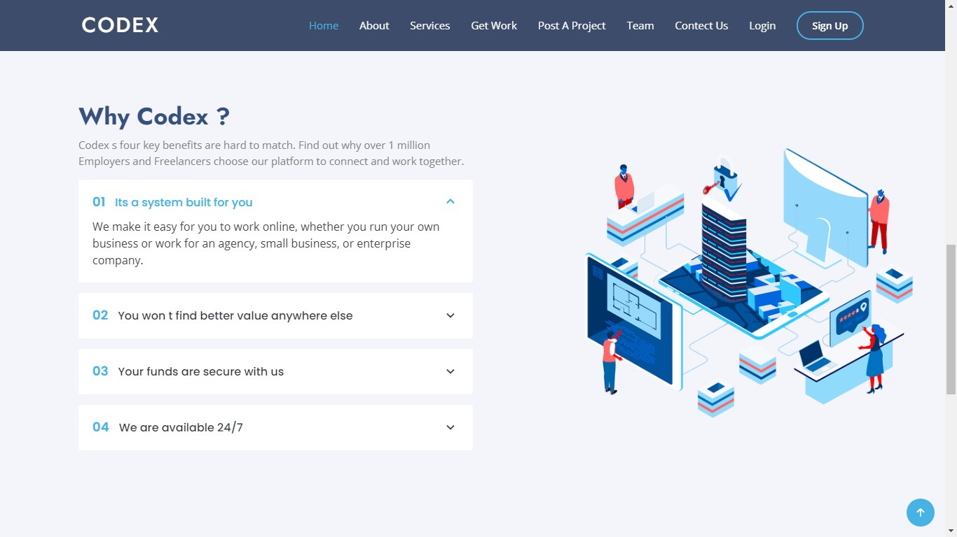

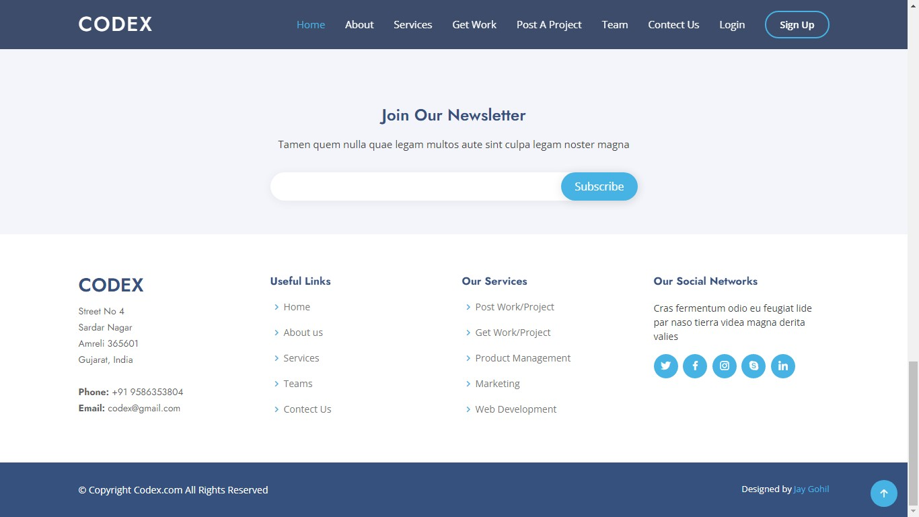
- Footer Area :

36 | Develop By Jay Gohil

- About Us :
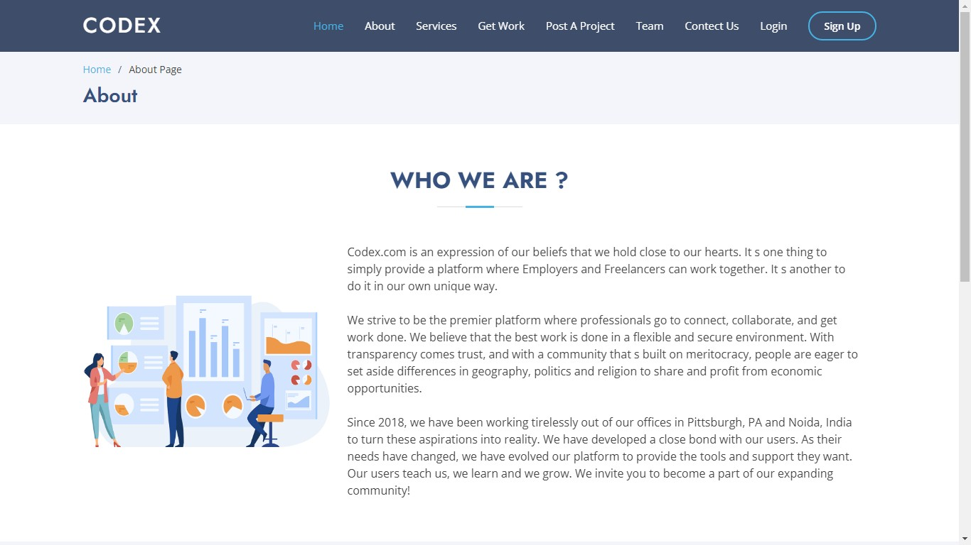

- About Us Footer :

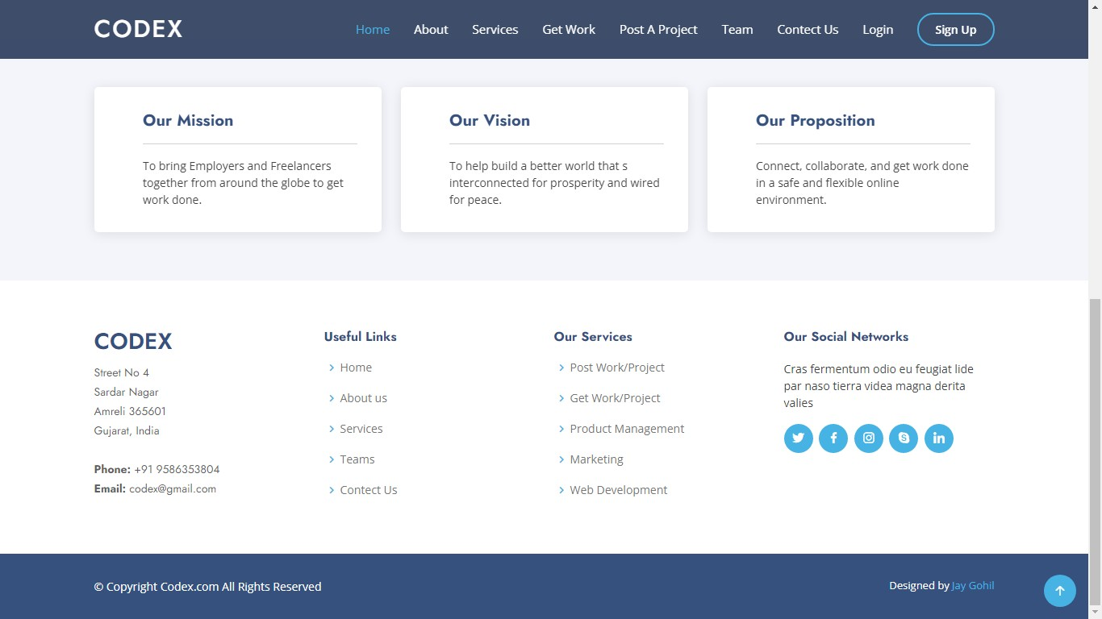

37
Develop By Jay Gohil
- Services :

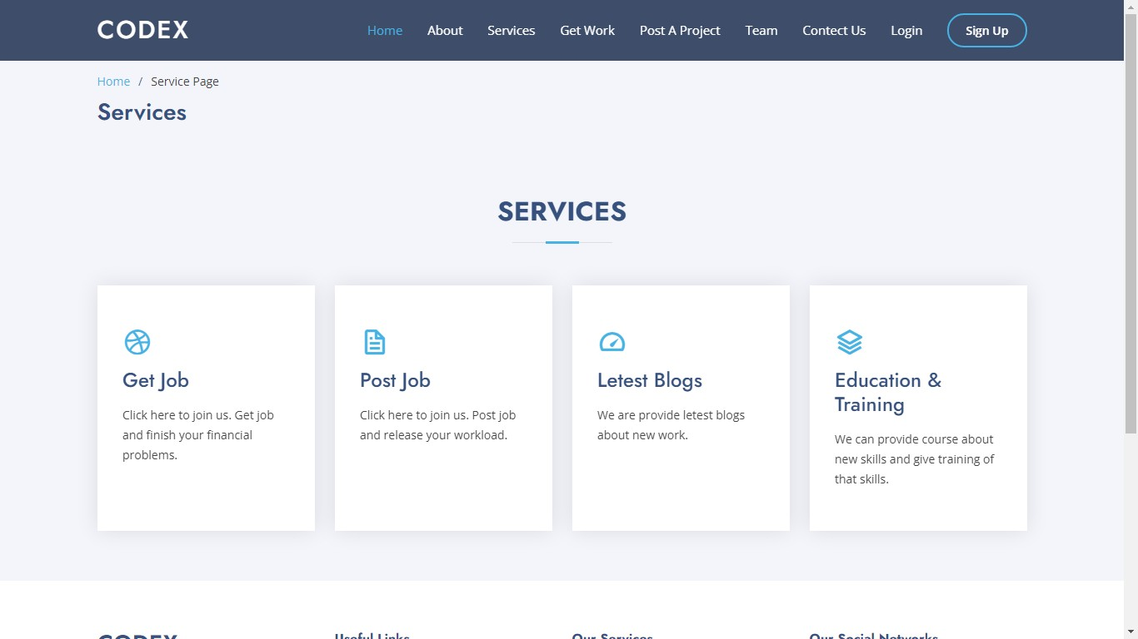
- Team :

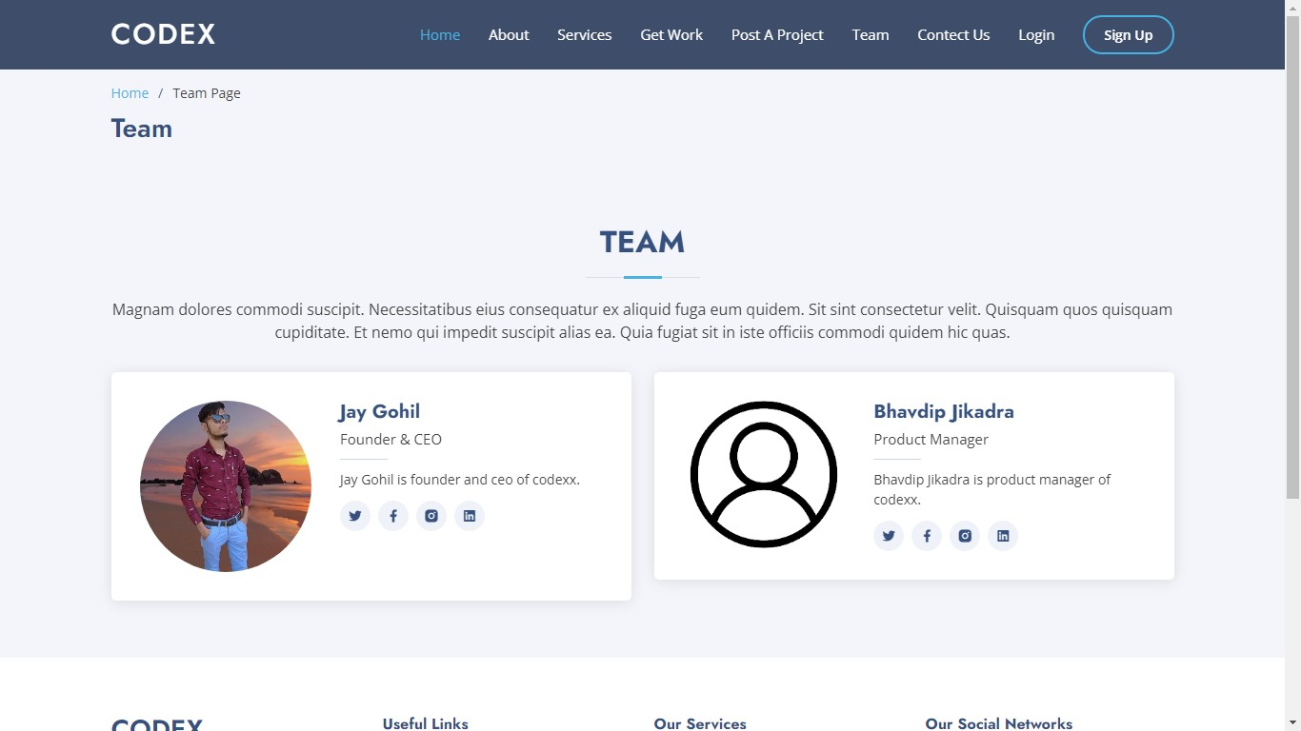
38 | Develop By Jay Gohil

- Registration Account Type :

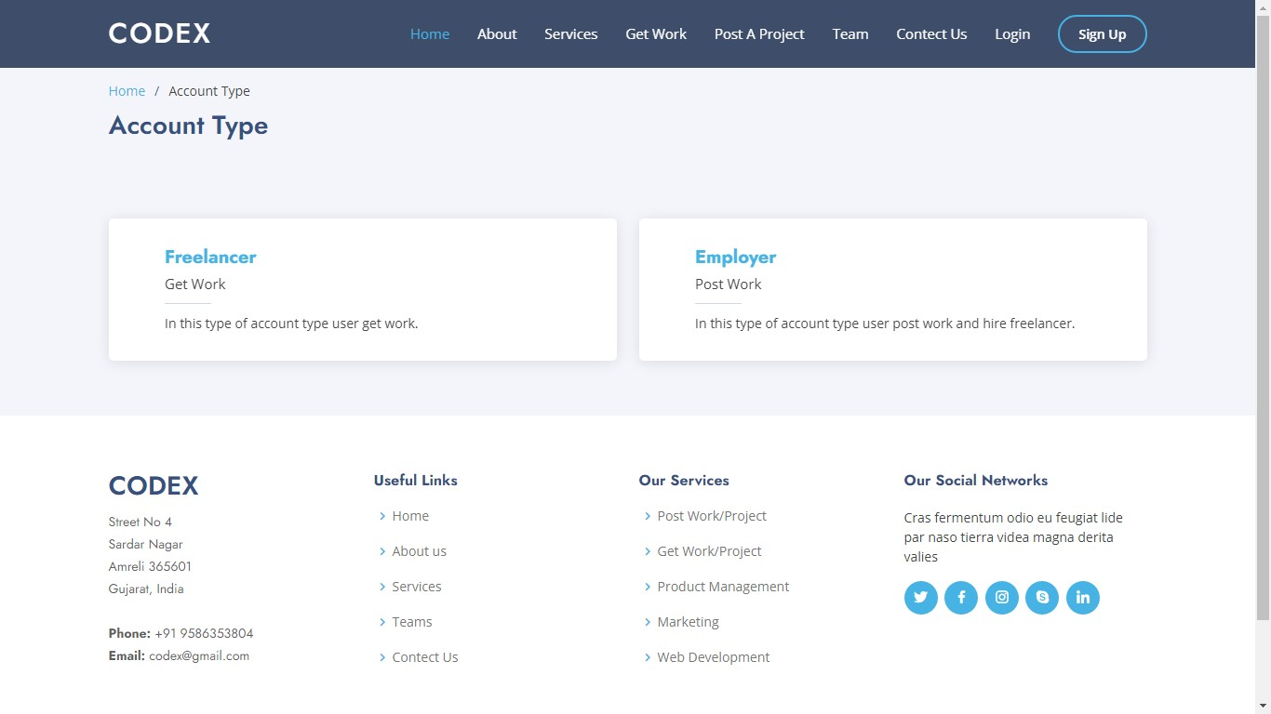

39
Develop By Jay Gohil

Employer Side
- Employer Registration Form :
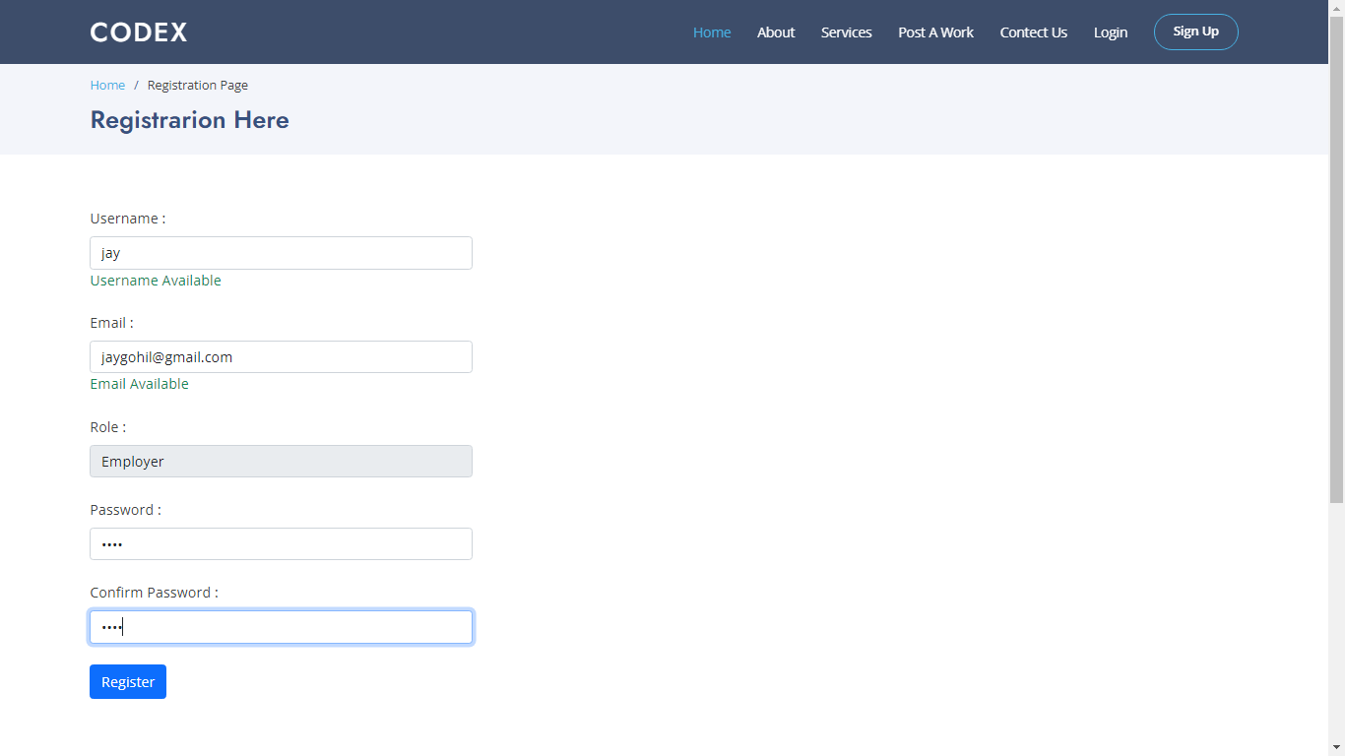

- Login Form :
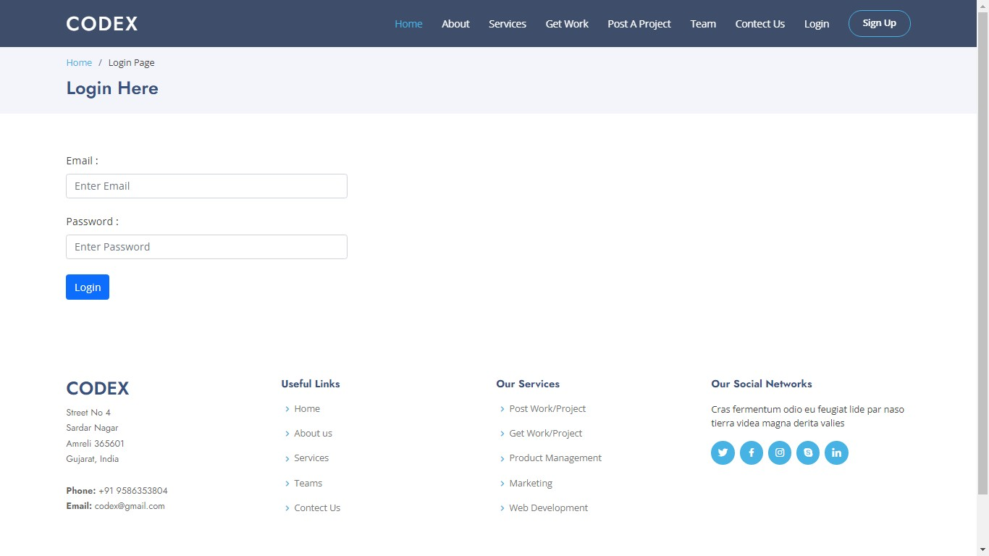

40
Develop By Jay Gohil
- Employer Index Page :


- Need Something Done :

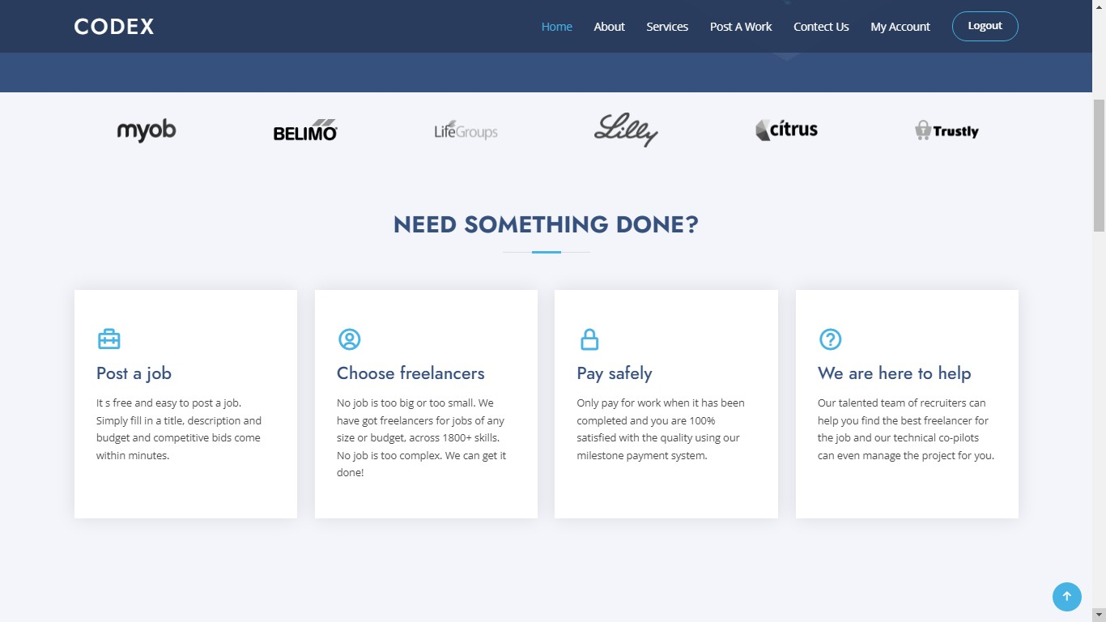
41
Develop By Jay Gohil

- Hire :
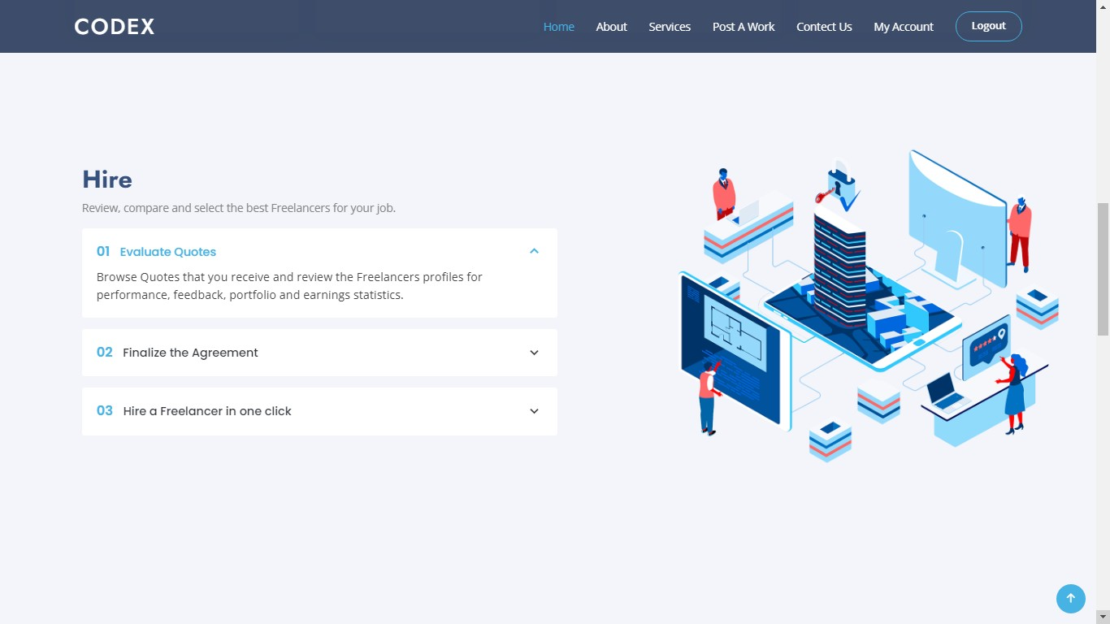

- Manage :

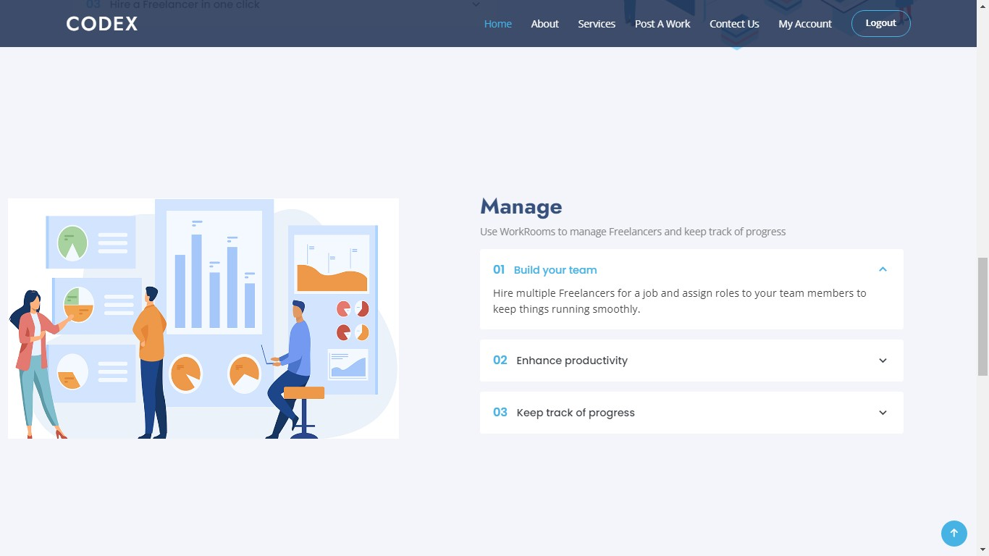
42
Develop By Jay Gohil

- Pay :

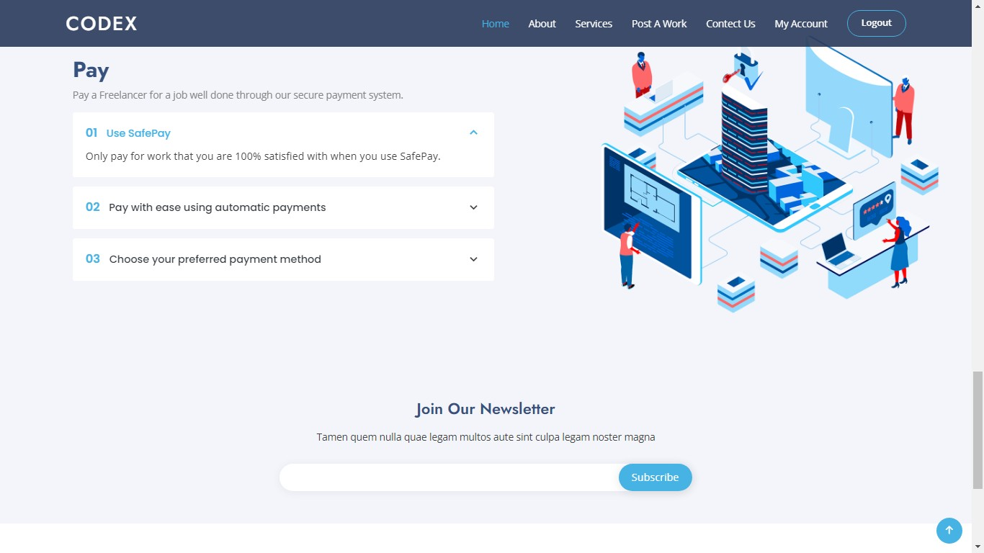

- Employer All Work :

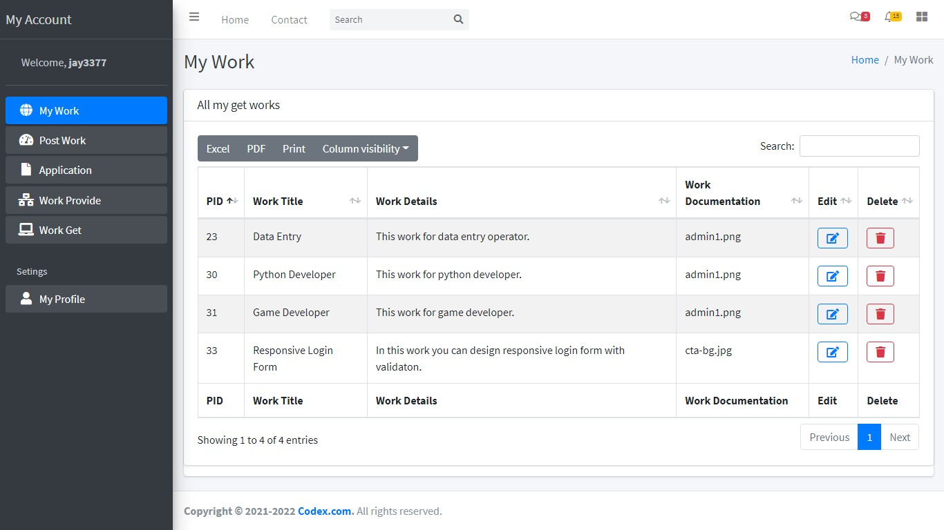
43 | Develop By Jay Gohil

- Edit Work :
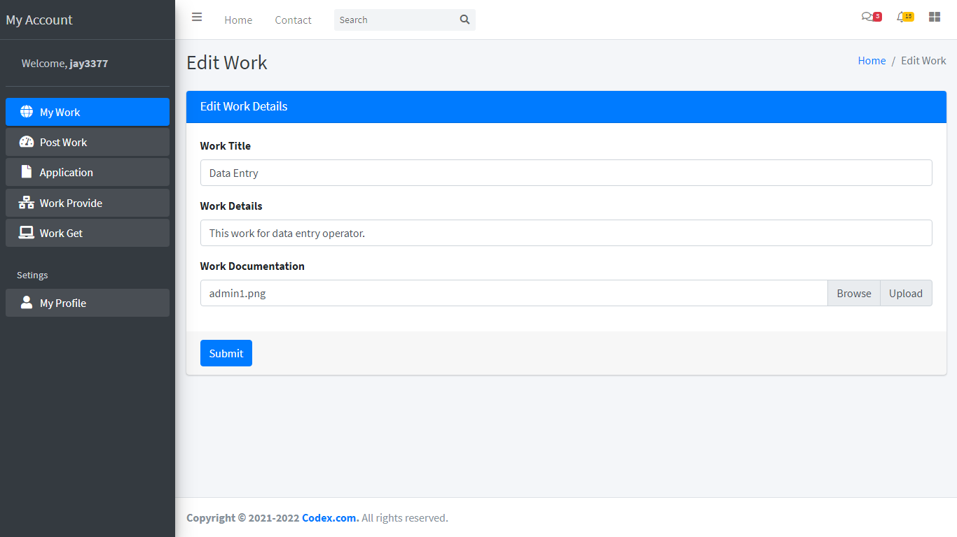

- Delete Work :

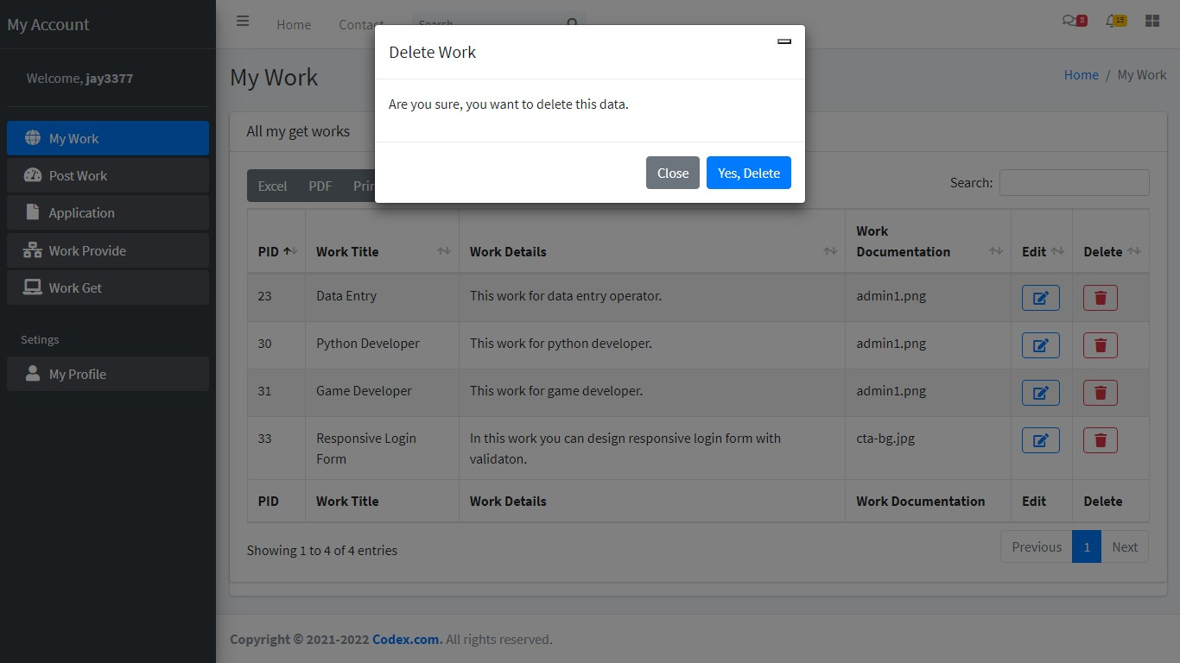
44
Develop By Jay Gohil

- Post Work :

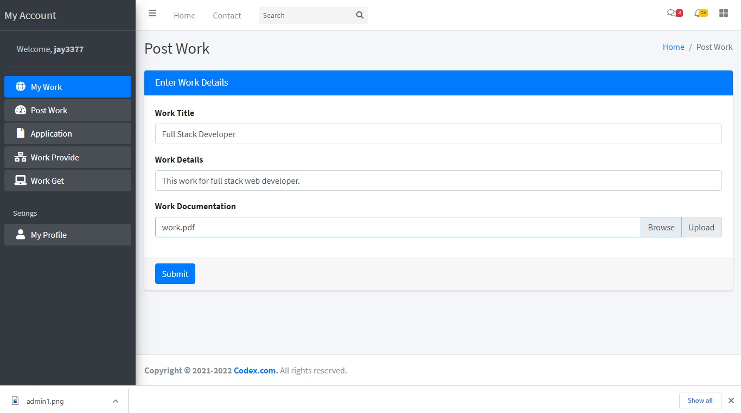
- Applications :

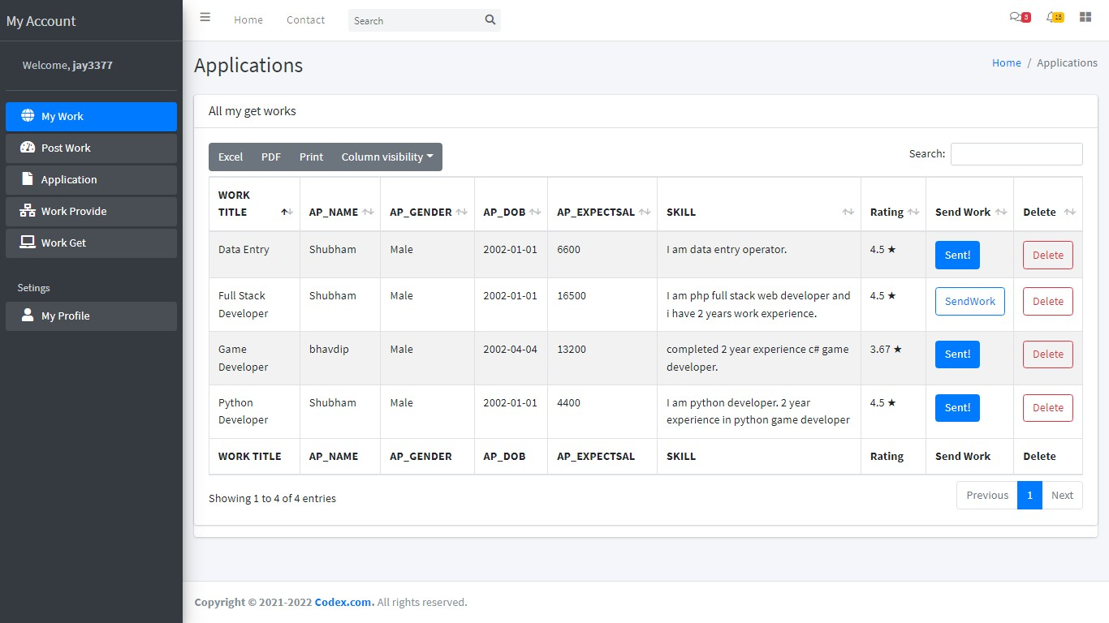
45
Develop By Jay Gohil

- Send Work :
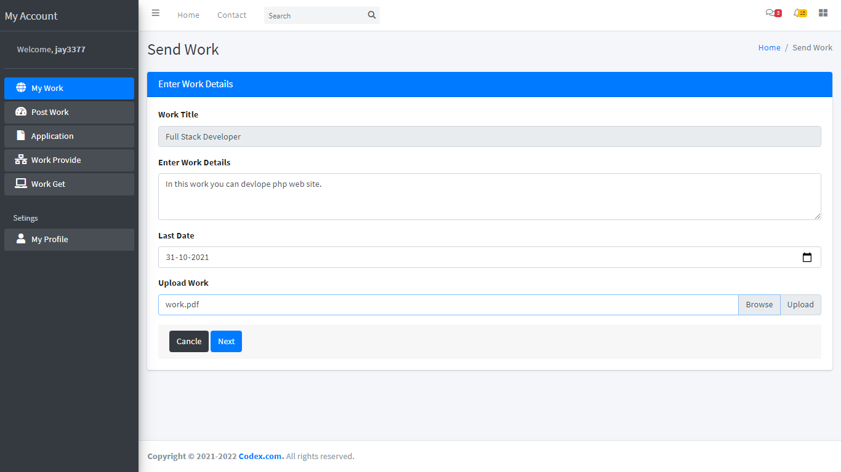

- Payment :

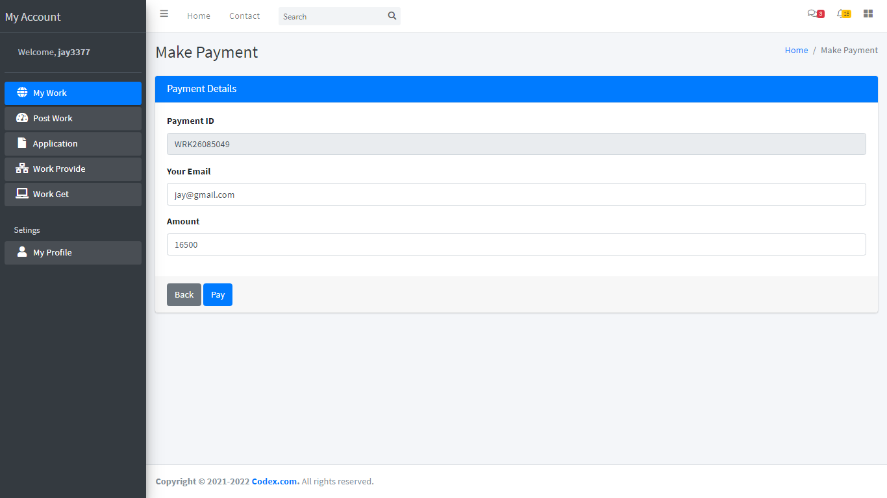
46
Develop By Jay Gohil

- Payment Process :

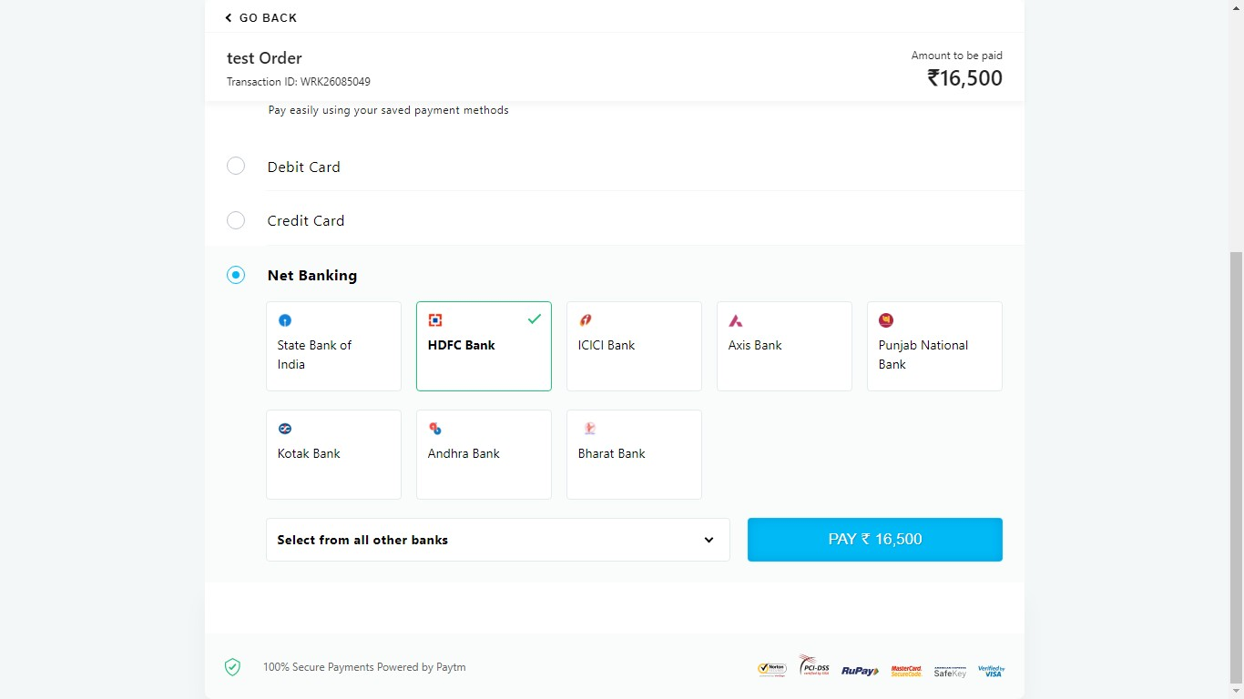

- Payment Success :

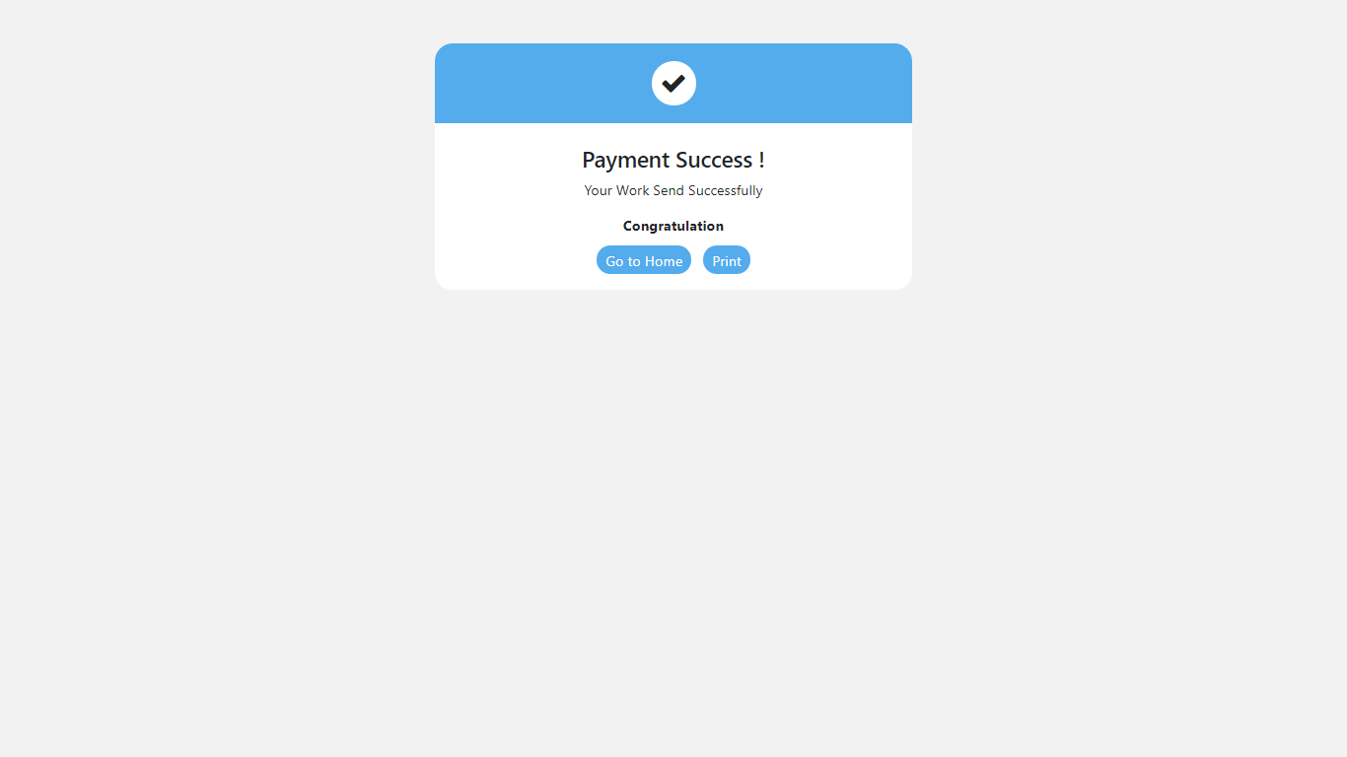
47
Develop By Jay Gohil

- Provided Work :
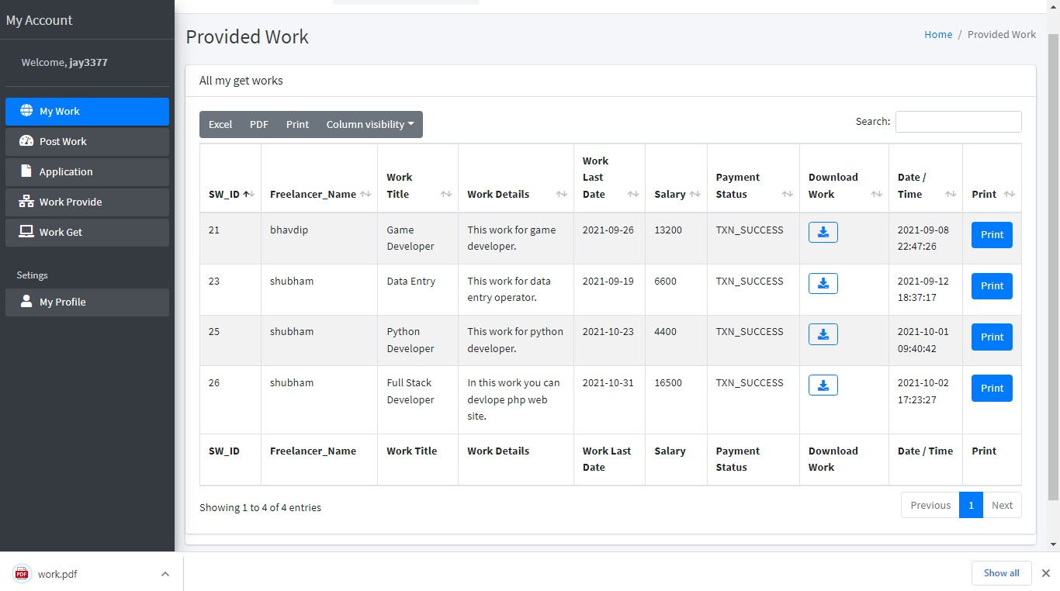

- Invoice :
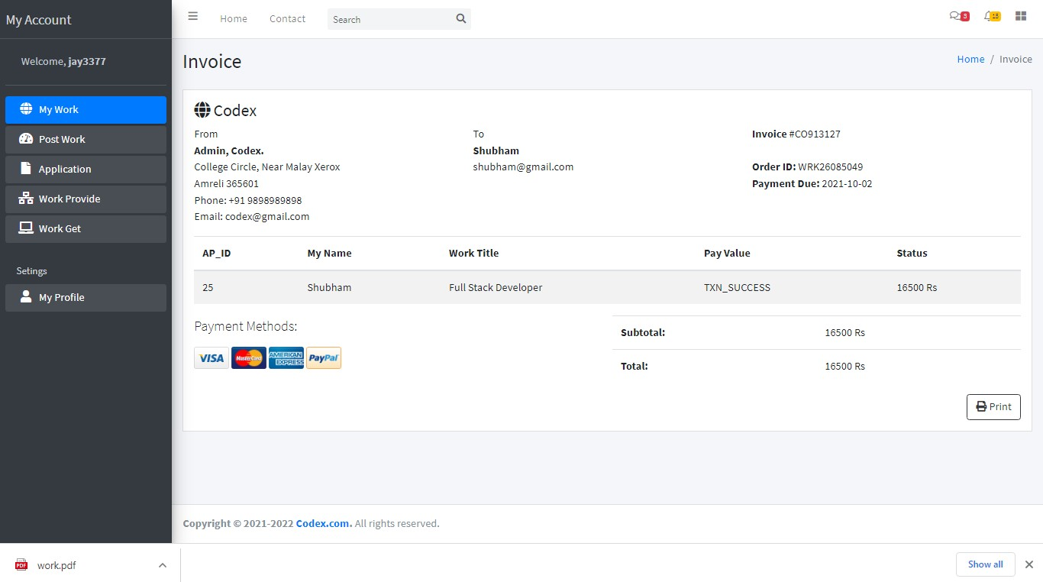
48
Develop By Jay Gohil

- Returned Work :
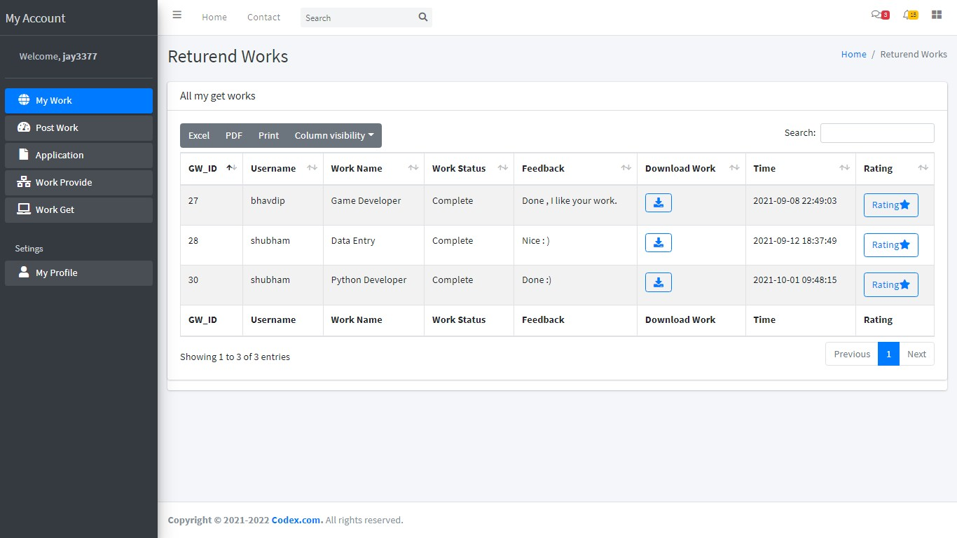

- Rating To Freelancer :

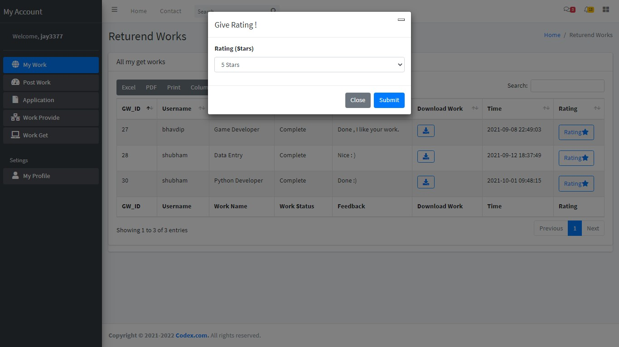
49
Develop By Jay Gohil

- Employer Profile :
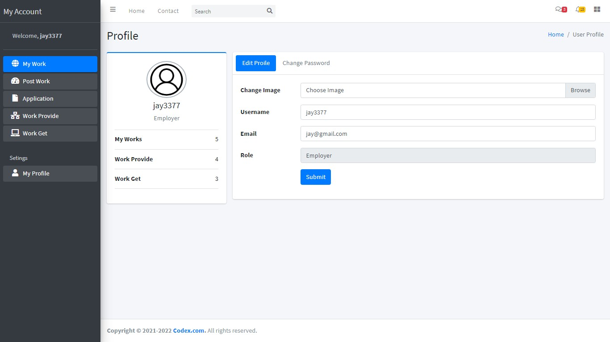

- Change Password :
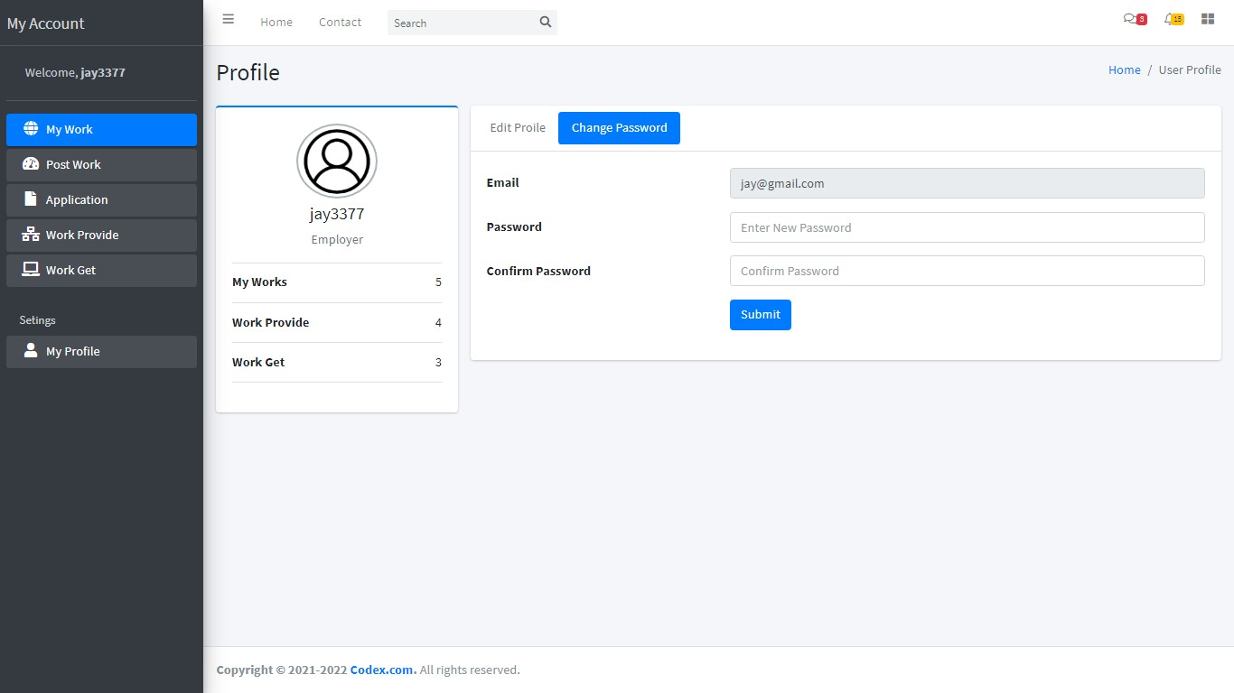
50
Develop By Jay Gohil

Freelancer Side
- Freelancer Index Page :
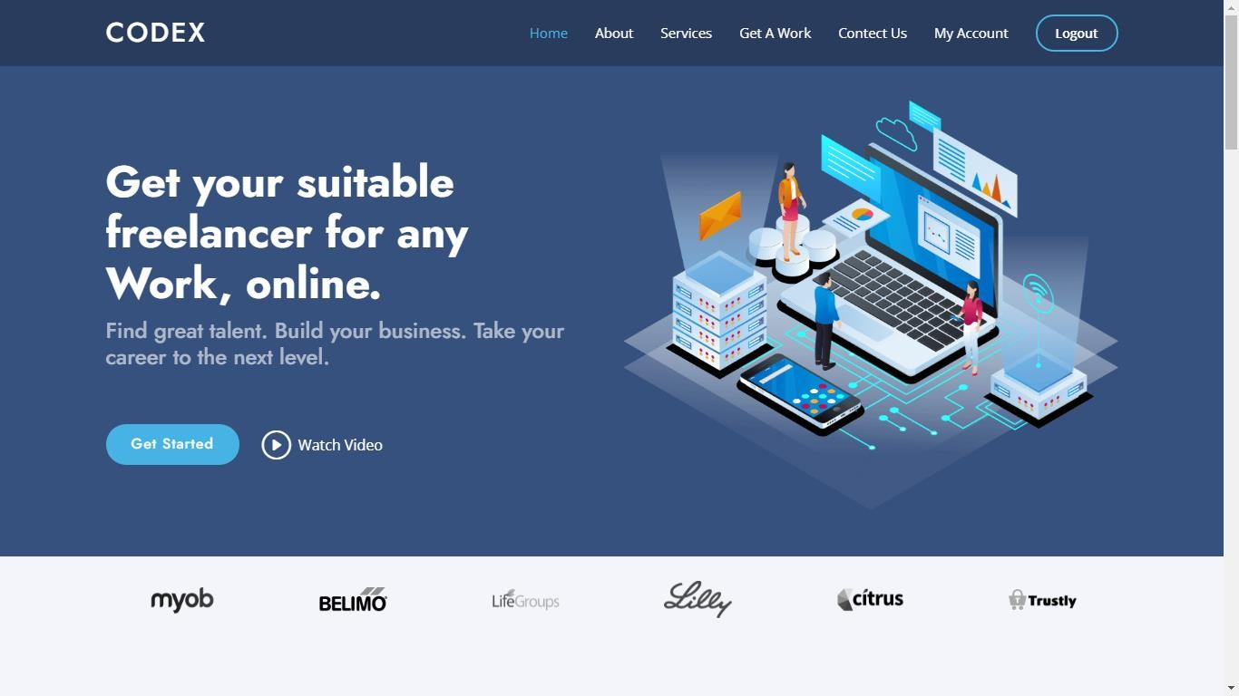

- Need Something Done :

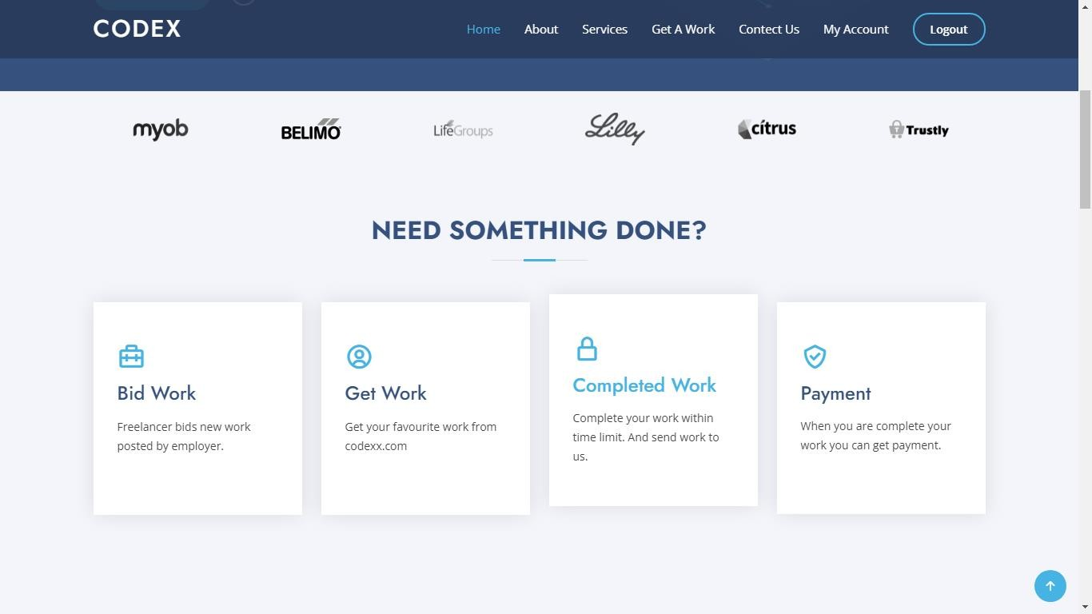
51 | Develop By Jay Gohil

- Find The Right For You :



- Manage The Work :
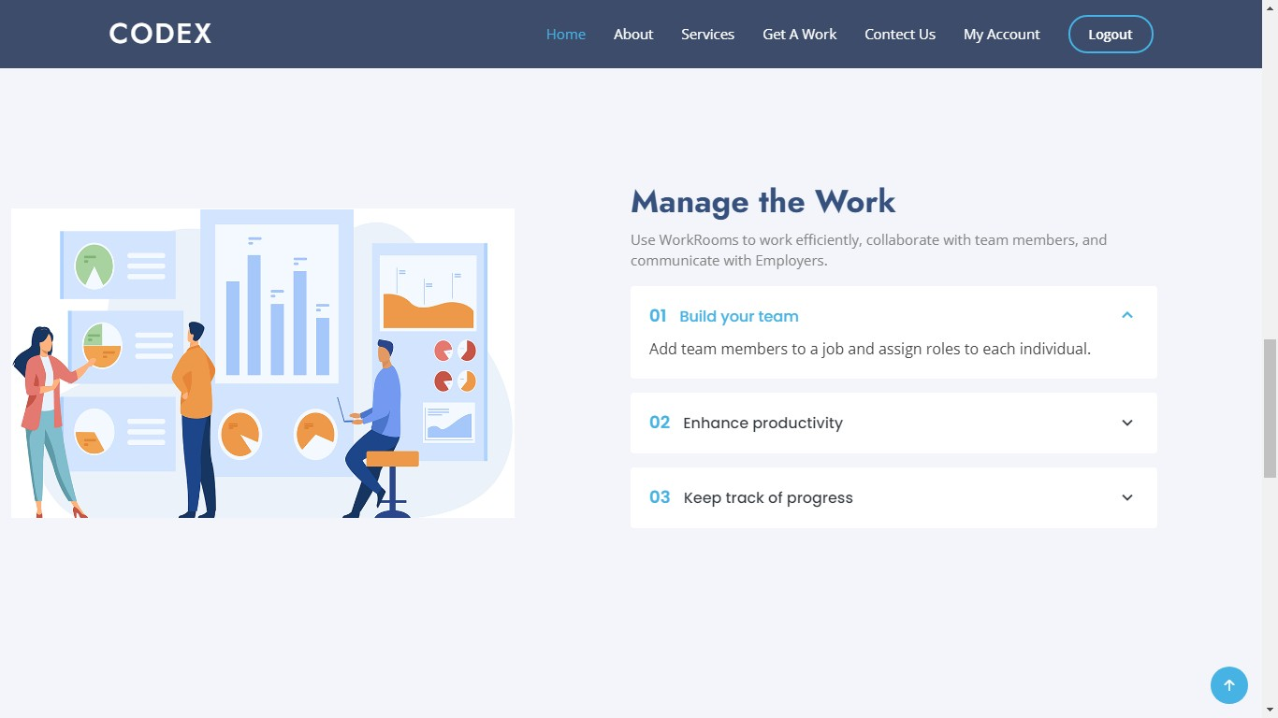
52
Develop By Jay Gohil

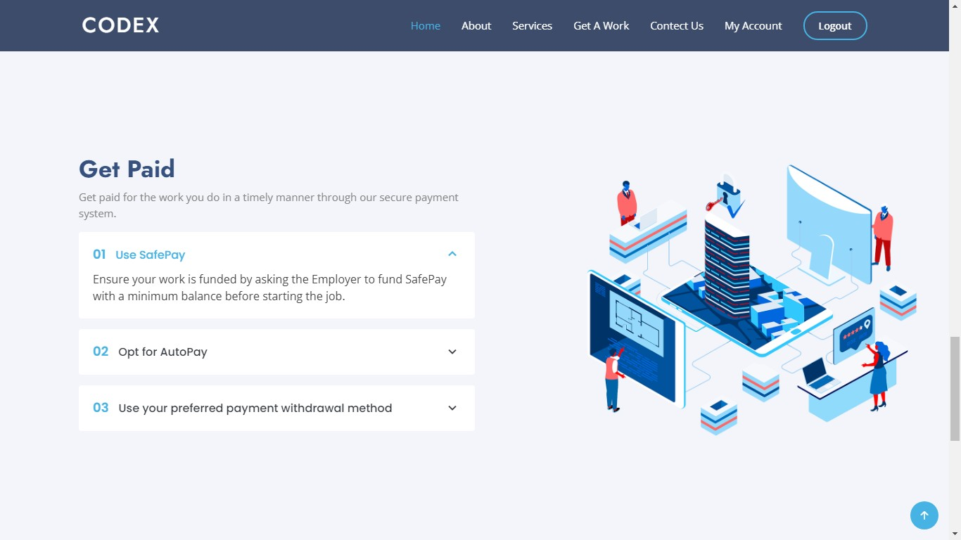
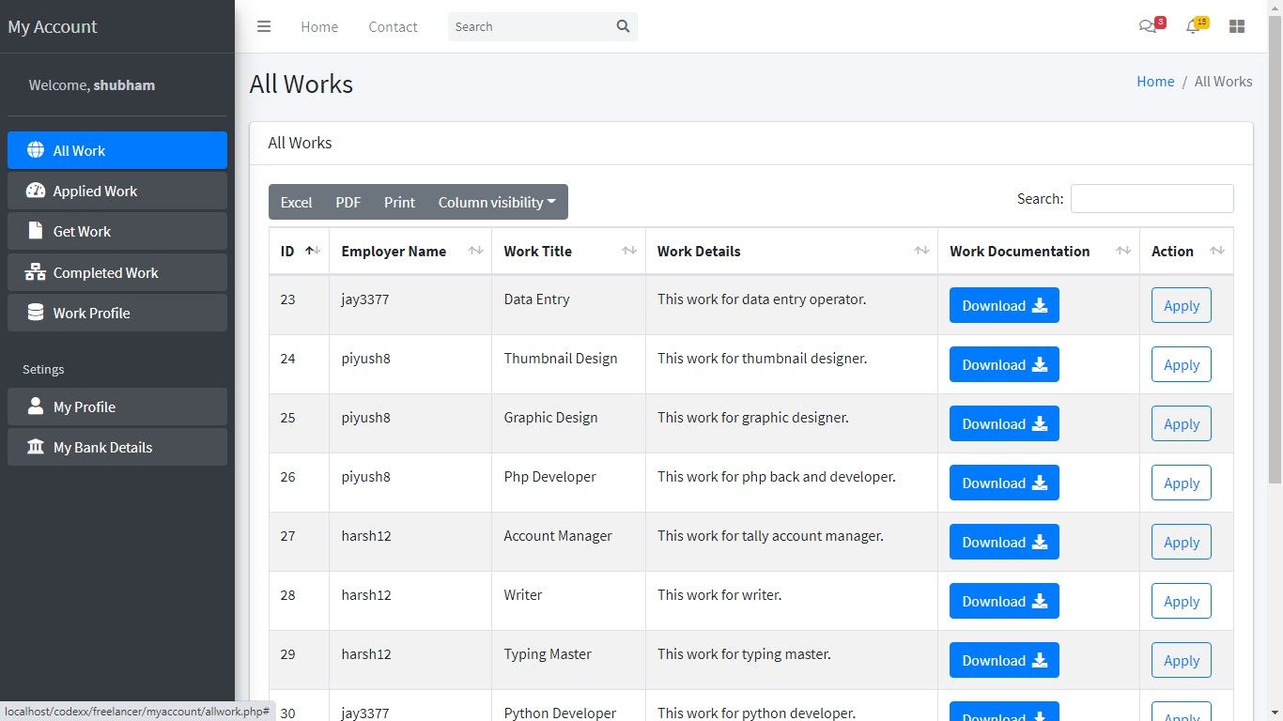
- Get Paid :

- All work :

53
Develop By Jay Gohil
- Applied Work :
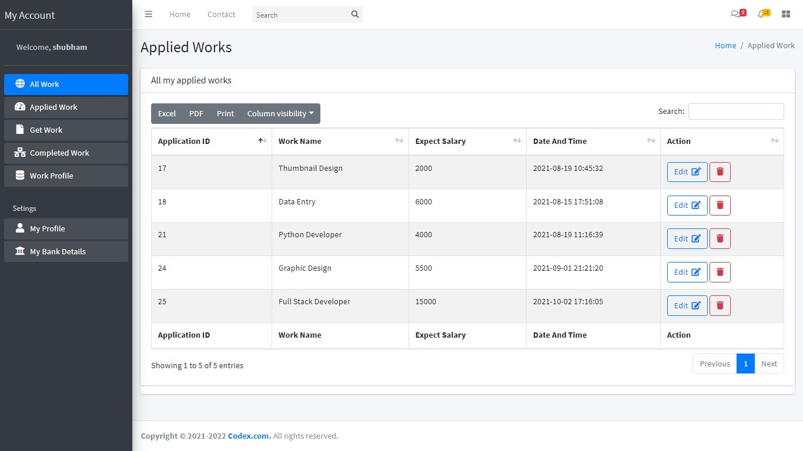

- Edit Application :

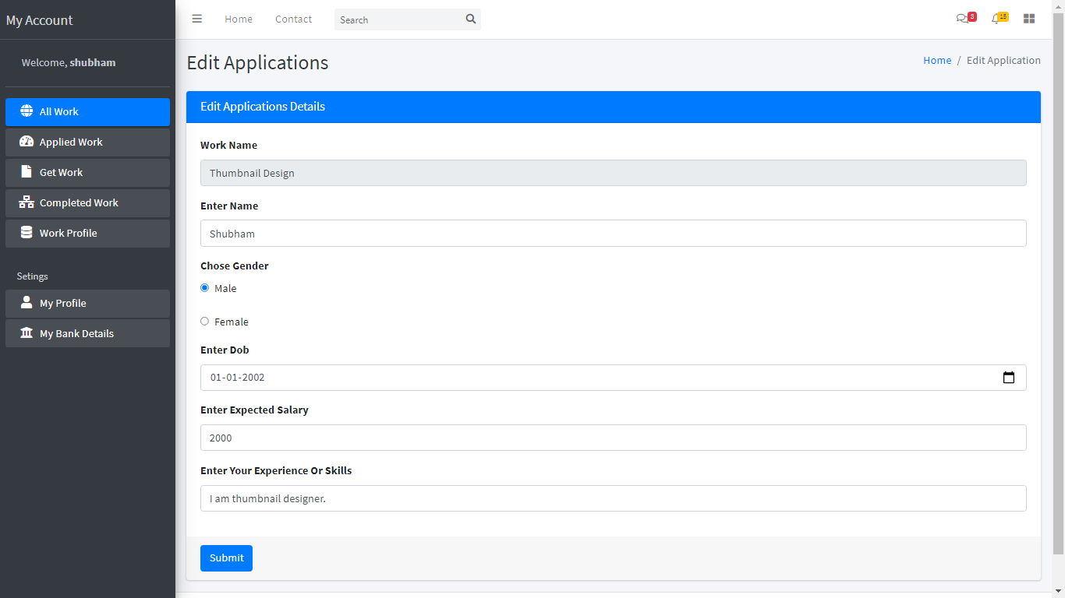
54
Develop By Jay Gohil

- Completed Work :

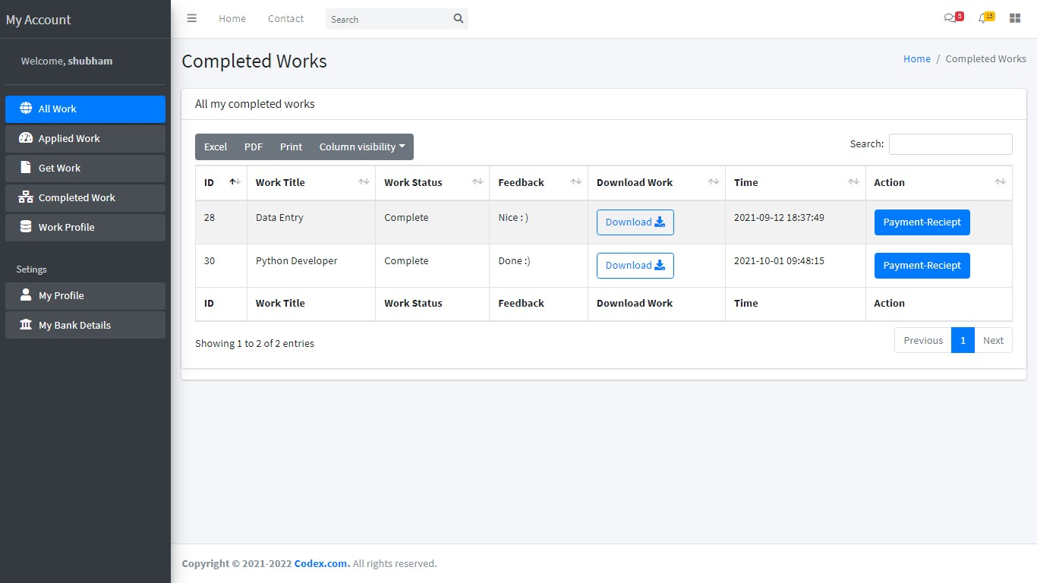

- Freelancer Work Profile :

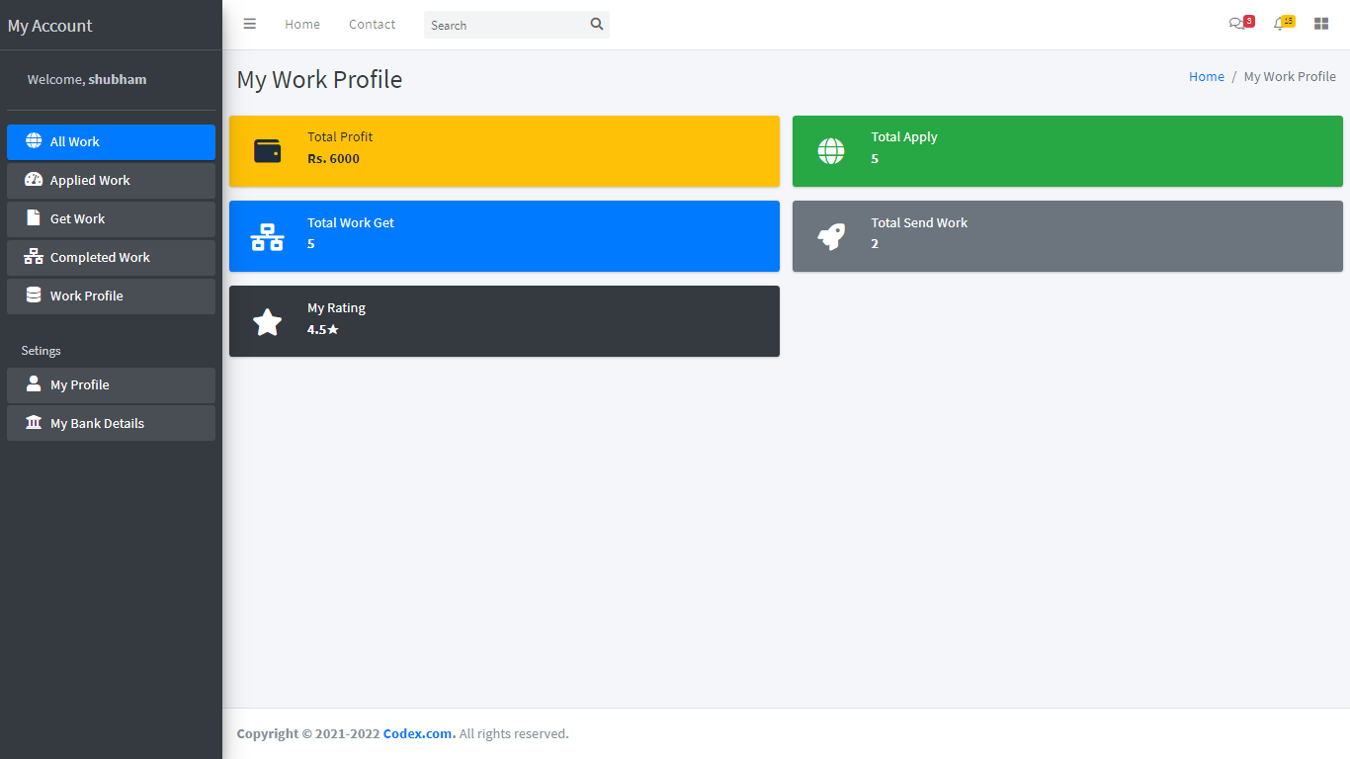

55
Develop By Jay Gohil
- Freelancer Profile :

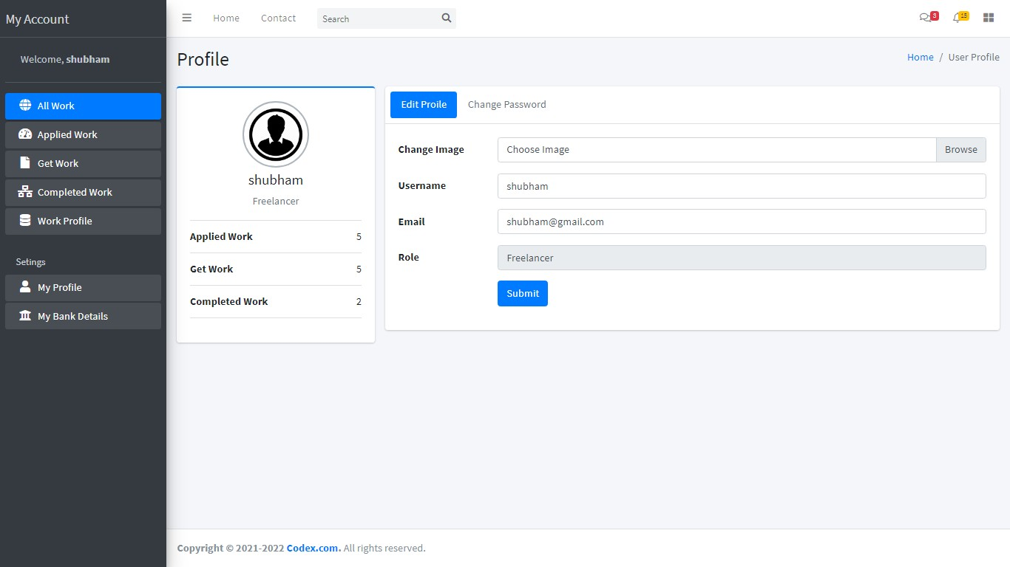

- Change Password :
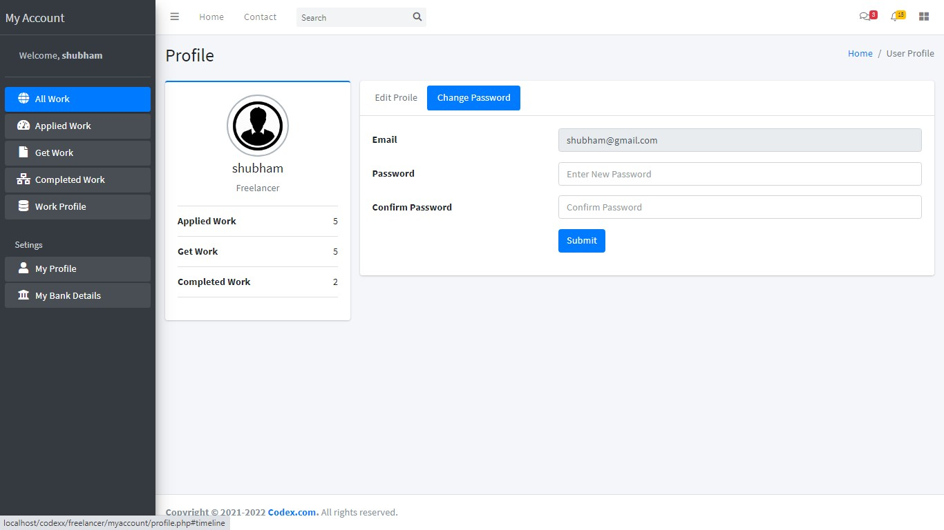
56
Develop By Jay Gohil

- Freelancer Bank Details :

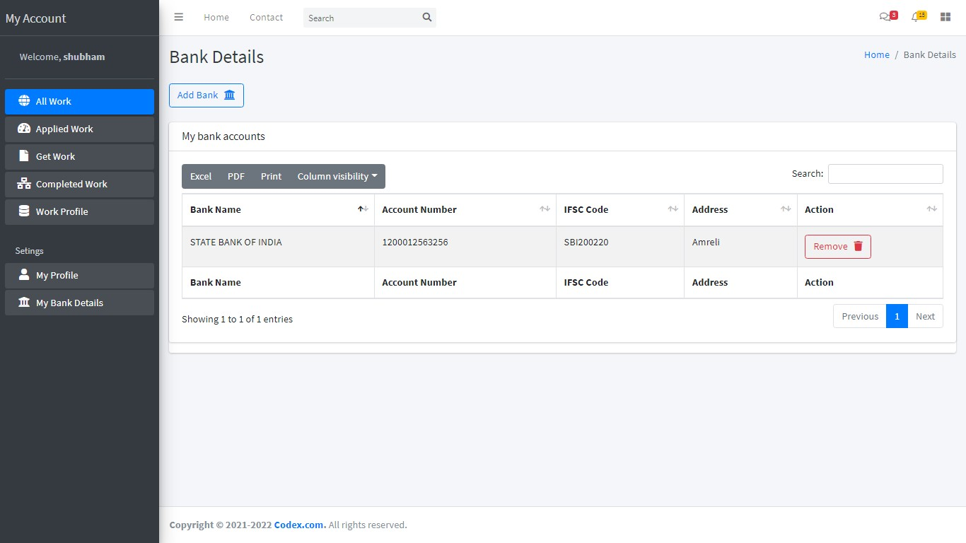

- Add Bank Details :
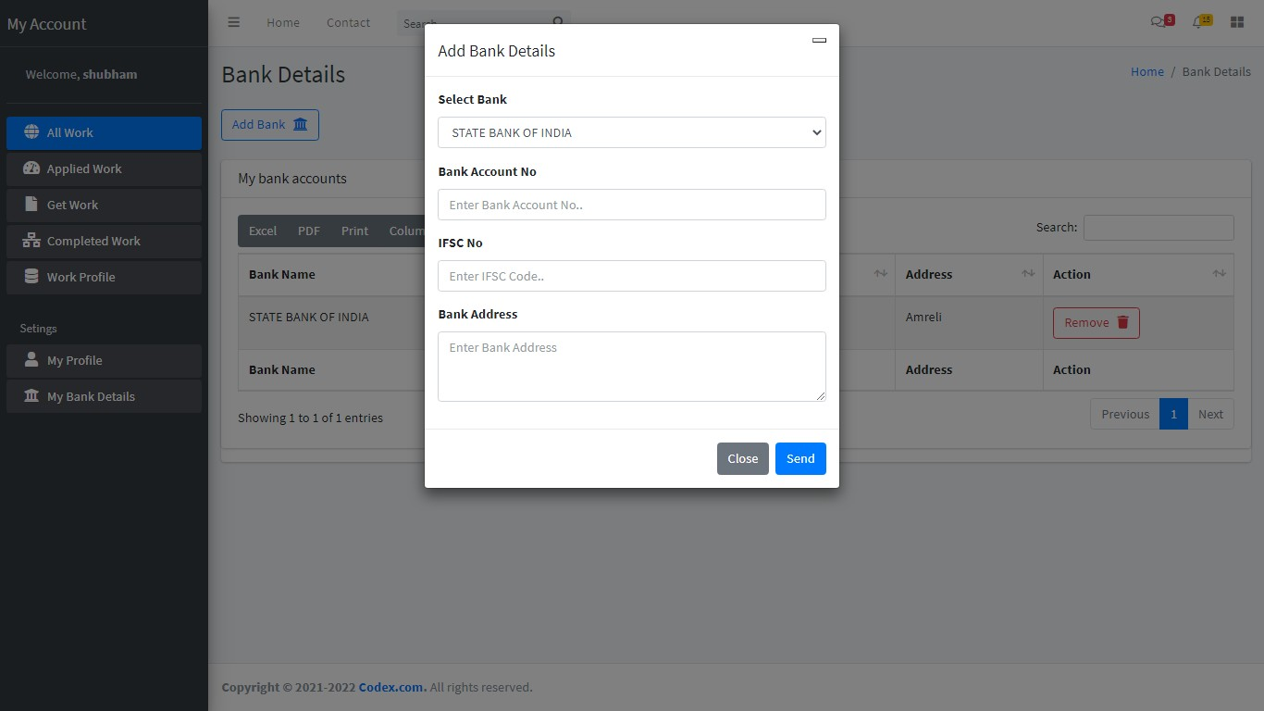
57
Develop By Jay Gohil

Admin Side
- Login Form :

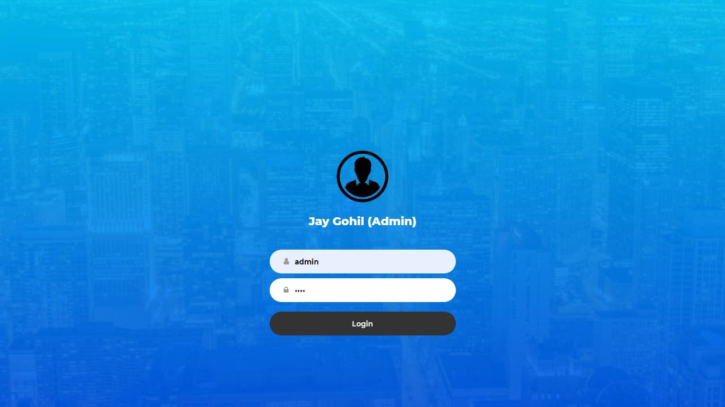

- Admin Dashboard :
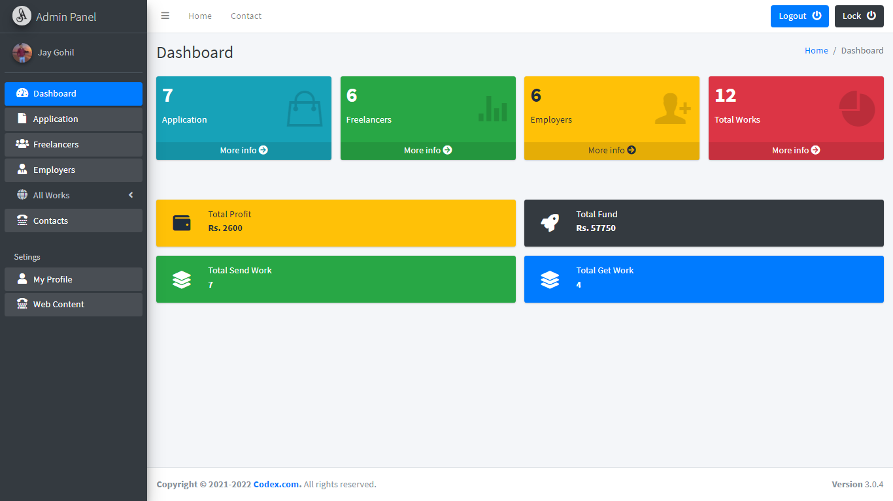

58
Develop By Jay Gohil
- All Application :
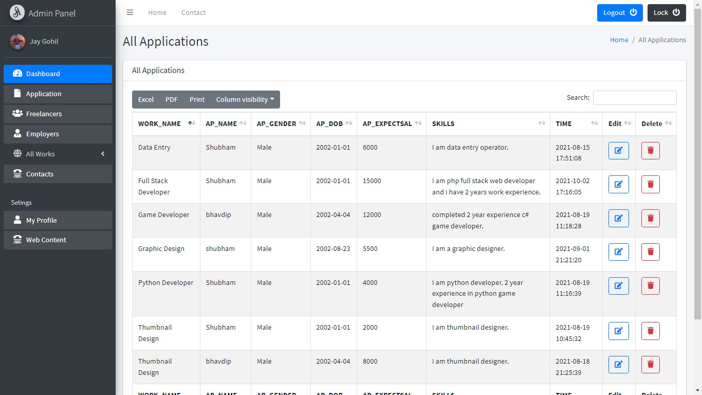

- All Freelancers :

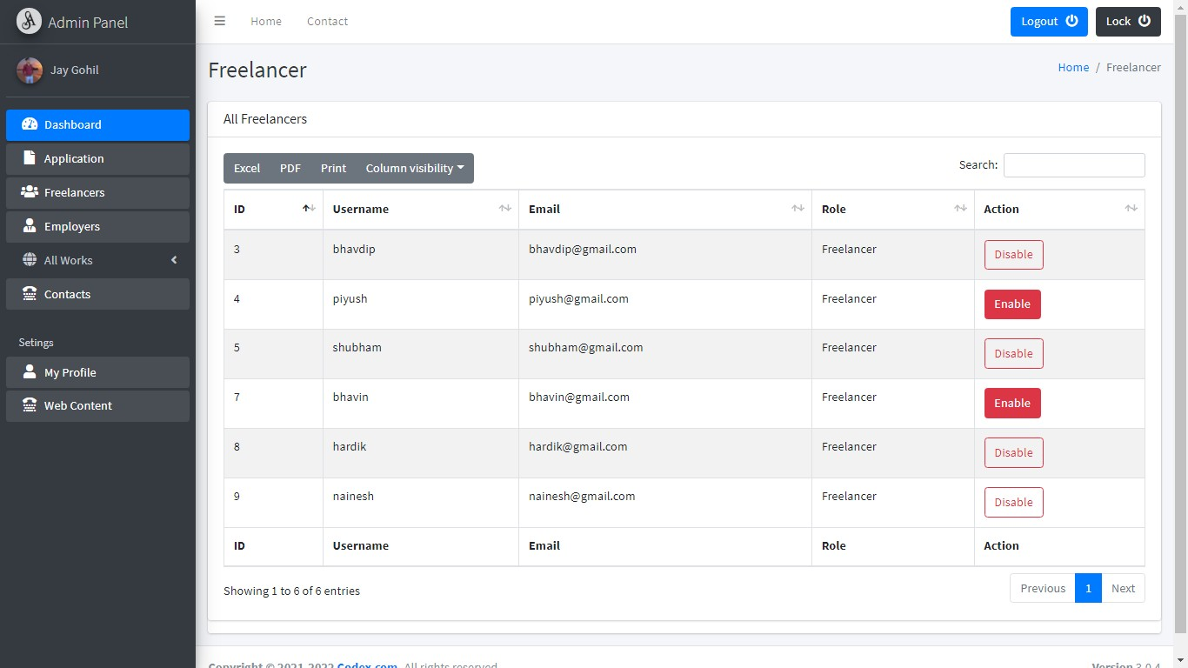
59
Develop By Jay Gohil

- All Employers :

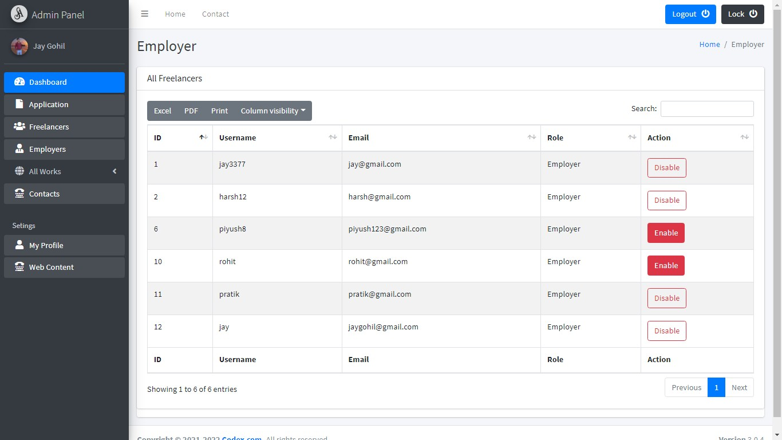

- All Work :

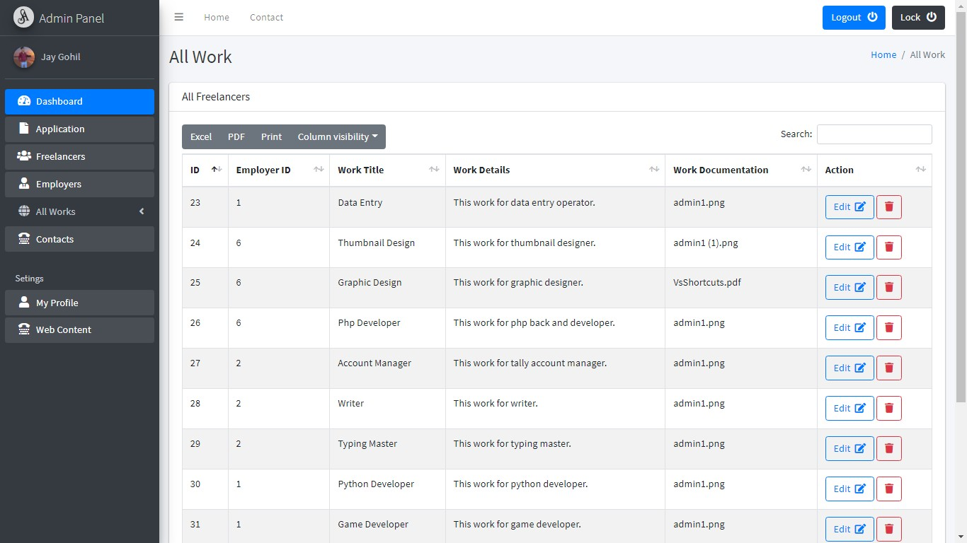

60
Develop By Jay Gohil
- Send Work :
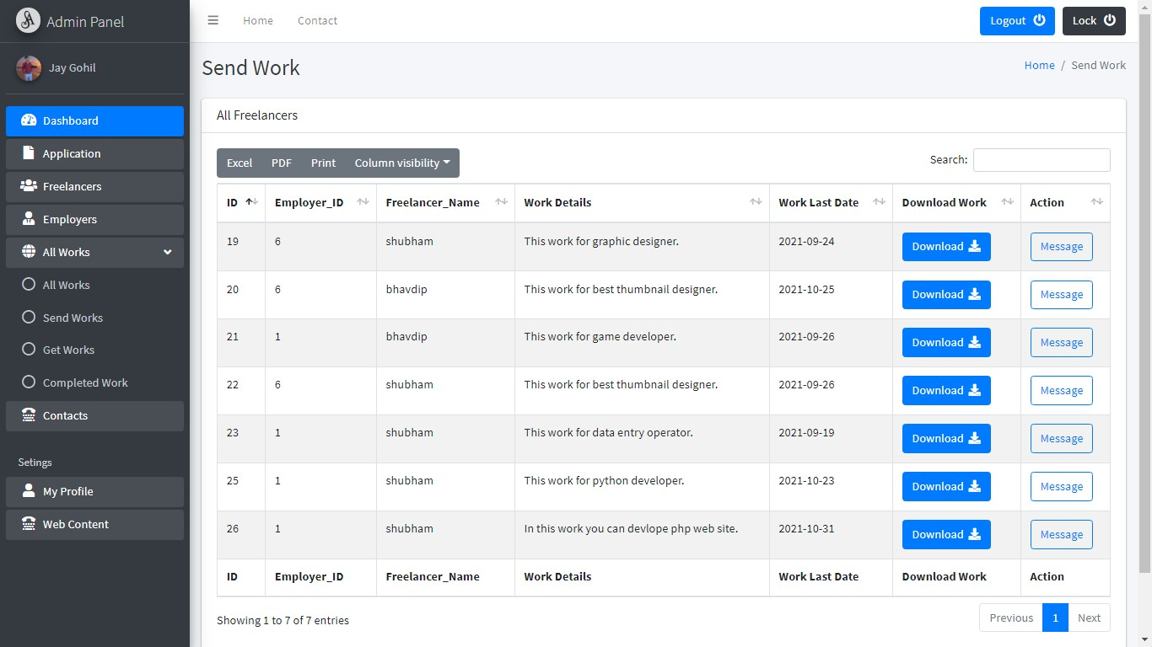

- Get Work :
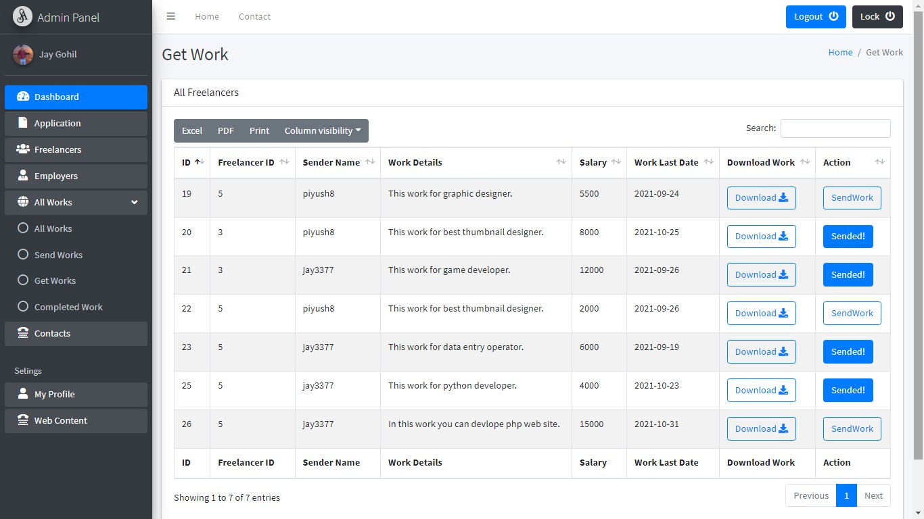
61
Develop By Jay Gohil

- Returned Work :
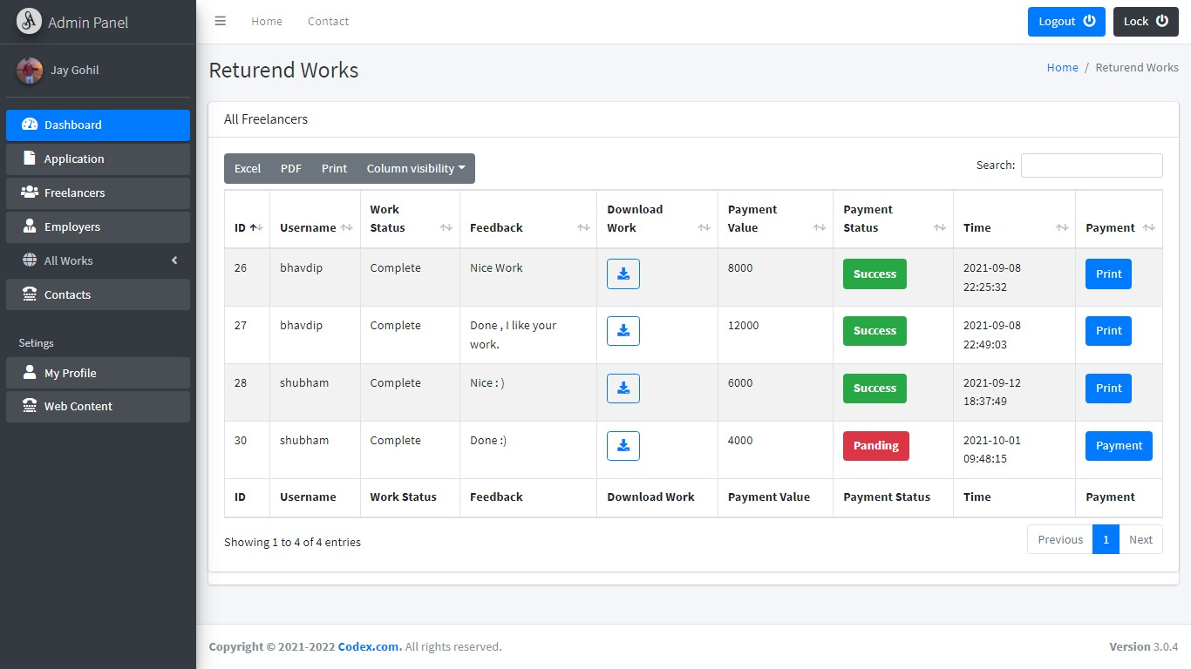

- Contacts :

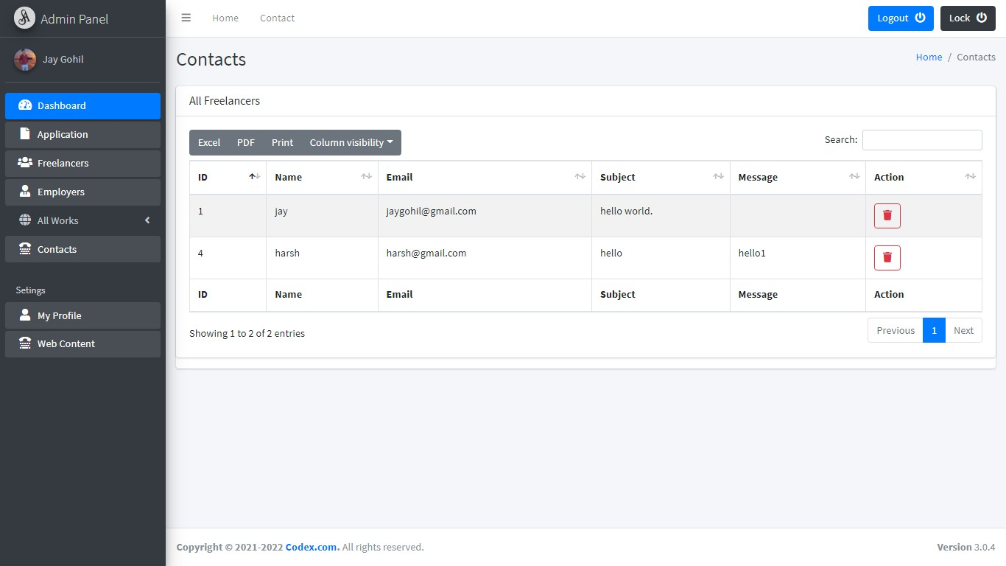
62
Develop By Jay Gohil

- Profile :

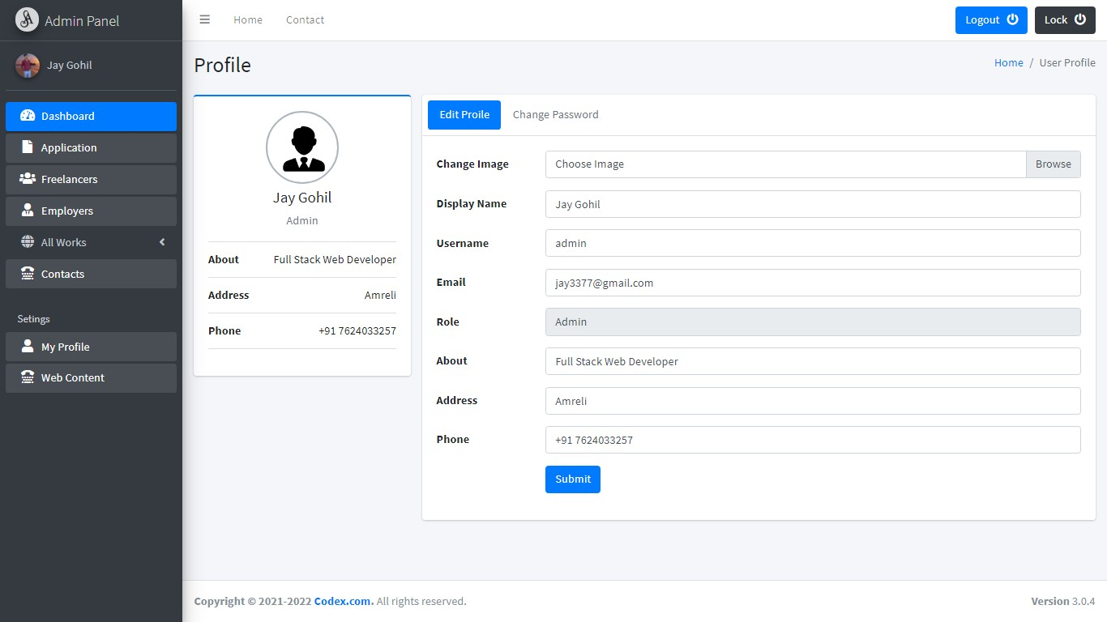

- Change Password :

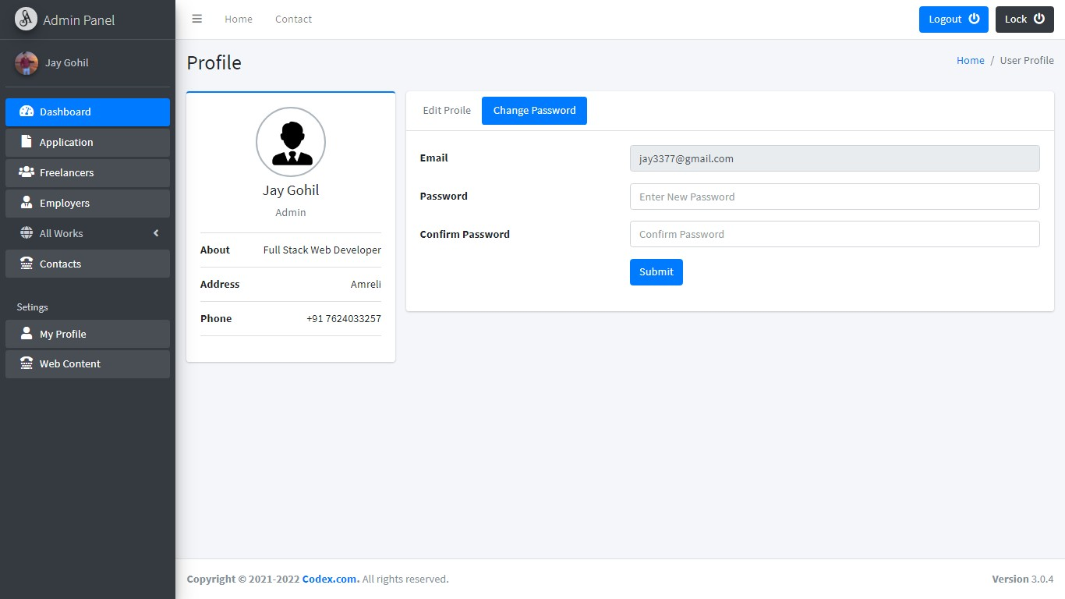

63
Develop By Jay Gohil
- Change Web Content :

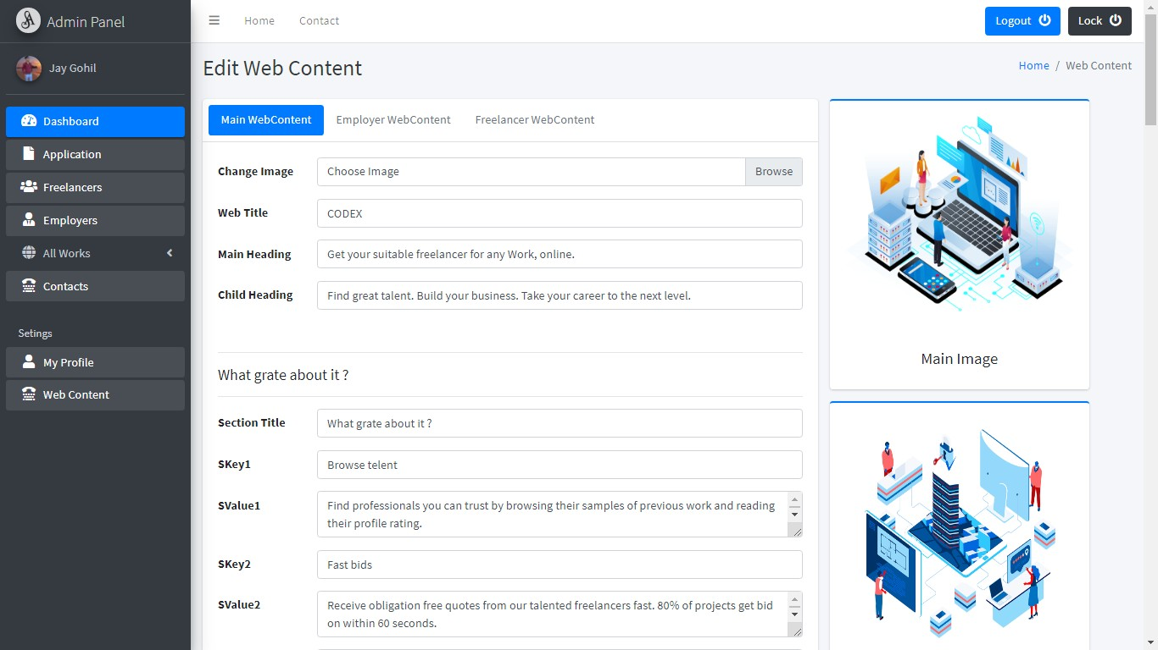

- Lock System :

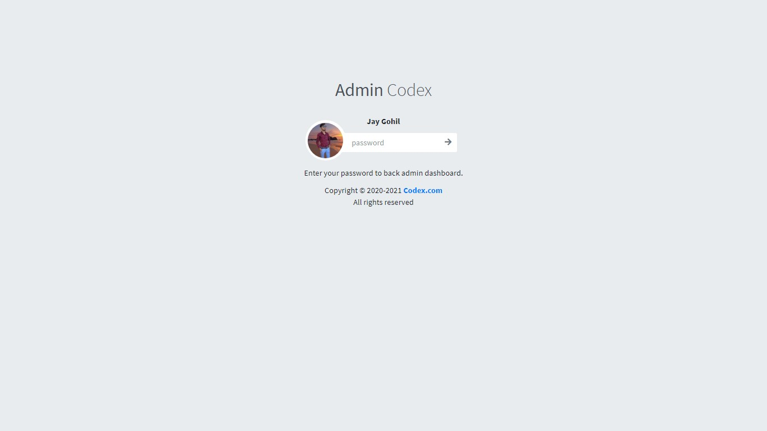

64
Develop By Jay Gohil

Future Scope

The future scope of this project to help most unemployed persons and help them to earn money from home.
Freelancing in India has already become popular enough to catch hold of a large segment of job-seeking, independent professionals looking forward to learning new ideas and explore more work genres. Freelancing in India sees a remarkable growth, giving a new voice to the modern, hard-working youth from different aspects of Indian society.
The future of freelancing in India looks promising. Many individuals are choosing to work according to their preference like where they want, when they want and the work of their choice.

Bibliography

- www.google.com
- www.upwork.com
- https://getbootstrap.com/
- Php Manual

This documentation is created by Gohil Jay
***

65
Develop By Jay Gohil

CD/DVD
Below items are included in cd/dvd.
- Project
- Database
- Documentation
- Screenshots

66
Develop By Jay Gohil

