**UML class diagram**

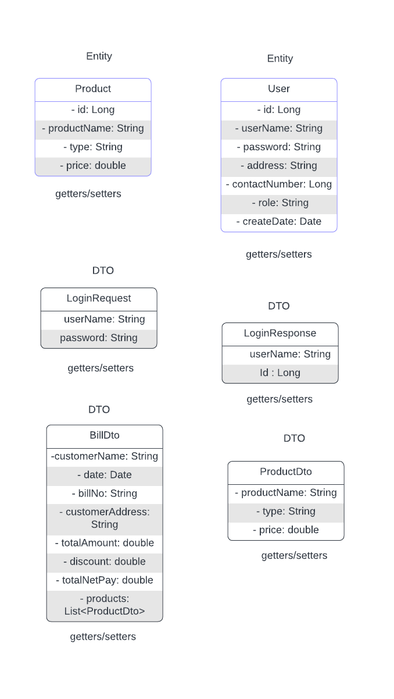

APIS:-

1 Create user api (POST)

Url:- <http://localhost:8090/store/api/user/save>

Request:-{

"userName":"aayush@123",

"address":"indore",

"contactNumber":"7867678668",

"role":"CUSTOMER"

}

Response:- {

    "id": 1,

    "userName": "ashvin@123",

    "password": "12345",

    "address": "indore",

    "contactNumber": 7867678668,

    "createDate": "2023-05-27T20:49:05.678+00:00",

    "role": "CUSTOMER"

}

Not :- we can use role like (“CUSTOMER”,”EMPLOYEE”,”AFFILIATE”)  
  
  
2 Create Product api (POST)

Url:- <http://localhost:8090/store/api/product/save>

Request:- {

    "productName":"Electric fan",

    "type":"electronic",

    "price":800.0

}

Response:- {

    "productName": "Electric pen",

    "type": "electronic",

    "price": 100.0,

    "id": 10

}

3 login api (POST)

Url:- <http://localhost:8090/store/api/user/login>

Request:-{

    "userName":"ashvin@123",

    "password":"12345"

}

Response :- {

    "userName": "ashvin@123",

    "id": 1

}

2 Generate-bill API (GET)

Then we take user id from login api and hit generate-bill api

Url:- <http://localhost:8090/store/api/bill/generate-bill/1>

Response:- {

    "billNo": "BILL095587",

    "date": "2023-05-27T22:33:11.832+00:00",

    "customerName": "ashvin@123",

    "customerAddress": "indore",

    "totalNetPay": 665.0,

    "discount": 35.0,

    "totalAmount": 700.0,

    "products": [

        {

            "productName": "Rice",

            "type": "groceries",

            "price": 150.0

        },

        {

            "productName": "Coffee",

            "type": "groceries",

            "price": 200.0

        },

        {

            "productName": "Book",

            "type": "stationery",

            "price": 350.0

        }

    ]

}