Name: Ashvini Agal

Roll No: 20MCA10018

**Moving A Character From Left To Right Using C# Scripts In Unity**

Step 1:

Create the 2D project in Unity.

Step 2:

Now open up main.Assets. Import the 2D Character for the Unity. Drag the Scene view onto your view controller.Select 2D Character and go to the Drag n Drop Scene view in Unity.

Step 3:

Create a Button in your project.

Click on the "GameObject" menu in the menu bar. Select Create UI (Button). The Create Button will be added to the scene View.

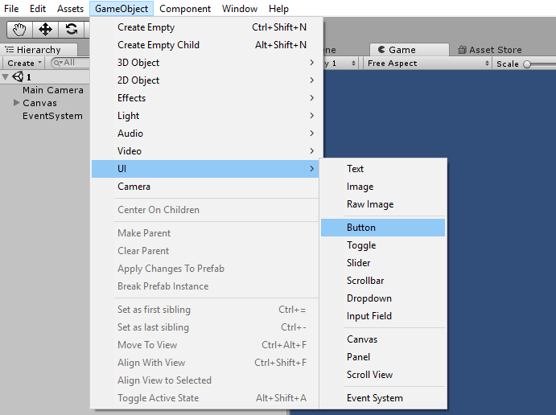

Step 4:

Rename the Button as Left button.

Step 5:

Create a DuplicateButton in your project.

Select the button and type the keys (Ctrl + D). The Create Duplicate Button will be added to the scene View.

Step 6:

Rename the Duplicate Button as the Right button.

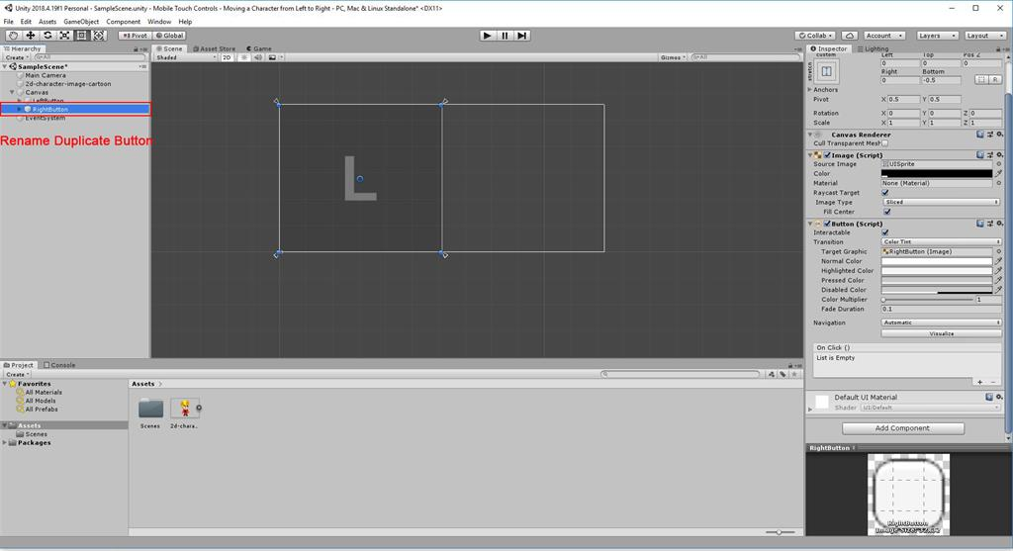

Step 7:

Create a C# Script

 Right-click on Assets. Select Create >> C# script.

Step 8:

Double click on the Movement. The MonoDevelop-Unity editor will open up.

using System.Collections;

using System.Collections.Generic;

using UnityEngine;

public class Movement: MonoBehaviour {

//variables

public float moveSpeed = 300;

public GameObject character;

private Rigidbody2D characterBody;

private float ScreenWidth;

// Use this for initialization

void Start() {

ScreenWidth = Screen.width;

characterBody = character.GetComponent < Rigidbody2D > ();

}

// Update is called once per frame

void Update() {

int i = 0;

//loop over every touch found

while (i < Input.touchCount) {

if (Input.GetTouch(i).position.x > ScreenWidth / 2) {

//move right

RunCharacter(1.0 f);

}

if (Input.GetTouch(i).position.x < ScreenWidth / 2) {

//move left

RunCharacter(-1.0 f);

}

++i;

}

}

Step 9:

Save the Program.

Go back to the Unity window. Drag and drop the movement script onto the MainCamera.

Step 10:

Drag and drop the 2D character onto the Movement script.

Click on the Play button. Press the “Left touch ” and “Left Arrow ” key. The 2D character will move to the Left side.

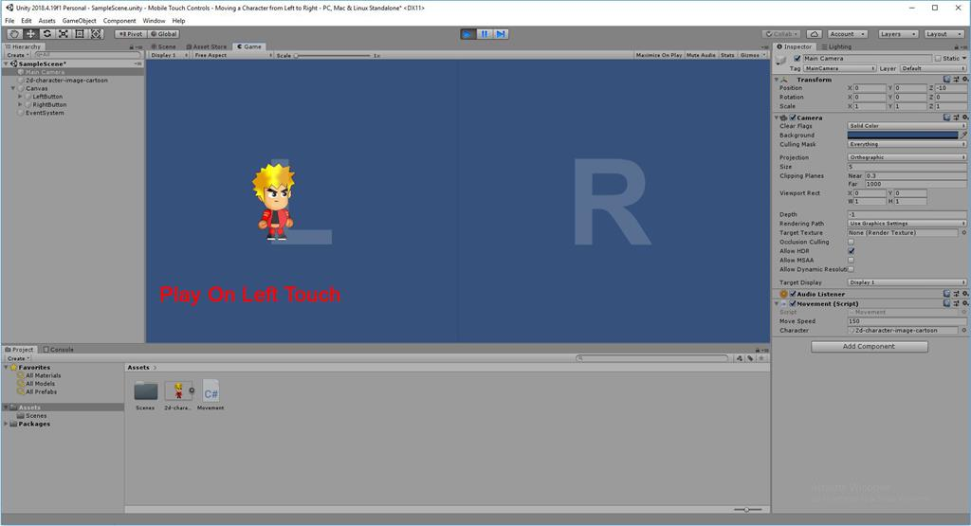

Step 11:

Click on the Play button. Press the “Right touch ” and “Right Arrow ” key. The 2D character will move to the Right side.

