**AWS AD Group - Access Request Instructions and Guidelines**

**Required RITM’s for AWS Access:**

|  |  |
| --- | --- |
| VPN: | [RITM8593123](https://anthem.service-now.com/ess?id=ant_request_item_details&table=sc_req_item&sys_id=fd651546db561c506d3bc6cd139619f8) |
| HA Account: | [RITM8593033](https://anthem.service-now.com/ess?id=ant_request_item_details&table=sc_req_item&sys_id=4534dd06db161c506d3bc6cd139619cc) |
| AWS Dev Account: | [RITM8523245](https://anthem.service-now.com/ess?id=ant_request_item_details&table=sc_req_item&sys_id=5f760b431b0e9010ba3c11b92a4bcb1c) |
| AWS Prod Account: | [RITM8565966](https://anthem.service-now.com/ess?id=ant_request_item_details&table=sc_req_item&sys_id=08826689db1a94102910a73fd3961993) |

**Once you get the access to the above accounts, please follow the below given instructions to Login to AWS account using Cyber Ark credentials**

Step 1:

Once you receive CyberArk ID. Login to CyberArk site with your AD Id and 4 digit pin+RSA token to get a secure token and ID to login to AWS.

<https://cyberark.anthem.com/PasswordVault/logon.aspx?ReturnUrl=%2fPasswordVault%2fdefault.aspx>

Step 2:

Search for your AD Id and add it to Favorites for your future use as you need to login to CyberArk every day to get a secure token which will be used to login to AWS as this token will expire in 10 hours.

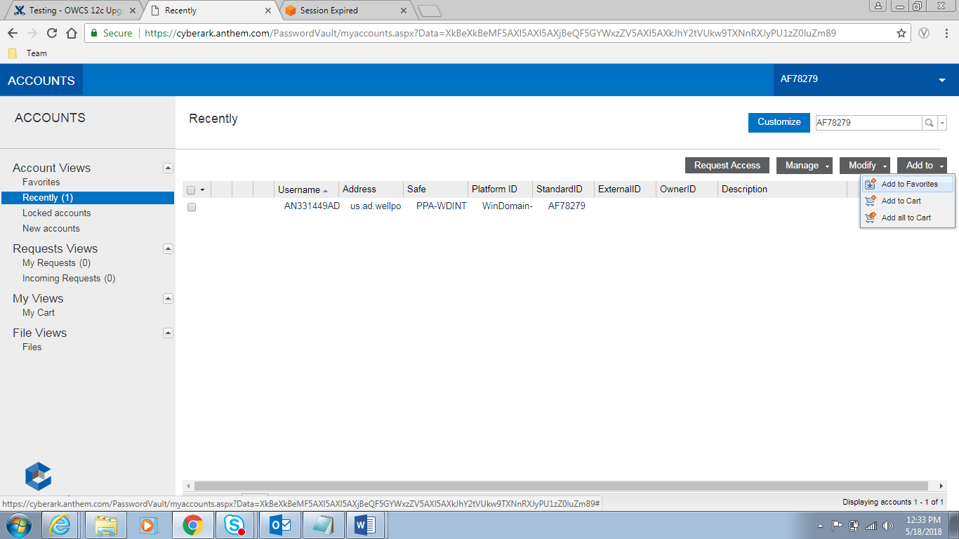

Step 3:

Get the account details by clicking your ID. Under password, click show to copy the password.

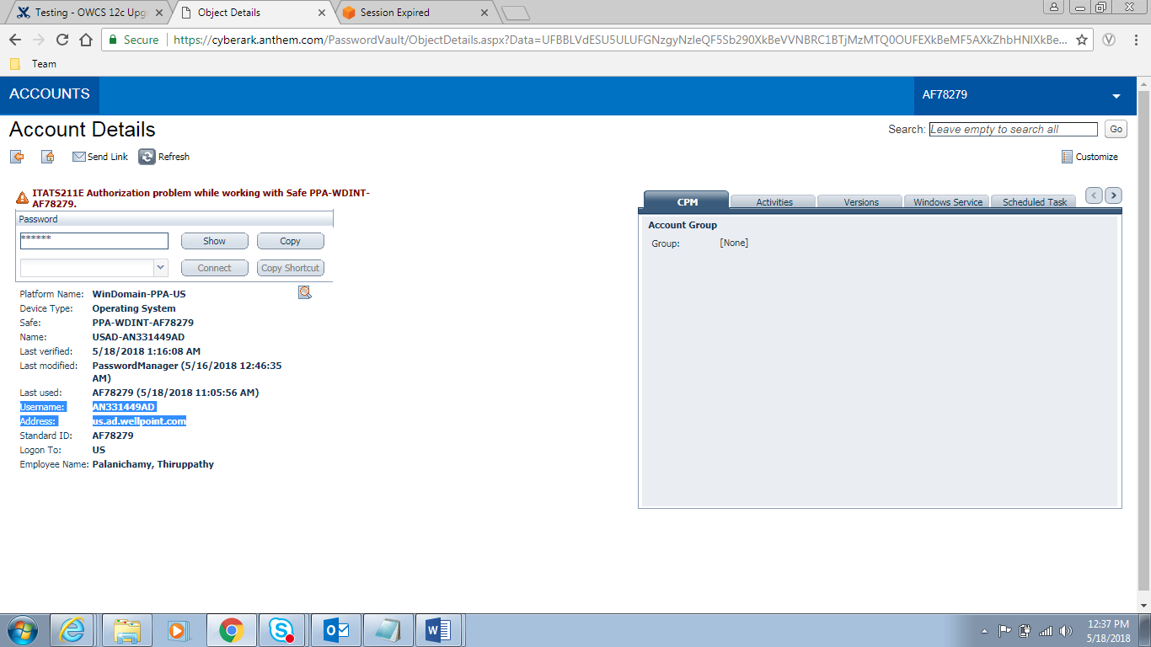

Step 4:

Login to this URL

Dev:

<https://secure-gateway.dev.va.antheminc.com/siteminderagent/forms/login.fcc?TYPE=33554433&REALMOID=06-00033773-03fa-1d25-a0a7-a3911e870000&GUID=&SMAUTHREASON=0&METHOD=GET&SMAGENTNAME=-SM-E4YrJBY7s4G7qAuccUu5aGjDGD0Oo1%2f1BLOaKvlh8zOrMyz1KDPWVA%2fymsvbn7hG&TARGET=-SM-HTTPS%3a%2f%2fsecure--gateway%2edev%2eva%2eantheminc%2ecom%2fsiteminderagent%2fredirectjsp%2fredirect%2ejsp%3fappName%3dWorknetCyberArkAWS%26SPID%3dhttps%3a%2f%2fsignin%2eaws%2eamazon%2ecom%2fsaml%26SMPORTALURL%3dhttps-%3A-%2F-%2Fsecure--gateway%2edev%2eva%2eantheminc%2ecom-%2Faffwebservices-%2Fpublic-%2Fsaml2sso%26SAMLTRANSACTIONID%3dc54a5c49--6678ad07--8277823f--ed6c7f6b--8182001f--87>

Prod:

<https://secure-gateway.antheminc.com/affwebservices/public/saml2sso?SPID=https://signin.aws.amazon.com/saml>

Enter your HA account ID as AWS account USERNAME for example:

AN331449AD@us.ad.wellpoint.com and password from above step.

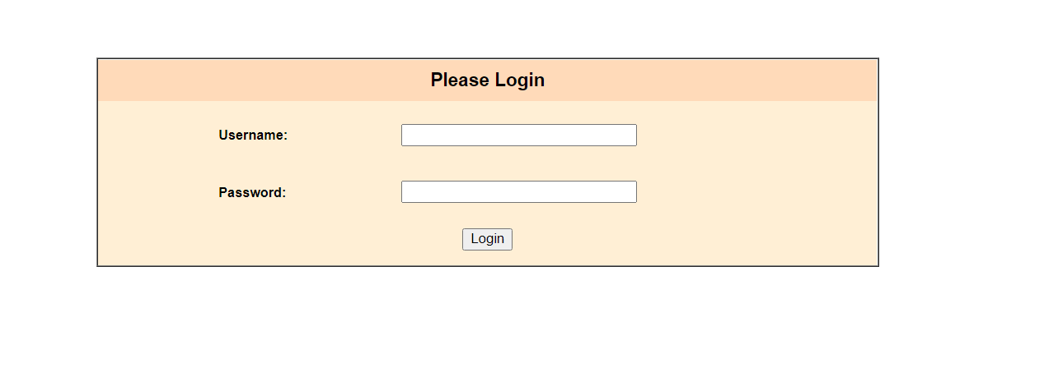

Step 5:

Select the SWITCH role option from the dropdown menu you want to get in.

Enter the Account number and provided Role details which you want to get in. Enter Display Name as any user understandable name

**Dev Role:**

**Acc-** 481935479534

**Role:** [DeveloperExecutionCIINOGBD](https://console.aws.amazon.com/iam/home?#/roles/DeveloperExecutionCIINOGBD)

**Prod Role:**

**Acc:** 075041934545

**Role:** DeveloperExecutionCIINOGBD

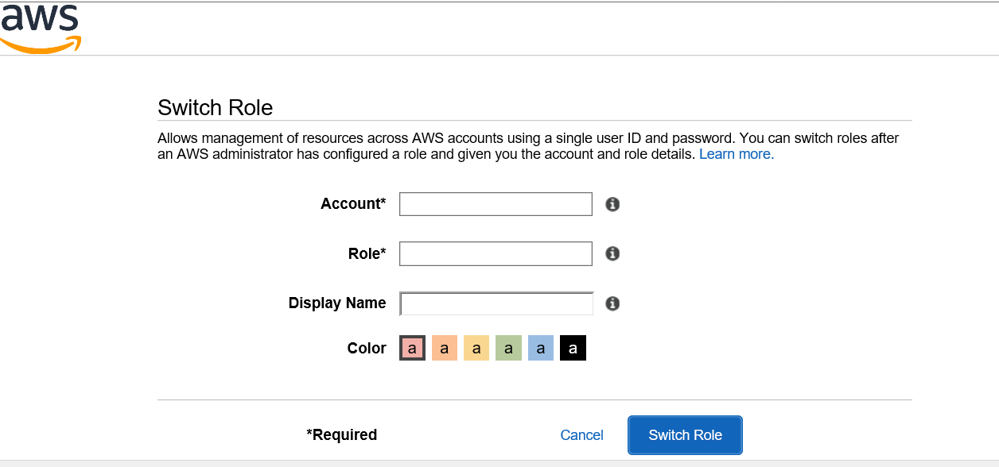

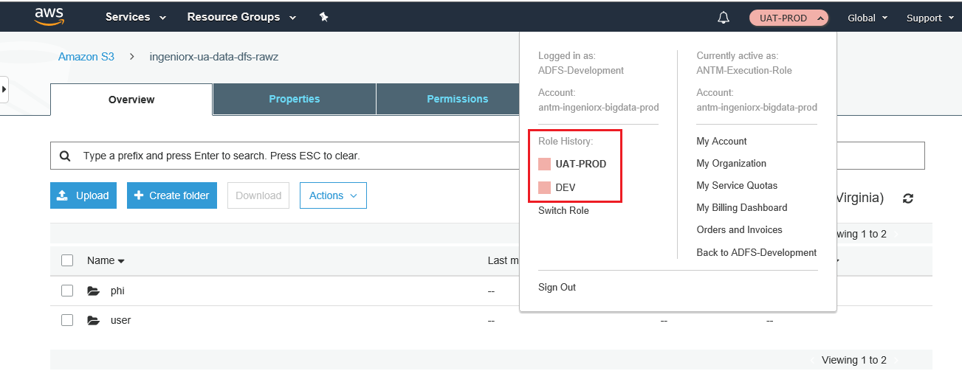

Once switched into the DEV AWS Role, then we can access the services like Athena, EMR, StepFunction etc..

EXAMPLE:

Services -> Athena -> query any discover or adhoc table as mentioned below

