Project Progress Report - Ashvini Surwase

Prescriptive Maintenance RAG Agent
Current Status: Phase 1 Completed

1.Project Overview
The objective of this project is to develop an AI-powered Prescriptive Maintenance RAG Agent that can analyze machinery manuals, retrieve relevant maintenance procedures, and provide maintenance recommendations based on equipment issues and alerts. The solution is being developed using FastAPI, ChromaDB, and Retrieval-Augmented Generation (RAG) technologies.

2.Progress Update
During the first phase of the project, the focus was on building the foundation required for the RAG system.

Day 1 – Project Initialization
- Created the GitHub repository.
- Set up the project folder structure.
- Configured the Python development environment.
- Added initial project documentation and README.

Screenshot: GitHub Repository Setup
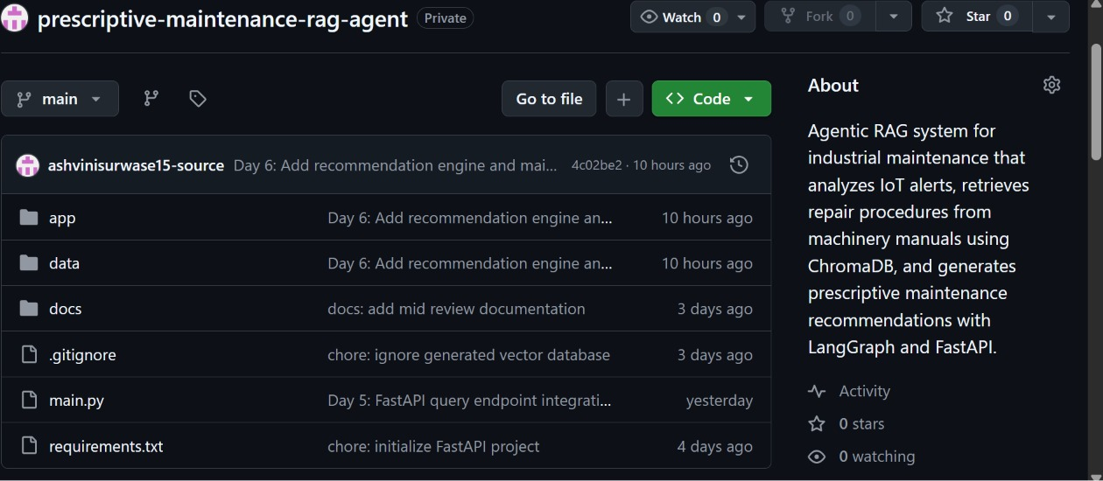

Day 2 – FastAPI Configuration
- Initialized the FastAPI application.
- Created the basic application structure.
- Implemented and tested the health-check endpoint.
- Verified that the application was running successfully.

Screenshot: FastAPI Application Setup

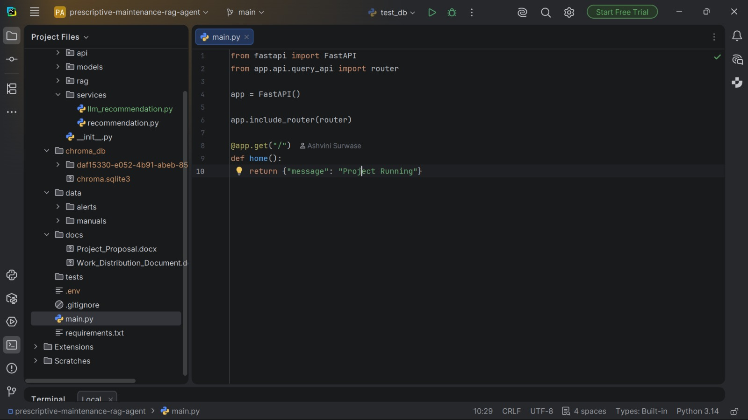

Day 3 – Document Loading Module
- Developed the document loading functionality.
- Successfully loaded and processed sample machinery maintenance manuals.
- Validated document extraction for further processing.

Screenshot : Document Loader Implementation
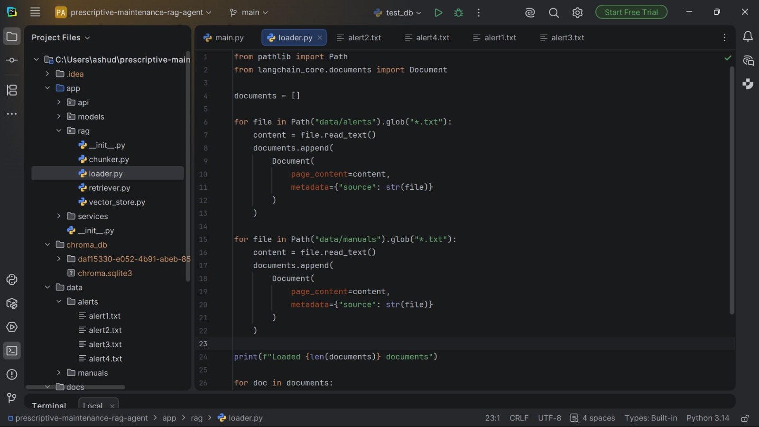

DAY 4 – Document Processing
- Implemented document chunking to prepare manual content for vector storage.
- Configured overlapping chunks to preserve context during retrieval.
- Tested chunk generation and document processing workflow.

Screenshot: Document Chunking Process
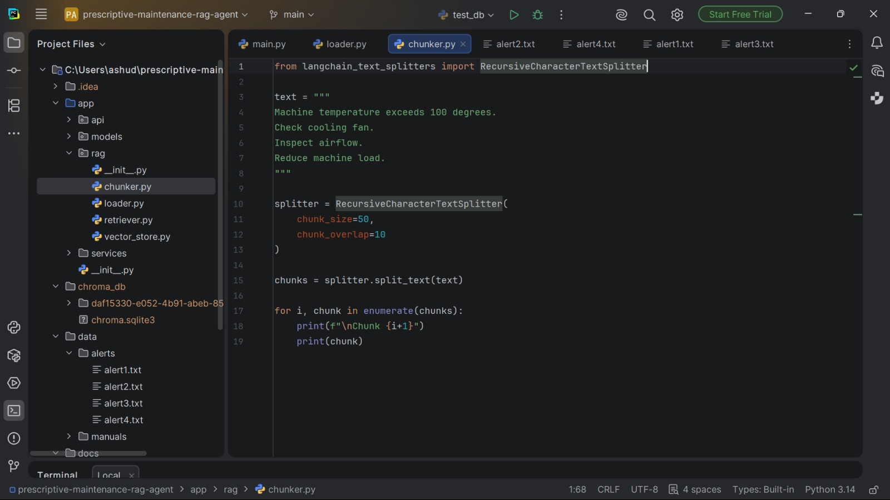

DAY 5 – ChromaDB Integration
- Configured ChromaDB as the vector database.
- Generated embeddings from the processed manual content.
- Stored vectors successfully in the database.
- Completed testing of document storage and retrieval functionality.

Screenshot: ChromaDB Integrationq
a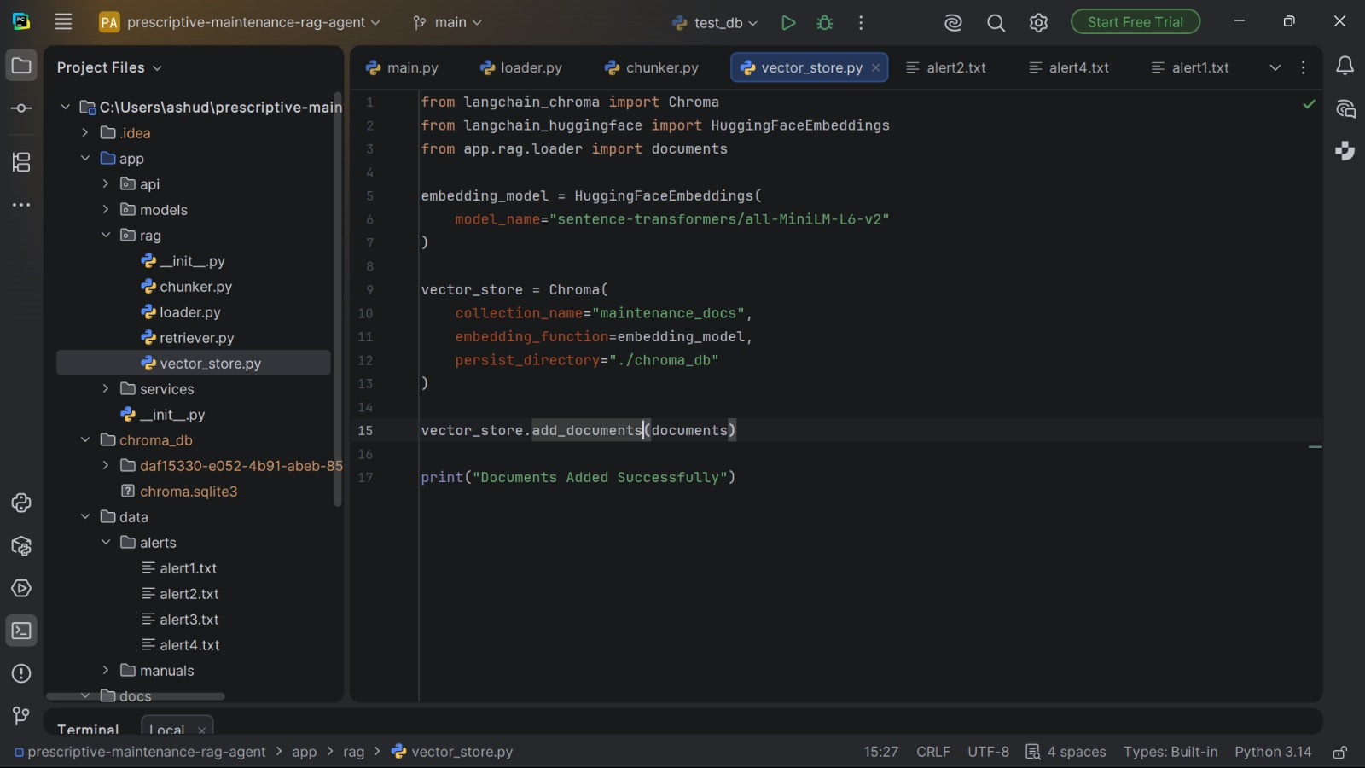

3. Current Project Structure
Implemented Modules:
Screenshot 6: Project Folder Structure
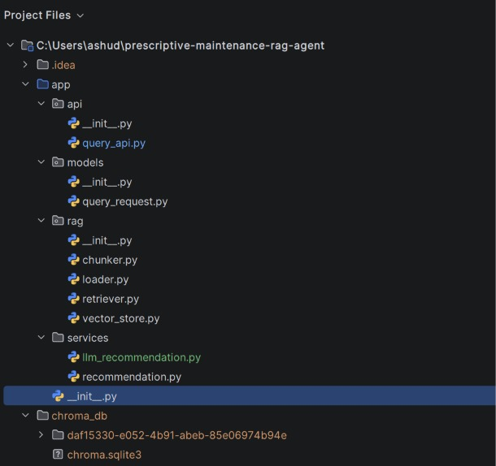
Additional Components:
- FastAPI Backend
- ChromaDB Vector Store
- PDF Loader
- Document Chunking Engine
- Retrieval Framework
- GitHub Repository Structure

4.Key Achievements
✅ Project repository created and maintained on GitHub.
✅ FastAPI backend successfully configured.
✅ Machinery manual ingestion process completed.
✅ Document chunking implemented and tested.
✅ ChromaDB vector database integrated successfully.
✅ Foundation for the RAG system established.

5.Next Steps
Phase | Duration | Activities | Status
Phase 1 – Foundation | 15 Jun – 19 Jun | GitHub Setup, FastAPI Setup, PDF Loader, Document Chunking, ChromaDB Integration | ✅ Completed
Phase 2 – RAG System | 20 Jun – 24 Jun | Retrieval Pipeline, OpenAI Integration, Question-Answer Workflow, Prompt Optimization, Testing | 🔄 In Progress
Phase 3 – IoT Integration | 25 Jun – 28 Jun | IoT Alert Model, FastAPI Alert Endpoint, Query Generation, End-to-End Testing | ⏳ Planned
Phase 4 – LangGraph Agent | 29 Jun – 1 Jul | LangGraph Setup, Agent Workflow, Repair Plan Generation | ⏳ Planned
Phase 5 – Tool Calling | 2 Jul – 3 Jul | Inventory Checking Tool, Tool Integration | ⏳ Planned
Phase 6 – UI & Documentation | 4 Jul – 5 Jul | Streamlit UI, Screenshots, Architecture Diagram, Final Documentation | ⏳ Planned

