RGP Template:

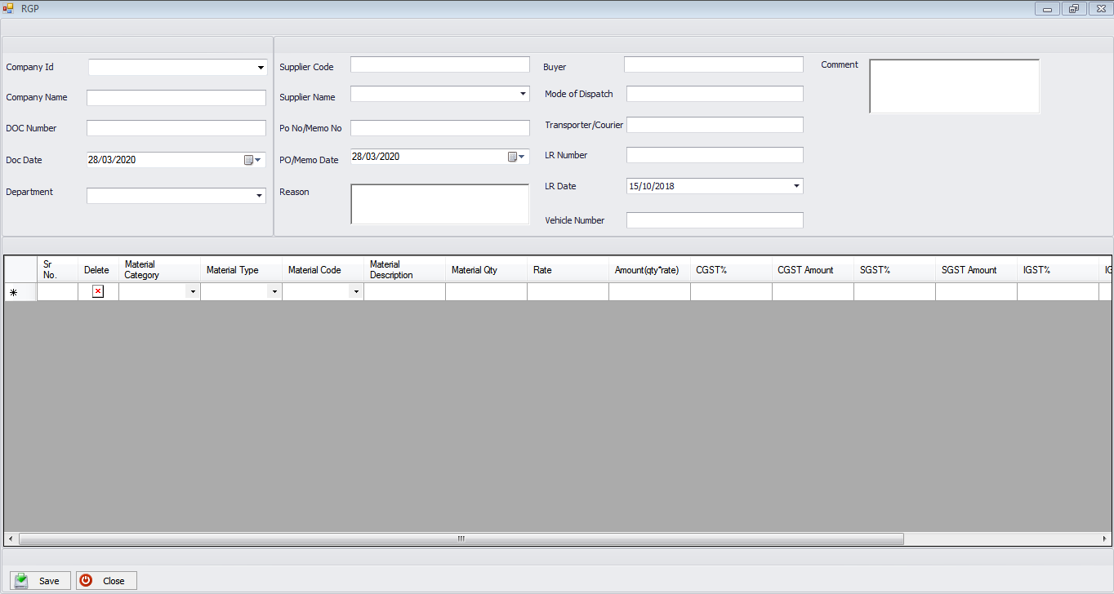

Elements for UI

1. Company Id:
Type: | Dropdown list box
Label: | ‘Company Id’
Content: | List of all ‘Company Id’, sorted alphabetically, and proceeded by the default.
Default: | ‘Choose from this list’
Behavior: | Standard.
Comment: | ‘Company Id’ field has to select by user from Dropdown list box.
2. Company Name:
Type: | Textbox
Label: | ‘Company Name’
Content: | Text Data
Default: | NONE
Behavior: | Standard.
Comment: | ‘Company Name’ field fill automatically when ‘Company Id’ field selected by user.

3. DC/RGP Counter Code :
Type: | Textbox
Label: | ‘DC/RGP Counter Code’
Content: | Auto generated code
Default: | Textbox is disable
Behavior: | Standard.
Comment: | ‘DC/RGP Counter Code’ field generate automatically when form data save event is occurred.
4. DC/RGP No & Date:
Type: | DateTimePicker
Label: | ‘DC/RGP No & Date’
Content: | Date
Default: | Current Date
Behavior: | Standard.
Comment: | ‘DateTimePicker’ field show current date, user has to select it manually else it takes current date as input.
5. Department:
Type: | Dropdown list box
Label: | ‘Department’
Content: | List of all Department, sorted ascending order by name, and proceeded by the default
Default: | Choose from this list
Behavior: | Standard.
Comment: | ‘Department’ field has to select by user from Dropdown list box.
6. Supplier Code:
Type: | Dropdown list box
Label: | ‘Dropdown list box’
Content: | List of all Supplier Code, sorted alphabetically, and proceeded by the default.
Default: | ‘Choose from this list’
Behavior: | Standard.
Comment: | ‘Supplier Code has’ field to select by user from Dropdown list box.

7. Supplier Name:
Type: | Textbox
Label: | ‘Supplier Name’
Content: | Text Data
Default: | Supplier Name
Behavior: | Standard.
Comment: | ‘Supplier Name’ field fill automatically when ‘Supplier Code’ field is selected by user
8. PO/Memo No:
Type: | Textbox
Label: | ‘PO/Memo No’
Content: | Text Data
Default: | NONE
Behavior: | Standard.
Comment: | ‘PO/Memo No’ field has to fill by user on base of material return against PO number.

9. PO/Memo Date :
Type: | Dropdown list box
Label: | ‘PO/Memo Date’
Content: | Date
Default: | Current Date
Behavior: | Standard.
Comment: | ‘PO/Memo Date’ field has to fill by user on base of material return against PO number.
10. Reason:
Type: | RichTextbox
Label: | ‘Reason’
Content: | Text Data
Default: | NA
Behavior: | Standard.
Comment: | ‘Reason’ field has to fill by user for Material return to Supplier
11. Buyer:
Type: | Textbox
Label: | ‘Buyer’
Content: | Text Data
Default: | NONE
Behavior: | Standard.
Comment: | ‘Buyer’ field has to fill by user, if supplier is nominated by buyer.

12. Mode of Dispatch:
Type: | Textbox
Label: | ‘Mode of Dispatch’
Content: | Text Data
Default: | NA
Behavior: | Standard.
Comment: | ‘Mode of Dispatch’ field has to fill manually by user
13. Transporter/Courier:
Type: | Textbox
Label: | ‘Transporter/Courier’
Content: | Text Data
Default: | NA
Behavior: | Standard.
Comment: | ‘Name of Transport/Courier’ field has to fill manually by user
14. LR/Docket No.:
Type: | Textbox
Label: | ‘LR/Docket No’
Content: | Text Data
Default: | NA
Behavior: | Standard.

15. LR Date:
Type: | DateTimePicker
Label: | ‘DC/RGP No & Date’
Content: | Date
Default: | Current Date
Behavior: | Standard.
Comment: | DateTimePicker show current date, user has to select it manually else it takes current date as input.
16. Vehicle No:
Type: | Textbox
Label: | ‘Vehicle No’
Content: | Text Data
Default: | NA
Behavior: | Standard.
Comment: | Vehicle No has to fill by user manually.
17. Comment:
Type: | RichTextbox
Label: | ‘Comment’
Content: | Text data
Default: | NA
Behavior: | Standard.
Comment: | Comment if any for Material Return
18. Material Category:
Type: | DataGridViewComboBoxColumn
Header Text: | ‘Material Category’
Content: | List of all Material Category, sorted alphabetically, and proceeded by the default.
Default: | NONE
Behavior: | Standard.
Comment: | 'Material Category’ has to select by user from DataGridViewComboBoxColumn list box
19. Material Type:
Type: | DataGridViewComboBoxColumn
Header Text: | ‘Type’
Content: | List of all Material Type, sorted alphabetically on base of Category, and proceeded by the default.
Default: | NONE
Behavior: | Standard.

20. Material Code:
Type: | DataGridViewComboBoxColumn
Header Text: | ‘Material Code’
Content: | List of all Material Code, sorted alphabetically on base of Material Type, and proceeded by the default.
Default: | NONE
Behavior: | Standard.
Comment: | ‘Material code’ field has to select by user from DataGridViewComboBoxColumn list box

21. Material Description:
Type: | DataGridViewTextBoxColumn
Header Text: | ‘Material Description’
Content: | Text Data
Default: | NONE
Behavior: | Standard.
Comment: | ‘Material Description’ field fill automatically when Material code selected by user
22. HSN/SAC CODE:
Type: | DataGridViewTextBoxColumn
Header Text: | ‘HSN/SAC CODE’
Content: | Text Data
Default: | HSN/SAC CODE
Behavior: | Standard.
Comment: | ‘HSN/SAC CODE’ filed fill automatically when Material code selected by user
23. Material Qty:
Type: | DataGridViewTextBoxColumn
Header Text: | ‘Material Qty’
Content: | Decimal/ Integer Data
Default: | NA
Behavior: | Standard.
Comment: | ‘Material Qty’ filed has to fill by user, It should be Decimal/Integer
24. Rate:
Type: | DataGridViewTextBoxColumn
Header Text: | ‘Company Name’
Content: | Decimal/ Integer Data
Default: | NA
Behavior: | Standard.
Comment: | ‘Rate’ field has to fill by user, It should be Decimal/Integer
24. Amount(qty*rate):
Type: | DataGridViewTextBoxColumn
Header Text: | ‘Amount(qty*rate)’
Content: | Auto Generated Decimal Data
Default: | NA
Behavior: | Standard.
Comment: | ‘Amount(qty*rate)’ field has to fill by user, It should be Decimal/Integer
25. CGST%:
Type: | DataGridViewTextBoxColumn
Header Text: | ‘CGST’
Content: | Decimal/ Integer Data
Default: | NA
Behavior: | Standard.
Comment: | ‘CGST’ filed has to fill by user, It should be Decimal/Integer
26. CGST Amount:
Type: | DataGridViewTextBoxColumn
Header Text: | ‘CGST Amount’
Content: | Decimal Data
Default: | Disable DataGridViewTextBoxColumn
Behavior: | Standard.
Comment: | ‘CGST Amount’ field is automatically calculated based on ‘CGST’ field
27. SGST%:
Type: | DataGridViewTextBoxColumn
Header Text: | ‘SGST’
Content: | Decimal/ Integer Data
Default: | NA
Behavior: | Standard.
Comment: | ‘SGST’ field has to fill by user, It should be Decimal/Integer
28. SGST Amount:
Type: | DataGridViewTextBoxColumn
Header Text: | ‘SGST Amount’
Content: | Decimal Data
Default: | Disable DataGridViewTextBoxColumn
Behavior: | Standard.
Comment: | ‘SGST Amount’ field is automatically calculated based on ‘SGST’ field

29. IGST%:
Type: | DataGridViewTextBoxColumn
Header Text: | ‘IGST’
Content: | Decimal/ Integer Data
Default: | NA
Behavior: | Standard.
Comment: | ‘IGST’ field has to fill by user, It should be Decimal/Integer
29. IGST Amount:
Type: | DataGridViewTextBoxColumn
Header Text: | ‘IGST Amount’
Content: | Decimal Data
Default: | Disable DataGridViewTextBoxColumn
Behavior: | Standard.
Comment: | ‘IGST Amount’ field is automatically calculated based on ‘IGST’ field
31. GST Amount:
Type: | DataGridViewTextBoxColumn
Header Text: | ‘GST Amount’
Content: | Decimal Data
Default: | Disable DataGridViewTextBoxColumn
Behavior: | Standard.
Comment: | ‘GST Amount’ filed is automatically calculated based on ‘SGST,CGST’ or ‘IGST’ field
32. Total Amount:
Type: | DataGridViewTextBoxColumn
Header Text: | ‘Total Amount’
Content: | Decimal Data
Default: | Disable DataGridViewTextBoxColumn
Behavior: | Standard.
Comment: | ‘Total Amount’ field fill & calculated automatically by adding field like ‘Amount’ and ‘GST Amount’

