SE LAB 1

Name: Ashvin Ronald Lobo

SRN: PES1UG24AM345

Class: AIML F

PROBLEM STATEMENT #45

Multi-Cloud Asset Cost Optimization Portal

Requirements Table
Req ID | Type | Description | Priority | Acceptance Criteria | Rationale
FR-001 | Functional | The system shall ingest cloud billing CSV exports from AWS, Azure, and GCP, categorize costs by service and project tag, and highlight compute instances with less than 5% average CPU utilization over a 14-day window. | High | Pass: An idle cloud asset is flagged with a monthly savings estimate.  Fail: An active instance (≥5% CPU) is misclassified as idle. | Idle compute is one of the largest recurring sources of avoidable cloud spend; automated detection directly enables the portal's core cost-optimization value proposition.
FR-002 | Functional | The system shall scan ingested billing and inventory data to identify storage volumes (e.g., EBS, Managed Disks, Persistent Disks) that have been unattached to any compute instance for more than 7 consecutive days. | High | Pass: A volume unattached for >7 days is flagged with its size, provider, and estimated monthly cost.  Fail: A volume attached at any point within the 7-day window is flagged as unattached. | Orphaned storage volumes continue to accrue cost with no operational benefit; surfacing them lets FinOps analysts recover spend without impacting running workloads.
FR-003 | Functional | The system shall compare aggregated actual spend per project/service against configured monthly budget thresholds and shall dispatch a budget breach alert (email and/or SMS) to designated recipients when actual spend exceeds the threshold. | High | Pass: An alert is dispatched within 5 minutes of spend crossing the configured threshold, containing project name, threshold, and actual spend.  Fail: Spend exceeds threshold by more than 5% and no alert is generated or logged. | Timely breach notifications prevent budget overruns from going unnoticed until the end of a billing cycle, giving stakeholders a chance to intervene early.
FR-004 | Functional | The system shall display a categorized cost breakdown (by cloud provider, service, and project tag) on the FinOps Analyst dashboard, refreshed within 2 minutes of new billing data being ingested. | Medium | Pass: Dashboard totals reconcile with the source CSV totals within 0.5% after a refresh.  Fail: Dashboard values remain stale more than 2 minutes after successful ingestion. | A trustworthy, near-real-time dashboard is the primary interface analysts use to act on cost data; stale or inaccurate figures undermine confidence in the whole portal.
FR-005 | Functional | The system shall restrict configuration of budget thresholds and management of user access/roles to users assigned the Cloud Administrator role, and shall reject such actions from any other role. | Medium | Pass: A Cloud Administrator successfully updates a threshold; a FinOps Analyst attempting the same action receives an authorization error and no change is persisted.  Fail: A non-administrator role is able to modify a budget threshold or user access setting. | Budget thresholds and access control govern financial alerting and data exposure; limiting configuration rights to administrators reduces the risk of misconfiguration or unauthorized changes.
NFR-001 | Performance & Security | The portal must parse multi-gigabyte cloud billing files and update cost dashboards in under 2 minutes, while enforcing encryption of billing data in transit and at rest. | High | Pass: Benchmarking tests confirm dashboard update latency under target with a multi-GB file under simulated peak load, and security scans confirm TLS in transit and AES-256 at rest.  Fail: Latency exceeds 2 minutes under peak load, or billing data is found unencrypted at rest or in transit. | Large enterprises generate very large billing exports; slow processing delays cost visibility, and billing data is sensitive financial information requiring strong protection.
NFR-002 | Reliability & Usability | The portal shall maintain 99.5% monthly uptime during business hours and render the cost dashboard within 3 seconds for datasets of up to 500,000 billing line items. | Medium | Pass: Uptime monitoring logs show ≥99.5% availability over a rolling 30-day period, and dashboard load tests with 500,000 records complete in ≤3 seconds.  Fail: Monthly uptime falls below 99.5%, or dashboard render time exceeds 3 seconds at the specified data volume. | FinOps decisions depend on the dashboard being consistently available and responsive during working hours; excessive downtime or lag directly erodes user trust and adoption.

UML Use Case Diagram:

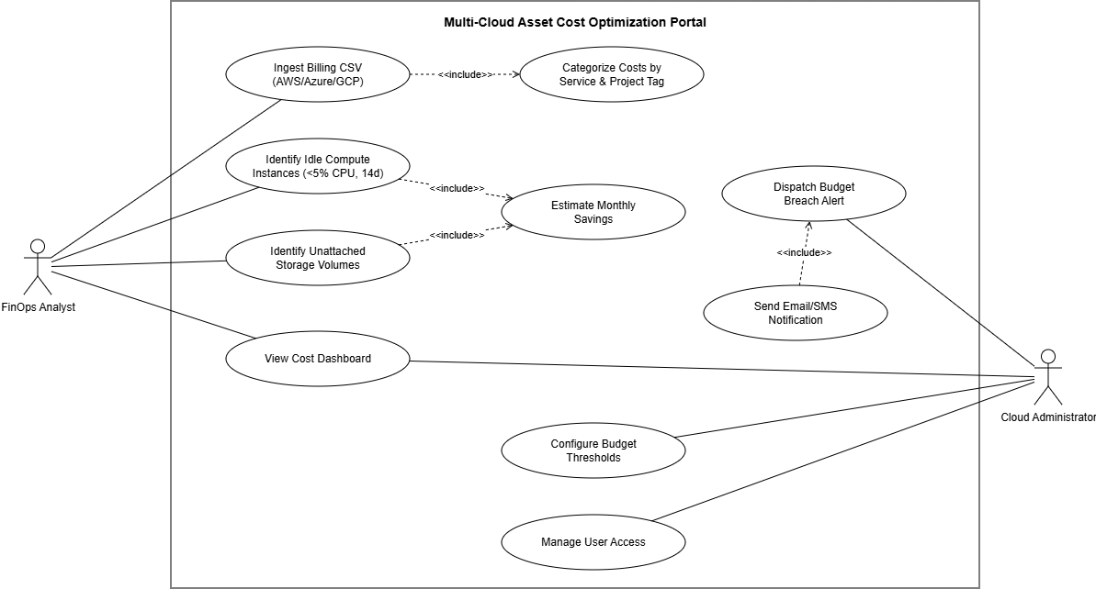

Use-Case Flow Document

Use Case: Dispatch Budget Breach Alert

Main Success Scenario
1. The system aggregates categorized cost data by project and service on a scheduled interval.
2. The system compares aggregated actual spend against the configured budget threshold for each project/service.
3. The system detects that actual spend has exceeded the configured threshold for a given project.
4. The system generates a budget breach alert containing the project name, threshold amount, actual spend, and percentage overage.
5. The system dispatches the alert via email and/or SMS to the assigned Cloud Administrator and FinOps Analyst.
6. The Cloud Administrator receives the notification and reviews the breach details on the cost dashboard.
7. The Cloud Administrator acknowledges the alert; the system logs the acknowledgment with a timestamp, and the use case ends successfully.

Alternate Flow - Notification Delivery Failure
Branches from step 5 of the main success scenario.
1. The notification service fails to deliver the email or SMS (e.g., invalid contact address, network or provider outage).
2. The system logs the delivery failure with an error code and timestamp.
3. The system automatically retries delivery up to 3 times at 5-minute intervals.
4. If all retries fail, the system marks the alert as “Undelivered” and surfaces it prominently on the Cloud Administrator's dashboard for manual review.
5. The use case resumes at step 6, with the Cloud Administrator reviewing the alert via the dashboard instead of the external channel.

Alternate Flow - No Budget Threshold Configured
Branches from step 2 of the main success scenario.
1. The system finds that no budget threshold has been configured for the project/service being evaluated.
2. The system skips breach evaluation for that project and logs it as “Unmonitored.”
3. The system flags the project on the dashboard, prompting the Cloud Administrator to configure a threshold.
4. The use case ends without an alert being generated.

