Flowboard

System Design

STATUS  Planning only |  | OWNER  Not assigned |  | LAST UPDATED  October 22 2026

Authors | Prepared for the Flowboard project maintainer
Reviewers | Reviewer to be assigned
Related docs | PLAN.md and DECISIONS.md are canonical
Scope | Architecture, trust boundaries, domain rules and delivery gates

1. Abstract
Build Flowboard as a self-hosted project manager with a modular NestJS API, a separate BullMQ worker, and a Next.js interface. PostgreSQL owns durable state; Redis transports jobs and realtime invalidations. This proposed design supports inherited configuration, strict tenant isolation and atomic task moves. Implementation has not started.
The first release targets a manageable hobby deployment, launched with Docker Compose. It includes hierarchy, authentication, permissions, tasks, board/list/drawer views, activity, generated API contracts and tests. PLAN.md and DECISIONS.md remain the canonical implementation sources; this document summarizes their design and release gates.

2. Goals and Non Goals
Goals | Non-goals
Strict tenant and ancestor permission boundaries | Billing, teams, public sharing or production OIDC
Stable statuses and safe inherited custom fields | Email delivery, file uploads or offline sync
Atomic task moves and durable activity intent | Webhook delivery or searchable indexing
One-command demo with real integration and browser tests | Microservices, fine-grained locking or unmeasured caching

3. Background and Domain Rules
The hierarchy is workspace → space → folder → list; each task has one primary list. Workspace is a virtual root, while space, folder and list are stored nodes. Tenant-owned records and joins carry workspaceId. Global users and credential sessions are explicit exceptions. Composite tenant foreign keys and scoped repositories prevent cross-workspace relationships.
Statuses resolve from workspace to list by immutable key and identity. Nearer overrides change display properties; hide/unhide is reversible, and not_started, active and done must remain available. Fields resolve space to list by nearest whole definition. Types, options, required values and unknown keys are validated strictly. Configuration changes must preserve every affected live task; removing referenced status identities is also blocked for archived tasks.

4. Proposed Architecture

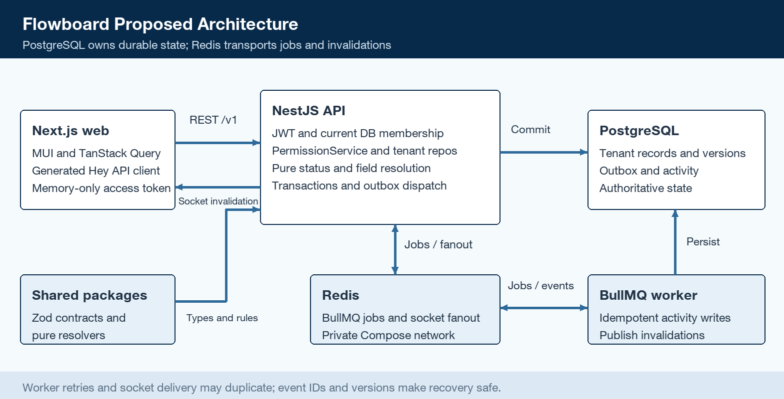
Figure 1. Proposed Flowboard components and durable event flow.

Core components

Component | Responsibility | Primary storage | Failure behavior
Next.js web | MUI views, forms and workspace-scoped query state | Browser memory | Match config versions; preserve edits and rollback failures
NestJS API | Auth, permissions, domain rules, REST and sockets | PostgreSQL via tenant repositories | Fail closed; validate before commit
PostgreSQL | Tenant records, versions, activity and outbox | Named persistent volume | Reject failed transactions; no partial mutation
Redis and worker | BullMQ delivery, activity processing and fanout | Redis transport; durable DB intent | Retry/deduplicate; task writes survive Redis outage
Shared packages | Zod contracts, pure resolvers, DB and UI boundaries | Versioned source and generated contracts | Build/lint/drift checks catch invalid dependency changes

5. Task Mutation Lifecycle
- Receive a strict /v1 mutation with access JWT, resource IDs and expected version.
- Load current membership and authorize source/destination resources; never trust client-supplied caller authority.
- Lock the workspace, recheck permissions and resolve effective statuses and custom fields.
- Validate the complete result. Keep the status or choose the first same-category match; otherwise reject.
- Commit the task, ordering, version and outbox event together; validation failures leave state unchanged.
- Create activity idempotently, publish invalidation, then mark completion. Retry publication even if activity already exists.
- Return authoritative state for UI reconciliation. Authorized subscribers and reconnecting clients refetch.

6. API and Data Contracts

Data model and invariants

Record | Key | Scope | Important contract
User and Membership | UUID; user/workspace | User global; member tenant | Current DB role is authoritative; normalized email is unique
Node and Grant | UUID; resource/user pair | Workspace | Typed parent chain; allow/deny and private ancestors apply cumulatively
StatusIdentity and Override | Stable statusId; owner/key | Workspace and scope | Key/category immutable; nearer display overrides never change identity
FieldDefinition | Owner/key | Workspace and scope | Nearest whole definition wins; options use stable IDs
Task and Assignee | UUID; task/user pair | Workspace | One primary list, stable statusId, JSONB fields and optimistic version
Outbox and Activity | Event UUID | Workspace | Task commit includes intent; unique eventId makes activity idempotent
Session and Invitation | UUID; token digest | Global session; tenant invite | Expiry, atomic rotation or acceptance; no plaintext token persistence

Contract guarantees

- Shared Zod schemas define strict requests, typed responses, errors and pure resolvers. Controllers translate HTTP; services own orchestration; repositories own tenant checks.
- Each endpoint carries a stable operationId, auth/permission metadata, response serialization and a behavioral test. OpenAPI and generated Hey API sources are committed.
- Explicit generation updates committed sources. Normal builds use ignored outputs. Drift checks regenerate into temporary paths; the spec bootstrap needs no DB or Redis.
- Lists use opaque, query-bound cursors: default 50, maximum 100, with stable ID tie-breaks. Errors carry code, message and typed path issues. Task/status/field reads carry configVersion; render them together only when versions match.
REST groups cover auth, workspaces, hierarchy, grants, scoped configuration, tasks and activity. Examples include GET /v1/tree and POST /v1/tasks/:id/move. Create returns 201, archive 204 and read/update 200. Use 401 for missing auth, 403 for tenant-local denial and 404 for absent or other-tenant data.
Full route and error contracts in PLAN.md section 6

7. Consistency and Recovery

PostgreSQL is authoritative for tasks, permissions and durable delivery intent. Workspace-level write locks deliberately serialize domain, configuration and grant writes at hobby scale. Multi-query reads use a consistent snapshot. Task/node versions reject stale edits. Move payloads explicitly clear source-only custom fields and supply destination-required values; neither silent data loss nor partial moves are allowed.
Scenario | Expected behavior | Reasoning
Duplicate job or invalidation | One activity row; clients deduplicate event/version | At-least-once processing does not duplicate durable activity
Invalid move or stale edit | Reject with typed 400/409; leave task/order unchanged | Status, fields, access and version are checked inside the lock
Redis or worker failure | Keep committed task and retry pending outbox intent | Database durability is independent of queue transport
Config or access changes | Revalidate affected tasks; revoke forbidden rooms | Shared lock order and permission checks prevent stale authority

8. Security and Privacy

- TenantContext comes from verified identity and current DB membership. Scoped repositories fail without it, inject tenant filters, validate relation targets and hide raw Prisma. Admin bypass applies only inside the current workspace.
- For members, ancestor denies block the subtree and every private ancestor requires its own explicit allow. Child allows cannot pierce restrictions. Visible containers permit task edits; configuration, containers, grants and membership changes are admin-only.
- Use Argon2id and 15-minute access JWTs. Store browser access tokens only in memory. Seven-day random refresh tokens are digest-only, rotate atomically and revoke their family on reuse. Cookies are HttpOnly and SameSite=Lax; HTTPS requires Secure.
- Check Origin, credentialed CORS and credential rate limits. Invitations expire and require the authenticated email. Prevent last-admin removal. Member removal cleans grants and assignments with updates. Workspace switch/logout clears tokens, queries and sockets.
- Sockets verify JWT and membership, authorize each list, reauthorize fanout and disconnect at token expiry. Grant changes revoke rooms. Payloads reveal only permitted IDs/version. Sanitize errors/logs and never serialize password or refresh-token material.

9. Operational Readiness
Signal | Evidence required | Owner | Release gate
Build and contracts | Build, lint and spec/client drift checks pass | Maintainer | Required
Tenant and domain safety | Real-Postgres auth, hierarchy and mutation tests pass | Maintainer | Required
Queue and fanout | Retry, duplicate, outage and revoked-room tests pass | Maintainer | Required
UI and browser flows | Persistence, permissions, keyboard and realtime tests pass | Maintainer | Required
Deployment readiness | Clean Compose start; seed once; honest health checks | Maintainer | Required
Rollout constraint: Web, API, worker, PostgreSQL and Redis are the five normal services. Publish web/API to localhost; keep DB/Redis private. Migrations and seed-once finish before readiness. Production disables demo seed and supplies secrets. Performance SLOs require measurement.

10. Alternatives Considered

Alternative | Why it was considered | Why it was not selected
Microservices | Independent scaling and deployment | One API and worker keep hobby operations manageable
Database RLS first | Another tenant isolation layer | Scoped repositories and composite FKs are the initial enforcement boundary
EAV custom fields | Relational values and flexible indexing | JSONB keeps task persistence simpler; indexing follows measured queries
Fine locks and caches | Higher write throughput and faster reads | Workspace locks and direct reads are easier to reason about initially

11. Verification Before Release
- Pin compatible stable versions in Phase 0 and verify Next/MUI, Zod/nestjs-zod and Hey API integration. The planning documents do not establish executable compatibility.
- Prove status/field edge cases, tenant isolation, permission revocation, last-admin races, concurrent moves/config changes and refresh replay with behavioral tests.
- Measure PostgreSQL lock contention, endpoint latency, outbox backlog and worker health before defining production SLOs or introducing application caches.
- Validate deployment secrets, demo-seed disabling, backup/recovery expectations and operational ownership before use beyond the local demonstration.

12. Decision and Next Steps
Proceed with the modular monolith and one worker. Follow the canonical backlog sequentially, with feature tests added alongside implementation. Phase 0 remains unstarted. The first release gate is a clean Docker Compose launch, then tenant and domain correctness, then accessible task workflows and permission-safe collaboration.
Milestone | Deliverable | Exit criteria
Phases 0 to 3 | Foundation, data/contracts, identity and hierarchy | Compose shells, real DB tests, tenant and permission safety
Phases 4 to 7 | Statuses, fields, tasks and complete API tooling | Resolution edge cases, atomic moves and contract drift checks
Phases 8 to 10 | UI library, task experience and configuration screens | Accessible controls; drawer edits persist after reload
Phases 11 to 12 | Activity/realtime and release documentation | Recovery, permission-safe fanout and clean Docker E2E pass

Calendar dates use YYYY-MM-DD; timestamp fields use ISO UTC. Required numeric zero and boolean false are valid values. Optional null clears a field; PATCH omission preserves it.

