Q1) a) Comparision between Analytical and Numerical Methods.
t = 0 secs
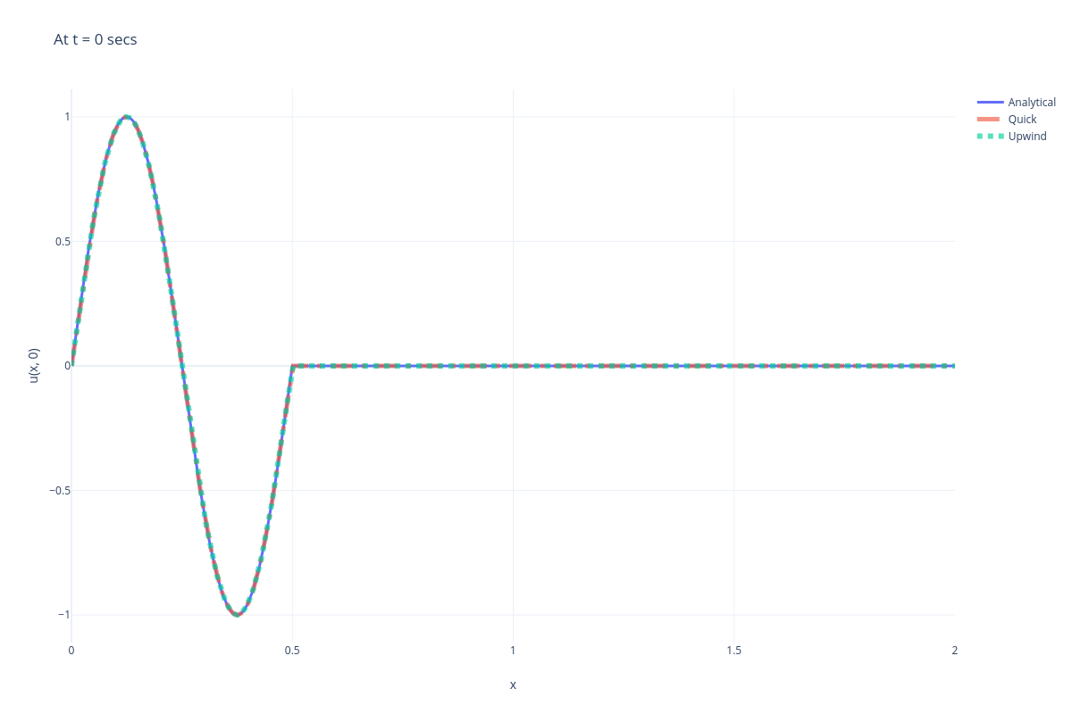
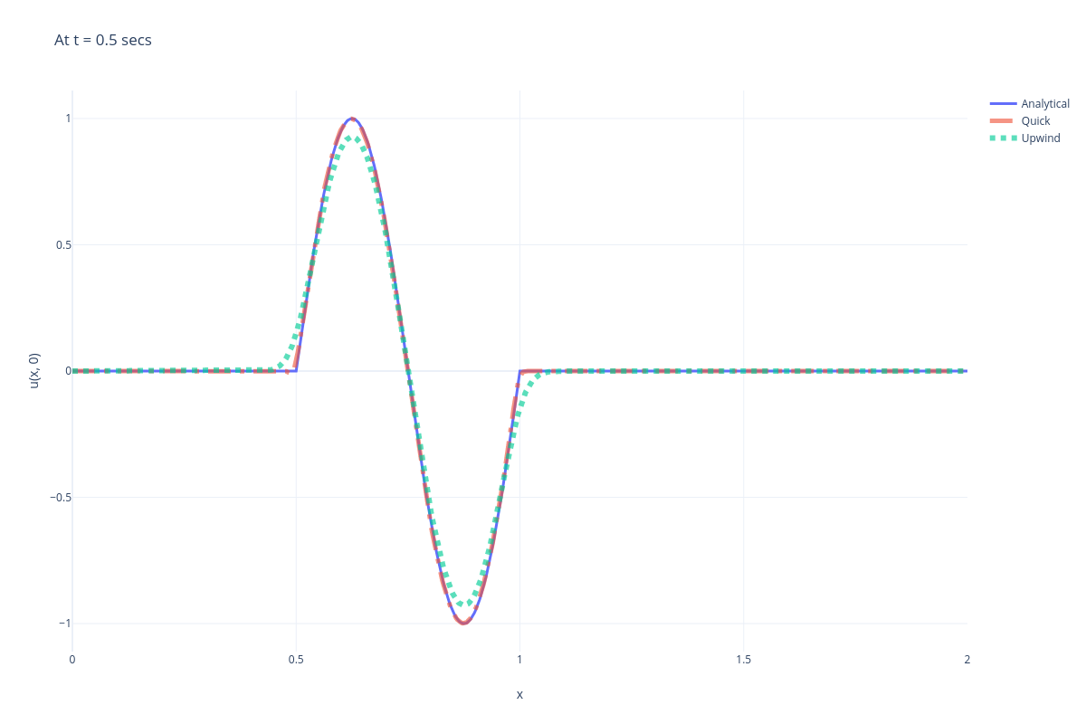
t = 0.5 secs

t = 1 secs
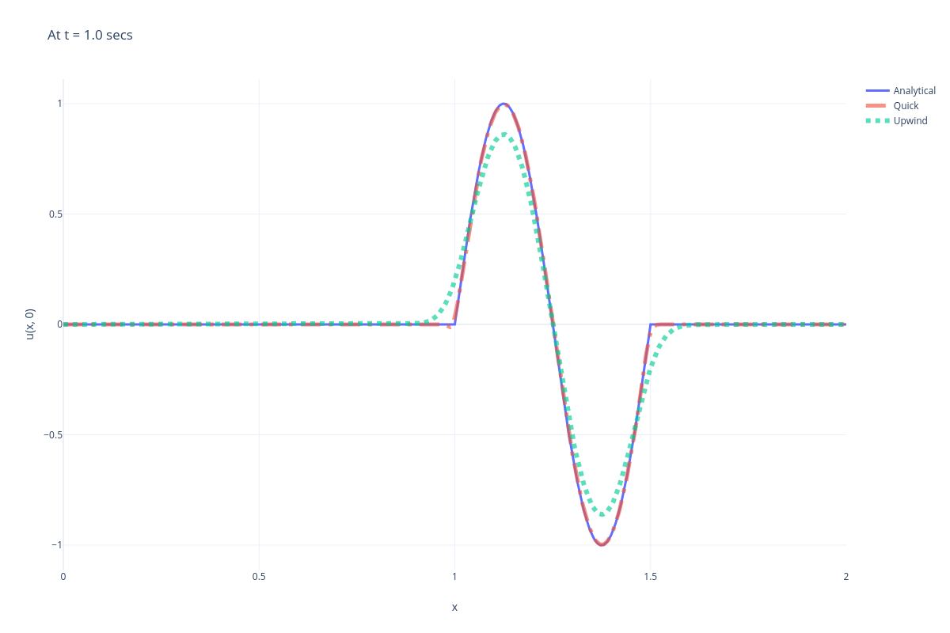
b) Upwind Scheme (parallel 2, 4 threads vs analytical)
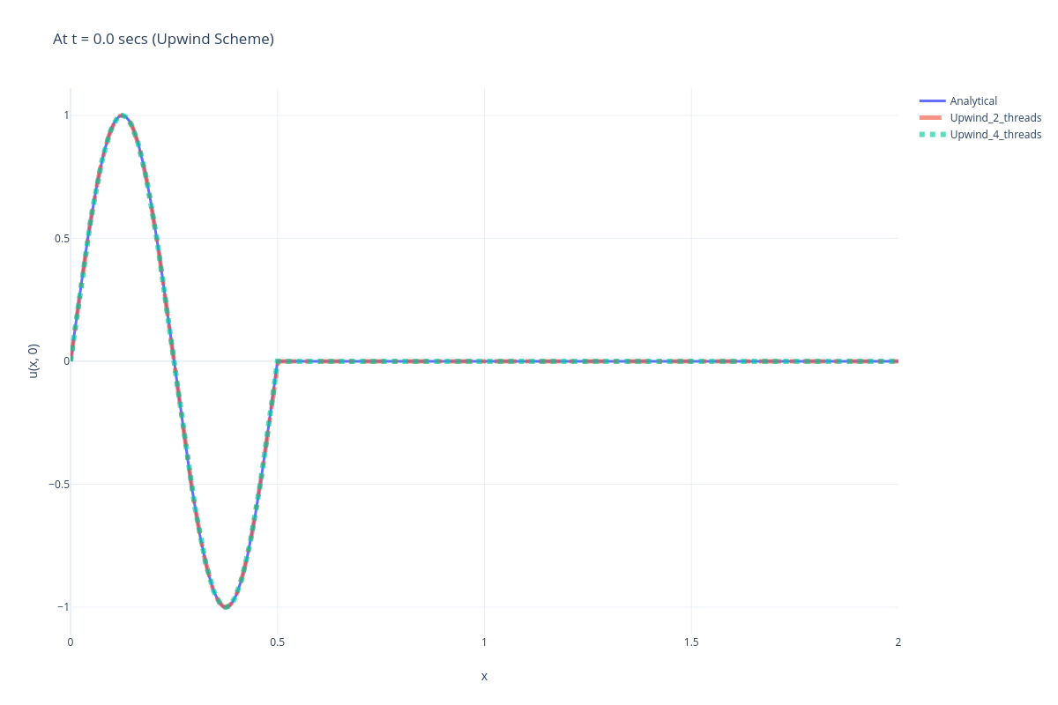
t = 0 secs

t = 0.5 secs
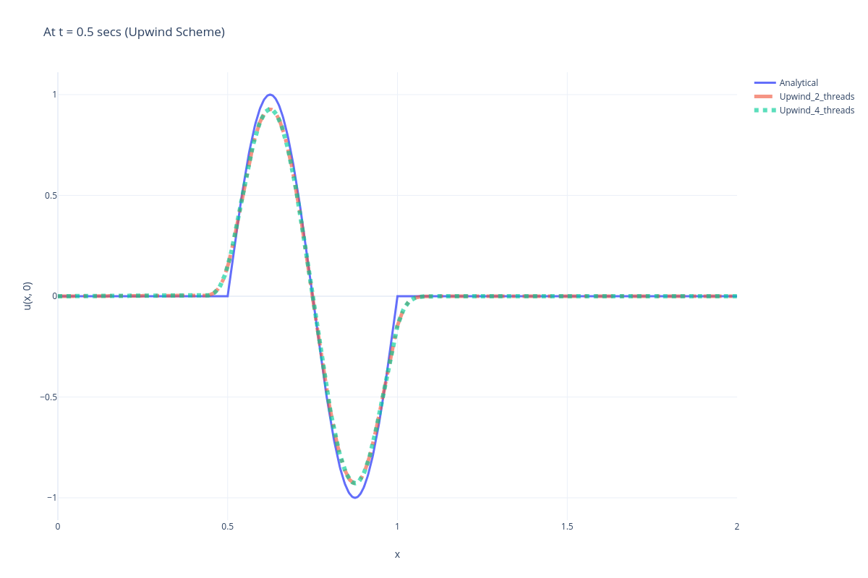
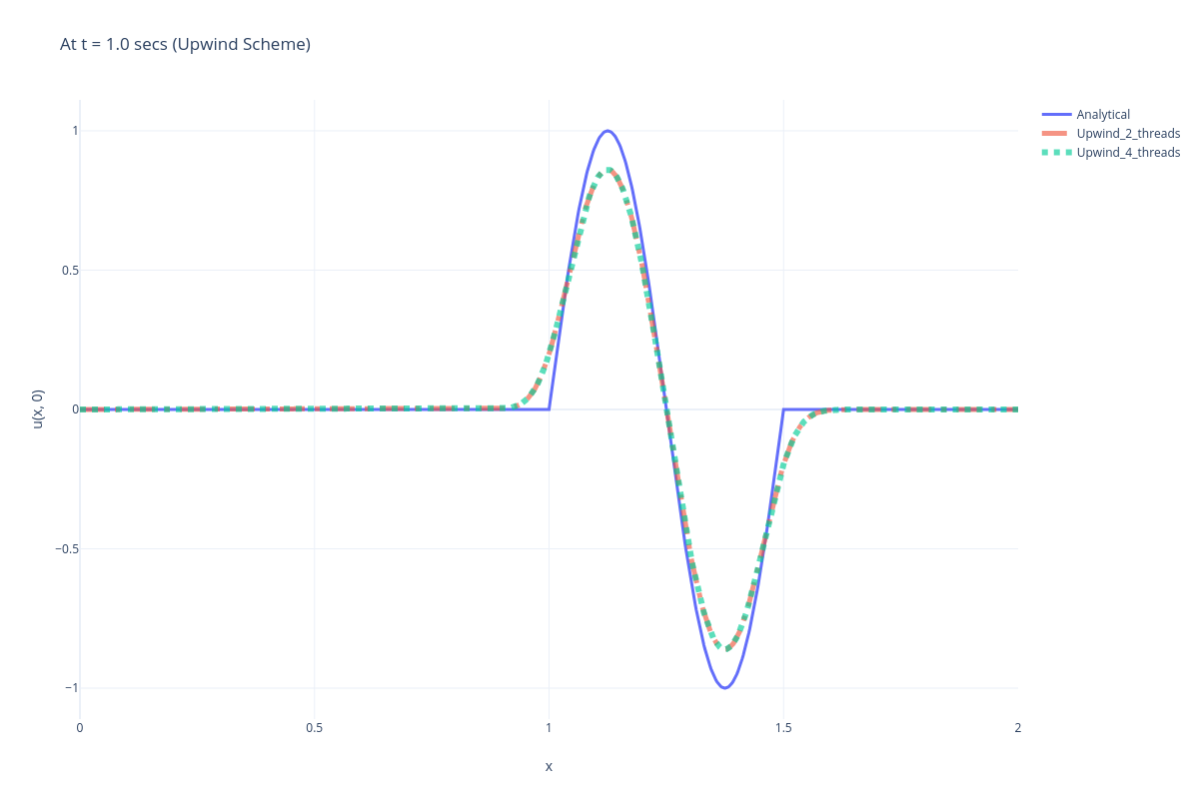
t = 1.0 secs

Quick Scheme(parallel 2, 4 threads vs analytical)
t = 0 secs
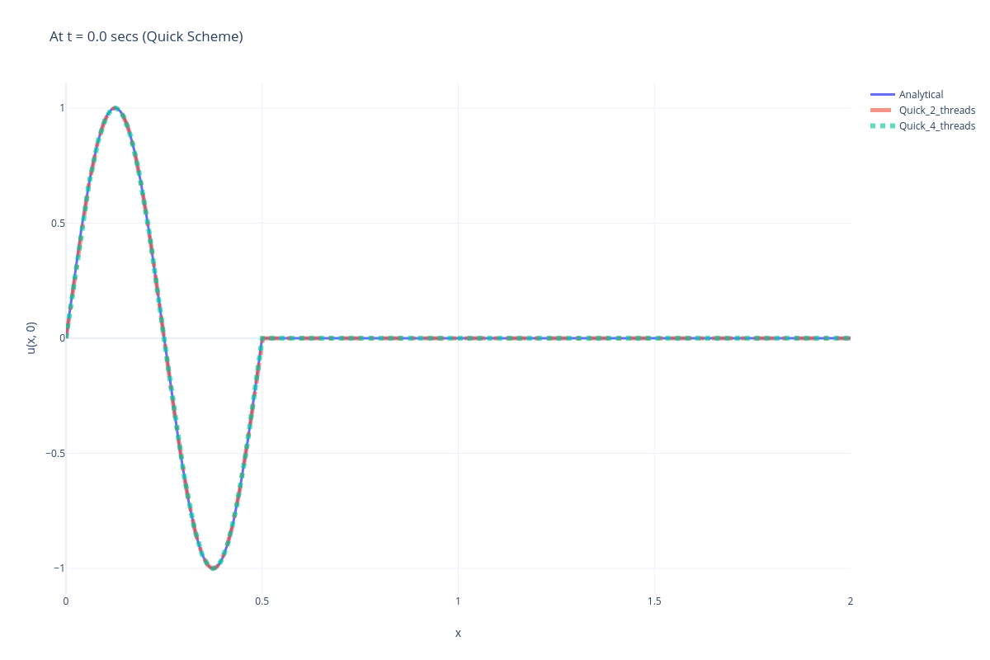
t = 0.5 secs
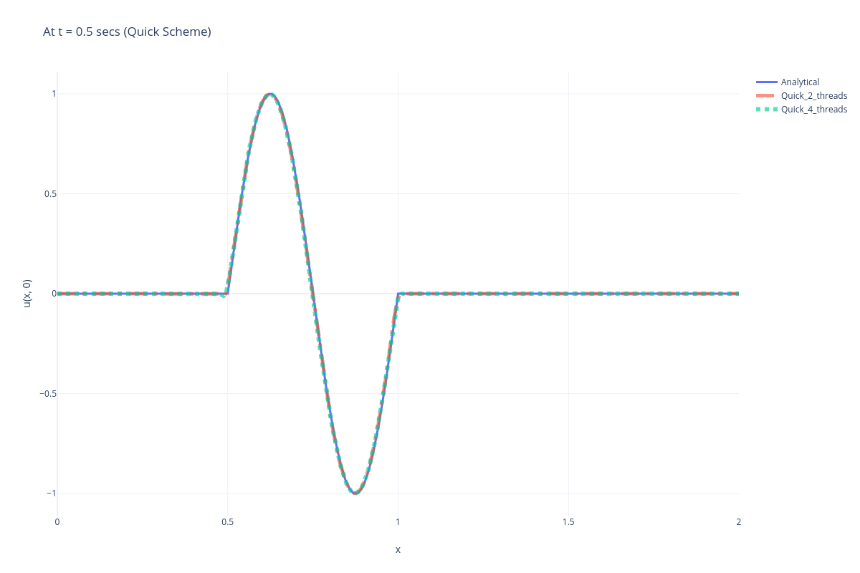
t = 1.0 secs
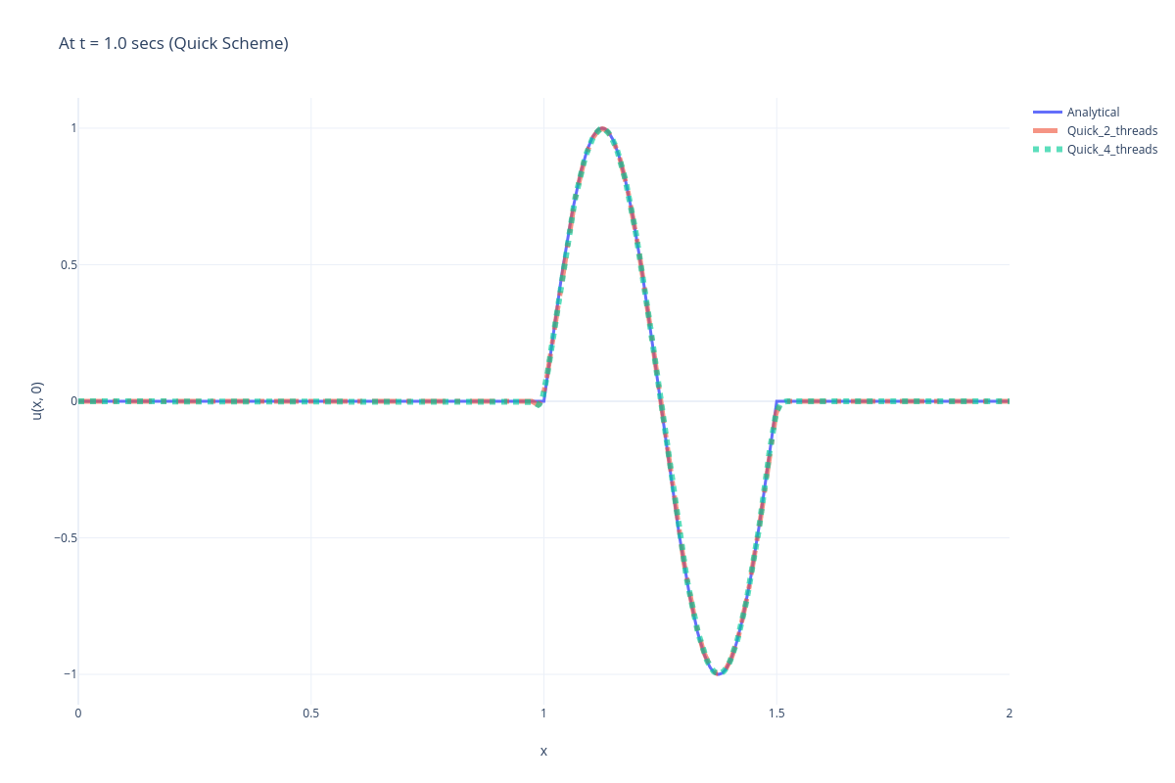
c) In the upwind scheme the wave flattens as time increases (amplitude decreases, wavelength increases). The Quick Scheme very well approximates the exact solution, but at the end points, a slight deviation can be observed as we are using lower order scheme at those points

Q2) a)
It took 491 iterations to cnoverge within 0.0001 between successive iterations(Using L2norm).
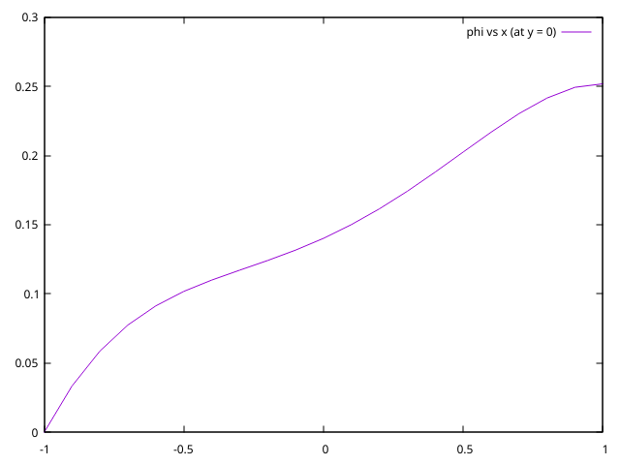
φ vs x (at y = 0):

φ vs y (at x = 0):

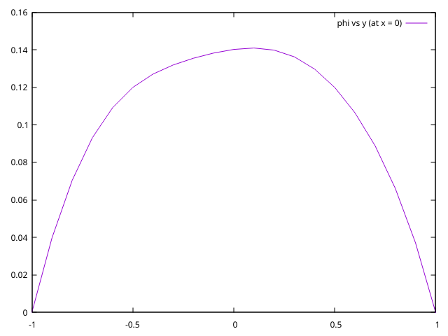
b)
Iterations taken for parallel jacobi (delta = 0.01)
For 2 process: 1701.
For 4 process: 2606.
For 8 process: 3900.

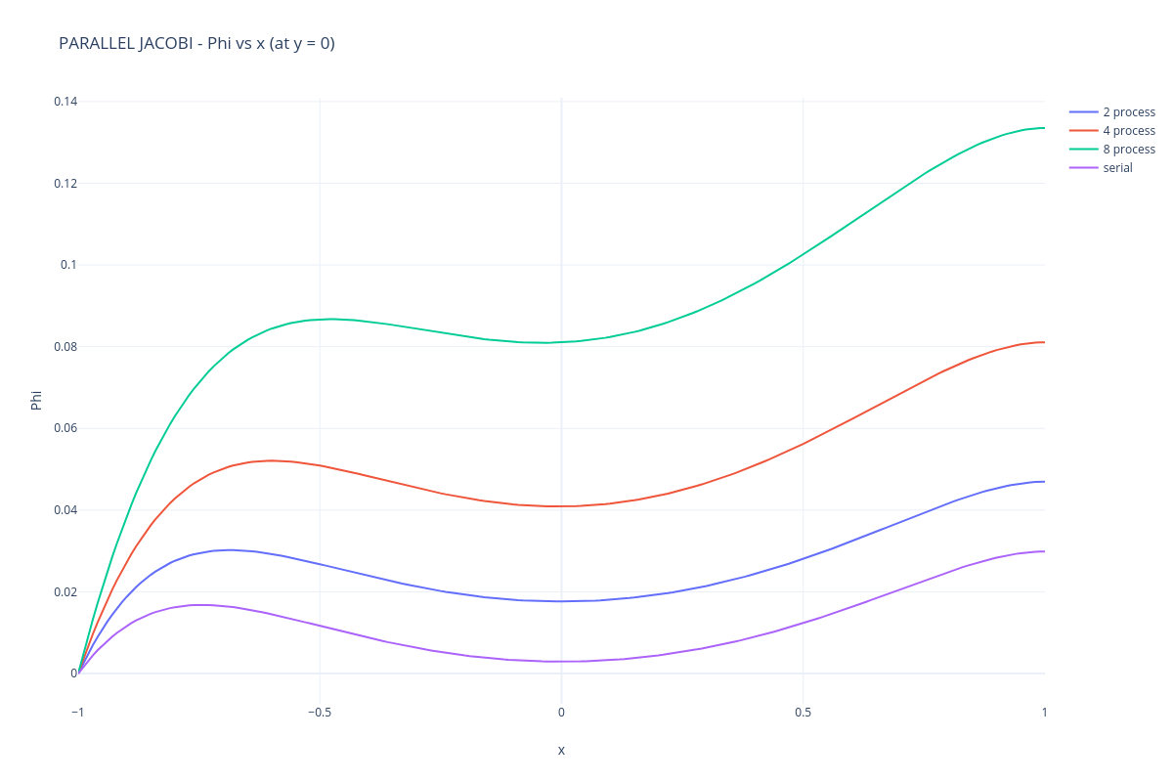
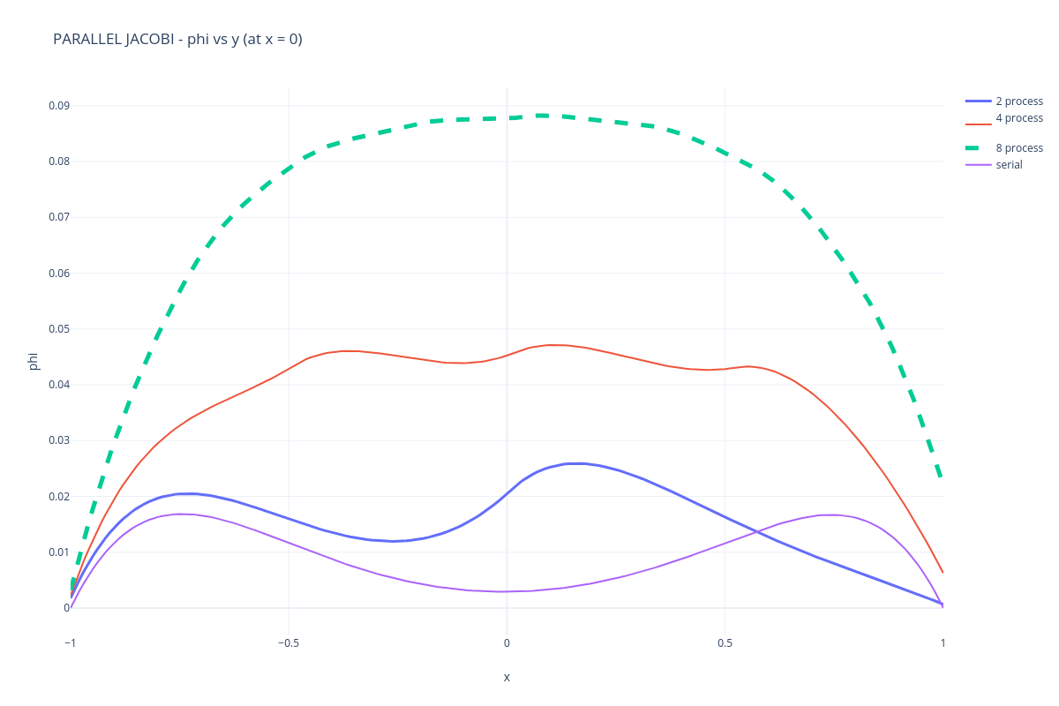

c) Iterations taken for red black gauss seidel(delta = 0.01)
For 2 process: 3023.
For 4 process: 4347.
For 8 process: 4928.
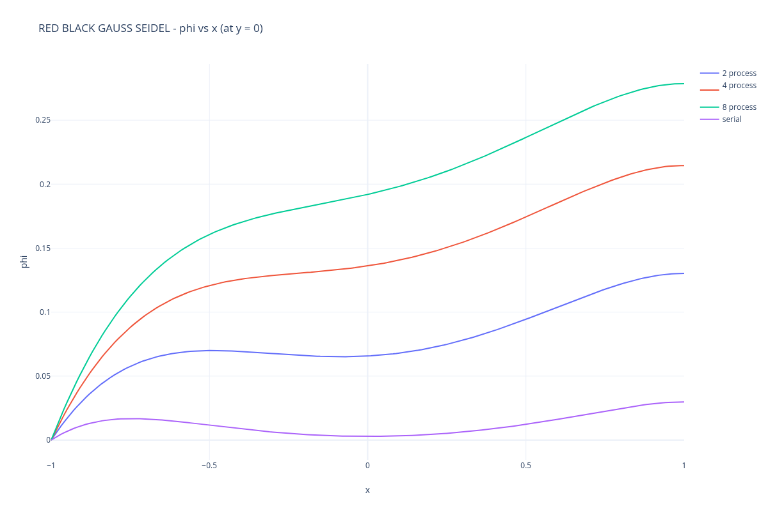
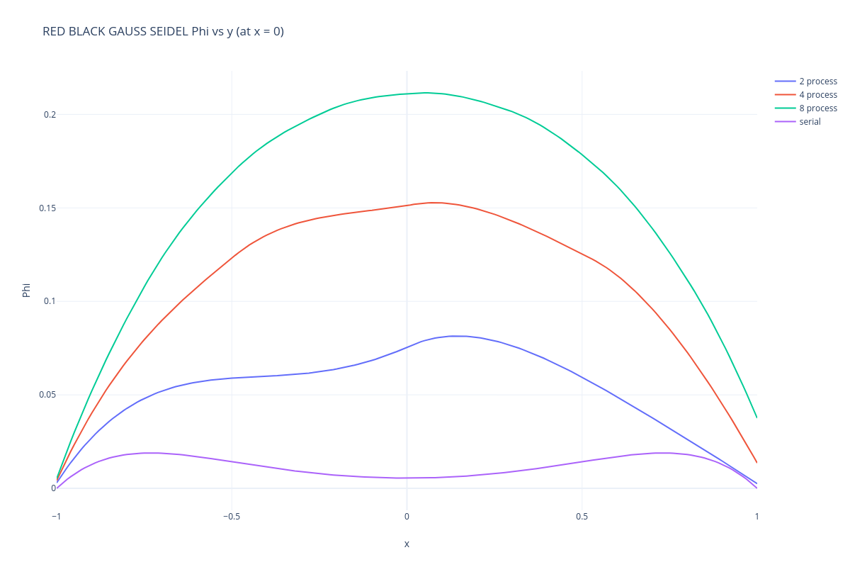
d)The Performance is the best at 4 threads (highest speed up) for delta = 0.005. But as the number of threads increases beyond 4, the overheads associated with parallel program. Also the Red-Black Method is the better one as the speed up is the higher compared with jacobi and also the code converges faster.
PS: My Laptop can’t run 16 processes as MPI throws an error saying not enough slots.
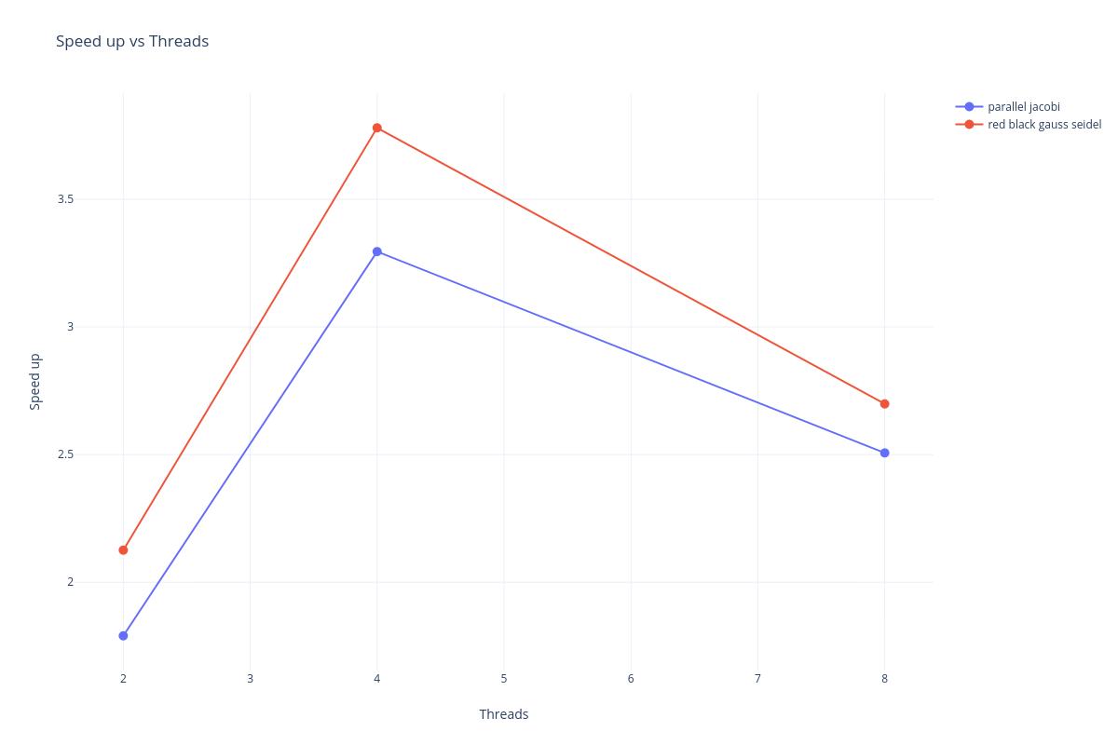
Name: SRINIVASAN N, Rollno: ME21B195

