ASSIGNMENT – 3
ME21B195
SRINIVASAN N
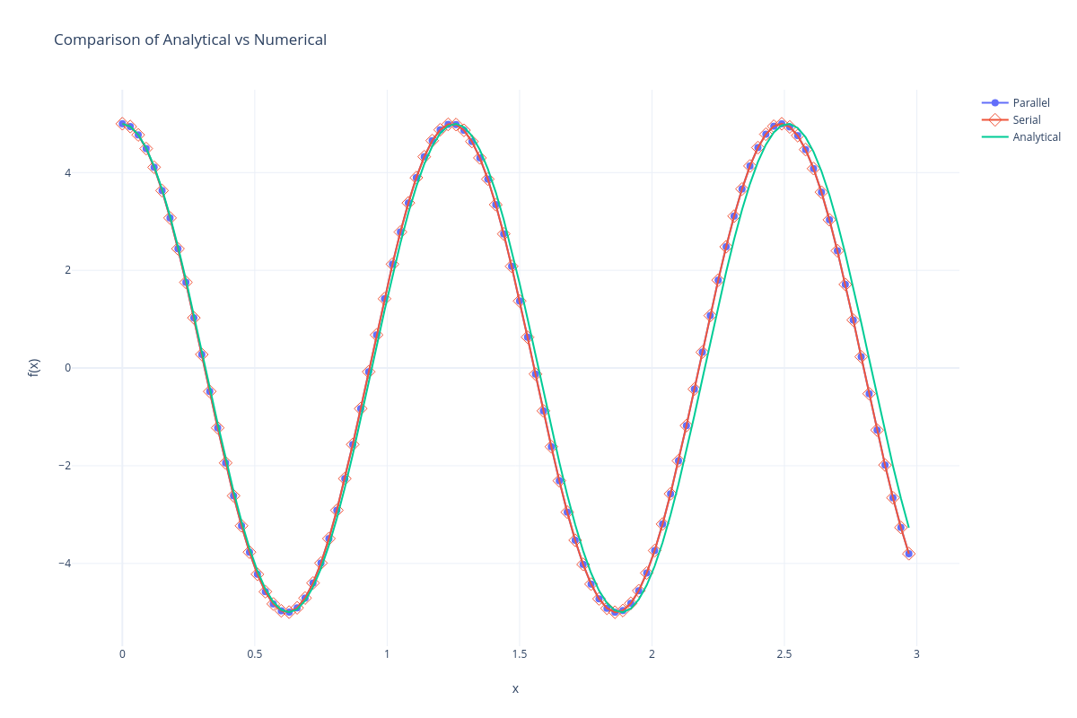
Prob 1) Analytical vs Numerical solution plot:

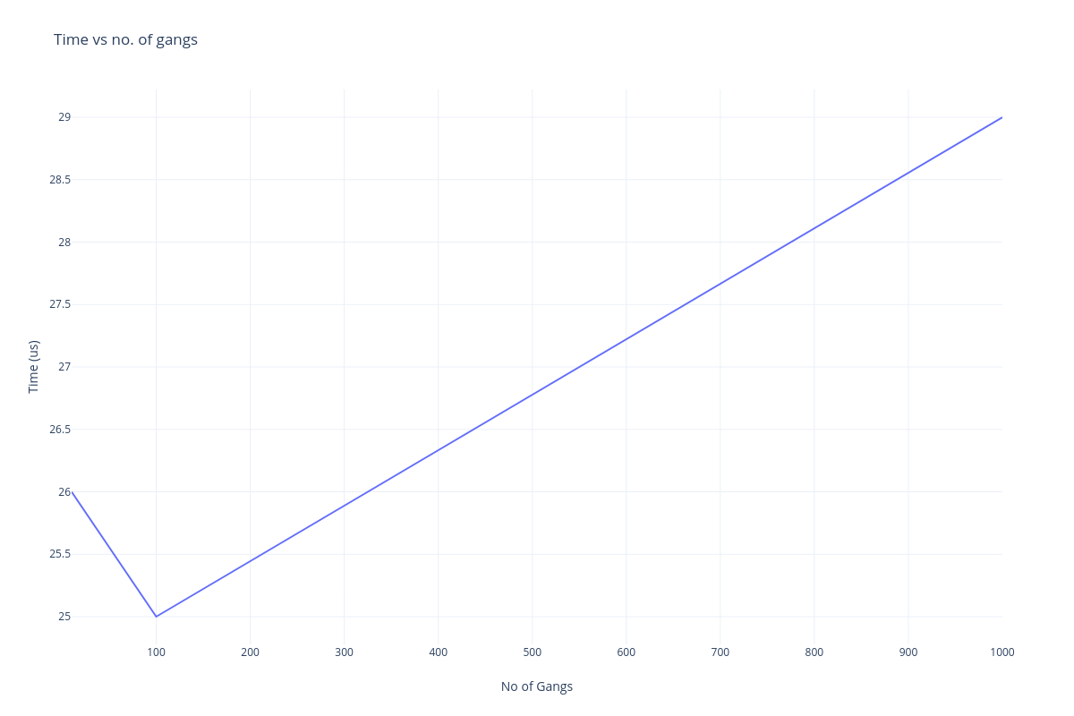
Time taken by solver vs No. of gangs

The difference seems huge(visually), but observe the scale of y-axis, the time vaires only around 5 us (microseconds).

Prob 2)
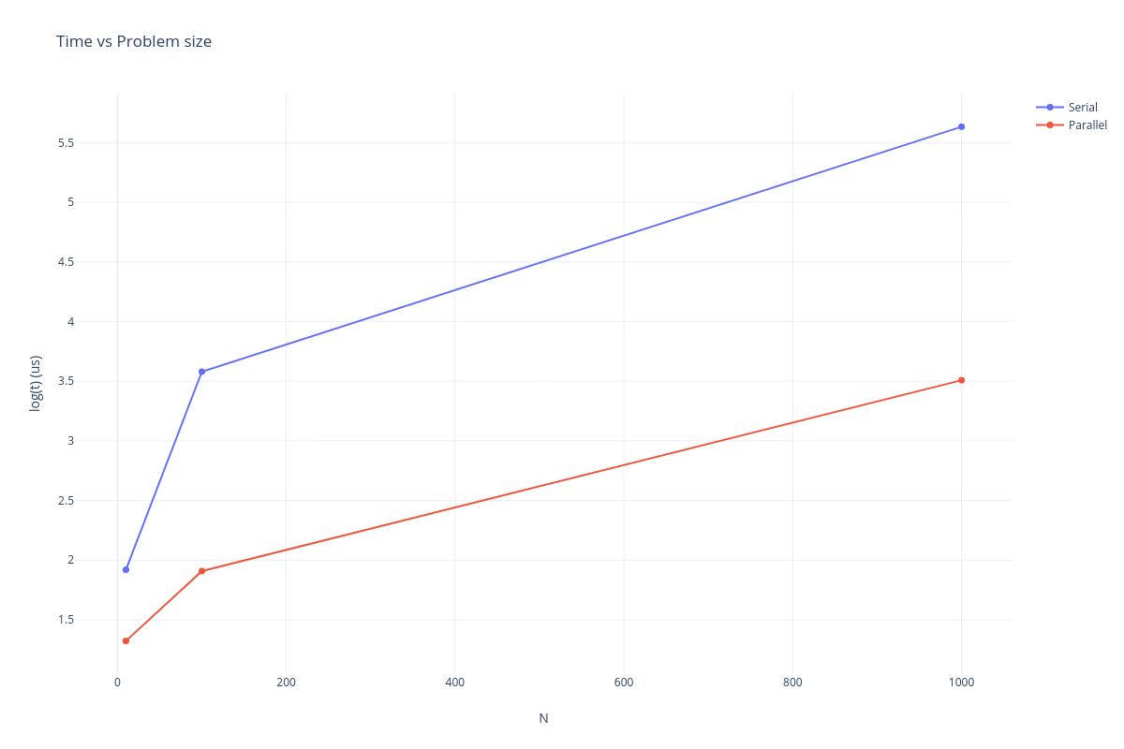
Serial, Parallel time taken vs Problem size for Cholesky
Result of parallel execution:

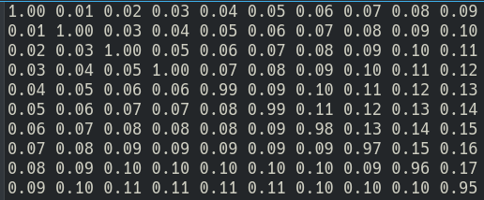
Result of serial execution:
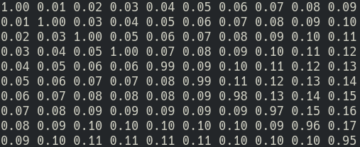

I have also additionally plotted the Time vs No. Of gangs for Cholesky
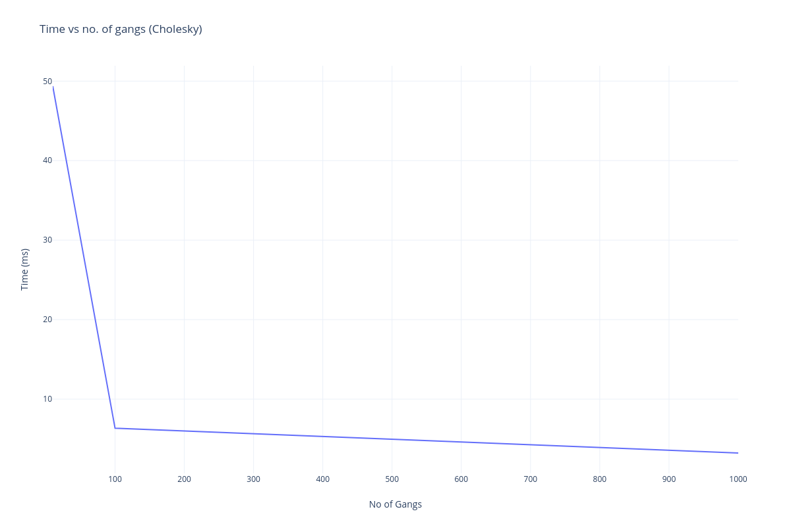
From all the above trends, it can be verified that the parallel program is working correctly and also reduces the execution time.

PS: I noticed that in many cases, not mentioning the no of gangs, workers or vectors and letting the compiler choose optimal values results in the minimum execution time (Although not advised).

