Problem 2)

- Numerical(LU) vs Analytical
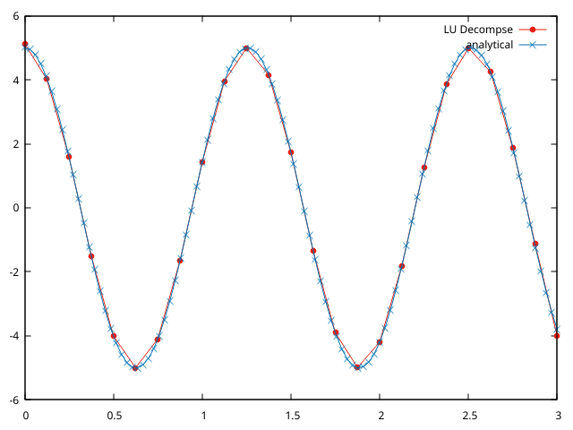

- Numerical(Recursive doubling) vs Analytical --> n=100, threads p = 2.

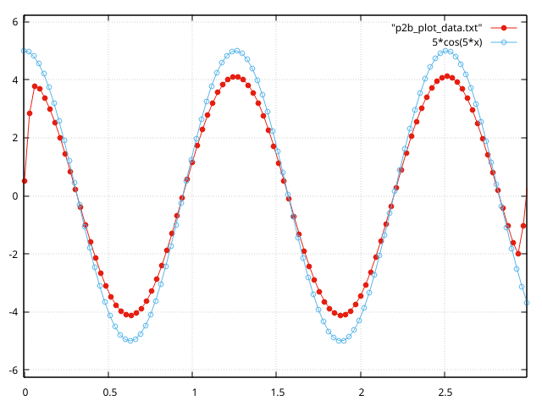

- Time taken(microsecs) vs No. of threads --> n=1000, p = 2, 4, 8

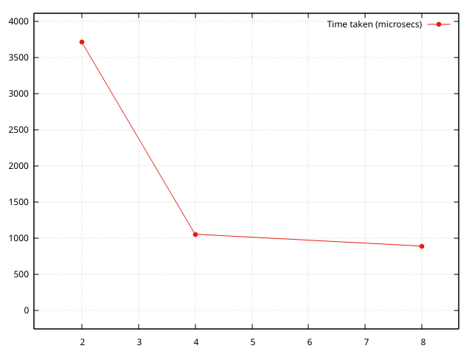

Problem 3)
a) It took 282 iterations to converge within 1% of exact solution.
The plot below is “phi vs x for y = 0.5”.

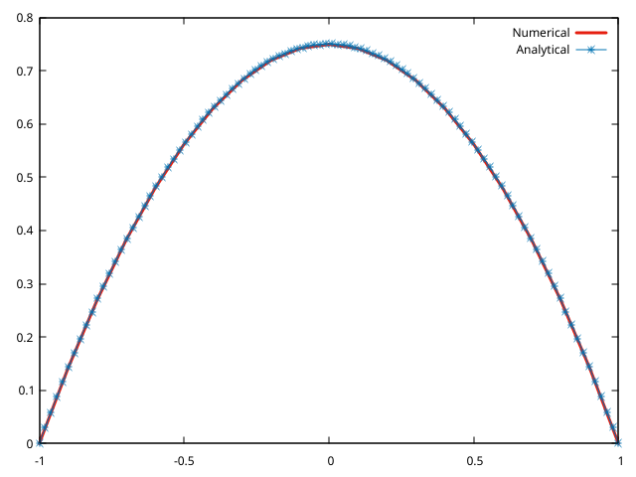

c)
- Red Black vs Analytical
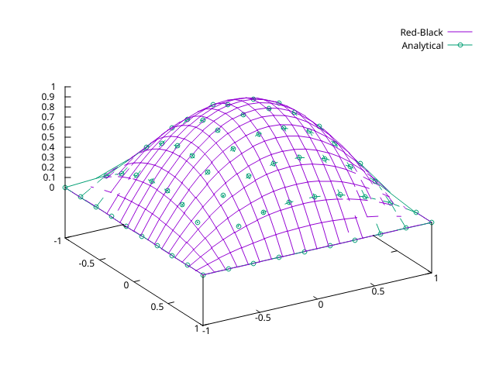

- Diagonal vs Analytical

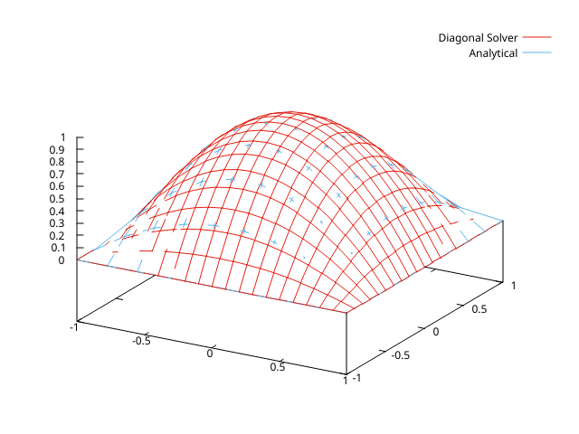

- Parallel Solvers vs Serial --> delta = 0.1, 0.01, 0.005 and p = 8
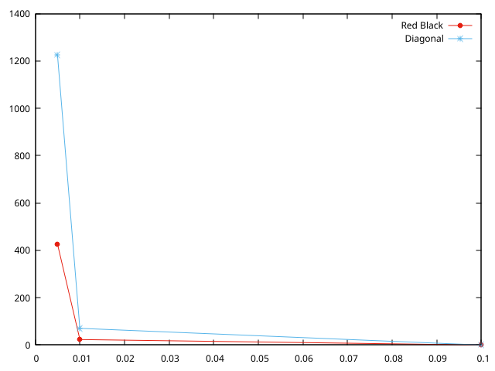

d)
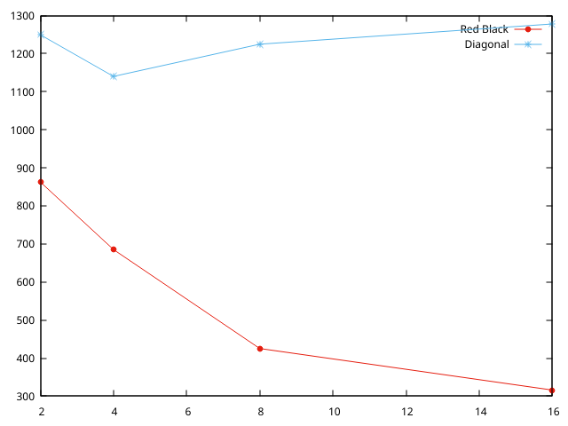

It can clearly be seen that the Red Black solver is much better compared to Diagonal solver. The time taken for increasing threads also decreases in the Red Black solver.
-- Srinivasan N (ME21B195)

