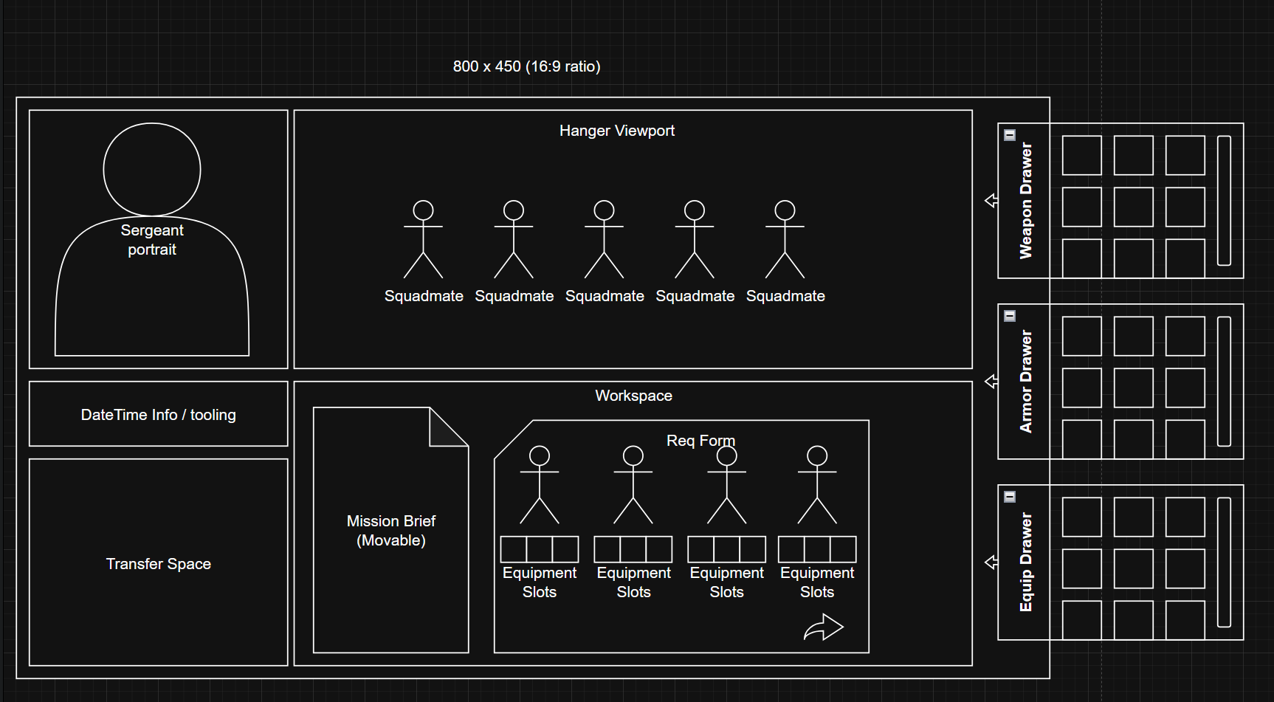
*Action*
“Displayed Text”
Descriptive Text
Screen opens on a black backdrop. Text types out the following
“June 5th, 2552
The United Federation of Solar Planets has stood for two millennia.
Rebellion has broken out in the Mcarrius Sector, galactically north of the Sol System, humanity’s cradle.
You are serving as the quartermaster aboard the ‘Silent Vigil’, a troop carrier for the UFSP’s elite
Serve them, and they will serve you.
Glory to Sol
”
Screen fades to the main view of the game pictured above. A face occupies the “Sergeant Portrait” It is clear that the face is that of the Captain
Captain: “Good morning Quartermaster, I trust you rested well before your boarding?”
Player (non-choice): “Yes Sir. Ready to serve Sol and preserve her union.”
Captain: “I am glad to hear it. Loyalty appears to be in such low regard these days.”
Captain: “We have our orders to finally drop the first of our storm trooper squads today.”
Captain: “Despite our extensive preparation, drilling and anticipation, I will be the first to admit that we are all still very green”
Captain: “So lets run through your duties shall we? If we do this right, we’ll be back home by Christmas”
Tutorial will play here. Exempted from description for the sake of brevity
Captain leaves player and the first squad can be seen moving into the hanger view port. There are 5 troopers. One begins walking toward the screen. Disappearing as he gets close and his unhelmeted face can be seen in the Sergeant Portrait section.

Player (non-choice): “Designation and Assignment”
Sergeant: “Storm Squad Zeta Six. Assignment number 837294”
*Player clicks and drags the assignment stack from Tooling section of the UI to the Workspace section*
*Player flips through assignment stack via arrows and drags out Diagram depicting Squad Zeta-six’s 5 members and the details of assignment 837294*

*Player replaces the assignment stack to Tooling section*
Assignment 837294 reads as follows:
“
ASSIGNMENT 837294
OBJECTIVE DISRUPT KEY RESISTANCE EFFORTS VIA DESTRUCTION OF INFRASTRUCTURE
EXPECTED HOSTILES: REBEL

EXPECTED RESISTANCE: LIGHT

EXPECTED OPPOSITION: LIGHT INFANTRY, LIGHT ARMOR

EXPECTED TERRAIN: DENSE URBAN

NOTABLE OBSTRUCTIONS: FRIENDLY TERRITORY
”
*Noting the objective is to destroy key infrastructure, player opens the equipment drawer by clicking and dragging it out. Player then drags the demolition charge equipment out of the drawer and places it into one of the equipment slots of a squad member. Player closes the equipment drawer*

*Noting that there is an expected mix of armor and infantry, Player opens the weapon drawer and equips 4 members with assault rifles. Given that the mission is within Friendly Territory, the player opts to equip one member with an Anti-Tank rifle instead of the more destructive, RPG. This happens in the same manner as the equipment*

*The player only has standard trooper armor at their disposal, so the player equips the entire squad with it. Since resistance is light, it should suffice.*
*The player, after filling out the equipment of their first squad, drags both the Assignment and Squad paper into the Sergeant Portrait. This hands all information to the Sergeant and confirms that the player is finished*
Sergeant: “Demolitions huh? 4 hours in ‘n we’re already blowing things up?”
Player (non-choice): “That is the mission, yes. Sol demands a quick end to this”
Sergeant: “I do as well, but they’re in there there are bound to be innocents wrapped up in this, right?”
Player (Non-choice): “Details are in the file. Serve Sol now, and you will be Served by Sol”
Sergeant: (Disgruntled) “Indeed…. Glory to Sol”
Player (non-choice): “Glory to Sol”

