Human Body Fall Detection

1st Ashwani Singla
Multimedia, University of Alberta,

Edmonton, Canada ashwanik@ualberta.ca

2nd Ranjit Singh
Multimedia, University of Alberta,

Edmonton, Canada
ranjit1@ualberta.ca

3rd Kumar Halder
Multimedia, University of Alberta

Edmonton, Canada khalder@ualberta.ca

Abstract—Falls are a hazardous situation especially among elderly people, because they may lead to fractures, concussion, and other injuries. Without the timely rescue, falls may even endanger their lives. With the advancement of technology, an automatic system that can detect the fall of a body will be much more helpful to save severe injuries. Manual monitoring is expensive and resource intensive. Current methods that implement fall detection use wearable technologies or phone's accelerometer. Seniors might not always be comfortable using the wearable devices. Camera's used for monitoring could be the solution by using them as fall detectors. In this report, we will explain how we detect the fall of a human body with a simple CCTV camera without using any sensors such as wearable, heat sensors etc. Our approach was to detect the moving body first from the room and then determine the angle of the body with the relative environment. If the angle is within the range of falling angle, then our algorithm will consider it is a fall and output result accordingly. We used traditional OpenCV and trigonometric functions to detect the fall without using any kind of machine learning (Abstract)

Keywords—computer vision, fall detection, automation, background subtraction

I. INTRODUCTION

In this project, we used real-time video of a room and will detect any kind of fall happening in the range of the camera without using any electronic wearable sensors. The system is able to identify fall at any angle of the direction of fall, i.e., either horizontal fall, vertical fall or at some angle. There will be one camera set up in the room. This video is fed to the system, and the system will run its algorithm and detect the fall in real time. This system is more economical than using electronic sensors approach. Challenge of fall detection is to determine depth in the image such as when a body falls away from the camera or towards the camera. When body falls over horizontal angles, it is very easy to detect the fall. To determine the depth in an image, multiple cameras were required as

relative to all the cameras position of body is determined. Our main constraint was to use single camera to accomplish the task. In this report further, we will explain our approach step by step..

II. LITERATURE REVIEW

The state of the art in fall detection technologies can be divided into three categories per Mubashir et al. [1]: wearable sensors, ambient sensors and vision based technologies.

A. Wearable Sensors

The most common technologies found in these types of sensors are accelerometers and gyroscopes. These are devices that are easy to wear, but have some drawbacks as the power consumption (limiting its usability) and the sensitivity to body movement (which may cause false alarms). In addition, a considerable amount of these devices rely on a user’s ability to manually activate an alarm after a fall event. Furthermore, even if they incorporate automatic fall detection technology, these types of devices generally have a lot of false positives.

Bagala et al. [2] presented 13 algorithms based exclusively on accelerometers and reported an average detection rate of 83% and a fall detection rate of 98% for the highest performing algorithm. The chief problem with accelerometer detectors lies in discriminating real falls from abrupt movements, which can generate false fall warnings. To solve this problem, Wang et al. [3] propose placing an accelerometer inside the wearer’s head. Lindemann et al. [4] propose a similar solution inside the wearer’s ear.

B. Ambient Devices

Ambient devices measure the environment of a subject under protection. The most common technology used in this group is infra-red sensing, but additional technologies based on sound and vibration sensing are the subject of promising

developments. One of the drawbacks of these systems is that they have to be installed in several rooms to cover the whole area of actuation.

Although ambient-based technologies are also used in commercial fall detection devices, they typically consist of sensors (presence, force, pressure) associated with wearable sensors and focus their detection capabilities on monitoring unusual behaviour such as subjects who do not return to bed after waking up at night

Zhuang et al. [5] present a fall detection system based on audio sampling. They acknowledge that their system exhibits high detection failure rates, which they were able to decrease using machine learning algorithms. Khan et al. [6] sample environmental noise to better discern the noise made by a subject.

C. Vision Based Devices

Vision based devices such as cameras have some limitations as that of ambient device such as installing cameras in every room and there is also a concern of privacy but it is the economical, cheap and plausible way for the solution to problem mentioned. As not everyone is comfortable wearing electronic sensors, so it is quite a good way to handle the problem effectively.

However, for the privacy concerns, it is possible to determine the alert when there is actual fall only. In the mean time when there is no fall, there will be no alert or data sharing to anyone else. Also it is also possible to display the blurry frame to the person who may be monitoring the system which can barely recognize about the person under observation.

Several techniques were imposed on this vision-based system. One of the most popular is “Realtime Multi-Person 2D Pose Estimation using Part Affinity Fields” by Zhe Cao et al[7].The architecture encodes global context, allowing a greedy bottom-up parsing step that maintains high accuracy while achieving real-time performance, irrespective of the number of people in the image. The architecture is designed to their association via two branches of the same sequential prediction process. But the problem with this algorithm is that it requires high computational power which is not practical.

In our approach, we tried to build a system which is as light as possible and is able to detect the fall in real time. This method is very convenient in terms of computational power and it can easily be implemented on small devices such as Raspberry-Pi. So, below is our approach that we used.

III. APPROACH

- Brief Overview

  - Subtracting the background from the frame.

  - Using thresholding and pixel manipulation techniques to get the optimal frame.

  - Using contours to detect the ROI (Region Of Interest) changing from other frames.

  - Calculating the position of the body and determining whether it is a fall or not.

- Description

To subtract the background we first use frame comparison between the first frame when video starts capturing and the current frame. The first frame will be either empty or can have objects in it. The absolute difference between current frame and first frame will find the objects or pixels that are changed relative to the first frame. In this way, we get the moving body from the background. But in this approach, there are several constraints such as clothes and background should not be of same pixel intensity as it may not be able to subtract background clearly.

For background subtraction, MOG2 can also be used however there are noise issues in dataset provided.

To get more fine foreground, we use silhouette of the body and applied thresholding, dilation and erosion by tweaking the parameters to get the desired output. In this way we got rid of un-necessary noise and distortion of the moving object.

Contour is an outline or bounding box of a shape or something. With “findContour” method in OpenCV, several number of contours comes to picture which are supposed to be some shape. To get rid of extra contours, we set a minimum area of the contour and extract only those contours which have larger area than the threshold area. As, the method is getting applied to the Background subtracted moving body, it is likely that contour will be around moving human or around a large object if it is moving. After getting the contours or Region of Interest, we bound the body with an ellipse as ellipse is much more efficient in determining angles than that of rectangle.

Example: A rectangle will always give angle either 0 degree or π/2 degree but with ellipse we can get lot more variations between 0 to π.

The angle of the body with both horizontal and vertical should be considered to determine whether it is fall or not.

Let alpha and beta be the minor and major axis of the ellipse respectively. Major axis determines the width of the ellipse and similarly minor axis determine height. So technically, approximate height of ellipse will be 2*beta and
approximate width will be 2*alpha.

We have to now determine the angle of these axis with Horizontal and vertical respectively. Let us suppose following assumptions for the algorithm:

alphaH be the angle of minor axis with Horizontal axis alphaV be the angle of minor axis with Vertical axis betaH be the angle of major axis with Horizontal axis betaV be the angle of major axis with vertical axis

For a body to fall, we assume that if body leans over the angle of 2π/5 from the vertical and an angle of π/10 with the

horizontal and if it follows the following condition then it is considered to be a fall.

Abs (betaH + π/2+ alphaV +3π/2) = π

In this way we can get all the orientations of the fall. But here degree of freedom is not much. So, to proceed further following manipulation needs to be done:

If 0.9*beta <=alpha <=1.1*beta:

Gamma = Beta;

Beta = Alpha;

Alpha = Gamma;

C. Pictorial view of the algorithm

i.
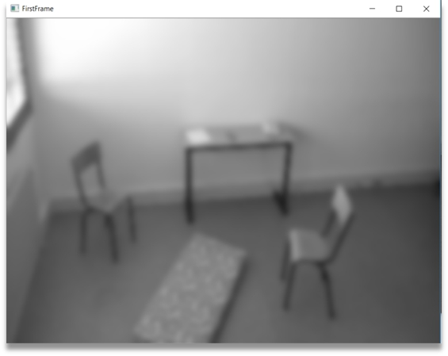

Figure 1: First Frame which will be compared with all other frames and the areas changing will be represented as contours

ii.
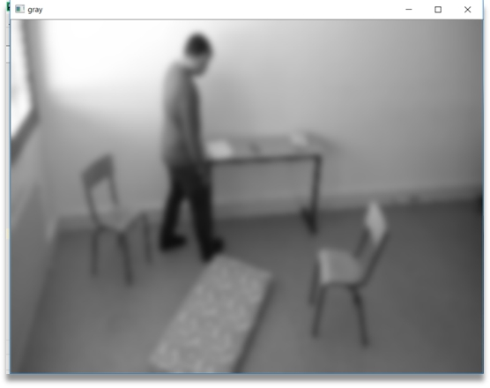
Figure 2: Blurred frame to remove noise and retaining the as much information as possible.

iii.
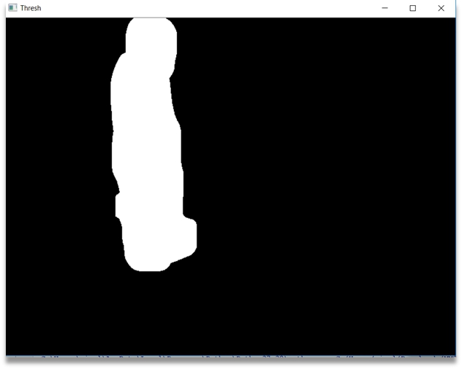

Figure 3: Silhouette of the moving body with the appropriate amount thresholding and dilation of pixels.

iv.
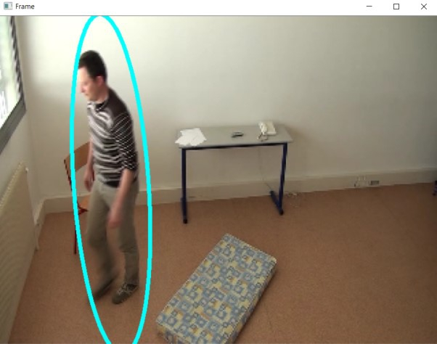

Figure 4: Marking area of interest with bounding ellipse and determining angle and size of ellipse. After calculations with the mechanism used, system will tell whether it is a plausible fall or not.

IV. RESULTS

We tested our algorithm on “Le2i” and we tested our algorithm on a total of 60 videos and results are as:

Accuracy | Precision | Recall
88 | 93.75 | 78.9

Recall = True Positive / (True Positive + False Negative)

Precision = True Positive / (True Positive + False Positive)

There are 48 true positives which are detecting possible falls and 3 videos shows false positives out of 51 videos in which there is falling body. Precision is 78.9 which consider true positives and false negatives. False negatives are detecting no fall when there is no fall such as not considering a fall when a person tries to sit,walk and do other stuff than falling. True positives includes detecting fall when there is a fall.

V. LIMITATIONS AND AREA OF IMPROVEMENT

The limitations of algorithm is to compare frames not in reference to first frame but relative to previous frames. However, there is lot of noise when in comparing with other relative frames. If it is possible to reduce the noise, then results would be much better.

Improvement on working when a person goes behind an object such as there is a table is the first frame and when person goes behind the table, the contour gets divided into 2 parts and it is not very convenient to detect the fall.

Improving when first frame is not empty. As it is always comparing with first frame, so when first frame is not empty it may not display all the contours

VI. CONCLUSION

We used traditional Image processing techniques and mathematics to determine the angles of a moving body and determining whether a fall is happening or not. There is no requirement of any additional device or sensors that the subject under observation should wear all the time during
observation. A simple camera needs to be installed in the room and the algorithm will do the rest.

This approach is the real time or fastest approach and computationally light and economically feasible to implement as it does not require heavy processing unit with graphics card or any kind of additional sensors. As a result the maintenance cost of the system will also be very much economic.

ACKNOWLEDGMENT

We would like to acknowledge project proposer Nasim Hajari (University of Alberta) for providing us the necessary dataset of fall videos for testing our algorithm.

REFERENCES

- Mubashir M., Shao L., Seed L. A survey on fall detection: Principles

and | approaches. | Neurocomputing. | 2013;100:144–152. | doi:
10.1016/j.neucom.2011.09.037. [CrossRef]

- Bagalà F., Becker C., Cappello A., Chiari L., Aminian K., Hausdorff J.M., Zijlstra W., Klenk J. Evaluation of Accelerometer-Based Fall Detection Algorithms on Real-World Falls. PLoS ONE. 2012;7:37062 doi: 10.1371/journal.pone.0037062. [PMC free article] [PubMed] [CrossRef]

- Wang C.-C., Chiang C.-Y., Lin P.-Y., Chou Y.-C., Kuo I.-T., Huang C.-N., Chan C.-T. Development of a Fall Detecting System for the Elderly Residents; Proceedings of the 2008 2nd International Conference on Bioinformatics and Biomedical Engineering; Shanghai, China. 16–18 May 2008; pp. 1359–1362.

- Lindemann U., Hock A., Stuber M., Keck W., Becker C. Evaluation of a fall detector based on accelerometers: A pilot study. Med. Biol. Eng. Comput. 2005;43:548–551. doi: 10.1007/BF02351026.[PubMed] [CrossRef]

- Zhuang X., Huang J., Potamianos G., Hasegawa-Johnson M. Acoustic fall detection using gaussian mixture models and gmm supervectors; Proceedings of the IEEE International Conference on Acoustics, Speech and Signal Processing (2009); Taipei, Taiwan. 19–24 April 2009; pp. 69–72.

- Khan M.S., Yu M., Feng P., Wang L., Chambers J. An unsupervised acoustic fall detection system using source separation for sound interference suppression. Signal Process. 2015;110:199–210. doi: 10.1016/j.sigpro.2014.08.021. [CrossRef]

- Zhe Cao Tomas Simon Shih-En Wei Yaser Sheikh The Robotics Institute, Carnegie Mellon University {zhecao,shihenw}@cmu.edu {tsimon,yaser}@cs.cmu.edu

