1. **Top 5 employees (employee id and employee name) with highest rating.**

**(In case two employees have same rating, employee with name coming first in dictionary**

**Should get preference)**

* Load file into emp

Grunt> emp = LOAD 'employee_details.txt' USING PigStorage(',') AS (emp_id:int, emp_name:chararray, emp_salary:int, emp_rating :int);

Grunt > dump emp;

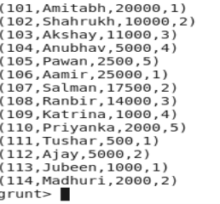

* Ordering the relation on the basis of rating and emp name

Grunt> Emp_rating_odering= ORDER emp by emp_rating,emp_name;

* Taking top 5 record

Grunt > Top_Five_Emp= limit EMP_rating_odering 5;

* Taking only emp_id and emp_name

Grunt > Top_Five_EmpIDEmpName= FOREACH Top_Five_Emp generate emp_id,emp_name;

Grunt > dump Top_Five_EmpIDEmpName;

Output :

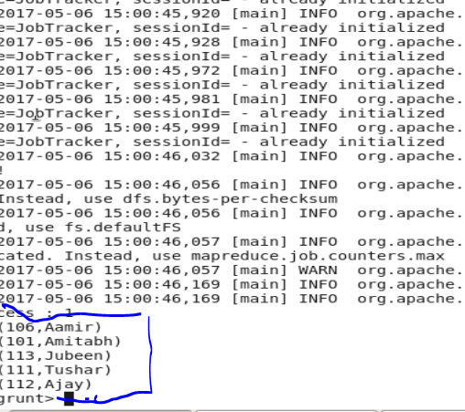

**(b) Top 3 employees (employee id and employee name) with highest salary, whose empl oyee id**

**is an odd number.**

**(In case two employees have same salary, employee with name coming first in dictionary**

**should get preference)**

* Load file into emp

Grunt> emp = LOAD 'employee_details.txt' USING PigStorage(',') AS (emp_id:int, emp_name:chararray, emp_salary:int, emp_rating :int);

* Emp with odd emp id

Grunt > Emp_With_Odd_ID= FILTER emp by emp_id % 2 !=0;

* Emp with salary ordering

Grunt> Emp_With_Salary_Ordering= ORDER Emp_With_Odd_ID by emp_salary desc;

* Taking top 3 employee

Grunt > TopThreeEmp = Limit Emp_With_Salary_Ordering 3;

* Taking empid and emp name

Grunt > Result = FOREACH TopThreeEmp generate emp_id, emp_name;

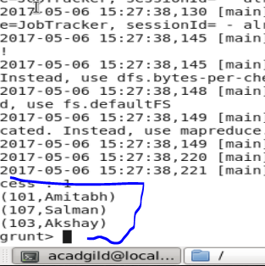

**(c) Employee (employee id and employee name) with maximum expense**

**(In case two employees have same expense, employee with name coming first in dictionary**

**should get preference)**

* Load employee_details.txt file into emp_details

Grunt> emp = LOAD 'employee_details.txt' USING PigStorage(',') AS (emp_id:int, emp_name:chararray, emp_salary:int, emp_rating :int);

* Load employee_expenses.txt file into emp_exp

Grunt> emp_exp = LOAD 'employee_expenses.txt' AS (emp_id:int, exps :int);

* Join both relation on empid basis

Grunt > joinData = join emp by emp_id , emp_exp by emp_id;

Grunt> dump joinData;

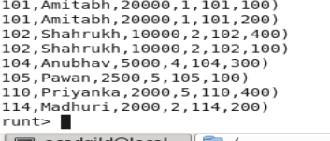

* Ordering data on the basis of expenses and emp name

Grunt > orderdData = ORDER joinData by exps desc, emp_name;

* Get the top 1 record

Grunt > EmpWithMaxExpanse= limit orderedData 1;

* Get emp id and emp name only

Grunt > result= FOREACH EmpWithMaxExpanse generate emp::emp_id,emp::emp_name;

Grunt > dump result;

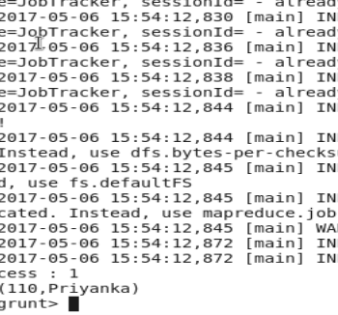

**(d) List of employees (employee id and employee name) having entries in employee_expenses**

**file.**

* Load employee_details.txt file into emp_details

Grunt> emp = LOAD 'employee_details.txt' USING PigStorage(',') AS (emp_id:int, emp_name:chararray, emp_salary:int, emp_rating :int);

* Load employee_expenses.txt file into emp_exp

Grunt> emp_exp = LOAD 'employee_expenses.txt' AS (emp_id:int, exps :int);

* Join both relation on empid basis

Grunt > joinData = join emp by emp_id , emp_exp by emp_id;

Join data contain only those recors that are present in both relation.

* Taking empid and emp name

Grunt > result= FOREACH joinData generate emp::emp_name,emp::emp_id;

Grunt> dump result;

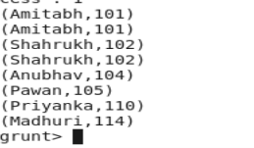

**e) List of employees (employee id and employee name) having no entry in employee_expenses**

**file.**

* Load employee_details.txt file into emp_details

Grunt> emp = LOAD 'employee_details.txt' USING PigStorage(',') AS (emp_id:int, emp_name:chararray, emp_salary:int, emp_rating :int);

* Load employee_expenses.txt file into emp_exp

Grunt> emp_exp = LOAD 'employee_expenses.txt' AS (emp_id:int, exps :int);

* Left outer Join both relation on empid basis

Grunt >leftjoinData = join emp by emp_id left outer , emp_exp by emp_id;

Grunt > dump leftjoinData ;

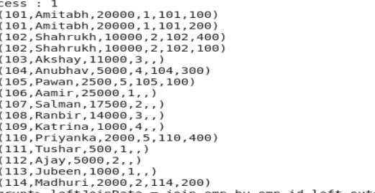

* Filter record that have null value for column expns

Grunt> FilterNullExpnsData= FILTER leftjoinData by expns is null;

* Take emp name and empid in final result.

Grunt > result= FOREACH FilterNullExpnsData generate emp::emp_name, emp::emp_id;

Grunt: dump result;

