**Write a wordcount program to implement wordcount using Pig.**

* Loadig file employee_details.txt

grunt> countLoad = load ‘employee.txt’ as (line : chararray);

grunt> dump countLoad;

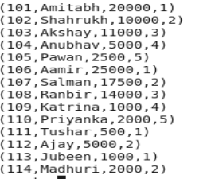

* Flatten the loaded relation into single column

Grunt> words = FOREACH countLoad GENERATE FLATTEN(TOKENIZE(line)) as word;

* Grouping the tuple on the basis of words column.

Grunt> GroupData = GROUP words by word;

* Taking count for each grouped data.

Grunt > CountResult = FOREACH GroupData generate group , COUNT (words);

Grunt > dump CountResult;

