
Linux Basics
DEVOPS | Assignment
SUBMISSION GUIDELINES
• Complete all tasks and document your work in a doc (Google Doc or Microsoft Word) with screenshots/commands and explanations.
• Create one folder named Linux_Basics_YourName.
• Put your complete project source code and all files inside this folder.
• Add your documentation file (with screenshots and explanations) inside the same folder.
• Compress the folder into a .zip file (Linux_Basics_YourName.zip).
• Upload the .zip file on the submission portal.
Zip File Must Contain
• Your complete project source code and all files
• Document with screenshots/commands and explanation for every task
• GitHub repository link
⚠ Your full project code MUST be submitted inside this .zip file. Screenshots (terminal / commands / output) are mandatory. Also share your GitHub repository link.
Do NOT upload separate files.
Do NOT submit without compressing into a .zip file.

Objective: Practise essential Linux command-line operations — file and directory management, viewing files, searching, archiving, downloading, permissions, and environment variables.

1. Creating and Renaming Files/Directories
- Create a directory named test_dir using mkdir.
- Inside test_dir, create an empty file called example.txt.
- Rename example.txt to renamed_example.txt using mv.
Solution:

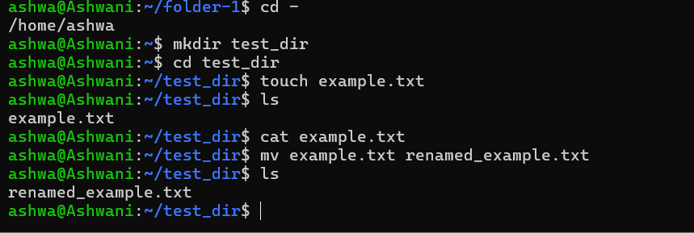

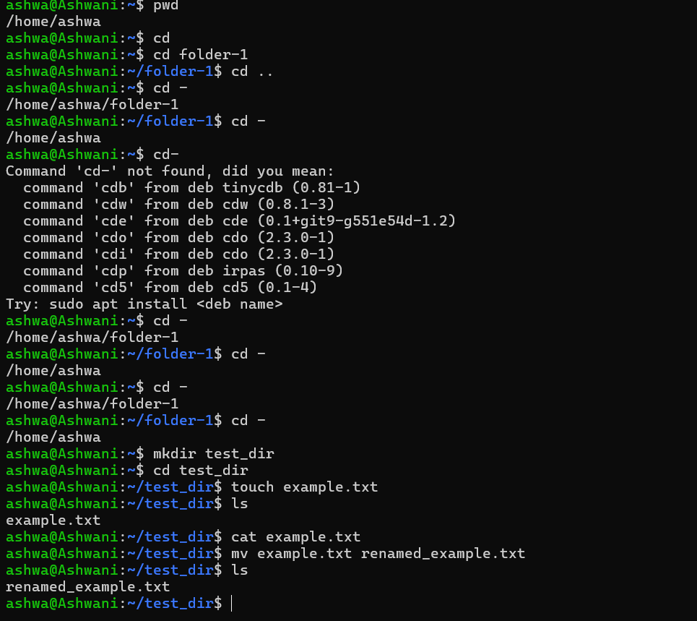

2. Viewing File Contents
- Use cat to display the contents of /etc/passwd.
- Display only the first 5 lines of /etc/passwd using head.
- Display only the last 5 lines of /etc/passwd using tail.
Solution:
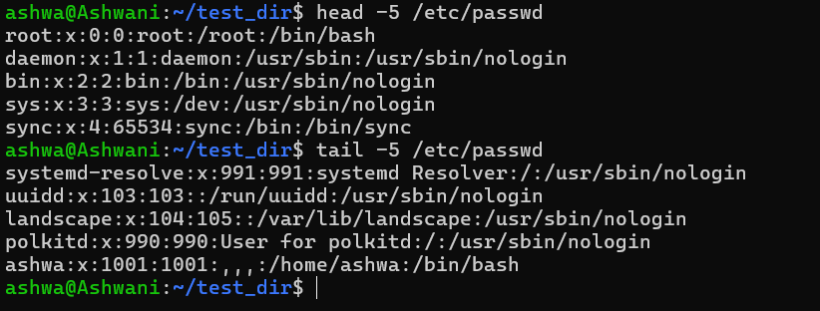
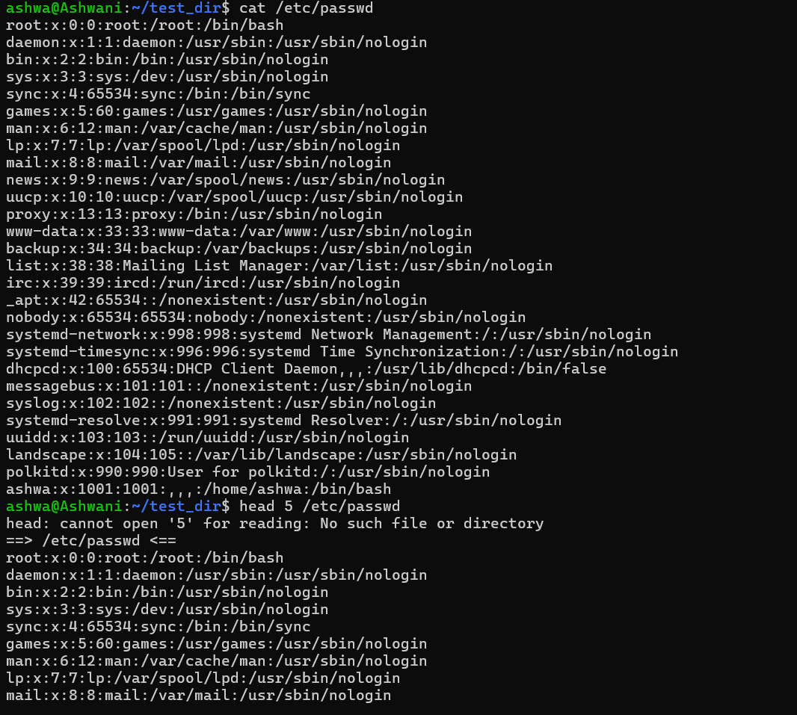
3. Searching for Patterns
- Use grep to find all lines containing the word “root” in /etc/passwd.
Solution:
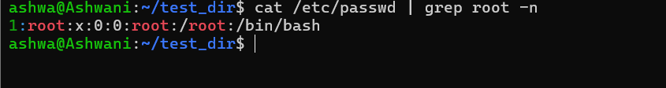
4. Zipping and Unzipping
- Compress the test_dir directory into a file named test_dir.zip using zip.
- Unzip test_dir.zip into a new directory named unzipped_dir.
Solution:
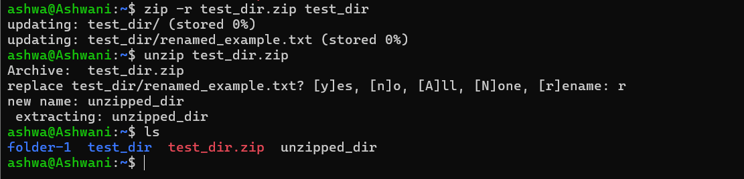

5. Downloading Files
- Use wget to download a file from a URL (e.g., https://example.com/sample.txt).
Solution:
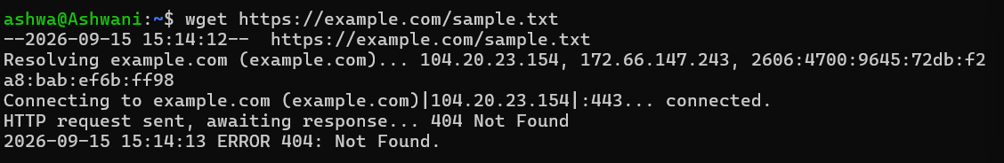

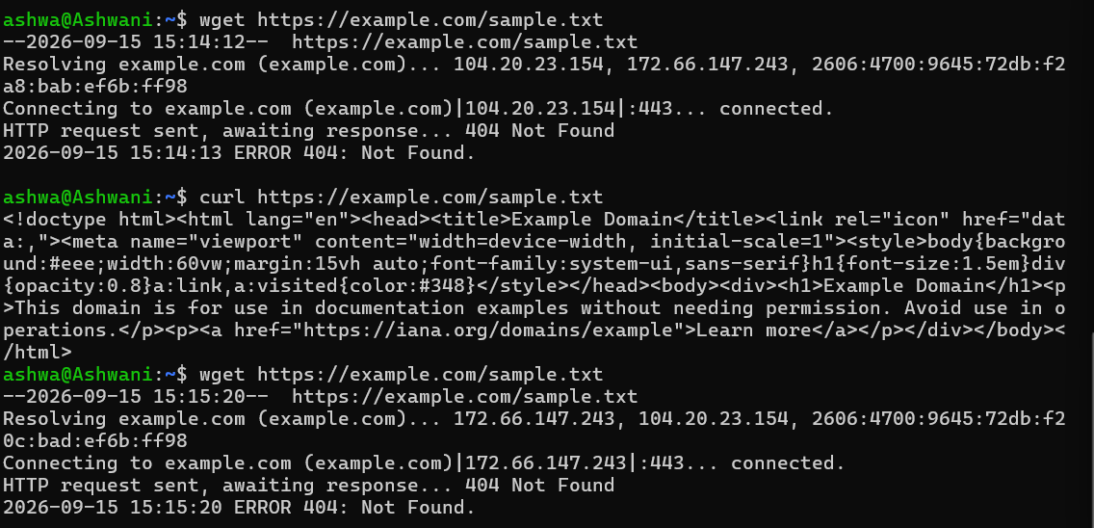
6. Changing Permissions
- Create a file named secure.txt and change its permissions to read-only for everyone using chmod.
Solution:

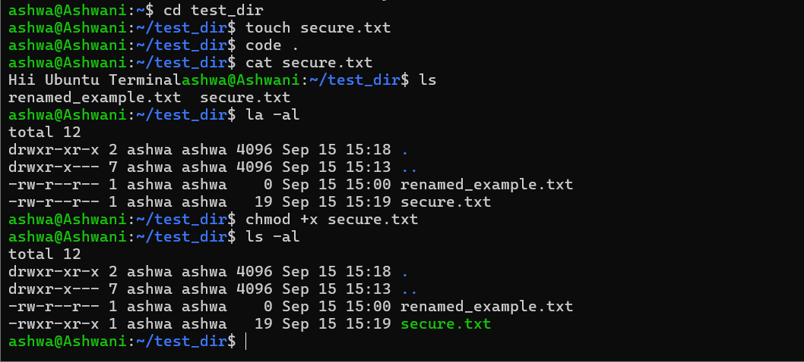
7. Working with Environment Variables
- Use export to set a new environment variable called MY_VAR with the value “Hello, Linux!”.
Solution: 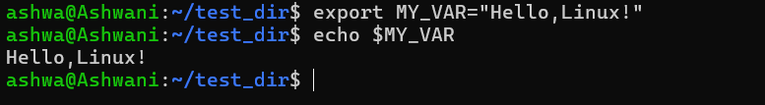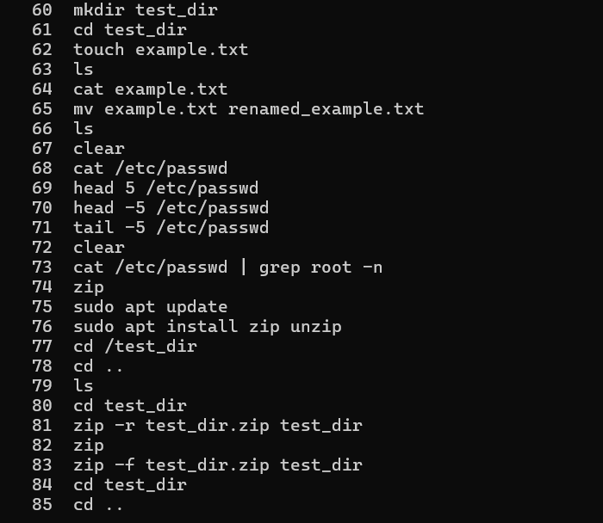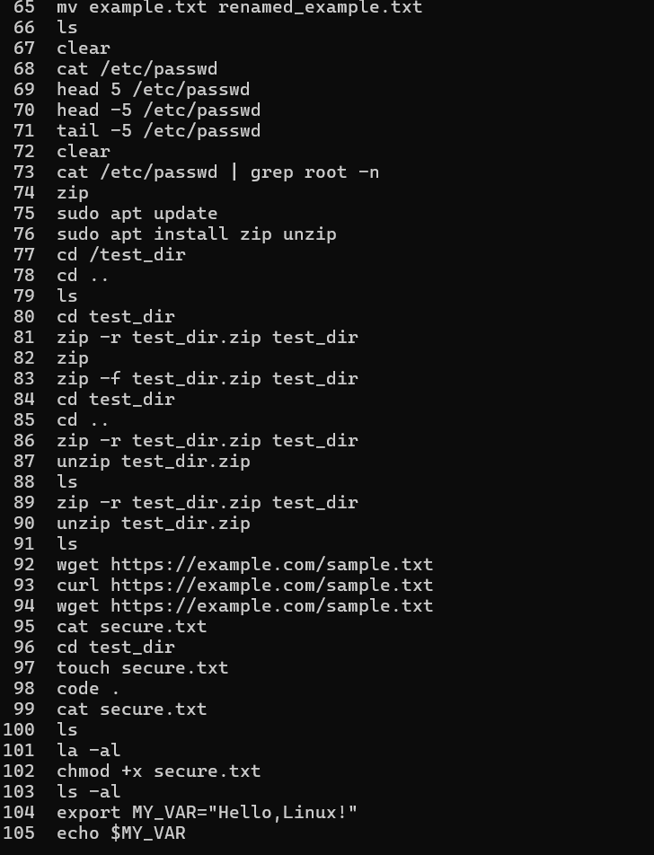
If you have any doubt, you can directly contact the Tutedude mentor.

