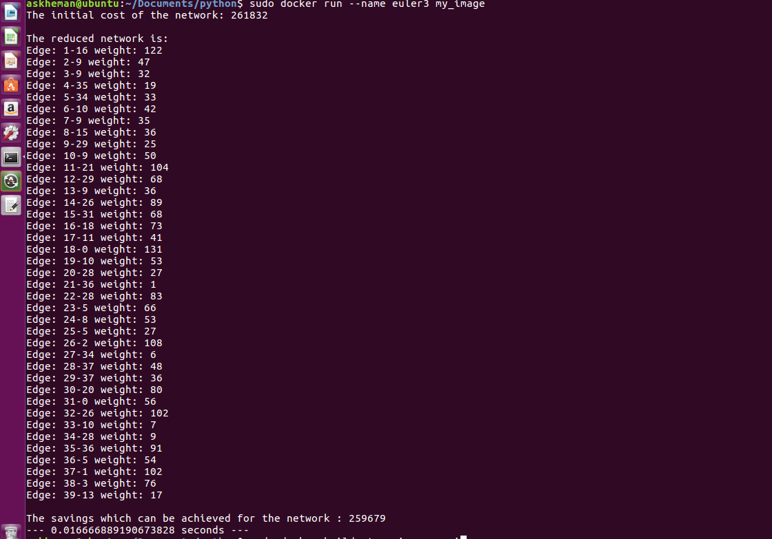

Output from pytest.

To install pytest if not available use

Pip install pytest

