Microservices Assignment

Implementation includes

1. API Gateway – OCELOT
2. Consul – Service Discovery and Centralized Configuration

Run consul – cmd to directory and run command “consul agent -dev -node=localhost”

1. Authentication on API gateway for delete API’s - User "admin", "aDm1n" has access to delete account or customer
2. Validation from centralized key value saved for emails to allow them to be the part of the system

1. Exception handling – through middleware and customdelegatehandler middleware in api gateway

**OCELOT API’s Urls:**

**Auth API**

<https://localhost:7097/login>

**Customer API --** [**http://localhost:5102**](http://localhost:5102) **for http endpoint**

[https://localhost:7097/customers](https://localhost:7097/savecustomer)

[https://localhost:7097/customerbyemail](https://localhost:7097/savecustomer)

<https://localhost:7097/savecustomer>

<https://localhost:7097/updatecustomer>

<https://localhost:7097/deletecustomer>

**Account API**

<https://localhost:7097/accounts>

<https://localhost:7097/accountdetail>

<https://localhost:7097/savemoney>

<https://localhost:7097/withdrawmoney>

Tested all with Postman

**Customer API’s**

1. **Save Customer:**

[https://localhost:44369/api/Customers/Post](https://localhost:44369/api/Customers/PostCustomer%20)

**Request parameter object:**

|  |
| --- |
| **{**  **"name": "string",**  **"address": "string",**  **"city": "string",**  **"email": "string",**  **"phone": "string"**  **}** |

1. **Get all customers:**

[https://localhost:44369/api/Customers/Get](https://localhost:44369/api/Customers/GetAllCustomer)

1. **Get customer by email**

<https://localhost:44369/api/Customers/GetCustomerByEmail>

Request Parameter – string email

1. **Update Customer**

<https://localhost:44369/api/Customers/Put>

Request parameters:

String email, Object customer

1. **Delete Customer**

<https://localhost:44369/api/Customers/Delete>

Request Parameter

String email address

**Account API’s**

1. **Get all accounts**

<https://localhost:44378/api/accounts/get>

1. **Get account by email**

<https://localhost:44378/api/accounts/getaccountbyemail>

Request Parameter : email string

1. **AddMoney in account**

<https://localhost:44378/api/accounts/AddMoney>

Request parameter:

**{**

**"customerEmail": "string",**

**"amount": 0**

**}**

1. Withdraw money from account

<https://localhost:44378/api/accounts/withdrawmoney>

Request parameter:

**{**

**"customerEmail": "string",**

**"amount": 0**

**}**

1. Delete account

<https://localhost:44378//api/accounts/delete>

Request parameter: email string

Auth API’s

1. <https://localhost:7173/api/auth/login>

Request Object:

{

"username": "string",

"password": "string"

}

PostMan – calls each service

**Using http service endpoint**

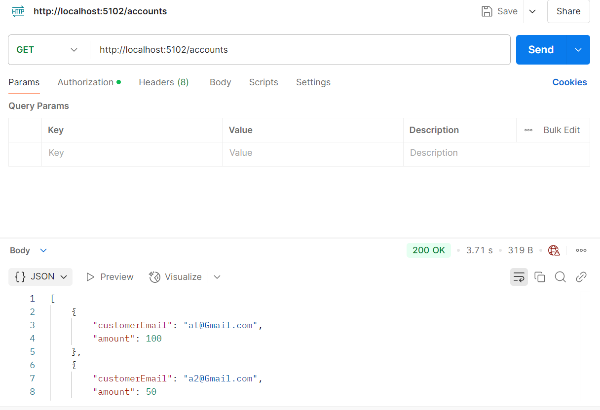

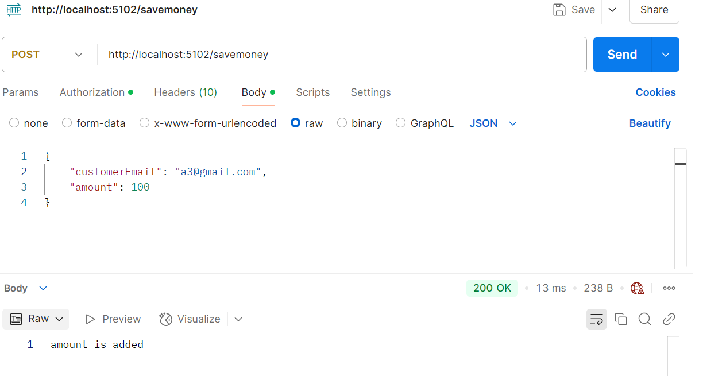

**Using https service endpoint**



