AI GOVERNANCE RESEARCH
AI Governance in Practice: The NIST AI RMF Playbook
How organisations govern AI today — and how one well-designed control set delivers GDPR, HIPAA and DPDPA compliance through five pillars: Trust, Security, Governance, Compliance and Data Protection

Prepared by | Narendra Kalam
Date | 17 July 2026
Version | 2.0 — for internal review
Audience & scope | Technology and business leaders. Framework-level research applicable to any AI/LLM-enabled product or service — no system-specific assumptions.

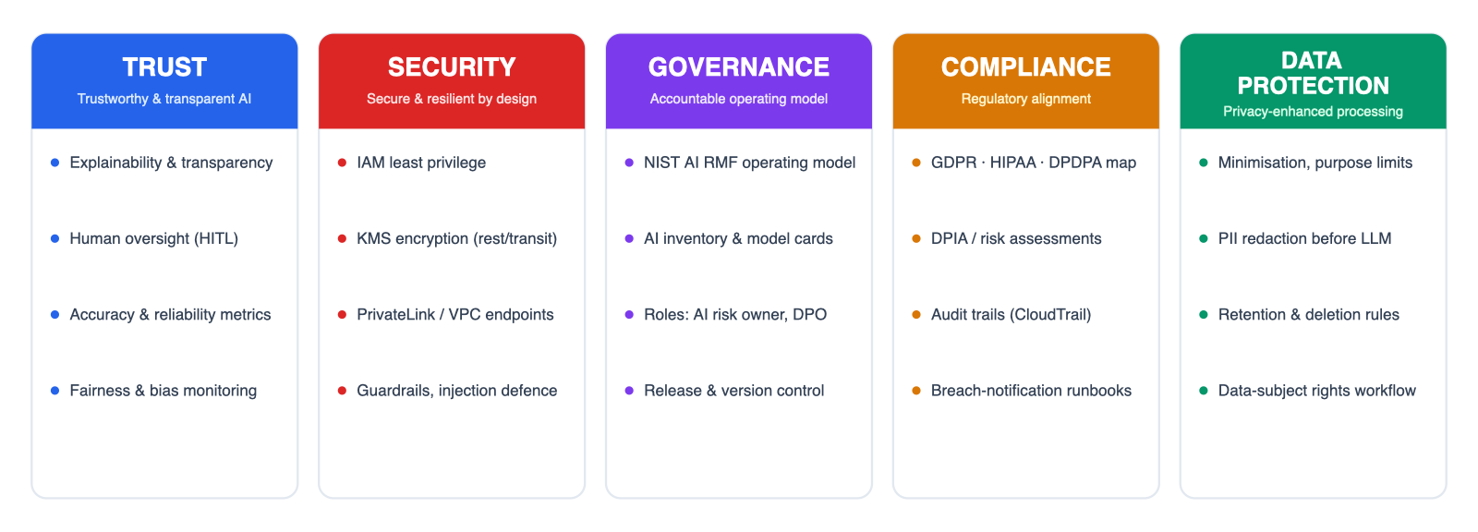

Contents

In Microsoft Word: right-click the table of contents and choose “Update Field” to populate page numbers.

1. Executive summary
Every organisation is deploying AI faster than it is governing it. Boards discuss it, customers ask about it, and three very different regulators — Europe's GDPR, America's HIPAA and India's new DPDPA — are already attaching real money to getting it wrong. This report is the research behind a simple thesis: the NIST AI Risk Management Framework is the most practical operating model for AI governance available today, and an organisation that runs it well is simultaneously most of the way to compliance with all three regulations.
The report explains how the framework works in plain terms, how companies are actually using it in 2026, what regulators have already punished, and how one shared control set — organised into five pillars of Trust, Security, Governance, Compliance and Data Protection — satisfies many legal obligations at once. It closes with a 180-day action plan.
This report at a glance
4  NIST functions  Govern, Map, Measure, Manage — the operating model |  | 3  Regulations  GDPR, HIPAA and DPDPA, mapped in one crosswalk |  | 5  Pillars  Trust, Security, Governance, Compliance, Data Protection |  | 1  Control set  Implemented once — claimed by every framework |  | 180  Days  From invisible AI estate to audit-ready programme

2. Why AI governance, why now
Two curves are diverging. AI adoption is close to vertical — most large organisations now run generative AI somewhere in production. Governance is climbing far more slowly. The numbers from 2025's major surveys tell the story better than any argument:

2.1 The adoption–governance gap, in numbers
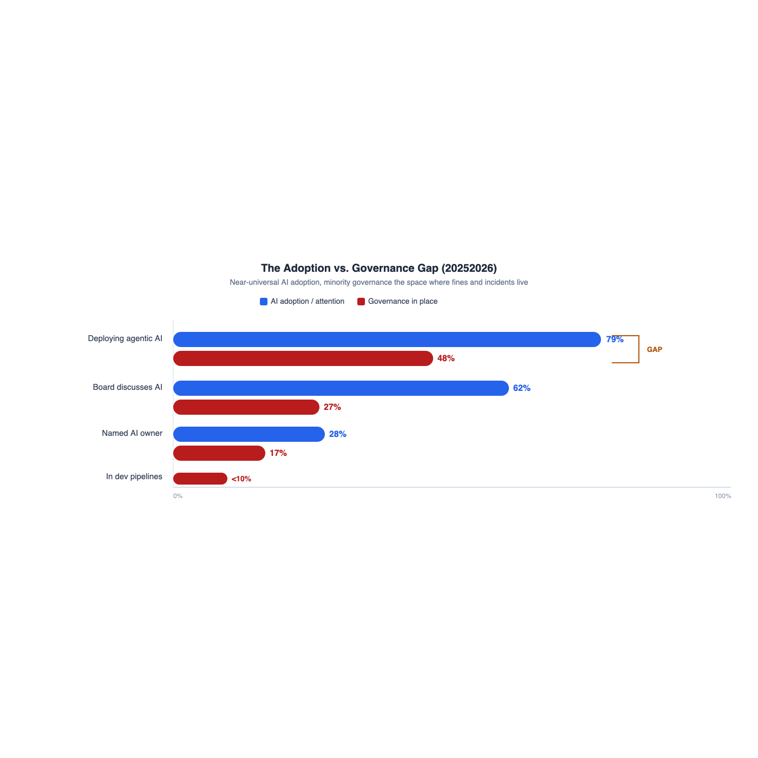
The adoption vs. governance gap
79% vs 48%  Adoption outruns control  79% of businesses are adopting agentic AI — only 48% have a framework to govern its autonomy. |  | 55%  Have anyone in charge  Only 55% of organisations have an AI board or oversight committee (Gartner, 1,800+ executives) — nearly half have nobody formally accountable. |  | 62% vs 27%  Talk outpaces accountability  62% of boards discuss AI regularly — only 27% have written it into a committee charter.

28% / 17%  Ownership at the top is rare  Only 28% of companies say the CEO owns AI governance; just 17% say the board does (McKinsey, State of AI). |  | < 1 in 10  Risk checks where work happens  Fewer than one in ten organisations build AI risk and compliance review into their development pipelines (Trustmarque, 2025). |  | 23%  Confidence is scarce  Only 23% of IT leaders are very confident in their ability to manage generative-AI security and governance (Gartner, Q2 2025).

The space between those two rows — near-universal adoption, minority governance — is exactly where fines, incidents and reputational damage live.

2.2 What getting it wrong already costs
≈ €100m  Clearview AI  Cumulative fines from five European regulators for scraping faces without consent |  | €15m  OpenAI (Italy)  Fined over training-data transparency and legal basis (later annulled — the expectations remain) |  | €300k  One automated 'no'  A bank's unexplained automated credit rejection — the textbook GDPR Article 22 lesson |  | ₹250 cr  DPDPA's new ceiling  ≈ US$30m per instance for failing security safeguards under India's new law

Case | What happened | Consequence
Clearview AI (facial recognition) | Scraped billions of face images from public websites without consent to build a recognition database sold to law enforcement | Fines across five European regulators — Netherlands €30.5m, Italy, France and Greece €20m each, UK £7.5m — roughly €100m cumulative, plus processing bans
OpenAI / ChatGPT (Italy) | Regulator found the training of ChatGPT lacked a clear legal basis and transparent information for users, including minors | Temporary national ban in 2023; €15m fine in December 2024 (later annulled on appeal in 2026 — the legal test continues, but the compliance expectations it set remain the market norm)
Berlin bank (automated decisions) | Rejected a credit-card application through a fully automated process and could not explain why | €300,000 GDPR fine — the textbook Article 22 lesson: automated decisions need explanation and a human route of appeal
Sharp HealthCare (US, 2025) | Deployed an ambient AI documentation tool that recorded clinical conversations, allegedly without proper patient consent | Proposed class action under state privacy laws — a reminder that consent applies to AI listening, not just AI deciding
DPDPA exposure (India) | The new law's penalty schedule for organisations that fail on security or breach reporting | Up to ₹250 crore (≈ US$30m) per instance for inadequate security safeguards; ₹200 crore for failing to notify breaches

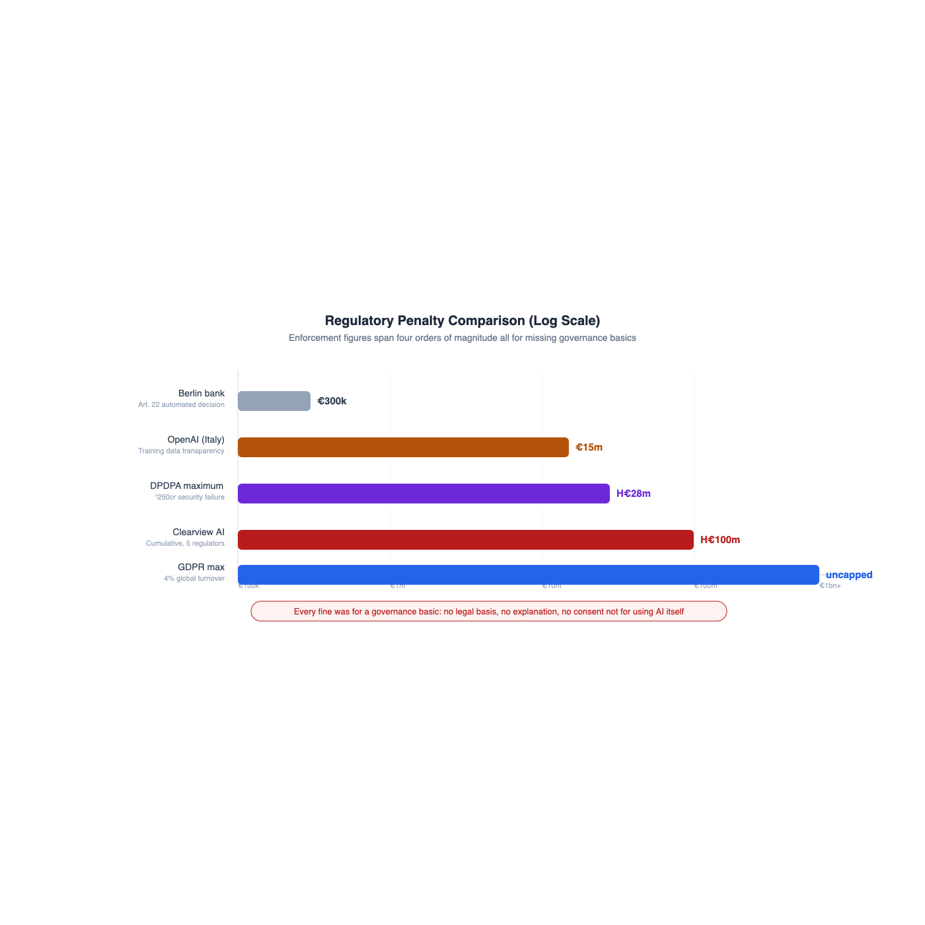
Regulatory penalties on a log scale — all for missing governance basics
The pattern across every case
None of these organisations were punished for using AI. They were punished for using personal data without a clear legal basis, for being unable to explain an automated decision, or for skipping consent — basics a working governance programme would have caught before launch. That is precisely what the framework in the next sections is for.

2.3 Why governing well pays
3.4×  More effective  Organisations using AI governance platforms are 3.4× more likely to run highly effective AI programmes (Gartner, 2025). |  | 3×  More value from GenAI  Regular assessment of AI systems makes high value from generative AI three times more likely (Gartner, 2025). |  | US$1bn+  The market has priced it in  Gartner now sizes AI governance platforms as a billion-dollar category, driven by global regulation.

The business case is no longer defensive. Companies that govern well ship AI faster — because launch reviews stop being fights — and increasingly win deals, because enterprise buyers now send AI governance questionnaires before they sign.

3. The research sketch, decoded
This research began as a whiteboard sketch: a cloud of governance qualities (trust, security, fairness, explainability, accuracy, resilience, data privacy, low risk), an operational block for running language models, a circular Map–Measure–Manage flow with Govern alongside, and a data-governance anchor. Every element of that sketch corresponds to a formal concept in the NIST framework — the table below is the bridge between the whiteboard and this report:
Element on the research sketch | What it is, formally | Where this report develops it
Trust · Security · Fairness · Explainability · Accuracy · Resilient · Data privacy · Low risk | NIST's seven characteristics of trustworthy AI — the measurable qualities every AI system should demonstrate | Section 4.3
Map → Measure → Manage circle with Govern at the side | The four core functions of the NIST AI Risk Management Framework — the operating rhythm of an AI governance programme | Sections 4.1–4.2
LLM release & version management · Monitoring and alert · Experimentation and evaluation · Define the metrics | The LLMOps discipline — how engineering teams turn governance intentions into daily routine | Section 4.5
Regulations | The external rulebooks — GDPR (Europe), HIPAA (US healthcare), DPDPA (India) | Section 6
Data Governance | The data foundation: knowing what data you hold, where it came from, who may use it and when it must go | Sections 5 and 7

4. NIST AI RMF — how it works, and how companies use it

4.1 What it is, and its place in the landscape
The NIST AI Risk Management Framework (AI RMF 1.0, published January 2023) is the US national standards body's answer to a hard question: how does an organisation get the benefits of AI without being blindsided by its failures? It is voluntary — there is no NIST fine — and deliberately so: it is written as an operating manual rather than a statute, applicable to any organisation, any sector, any size.
4  Core functions  Govern, Map, Measure, Manage — one standing capability plus a repeating cycle |  | 7  Trust characteristics  The measurable qualities every trustworthy AI system must show |  | 12  GenAI risks catalogued  The Generative AI Profile (AI 600-1, 2024) names the failure modes of language models |  | 5  US regulators reference it  FTC, SEC, FDA, CFPB and EEOC cite its principles in enforcement guidance

In practice, companies rarely use it alone. The pattern that settled in across 2025–2026 is a stack:
- Values → OECD principles. The public statement of what the organisation stands for on AI.
- Operating model → NIST AI RMF. The internal machinery: inventories, risk tiers, testing, oversight. Most enterprises now run two or more frameworks simultaneously, with NIST as the working core.
- External proof → ISO/IEC 42001. The certifiable international standard buyers increasingly demand in procurement questionnaires. Teams that do NIST first find certification substantially easier — the same documentation serves both.
Governance has become a sales requirement, not just a legal one.

4.2 The four functions, in business terms
The framework's core is four functions. One — Govern — is a standing organisational capability; the other three form a repeating cycle applied to every AI system:
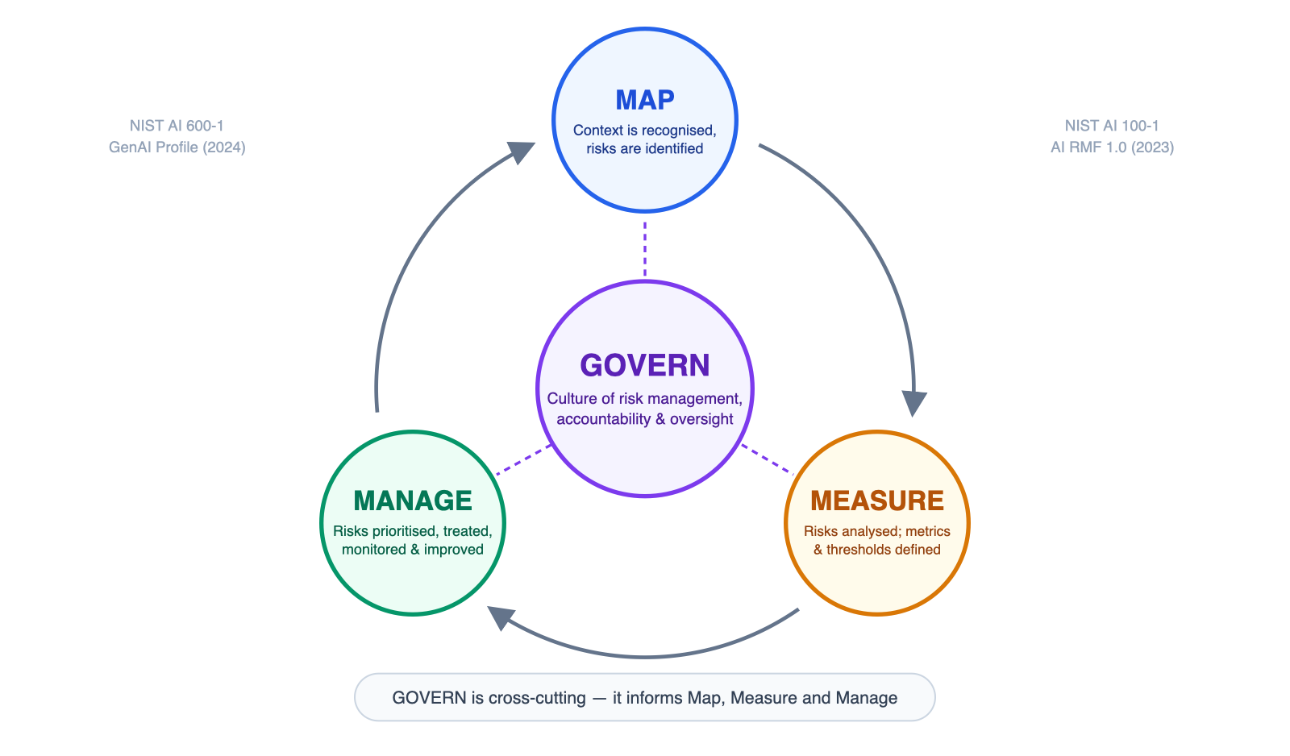
Figure 1 — The NIST AI RMF core: Govern at the centre, Map–Measure–Manage as the cycle
Function | Plain-English question it answers | What it looks like inside a company | Typical evidence
GOVERN | Who is accountable for AI, and what are our rules? | An AI oversight committee with real authority; a written AI policy stating what is allowed, what is banned and who signs off; vendor admission rules for models and data suppliers; training so people know the policy exists | AI policy; committee charter; roles & escalation paths; vendor register
MAP | What AI do we actually have, and what could go wrong? | An AI inventory (most organisations are surprised by what they find); for each use case: who is affected, what data flows in, what harm looks like, and a risk tier that decides how much scrutiny it gets | AI system inventory; use-case intake form; risk register; data map
MEASURE | How do we know it works — and keeps working? | Agreed metrics and thresholds (accuracy, error rates, bias across customer groups, privacy leakage); systems are tested before launch and re-tested on a schedule; red-teaming for the risky ones | Test & evaluation reports; bias audits; monitoring dashboards
MANAGE | What do we do when the answer is 'not well enough'? | Ranked risks with owners and deadlines; humans review the consequential decisions; an incident playbook for AI failures; the ability to roll back to a previous model version; retirement plans for systems past their usefulness | Risk treatment plan; incident post-mortems; release & rollback records

4.3 The seven qualities of trustworthy AI
NIST defines seven characteristics that a trustworthy AI system must demonstrate — the formal version of the qualities on the research sketch. Their power is that each can be turned into something measurable:
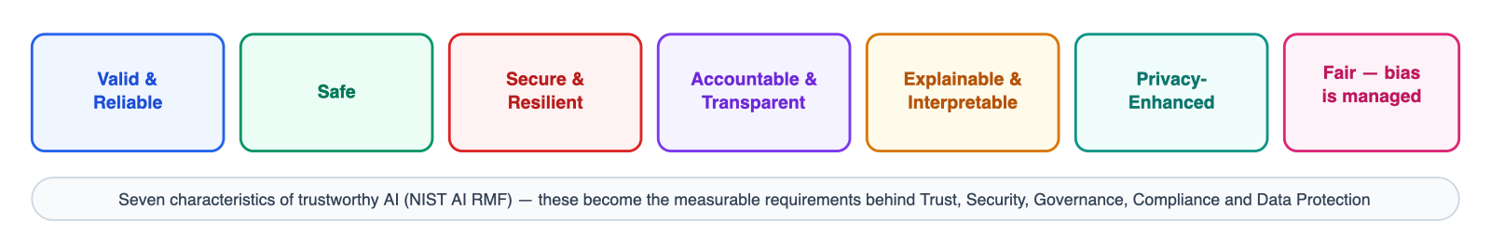
Figure 2 — The seven characteristics of trustworthy AI
Characteristic | Business meaning | Practical mechanism
Valid & reliable (Accuracy) | The system gives right answers, and keeps giving them as the world changes | A curated test set the model must pass before every release; production accuracy tracked against agreed thresholds
Safe (Low risk) | A wrong output cannot cascade into real-world harm | Risk-tier the use case; keep high-stakes decisions with people; limit what the AI can trigger automatically
Secure & resilient (Security, Resilient) | The system withstands attack and recovers from failure | Access controls, encryption, defences against prompt manipulation; fallback paths when the model is unavailable
Accountable & transparent (Trust) | Someone owns every AI decision path, and its existence is not a secret | Named owners per system; disclosure to users that AI is involved; decision trails that can be reconstructed
Explainable & interpretable (Explainability) | People affected can get a meaningful 'why' | Confidence scores and reasons surfaced with outputs; explanation good enough to survive a customer complaint or a regulator's question
Privacy-enhanced (Data privacy) | Personal data exposure is minimised at every step | Collect less; mask or de-identify before the model sees it; strict retention; privacy assessments before launch
Fair — harmful bias managed (Fairness) | Quality does not differ by language, gender, region or other group | Test results split by group; periodic independent bias audits; documented fixes when gaps appear

4.4 What generative AI adds to the risk picture
Language models introduce failure modes that classical software governance never had to name. The Generative AI Profile catalogues twelve; the six that matter to most businesses:
Generative-AI risk (NIST AI 600-1) | Plain-English version | What good companies do about it
Confabulation | The model states things that are simply not true, fluently and confidently | Never let free-form output drive decisions directly; constrain outputs to checkable formats; verify against source data; label AI-generated content
Data privacy | Personal data leaks in — through training data, prompts or logs — and can leak back out | Redact personal data before it reaches the model; choose providers that do not train on your prompts; treat model inputs and outputs as regulated data
Information security | Attackers use crafted inputs (prompt injection) to make the model misbehave | Treat every external text as untrusted; content guardrails; limit what the model can access or execute; regular adversarial testing
Harmful bias | Output quality differs across languages, dialects and demographics | Multilingual and cross-group evaluation; bias metrics reviewed like financial metrics — on a schedule, with owners
Value-chain risk | You inherit the weaknesses of model providers and data suppliers you did not build | Vendor due diligence; contractual breach-notification and data-use terms; model documentation from providers; an exit plan per vendor
Human-AI over-reliance | People stop checking the AI because it is usually right | Show confidence levels; sample outputs for human quality review; train staff on when to override; measure automation bias, not just accuracy

4.5 LLMOps — governance as a daily routine
Frameworks fail when they live in documents. The operational block on the research sketch — release management, metrics, experimentation, monitoring — is how governance becomes something engineering teams do every day rather than something they answer for once a year:
LLMOps practice (from the sketch) | What it means day to day | Why regulators care
LLM release & version management | Every model, prompt and configuration is versioned; changes go through staged rollout with an approval gate; you can roll back in minutes | You can answer 'which model made this decision on 3 March?' — the audit question every regime asks
Define the metrics | Accuracy, error and bias rates, privacy-leak rate, cost and speed — agreed numbers with thresholds, not vibes | Objective evidence that the system is 'appropriate and proportionate' — the standard legal test
Experimentation & evaluation | New models and prompts are tested against a golden set offline, then shadow-tested, before they touch customers | Demonstrates due diligence before deployment — central to DPIA and to DPDPA's algorithm-check duty
Monitoring & alerting | Dashboards watch quality drift, unusual inputs and failures; alerts route to named owners | Continuous monitoring is explicitly expected by NIST, GDPR accountability and the HIPAA Security Rule

5. The five pillars
Trust, Security, Governance, Compliance and Data Protection are the five lenses this research was asked to cover. The important insight from studying how mature organisations run them: they are not five programmes. They are five views of one control set.
Build ×1  One control set  Each mechanism is implemented once — e.g. logging every model decision |  | Claim ×5  Five pillars served  That one log serves Trust (explain outcomes), Compliance (audit evidence), Governance (who changed what) — and more |  | Prove ×4  Four frameworks satisfied  The same control maps to NIST AI RMF, GDPR, HIPAA and DPDPA in the Section 6.4 crosswalk

Pillar | Objective | What delivers it
TRUST | Customers, employees and regulators can rely on — and challenge — AI outputs | Disclose where AI is used; provide explanations and confidence levels; keep humans over consequential decisions; publish accuracy and fairness results internally so trust is earned with numbers, not assurances
SECURITY | The AI system and its data resist attack and failure | Least-privilege access; encryption in storage and transit; guardrails against prompt manipulation; secrets management; tested recovery paths — the classic security canon, extended to models and prompts
GOVERNANCE | Clear ownership, policy and lifecycle discipline | NIST AI RMF as the operating model; an AI inventory nobody bypasses; named risk owners; version-controlled releases with evaluation gates; vendor governance for model and data suppliers
COMPLIANCE | Provable conformity with every regime you touch | One control set mapped to GDPR, HIPAA and DPDPA (the crosswalk in Section 6.4); impact assessments before launch; audit trails; breach playbooks tuned to each law's clock; evidence generated as a by-product of normal work
DATA PROTECTION | Personal data is minimised, protected and lifecycle-managed | Collect only what the use case needs; mask personal data before models see it; retention schedules that actually delete; a workflow for people exercising their rights that reaches training data, prompts and logs

6. The three regulations, and how companies comply

6.1 GDPR — Europe's general rulebook
GDPR is not an AI law — it is a personal-data law that AI keeps colliding with. It applies to any organisation, anywhere, that processes personal data of people in the EU/UK. Its logic is principles-based: have a legal reason, tell people, collect less, protect it, be able to prove all of the above.
4%  Of global turnover  The maximum GDPR penalty (or €20m if higher) — calculated on worldwide revenue, not local profit |  | 72 h  The breach clock  Qualifying breaches must reach the regulator within 72 hours of discovery |  | ≈ €100m  Already spent on AI lessons  AI-related GDPR fines issued to date (Section 2.2) — all traceable to missing basics, not to using AI

AI creates pressure at specific points — training data gathered without a clear basis, systems that cannot explain their decisions, personal data flowing to model providers across borders:
GDPR obligation | What it means in business terms | What leading companies do
Have a legal reason (Art. 6) | You must be able to name the lawful basis for every use of personal data — including data used to train or prompt AI — before you build, not after | Run a documented legitimate-interest assessment for AI use of customer data; where consent is the basis, make it specific to the AI purpose
Special categories (Art. 9) | Health, biometric and similar data is near-forbidden territory without an explicit legal condition | Keep sensitive data out of AI pipelines by default; where unavoidable (health tech), engage counsel early and minimise aggressively
Tell people (Arts. 13/14) | People must be told, in plain language, that AI processes their data and why | Update privacy notices to name AI processing; explain it at the point of interaction, not just in a policy nobody reads
Keep humans in charge (Art. 22) | Fully automated decisions with legal or similarly significant effects need human review and a route to contest | Design decision flows so a person makes the consequential call; the €300k Berlin bank fine shows 'the computer said no' is not a defence
Build privacy in (Art. 25) | Privacy is an architecture requirement, not a policy document | Data minimisation and masking by default; privacy requirements in the definition-of-done for AI features
Assess before you build (Art. 35) | High-risk processing — which most AI over personal data is — requires a Data Protection Impact Assessment | Make the DPIA part of the AI intake process; revisit it when the model or purpose changes
Vendors & data location (Art. 28, Ch. V) | Your AI providers are your responsibility; data leaving Europe needs a lawful transfer route | Data-processing agreements with every AI vendor; keep European data in European regions where offered; check providers' sub-processor chains
Protect it & report breaches (Arts. 32–34) | Security proportionate to risk; regulator notified within 72 hours of a qualifying breach | Standard security controls extended to AI components; breach playbooks rehearsed, with the 72-hour clock built in
Individual rights (Arts. 15–22) | People can ask what you hold, demand correction or deletion | Rights workflows that reach everywhere personal data lives — including prompts, logs and fine-tuning sets, the places AI programmes forget

6.2 HIPAA — the US healthcare regime
HIPAA is narrower than GDPR — it governs protected health information held by healthcare providers, insurers and their vendors — but healthcare is where AI adoption is most explosive, which makes it the best real-world laboratory for AI compliance:
62.6%  Of Epic hospitals use AI scribes  Ambient AI that listens to consultations and drafts clinical notes — deployed by mid-2025 (Emory study, 2,784 health systems) |  | 1,794  Physician-days saved  Kaiser Permanente's result across 2.5 million patient encounters — 84% of physicians report better interactions |  | 2.4×  Category growth in one year  Spending on ambient AI documentation grew 2.4× in 2025 — ≈ US$600m in revenue |  | 60 days  The breach clock  Affected individuals must be notified within 60 days; the regulator and media if 500+ people are affected

The compliance lesson from this wave is encouraging: massive AI adoption inside one of the world's strictest privacy regimes is working, because the sector applies a small set of non-negotiables:
HIPAA element | What it means in business terms | What healthcare organisations do
Who it binds | Healthcare providers, insurers and their service vendors ('business associates') handling protected health information (PHI) | Establish early whether your AI touches PHI; ordinary employer HR records are typically outside HIPAA — scope discipline saves effort
The BAA gate | Before any PHI touches an AI service, a signed Business Associate Agreement must exist — no exceptions | Sign the cloud provider's BAA and use only HIPAA-eligible services (the major AI platforms, including Amazon Bedrock and Azure OpenAI, qualify); the industry lesson: BAAs get skipped in fast procurement more often than anyone admits
Minimum necessary | Use and reveal the least PHI the task needs | AI outputs carry the clinical fact, not the full record; role-based access so only the right staff see AI-generated notes
Security Rule safeguards | Documented risk analysis plus administrative, technical and physical protections | Add AI systems to the annual security risk analysis; unique logins, audit logs, encryption; treat model inputs and outputs as PHI and keep them out of general logs
Breach notification | Affected individuals within 60 days; the regulator (and media, if 500+ people) notified | One breach playbook covering AI incidents — a mis-shared AI-generated note is a breach like any other
De-identification | Properly de-identified data leaves HIPAA scope — the safe path for analytics and model improvement | Apply the Safe Harbor method (remove 18 identifier types) or expert determination before data is reused

6.3 DPDPA — India's new regime
India's Digital Personal Data Protection Act 2023, activated by the DPDP Rules of 2025, is the newest of the three and in some ways the most modern: digital-first, consent-centric, and the only law that names algorithmic due diligence as an explicit duty. It follows the data, like GDPR — offices in India are not required for it to apply:
₹250 cr  Maximum penalty  ≈ US$30m per instance for failing on security safeguards; ₹200 crore for breach-notification failures |  | 72 h  Breach report to the Board  Individuals and the Data Protection Board informed without delay; detailed report within 72 hours |  | 22  Languages for notices  Consent notices must be available in English plus India's 22 scheduled languages where relevant |  | May 2027  Full enforcement  Partial effect began November 2025 — 2026 is the readiness window

DPDPA element | What it means in business terms | What companies operating in India do
Consent-first model (Secs. 5–7) | Personal data needs informed, specific, withdrawable consent, with plain-language notice — available in English and India's 22 scheduled languages where relevant | Rebuild consent flows to be granular and revocable; prepare for 'consent managers' — a uniquely Indian institution of licensed consent intermediaries
Reasonable security safeguards (Sec. 8, Rule 6) | A concrete minimum list: encryption or masking, access control, logging and monitoring with logs kept at least a year, tested backups | Map the Rule 6 list against existing controls — for most cloud-native companies this is verification work, not new build
Breach reporting | Affected individuals and the Data Protection Board informed without delay; a detailed report to the Board within 72 hours | Add the DPDPA branch to the breach playbook, including plain-language user notification templates
Data principal rights (Secs. 11–14) | Access, correction, erasure, grievance redressal — plus a right unique to India: nominating someone to exercise your rights if you die or are incapacitated | Extend existing GDPR rights tooling; the nomination right needs a small but real process addition
Significant Data Fiduciary duties | Larger or higher-risk processors get extra duties: an India-resident data protection officer, annual audits and impact assessments — and due diligence that their algorithmic software does not endanger people's rights | This is the world's most direct legal hook for AI governance: a NIST AI RMF programme (Section 4) with its evaluation reports and bias audits is precisely the evidence this duty demands
Cross-border transfers (Sec. 16) | Transfers are allowed by default except to countries the government blacklists; sector regulators may add localisation rules | Prefer India-region processing for Indian users where practical; watch for restriction notifications
Timeline & penalties | Phased enforcement: partial from November 2025, full obligations by May 2027; penalties up to ₹250 crore | Treat 2026 as the readiness window — companies moving now set the compliance bar their competitors will be measured against

6.4 The unified crosswalk — implement once, map many times
This table is the working artefact of the whole report: each row is one control theme; the columns show the specific provision it satisfies in each regime. Use it in audits, vendor reviews and board reporting.
Control theme | NIST AI RMF | GDPR | HIPAA | DPDPA + Rules
Accountability & roles | GOVERN: policy, owners, culture | Arts. 5(2), 24; DPO Arts. 37–39 | Security official; workforce training | Data Fiduciary duties; SDF: India-resident DPO
Risk / impact assessment | MAP + MEASURE; risk register | Art. 35 DPIA | Security Rule risk analysis | SDF annual DPIA + algorithmic due diligence
Lawful basis, notice & transparency | GOVERN; MAP (context & stakeholders) | Arts. 6, 9, 13/14 | Notice of Privacy Practices | Secs. 5–7 notice & consent; consent managers
Data minimisation & purpose limits | MAP; privacy-enhanced characteristic | Art. 5(1)(b)(c) | Minimum-necessary standard | Sec. 6 purpose-limited consent
Security safeguards | MEASURE/MANAGE; secure & resilient | Art. 32 | Security Rule safeguards | Sec. 8(5); Rule 6 minimum list
Breach notification | MANAGE: incident response | 72 h to authority; individuals if high risk | 60 days to individuals; HHS; media if 500+ | Without delay to individuals & Board; 72 h detailed report
Automated decisions & human oversight | Human-AI configuration; MANAGE | Art. 22 | General oversight expectation | SDF algorithmic-software due diligence
Third parties & vendors | GOVERN; value-chain risk | Art. 28 DPAs; Ch. V transfers | BAAs with business associates | Valid contracts with processors
Individual rights | Transparency & redress | Arts. 15–22 | Access & amendment rights | Secs. 11–14 incl. nomination & grievance
Records, audit & logging | MEASURE; documentation | Art. 30 records of processing | Audit controls; 6-year retention | Rule 6: logs kept ≥ 1 year
Retention & deletion | MANAGE (decommissioning) | Art. 5(1)(e) | PHI retention policies | Erase when purpose served or on request

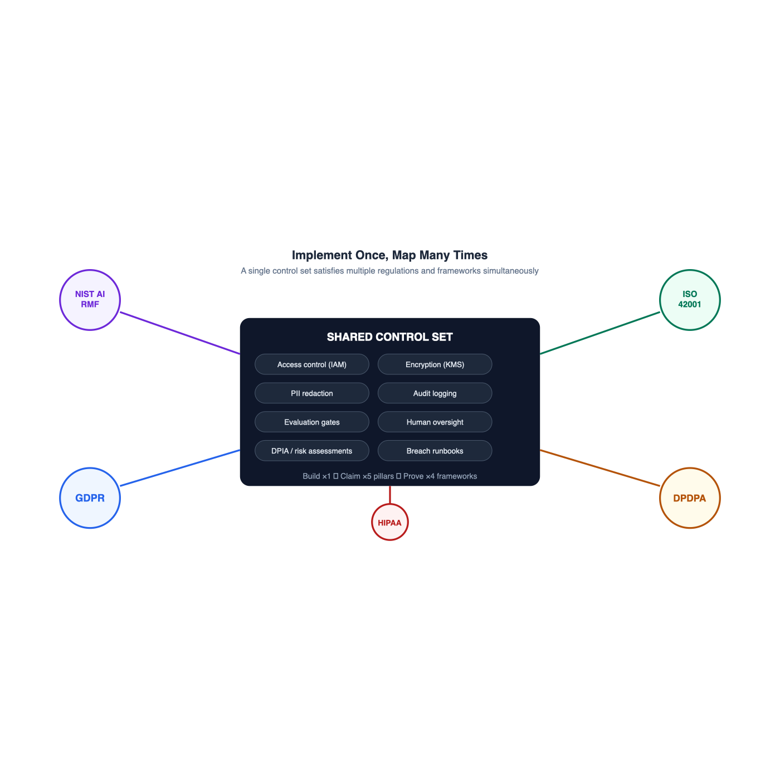
Implement once, map many times — one control set satisfies multiple frameworks

7. Governing the AI lifecycle end to end
Regulations and frameworks both converge on the same practical shape: controls attached to the lifecycle of an AI system, resting on a data-governance foundation and an LLMOps routine, with a cross-cutting control plane that applies everywhere. This is the generic architecture of AI governance — it fits any AI-enabled product or service:
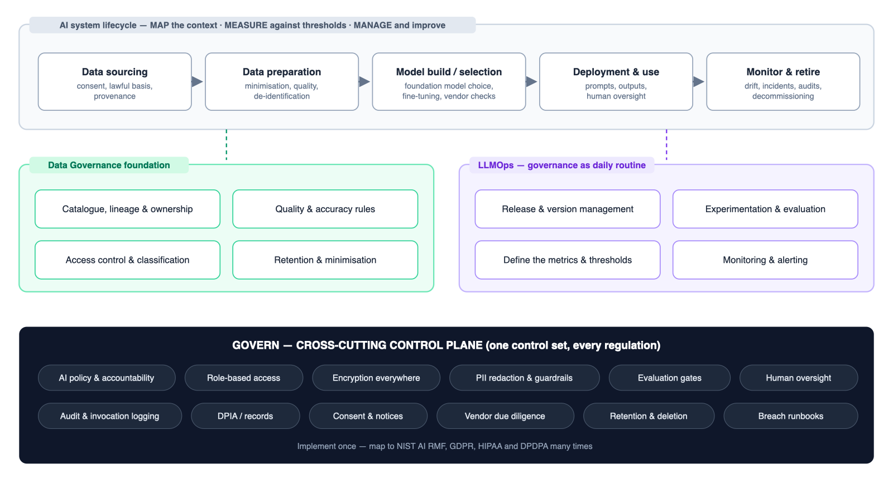
Figure 3 — The AI lifecycle, its foundations, and the cross-cutting governance control plane
Lifecycle stage | The business questions to ask | Essential controls
Data sourcing | Do we have the right to use this data for AI? Would the people in it be surprised? Where did it actually come from? | Lawful-basis check and consent records at intake; provenance documented; sensitive data flagged before it enters any pipeline
Data preparation | Are we carrying more personal data than the use case needs? Is the data good enough to train or ground a model on? | Minimise and de-identify by default; quality and accuracy rules; access restricted to the preparation team
Model build / selection | Build, fine-tune or buy? What do we know about the provider's data practices? What did the model learn that we cannot see? | Vendor due diligence and contracts; providers that do not train on your data; documented model choice rationale; evaluation before acceptance
Deployment & use | Who is allowed to use it, for what? What happens when a person disagrees with the output? Can a crafted input make it misbehave? | Guardrails and personal-data masking at the prompt boundary; human review over consequential outputs; use policies people have actually seen
Monitor & retire | Is it still as good as the day we tested it? Who is watching? When and how does it die? | Drift and quality dashboards with named owners; incident playbook; scheduled re-testing; decommissioning that includes data deletion

8. A 180-day action plan
Sequenced the way successful programmes actually run: visibility first, measurement second, proof third. Each phase produces something leadership can see.
Day 30  See it  The whole AI estate is visible, owners are named, and the worst legal exposure is closed |  | Day 90  Measure it  Every important AI system has numbers, thresholds and a tested failure plan |  | Day 180  Prove it  An audit-ready evidence pack that doubles as a sales asset in enterprise deals

Phase | Timeframe | Actions | Outcome
1 — See it | 0–30 days | Build the AI inventory (every model, tool and vendor in use — including the unofficial ones); appoint an AI risk owner and confirm DPO coverage; map where personal data meets AI; quick wins: vendor contracts checked (DPA/BAA), encryption and access verified, personal-data masking switched on | Leadership can finally see the whole AI estate; highest legal exposure removed
2 — Measure it | 30–90 days | Impact assessments (DPIA) for the significant use cases; define metrics and thresholds per system; stand up evaluation before release and monitoring after it; add human-review points to consequential decisions; rehearse the breach playbook against all three regulatory clocks; refresh privacy notices and consent | Every important AI system has numbers, owners and a tested failure plan
3 — Prove it | 90–180 days | Write up the NIST AI RMF profile; publish model cards internally; first independent bias audit; gap-assess against ISO 42001 (the certifiable version buyers increasingly ask for); DPDPA readiness pack for India operations; end-to-end test of the individual-rights workflow; quarterly AI risk reporting to the board | An audit-ready programme that doubles as a sales asset

Why this order: you cannot govern what you cannot see (Phase 1); you cannot improve or defend what you do not measure (Phase 2); and evidence assembled as a by-product of normal work (Phase 3) is what turns a compliance cost into a procurement advantage — the organisations winning enterprise deals in 2026 are the ones that can hand over their governance pack the day it is requested.

9. References
- NIST AI 100-1 — Artificial Intelligence Risk Management Framework (AI RMF 1.0) — nvlpubs.nist.gov
- NIST AI RMF Core (Govern / Map / Measure / Manage) — NIST AI Resource Center — airc.nist.gov
- NIST AI RMF Playbook — www.nist.gov
- Global AI governance comparison — EU AI Act vs NIST AI RMF vs ISO/IEC 42001 — gaicc.org
- EU AI Act, NIST AI RMF and ISO/IEC 42001 — a plain-English comparison (EC-Council) — www.eccouncil.org
- The 20 biggest AI governance statistics and trends of 2025 (Knostic) — www.knostic.ai
- Gartner — global AI regulations fuel billion-dollar market for AI governance platforms — www.gartner.com
- Gartner — regular AI system assessments triple the likelihood of high GenAI value — www.gartner.com
- 18 AI privacy violations: real enforcement examples (Enzuzo) — www.enzuzo.com
- Italy's Garante fines OpenAI €15m for GDPR non-compliance (DataGuidance) — www.dataguidance.com
- GDPR Article 22 — automated decision-making explained — gdprlocal.com
- Ambient AI scribes and HIPAA compliance — 2026 guidance (Medcurity) — medcurity.com
- HIPAA compliance for generative AI solutions on AWS — aws.amazon.com
- EY India — decoding the DPDP Act 2023 and DPDP Rules 2025 — www.ey.com
- DPDP Rules 2025 — comprehensive compliance guide — www.dpdpa.com
- DLA Piper — data protection laws in India — www.dlapiperdataprotection.com

