AI GOVERNANCE RESEARCH
Open-Source AI Governance Frameworks
A practical guide to implementing NIST AI RMF with open-source tools — covering Trust, Security, Governance, Compliance and Data Protection through a layered architecture

Prepared by | Narendra Kalam
Date | 17 July 2026
Version | 1.0 — for internal review
Scope | Open-source frameworks for AI governance, mapped to NIST AI RMF, EU AI Act, ISO 42001, GDPR, HIPAA and DPDPA

Contents

In Microsoft Word: right-click the table of contents and choose “Update Field” to populate page numbers.

1. Executive summary
No single open-source tool covers every pillar of AI governance. The market has settled on a layered architecture: organisational governance platforms at the base, policy-as-code at deploy time, runtime guardrails in the data path, and continuous evaluation on top. This report maps each layer to the five governance pillars (Trust, Security, Governance, Compliance, Data Protection) and recommends an implementation strategy aligned to the NIST AI RMF operating model.
5  Governance platforms  Full NIST AI RMF lifecycle coverage |  | 4  LLM gateways  Runtime PII redaction & audit |  | 3  Fairness toolkits  70+ bias metrics combined |  | 4  Layers  Org → deploy → runtime → eval |  | 0  Vendor lock-in  All MIT/Apache licensed

Key takeaway
Implement bottom-up: organisational structure first (so you know what you have), then policy gates (so non-compliant code cannot ship), then runtime guardrails (so personal data never reaches a model unmasked), then continuous evaluation (so you can prove it to an auditor). Each layer maps to specific NIST AI RMF functions and satisfies specific regulatory articles.

2. The four-layer architecture
Governance tools operate at different enforcement points in the AI lifecycle. Rather than choosing one tool, mature organisations deploy a stack:
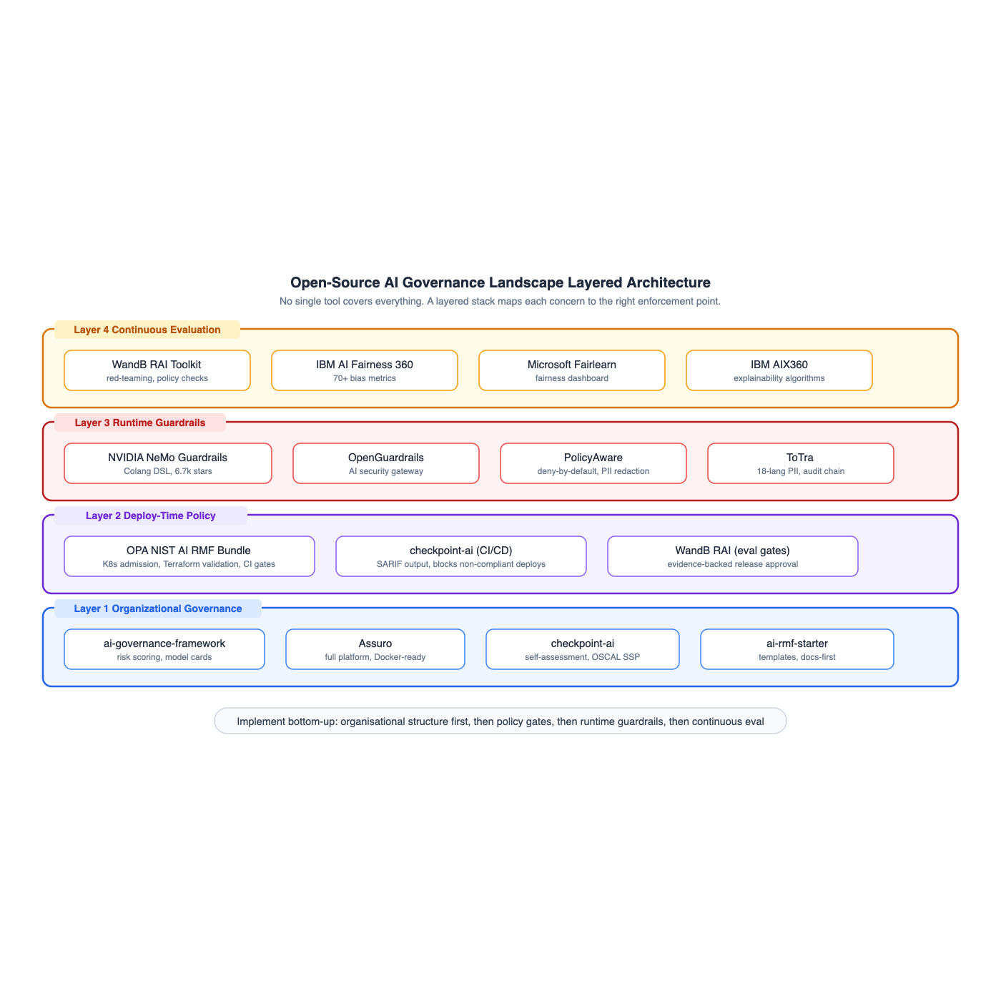
Figure 1 — The four-layer open-source governance architecture
Layer | Enforcement Point | What It Does | When to Deploy
1 | Before build | AI inventory, risk scoring, model cards, committee structure, framework mapping | Days 0–30
2 | CI/CD pipeline | Policy gates that block non-compliant workloads at deploy time | Days 30–60
3 | Data path (proxy) | PII redaction, injection defence, content safety, immutable audit logs | Days 60–90
4 | Periodic + continuous | Red-teaming, bias audits, drift detection, fairness metrics, evidence packs | Day 90+

This mirrors the NIST AI RMF structure: Layer 1 is Govern + Map, Layer 2 is the Measure gate, Layer 3 is Manage at runtime, and Layer 4 is continuous Measure + Manage feedback.

3. End-to-end governance platforms
These platforms cover the full NIST AI RMF lifecycle: Govern, Map, Measure, and Manage. They provide the organisational infrastructure — inventories, risk scores, model cards, compliance mapping — that every other layer depends on.
Framework | Language | Key Capabilities | Regulations | Maturity
ai-governance-framework | Python | Risk scoring, data lineage validation, bias detection, model cards, dashboard | NIST AI RMF, EU AI Act | Enterprise-ready
Assuro | Go + TS | System registry, risk scores, evidence tracking, SHA-256 audit logs, shadow AI discovery | EU AI Act, NIST, ISO 42001 | Docker-ready
checkpoint-ai | Python | Self-assessment, OSCAL SSP generation, CI gating (SARIF), MCP-native | NIST, EU AI Act, ISO 42001 | PyPI published
OPA NIST AI RMF | Rego | 12 deploy-time rules, K8s admission, Terraform validation, CI checks | NIST AI RMF, EU AI Act | MIT reference
WandB RAI Toolkit | Python | Red-teaming (32 attacks), policy checks, evidence reports, industry presets | NIST, EU AI Act, MIT Risk Repo | Active

3.1 Assuro (recommended starting point)
Assuro is the most complete single-deployment option. It ships EU AI Act, NIST AI RMF 1.0 and ISO/IEC 42001 pre-loaded with control mappings. Its extensible connector framework scans AWS Bedrock, Azure AI, GCP Vertex AI, GitHub repositories and HuggingFace Hub to discover shadow AI automatically.
- Risk engine: Computes weighted risk scores based on assessment findings, incident history and monitoring data. Scores are stored historically.
- Audit trail: Every mutation is written to a tamper-evident log with SHA-256 hashes on generated reports.
- Test suites: Define tests by category (functional, bias, robustness, security) with expected outcomes. Failed runs trigger alerts and feed risk scores.

3.2 OPA NIST AI RMF (policy-as-code)
This bundle turns NIST controls into deploy-time machine checks. Each rule maps to a specific NIST AI RMF control and (where applicable) EU AI Act articles:
Rule | NIST / EU AI Act mapping | What it enforces
risk_tier_declared | GOVERN-2, EU Art. 9 | Workload must declare risk tier with rationale
data_lineage_attached | MAP-2, EU Art. 10 | Reference to data lineage required
eval_set_required | MEASURE-2.7, AI 600-1 | Active eval set required on prod deploys
prompt_versioned | MEASURE-2.7 | Inline prompts blocked; registry reference required
audit_evidence_sink | MEASURE-3.3, EU Art. 12 | Audit sink + retention policy declared
human_oversight_pattern | GOVERN-3, EU Art. 14 | HITL pattern declared for high-risk tier

4. LLM guardrails and security gateways
These sit between your applications and model providers. Every LLM call passes through a single enforcement point where PII redaction, injection defence, content safety and audit logging are applied — with zero application code changes.
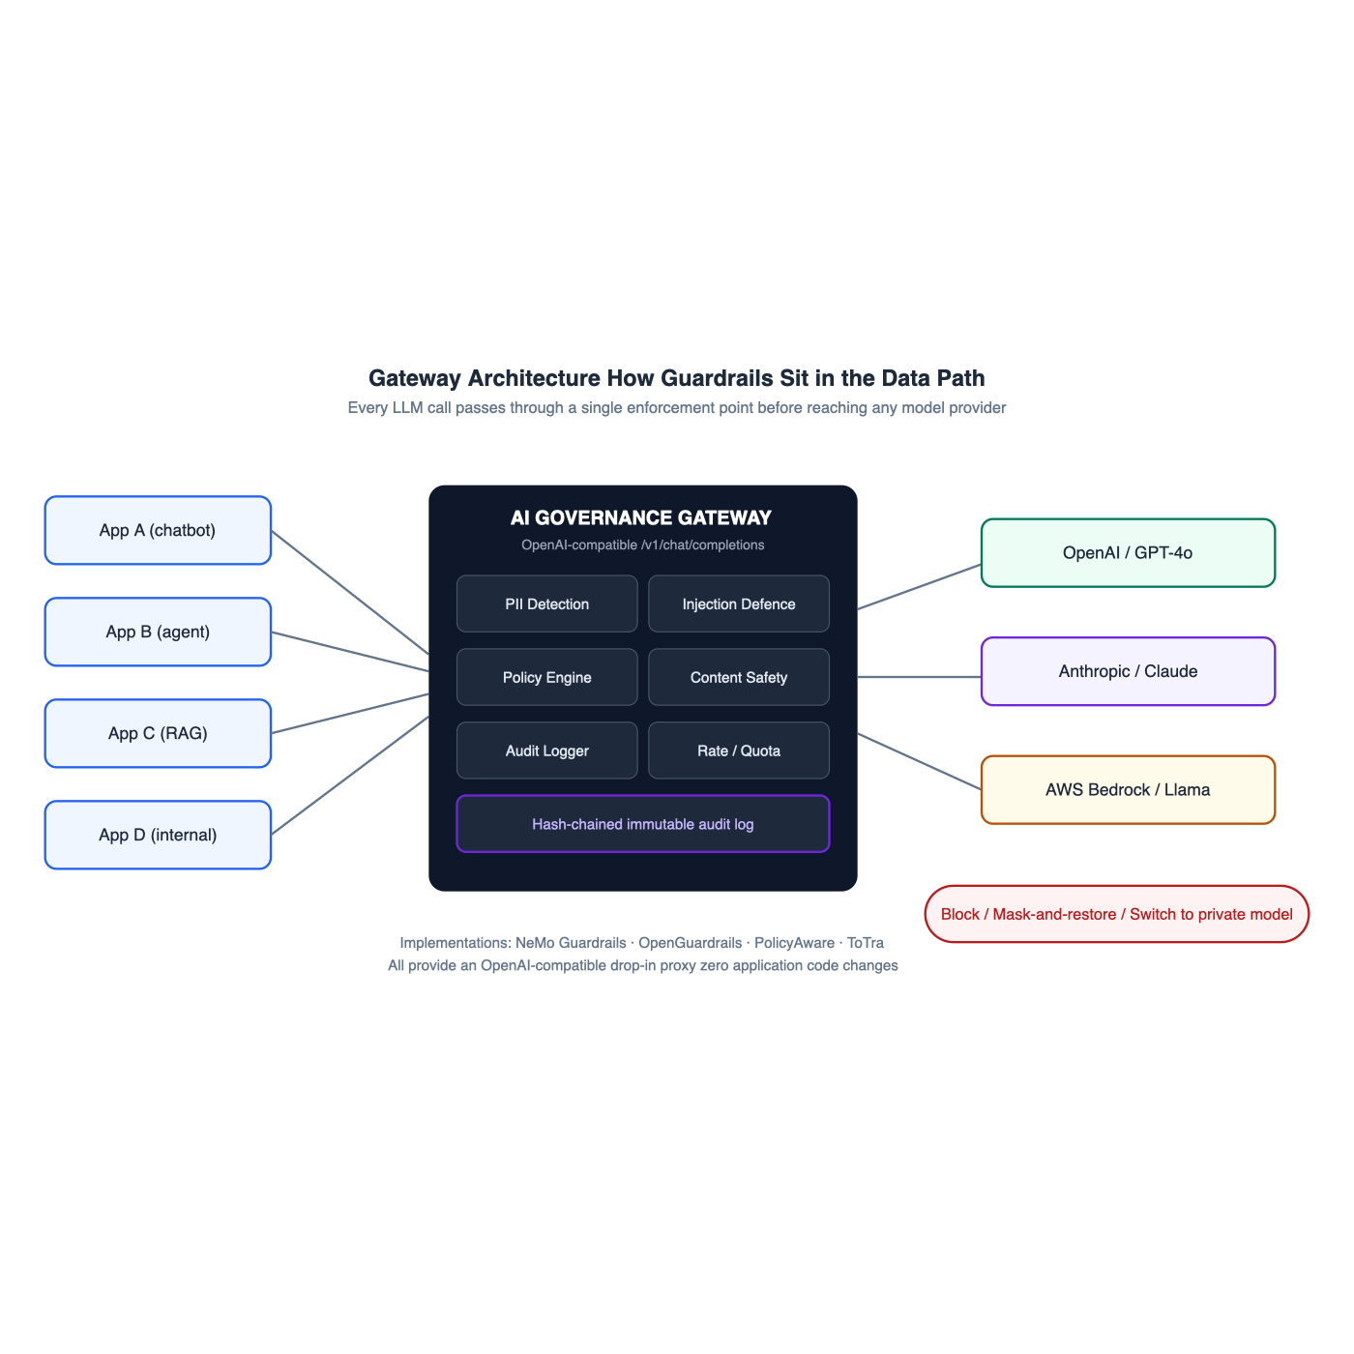
Figure 2 — Gateway architecture: how guardrails sit in the data path
Framework | Language | Key Capabilities | Deployment
NVIDIA NeMo Guardrails | Python | Programmable rails (Colang DSL), jailbreak detection, fact-checking, hallucination detection, topic control, PII handling | Python SDK + API server + Docker
OpenGuardrails | Go | AI security gateway, GenAI PII detection, mask-and-restore, prompt injection defence, 19-category content safety, multi-tenant | OpenAI-compatible proxy
PolicyAware | Python | Deny-by-default policy, PII/PHI/secret redaction, MCP tool governance, model routing, RBAC, audit traces | Control plane / SDK
ToTra | Go | PII blocking (18 languages), per-user quotas, cost tracking, GDPR workflows, EU AI Act checklist, hash-chained audit | OpenAI-compatible gateway

4.1 How the gateway pattern works
- Drop-in proxy: Exposes an OpenAI-compatible /v1/chat/completions endpoint. Applications swap one URL.
- PII detection: Scans every request body in real time. Detected PII is redacted or the request is blocked (configurable).
- Injection defence: Content safety models and pattern matching block prompt injection attempts.
- Policy routing: Sensitive requests can be routed to a private/on-premise model instead of a cloud provider.
- Immutable audit: Every request/response is hash-chained. The log cannot be tampered with after the fact.

The mask-and-restore pattern
OpenGuardrails and PolicyAware support a mask-and-restore strategy: PII is detected and replaced with tokens before the prompt reaches the model. When the response comes back, tokens are restored to original values. The model never sees real personal data, but the user gets a natural response. This satisfies GDPR’s data minimisation principle without degrading the user experience.

5. Fairness, bias and explainability toolkits
These address the Trust pillar — making AI measurably fair and interpretable. They are the evidence generators for NIST’s “fair, with harmful bias managed” and “explainable and interpretable” characteristics.
Toolkit | Capabilities | Best for
IBM AI Fairness 360 | 70+ metrics, 10+ mitigation algorithms (pre/in/post-processing), scikit-learn/TensorFlow/PyTorch | Comprehensive bias detection and debiasing across the ML lifecycle
Microsoft Fairlearn | Fairness dashboard, mitigation (reweighting, reductions), allocation and quality-of-service harm assessment | Teams in the Azure/Microsoft ecosystem needing visual reporting
IBM AI Explainability 360 | 8 algorithms (LIME, SHAP, contrastive, boolean rules), tabular/text/image/time-series | Making model decisions interpretable for regulators and customers

5.1 How they complement the governance platforms
The governance platforms (Layer 1) track what AI systems exist and what their risk scores are. The fairness toolkits provide the measurement that feeds those scores:
- Before release: Run AIF360 bias metrics on the evaluation set. If any group-fairness threshold is breached, the release is blocked.
- In production: Sample live traffic through Fairlearn’s dashboard weekly. Feed results back to Assuro’s risk engine.
- On demand: When a customer or regulator asks “why did your system do X?”, AIX360 generates the explanation.

6. Coverage matrix — pillars vs. tools
Which tools address which governance pillar. No single tool covers all five — the layered stack is essential:
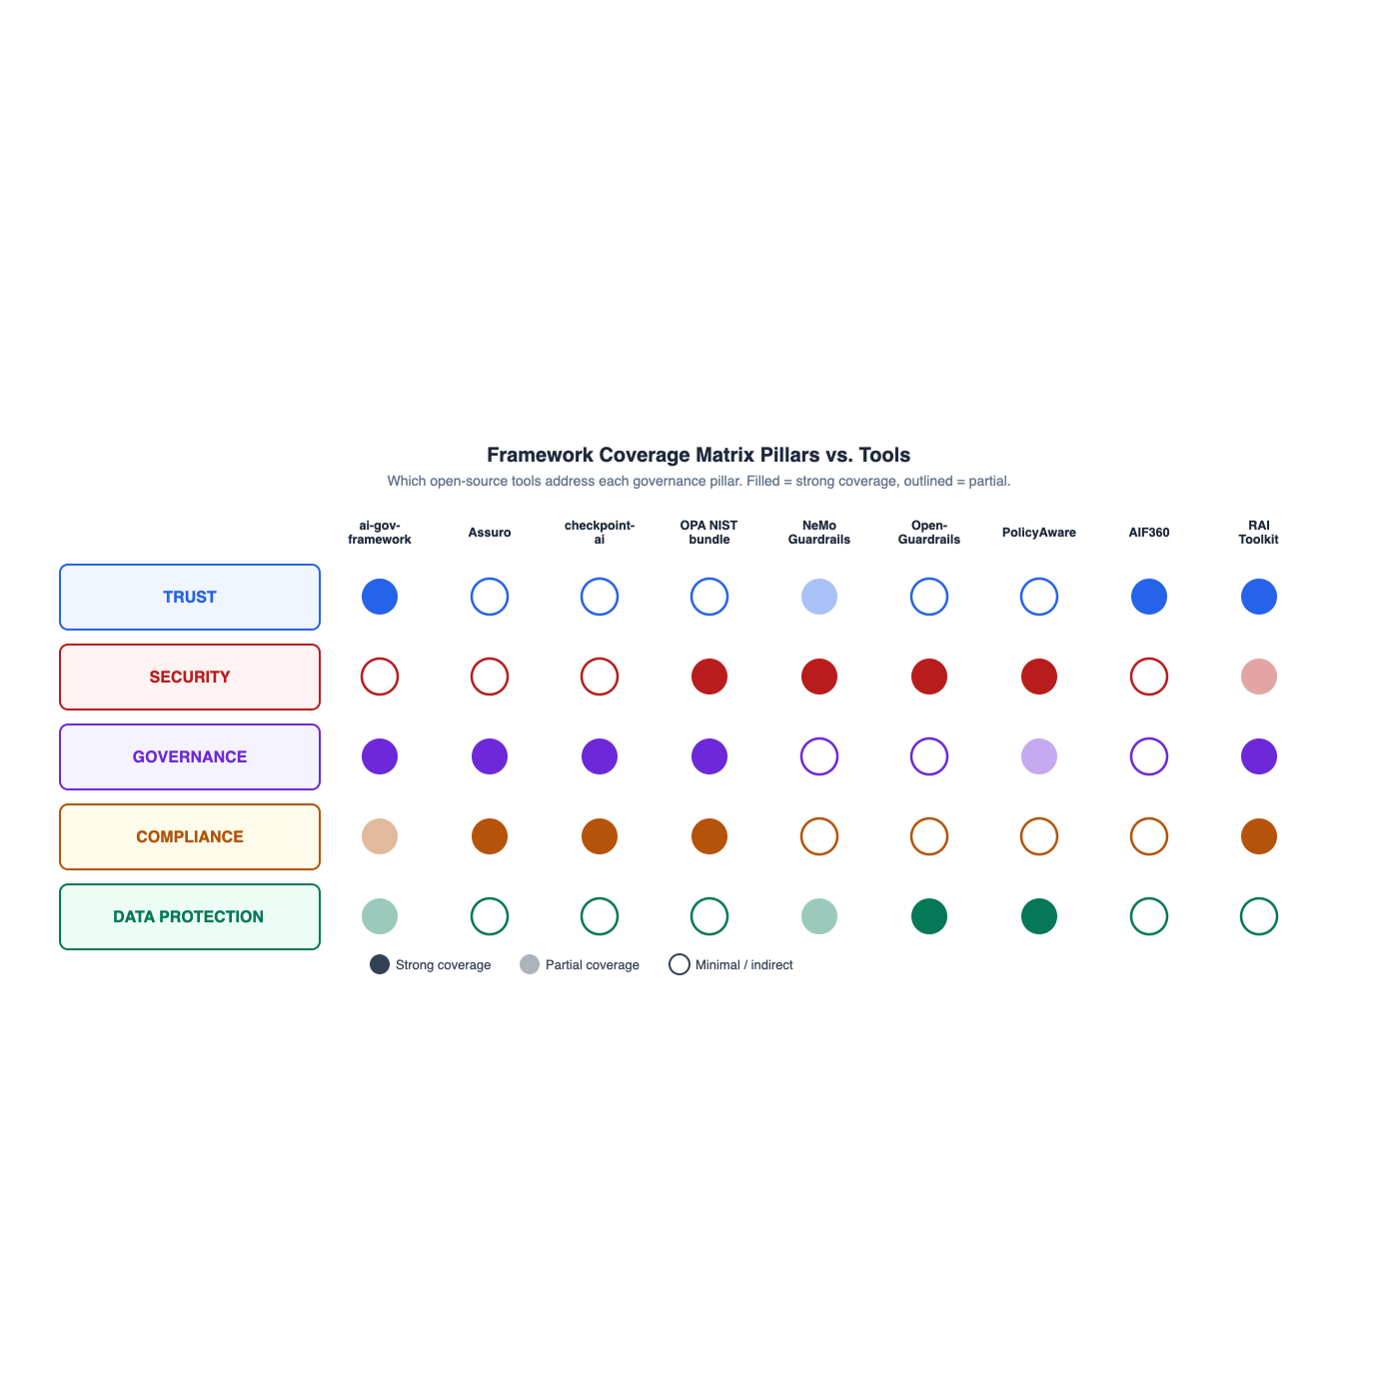
Figure 3 — Coverage matrix: filled = strong, half = partial, outline = indirect
Pillar | Primary Tools | What They Deliver
TRUST | AIF360, Fairlearn, AIX360, RAI Toolkit | Fairness metrics, bias detection, explainability algorithms, adversarial red-teaming
SECURITY | NeMo Guardrails, OpenGuardrails, PolicyAware, ToTra | PII redaction, injection defence, content safety, encryption enforcement
GOVERNANCE | ai-governance-framework, Assuro, checkpoint-ai, OPA bundle | AI inventory, model cards, risk scoring, version control, committee structure
COMPLIANCE | Assuro, checkpoint-ai, ToTra, RAI Toolkit | Framework mapping, DPIA templates, audit trails, breach workflows, evidence reports
DATA PROTECTION | OpenGuardrails, PolicyAware, ToTra | PII masking, data-subject rights, retention enforcement, minimisation at the edge

The pattern: governance platforms cover Governance and Compliance deeply but only touch Security and Data Protection indirectly. Guardrail gateways cover Security and Data Protection deeply but don’t handle organisational structure. You need both.

7. Implementation roadmap (180 days)
Sequenced to match the NIST AI RMF functions: Govern first (know what you have), then Map + Measure (gates and evaluation), then Manage (runtime and continuous improvement).
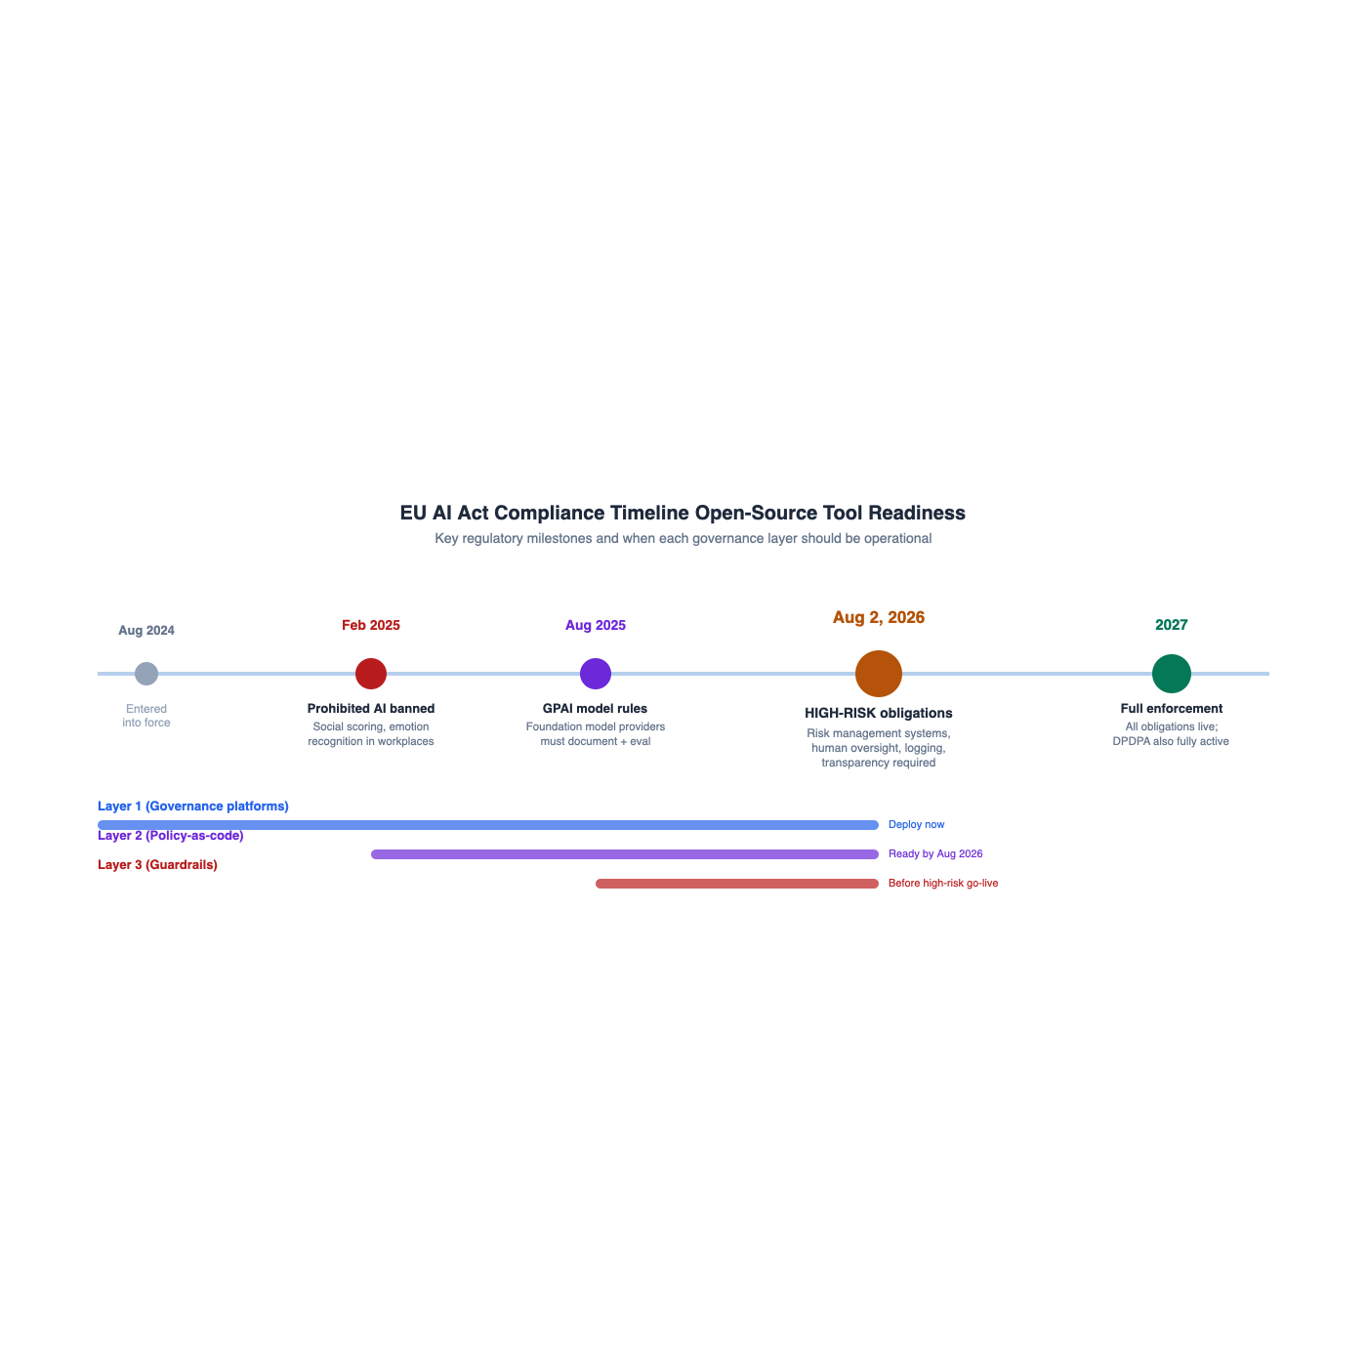
Figure 4 — EU AI Act compliance timeline with tool-readiness milestones
Day 30  Structure  AI estate visible, risks scored, owners named |  | Day 60  Gates  Non-compliant workloads cannot deploy |  | Day 90  Runtime  All LLM traffic governed, PII masked

Phase | Timeframe | Actions | Outcome
1 — Structure | 0–30 days | Deploy Assuro or ai-governance-framework; register all AI systems; compute risk scores; map controls to NIST/EU AI Act/ISO 42001; generate model cards; name risk owners | Visible AI estate with scored risks and owners
2 — Gates | 30–60 days | Integrate OPA bundle into K8s/Terraform/CI; require risk tier, data lineage, prompt versioning, audit sinks; run checkpoint-ai self-assessments with SARIF output | Non-compliant workloads cannot deploy
3 — Runtime | 60–90 days | Deploy NeMo Guardrails or OpenGuardrails as gateway proxy; route all LLM traffic through it; PII redacted before data leaves network; hash-chained audit log on every request | Zero-code-change enforcement for all apps
4 — Eval | 90–180 days | Schedule RAI Toolkit red-team runs; pair with AIF360/Fairlearn for bias on production samples; drift dashboards; quarterly governance reports | Continuous evidence generation for auditors

EU AI Act deadline
High-risk (Annex III) obligations apply from 2 August 2026. Teams building high-risk AI systems should treat this as the hard deadline for having the full four-layer stack operational. DPDPA full enforcement follows in May 2027.

8. References
- NIST AI 100-1 — AI Risk Management Framework 1.0 — doi.org
- NIST AI 600-1 — Generative AI Profile — airc.nist.gov
- EU AI Act — Official Journal — eur-lex.europa.eu
- ISO/IEC 42001:2023 — AI Management System — www.iso.org
- NVIDIA NeMo Guardrails — github.com
- IBM AI Fairness 360 — aif360.res.ibm.com
- Microsoft Fairlearn — fairlearn.org
- IBM AI Explainability 360 — aix360.res.ibm.com
- Assuro — open-source AI governance platform — github.com
- ai-governance-framework — github.com
- checkpoint-ai — NIST/EU/ISO self-assessment — github.com
- OPA NIST AI RMF bundle — github.com
- WandB RAI Toolkit — github.com
- OpenGuardrails — AI security gateway — github.com
- PolicyAware — LLM control plane — github.com
- ToTra — AI gateway with PII and compliance — github.com

