RAG Chatbot AI Governance Evaluation - Backend Flow
Table of Contents

Standard-Driven Evaluation Architecture Prepared by: AI Governance Assessment Engine Design Team Date: July 2026

1. Architecture Overview

Core Principle: Evaluation Follows Selection
The system does not run a fixed checklist against every client. Instead, the user tells the system which industry they operate in and which compliance standards matter to them, and the backend evaluates the chatbot only against those standards - nothing more, nothing less.
This is the defining characteristic of the platform: dynamic, standard-driven evaluation.
INDUSTRY SELECTED --> STANDARDS RECOMMENDED --> USER PICKS 1-3 --> EVALUATE ONLY THOSE --> ONE REPORT PER STANDARD

Why This Works
Each compliance standard already contains its own governance, security, and risk requirements internally - there’s no need to run separate, generic engines for those concepts. The evaluation engine simply loads the control pack for whichever standard was selected and tests every control inside it:
- ISO 42001 covers AI policy, data security, and bias testing within its 38 Annex A controls
- HIPAA covers admin safeguards, technical safeguards, and physical safeguards within its own structure
- NYC LL144 covers auditor requirements, bias testing, and transparency disclosures
Underneath these standard-specific structures, every individual control is also tagged to one of 5 common governance pillars (Trust, Security, Governance, Compliance, Data Protection) so that results stay comparable across industries and standards, and so the system can automatically detect when fixing one gap satisfies requirements in multiple standards at once. See Section 6.

2. Complete Pipeline Flow
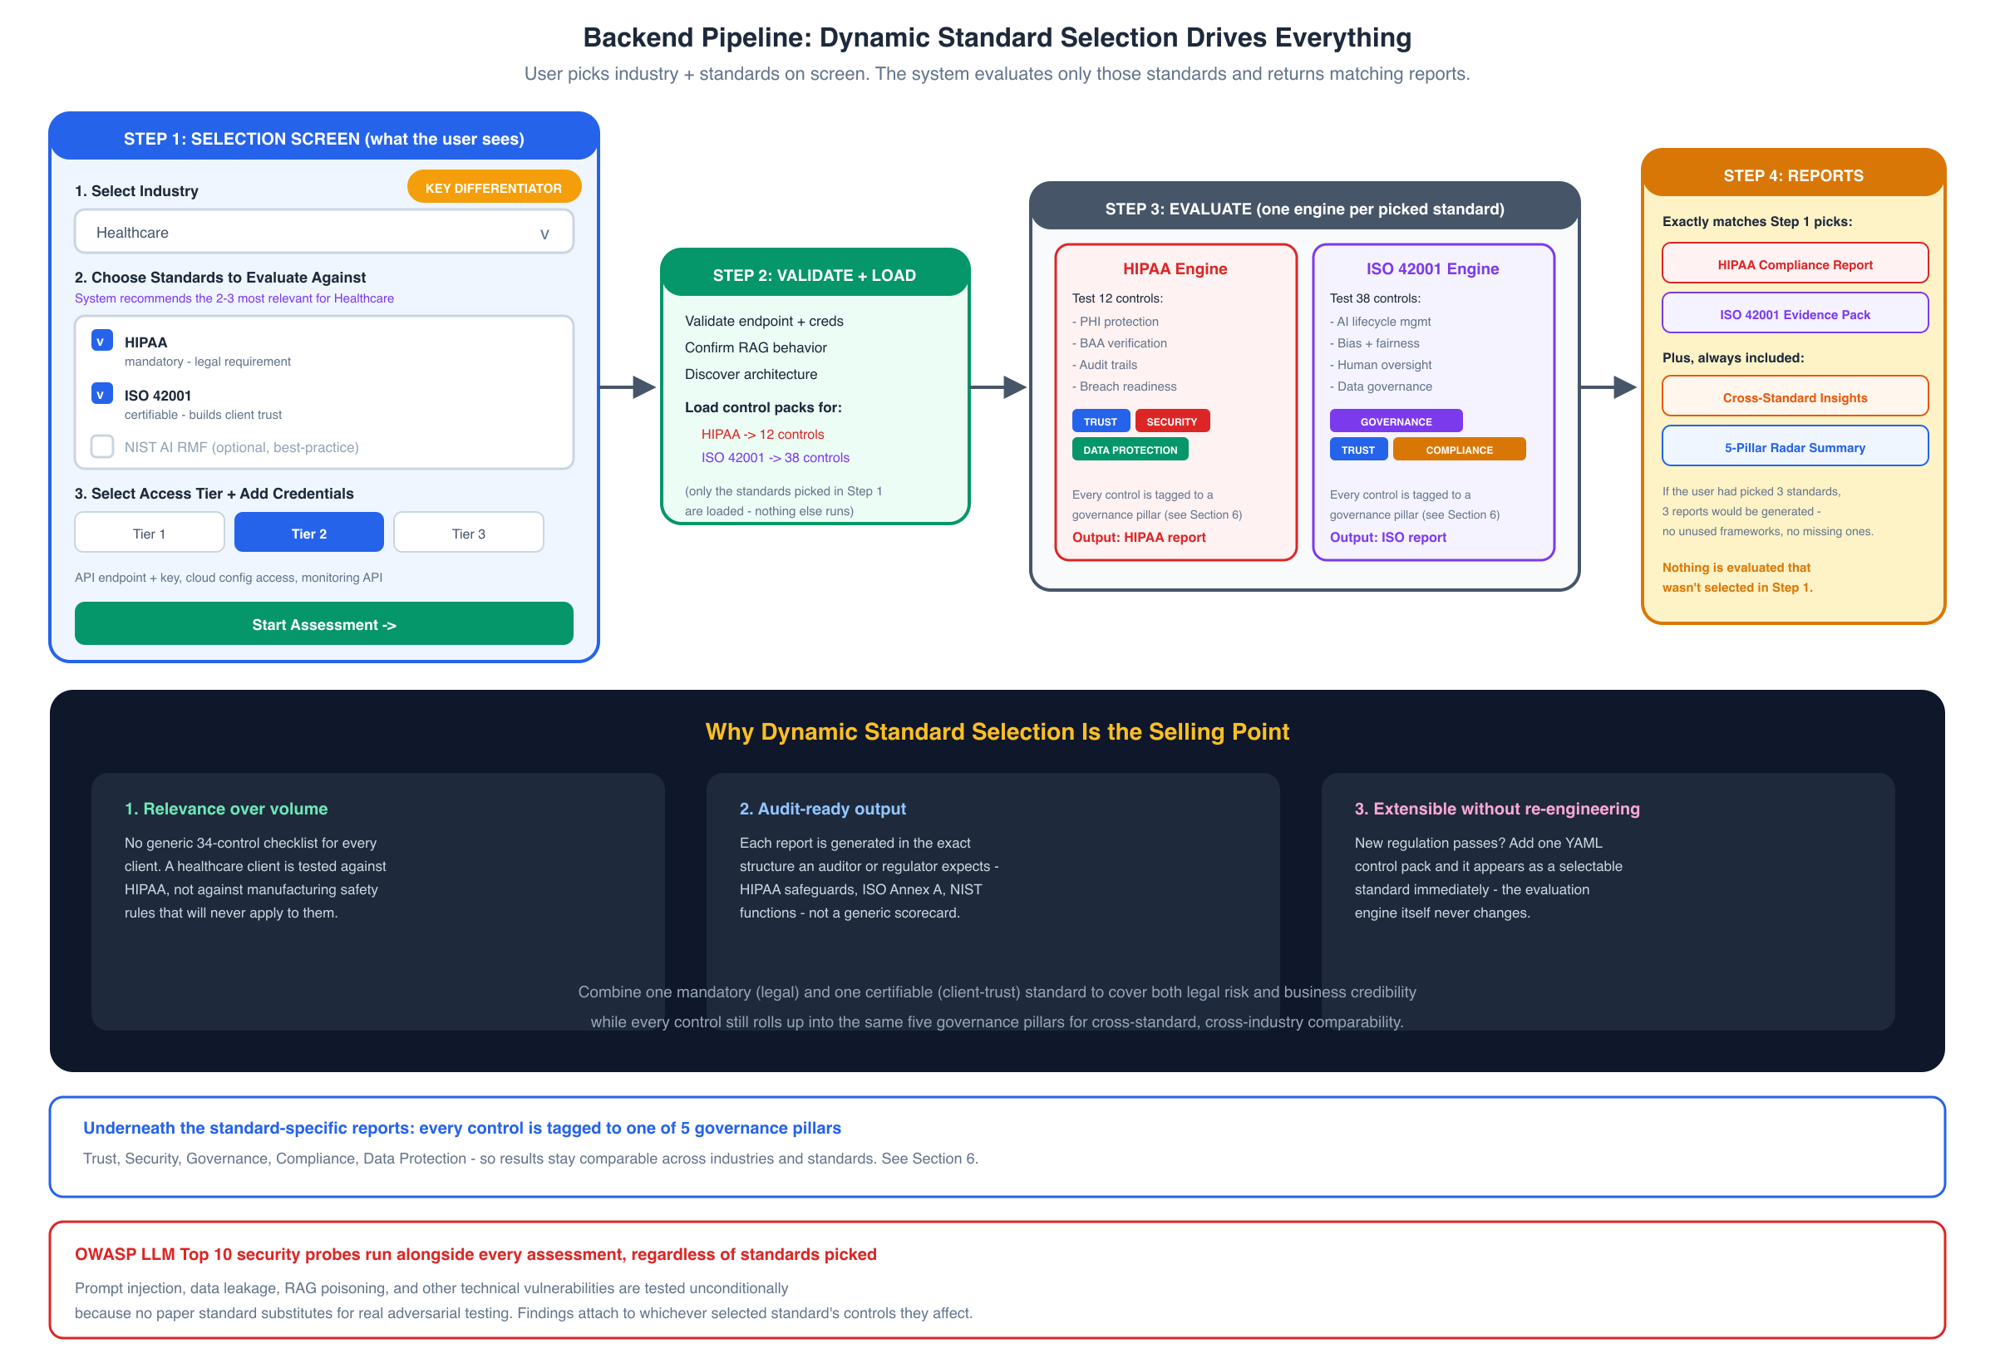
Backend Pipeline Flow

Pipeline Steps
Step 1: Selection Screen (what the user sees) - Select industry from a dropdown (10 industries supported) - The system immediately recommends the 2-3 most relevant standards for that industry, pre-checked - User can accept the recommendation or adjust (pick 1-3 standards total) - Select access tier (Tier 1/2/3) and provide the matching credentials
Step 2: Validate + Load - Validate the chatbot endpoint and credentials - Confirm the target is actually a RAG system (not a plain LLM wrapper) - Discover architecture (model, vector DB, embedding model) - Load the control pack only for the standards selected in Step 1 - nothing else is loaded
Step 3: Evaluate (one engine per picked standard) - Each selected standard spins up its own evaluation engine, running in parallel - Controls are filtered by tier so only testable controls run - Every control carries a pillar tag (Trust / Security / Governance / Compliance / Data Protection) - OWASP LLM Top 10 security probes run alongside every assessment regardless of which standards were picked, since no paper standard replaces real adversarial testing
Step 4: Reports (exactly matches Step 1) - One report generated per selected standard, in that standard’s native format - A Cross-Standard Insights report is added automatically when 2+ standards are selected - A 5-Pillar Radar Summary rolls everything up for an at-a-glance comparable view - If the user picked 3 standards, 3 reports are generated - no unused frameworks, no missing ones, nothing evaluated that wasn’t selected

3. Dynamic Standard Selection - The Core Differentiator
Selecting the right standards is the single most important decision a user makes, and the platform is built around making that decision easy and defensible.

How It Works
- User selects industry (e.g. Healthcare, Finance, HR/Recruitment, Education, Autonomous Vehicles, etc.)
- System looks up the industry-to-standard mapping (see Section 4) and pre-selects the 2-3 most popular, most relevant standards for that industry
- Each recommended standard shows why it’s recommended - mandatory/legal, certifiable/business-trust, or methodological/best-practice
- User can add or remove standards from the list, or search for additional ones
- The evaluation engine loads exactly those control packs - no more, no less
- Reports come back in the native format of each selected standard, plus a cross-standard insights view

Why This Is the Selling Point
Benefit | What It Means in Practice
Relevance over volume | No generic 34-control checklist for every client. A healthcare client is tested against HIPAA, not against manufacturing safety rules that will never apply to them
Audit-ready output | Each report is generated in the exact structure an auditor or regulator expects - HIPAA safeguards, ISO Annex A, NIST functions - not a generic scorecard
Extensible without re-engineering | A new regulation passes? Add one YAML control pack and it appears as a selectable standard immediately. The evaluation engine itself never changes
Combines legal + business needs | Users are guided to pick one mandatory (legal) standard and one certifiable (client-trust) standard, covering both legal risk and business credibility in a single assessment
Cross-standard efficiency | Because every control is pillar-tagged, the system automatically finds gaps that affect multiple standards at once, so remediation effort isn’t duplicated

4. Industry-Based Standard Recommendations

Available Industries and Standards
Industry | Standard 1 (most popular) | Standard 2 | Standard 3
Healthcare | HIPAA (mandatory, US) | ISO 42001 (certifiable) | NIST AI RMF
Finance/Banking | MAS AI Guidelines / SR 11-7 | SOC 2 Type II | ISO 42001
Insurance | NAIC Model Bulletin | ISO 42001 | EU AI Act
HR/Recruitment | NYC LL144 (mandatory, NYC) | Colorado AI Act | EU AI Act
Education | FERPA | NIST AI RMF | ISO 42001
Autonomous Vehicles | UNECE ADS Regulation | ISO 21448 (SOTIF) | UK AV Act 2024
Legal/Judiciary | CEPEJ Ethical Charter | EU AI Act | Canada AIA
Manufacturing | EU Machinery Regulation | IEC 62443 | ISO 13849
Media/Content | China Deep Synthesis Regs | C2PA Standard | EU AI Act
Government/Public Sector | US OMB M-24-10 | Canada AIA | Netherlands IAMA

Why Multiple Standards Per Industry?
No single standard covers everything an organization needs:
Standard Type | What It Does | Example
Mandatory/Regulatory | Legal requirement - must comply | HIPAA, NYC LL144, EU AI Act
Certifiable | Get a certificate to show clients | ISO 42001, SOC 2
Methodological | Best-practice guidance | NIST AI RMF, CEPEJ Charter
Most organizations need two: one mandatory (legal) and one certifiable (business trust). The third standard is optional for organizations wanting comprehensive coverage.

5. Three-Tier Access Model
The tier determines how many controls within each standard can actually be tested.
Tier | Access Level | What You Provide | Coverage
Tier 1 | API Only | Chatbot endpoint + API key | ~55-60% of controls
Tier 2 | API + Infrastructure | + Cloud API keys, monitoring API, CI/CD access | ~80-85% of controls
Tier 3 | Full Source + Staging | + Source code repo, staging env, model registry | 100% of controls

What Each Tier Unlocks
Tier 1 (Black-Box): - Prompt injection testing - Data leakage probes - Output filtering checks - Response consistency analysis - Hallucination detection - Self-reported compliance questionnaire probes
Tier 2 (adds Gray-Box): - Cloud configuration audit (AWS/GCP/Azure APIs) - Monitoring and logging verification (Datadog/CloudWatch) - CI/CD pipeline security checks - Access control configuration review - Encryption-at-rest/in-transit verification - Network isolation checks
Tier 3 (adds White-Box): - Source code review for security vulnerabilities - Model card and documentation verification - Training data audit for bias/PII - Vector DB content scanning - Staging environment penetration testing - Full dependency vulnerability scan

Tier Coverage by Standard
Standard | Tier 1 | Tier 2 | Tier 3
HIPAA | 7/12 controls | 10/12 | 12/12
ISO 42001 | 22/38 controls | 32/38 | 38/38
NIST AI RMF | 15/27 controls | 23/27 | 27/27
EU AI Act | 12/22 controls | 18/22 | 22/22
SOC 2 Type II | 8/17 controls | 15/17 | 17/17
NYC LL144 | 6/8 controls | 7/8 | 8/8
Controls that cannot be tested at the current tier are marked “Not Assessed - requires Tier X” in the report, with confidence scored at 0.

6. Governance Pillars and Trustworthy-AI Characteristics
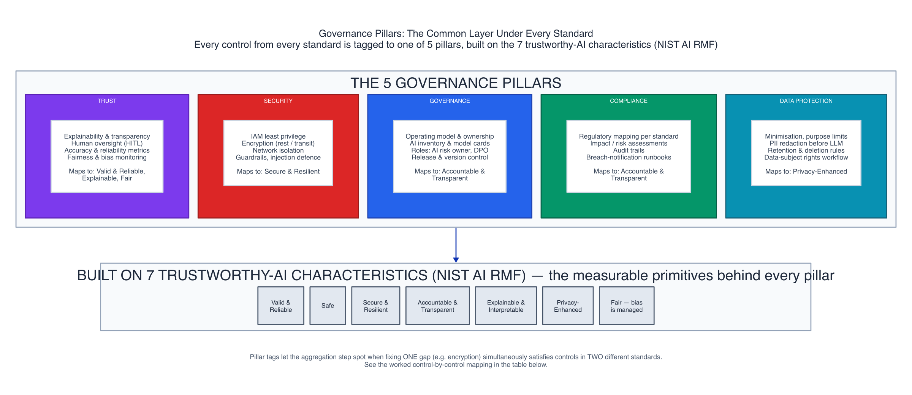
Governance Pillars Mapping

The Common Layer Under Every Standard
Even though evaluation is organized by standard, every single control - regardless of which standard it comes from - is tagged to one of 5 governance pillars:
Pillar | Covers | Built on (NIST Trustworthy-AI Characteristics)
Trust | Explainability, human oversight, accuracy, fairness/bias monitoring | Valid & Reliable, Explainable & Interpretable, Fair (bias managed)
Security | IAM, encryption, network isolation, guardrails, injection defence | Secure & Resilient
Governance | Operating model, AI inventory, model cards, roles, release control | Accountable & Transparent
Compliance | Regulatory mapping, impact assessments, audit trails, breach runbooks | Accountable & Transparent
Data Protection | Minimisation, PII redaction, retention rules, data-subject rights | Privacy-Enhanced
These 5 pillars are themselves built on the 7 trustworthy-AI characteristics defined by the NIST AI Risk Management Framework: Valid & Reliable, Safe, Secure & Resilient, Accountable & Transparent, Explainable & Interpretable, Privacy-Enhanced, and Fair (bias managed).

Why Pillar Tagging Matters
- Cross-standard comparability - a client who runs HIPAA + ISO 42001 can see how they’re doing on “Security” overall, not just per standard
- Shared-gap detection - if a HIPAA control and an ISO control both tag to “Security” and both fail for the same underlying reason (e.g. no encryption at rest), the system flags this as one fix that resolves two findings
- Consistent executive reporting - leadership gets a simple 5-pillar radar chart regardless of which specific standards were technically evaluated
- Future-proofing - when a new standard is added via a YAML control pack, tagging its controls to the existing 5 pillars means it plugs directly into existing dashboards and cross-standard insight logic with no extra engineering

Example: Same Pillar, Different Standards
Standard | Control | Pillar Tag(s) | Trustworthy-AI Characteristic
HIPAA | 164.312(a)(2)(iv) Encryption | Security, Data Protection | Secure & Resilient
ISO 42001 | A.6.2.7 Data Security | Security, Data Protection | Secure & Resilient
HIPAA | 164.308(a)(1) Risk Analysis | Governance, Compliance | Accountable & Transparent
NYC LL144 | Bias Audit - selection rate by group | Trust | Fair (bias managed)
ISO 42001 | A.4.3 AI System Risk Assessment | Trust, Governance | Valid & Reliable
OWASP LLM01 | Prompt Injection Resistance | Security | Secure & Resilient
Because the HIPAA encryption control and the ISO 42001 data security control share the same pillar tags, fixing the underlying encryption gap resolves both findings at once - this is exactly what the Cross-Standard Insights report surfaces.

7. Per-Standard Evaluation Engine
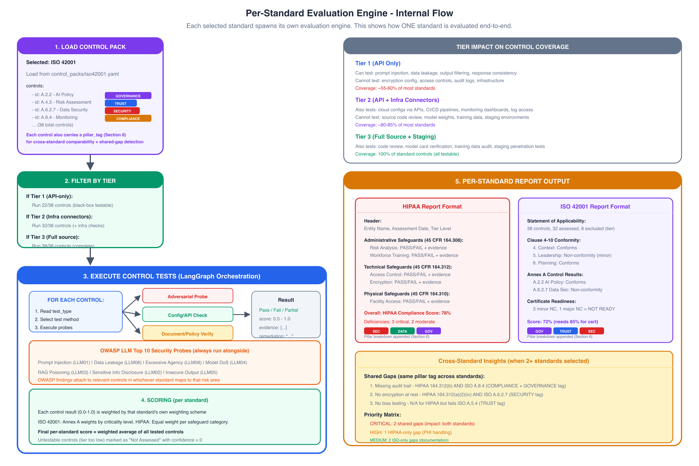
Per-Standard Evaluation Detail

Internal Flow
Each selected standard follows this flow:
LOAD CONTROL PACK --> FILTER BY TIER --> EXECUTE TESTS --> SCORE --> FORMAT REPORT

7.1 Control Pack Structure
Each standard is defined as a YAML control pack, and every control carries a pillar_tag alongside its test definition:
# control_packs/hipaa.yaml
standard:
id: hipaa
name: "HIPAA (Health Insurance Portability and Accountability Act)"
version: "45 CFR Parts 160, 162, 164"
report_format: "hipaa_safeguard_report"
scoring: "equal_weight_per_category"
controls:
- id: "164.308(a)(1)"
name: "Risk Analysis"
category: "Administrative Safeguards"
test_type: "config_check" # or "adversarial_probe" or "document_verify"
tier_minimum: 2 # minimum tier needed to test this
pillar_tags: ["governance", "compliance"]
weight: 1.0
probes:
- type: "api_check"
target: "cloud_config"
check: "risk_assessment_document_exists"
- type: "log_check"
target: "monitoring"
check: "risk_reviews_scheduled"
pass_criteria: "all_probes_pass"
evidence_needed: "risk_assessment_report, review_schedule"
remediation: "Conduct formal risk analysis per NIST SP 800-30"
- id: "164.312(a)(2)(iv)"
name: "Encryption and Decryption"
category: "Technical Safeguards"
test_type: "config_check"
tier_minimum: 2
pillar_tags: ["security", "data_protection"]
weight: 1.0
probes:
- type: "api_check"
target: "cloud_config"
check: "encryption_at_rest_enabled"
- type: "api_check"
target: "network"
check: "tls_1_2_or_higher"
pass_criteria: "all_probes_pass"
evidence_needed: "encryption_config_screenshot, TLS_cert_details"
remediation: "Enable AES-256 encryption at rest, enforce TLS 1.2+"

7.2 Test Types
Test Type | How It Works | Tier Required | Example
adversarial_probe | Send crafted inputs to the chatbot API | Tier 1+ | Prompt injection, data extraction attempts
config_check | Query infrastructure APIs for settings | Tier 2+ | Check if encryption enabled, logs configured
document_verify | Check for existence/content of policies | Tier 3 (or self-report at Tier 1) | Model card exists, bias testing report filed

7.3 Execution via LangGraph
Each standard’s evaluation is a LangGraph state machine:
from langgraph.graph import StateGraph, END
class StandardEvalState(TypedDict):
standard_id: str
controls: list[Control]
current_index: int
results: list[ControlResult]
tier: int
credentials: dict
def load_controls(state):
pack = load_yaml(f"control_packs/{state['standard_id']}.yaml")
filtered = [c for c in pack['controls'] if c['tier_minimum'] <= state['tier']]
return {"controls": filtered, "current_index": 0}
def execute_control(state):
control = state['controls'][state['current_index']]
result = run_probes(control, state['credentials'])
return {
"results": state['results'] + [result],
"current_index": state['current_index'] + 1
}
def should_continue(state):
if state['current_index'] >= len(state['controls']):
return "score"
return "execute"
def score_standard(state):
weights = get_scoring_scheme(state['standard_id'])
score = weighted_average(state['results'], weights)
return {"final_score": score}
graph = StateGraph(StandardEvalState)
graph.add_node("load", load_controls)
graph.add_node("execute", execute_control)
graph.add_node("score", score_standard)
graph.set_entry_point("load")
graph.add_edge("load", "execute")
graph.add_conditional_edges("execute", should_continue)
graph.add_edge("score", END)

7.4 OWASP Security Testing (Always Included)
Regardless of which standards the user selects, OWASP LLM Top 10 security probes always run:
OWASP ID | Vulnerability | Test Method | Pillar Tag
LLM01 | Prompt Injection | Direct + indirect injection attempts | Security
LLM02 | Sensitive Info Disclosure | PII extraction probes | Security, Data Protection
LLM03 | Training Data Poisoning | RAG retrieval manipulation tests | Security, Trust
LLM04 | Model Denial of Service | Resource exhaustion probes | Security
LLM05 | Insecure Output Handling | XSS/injection in responses | Security
LLM06 | Excessive Agency | Tool-use boundary tests | Security, Governance
LLM07 | System Prompt Leakage | Extraction techniques | Security
LLM08 | Vector DB Poisoning | Retrieval integrity checks | Security, Trust
OWASP findings are mapped to relevant controls in whichever standards are selected via shared pillar tags. For example: - A prompt injection finding (Security) maps to HIPAA 164.312(a)(1) Access Control (also Security) - A data leakage finding (Security, Data Protection) maps to ISO 42001 A.6.2.7 Data Security - If no selected standard covers that pillar area, the finding appears in a separate “Security Findings” appendix

8. Scoring Model

Per-Standard Scoring
Each standard uses its own native scoring scheme:
Standard | Scoring Method | Pass Threshold
HIPAA | Equal weight per safeguard category (Admin/Tech/Physical) | 100% required (regulatory)
ISO 42001 | Conformity levels: Conforms / Minor NC / Major NC / Not Assessed | 0 Major NC for certification
NIST AI RMF | Maturity levels 1-5 per function (Govern/Map/Measure/Manage) | Level 3+ recommended
EU AI Act | Mandatory requirements checklist (pass/fail per article) | 100% for high-risk systems
SOC 2 | Controls effective/not effective with exceptions noted | All controls effective
NYC LL144 | 4/5ths rule for bias + disclosure requirements | Statistical threshold

Pillar Rollup Scoring
In addition to the native per-standard score, every assessment also produces a 5-pillar radar score, computed by averaging all tested controls (across all selected standards) that share each pillar tag. This is what powers the “5-Pillar Radar Summary” shown in every report package, regardless of which specific standards were evaluated.

Score Presentation
Each control result includes: - Status: Pass / Fail / Partial / Not Assessed - Score: 0.0 to 1.0 (for weighted calculation) - Confidence: How certain we are (lower if tier limits testing) - Evidence: What we observed/collected - Pillar Tag(s): Which of the 5 pillars this control rolls up to - Remediation: Specific fix if failed

9. Report Generation

Per-Standard Reports
Each standard generates a report in that standard’s native format:
HIPAA Report Structure:
1. Entity Information + Assessment Scope
2. Administrative Safeguards (45 CFR 164.308)
- Each control: PASS/FAIL + evidence + remediation + pillar tag
3. Technical Safeguards (45 CFR 164.312)
- Each control: PASS/FAIL + evidence + remediation + pillar tag
4. Physical Safeguards (45 CFR 164.310)
- Each control: PASS/FAIL + evidence + remediation + pillar tag
5. Overall Compliance Status + Pillar Breakdown
6. Remediation Priority List
ISO 42001 Report Structure:
1. Statement of Applicability
2. Clause 4-10 Conformity Assessment
3. Annex A Control Results (per control, with pillar tag)
4. Non-Conformities (Major/Minor)
5. Observations and Opportunities for Improvement
6. Certificate Readiness Assessment + Pillar Breakdown
NIST AI RMF Report Structure:
1. AI System Profile
2. Govern Function Assessment (maturity levels)
3. Map Function Assessment (maturity levels)
4. Measure Function Assessment (maturity levels)
5. Manage Function Assessment (maturity levels)
6. Risk Summary + Recommended Actions

Cross-Standard Insights Report
When 2+ standards are selected, an additional insights report is generated, built directly from shared pillar tags:
CROSS-STANDARD INSIGHTS
========================
1. Shared Gaps (same pillar tag across standards - fix once, satisfy both):
- Gap: No encryption at rest
Affects: HIPAA 164.312(a)(2)(iv) + ISO A.6.2.7 [pillar: Security, Data Protection]
Priority: CRITICAL (impacts both)
Single Fix: Enable AES-256 on cloud storage
2. Standard-Specific Gaps:
- HIPAA only: Missing BAA with cloud provider [pillar: Compliance]
- ISO only: No formal AI policy document [pillar: Governance]
3. Priority Matrix:
CRITICAL: 2 shared gaps
HIGH: 1 HIPAA-specific
MEDIUM: 3 ISO-specific (documentation)
LOW: 1 ISO-specific (nice-to-have)
4. 5-Pillar Radar Summary:
Trust: 74% Security: 61% Governance: 80% Compliance: 88% Data Protection: 65%
5. Effort Estimate:
Fix shared gaps first = 2 standards improved simultaneously
Total remediation items: 7
Estimated effort: 3-4 weeks

10. Technical Stack
Component | Technology | Purpose
Orchestration | LangGraph (Python) | State machine for evaluation flow
API Server | FastAPI | REST endpoints + SSE streaming
Control Packs | YAML files | Standard definitions (portable, version-controlled)
Task Queue | Celery + Redis | Parallel standard evaluation
Database | PostgreSQL (Neon) | Assessment results, history
Cache | Upstash Redis | Rate limiting, session state
LLM | GPT-4o / Claude | Probe generation, result analysis
Frontend | Next.js 14 | Input forms + live dashboard
Streaming | Server-Sent Events (SSE) | Real-time progress to frontend
Reports | WeasyPrint + Jinja2 | PDF generation per standard

Backend Folder Structure
backend/
app/
main.py # FastAPI app + SSE endpoints
models/ # Pydantic schemas
routers/
assessments.py # Start/status/results endpoints
standards.py # List standards per industry
engine/
orchestrator.py # LangGraph coordinator
standard_eval.py # Per-standard evaluation engine
probe_runner.py # Execute individual probes
owasp_runner.py # OWASP LLM Top 10 tests
scoring.py # Per-standard + pillar rollup scoring
pillar_mapper.py # Cross-standard shared-gap detection
control_packs/
hipaa.yaml
iso42001.yaml
nist_ai_rmf.yaml
eu_ai_act.yaml
soc2.yaml
nyc_ll144.yaml
mas_ai.yaml
... (one per standard)
connectors/
aws.py # AWS config reader
gcp.py # GCP config reader
azure.py # Azure config reader
datadog.py # Monitoring API
github.py # CI/CD + source access
reports/
templates/ # Jinja2 templates per standard
generator.py # PDF/DOCX report builder
cross_insights.py # Multi-standard gap analysis

11. Frontend Overview
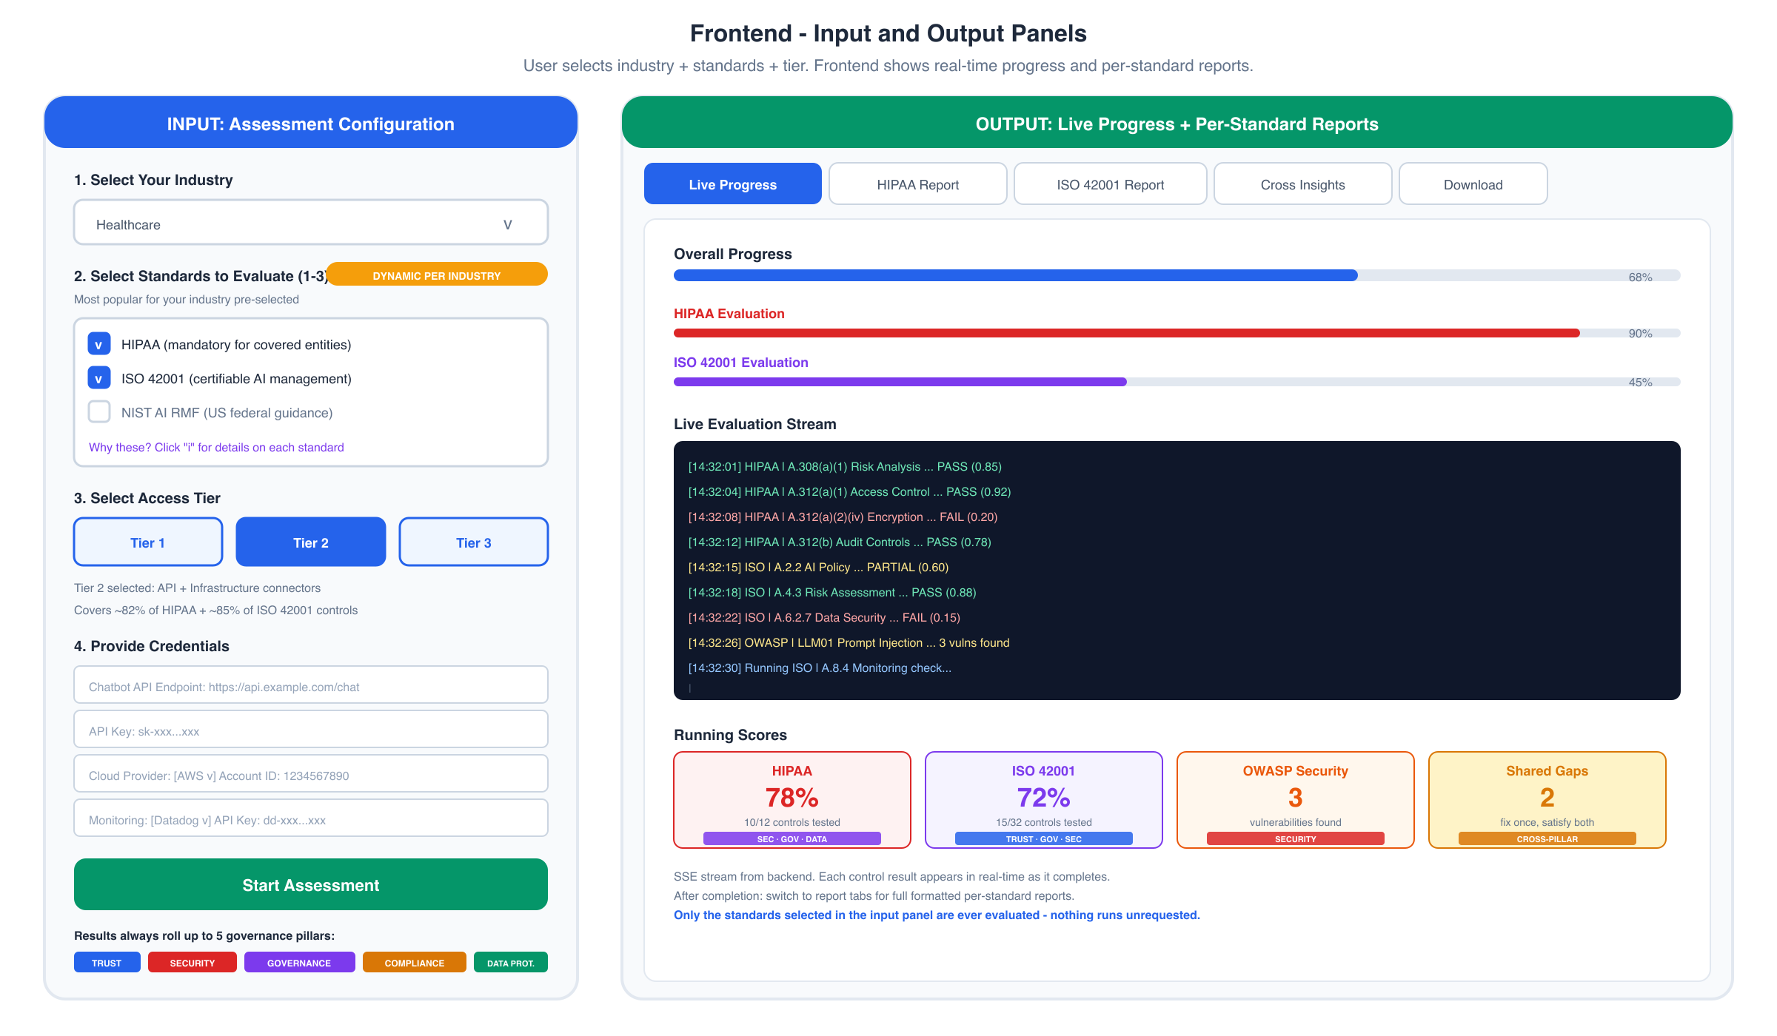
Frontend Panels

Input Panel
The frontend collects:
- Industry Selection - Dropdown with 10 industries
- Standard Selection - Checkboxes (1-3), dynamically pre-populated with the most popular standards for the selected industry. Each recommended standard shows a tooltip explaining why it’s recommended (mandatory / certifiable / methodological)
- Tier Selection - Toggle between Tier 1/2/3 with live coverage % update per selected standard
- Credentials - Dynamic form based on tier:
  - Tier 1: API endpoint + key only
  - Tier 2: + Cloud provider API key, monitoring API key
  - Tier 3: + Git repo URL, staging environment URL

Output Panel (Tabbed)
Tab | Content
Live Progress | Real-time stream showing each control being tested, pass/fail, running scores per standard
[Standard 1] Report | Full formatted report in that standard’s structure
[Standard 2] Report | Full formatted report in that standard’s structure
Cross Insights | Shared gaps, priority matrix, 5-pillar radar summary, effort estimate
Download | PDF download for each report + combined package
A persistent banner across the output panel reinforces the core mechanic: “Only the standards selected in the input panel are ever evaluated - nothing runs unrequested.”

Real-Time Communication (SSE)
# Backend: FastAPI SSE endpoint
@app.get("/api/assessments/{id}/stream")
async def stream_assessment(id: str):
async def event_generator():
async for event in engine.run_assessment(id):
yield {
"event": event.type, # "control_start", "control_result", "standard_complete"
"data": json.dumps({
"standard": event.standard_id,
"control_id": event.control_id,
"status": event.status, # "pass", "fail", "partial"
"score": event.score,
"pillar_tags": event.pillar_tags,
"message": event.message
})
}
return EventSourceResponse(event_generator())
// Frontend: React hook
function useAssessmentStream(assessmentId: string) {
const [progress, setProgress] = useState<Record<string, StandardProgress>>({});
useEffect(() => {
const source = new EventSource(`/api/assessments/${assessmentId}/stream`);
source.addEventListener('control_result', (e) => {
const data = JSON.parse(e.data);
setProgress(prev => updateStandardProgress(prev, data));
});
source.addEventListener('standard_complete', (e) => {
const data = JSON.parse(e.data);
// Switch to report tab for this standard
});
return () => source.close();
}, [assessmentId]);
return progress;
}

12. Deployment
Component | Platform | Reason
Frontend (Next.js) | Vercel | Optimized for Next.js, edge caching
Backend (FastAPI) | Railway / Fly.io | Long-running evaluations (5-15 min), no serverless timeout
Database | Neon PostgreSQL | Serverless Postgres, auto-scaling
Cache/Queue | Upstash Redis | Serverless Redis for task queue
Control Packs | Git repo (versioned) | Easy to update standards, PR-based changes

Local Development
# Backend
cd backend
python -m venv venv && source venv/bin/activate
pip install -r requirements.txt
uvicorn app.main:app --reload --port 8000
# Frontend
cd frontend
npm install
npm run dev # localhost:3000, proxies /api to :8000

13. Adding New Standards
To add a new standard (e.g., a new regulation passes):
- Create control pack: control_packs/new_standard.yaml
- Define controls: Each with id, test_type, tier_minimum, pillar_tags, probes, pass_criteria
- Create report template: reports/templates/new_standard.jinja2
- Add to industry mapping: Update standards.py to include in relevant industries
- Test: Run against a test chatbot, verify all controls execute correctly and pillar tags roll up properly
No code changes are needed to the evaluation engine itself. The system is entirely data-driven via YAML control packs, and pillar tagging means new standards plug directly into existing cross-standard insight logic and dashboards.

14. Summary
Question | Answer
What drives the evaluation? | The industry and standards the user selects on the input screen
How many engines? | One per selected standard (1-3), running in parallel
What about security? | OWASP runs always, findings map to standard controls via shared pillar tags
How is output formatted? | Each standard gets its own native report format
What if standards overlap? | Cross-insights report shows shared gaps using pillar tags
How do results stay comparable? | Every control also rolls up to 5 governance pillars (Trust, Security, Governance, Compliance, Data Protection)
How to add new standards? | Add a YAML control pack + report template - it plugs into the same pillar system automatically
What determines depth? | The access tier (1/2/3) limits which controls can be tested
Is anything hardcoded? | No - fully data-driven via YAML packs

