**ROBOTIC ARM INTERFACING WITH- MSP432P401R**

**TEAM MEMBERS**

CB.EN. U4CCE21009 - ASHWANTHRAM A C

CB.EN. U4CCE21015 - DHANUSHRAJU S

CB.EN. U4CCE21020 - GAUTAM R S

CB.EN. U4CCE21026 - HARINI RAJ AKHTSHYA RG



**B. TECH COMPUTER AND COMMUNICATION ENGINEERING**

**2021 BATCH**

**ROBOTIC ARM INTERFACING WITH- MSP432P401R**

**AIM:**

To enable the MSP432 microcontroller to receive input commands via UART or button presses and use these commands to control the motor's movement. The code should allow for different modes of operation, such as automatic, UART, and switch mode, each triggering specific motor movements based on the received commands. The specific motor control actions will depend on the commands defined in the code and the associated pin configurations. These actions may include moving the motor forward, backward, or stopping its motion. The code should also handle cases where the motor needs to be turned off or where different motor control signals are required.

**DESIGN:**

**PERIPHERALS AND ITS PIN USED DESCRIPTION:**

|  |  |  |
| --- | --- | --- |
| **PERIPHERAL** | **PINS USED** | **DESCRIPTION** |
| UART | P1.2 | UART communication pins for transmitting data |
| UART | P1.3 | UART communication pins for receiving data. |
| GPIO | P2.0 | To glow red LED. |
| GPIO | P2.1 | To glow green LED. |
| GPIO | P2.2 | To glow blue LED. |
| GPIO | P2.3 | Control pin for the motor. |
| GPIO | P2.4 | Control pin for the motor. |
| GPIO | P2.5 | Control pin for the motor. |
| GPIO | P2.6 | Control pin for the motor. |
| GPIO | P2.7 | Control pin for the motor. |
| GPIO | P3.0 | Input pin for Switch mode. |
| GPIO | P3.1 | Input pin for Switch mode. |
| GPIO | P3.2 | Input pin for Switch mode. |
| GPIO | P3.3 | Input pin for Switch mode. |
| GPIO | P3.4 | Input pin for Switch mode. |
| GPIO | P3.5 | Input pin for Switch mode. |
| GPIO | P1.6 | Input pin for Switch mode. |
| GPIO | P1.7 | Input pin for Switch mode. |
|  |  |  |

**CODE:**

#include "msp.h"

#include <string.h>

void UART0_init(void);

void delayMs(int n);

void ipconfig(void);

int main () {

int i;

unsigned char c;

char message [] = "1. automatic,2. UART,3. switch\n";

char automatic [] = "automatic mode";

char uart[] = "UART mode";

char button [] = "switch mode";

pinconfig();

UART0_init (); // Call UART Transmission Function

for (i = 0; i < strlen(message); i++)

{

while (! (EUSCI_A0->IFG & 0x02))

{

}

// Wait until transmitter buffer is empty

EUSCI_A0->TXBUF = message[i]; // Send a character

}

// Infinite Loop (An embedded program does not stop):

while (1)

{

while (! (EUSCI_A0-> IFG & 0x01)) {} // Wait until transmitter buffer is empty

c = EUSCI_A0 -> RXBUF; // Receive a character

if (c == 1)//UART mode

{

for (i = 0; i < strlen(uart); i++)

{

while (! (EUSCI_A0->IFG & 0x02)) {}

// Wait until transmitter buffer is empty

EUSCI_A0->TXBUF = uart[i]; // Send a character

}

P2->OUT |= 1; // Turn ON P2.0 RED LED

while (1) {

while (! (EUSCI_A0-> IFG & 0x01)) {} // Wait until transmitter buffer is empty

c = EUSCI_A0 -> RXBUF; // Receive a character

if (c == 'A' || c == 'a')

{

P2->OUT |= 0x80;

}

else if (c == 'B' || c == 'b')

{

P2->OUT |= 0x40;

}

else if (c == 'C' || c == 'c')

{

P2->OUT |= 0x20;

}

else if (c == 'D' || c == 'd')

{

P2->OUT |= 0x10;

}

else if (c == 'E' || c == 'e')

{

P4->OUT |= 0x01;

}

else if (c == 'F' || c == 'f')

{

P4->OUT |= 0x02;

}

else if (c == 'G' || c == 'g')

{

P4->OUT |= 0x04;

}

else if (c == 'H' || c == 'h')

{

P4->OUT |= 0x08;

}

else if (c == 'M' || c == 'm')

{

break;

}

else if (c== 'I' || c == 'i') //off

{

P2->OUT &= ~0x80;

P2->OUT &= ~0x40;

P2->OUT &= ~0x20;

P2->OUT &= ~0x10;

P4->OUT &= ~0x01;

P4->OUT &= ~0x02;

P4->OUT &= ~0x04;

P4->OUT &= ~0x08;

}

}

break;

}

else if (c == 2)//button mode

{

for (i = 0; i < strlen(button); i++)

{

while (! (EUSCI_A0->IFG & 0x02)) {} // Wait until transmitter buffer is empty

EUSCI_A0->TXBUF = button[i]; // Send a character

}

P2->OUT |= 2; // Turn ON P2.1 Green LED

while(1) {

while (! (EUSCI_A0-> IFG & 0x01)) {} // Wait until transmitter buffer is empty

c = EUSCI_A0 -> RXBUF; // Receive a character

if (! (P1->IN & 0x40))

{

P2->OUT |= 0x80;

}

else if(! (P1->IN & 0x80))

{

P2->OUT |= 0x40;

}

else if(! (P3->IN & 0x01))

{

P2->OUT |= 0x20;

}

else if (! (P3->IN & 0x02))

{

P2->OUT |= 0x10;

}

else if (! (P3->IN & 0x04))

{

P4->OUT |= 0x01;

}

else if (! (P3->IN & 0x08))

{

P4->OUT |= 0x02;

}

else if (! (P3->IN & 0x10))

{

P4->OUT |= 0x04;

}

else if (! (P3->IN & 0x20))

{

P4->OUT |= 0x08;

}

else if (c == 'm' || c == 'M')

{

break;

}

else //off

{

P2->OUT &= ~0x80;

P2->OUT &= ~0x40;

P2->OUT &= ~0x20;

P2->OUT &= ~0x10;

P4->OUT &= ~0x01;

P4->OUT &= ~0x02;

P4->OUT &= ~0x04;

P4->OUT &= ~0x08;

}

} break;}

else if (c == 3)//automatic mode

{

for (i = 0; i < strlen(automatic); i++)

{

while (! (EUSCI_A0->IFG & 0x02)) {} // Wait until transmitter buffer is empty

EUSCI_A0->TXBUF = automatic[i]; // Send a character

}

P2->OUT |= 4; // Turn OFF P2.2 BLUE LED

while(1) {

while (! (EUSCI_A0-> IFG & 0x01)) {} // Wait until transmitter buffer is empty

c = EUSCI_A0 -> RXBUF;

if(c=='m'||c=='M') {

break;

}

else{

P2->OUT |= 0x80;

delayMs(5000);

P2->OUT &= ~0x80;

delayMs(5000);

P2->OUT |= 0x20;

delayMs(5000);

P2->OUT &= ~0x20;

delayMs(5000);

P4->OUT |= 0x01;

delayMs(5000);

P4->OUT &= ~0x01;

delayMs(5000);

P4->OUT |= 0x04;

delayMs (5000);

P4->OUT &= ~0x04;

delayMs (5000);

P2->OUT |= 0x40;

delayMs(5000);

P2->OUT &= ~0x40;

delayMs(5000);

P2->OUT |= 0x10;

delayMs(5000);

P2->OUT &= ~0x10;

delayMs(5000);

P4->OUT |= 0x02;

delayMs(5000);

P4->OUT &= ~0x02;

delayMs(5000);

P4->OUT |= 0x08;

delayMs(5000);

P4->OUT &= ~0x08;

delayMs(5000);

}

} break;

}

}

}

//PIN CONFIGURATION

void ipconfig(void) {

P2->SEL0 &= ~1;

P2->SEL1 &= ~1;

P2->DIR |= 1;

P2->SEL0 &= ~2;

P2->SEL1 &= ~2;

P2->DIR |= 2;

P2->SEL0 &= ~4;

P2->SEL1 &= ~4;

P2->DIR |= 4;

P2->SEL0 &= ~0x80;

P2->SEL1 &= ~0x80;

P2->DIR |= 0x80;

P2->SEL0 &= ~0x40;

P2->SEL1 &= ~0x40;

P2->DIR |= 0x40;

P2->SEL0 &= ~0x20;

P2->SEL1 &= ~0x20;

P2->DIR |= 0x20;

P2->SEL0 &= ~0x10;

P2->SEL1 &= ~0x10;

P2->DIR |= 0x10;

P4->SEL0 &= ~0x01;

P4->SEL1 &= ~0x01;

P4->DIR |= 0x01;

P4->SEL0 &= ~0x02;

P4->SEL1 &= ~0x02;

P4->DIR |= 0x02;

P4->SEL0 &= ~0x04;

P4->SEL1 &= ~0x04;

P4->DIR |= 0x04;

P4->SEL0 &= ~0x08;

P4->SEL1 &= ~0x08;

P4->DIR |= 0x08;

P1->SEL1 &= ~0x40;

P1->SEL0 &= ~0x40;

P1->DIR &= ~0x40;

P1->REN |= 0x40;

P1->OUT |= 0x40;

P1->SEL1 &= ~0x80;

P1->SEL0 &= ~0x80;

P1->DIR &= ~0x80;

P1->REN |= 0x80;

P1->OUT |= 0x80;

P3->SEL1 &= ~0x01;

P3->SEL0 &= ~0x01;

P3->DIR &= ~0x01;

P3->REN |= 0x01;

P3->OUT |= 0x01;

P3->SEL1 &= ~0x02;

P3->SEL0 &= ~0x02;

P3->DIR &= ~0x02;

P3->REN |= 0x02;

P3->OUT |= 0x02;

P3->SEL1 &= ~0x04;

P3->SEL0 &= ~0x04;

P3->DIR &= ~0x04;

P3->REN |= 0x04;

P3->OUT |= 0x04;

P3->SEL1 &= ~0x08;

P3->SEL0 &= ~0x08;

P3->DIR &= ~0x08;

P3->REN |= 0x80;

P3->OUT |= 0x08;

P3->SEL1 &= ~0x10;

P3->SEL0 &= ~0x10;

P3->DIR &= ~0x10;

P3->REN |= 0x10;

P3->OUT |= 0x10;

P3->SEL1 &= ~0x20;

P3->SEL0 &= ~0x20;

P3->DIR &= ~0x20;

P3->REN |= 0x20;

P3->OUT |= 0x20;

}

// Function for UART Transmission:

void UART0_init(void)

{

EUSCI_A0->CTLW0 |= 1; // Put in reset mode to configure UART

EUSCI_A0->MCTLW = 0; // Disable oversampling

EUSCI_A0->CTLW0 = 0x0081; // 00 - 1 stop bit, No Parity, 8-bits data, Asynchronous Mode, First LSB Then MSB, SMCLK

// 81 - Enabled EUSCI_A0 logic is held in reset state

EUSCI_A0->BRW = 26; // 3000000/115200 = 26

P1->SEL0 |= 0x0C; // Configure functionality of P1.2, P1.3 as UART Pins

P1->SEL1 &= ~0x0C;

EUSCI_A0->CTLW0 &= ~1; // Take UART out of reset mode

}

// Delay milliseconds when system clock is at 3 MHz for Rev C MCU:

void delayMs(int n)

{

int i, j;

for (j = 0; j < n; j++)

for (i = 750; i > 0; i--)

; // Delay of 1 MS

}

**IMPLEMENTATION STATUS:**

The code is running without any errors and warnings.

**INFERENCE:**

The code for designing a Robotic arm using the MSP432 microcontroller and UART communication involves initializing the necessary peripherals. The code enters an infinite loop and waits for user input from the terminal. Once a character is received, it checks the value of the character. If the character is '1', it enters the UART mode. It sends a message confirming the mode through UART and starts to glow RED LED and a nested loop to receive characters continuously. Based on the received characters, it sets or clears certain pins to control the MOTOR connected to the microcontroller's GPIOs.If the character is '2', it enters the SWITCH mode. It sends a message confirming the mode through UART and starts to glow GREEN LED and a nested loop to continuously check the state of specific buttons connected to the microcontroller's GPIOs. Based on the button states, it sets or clears certain pins to control the MOTORS. If the character is '3', it enters the automatic mode. It sends a message confirming the mode through UART and starts to glow BLUE LED and a nested loop to repeatedly toggle the state of certain pins to control the MOTORS with a predefined sequence.

If the character is 'm' or 'M', it breaks the current mode loop and goes back to the main loop to wait for new input. Within each mode, if the character is not recognized or is a different control character, it turns off all the LEDs. Turning off all LEDs indicates that none of the loop started to run, it waits for the input to receive from UART.

**CONCLUSION:**

The provided code is designed to control a motor using the MSP432 microcontroller. It incorporates UART communication and button input to enable different modes of operation, including automatic, UART, and switch mode. The code utilizes pin configurations to control the motor's movement by sending appropriate signals to the motor driver.

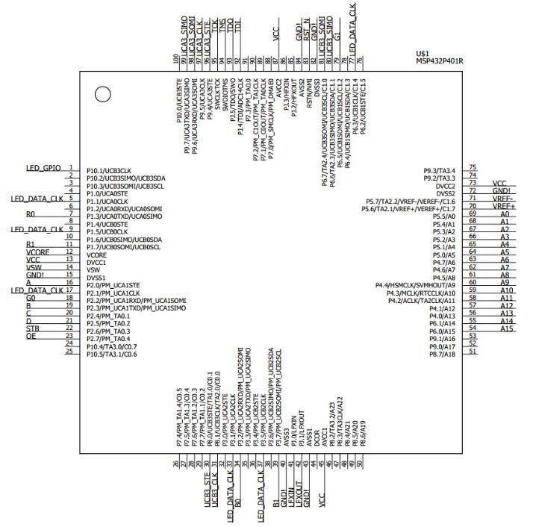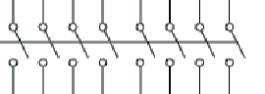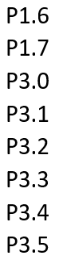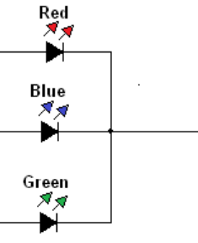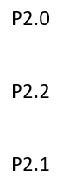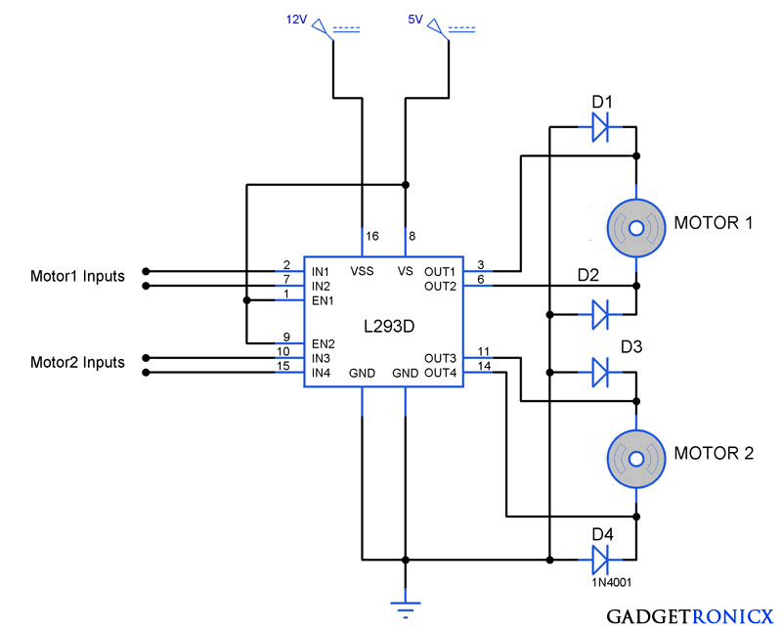

TX  
 UART  
RX

P4.0  
P4.1  
P4.2  
P4.3

P2.7  
P2.6  
P2.5  
P2.4