**File/Folder Searching Using Java**

**Problem:**

Find all the user defined files/folders across the PC and give the output of the paths.

**Input:**

1. String for getting the file name from the user.

**Algorithm:**

1. Create a main class in java.
2. Get the file/folder name input from the user and store it in a string variable.
3. Get the initial directories using the File.listRoots() function and store it in a File array.
4. Using a for loop pass the directory to a recursive function that runs a loop until the directory reaches its end.
5. While the directory is running check whether the user entered string matches the filename using File.getName() method and for comparing use String.equalsIgnoreCase() method.
6. If the folder name and the string matches then get the path using File.getAbsolutePath() and store it in file.
7. For getting the file, the condition for checking must be the file must not be a directory and the file name must match the user entered string.
8. Get the file path also by using File.getAbsolutePath() and store it in a new file.
9. Finally return the path to the user where they can check for the paths found for the matching keyword.

**Output:**

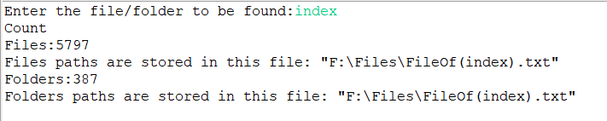

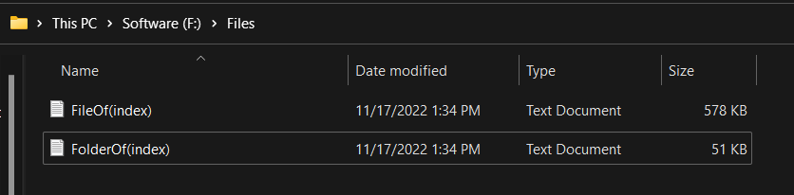

Files are attached in \File Path Documentation\Output folder.