Our submission contains 3 files LCS_BF.py, LCS_DP.py, and LCS_DP_CB.py. 2 text files LCS1.txt and LCS2. We have written our code in python version 3.7.6. We have ran our code using “Spyder” IDE. We have attached a screenshot on how to run the code. Please click the run button as shown below.

Note: In the 3 code files that we have submitted and we are taking inputs from the file for which we have mentioned the path that is there in our local system. Please make sure to change the path according to your system while executing the code.

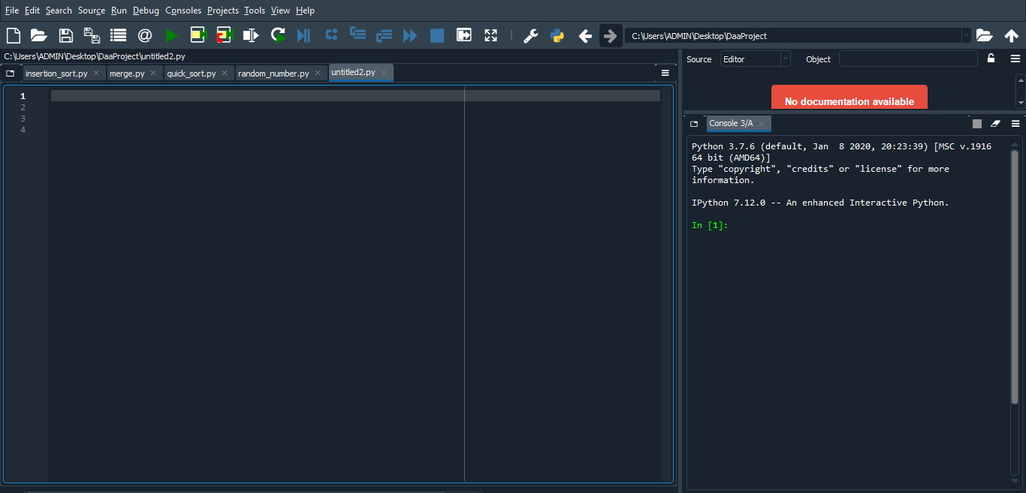
Python 3.7.6 (default, Jan 8 2020, 20:23:39) [MSC v.1916 64 bit (AMD64)]
IPython 7.12.0 -- An enhanced Interactive Python.

