Our submission contains 3 files insertionsort.py, mergesort.py, and quicksort.py. A random.py program that generates 4 data files named arr20.txt, arr100.txt, arr1000.txt, and arr4000.txt. We have written our code in python version 3.7.6. We have ran our code using “Spyder” IDE. We have attached a screenshot on how to run the code. Please click the run button as shown below.
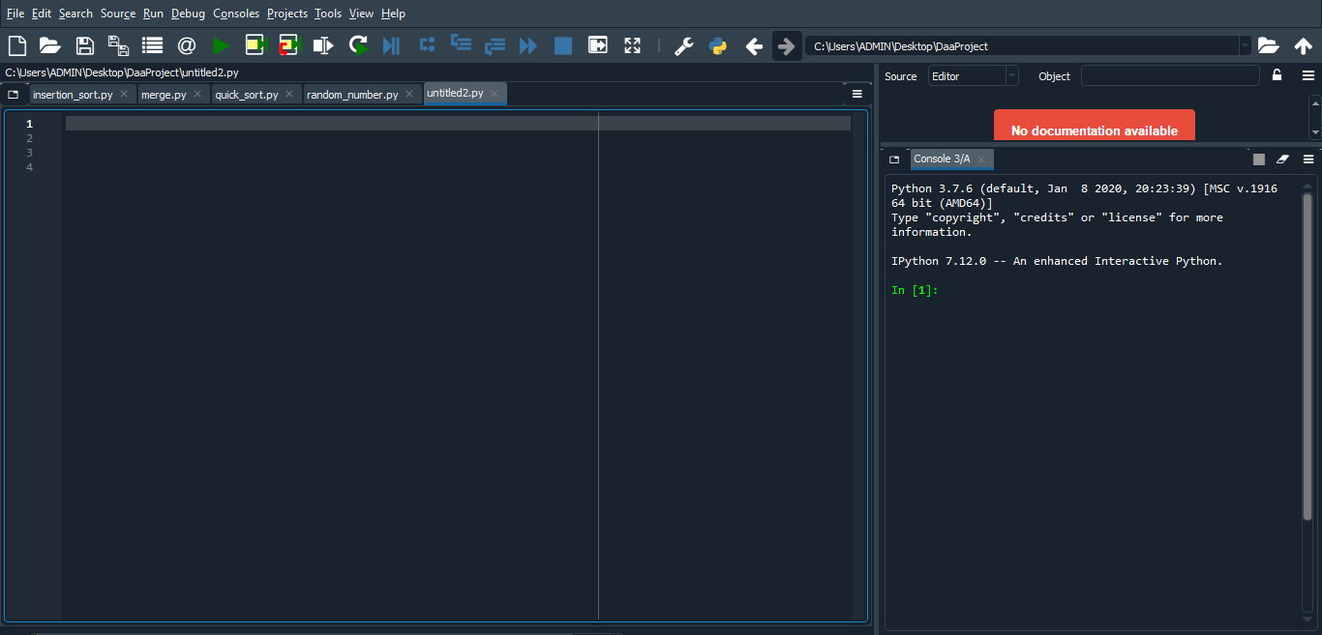
Python 3.7.6 (default, Jan 8 2020, 20:23:39) [MSC v.1916 64 bit (AMD64)]
IPython 7.12.0 -- An enhanced Interactive Python.

Note: In the 3 code files that we have submitted and the file that creates the list of random variables, we have mentioned the path that is there in our local system. Please make sure to change the path while executing the code.

