References

https://www.geeksforgeeks.org/timeit-python-examples/
https://www.geeksforgeeks.org/insertion-sort/
https://www.geeksforgeeks.org/merge-sort/
https://www.geeksforgeeks.org/quick-sort/

Time complexity of each of the algorithm

Sorting Algorithm
Insertion sort: | Best case: O (n) | Worst case: (N^2)
Merge sort: | Best case: O (n* log n) | Worst case: O (n)
Quick Sort: | Best Case: O (n*log n) | Worst Case: O (n^2)

Experimental results (time it takes for algorithm to sort 4 integer arrays of varying lengths).
The time taken for insertion sort to sort 20 elements is

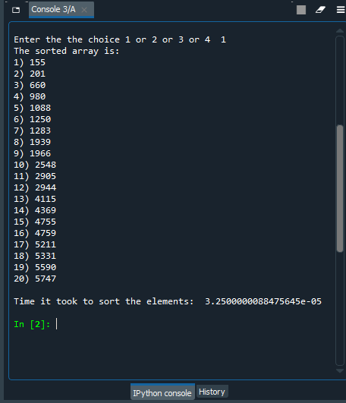

The time taken for insertion sort to sort 100 elements is

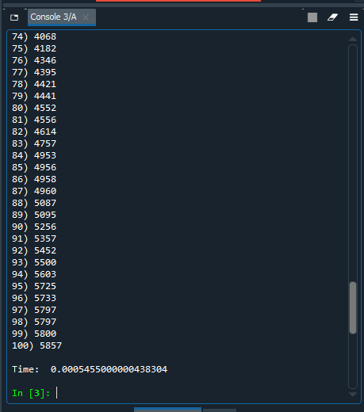

The time taken for insertion sort to sort 1000 elements is

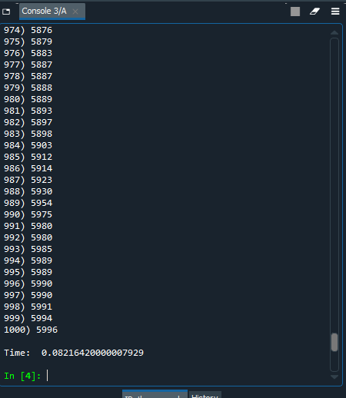
The time taken for insertion sort to sort 4000 elements is

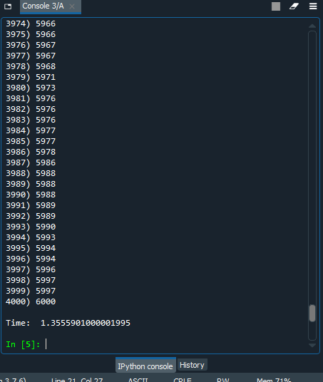

The time taken for Merge sort to sort 20 elements is

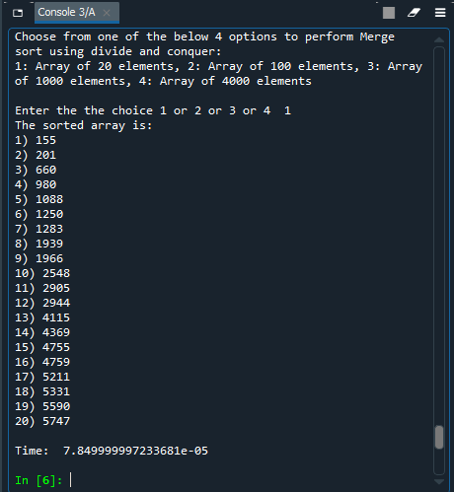

The time taken for Merge sort to sort 100 elements is

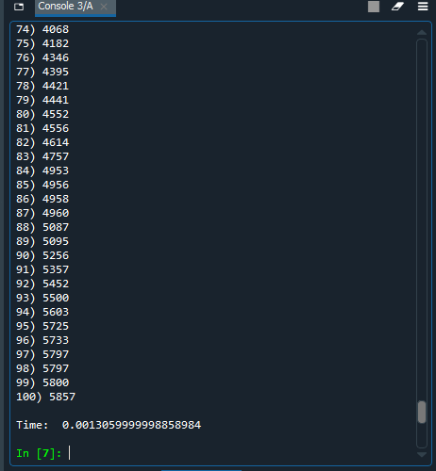
The time taken for Merge sort to sort 1000 elements is

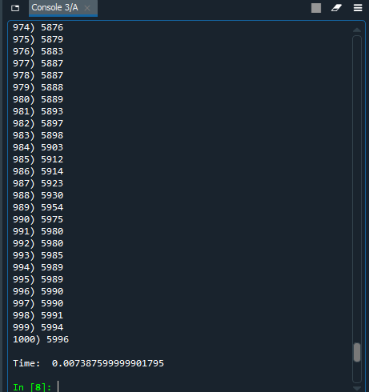
The time taken for Merge sort to sort 4000 elements is

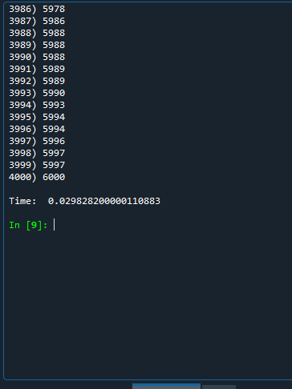

The time taken for Quick sort to sort 20 elements is

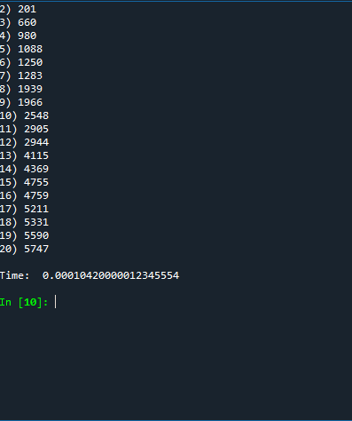
The time taken for Quick sort to sort 100 elements is

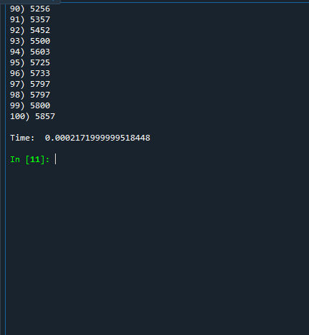
The time taken for Quick sort to sort 1000 elements is

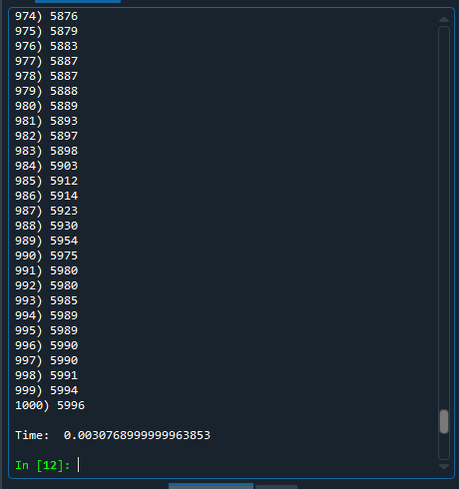
The time taken for Quick sort to sort 4000 elements is

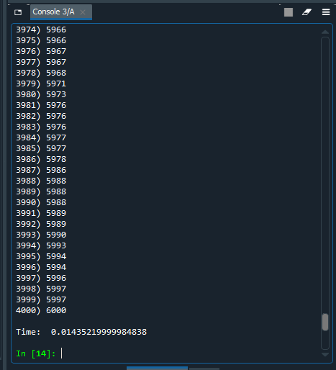

Experimental and Theoretical Results with Anomalies

SORTING ALGORITHM NAME | TEXT FILE WITH 20 ELEMENTS | TEXT FILE WITH 100 ELEMENTS | TEXT FILE WITH 1000 ELEMENTS | TEXT FILE WITH 4000 ELEMENTS
INSERTION SORT | 3.35*e^-5 which is approximately 0.021 | 0.0005 | 0.08 | 1.35
MERGE SORT | 7.8* e^-55 which is approximately 0.052 | 0.013 | 0.007 | 0.02
QUICK SORT | 0.0010 | 0.00021 | 0.0030 | 0.1435
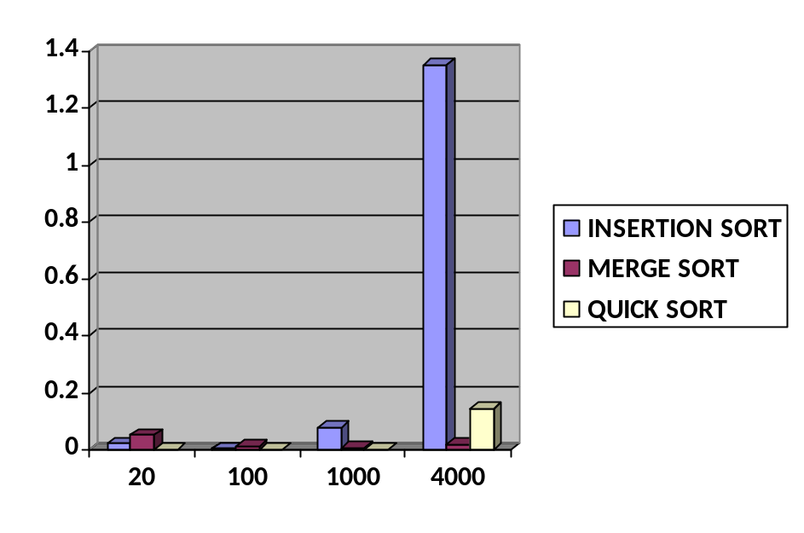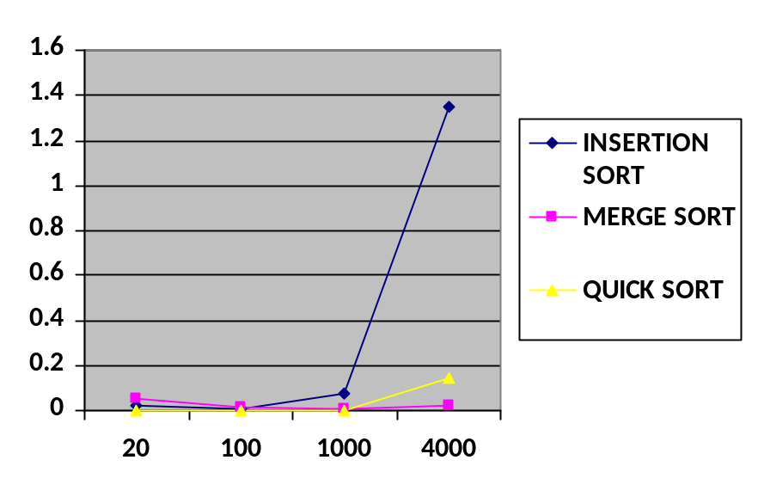
We have tried plotting the time complexities we got using a line and bar graph for visualization purpose. We can infer a few things:

1. As number of element increases, the time increases for all 3 algorithm.
2. Merge sort takes more time if there are lesser elements and it performs well if there are more elements
3. Insertion sort becomes worse with increase in number of elements
4. We do know that all 3 has their own best and worst case complexities. Depending on the dataset and implementation code our complexities are bound to vary.

List of 4 arrays used in the experiments
20:
[5590, 5211, 1250, 1283, 201, 1088, 1966, 4755, 2548, 660, 155, 4759, 5331, 4369, 5747, 4115, 2905, 2944, 980, 1939]

100:
[5357, 2726, 5797, 5857, 2604, 4346, 4395, 4953, 1440, 4552, 2776, 2965, 3107, 899, 5725, 4960, 5087, 2213, 637, 4066, 9, 725, 4956, 2029, 2925, 3285, 2398, 3142, 1370, 360, 4182, 5797, 5095, 1160, 824, 3093, 964, 3019, 3835, 603, 73, 3172, 2460, 663, 211, 2763, 263, 1583, 4026, 3453, 4421, 3124, 1092, 5500, 4614, 1819, 881, 2327, 3329, 2704, 1996, 3616, 1232, 2535, 3686, 2715, 658, 5800, 808, 4441, 2147, 927, 28, 1176, 4556, 704, 681, 330, 1022, 5603, 3746, 5452, 3814, 3148, 5733, 2269, 845, 2358, 4036, 2979, 1997, 2301, 1861, 5256, 2217, 4068, 3439, 3191, 4958, 4757]

1000:
[4063, 2830, 1957, 3885, 1559, 4912, 169, 5492, 1441, 5412, 2856, 1123, 4271, 4543, 2195, 3135, 922, 5004, 4391, 2683, 2417, 3404, 2515, 2838, 1075, 2643, 55, 2140, 4871, 864, 2563, 884, 2762, 2627, 3264, 5110, 2962, 5449, 4054, 2955, 5066, 3336, 4203, 4607, 711, 4448, 2325, 949, 5746, 4760, 5432, 2846, 5364, 5194, 1634, 4765, 2177, 5663, 1583, 2692, 5980, 2537, 944, 2181, 1705, 231, 3723, 5770, 3357, 3047, 1219, 3244, 4404, 1839, 645, 2210, 2316, 1401, 2409, 4160, 4337, 1105, 5237, 899, 2073, 4191, 5841, 2721, 3601, 1188, 2674, 1267, 3726, 5888, 3493, 4740, 3503, 3669, 1297, 3974, 2489, 5187, 2937, 3385, 5150, 2762, 4863, 4015, 3737, 174, 3271, 4592, 785, 194, 4319, 1577, 1639, 5553, 5545, 786, 2782, 4085, 952, 5387, 1760, 1629, 2139, 5797, 2853, 4294, 306, 4079, 1108, 452, 2666, 4867, 4501, 4196, 3182, 1886, 5227, 5654, 2959, 2898, 4852, 3258, 4026, 4971, 1380, 21, 3157, 2491, 1709, 4012, 3002, 4017, 3372, 862, 1793, 3641, 5155, 5762, 1153, 1723, 964, 801, 3279, 5231, 527, 4411, 5213, 2598, 162, 992, 3993, 1945, 1626, 5893, 4495, 4585, 2708, 4284, 4115, 700, 3824, 2414, 5782, 5592, 2237, 4138, 2707, 1303, 1183, 4657, 3343, 2458, 2219, 738, 888, 3097, 4992, 2030, 5796, 5582, 1268, 2970, 3869, 1509, 2869, 1573, 2013, 4892, 5297, 482, 5248, 3207, 3976, 2392, 101, 2326, 2743, 3821, 3803, 5623, 1820, 1005, 4340, 5764, 4554, 2629, 84, 1825, 3640, 2268, 1007, 871, 5557, 2714, 1821, 3389, 99, 2110, 2835, 1509, 4705, 3428, 3137, 4992, 4929, 781, 3821, 3933, 1923, 1649, 3587, 5165, 4408, 5914, 2836, 2768, 4602, 284, 615, 2842, 4742, 1948, 5532, 922, 226, 1132, 444, 5396, 4640, 5802, 3125, 1300, 2091, 645, 1608, 2299, 2668, 5989, 5821, 2451, 93, 2679, 5121, 3959, 2271, 5912, 3496, 904, 3050, 4954, 523, 2373, 5887, 2967, 692, 1017, 235, 208, 5608, 5337, 3627, 3985, 4610, 4824, 1049, 1687, 644, 1241, 3285, 5178, 1064, 1126, 5994, 4039, 1977, 1189, 5217, 4118, 2754, 1974, 4494, 1566, 5221, 3606, 1491, 896, 2018, 1130, 452, 1008, 5212, 3058, 672, 5985, 5155, 4867, 3297, 5876, 4161, 4700, 3038, 4632, 2367, 2623, 38, 3431, 4519, 2374, 5493, 4639, 4803, 3242, 103, 2578, 685, 5132, 3313, 4171, 5887, 2196, 508, 5396, 2967, 3793, 4468, 4842, 2756, 2365, 2278, 9, 540, 323, 5897, 832, 4125, 1109, 3689, 2110, 3377, 446, 4005, 554, 2299, 3265, 888, 5695, 2210, 4153, 1083, 2272, 2769, 2377, 5683, 1418, 1412, 4376, 5284, 5862, 5990, 685, 3168, 3640, 5508, 2669, 1814, 5104, 1071, 2894, 5708, 1261, 2591, 2867, 5572, 5038, 1869, 5079, 1402, 1537, 1481, 103, 1702, 3111, 4685, 553, 99, 2092, 1295, 5883, 2212, 3353, 5102, 5542, 3728, 2150, 69, 5263, 1580, 3754, 1692, 4922, 532, 5802, 4251, 3234, 3701, 2285, 67, 4075, 5212, 2079, 1162, 2160, 616, 4690, 5630, 2530, 4448, 5254, 1253, 2049, 397, 5412, 564, 4972, 2995, 3458, 2086, 277, 4729, 1255, 1893, 5268, 4524, 973, 1439, 5087, 5980, 1149, 3135, 416, 2783, 2425, 3209, 567, 5343, 3643, 2698, 782, 2653, 4983, 5348, 246, 1213, 2962, 4394, 1190, 3318, 5803, 4617, 1893, 3035, 4564, 984, 5311, 1764, 296, 1413, 3522, 5018, 3302, 3425, 692, 4069, 1375, 1232, 3364, 1170, 1127, 449, 3606, 4807, 1560, 4796, 5509, 3884, 2716, 588, 1366, 276, 3639, 1794, 4149, 1319, 3597, 5158, 3821, 3338, 3252, 3915, 3730, 1670, 4424, 3905, 3801, 5476, 4697, 4257, 2436, 2187, 1482, 872, 5595, 851, 4247, 1989, 5386, 4019, 2676, 5975, 5371, 2923, 230, 399, 3945, 5687, 4218, 3208, 1207, 1864, 5440, 4877, 5879, 5318, 5989, 5505, 5833, 2171, 1743, 3229, 4451, 1039, 4104, 5085, 4436, 5248, 1434, 5344, 3283, 3706, 2068, 5684, 56, 365, 1579, 2963, 5559, 3063, 1044, 2436, 2975, 1032, 2171, 2232, 2598, 4113, 588, 2137, 4585, 2696, 473, 4816, 691, 3809, 4502, 3748, 3339, 3315, 1470, 2341, 1485, 3488, 5567, 164, 1413, 1121, 2752, 2072, 5930, 4801, 2543, 5506, 5637, 173, 1864, 4959, 3835, 1795, 1075, 4200, 3843, 1641, 418, 3276, 3192, 4592, 4416, 5156, 3276, 1453, 5889, 1434, 4600, 4072, 4409, 4060, 3762, 4907, 1660, 2420, 1319, 1290, 843, 214, 2655, 4479, 1927, 5954, 3865, 4594, 4029, 672, 5254, 4418, 5209, 5803, 2032, 3027, 5778, 5179, 5098, 1673, 3595, 646, 1616, 5203, 1508, 2466, 937, 1918, 3715, 646, 4668, 4636, 1958, 5193, 5996, 402, 5729, 3591, 3824, 2776, 1800, 4818, 2863, 257, 5575, 5652, 4999, 371, 5097, 5437, 5991, 4597, 543, 4936, 1315, 5162, 3245, 5654, 4881, 2288, 3496, 4286, 214, 4185, 2122, 1638, 4853, 3564, 4535, 800, 4054, 333, 5161, 1904, 5388, 3501, 445, 403, 5238, 5025, 2110, 4770, 5990, 4259, 3852, 119, 2080, 4143, 3576, 4883, 3793, 4340, 1238, 1593, 4086, 1383, 65, 5240, 1756, 2122, 1802, 3696, 632, 5650, 288, 1083, 4698, 4791, 1425, 1903, 2931, 983, 2430, 3546, 2161, 5009, 1064, 1248, 2204, 847, 2104, 5865, 3298, 790, 5265, 1969, 2210, 5729, 3795, 4745, 1148, 939, 1698, 4030, 111, 4951, 2427, 2714, 3719, 3076, 2577, 4138, 2134, 3881, 1695, 3198, 4687, 1723, 2188, 4181, 3848, 4822, 3662, 4914, 370, 4372, 3883, 5547, 4607, 153, 4322, 2156, 5018, 1327, 4872, 5697, 5923, 2840, 1962, 5320, 1026, 3132, 5211, 4650, 4676, 5552, 5019, 1813, 5060, 1358, 4750, 5693, 1947, 1722, 4690, 2467, 2757, 2477, 2730, 2336, 2523, 472, 827, 4854, 4735, 3684, 3211, 3756, 2731, 2438, 796, 4908, 5519, 3405, 5337, 2020, 5105, 3603, 4606, 1157, 4545, 1507, 3741, 1576, 1464, 1945, 3582, 3109, 2735, 1696, 4829, 3530, 3742, 1095, 3911, 5135, 1431, 1451, 2436, 5564, 5736, 5656, 755, 4916, 218, 4910, 751, 3496, 1094, 3186, 3462, 527, 5898, 2478, 2865, 3634, 3938, 4639, 4108, 4245, 2749, 2363, 2360, 445, 5318, 3399, 3910, 995, 3494, 2640, 3615, 1282, 489, 1441, 369, 1485, 4880, 5903, 1880, 1394, 5295, 3082, 1131, 1483, 5546, 1817, 3313, 5417, 140, 4307, 4819, 1399, 4651, 2571, 3391, 5270, 1119, 4782, 1120, 5222, 5401, 1006, 2981, 322, 1795, 4807, 869, 2470, 380, 3069, 298, 2122, 1538, 3986, 1276, 2776, 4919, 1258, 2044, 4361, 2202, 2598, 3870, 828, 5577, 372, 5139, 577, 313, 3996, 2972, 4699, 4515, 1883, 2348, 327, 4362, 4044, 5537, 971, 2303, 72, 4565, 5127, 3754]

4000:

[4013, 2478, 5142, 5390, 4856, 4385, 5133, 4176, 4229, 2416, 1742, 135, 2930, 2056, 2806, 5027, 3517, 5559, 590, 4203, 1953, 2647, 4337, 1994, 5411, 3189, 5294, 4232, 4048, 2984, 2081, 79, 1768, 3896, 5986, 3604, 506, 3895, 5380, 4011, 2255, 4083, 130, 892, 823, 3905, 5760, 2739, 5864, 4665, 5448, 5301, 3861, 4511, 3464, 3002, 246, 2818, 4688, 1072, 562, 4126, 342, 2536, 4174, 1465, 637, 2415, 3443, 1647, 703, 814, 1080, 98, 4140, 3312, 5923, 1918, 1612, 4702, 5393, 1071, 2722, 342, 2152, 262, 581, 2183, 2826, 3826, 5016, 2833, 5869, 1487, 4817, 4408, 1682, 197, 3395, 3274, 3933, 3808, 1762, 2673, 2322, 3141, 1606, 96, 3643, 4144, 4376, 5370, 1101, 5506, 165, 2208, 5453, 773, 4150, 2926, 5383, 964, 211, 1860, 1065, 2271, 5357, 4513, 122, 3063, 42, 1096, 5090, 5407, 871, 5784, 4489, 2928, 1135, 3883, 4729, 4793, 2732, 3690, 65, 4929, 2503, 3771, 5013, 4453, 971, 3643, 5962, 1139, 2129, 526, 364, 3814, 5445, 209, 2020, 2218, 4081, 4834, 506, 1828, 5659, 5087, 3833, 4457, 1829, 4457, 733, 2608, 5231, 1062, 5642, 2083, 5925, 1815, 124, 2223, 4461, 1309, 5735, 1760, 3813, 3, 4191, 3226, 5419, 2374, 5228, 1522, 3101, 4869, 2320, 5456, 2777, 2010, 4227, 3804, 1929, 4091, 3660, 3183, 1778, 5231, 4578, 5171, 2369, 1431, 4319, 3570, 3745, 3033, 4565, 2257, 593, 536, 1982, 2917, 5349, 2740, 3179, 695, 3402, 3711, 1302, 2880, 698, 3604, 3191, 5108, 3873, 2350, 4952, 3883, 4415, 3424, 5767, 5303, 5750, 434, 2048, 897, 674, 4226, 1156, 5820, 2545, 3301, 4814, 4529, 1440, 3329, 3260, 3734, 399, 917, 4612, 3095, 2394, 3701, 777, 974, 4548, 2401, 294, 2389, 4964, 4635, 3752, 28, 891, 5299, 3070, 134, 5994, 1168, 1873, 1721, 3882, 1997, 864, 896, 4093, 2955, 4548, 4989, 3168, 2213, 2472, 2106, 2805, 1682, 5358, 384, 1442, 2681, 3707, 785, 5450, 553, 840, 3006, 3200, 5627, 2675, 3336, 5633, 4289, 4685, 4010, 1512, 3574, 1213, 2693, 5254, 3686, 1839, 115, 3765, 2265, 4691, 994, 3111, 1684, 4907, 4741, 3982, 4202, 4909, 2473, 1083, 5612, 4763, 3205, 2866, 308, 5611, 5019, 3799, 4339, 2849, 3068, 4816, 5293, 406, 161, 2450, 1623, 5685, 4333, 4135, 3660, 2849, 2984, 111, 1193, 5459, 1462, 885, 2662, 5642, 5016, 5670, 4772, 1564, 2797, 5369, 4581, 3025, 5893, 1719, 1972, 3716, 2791, 5750, 5742, 5712, 2871, 1211, 5309, 1999, 670, 1189, 4370, 3571, 4001, 4714, 3959, 3048, 4561, 2076, 5741, 723, 3023, 4600, 2868, 4671, 1565, 1670, 3917, 4287, 2358, 3895, 25, 2701, 188, 419, 2298, 3294, 2135, 1237, 825, 1916, 2160, 245, 3224, 4824, 4801, 5066, 5113, 1597, 4460, 5695, 1581, 4409, 3380, 4177, 1790, 5107, 3429, 3014, 4134, 4900, 5624, 3637, 1710, 44, 3999, 2514, 592, 2415, 4090, 3386, 4952, 1500, 1512, 3670, 5542, 4494, 4984, 2141, 4036, 3962, 3013, 2223, 3990, 2628, 2029, 4863, 1807, 5362, 1872, 554, 5928, 2739, 5164, 1545, 4359, 2817, 2408, 5962, 3924, 443, 1315, 5511, 1788, 2068, 715, 5054, 1933, 2607, 424, 1693, 4694, 3912, 3029, 4383, 5968, 1476, 678, 1325, 421, 2299, 3072, 1620, 2817, 235, 562, 4163, 2070, 139, 4311, 4362, 5626, 472, 3585, 348, 3175, 4160, 2828, 104, 5870, 3098, 5029, 1957, 3016, 5567, 5043, 2645, 2815, 5921, 209, 3648, 720, 1067, 2926, 3151, 4146, 1492, 2444, 3877, 1359, 5939, 2272, 5320, 2164, 2366, 653, 1663, 5506, 3997, 1427, 931, 2394, 417, 2817, 2032, 5308, 5855, 2324, 2547, 4989, 5559, 5154, 5551, 3812, 5398, 5967, 720, 3323, 937, 1374, 2854, 2270, 3699, 2236, 4261, 2066, 3659, 4774, 5190, 5535, 1497, 314, 947, 4066, 2266, 2730, 2599, 5048, 3320, 5850, 196, 4885, 5743, 937, 4787, 1967, 3458, 509, 5901, 4115, 3293, 4595, 3246, 1566, 4825, 4020, 4632, 5459, 2654, 1825, 5545, 3946, 2030, 1620, 5973, 3115, 363, 4575, 2349, 4300, 101, 1431, 5092, 3607, 5325, 1233, 237, 2041, 1966, 3617, 1701, 754, 3526, 2514, 2122, 5835, 4186, 1215, 3254, 3212, 1307, 252, 3064, 2177, 5155, 876, 1073, 3560, 1903, 5318, 3163, 106, 1111, 24, 1773, 561, 6000, 4350, 1270, 2410, 2531, 2811, 9, 723, 1094, 1624, 5059, 554, 2723, 319, 4117, 4230, 2149, 5628, 3024, 377, 4572, 4742, 3818, 3656, 3008, 4948, 5063, 4466, 690, 3501, 666, 2645, 1486, 4072, 2749, 5649, 2240, 3885, 3699, 363, 3352, 4202, 204, 5492, 4577, 1388, 1454, 288, 3747, 2478, 2118, 2085, 2437, 508, 2304, 373, 3281, 4799, 5096, 2321, 874, 5363, 5123, 5159, 4195, 1776, 322, 5725, 408, 4834, 5948, 3305, 3932, 1912, 3314, 3219, 1959, 1497, 5398, 5694, 3783, 502, 1383, 5198, 5232, 3937, 2150, 465, 1263, 5083, 942, 3447, 5693, 2985, 2287, 1314, 4590, 3327, 1289, 352, 912, 780, 481, 1989, 5524, 2298, 1975, 47, 842, 5471, 1954, 282, 5067, 1646, 161, 2677, 5457, 753, 3461, 651, 3087, 4640, 383, 1924, 2979, 3577, 5447, 4379, 3654, 1143, 3043, 5134, 4030, 4361, 4803, 4666, 3039, 5659, 4205, 4161, 4901, 2687, 4629, 2896, 5307, 2181, 4626, 2225, 3456, 5741, 5129, 1034, 1293, 3695, 3732, 2041, 2469, 749, 1062, 5871, 3969, 3192, 4003, 673, 5438, 5828, 1888, 1361, 421, 1961, 2672, 3940, 5718, 657, 716, 3511, 5997, 3077, 1323, 4674, 1082, 3425, 2228, 3802, 1656, 1932, 1822, 5384, 193, 4496, 5220, 3655, 5079, 2537, 3042, 5945, 2113, 2523, 5958, 5054, 370, 505, 186, 4477, 3599, 472, 5722, 299, 3903, 1650, 5174, 3070, 110, 2404, 2200, 2452, 3824, 487, 771, 4267, 2476, 5707, 3220, 1345, 781, 1804, 229, 2916, 4512, 2730, 839, 1108, 4151, 881, 4284, 4871, 3642, 1181, 5437, 3089, 3349, 2228, 998, 656, 283, 1952, 1017, 1777, 3066, 1987, 1569, 4928, 3879, 3247, 2518, 2850, 2305, 5388, 320, 1139, 1115, 343, 5697, 3032, 4011, 180, 1479, 1840, 952, 3754, 5118, 4720, 1995, 5456, 3793, 5350, 3354, 499, 1700, 987, 5770, 2657, 72, 749, 526, 599, 186, 5976, 309, 5420, 3867, 3132, 3364, 2342, 64, 1931, 4630, 5687, 933, 4494, 474, 3, 5767, 903, 1583, 538, 3865, 3423, 3128, 884, 3336, 1277, 4452, 2429, 667, 40, 4839, 5436, 3937, 5219, 3382, 1062, 3747, 2987, 4708, 1382, 5818, 4001, 2059, 2412, 5924, 1236, 101, 5048, 5459, 2099, 5212, 1420, 3479, 1342, 2974, 1820, 3768, 1947, 3173, 5428, 2111, 4449, 1631, 546, 4134, 3402, 2690, 2606, 596, 2540, 745, 1852, 1395, 611, 2824, 1957, 1240, 2935, 3537, 5523, 640, 1231, 5143, 3672, 5529, 2880, 60, 2075, 2571, 2080, 1820, 3582, 4831, 2565, 2477, 5375, 2712, 4640, 2816, 812, 2128, 5109, 4682, 3184, 1703, 529, 1602, 719, 1861, 2134, 5404, 4171, 4674, 5267, 2014, 5402, 2862, 5790, 3882, 385, 3163, 4630, 2683, 4134, 1453, 1636, 2387, 1890, 4909, 5100, 2968, 1751, 4800, 3438, 5624, 2165, 5811, 2869, 4165, 4454, 2216, 5259, 2760, 4422, 3567, 1466, 4025, 4256, 1819, 1967, 5617, 590, 1702, 1435, 4160, 5412, 2721, 5477, 862, 1357, 5358, 3639, 4145, 928, 263, 3914, 2925, 2666, 3862, 3978, 1697, 1890, 1173, 94, 3073, 492, 2740, 3332, 5102, 2763, 4025, 4998, 2661, 4601, 4147, 181, 3204, 641, 2801, 381, 2093, 3999, 2672, 3527, 3442, 4284, 3777, 905, 4204, 1769, 2509, 5762, 1410, 1015, 3053, 1192, 5499, 339, 2815, 4182, 3844, 840, 3061, 3071, 2571, 984, 2117, 3648, 3745, 581, 659, 690, 4626, 5611, 4199, 938, 3634, 3849, 1842, 2314, 4408, 4675, 1785, 1746, 4150, 1697, 1809, 5919, 179, 4069, 388, 3192, 2774, 298, 4815, 3784, 1794, 2171, 4024, 3320, 1533, 1356, 5262, 4438, 2647, 4781, 5337, 3230, 2390, 5681, 4813, 2495, 4926, 4060, 3391, 520, 1857, 3323, 4885, 4303, 4775, 533, 549, 5949, 4191, 3533, 3057, 5762, 5233, 4324, 3558, 3860, 97, 197, 5884, 1458, 2353, 3159, 4586, 3494, 518, 3453, 1443, 1066, 388, 4150, 2593, 4659, 2923, 144, 3083, 618, 5494, 4060, 4831, 5639, 4475, 4485, 1510, 5323, 4482, 5063, 2941, 297, 3367, 35, 1564, 2654, 98, 2254, 1854, 2423, 668, 2473, 1977, 3806, 5431, 172, 2461, 1229, 2878, 2641, 3788, 3826, 3304, 2410, 5640, 922, 3451, 4124, 1613, 2786, 1629, 5282, 4131, 2704, 2527, 2693, 1375, 2557, 3466, 193, 512, 3830, 2339, 4871, 2974, 2315, 650, 154, 1183, 1709, 2143, 2238, 2524, 3684, 3629, 2202, 4747, 479, 3612, 4996, 1553, 2444, 5869, 3536, 5394, 1428, 933, 214, 3225, 2465, 213, 1604, 224, 2440, 3620, 4360, 964, 1497, 1869, 3821, 1239, 4869, 3603, 5167, 61, 4851, 3487, 1356, 3806, 1579, 5616, 1061, 2886, 5799, 967, 5128, 225, 5545, 4736, 2826, 5439, 1639, 205, 4133, 4140, 4105, 3460, 2622, 926, 2709, 2466, 5611, 1608, 4233, 2474, 2501, 3232, 576, 5802, 5327, 45, 5935, 1401, 1911, 1970, 474, 261, 308, 2837, 5976, 1145, 1857, 1068, 5287, 1603, 3127, 3187, 2683, 1398, 532, 1040, 5211, 1887, 449, 5691, 2209, 3416, 693, 175, 208, 5610, 3212, 5429, 4897, 374, 1208, 2231, 3183, 3159, 2861, 4552, 2423, 5300, 1317, 5176, 142, 5967, 4578, 5390, 1612, 2861, 4993, 1966, 4366, 5035, 3338, 3676, 5183, 3212, 4908, 3156, 1423, 4682, 1326, 2331, 894, 2712, 1651, 1715, 781, 678, 925, 4806, 2151, 870, 5293, 1034, 5801, 403, 2224, 721, 631, 2953, 360, 5641, 3778, 4764, 1681, 3019, 555, 3498, 2874, 3858, 5292, 966, 1495, 739, 1262, 1837, 2360, 4931, 180, 1, 5334, 593, 282, 5990, 5314, 2433, 525, 1067, 290, 334, 128, 601, 1751, 1710, 4625, 1726, 2374, 482, 5259, 5871, 456, 1075, 3319, 1550, 381, 1702, 5215, 534, 4532, 3902, 4489, 406, 1268, 4862, 1362, 5903, 345, 5854, 3378, 4146, 2630, 2125, 3118, 2676, 1754, 4935, 5084, 2650, 4669, 4975, 1330, 3981, 5372, 3865, 3428, 5400, 811, 1371, 2096, 812, 4485, 3034, 1728, 5132, 4835, 5236, 3475, 2643, 4584, 3294, 1090, 152, 3714, 4498, 2466, 5775, 1922, 2763, 4656, 4949, 4114, 4119, 3233, 1973, 1242, 1114, 5966, 4243, 4504, 1927, 4383, 5287, 2822, 4991, 5204, 196, 3381, 3743, 5357, 4671, 1177, 3104, 615, 1269, 2938, 2446, 1478, 3277, 2792, 5521, 2985, 5102, 5716, 5523, 2027, 4339, 5936, 4770, 4650, 3376, 4871, 5664, 2587, 2210, 3098, 691, 1496, 4809, 5961, 4408, 829, 3637, 2854, 3233, 4985, 1207, 1276, 1354, 177, 4709, 4049, 4720, 4469, 2628, 4677, 4247, 4673, 5469, 5928, 4107, 4082, 4774, 4085, 2560, 4617, 1553, 3365, 4882, 2737, 1379, 5629, 174, 3350, 5650, 3443, 1934, 2227, 5304, 1358, 2261, 3224, 1282, 3596, 3408, 5952, 1120, 150, 3323, 3033, 277, 4281, 4657, 3510, 348, 4406, 490, 4387, 3308, 5723, 1789, 5751, 1315, 3826, 4874, 5677, 3522, 531, 456, 5172, 5933, 297, 5569, 721, 1662, 4068, 4426, 1611, 2508, 1898, 5322, 5539, 4405, 892, 2560, 5809, 4105, 1837, 426, 3018, 2738, 4551, 3091, 4901, 3002, 1740, 2407, 4, 1379, 3338, 1977, 5901, 2334, 3808, 5003, 2211, 4834, 5847, 5488, 497, 4729, 5939, 588, 5837, 4550, 438, 4432, 5564, 4125, 4932, 2979, 3660, 2838, 1800, 401, 570, 5306, 94, 4837, 5432, 3269, 133, 3113, 4372, 139, 1149, 2315, 800, 1403, 722, 3144, 1612, 1492, 1445, 4372, 282, 5925, 3109, 201, 5951, 983, 4114, 1749, 1831, 1287, 5787, 5577, 4707, 4504, 3202, 4483, 5806, 5765, 1503, 1707, 4641, 1153, 594, 160, 1821, 2936, 2531, 2658, 3423, 367, 4563, 507, 993, 1798, 3050, 2526, 4080, 5573, 1727, 3138, 1359, 150, 367, 4846, 1712, 4743, 4770, 5323, 1863, 5505, 5257, 3714, 1123, 3429, 5111, 4615, 2113, 4129, 3818, 5186, 4767, 3378, 2276, 2927, 753, 4455, 3329, 4588, 4797, 3961, 1432, 510, 4635, 2265, 5734, 87, 5959, 274, 1941, 1257, 1375, 2134, 5120, 197, 2606, 615, 1157, 4335, 1164, 3311, 3497, 2674, 4213, 1387, 494, 2886, 4805, 963, 1498, 1293, 4315, 3447, 2145, 5914, 976, 4341, 2713, 5844, 4820, 4524, 4637, 3165, 803, 3229, 2948, 1964, 1393, 1509, 3824, 1506, 1941, 5638, 2688, 3186, 3670, 4652, 436, 4927, 1847, 1276, 1478, 2450, 3573, 3988, 82, 3006, 5952, 1394, 5415, 514, 4784, 817, 3951, 2127, 3946, 293, 652, 812, 5391, 5046, 4902, 2069, 3913, 1197, 147, 5667, 5380, 3904, 602, 3087, 4584, 2280, 4653, 2781, 1305, 435, 1350, 2262, 450, 751, 3362, 5362, 3332, 3084, 1621, 614, 1735, 4859, 5685, 4670, 3803, 791, 1935, 5966, 63, 318, 1354, 2580, 5996, 4238, 2583, 1112, 3835, 5118, 1745, 4678, 1282, 4238, 238, 3060, 2238, 3956, 1314, 4589, 5359, 4827, 4223, 2936, 5993, 4054, 858, 5437, 1874, 5897, 320, 3249, 5782, 660, 462, 3598, 2188, 486, 3265, 495, 4956, 4743, 2068, 376, 361, 2148, 5020, 2663, 4575, 3962, 1058, 491, 2225, 2010, 3660, 4513, 1006, 822, 2763, 4832, 1527, 713, 3878, 4280, 3310, 3457, 3803, 3667, 3601, 27, 1617, 2943, 5289, 4744, 2857, 5130, 189, 3065, 4071, 2185, 3860, 2803, 5205, 1797, 5881, 4761, 5373, 3380, 3004, 4824, 153, 4677, 5306, 270, 1425, 5483, 2588, 342, 5817, 3132, 3146, 5764, 576, 239, 1823, 3394, 3600, 1523, 3290, 4458, 3419, 1406, 3979, 3587, 4361, 3161, 3792, 3644, 5133, 2631, 5206, 4364, 184, 1242, 2154, 4441, 1991, 2401, 5639, 18, 46, 4669, 5949, 3959, 3547, 2222, 4917, 2324, 1985, 5389, 4995, 5385, 2556, 975, 4398, 649, 5402, 3113, 4366, 3124, 1179, 2243, 4259, 756, 269, 5396, 4939, 4142, 89, 1403, 2119, 5328, 2138, 2797, 2324, 1818, 4184, 2528, 2381, 2925, 3118, 2155, 5977, 5017, 1493, 4296, 5109, 1598, 132, 3371, 4468, 334, 3538, 4800, 8, 5558, 2912, 4085, 3254, 2124, 3156, 5487, 5087, 3868, 2016, 5083, 5873, 4757, 348, 1084, 3153, 1996, 2351, 3279, 4910, 4746, 1516, 3385, 2277, 1531, 2729, 939, 4017, 5797, 1905, 681, 2519, 2664, 2298, 5881, 2858, 5737, 4529, 2867, 4886, 1333, 5395, 4975, 400, 3154, 346, 5466, 4228, 910, 5724, 3794, 5330, 646, 3702, 4947, 298, 5784, 1028, 1318, 4998, 1004, 1167, 4596, 1244, 4712, 262, 5144, 2535, 4687, 5933, 2713, 1760, 336, 3463, 1205, 3851, 2281, 3683, 1678, 5179, 914, 4412, 623, 1260, 1448, 3882, 5811, 5473, 352, 4781, 3651, 2777, 514, 750, 3127, 3151, 2856, 1313, 4281, 4429, 2414, 755, 5785, 1572, 16, 4463, 3439, 5282, 148, 2412, 4171, 845, 5933, 3855, 5123, 2695, 185, 1747, 170, 3951, 110, 2213, 2756, 143, 2264, 3892, 2604, 5192, 4604, 1702, 2695, 15, 3389, 5538, 2389, 4244, 2397, 5037, 2364, 4701, 2768, 2837, 498, 2821, 4924, 1581, 3185, 1005, 3931, 186, 3194, 1496, 242, 5398, 2851, 5920, 860, 1526, 5401, 5366, 1368, 2469, 1008, 837, 4382, 3474, 5607, 4758, 4995, 2066, 2521, 1184, 1083, 736, 1347, 5084, 4096, 1354, 1074, 5346, 1081, 5912, 1961, 5033, 4820, 2254, 3963, 755, 2623, 2573, 1997, 258, 254, 1377, 3319, 4205, 5792, 2388, 5392, 26, 5710, 4563, 1610, 2183, 3924, 1307, 2983, 2454, 1523, 1699, 3186, 4559, 4902, 5113, 2762, 3048, 2659, 2098, 254, 520, 5775, 5857, 1651, 121, 4363, 1152, 4208, 2063, 3930, 2038, 1936, 1520, 2918, 5362, 95, 3108, 617, 1250, 3074, 1839, 4861, 1617, 3642, 74, 4975, 5058, 238, 2391, 1959, 1307, 1366, 2303, 1540, 5316, 3606, 1560, 1898, 2505, 4221, 4021, 282, 1407, 5575, 2608, 1027, 2241, 1488, 2853, 4623, 4395, 2898, 2092, 1327, 828, 4037, 1700, 3485, 4084, 2789, 5163, 5961, 3669, 5010, 1722, 2130, 4523, 489, 2148, 2359, 4503, 5727, 1051, 1741, 3244, 1242, 1435, 5678, 1513, 2358, 1718, 5313, 1450, 1882, 1866, 5297, 5278, 3992, 4493, 5129, 558, 3237, 3937, 715, 2127, 5126, 5523, 5684, 4073, 5875, 32, 1961, 5233, 5791, 2877, 3373, 4256, 2307, 6, 1297, 3183, 4628, 4951, 2872, 1308, 4908, 5363, 4900, 2214, 3461, 3757, 1833, 3476, 28, 4143, 640, 760, 1571, 2982, 5047, 5612, 4041, 3077, 2336, 5869, 4017, 5176, 3247, 1342, 3307, 1784, 2058, 4303, 27, 2409, 3925, 5194, 3778, 1894, 4982, 5536, 767, 5644, 3482, 1439, 3393, 4487, 2348, 2110, 1218, 5686, 2127, 217, 22, 4546, 4285, 1414, 5672, 5792, 2899, 527, 4741, 3425, 5570, 288, 2634, 1713, 3774, 5018, 2541, 4845, 1731, 5816, 2799, 5812, 4388, 2161, 3118, 5215, 1800, 1087, 4444, 3030, 2087, 5452, 3472, 3943, 1421, 5147, 5089, 579, 2684, 5976, 1530, 4359, 3134, 3534, 5617, 4599, 4062, 4229, 800, 1140, 4897, 171, 1920, 933, 5141, 3177, 4647, 3117, 3639, 3466, 254, 1937, 2794, 1303, 1950, 228, 197, 2253, 882, 1221, 5580, 4838, 4958, 875, 2699, 4862, 5314, 4459, 5148, 3553, 3947, 2158, 255, 1396, 4261, 2778, 4868, 1540, 1850, 5542, 5474, 3153, 3821, 4623, 3026, 940, 1615, 827, 2533, 3539, 5381, 1156, 1133, 4334, 1647, 1869, 2854, 1622, 1067, 1642, 1141, 5107, 5134, 780, 2800, 1083, 4359, 2473, 5697, 5786, 2142, 3167, 4329, 3572, 1164, 3029, 3737, 1177, 5500, 353, 1073, 1778, 2775, 1590, 2035, 4203, 1738, 420, 2863, 3836, 5183, 4255, 5054, 3503, 2868, 5925, 2442, 1889, 3153, 5572, 3898, 4242, 366, 886, 332, 5092, 4278, 5350, 1029, 2260, 2724, 4382, 652, 2763, 3578, 2507, 730, 551, 2305, 5609, 4151, 264, 3301, 276, 5087, 2691, 3767, 4233, 4415, 5640, 4904, 1261, 3536, 675, 3347, 1829, 3271, 2531, 1922, 4847, 5392, 1752, 3856, 1316, 5631, 2287, 5656, 4420, 828, 3373, 4430, 4077, 3608, 2963, 3932, 4539, 3286, 4381, 3331, 1909, 3902, 756, 5390, 1845, 1481, 1636, 5694, 5380, 2708, 383, 4618, 5492, 2409, 1846, 3912, 5406, 2106, 1873, 459, 2583, 5988, 5718, 3655, 3368, 301, 5740, 5908, 1282, 3165, 2137, 497, 2323, 2961, 2445, 1064, 3890, 5808, 3558, 809, 4460, 649, 181, 263, 1539, 1335, 5223, 5988, 2517, 5747, 5712, 5123, 1030, 1425, 4484, 1473, 4145, 284, 5299, 4201, 1237, 851, 5904, 2651, 3048, 633, 2716, 5110, 2397, 5697, 1655, 3643, 104, 4770, 3082, 1426, 761, 1391, 3556, 126, 2151, 4083, 187, 4613, 1640, 331, 4921, 2170, 5336, 1132, 3369, 3484, 3699, 3741, 694, 4273, 5939, 2502, 1226, 3267, 81, 743, 1502, 4924, 1484, 4382, 2604, 5546, 1394, 2275, 5940, 1093, 4103, 1286, 1913, 451, 2032, 5870, 3246, 3479, 5400, 3409, 2824, 4688, 3358, 4121, 4723, 1028, 2782, 2176, 3352, 963, 5924, 2930, 3589, 3613, 2463, 3672, 4452, 4760, 5642, 1577, 3581, 5893, 5576, 4656, 5725, 5787, 355, 5934, 2110, 1874, 5921, 2118, 4885, 5663, 196, 1576, 2234, 1305, 2842, 3911, 2134, 1797, 1847, 5067, 1736, 2522, 205, 1675, 3577, 3057, 744, 3035, 5737, 2333, 1377, 2960, 1140, 2637, 45, 5926, 1725, 1157, 2999, 1031, 5570, 3918, 4099, 1590, 4458, 3596, 2480, 5144, 1457, 1530, 4870, 869, 5365, 4387, 877, 2506, 1531, 1069, 2908, 4535, 4159, 5365, 5017, 612, 3090, 2701, 2230, 1218, 1495, 2373, 4119, 3767, 279, 5217, 3957, 1353, 5598, 2148, 700, 5186, 5516, 5851, 2066, 1870, 2873, 4346, 4473, 4947, 3092, 5197, 4651, 4625, 3895, 5698, 5459, 3967, 4578, 1266, 3016, 5023, 4205, 4539, 1386, 3275, 5836, 4388, 2041, 4539, 1232, 5108, 2074, 814, 1720, 639, 4890, 2648, 3145, 4425, 4696, 5310, 869, 2167, 2218, 4392, 1567, 5648, 2383, 1867, 3070, 2486, 3193, 4629, 3394, 135, 957, 1866, 492, 2804, 679, 4579, 4745, 2052, 1858, 5988, 57, 199, 1901, 4363, 660, 185, 1734, 4776, 2643, 3560, 5069, 2126, 4823, 4215, 1443, 3452, 50, 362, 5299, 2968, 4350, 3538, 2900, 3148, 2263, 848, 4244, 4595, 232, 1212, 2951, 575, 373, 832, 3760, 2689, 4697, 4013, 252, 3293, 3320, 4531, 582, 5139, 584, 2871, 5784, 2937, 5578, 458, 5383, 94, 2929, 142, 3688, 4186, 5113, 948, 4190, 2090, 146, 2180, 4348, 3301, 3325, 2439, 1633, 2572, 1481, 171, 3546, 4241, 5604, 617, 4132, 2269, 1998, 5074, 5115, 4277, 1138, 478, 4765, 5901, 5379, 654, 4909, 3974, 1003, 200, 1764, 4033, 4215, 1235, 2330, 455, 2764, 2725, 5901, 3340, 1594, 5544, 3731, 2519, 3750, 513, 2, 1620, 4566, 4910, 2941, 4079, 1944, 5553, 5146, 1993, 505, 5808, 1902, 2493, 5997, 2085, 4343, 3575, 3211, 4468, 4392, 5204, 5746, 2675, 4315, 1131, 3956, 1891, 1536, 1083, 3166, 3998, 3673, 1900, 866, 2716, 1250, 4502, 1341, 5384, 1590, 3938, 70, 5150, 2652, 5169, 2465, 4243, 3744, 4571, 3663, 4742, 999, 2624, 2729, 4942, 4819, 3638, 5697, 4320, 3815, 3188, 4390, 5281, 3868, 726, 5977, 2047, 5543, 5461, 5925, 5820, 1875, 3432, 5163, 4260, 5822, 4821, 5515, 5376, 2208, 4400, 3494, 2213, 5093, 499, 4993, 4717, 4345, 5499, 3515, 5638, 936, 4857, 732, 2840, 4651, 374, 664, 3030, 3552, 3857, 5893, 774, 865, 4819, 2935, 135, 4392, 5781, 1650, 2253, 2068, 3870, 5123, 5864, 3256, 3900, 5701, 4302, 1174, 1159, 1901, 3567, 2422, 710, 1252, 1067, 2779, 407, 3064, 1436, 3257, 5106, 1595, 1066, 5152, 1377, 2482, 4886, 5989, 825, 3998, 3544, 1449, 2855, 4119, 1388, 1582, 2395, 5378, 578, 333, 1375, 878, 3189, 34, 1600, 4185, 1602, 3804, 3720, 2102, 2371, 3558, 1148, 5758, 3459, 5628, 2955, 2829, 3157, 2515, 5017, 5380, 5994, 3614, 5795, 1534, 3548, 4614, 1665, 616, 5802, 2891, 1388, 1210, 4686, 4086, 1259, 2693, 445, 2237, 4224, 5707, 2146, 2969, 5481, 5107, 2005, 2876, 4115, 1858, 4981, 5669, 3503, 4070, 4434, 379, 5271, 675, 4372, 502, 3389, 4428, 1992, 5422, 995, 4926, 486, 4650, 2039, 5328, 5774, 3079, 1234, 5030, 2974, 3285, 4952, 2983, 3518, 1389, 4805, 5767, 4883, 1090, 1873, 4911, 931, 2352, 1165, 5915, 1952, 1071, 1040, 863, 4182, 1784, 1137, 3797, 2031, 933, 289, 455, 2384, 4029, 5090, 4841, 3320, 5081, 4764, 5694, 4582, 284, 2502, 1777, 5342, 5857, 1606, 596, 5690, 4988, 2403, 1515, 1748, 5757, 5360, 4681, 1811, 5943, 2795, 3759, 4484, 2759, 4753, 1144, 3254, 684, 486, 1400, 146, 5945, 2005, 1106, 4166, 1385, 2259, 5672, 370, 3120, 2279, 374, 4231, 2360, 5775, 2172, 5076, 3956, 738, 3804, 1120, 886, 5428, 3120, 3929, 3796, 5631, 4203, 4987, 4765, 3958, 1756, 1483, 775, 3559, 1977, 2181, 3011, 3375, 3576, 1439, 5957, 3275, 4841, 4607, 3357, 3537, 698, 2571, 1459, 155, 1977, 5237, 1052, 858, 1690, 2906, 675, 4952, 1133, 1123, 1331, 3612, 5177, 3309, 589, 4924, 5015, 5793, 1209, 3235, 572, 2650, 1279, 4689, 2097, 2418, 640, 4479, 5150, 3536, 1893, 3416, 3363, 2458, 3773, 3878, 4305, 4343, 2204, 260, 1216, 2271, 5163, 4224, 924, 3448, 1029, 3825, 989, 4714, 1850, 5038, 2050, 5272, 380, 4670, 2994, 1911, 3682, 1078, 4317, 1610, 4555, 5912, 1506, 2923, 3110, 1498, 1625, 765, 4973, 2099, 457, 4438, 1975, 1299, 4860, 1219, 3363, 5586, 3296, 709, 1973, 4201, 3461, 3995, 1238, 4371, 1413, 2637, 4621, 4448, 1568, 5443, 2872, 5276, 2015, 5471, 685, 1909, 4388, 822, 3946, 422, 2293, 5056, 967, 1442, 4253, 5960, 5475, 2036, 2642, 2648, 2014, 3786, 5891, 3601, 1647, 3882, 2061, 4214, 1936, 14, 2643, 4678, 4302, 5353, 2693, 409, 1558, 1212, 2633, 4212, 2124, 5178, 309, 2150, 5783, 1934, 2496, 1425, 4588, 4848, 2157, 1797, 805, 2563, 3, 2050, 3563, 4411, 5051, 4210, 3688, 2711, 5150, 999, 4760, 455, 2466, 3957, 1695, 2662, 5091, 3540, 106, 4741, 1413, 3024, 957, 5920, 5607, 5026, 1905, 3466, 2092, 4157, 4221, 303, 4588, 1689, 1252, 2610, 3783, 3100, 5843, 4446, 4852, 2502, 1433, 3713, 2112, 2665, 542, 4923, 925, 1823, 1413, 3759, 4362, 532, 3991, 1727, 4113, 4814, 2809, 3406, 3509, 3099, 5334, 4568, 890, 2953, 1620, 3861, 1617, 2258, 3043, 5616, 1608, 2940, 3992, 3751, 3271, 1587, 269, 3120, 4084, 2999, 2545, 415, 4783, 804, 3746, 4949, 1673, 5559, 3379, 1653, 1784, 2218, 3419, 4842, 999, 5244, 4830, 849, 2244, 3725, 5326, 1885, 3722, 1362, 951, 4099, 1234, 2586, 3512, 510, 5920, 5301, 4052, 5309, 5334, 4492, 775, 5066, 3804, 701, 996, 149, 5569, 1087, 5510, 4835, 822, 2862, 3170, 5978, 1498, 26, 1566, 201, 1881, 953, 4337, 734, 3794, 290, 3875, 1595, 732, 4180, 896, 5989, 5069, 1853, 1648, 5100, 4709, 2545, 3501, 599, 2425, 3418, 158, 3531, 1237, 2197, 3574, 5489, 5720, 3593, 4872, 4691, 4439, 238, 4731, 5871, 1592, 3165, 5626, 5202, 2902, 5971, 1227, 4636, 1431, 2797, 2912, 2754, 4169, 1074, 5751, 1532, 4404, 5893, 776, 2707, 5732, 5050, 2561, 5067, 5241, 3868, 4354, 2273, 4413, 3854, 3636, 3790, 3204, 4710, 5267, 2602, 2348, 2432, 2254, 2196, 5474, 4474, 1257, 2445, 395, 1265, 510, 2257, 3327, 338, 3257, 4677, 926, 4087, 5486, 2955, 2575, 1750, 3786, 56, 4473, 1957, 5823, 1603, 3501, 3434, 2503, 5513, 2055, 4856, 4030, 3468, 2464, 4946, 2915, 4383, 2432, 2531, 3187, 778, 3538, 579, 1972, 2371, 1103, 1210, 891, 5388, 1583, 3506, 1297, 5399, 3643, 1926, 4559, 3152, 511, 976, 5616, 4522, 2319, 1417, 826, 5954, 654, 343, 2447, 2675, 4951, 3809, 772, 2856, 2873, 1712, 3098, 1398, 5376, 4427, 2520, 3473, 4106, 4094, 3150, 2908, 2230, 2509, 1684, 1216, 2255, 4114, 1830, 5577, 2693, 2828, 1768, 3502, 1149, 4356, 729, 841, 3023, 698, 2505, 2796, 3255, 5823, 4561, 1071, 1064, 4179, 4934, 2691, 2233, 363, 2991, 2096, 1275, 983, 4782, 1236, 1927, 4675, 3275, 4126, 4982, 4639, 3130, 1489, 885, 3256, 2729, 5694, 1114, 2590, 2714, 4676, 5149, 2153, 776, 1951, 1679, 5125, 4608, 3272, 14, 4382, 2689, 3974, 5927, 1200, 3501, 215, 398, 5559, 1958, 2239, 4669, 3665, 4164, 4346, 2785, 2451, 3072, 63, 647, 5937, 3299, 1624, 3850, 253, 1609, 2951, 1234, 5932, 463, 320, 2516, 5170, 1033, 2643, 3885, 4764, 3745, 5047, 681, 2613, 4891, 1475, 5072, 4121, 5420, 3700, 3121, 3041, 1481]

Honor code

