ASW Phase-1

Steps 1: Load the Excel into application. Below a screen shot of Excel sheet.

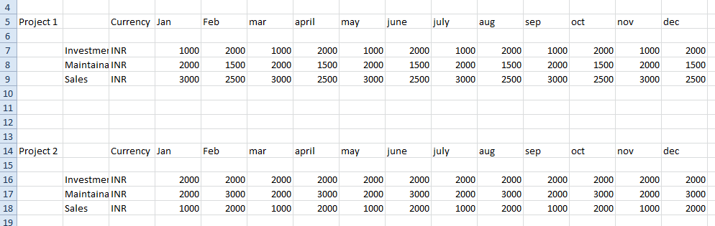

Step 2:

GUI design should be editable format. It should be similar to below Screen shot. Depending on the number of projects in the Excel sheet, GUI should insert the details such as project 1, investment, maintenance, sales, project2 etc. Other fields should be blank (Market,Bookkeeping,Group,End)

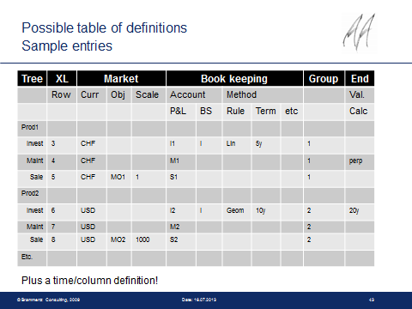

Step 3:

Program should read the rows in the excel sheet Using XL Row Column in the above screenshot.

Benny test andf sheirish