“Linux Memory-Mapped File Management System”
A Project Report Submitted in the partial fulfillment of the requirements for the award of the degree of

BACHELOR OF TECHNOLOGY
In

DEPARTMENT OF COMPUTER SCIENCE ENGINNERING

By

S. ASHWANTH REDDY 2520030081

P. NAVEEN 2520030518

CH. NRIPENDRA 2520030280

Under the Esteemed Guidance of

Ms. Soumya Enukonda
Assistant Professor
Department of Computer Science and Engineering




K L (Deemed to be) University DEPARTMENT OF COMPUTER SCIENCE ENGINEERING
&

DEPARTMENT OF COMPUTER SCIENCE AND INFORMATION TECHNOLOGY

Declaration

The Project Report entitled “Linux Memory-Mapped File Management System” is a record of Bonafide work of S. ASHWANTH REDDY - 2520030081, P. NAVEEN - 2520030518, CH. NRIPENDRA - 2520030280 submitted in
partial fulfillment for the award of B. Tech in Computer Science and Engineering (or) Computer Science and Information Technology to the K L University. The results embodied in this report have not been copied from any other departments/University/Institute.

S. ASHWANTH REDDY 2520030081

P. NAVEEN 2520030518

CH. NRIPENDRA 2520030280

K L (Deemed to be) University

DEPARTMENT OF COMPUTER SCIENCE ENGINEERING

CERTIFICATE

This is certify that the mini project based report entitled“Linux Memory-Mapped File Management System” is a bonafide work done and submitted by S. Ashwanth Reddy – 2520030081, P. Naveen – 2520030518 and CH. Nripendra – 2520030280 ,
in partial fulfillment of the requirements for the award of the degree of BACHELOR OF TECHNOLOGY in Department of Computer Science Engineering, K L (Deemed to be University), during the academic year 2026-2027.

Signature of the Guide

Signature of the Course Coordinator Signature of the HOD

ACKNOWLEDGEMENT
The success in this project would not have been possible but for the timely help and guidance rendered by many people. Our wish to express our sincere thanks to all those who has assisted us in one way or the other for the completion of our project.

Our greatest appreciation to our guide Ms. Soumya Enukonda, Department of Computer Science and Engineering, which cannot be expressed in words for her tremendous support, encouragement and guidance for this project.

We express our gratitude to Dr. P Venkateshwara Rao (CSE), Head of the Department for Computer Science Engineering for providing us with adequate facilities, ways and means by which we are able to complete this project-based Lab.

We thank all the members of teaching and non-teaching staff members, and also who have assisted me directly or indirectly for successful completion of this project. Finally, I sincerely thank our parents, friends and classmates for their kind help and cooperation during our work.

S. ASHWANTH REDDY 2520030081

P. NAVEEN 2520030518

CH. NRIPENDRA 2520030280
Abstract

Memory-mapped file I/O is a mechanism provided by the Linux kernel that maps a file's contents directly into a process's virtual address space, so that file data can be accessed with simple memory operations instead of the traditional read() and write() system calls. Conventional file I/O involves repeated context switches and copying of data between kernel and user-space buffers, which becomes a performance bottleneck for large files and frequent access. This project, the Linux Memory-Mapped File Management System, is designed and implemented in C on Ubuntu using the mmap(), munmap() and msync() system calls to provide efficient, low-overhead file access.

The system demonstrates core Operating Systems concepts such as virtual memory management, page tables, demand paging and page-fault handling, while addressing the synchronization of in-memory changes back to persistent storage. It provides command-line utilities to map a file into memory, perform sequential and random access, read, modify and search the mapped region, and safely synchronize or unmap it, with error handling for invalid file sizes, permission problems and page faults. The performance of the memory-mapped approach is also benchmarked against standard read()/write() based file I/O.

The expected outcome is a functional command-line file management tool that highlights the performance benefits of memory-mapped I/O for large files and frequent access patterns, correctly synchronizes changes to disk, releases all mapped memory and file resources, and gives deeper insight into how the Linux kernel manages virtual memory and file-backed pages.

Index

S. No. | Chapter | Topics / Subtopics | Page No.
 | Acknowledgement |  | i
 | Abstract |  | ii
1 | Introduction |  | 8–9
 |  | 1.1 Background of the Project
 |  | 1.2 Problem Statement
 |  | 1.3 Scope of the Project
 |  | 1.4 Objectives of the Project
 |  | 1.5 Importance of the Application
 |  | 1.6 Target Users / Audience
2 | OS Concepts and Background Study |  | 10–12
 |  | 2.1 Operating System Concepts Related to the Project
 |  | 2.2 Existing Methods / Algorithms
 |  | 2.3 Proposed Approach
 |  | 2.4 Advantages of the Proposed Approach
3 | System Requirements |  | 13
 |  | 3.1 Hardware Requirements
 |  | 3.2 Software Requirements
 |  | 3.3 Operating System Environment – Ubuntu / WSL
 |  | 3.4 Development Tools and Compilers
4 | Technology and Tools Used |  | 14–15
 |  | 4.1 C / C++ Programming
 |  | 4.2 GCC Compiler
 |  | 4.3 Linux System Calls
 |  | 4.4 POSIX Threads / Synchronization
 |  | 4.5 Linux Commands and Utilities
 |  | 4.6 Other Tools / Libraries Used
5 | System Architecture and Design |  | 16–18
 |  | 5.1 Overall System Architecture
 |  | 5.2System Workflow
 |  | 5.3 Flowchart / Data Flow
 |  | 5.4 Module Description
 |  | 5.5 Input and Output Design
6 | Implementation |  | 19–22
 |  | 6.1 Module-wise Implementation
 |  | 6.2 Algorithm / Pseudocode
 |  | 6.3 Core C / C++ Implementation
 |  | 6.4 Linux System Calls / APIs Used
 |  | 6.5 Process / Thread Implementation
 |  | 6.6 IPC / Synchronization Implementation
 |  | 6.7 Memory Management Implementation
 |  | 6.8 Optional User Interface Implementation
7 | Execution and Demonstration |  | 23–24
 |  | 7.1 Compilation in Ubuntu
 |  | 7.2 Execution Commands
 |  | 7.3 Sample Inputs and Outputs
 |  | 7.4 Screenshots of Execution
 |  | 7.5 Demonstration of OS Concepts
8 | Conclusion |  | 25–26
 |  | 8.1 Summary of the Project
 |  | 8.2 Objectives Achieved
 |  | 8.3 Results Achieved
 |  | 8.4 Skills and Learning Outcomes
9 | References |  | 27
 |  | 9.1 Books
 |  | 9.2 Research Papers
 |  | 9.3 Linux / GNU Documentation
 |  | 9.4 Online Resources

CHAPTER 1
INTRODUCTION
1.1 Background of the Project
Every program that works with files must move data between persistent storage and the memory of the running process. In Linux the traditional way of doing this is through the read() and write() system calls. When a process calls read(), the kernel first loads the requested data into its own buffer (the page cache) and then copies it into a buffer that belongs to the user process. A write() works in the opposite direction. Each call also requires a switch from user mode to kernel mode, so programs that access a file many times pay for many mode switches and many copies.
Linux offers a different mechanism called memory-mapped file I/O. With the mmap() system call the kernel maps the contents of a file directly into the virtual address space of the process. After the mapping is created, the program reads and writes the file simply by reading and writing ordinary memory addresses. The kernel loads the required pages from disk only when they are first touched (demand paging), and modified pages are written back to the file by the kernel or when the program explicitly asks for it with msync().
This project, the Linux Memory-Mapped File Management System, uses mmap(), munmap() and msync() to build a command-line utility that manages files through memory mapping. It was developed as the course project for Operating Systems and Systems Programming (25CS2104E), 2026-27, Term-I, and it connects theory taught in the course (virtual memory, paging, page faults) with practical systems programming in C.
1.2 Problem Statement
Traditional file access methods in Linux, such as read() and write(), require data to be copied between kernel space and user space, which introduces CPU overhead and reduces performance, especially for large files or frequent access. The problem addressed by this project is to design and implement a memory-mapped file management system, based on the Linux mmap() system call, in which files are mapped directly into a process's address space so that efficient file access is achieved through virtual memory and demand paging.
1.3 Scope of the Project
The scope of the project covers the following:
• A command-line utility written in C for Linux (Ubuntu) using standard POSIX APIs.
• Mapping an existing file into memory and performing sequential and random access on it (read, write and search operations).
• Synchronizing modified memory back to the file with msync() and releasing resources safely with munmap() and close().
• Error handling for invalid file sizes, permission problems and invalid offsets.
• A benchmark that compares memory-mapped I/O with conventional read()/write() I/O.
The following are outside the present scope and are listed as future work: multi-threaded access, memory-mapped databases and support for files larger than the available RAM through partial mapping.
1.4 Objectives of the Project
1. To study and understand the Linux mmap() system call and its role in virtual memory management.
2. To design and implement a file management system that uses memory mapping for reading and writing files.
3. To implement synchronization of mapped memory changes to disk using msync() and safe unmapping using munmap().
4. To compare the performance of memory-mapped file I/O with traditional read()/write() based file I/O.
1.5 Importance of the Application
Memory-mapped I/O is used widely in real systems: the Linux dynamic loader maps executables and shared libraries into memory, database engines and search indexes map their data files, and many programs use shared mappings for fast inter-process communication. Understanding how it works gives students a clear view of how the operating system connects files, virtual memory and physical memory. The project is important for the following reasons:
• It avoids the extra copy between kernel and user buffers and reduces the number of system calls, which lowers CPU overhead.
• It lets the programmer treat a file as an ordinary array of bytes, which simplifies random access.
• It demonstrates virtual memory, page tables, demand paging and page-fault handling through a working program.
• It teaches safe resource handling (synchronizing, unmapping and closing) that is essential in systems programming.
1.6 Target Users / Audience
• Students and instructors of Operating Systems who want a hands-on demonstration of virtual memory and file-backed pages.
• Systems programmers who need to read, modify or search large files efficiently from the command line.
• Developers who want to measure whether memory-mapped I/O suits their access pattern before using it in an application.

CHAPTER 2
OS CONCEPTS AND BACKGROUND STUDY
2.1 Operating System Concepts Related to the Project
Virtual memory and page tables
Each Linux process has its own virtual address space. The kernel and the hardware memory management unit translate virtual addresses to physical memory frames using page tables. The address space is divided into fixed-size pages (4096 bytes on the test system). A call to mmap() does not copy the file; it only creates a new region (a virtual memory area) in the process's address space and records that the region is backed by the file.
Demand paging and page-fault handling
When the program first touches a page of the mapped region, there is no page-table entry for it yet, so the CPU raises a page fault. The kernel's page-fault handler finds the file-backed region, locates the page in the page cache (or reads it from disk if it is not there), updates the page table and resumes the program. A fault that is satisfied from the page cache is called a minor fault, and one that needs disk I/O is called a major fault. Only the pages that are actually used are loaded, which is why mapping a very large file is cheap.
Page cache and write-back
With a MAP_SHARED mapping, the process and the kernel's page cache share the same physical pages. A store to the mapped memory marks the page dirty, and the kernel writes dirty pages back to the file later. msync() with MS_SYNC forces this write-back to complete before the call returns, so it is the way to guarantee that changes are on disk.
File descriptors and mapping types
A file must first be opened with open() to obtain a file descriptor, which is then passed to mmap(). The mapping can be MAP_SHARED (changes are visible to other processes and are carried through to the file) or MAP_PRIVATE (copy-on-write, changes stay private). This project uses MAP_SHARED so that modifications reach the file. The protection flags PROT_READ and PROT_WRITE control the allowed access, and a violation causes a segmentation fault.
Table 2.1 Operating system concepts and APIs used in the project
OS Concept / API / System Call | Purpose in the Project
mmap() | Maps a file's contents directly into the process's virtual address space
munmap() | Unmaps memory-mapped regions and releases virtual address space
File descriptors (open(), close()) | Provide the file handles required as the basis for mmap() operations
msync() | Synchronizes changes in mapped memory back to the disk file
Virtual memory management / page tables | Handle the mapping of virtual pages to physical memory frames
Page fault handling | Manages demand paging when accessing mapped memory regions

2.2 Existing Methods / Algorithms
• read() / write(): the standard system calls. Data is copied between the kernel page cache and a user buffer on every call, and each call is a mode switch.
• Buffered stdio (fread(), fwrite()): reduces the number of system calls by using a user-space buffer, but still copies data twice (disk to page cache to user buffer).
• pread() / pwrite(): allow random access without a separate lseek(), but still copy data and need one system call per access.
• Direct I/O (O_DIRECT): bypasses the page cache, which suits databases that manage their own cache, but requires aligned buffers and is slower for general use.
The common limitation of these methods is the repeated system calls and data copying, which show up as CPU overhead when a large file is accessed many times or at random positions.
2.3 Proposed Approach
The proposed system maps the whole file into the process's address space once and then performs all operations directly on the mapped memory. The steps are:
1. Open the file with open() and obtain the file descriptor; use fstat() to find its size.
2. Map the file with mmap() using MAP_SHARED and the required protection.
3. Expose the mapped region through command-line operations: read, write, search and info.
4. Flush modifications with msync() so that memory and disk remain consistent.
5. Unmap with munmap() and close the file descriptor to release resources.
6. Handle errors such as invalid file sizes, permission issues and invalid offsets.
7. Benchmark memory-mapped access against read()/write() access.
2.4 Advantages of the Proposed Approach
• Fewer copies: the program accesses the page-cache pages directly, so the kernel-to-user copy is removed.
• Fewer system calls: after mmap() the program uses ordinary loads and stores instead of one system call per access.
• Easy random access: any byte is reached with pointer arithmetic, with no lseek() needed.
• Lazy loading: only the pages that are touched are brought into memory, so large files can be handled with little start-up cost.
• Sharing: several processes that map the same file with MAP_SHARED share the same physical pages.
The approach also has limits that the project takes care of: a file cannot be mapped if it is empty, writes cannot go beyond the mapped size without resizing the file, and I/O errors or a truncated file appear as signals (SIGBUS) instead of return codes. The utility therefore validates sizes and offsets before accessing the mapped region.

CHAPTER 3
SYSTEM REQUIREMENTS
3.1 Hardware Requirements
Table 3.1 Hardware requirements
Component | Minimum Requirement
Processor | Dual-core 64-bit processor (x86-64) or better
RAM | 4 GB (8 GB recommended for benchmarking large files)
Storage | 2 GB free disk space (more if large test files are generated)
Display / Input | Standard monitor, keyboard and mouse (terminal access only is sufficient)

3.2 Software Requirements
Table 3.2 Software requirements
Software | Details
Operating system | Linux (Ubuntu 22.04 LTS or later) or Windows with WSL 2 running Ubuntu
Language | C (C99 / GNU extensions), standard POSIX APIs
Compiler and build | GCC and GNU Make
Debugging and analysis | GDB, Valgrind, strace
Version control | Git and GitHub
Editor | VS Code, Vim or any text editor

3.3 Operating System Environment – Ubuntu / WSL
The project is developed and tested on Ubuntu, because mmap(), munmap() and msync() are provided by the Linux kernel and are not available in the same form on Windows. Students who use Windows can run the project on WSL 2 (Windows Subsystem for Linux), which runs a real Linux kernel. Note that files stored on the Windows drive (for example under /mnt/c) are accessed through a translation layer and give slower and less representative results, so test and benchmark files should be placed in the Linux file system (for example the home directory).
3.4 Development Tools and Compilers
The program is compiled with GCC using the options -Wall -Wextra -O2 so that all warnings are reported. GNU Make automates the build. GDB is used to step through the program and to inspect the mapped region, and Valgrind is used to check for memory errors and leaks. Git and GitHub are used for version control and for collaboration between the three team members.

CHAPTER 4
TECHNOLOGY AND TOOLS USED
4.1 C / C++ Programming
The system is implemented in C because C gives direct access to pointers, memory and Linux system calls without a runtime in between. The mapped region is handled as a plain char pointer, which is exactly how the kernel exposes it. C++ can be used in the same way and could be adopted later to wrap the mapping in a class that unmaps automatically (RAII).
4.2 GCC Compiler
The GNU Compiler Collection (gcc) compiles the C source into an executable. The -Wall and -Wextra flags enable warnings, -O2 enables optimization (used for the benchmark) and -g adds debug symbols for GDB. Because mmapfs uses GNU extensions such as memmem(), the source defines _GNU_SOURCE.
4.3 Linux System Calls
Table 4.1 System calls used in the project
System Call | Header | Role
open() | <fcntl.h> | Opens the file and returns a file descriptor
fstat() | <sys/stat.h> | Obtains the file size and type before mapping
mmap() | <sys/mman.h> | Maps the file into the virtual address space
msync() | <sys/mman.h> | Writes modified mapped pages back to the file
munmap() | <sys/mman.h> | Removes the mapping and frees the address range
close() | <unistd.h> | Releases the file descriptor
getrusage() | <sys/resource.h> | Reports minor and major page faults during the benchmark
sysconf() | <unistd.h> | Reads the system page size (_SC_PAGESIZE)

4.4 POSIX Threads / Synchronization
The current version of the utility is single-threaded, so it does not create POSIX threads. Synchronization in this project means keeping the memory copy and the disk copy of the file consistent, which is done with msync(). If the tool is extended to multi-threaded access, which is listed as future scope, the mapped region would be protected with pthread mutexes or reader-writer locks, and processes that map the same file would coordinate with file locks (flock() or fcntl()).
4.5 Linux Commands and Utilities
Table 4.2 Commands used during development and testing
Command | Use
ls -l, stat | Check file size, permissions and timestamps
cat, head, hexdump | Verify file contents before and after a write
cat /proc/<pid>/maps | View the mapped regions of a process
strace -e trace=openat,mmap,msync,munmap | Trace the system calls made by the program
time, /usr/bin/time -v | Measure execution time and page faults
dd, head -c N /dev/urandom | Create large test files for benchmarking
free -h, vmstat | Observe memory and page-cache usage

4.6 Other Tools / Libraries Used
• GDB: debugging and inspection of the mapped region.
• Valgrind: memory error and leak analysis.
• GNU Make: build automation.
• Git / GitHub: version control; the project repository is https://github.com/ashwanthreddyy/OSSP.
• VS Code: source code development.
No third-party libraries are required; the program uses only the C standard library and the POSIX/Linux system call interface.

CHAPTER 5
SYSTEM ARCHITECTURE AND DESIGN
5.1 Overall System Architecture
The system has three layers. The user interacts with the command-line interface of the mmapfs application, which runs in user space. The application talks to the kernel only through a small set of system calls (open, mmap, msync, munmap, close). Inside the kernel, the virtual memory manager and the page cache bring the file's pages into memory on demand and write modified pages back to disk.
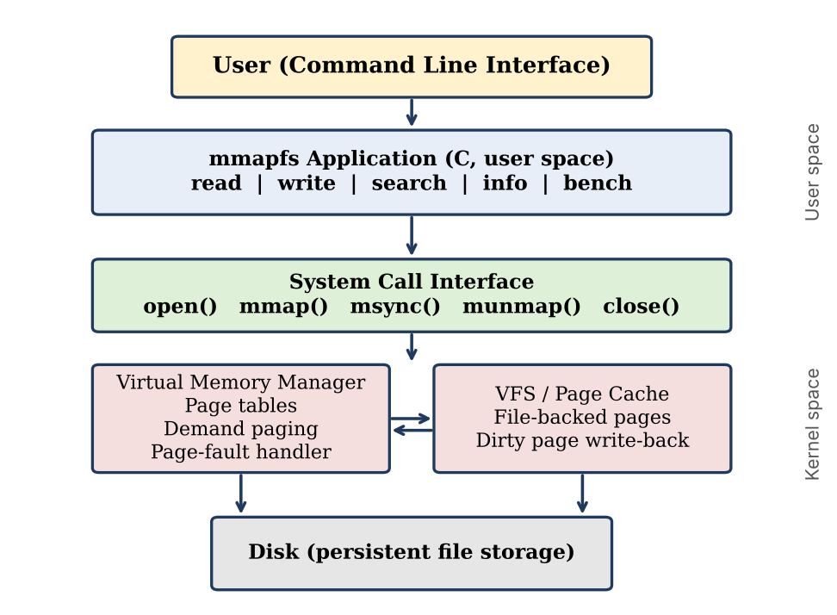
Figure 5.1 Overall system architecture
5.2 System Workflow
1. The user starts mmapfs with a file name and an operation.
2. The program opens the file and checks its size with fstat(); an empty or inaccessible file is rejected with an error message.
3. The file is mapped into memory with mmap() using MAP_SHARED.
4. The requested operation (read, write, search, info) is carried out directly on the mapped memory. Page faults load the touched pages from the file when needed.
5. If the file was modified, msync() flushes the changes to disk.
6. The program calls munmap() and close(), then exits and reports the result.
In short: Start → Open file → Map file → Perform operation → Synchronize → Unmap and close → Exit.
5.3 Flowchart / Data Flow
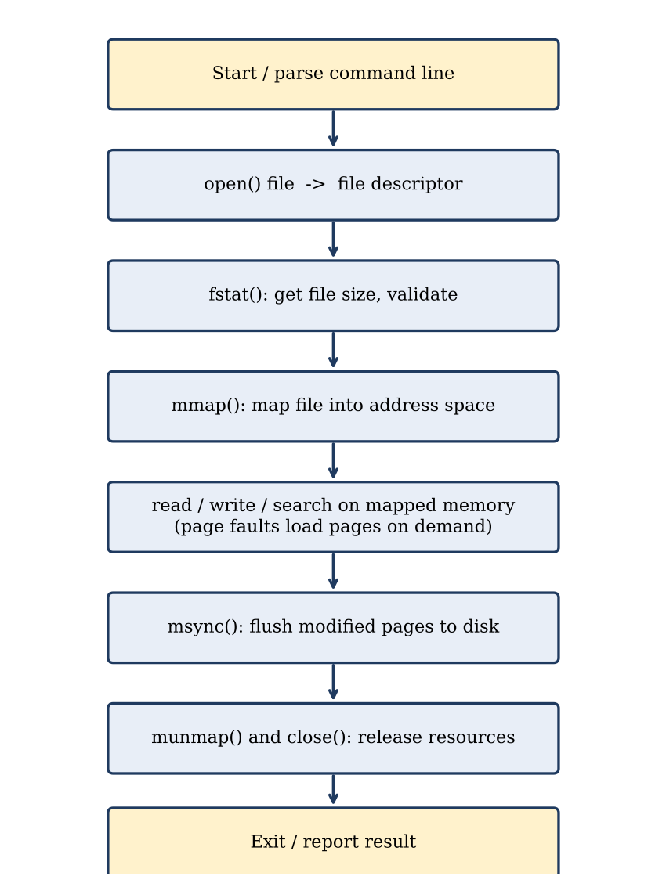
Figure 5.2 Flowchart of the memory-mapped file operation
Data flow: when the program reads a byte from the mapped region, the CPU translates the virtual address through the page table. If the page is present, the data comes straight from the page cache. If not, a page fault occurs, the kernel reads the page from the file into the page cache, updates the page table and the access continues. When the program writes, the page in the page cache is modified and marked dirty, and msync() or the kernel's write-back later copies it to the disk file.
5.4 Module Description
Table 5.1 Modules of the system and the team member responsible
Module | Description | Responsible
File mapping module | Opens the file, validates its size and maps it with mmap(); provides the read, write and search operations on the mapped region. | S. Ashwanth Reddy
Synchronization and unmapping module | Flushes modified memory to disk with msync() and releases the mapping and descriptor with munmap() and close(). | P. Naveen
Benchmark and documentation module | Compares memory-mapped I/O with read()/write() I/O, records time and page faults, and prepares the report. | CH. Nripendra

5.5 Input and Output Design
Table 5.2 Command-line interface of the utility
Command | Input | Output
mmapfs <file> info | File name | File size, mapped address, number of pages and page size
mmapfs <file> read <off> <len> | Offset and length in bytes | The requested bytes from the mapped file
mmapfs <file> write <off> <text> | Offset and text to store | Confirmation of the number of bytes written; change is synchronized to disk
mmapfs <file> search <text> | Text to find | Offset of every match and the total number of matches
mmapfs <file> bench | File name | Time and page faults for mmap access and for read() access

Error messages are printed to standard error for an empty or missing file, a permission problem, an offset beyond the end of the file, a write that would exceed the file size, and an invalid command.

CHAPTER 6
IMPLEMENTATION
6.1 Module-wise Implementation
File mapping module (S. Ashwanth Reddy)
The function map_file() opens the file (read-only or read-write depending on the operation), obtains its size with fstat(), rejects empty files and maps the entire file with mmap(). The pointer, size and descriptor are kept together in a MappedFile structure. The operations cmd_read(), cmd_write() and cmd_search() work on this pointer directly: read prints a range of bytes, write copies text into the region with memcpy(), and search scans the region with memmem().
Synchronization and unmapping module (P. Naveen)
The function unmap_file() calls msync() with MS_SYNC when the file was modified, so that the changes are on disk before the call returns, then calls munmap() to remove the mapping and close() to release the descriptor. Return values of all three calls are checked and reported with perror().
Benchmark and documentation module (CH. Nripendra)
The function cmd_bench() reads every byte of the same file twice: once through the mapped region and once with read() into a 64 KB buffer. It measures the elapsed time with clock_gettime() and the minor and major page faults with getrusage(). It also verifies that both methods compute the same checksum so that the comparison is fair.
6.2 Algorithm / Pseudocode
ALGORITHM MemoryMappedFileOperation(file, operation, args)
fd <- open(file, O_RDONLY or O_RDWR)
IF fd < 0 THEN report error; EXIT
size <- fstat(fd).st_size
IF size = 0 THEN report "empty file"; close(fd); EXIT
addr <- mmap(NULL, size, PROT_READ [| PROT_WRITE], MAP_SHARED, fd, 0)
IF addr = MAP_FAILED THEN report error; close(fd); EXIT
SWITCH operation
CASE read : validate offset; print addr[offset .. offset+len)
CASE write : validate offset+len <= size; copy text to addr[offset ..]
CASE search : scan addr[0 .. size) for pattern; print each offset
CASE info : print size, address, page count
END SWITCH
IF operation modified the file THEN msync(addr, size, MS_SYNC)
munmap(addr, size)
close(fd)
END

6.3 Core C / C++ Implementation
The listing below shows the core of the implementation: the data structure, the mapping and unmapping functions, and the read, write and search operations. The complete source file, including the benchmark function and the main() function that parses the command line, is part of the project repository.
typedef struct {
int fd; /* file descriptor */
char *addr; /* start of the mapped region */
size_t size; /* file size in bytes */
} MappedFile;

/* Open the file and map it into the virtual address space. */
static int map_file(const char *path, MappedFile *mf, int writable)
{
struct stat st;
mf->fd = open(path, writable ? O_RDWR : O_RDONLY);
if (mf->fd < 0) { perror("open"); return -1; }
if (fstat(mf->fd, &st) < 0) { perror("fstat"); close(mf->fd); return -1; }
if (st.st_size == 0) {
fprintf(stderr, "error: cannot map an empty file\n");
close(mf->fd); return -1;
}
mf->size = (size_t)st.st_size;
mf->addr = mmap(NULL, mf->size, writable ? PROT_READ | PROT_WRITE : PROT_READ,
MAP_SHARED, mf->fd, 0);
if (mf->addr == MAP_FAILED) { perror("mmap"); close(mf->fd); return -1; }
return 0;
}

/* Flush (optional), unmap and close - releases all resources. */
static void unmap_file(MappedFile *mf, int sync)
{
if (sync && msync(mf->addr, mf->size, MS_SYNC) < 0) perror("msync");
if (munmap(mf->addr, mf->size) < 0) perror("munmap");
close(mf->fd);
}

static int cmd_read(MappedFile *mf, size_t off, size_t len)
{
if (off >= mf->size) { fprintf(stderr, "error: offset beyond end of file\n"); return -1; }
if (off + len > mf->size) len = mf->size - off;
fwrite(mf->addr + off, 1, len, stdout);
putchar('\n');
return 0;
}

static int cmd_write(MappedFile *mf, size_t off, const char *text)
{
size_t n = strlen(text);
if (off + n > mf->size) { fprintf(stderr, "error: write exceeds file size\n"); return -1; }
memcpy(mf->addr + off, text, n); /* plain memory store, no write() */
printf("wrote %zu bytes at offset %zu\n", n, off);
return 0;
}

static int cmd_search(MappedFile *mf, const char *pat)
{
size_t plen = strlen(pat), hits = 0;
char *p = mf->addr, *end = mf->addr + mf->size;
while ((p = memmem(p, (size_t)(end - p), pat, plen)) != NULL) {
printf("found at offset %zu\n", (size_t)(p - mf->addr));
hits++; p++;
}
printf("%zu match(es) for \"%s\"\n", hits, pat);
return 0;
}

6.4 Linux System Calls / APIs Used
Table 6.1 System calls and the arguments used in the implementation
Call | Arguments used | Remarks
open() | O_RDONLY or O_RDWR | Read-only is used for read, search, info and bench; read-write only for write
mmap() | NULL, size, PROT_READ [| PROT_WRITE], MAP_SHARED, fd, 0 | Whole file mapped; kernel chooses the address; MAP_SHARED carries writes to the file
msync() | addr, size, MS_SYNC | Blocks until the dirty pages are written; MS_ASYNC would only schedule the write
munmap() | addr, size | Must use the same address and length as mmap()
close() | fd | The mapping stays valid after close(), but the descriptor is released to avoid a leak

6.5 Process / Thread Implementation
mmapfs runs as one process with one thread. It does not call fork() or create threads, because the goal of the project is to study the interaction between a single process, its virtual address space and the file. The Linux kernel handles the page faults of this process transparently. A multi-process or multi-threaded version is part of the future scope.
6.6 IPC / Synchronization Implementation
The project does not implement inter-process communication, but its design shows how it can be done: if two processes map the same file with MAP_SHARED, a store by one process is immediately visible to the other, because both mappings refer to the same page-cache pages. Within this project, synchronization refers to consistency between memory and disk, which is implemented with msync(addr, size, MS_SYNC) before unmapping. The difference between the flags is summarized below.
Table 6.2 msync() flags
Flag | Behaviour
MS_SYNC | The call returns only after the modified pages have been written to the file (used by the project)
MS_ASYNC | The write-back is scheduled and the call returns immediately
MS_INVALIDATE | Other mappings of the same file are invalidated so that they see the new data

6.7 Memory Management Implementation
• Page alignment: mmap() works in whole pages, so a file whose size is not a multiple of 4096 bytes is mapped with the last page padded with zeros. Accessing beyond the end of the file but inside the last page is not detected by the hardware, so the program checks every offset against the file size itself.
• Bounds checking: read and write validate offset and length against the file size before touching the region, which prevents SIGSEGV and SIGBUS.
• Empty files: an empty file cannot be mapped, so map_file() rejects it with a clear message.
• Resource release: every error path closes the descriptor, and the normal path calls munmap() and close(), so no mapping or descriptor is leaked.
• Page-fault measurement: getrusage() reports the minor and major faults, which shows demand paging in action.
6.8 Optional User Interface Implementation
The user interface is a command line interface: the user supplies the file name, the operation and its arguments as command-line arguments, and the results are printed on the terminal. A short usage message is printed when the arguments are missing or invalid. A menu-driven or graphical front end is not needed for the objectives of the project.

CHAPTER 7
EXECUTION AND DEMONSTRATION
7.1 Compilation in Ubuntu
$ sudo apt update && sudo apt install -y build-essential gdb valgrind
$ gcc -Wall -Wextra -O2 -o mmapfs mmapfs.c
$ ls -l mmapfs

A simple Makefile can be used instead: the rule 'mmapfs: mmapfs.c' with the command 'gcc -Wall -Wextra -O2 -o mmapfs mmapfs.c' lets the program be rebuilt with the make command.
7.2 Execution Commands
$ ./mmapfs <file> info
$ ./mmapfs <file> read <offset> <length>
$ ./mmapfs <file> write <offset> "<text>"
$ ./mmapfs <file> search "<text>"
$ ./mmapfs <file> bench

7.3 Sample Inputs and Outputs
The following run was produced with the program on a small text file demo.txt that contains the three lines: "Linux memory mapped file demo.", "mmap maps files into virtual memory." and "Demand paging loads pages lazily." (the mapped address differs from run to run).
$ ./mmapfs demo.txt info
file: demo.txt
size: 102 bytes
mapped at: 0x7f3d7efc8000
pages: 1 (page size 4096)
$ ./mmapfs demo.txt read 0 30
Linux memory mapped file demo.
$ ./mmapfs demo.txt search mmap
found at offset 31
1 match(es) for "mmap"
$ ./mmapfs demo.txt write 0 LINUX
wrote 5 bytes at offset 0
$ ./mmapfs demo.txt read 0 30
LINUX memory mapped file demo.
$ ./mmapfs demo.txt search xyz
0 match(es) for "xyz"
$ ./mmapfs demo.txt read 9999 5
error: offset beyond end of file

The output shows that the write is a plain memory store followed by msync(): the second read returns the modified text, and the error cases (offset beyond the end of the file) are reported without crashing the program.
7.4 Screenshots of Execution
Insert the screenshots of the terminal for the following runs (taken on the team's own system):
[Screenshot 1: Compilation of mmapfs.c with gcc]
[Screenshot 2: Output of the info, read and write commands]
[Screenshot 3: Output of the search command]
[Screenshot 4: Output of the bench command on a large file]
[Screenshot 5: strace output showing the openat, mmap, msync and munmap calls]
7.5 Demonstration of OS Concepts
• Virtual memory mapping: while the program runs under GDB, 'cat /proc/<pid>/maps' lists the new region created by mmap() with the file name and the permissions (rw-s for MAP_SHARED).
• System call interface: 'strace -e trace=openat,mmap,msync,munmap ./mmapfs demo.txt write 0 LINUX' shows that the whole write is done with one mmap() and one msync(), with no write() call on the file.
• Demand paging and page faults: the bench command prints the minor and major fault counts for each method; a freshly mapped file shows minor faults as pages are touched for the first time.
• Synchronization: after a write, running 'cat demo.txt' in another terminal shows the modified content, which confirms that the change reached the file.
Performance note: the benefit of memory mapping depends on the access pattern, the file size and whether the file is already in the page cache. Repeated runs on the same file are served from the page cache for both methods, so the benchmark should be repeated on large files and for random as well as sequential access, and the results recorded in the table below.
Table 7.1 Benchmark results (to be filled from the team's own measurements)
File size | Access pattern | mmap time (s) | read() time (s) | mmap minor faults

CHAPTER 8
CONCLUSION
8.1 Summary of the Project
The Linux Memory-Mapped File Management System shows how a file can be accessed through the virtual memory of a process instead of through repeated read() and write() calls. The utility opens a file, maps it with mmap(), performs read, write and search operations directly on memory, synchronizes the changes with msync() and releases all resources with munmap() and close(). Along the way it demonstrates virtual memory management, page tables, demand paging and page-fault handling in a working program.
8.2 Objectives Achieved
1. The Linux mmap() system call and its role in virtual memory management were studied and are explained in Chapter 2.
2. A file management system that reads, writes and searches files through memory mapping was designed and implemented.
3. Synchronization of mapped memory to disk with msync() and safe unmapping with munmap() were implemented.
4. A benchmark that compares memory-mapped I/O with read()/write() I/O, including page-fault counts, was implemented.
8.3 Results Achieved
• A working command-line utility that maps files into memory and performs read, write, search and info operations.
• Changes made in the mapped memory are written back to the file, and the mapping and file descriptor are released safely.
• Invalid input (empty file, invalid offset, write beyond the file size, missing permission) is detected and reported without crashing.
• A benchmark tool that is expected to show the advantage of memory-mapped access for large files and frequent access patterns, because it removes the copy between kernel and user buffers and reduces system calls.
Future scope: multi-threaded access with locking, memory-mapped databases, and support for files larger than the available RAM through partial mapping of windows of the file.
8.4 Skills and Learning Outcomes
• Understanding of virtual memory, page tables, demand paging and page-fault handling in Linux.
• Practical use of the mmap(), munmap(), msync(), open(), fstat() and close() system calls in C.
• Error handling and safe release of operating system resources.
• Use of GCC, Make, GDB, Valgrind, strace and Git for developing, debugging and versioning a systems program.
• Performance measurement and the ability to interpret benchmark results.
• Team work: dividing the project into modules and combining them through GitHub.

CHAPTER 9
REFERENCES
9.1 Books
• A. Silberschatz, P. B. Galvin and G. Gagne, Operating System Concepts, 10th ed., Wiley, 2018.
• M. Kerrisk, The Linux Programming Interface, No Starch Press, 2010.
• R. Love, Linux Kernel Development, 3rd ed., Addison-Wesley, 2010.
• W. R. Stevens and S. A. Rago, Advanced Programming in the UNIX Environment, 3rd ed., Addison-Wesley, 2013.
• D. P. Bovet and M. Cesati, Understanding the Linux Kernel, 3rd ed., O'Reilly, 2005.
9.2 Research Papers
• A. Crotty, V. Leis and A. Pavlo, “Are You Sure You Want to Use MMAP in Your Database Management System?”, Conference on Innovative Data Systems Research (CIDR), 2022.
• P. J. Denning, “Virtual Memory”, ACM Computing Surveys, vol. 2, no. 3, pp. 153–189, 1970.
9.3 Linux / GNU Documentation
• Linux manual pages: mmap(2), munmap(2), msync(2), open(2), fstat(2), getrusage(2), https://man7.org/linux/man-pages/
• The GNU C Library Reference Manual, https://www.gnu.org/software/libc/manual/
• The Linux Kernel documentation, Memory Management, https://docs.kernel.org/mm/
9.4 Online Resources
• Project repository: https://github.com/ashwanthreddyy/OSSP
• GCC documentation: https://gcc.gnu.org/onlinedocs/
• GDB documentation: https://sourceware.org/gdb/documentation/
• Valgrind documentation: https://valgrind.org/docs/manual/

