Table1: List of Searching Techniques used in AI towards problem solving

Name of the
Algorithm
Type of the
Algorithm
Advantage Descrip on Limita on Applica on
BFS Uninformed
Search 1.BFS will provide the solu on with low cost.
2.BFS has the poten al to ﬁnd the goal.
BFS is a general-graph or tree searching algorithm, which searches in breadth wise star ng from the root (HEAD) to following nodes.
1.Not memory eﬃcient because BFS will store states (current) to expand through that.
2.Need more computa ona l power
1.To ﬁnd nodes(USERS) with-in the range.

2.Broadcas ng in Network-to reach all nodes
DFS Uninformed
Search
1.We know BFS stores the states , but DFS no need to, as it follows a linear path(depth). less me complexity
2.Less
me-complexit
DFS searching algorithm Will start searching from the root and traverse through the depth to ﬁnd the solu on
1. Unlike BFS DFS will not guarantee a solu on.
2.If the depth of a larger , me complexity will be high.
1.Topological sor ng.
2.Finding Connected components.

UCS Uninformed
Search
y
1.UCS chooses the op mal path in each state.
2.UCS is op mal compared

UCS traverse through the tree or graph , Here cost wise searching happens , so unlike BFS,DFS
.UCS will focus on cost for searching and reaching the goal

1.No informa on on goal
loca on.
2.Explores diﬀerent paths in each and every state.

1.Delivery
so ware-(they can calibrate in every delivery
)
2.Plane air route planner.

Best First
Search
Informed
Search
1.Best ﬁrst
search can switch between BFS and DFS by gaining
the advantages of both the algorithms.
BFS always chooses the best path at that moment.
1.As it takes decision on each and every state , it
may end up in a loop.
1.GPS Naviga on systems.
2.Web
Crawlers
A* Informed
Search

AO* Informed
Search

Hill Climbing Informed
Search
A* is the best algorithm and the smartest
1.Best
Algorithm
2.less Time and memory .

1.It is an optimal algorithm than others.
2.And it can use OR and AND .

1.Hill climbing is good if the value is
con nuous
(Node).
2.If goal is in ﬁrst maxima then high performance we can get
A* is
essen ally a best-ﬁrst search algorithm and popular techniques used for pathﬁnding and graph traversals.
AO* algorithm is nothing but A*
with AND-OR tree, which gives advantages, the main diﬀerence lies in the way termina on condi ons are determined, since all goals following an AND nodes must be realized; where as a single goal
node following an OR node
will do.
Hill Climbing is a heuris c search used
for
mathema cal op miza on problems in the ﬁeld of
Ar ﬁcial
Intelligence.
1.cost is ﬁxed
2.the speed is dependent on heuristic function.

1.If the it gets unsolved goal,complexi ty will be high

1.Local maxima
2.If it get same values , not possible to get best goal state
1.Games
2.Web maps

1.Fintech
2.E-comm

1.Automa on
2.Map rou ng
.
Table2: performance of Searching Techniques used in AI towards problem solving

Parameters BFA DFS UCS Best First Search
A* AO* Hill
Climbing
Completeness Yes No Yes No Yes No No op mal Yes No Yes No Yes Yes No Heuris c No No No Yes Yes Yes Yes
Time
Complexity
O(b^s) 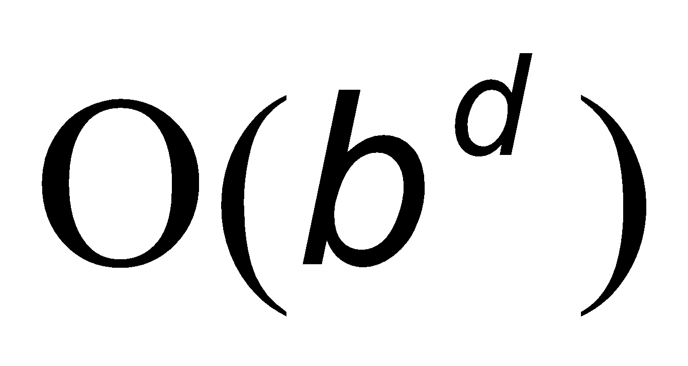 O(b^(1
+ C*/ε))
O(b^m
)
O(b^d
)
O(b^d
)
O(b^d)
Space
Complexity
O(b^s) 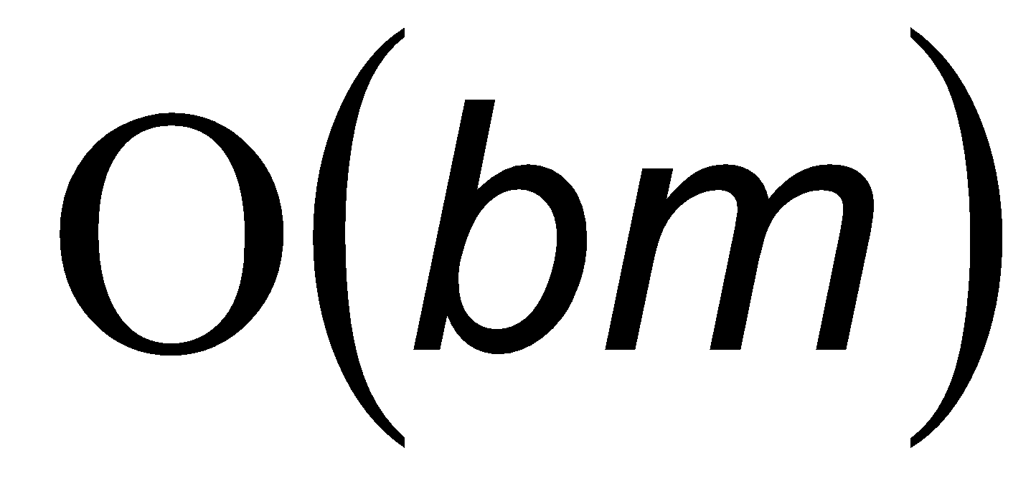 O(b^(1
+ C*/ε))
O(b^m
)
O(b^d
)
O(bm) O(b^d)

Table 3: Diﬀerent heuris c Func ons and its proper es

Heuris c Func on Proper es of heuris c func on
strength Limita on Applica on
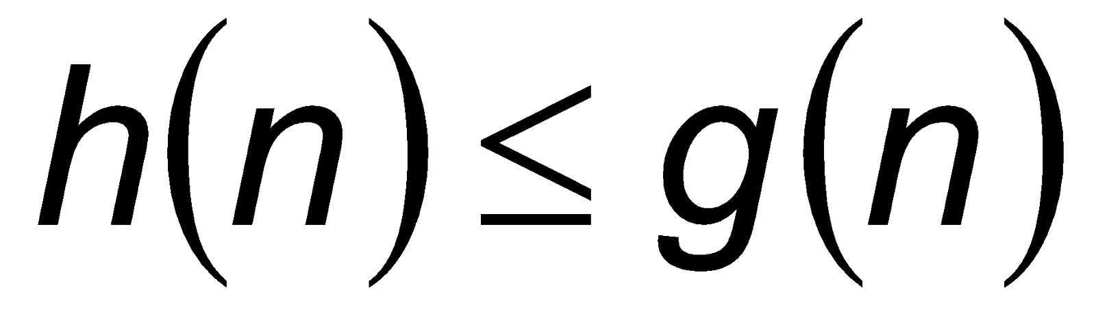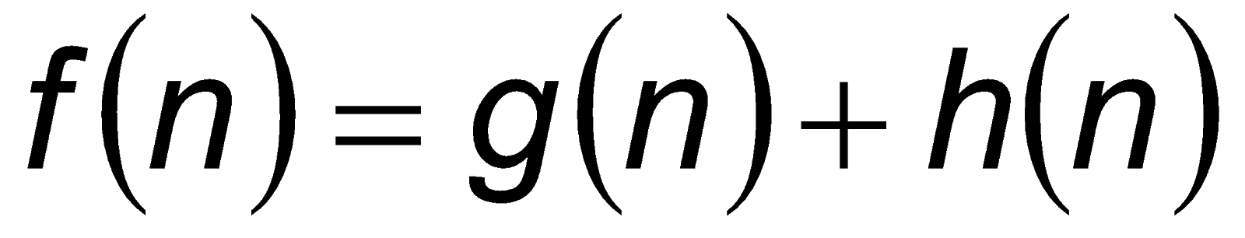 Admissible 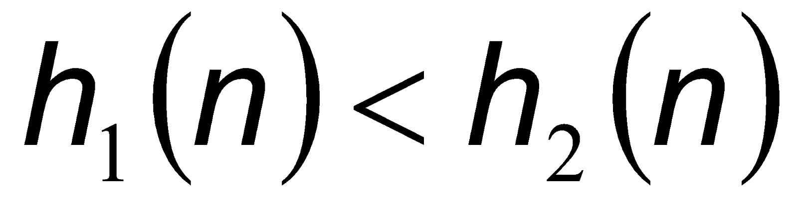 8 Puzzle problem

Combining heuris cs
h(s) ≤ h*(s)

Precompu ng

