Natural Language Processing – with Classification and Vector Spacing

Supervised ML & Sentiment Analysis

In supervised machine learning, you usually have an input X, which goes into your prediction function to get your Y^. You can then compare your prediction with the true value Y. This gives you your cost which you use to update the parameters θ. The following image, summarizes the process.

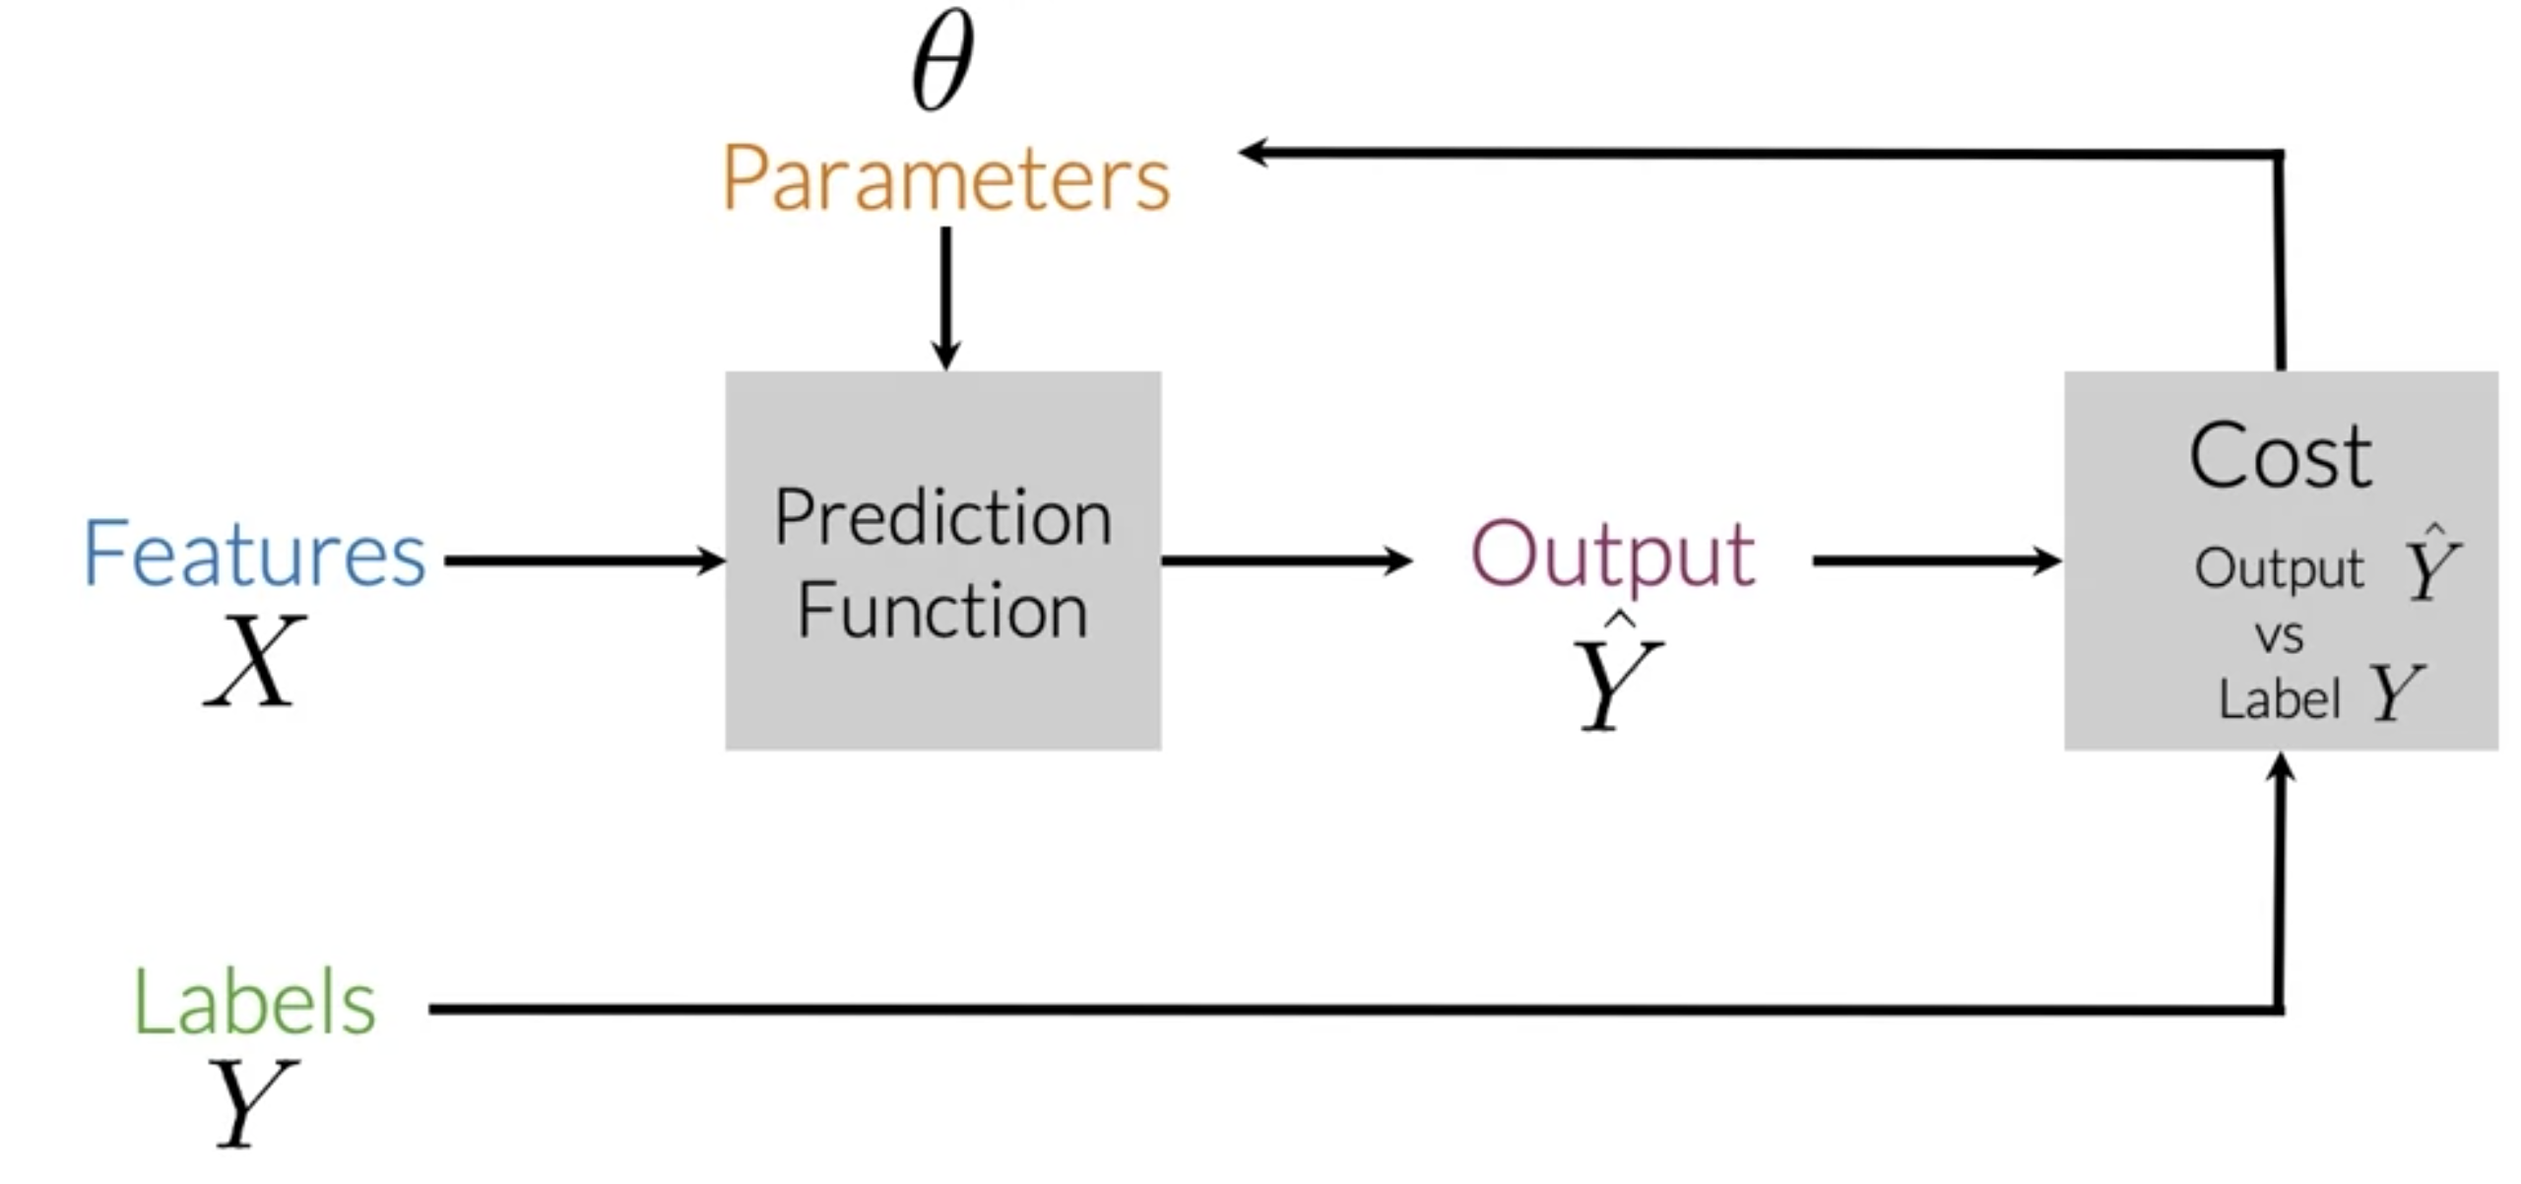

To perform sentiment analysis on a tweet, you first have to represent the text (i.e. "I am happy because I am learning NLP ") as features, you then train your logistic regression classifier, and then you can use it to classify the text.

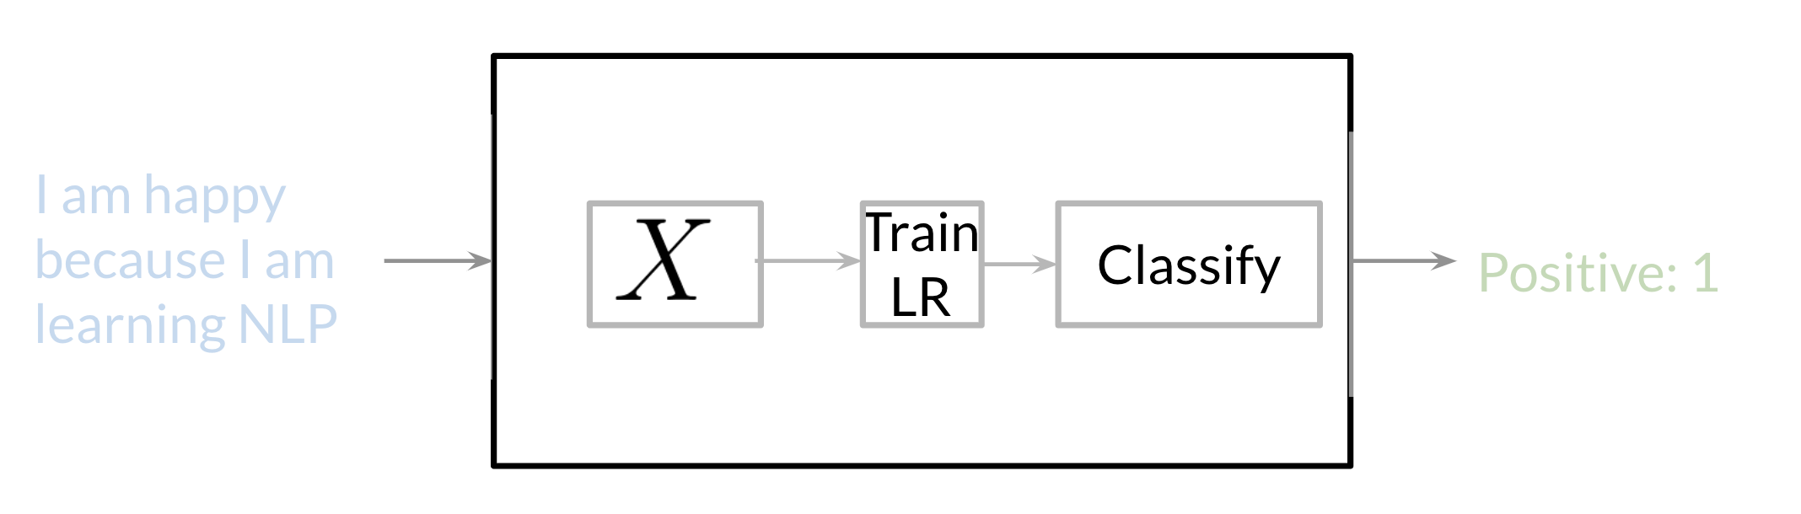

Note that in this case, you either classify 1, for a positive sentiment, or 0, for a negative sentiment.

Vocabulary:

Let’s see how Vocabulary is built. Taking example of Hotel Review

[Review1, Review2, Review3 ....]

[‘Great food’, ‘Tasty, quantity was not enough’,’bad’.......]. Here we need to create vocabulary. Vocabulary contains unique words from the reviews.

Simple Python Function to create Vocabulary

from collections import Counter
def createVocabulary(reviews):
vocabulary = []
for i in range(0,len(reviews)):
word = reviews[i].split(' ')
for j in range(0,len(word)):
join_word = ''.join(word[j])
un_word = Counter(join_word)
s = ' '.join(un_word.keys())
if s not in vocabulary:
vocabulary.append(s)

return vocabulary

createVocabulary(['I love this hotel, I love it'])

The above is the sample code to create vocabulary

Vocabulary & Feature Extraction

Given a tweet, or some text, you can represent it as a vector of dimension V, where V corresponds to your vocabulary size. If you had the tweet "I am happy because I am learning NLP", then you would put a 1 in the corresponding index for any word in the tweet, and a 0 otherwise.
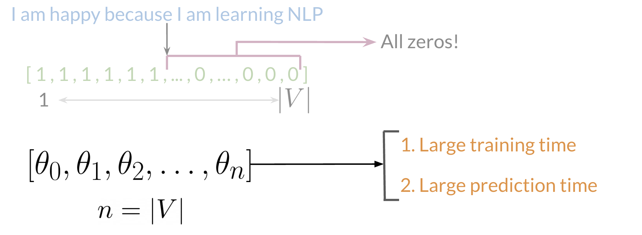
As you can see, as V gets larger, the vector becomes more sparse. Furthermore, we end up having many more features and end up training θ V parameters. This could result in larger training time, and large prediction time.

Once the Vocabulary is created, we can now start creating positive and negative frequency dictionary.

Feature Extraction:

Xm = [ 1 , sum(Positive_frequency) , sum(negative_frequency)]

Preprocessing

When preprocessing, you have to perform the following:
- Eliminate handles and URLs
- Tokenize the string into words.
- Remove stop words like "and, is, a, on, etc."
- Stemming- or convert every word to its stem. Like dancer, dancing, danced, becomes 'danc'. You can use porter stemmer to take care of this.
- Convert all your words to lower case.
For example the following tweet "@YMourri and @AndrewYNg are tuning a GREAT AI model at https://deeplearning.ai!!!" after preprocessing becomes
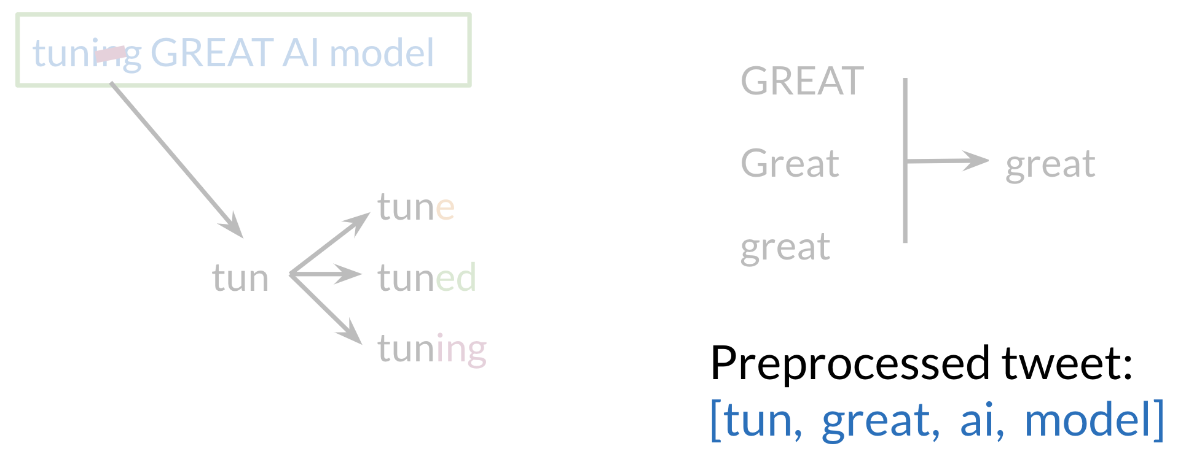

[tun,great,ai,model]. Hence you can see how we eliminated handles, tokenized it into words, removed stop words, performed stemming, and converted everything to lower case.

Putting it all together

Over all , you start with a given text, you perform preprocessing, then you do feature extraction to convert text into numerical representation as follows:

Your X becomes of dimension (m,3) as follows.
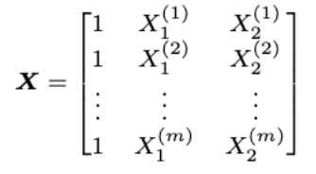
When implementing it with code, it becomes as follows:
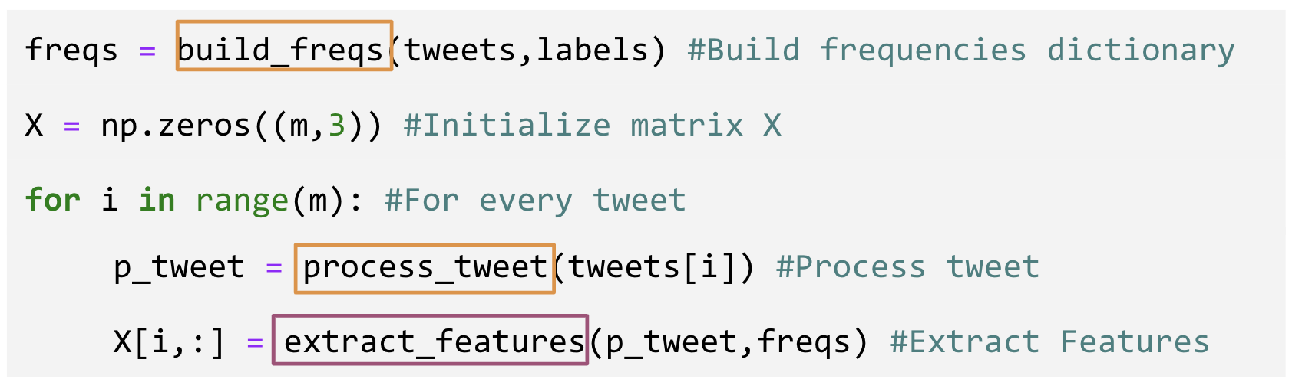
You can see in the last step you are storing the extracted features as rows in your X matrix and you have m of these examples.

