MINIMOUSE 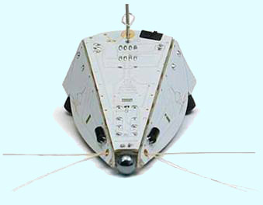

The advent of autonomous robots has put the globe on a different spin. It has got far reaching applications from industrial automation to its application in house hold tasks. Major problems faced in the design of robots are power efficiency; quick are reliable sensing mechanism and unfamiliar terrain conditions. Maze solving robots have the richest history in its own kind in robotics. Autobots like Pathfinder, Explorer, Assembly Line robots use various sensing and terrain identification methods to fulfil its application. Design of such robots involves and incorporates different techniques for the simplification and efficiency, both in algorithm and hardware of autonomous robots.

Problem Statement
Build an Autonomous Mini Mouse that can guide through the fastest and only possible route from the Start Zone to End Zone of a maze using the simple line following techniques.

Arena Specification
- Arena consists of 5 X 5 grids, (white in colour) with a black coloured background of dimension 164cm X 164cm. The pattern will consist of only straight lines and all the turns will only be at right angles.
- The total length of grid is 144cm, which means distance between the centres of two adjacent lines is 32cms.
- Each line in the grid will have a width 3 cms.
- There will be obstacles in the intersection of the grid.
- Obstacle will be a cube of 16 cms, coloured red.
- Arena will have a border, coloured red and 5cm thickness.
- The sketch of a sample arena is given below.
 Arena
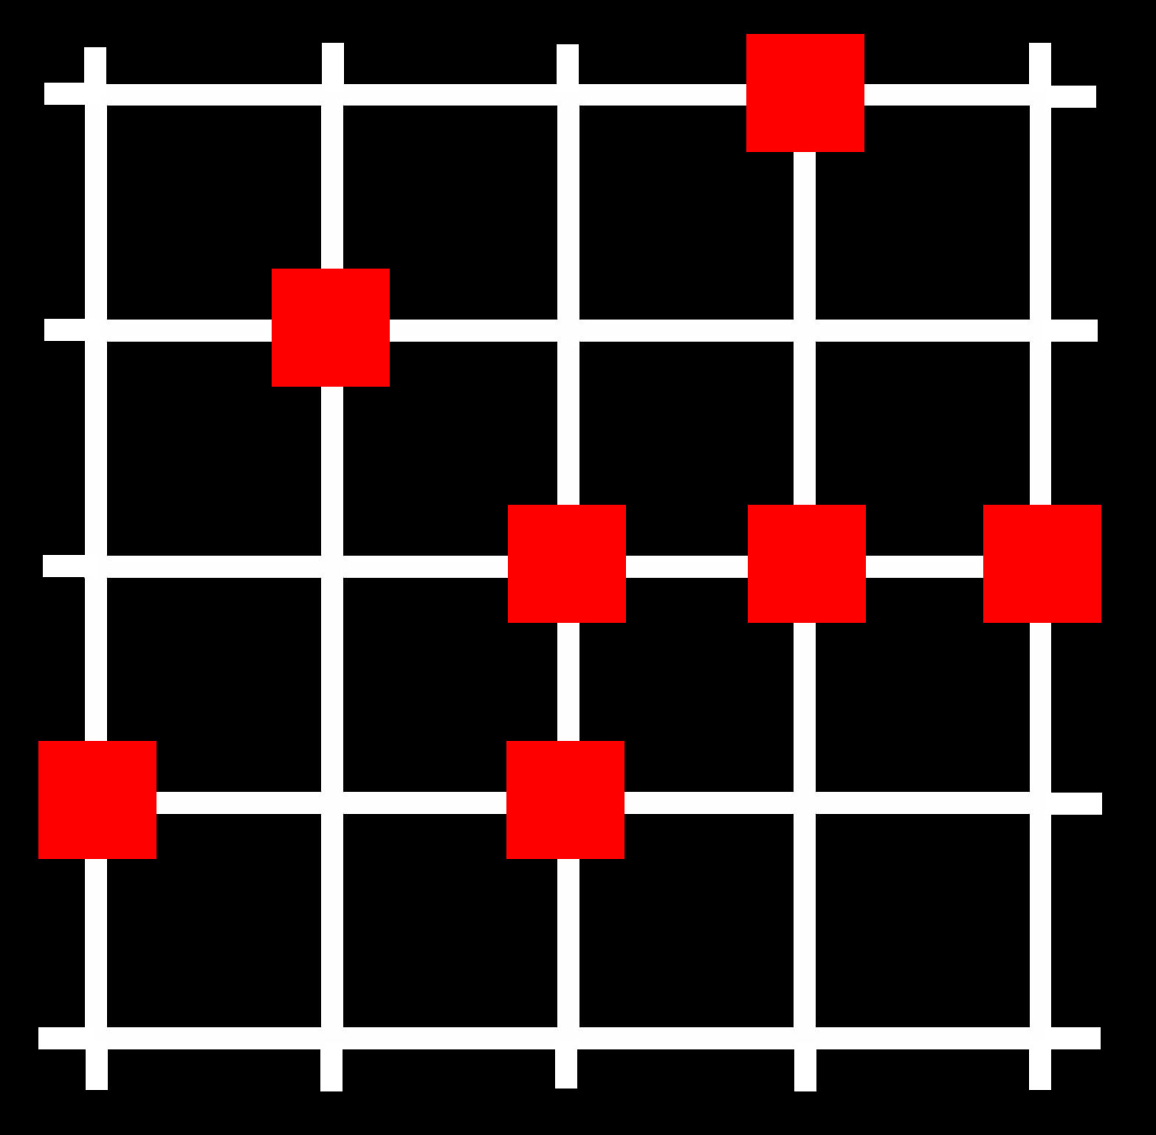 Arena with obstacles
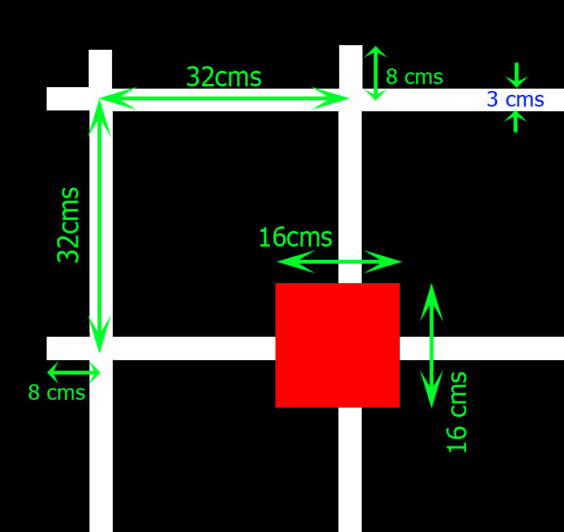 Arena Details
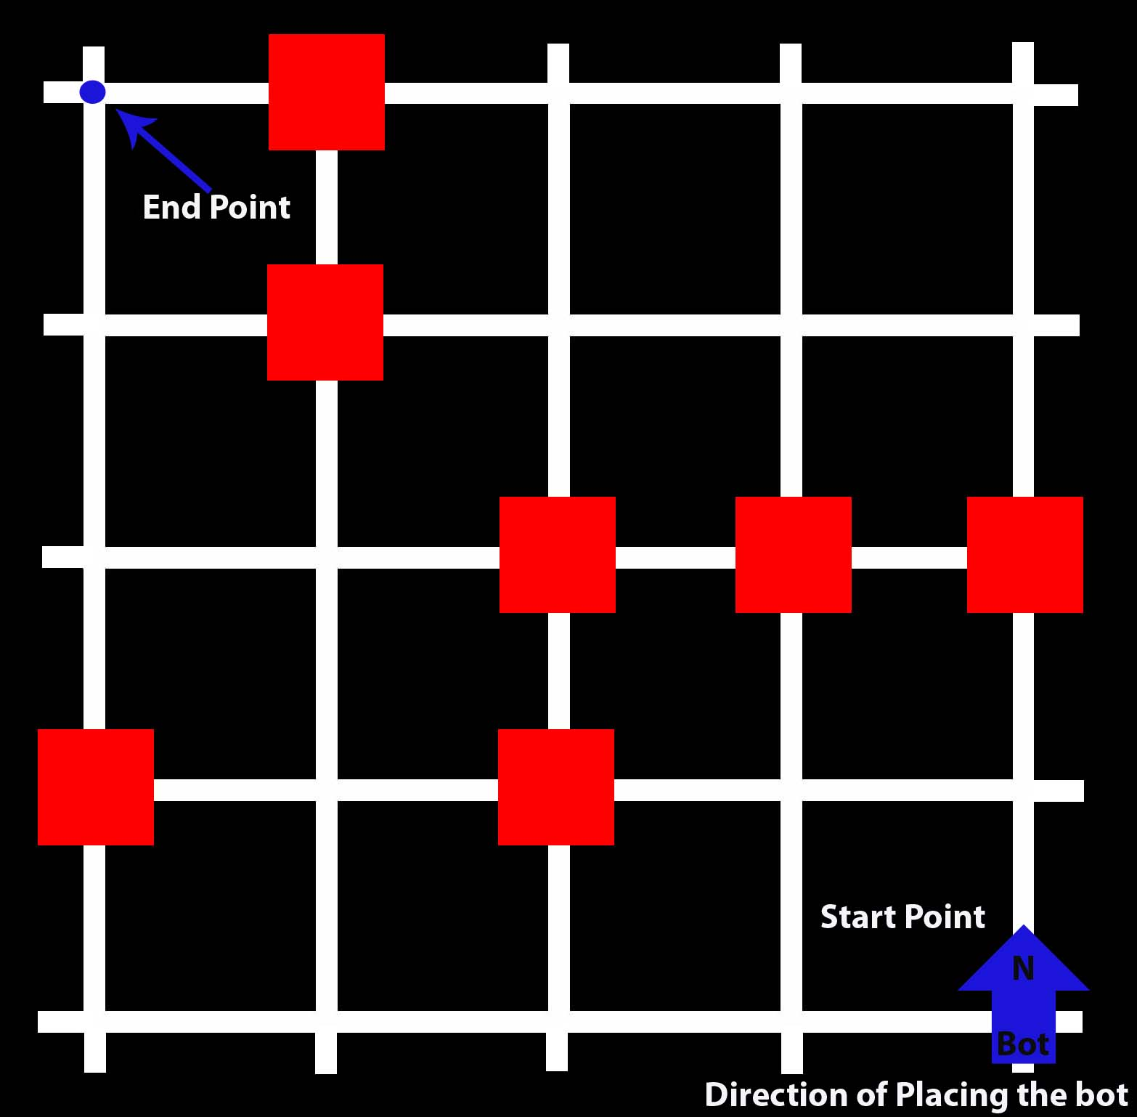 Arena with Start and End Points

Bot Specification
- Mini Mouse should be subjected to following size constraints: Length - 20cms, Width -16cms, Height - 20cms. At no point of the competition shall the size of the bot exceed the above constraints.
- The bot will be passed through a rectangular box having dimensions 20cm X 16cm X 20cm before competition to ensure that the size limits.
- The bot should not deposit anything in the maze and strictly banned from disturbing the arena.
- Mini Mouse should not create any sought of damage to the maze and such bots will be disqualified from the competition.
- Mini Mouse should not get any outside assistance, i.e. it should be self contained completely.
- The Power source used should be strictly cells. No other propulsion methods must be used.
- There should be some sought of indicator in the machine, either an LED or a buzzer to indicate that the machine reached the end point. The type of indicator should be informed to the organizers prior to the event.
- Use of any LEGO kits or other readymade kits is strictly prohibited and if found using, then the contestant will be disqualified from the competition. However participants are allowed to use Geared motors and Gear Mechanisms of toys.

Judging Criteria
- All contestants will be allowed to adjust their Mini Mouse Sensors in a sample track one day before the competition.
- All contestants are supposed to submit their Mini Mice to the organizers when informed before unveiling the maze.
- Each team will be given 5 mins before the RUN to make minor adjustments in sensor to avoid mismatched sensing due to ambient light.
- Contestants will place the Mini-Mouse on the arena on the right most end facing north(Start Point).
- The End Point will be the diagonally opposite extreme most corner to the Start Point.
- No changes can be made in the Program once the arena is unveiled. Any team doing so will be disqualified from the competition.
- The arena will be the same as that of the sample arena, but the position and number of obstacles can vary.
- The maximum time allotted to each team to access the grid is 10 minutes. The RUN TIME will only be recorded for successful run made by the mouse between these 10mins. After this period, the team will not be allowed to access the arena. If any team is not ready for competition in the given 15 mins they will be removed from the competition.
- The 10 minute Timer will commence after the end of 5 min period given for the adjustments.
- The navigation of the bot should be strictly based on the line following techniques.
E.g.: the bot should not travel from one junction to another avoiding the white line or the junctions between them.
- The Minimouse shouldn’t disturb any of the Red Obstacles. It can touch it if it uses a touch sensor, but any Mouse hitting or crashing into the obstacles there by disturbing its position will be forced to call a time Out.
- RUN TIME: It denotes the time a Mini Mouse takes to Navigate from Starting point to Destination point. RUN-TIME shall be recorded only after the Bot signals having reached the destination point. The mode of signalling must be declared prior to the RUN to the judges.
- If a mouse continues to navigate the maze after reaching the destination square, the time taken will not count toward any run. Of course, the 10-minute timer continues to run. When the mouse next leaves the start square, a new run will start. Thus, for better "Run time", a mouse may make several runs without being touched by the operator. It should make its own way back to the Starting Point to do so.
- TIME OUT: Contestants are allowed to call time out if the machine out of track or halts in between with the permission of the judges. Contestants are allowed to make Minor adjustments only in the sensors and not in the machine program. Mini Mouse shall be placed back in the Starting Point. Time taken for the Minor Adjustments will be included in the Competition time of 10mins.
- MINOR ADJUSTMENTS: A contestant may not feed information on the maze to the Minimouse. Therefore, changing ROMs or downloading programs is NOT allowed once the maze is revealed. However, contestants are allowed to:
o Replace batteries between runs
o Adjust sensors (gain, position etc.)
o Make repairs
o However, a contestant may not alter a mouse in a manner that alters its weight (e.g. removal of a bulky sensor array or switching to lighter batteries to get better speed after mapping the maze is declared is not allowed). The judges shall arbitrate.
- The Maximum number of TIME OUT for a team is 5.
- If no successful run has been made, the judge will make a qualitative assessment of the Mini Mouse’s performance; based on how close is the mouse to the end zone, 'purposefulness' versus random behaviour and quality of control.
The Point System is as follows:
- The winner will be decided based on a common point system.
- Points will be decided by:
• Number of NODE yet to cover to reach the End Zone
• Time taken for the run
• Number of TIME OUT
- The point will be calculated using the formula:
(–RT) * 10 + NNC * 100 – NTO*100, where
• RT :- Run Time
• NNC :- Number of Nodes Covered
• NTO :- Number of time out

Team Specification
- Maximum number of members per team is 4.
- The team members should produce valid identification (identity card) to claim that they are studying in the institute.
- However the team can consist of members from the same institute or different institutions.

Tutorials and Guidelines
Click here to download the tutorials and guidelines in pdf format.
Click here to download the sample codes

Contacts
Event Manager
Sony Joseph
+91-9947464184
sonyjoseph@tathva.org

