iBOT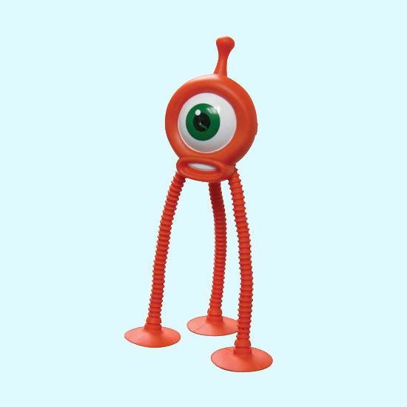

Design and construction of any human creation involves detailed dimensioning and mapping of the terrain. Image processing in an enhanced tool in computer aided photogrammetric surveying. Modern industries call for such autonomous robots which can navigate and execute the stipulated task depending upon the feedback from an aerial or self mounted photographic system. Modern GPS, GNSS, Real Time Satellite Imagery uses such image processing tools for its functionality. These robots are much efficient and more reliable than the traditional sensing robots, when the instruction set is too large and complex. It even avoids the usage of bulky array of sensors.

Problem Statement
To Build a Computer Controlled iBot, using the help of an Overhead Camera and a computer, navigate through one of the various paths available for it to go from a Starting Point to a Destination Point so as to fetch maximum points. The iBot is expected to use inputs only from computer and implement vision based navigation system with no other sensors.

Arena Specification
- Arena will be coloured in Black ([R G B] = [0 0 0]), 160cmX120cm.
- There are circles of diameter 15cm at two corners of arena, Red ([R G B] = [255 0 0]) in colour. These are Starting Point and Destination Point.
- A Co-Circle of diameter 5cms will be there in each of these circles having white and black colour.
- Starting Point will have a combination of colours Red and White.
- Destination Point will have a combination of colours Red and Black.
- There will be 4 distinct paths from Source to Destination.
- Paths consist of squares of dimension 5cm X 5cm.
- Each path will be of different colour, namely
o Green Path [R G B] = [0 255 0]
o Blue Path [R G B] = [0 0 255]
o Yellow Path [R G B] = [255 255 0]
o Orange Path [R G B] = [255 128 64]
- Paths will also contain Magenta [R G B] = [255 0 255] coloured squares which denotes BONUS Point Squares.
- There will be gap of 5cms between each coloured square.
- All the turns in the path will be less than 135°. Paths may overlap at bonus points and may have gradual curves.
- At a distance of 5cm from the arena, a 5cm thick White [R G B = 255 255 255] outline will be present and iBot should not go beyond the white outline.
- Organizers will provide an Over head camera and a Computer System having Video Adapter, Serial, Parallel and USB 2.0 Port with fully installed Matlab 7.X version.
- Details of the Camera and Mounting System will be uploaded soon.
The detailed sketch of the sample arena is given below.
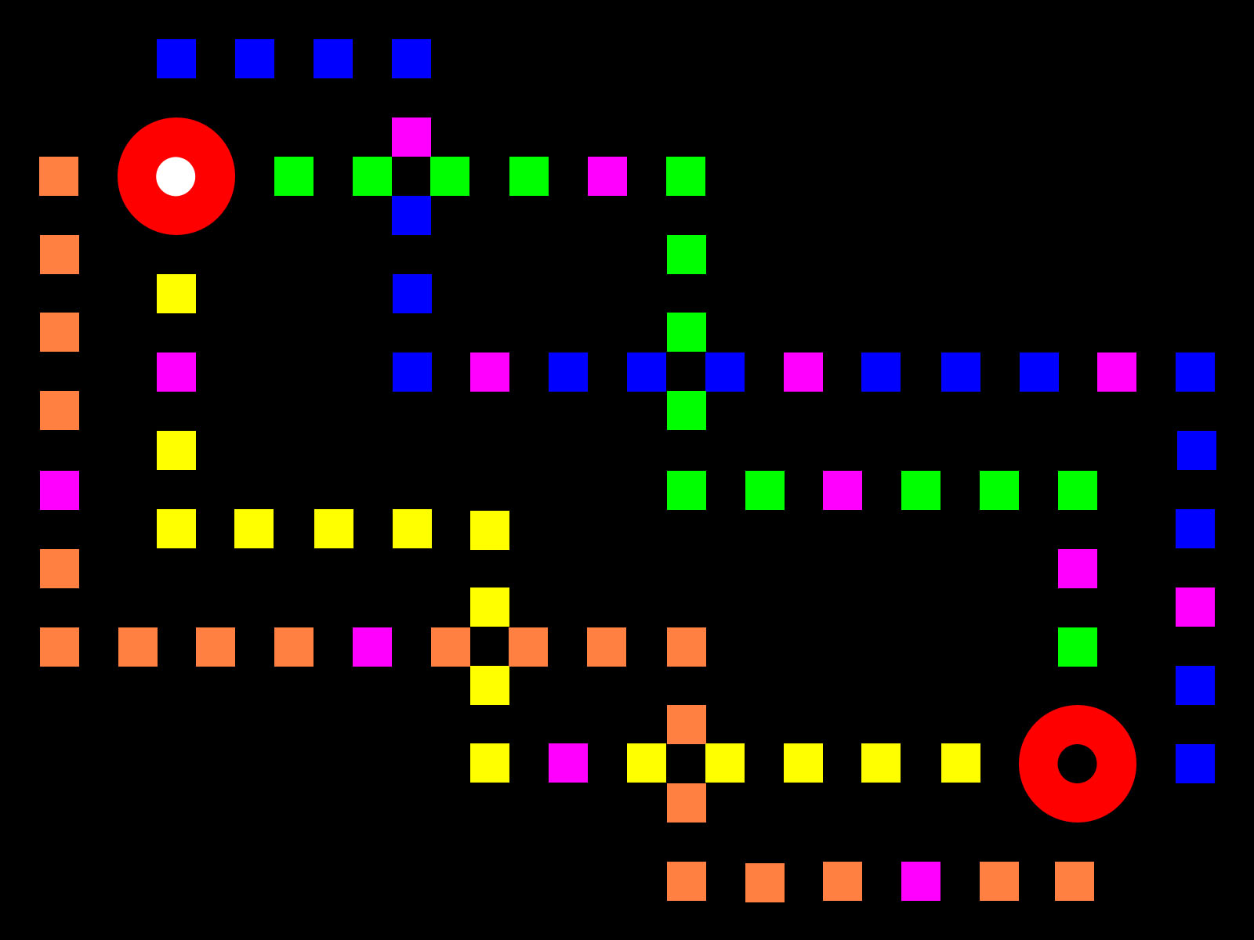
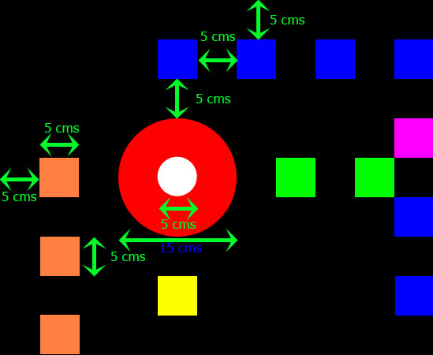

Bot Specification
- Length and Breadth of iBot should not exceed 20cms and 20cms respectively at any height. As far as Height is concerned there is no such limit. Organizers will be testing it by passing through a Square Shaped frame of side 20cm.
- Navigator should use an Onboard Power Supply. No external Power supply will be allowed.
- Navigator should not have any kind of sensors fitted on it. If found then it will lead to immediate disqualification.
- The only External input should be from the computer, either Serial or Parallel or USB Communication, using wires.
- Navigator can also use wireless communication to communicate with the computer.
- It is participant responsibility for any data misinterpretation of the arena image taken by the camera due to wires connected with the Bot.
- All the Bots should work strictly on the principle of Image Processing. Any ambiguity found will lead to immediate disqualification of the participant.
- Use of any LEGO kits or other readymade kits is strictly prohibited and if found using, then the contestant will be disqualified from the competition. However participants are allowed to use Geared motors and gear mechanisms of toys.

Judging Criterion
- Completion is based on Point System. The Team having maximum number of points wins the competition.
- Only one bot will be running on the arena at a time. Time duration for one run is 5 minutes.
- Participants will get 15mins prior to the actual competition. In this time participants should have to mount the camera, load the program.
- Participants should hand over the iBot to the organizers after they have loaded the program.
- Organizers will place the machine on the Arena at the starting point in any arbitrary direction, but the iBot front in the direction of any of the four valid paths.
- At the end of 15 minutes, 5 minutes counter will start for the run.
- The Actual colours on the arena may slightly vary from the specified colour because of the Ambient Light and Texture of the materials. A sample arena would be set up and time slots will be provided for the participants one day before the competition for them to calibrate their machine to the colour.
- If iBot manages to reach the Destination in stipulated time limit, it should signal that with an LED or a Buzzer, or by any means prior known to the Organizers.
- The colour of the first square that the iBot enters will be considered as the colour of the valid path it takes to navigate and any iBot going into any other colour will be forced to call a time out.
- Navigation time: It denotes the time an iBot takes to Navigate from Starting point to destination point. Navigation time shall be recorded only after the iBot signals having reached the destination point.
- Time Out: Contestants call for a time out if machine halts in between or deviated from the path. Contestants are allowed to make Minor adjustments. iBot shall be placed back in the Starting Point. Time taken for the Minor Adjustments will be included in the Navigation time.
- Minor adjustments: A contestant may not feed information on the arena to the iBot. Therefore, changing ROMs or downloading programs is NOT allowed once the arena is revealed. However, contestants are allowed to:
o Replace batteries between runs
o Change speed settings
o Make repairs
o However, a contestant may not alter the iBot in a manner that alters its weight (e.g. switching to lighter batteries to get better speed after mapping the arena is declared is not allowed). The judges shall arbitrate.
The Point System is as follows:
- There will be multiple valid paths through which the iBot can reach from the source to destination.
- Once navigator starts motion through any one valid path, each time it crosses one square of that valid path; it gets 10 points, regardless of how many times it crosses it. The colour of the first square chosen will be considered as the colour of the valid path.
- The point will be calculated using the formula:
(300-t)*10 + NS*100 + NBS*200, where
• t - time taken for the bot to travel in seconds.
• NS - Number of Squares covered of one Valid Path
• NBS - Number of Bonus Squares Covered.
- For an iBot to get Maximum points, it should travel through the path having Maximum number of Bonus Squares but in minimum time.
- All iBots which complete the competition will be ranked above those iBots which failed to reach the Destination Zone.
- In case, the iBot fails to reach the destination, the ‘T’ will be assumed to be 300 seconds.
- If two or more contestants get the same number of points, then the winner will be decided on the basis of:
o Simplicity of the Program
o Compactness and Speed of the iBot

Team Specification
- Maximum number of members per team is 4.
- The team members should produce valid identification (identity card) to claim that they are studying in the institute.
- However the team can consist of members from the same institute or different institutions.

Tutorials annd Guidelines
Click here to download the tutorials and guidelines in pdf format.

Contacts

