**Places Search App**

**ABOUT**

The Places Search app is intended to be a desktop app.

It uses the Google places library to enable users to look up places using google Maps.

**SETTING UP**

**Online access:**

The site is hosted at: <http://placesapp.byethost16.com/>

**Local server access:**

The zip file places.zip contains the source files:

1. index.html
2. places.js
3. styles.css

Places these files in your local server folder to use the app.

**FEATURES**

Using the Places search app, a user can perform the following actions:

1. By default, the app loads the user’s current location if the browser’s geolocation is enabled and not blocked. Otherwise the map loads San Francisco.
2. Users can look up anything on the globe- addresses,city and establishments (hotels, restaurants, hospitals and so on).
3. The search box throws suggestions based on user input. The user can select one of the suggestions and use the search button to fetch the places.
4. The results and the relevant details (price, star rating, reviews, hours) are displayed in the right panel.
5. Hovering over a result detail pans the map to the location and the map marker bounces.
6. Google reviews for a place can be accessed when available. The reviewer’s google plus link can be accessed from the review window.
7. The location arrow button enables users to go back to their current location and start a fresh search. (Caution! – Pressing current location button removes the current search details completely.
8. Once the map is at a specific location the futures are specific to that place. Example if user looks up Cancun and then searches hotels. Hotels in Cancun will show up.

**SCREENSHOTS**

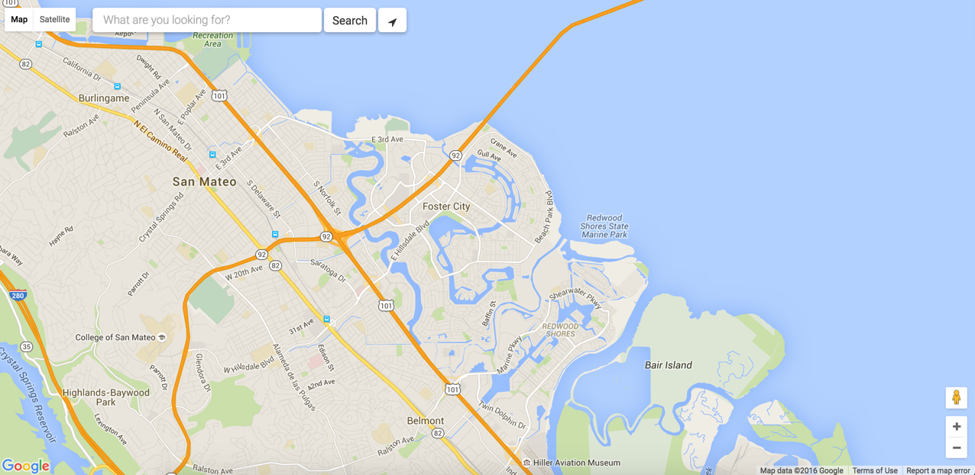

Search autocomplete:

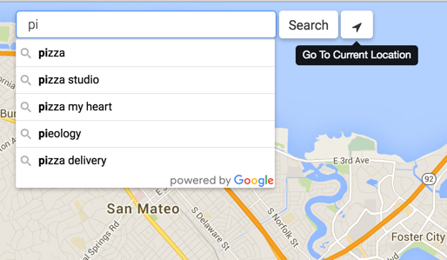

Search Results:

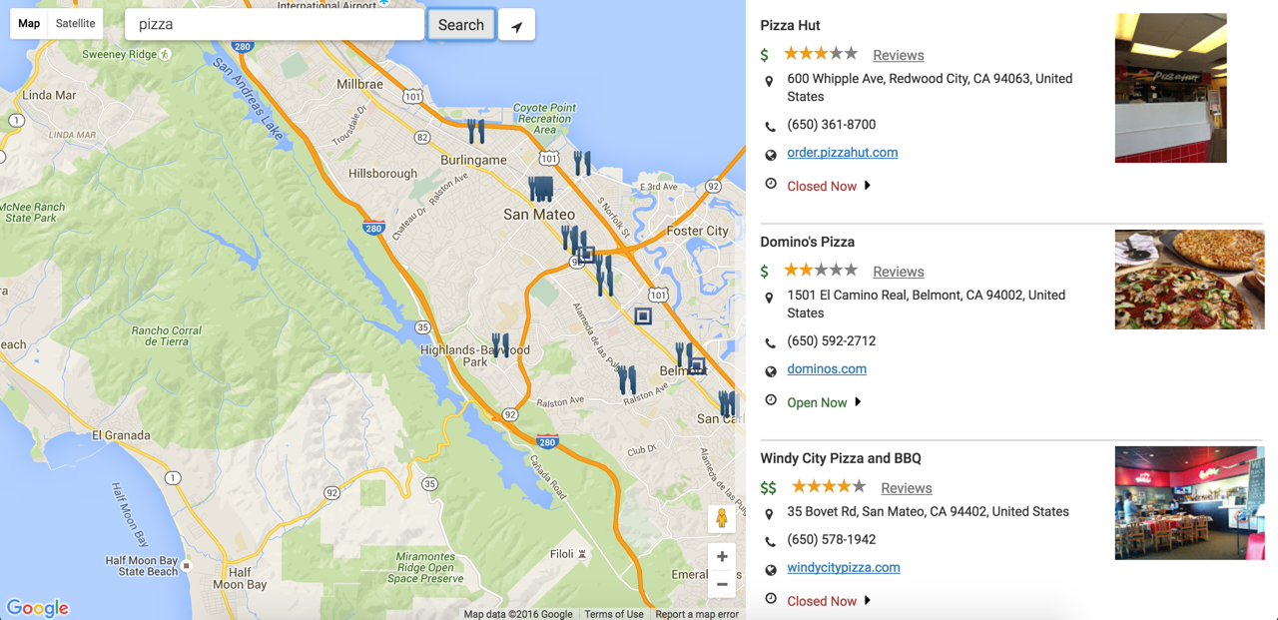

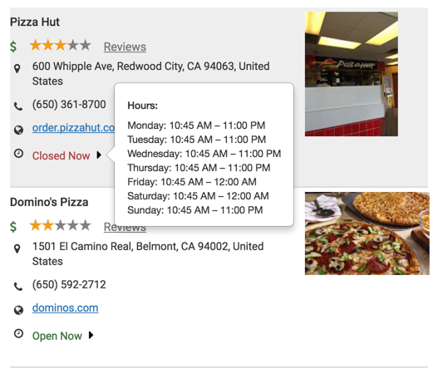

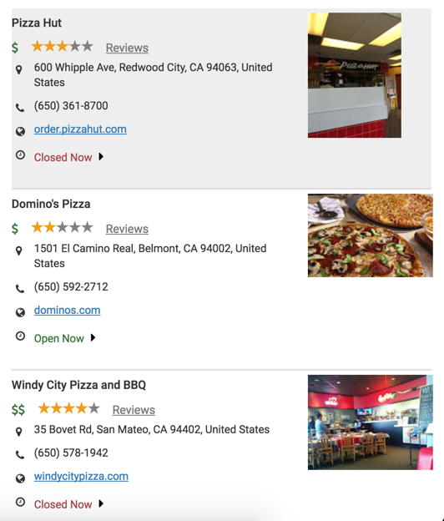

Reviews:

